**Step 3 answers**

**Chapter 1 Number**

**1.1 Multiplying and dividing by 10, 100 and 1000**

**1 a** 70 **b** 74 **c** 79 **d** 660 **e** 66 **f** 6.6 **g** 400 **h** 4.5 **i** 98.7 **j** 0.23 **k** 8070

**l** 60.52

**2 a** 0.5 **b** 0.52 **c** 0.54 **d** 2.8 **e** 0.28 **f** 0.028 **g** 0.09 **h** 80 **i** 2.099

**j** 0.003 **k** 56.9 **l** 7.563

**3 a** 300 **b** 310 **c** 314 **d** 9000 **e** 200 **f** 925 **g** 54 **h** 29 000 **i** 2.5 **j** 765.4

**k** 3050 **l** 126

**4 a** 4 **b** 4.3 **c** 4.38 **d** 0.6 **e** 0.69 **f** 0.05 **g** 0.003 **h** 0.087 **i** 0.423

**j** 0.902 **k** 80 **l** 62.5

**5 a** 4000 **b** 4400 **c** 44 000 **d** 440 **e** 6700 **f** 3750 **g** 500 **h** 2640

**i** 75 **j** 106 **k** 17 200 **l** 4930

**6 a** 7 **b** 7.3 **c** 7.125 **d** 0.35 **e** 0.035 **f** 0.008 **g** 0.505

**h** 8.04 **i** 0.0035 **j** 0.0009 **k** 7.8 **l** 0.0692

**7 a** 10 **b** 1000 **c** 1000 **d** 100 **e** 1000 **f** 100

**8 a** 100 **b** 1000 **c** 10 **d** 10 **e** 100 **f** 1000

**1.2 Rounding**

**1 a** 4.4 **b** 7.8 **c** 3.5 **d** 23.6 **e** 75.9 **f** 0.8

**2 a** 0.67 **b** 0.09 **c** 1.73 **d** 14.29

**3 a** 0.333 **b** 0.667 **c** 0.182 **d** 9.877 **e** 4.568 **f** 3.460

**4 a** 6.3 **b** 0.04 **c** 64.8 **d** 9.90 **e** 29.0 **f** 0.007

**5 a** 4.3 **b** 4.30 **c** 4.296

**1.3 Fractions**

**1 a**  **b**  **c** 



**2 a**  **b**  **c**  **d** 



**3 a**  **b**  **c**  **d** 



**4 a**  **b**  **c**  **d** 



**5 a**  **b**  **c**  **d** 



**6 a**  **b**  **c**  **d** 



**7 a** 12 **b** 12 **c** 25 **d** 6 **e** 48

**1.4 Fractions and decimals**

**1 a**  **b** 



**2 a**  **b** 



**3** 0.19, , 0.24, , 0.3



**4** 0.8, , , 0.65, 



**5** , 0.55, 0.6, , 



**6** 1, 1.7, 1, 1.65, 1



**7** 

**8** 

**9** 4.29

**1.5 Calculations**

**1 a** 16 **b** 11 **c** 32

**2 a** 14.6 **b** 11.7 **c** 7

**3 a** 25 **b** 30 **c** 9

**4 a** 55 **b** 66 **c** 4.1

**5 a** 5 **b** 3 **c** 2

**6 a** 4 **b** 6.5

**1.6 Fractions and percentages**

**1 a** 9 cm **b** 27 kg **c** 36 ml

**2 a** 8 **b** 18 **c** 20 **d** 24 **e** £10 **f** £20 **g** 12 cm

**h** 28 cm **i** 9 ml **j** 27 kg **k** 25 cm **l** $12

**3 a** £6.50 **b** 15 g **c** 7 km **d** 10.5 **e** 40 **f** 120 **g** £1.80

**h** 84 m **i** £2.79 **j** £0.99

**4 a** £3.68 **b** 27.30 **c** 20.64 m **d** £6.03 **e** 2.89 kg **f** 316 **g** 6.12 g

**h** 2628 people **i** £75 **j** £24.05 **k** 299.2 **l** 2.418 km

**1.7 Calculations without a calculator**

**1 a** 4544 **b** 2445 **c** 13 905 **d** 14 091 **e** 9540 **f** 43 452

**g** 5842 **h** 19 812 **i** 15 238

**2 a** 25 **b** 43 **c** 64 **d** 37 **e** 44 r 6 **f** 26 r 8

**g** 13 r 18 **h** 56 r 4 **i** 16 r 10

**1.8 Negative numbers**

**1** −10, −5, −3, 0, 7, 8

**2** 6, 3.5, 0, −2, −2.5, −4

**3** 5

**4** −12

**5 a** 2 **b** 10 **c** −10 **d** −2 **e** −2 **f** 18

**6 a** −9 **b** −3 **c** −5 **d** −10 **e** −10 **f** −20

**7 a** −9 **b** 8 **c** −15 **d** 8 **e** 30 **f** −30

**8 a** −5 **b** −8 **c** 11 **d** −16 **e** −1.5 **f** −4.5

**g** −46 **h** 4 **i** 1.5

**9 a** −7 **b** 8 **c** −15 **d** 10 **e** −2 **f** 3

**1.9 Approximations**

**1 a** B **b** C **c** C **d** B **e** D

**2 a** B **b** C **c** A **d** C **e** D

**3 a** Must be incorrect **b** Could be correct

**1.10 Units of measurement**

**1 a** km **b** mm **c** m **d** cm

**2 a** ml **b** kg **c** m **d** l **e** g

**3 a** 2 **b** 3000 **c** 5

**4 a** 250 **b** 34 **c** 0.7

**5** 2 l and 2000 ml; 0.25 l and 250 ml; 0.5 l and 500 ml; 0.33 l and 330 ml; the odd one out is 0.75 l

**6 a** 4000 **b** 1300 **c** 250 **d** 9500 **e** 2 **f** 0.5

**7 a** 30 **b** 3 **c** 0.3 **d** 4.25 **e** 400 **f** 6.5 **g** 2500

**h** 0.1 **i** 0.35

**1.11 Number relationships**

**1 a** 1, 2, 4, 8, 16 **b** 1, 2, 4, 7, 14, 28 **c** 1, 2 and 4

**2 a** 1, 2, 3, 6, 9, 18 **b** 1, 3, 9, 27 **c** 1, 3 and 9

**3 a** 1, 3, 5, 9, 15, 45 **b** 1, 3, 7, 9, 21, 63 **c** 1, 3 and 9

**4** 1, 2, 5, 10

**5** 1, 5, 25

**6 a** 3, 6, 9, 12, 15, 18 **b** 5, 10, 15, 20, 25, 30

**c** Any two from 15, 30, 45, 60, 75, ...

**7 a** 10, 20, 30, 40, 50 **b** 15, 30, 45, 60, 75

**c** Any two from 30, 60, 90, 120, ...

**8** Any two from 100, 200, 300, 400, ...

**9** Any two from 36, 72, 108, 144, 180, ...

**1.12 Number patterns**

**1 a** 35, 38 **b** 24, 31 **c** 52, 66 **d** 26, 37 **e** 64, 60 **f** 35, 29

**g** 39, 52 **h** 27, 33.5

**2** 1 + 2 + 3 + 4 + 5 = 15 and 1 + 2 + 3 + 4 + 5 + 6 = 21

**3** 1 + 3 + 5 + 7 + 9 = 25 and 1 + 3 + 5 + 7 + 9 + 11 = 36

**4 a** 24 and 34 and 39 **b** 28 and 25 and 22 **c** 14 and 25 and 40

**d** 17 and 50

**1.13 Squares, cubes and roots**

**1 a** 9 **b** 36 **c** 81 **d** 144

**2 a** 8 **b** 27 **c** 216 **d** 1000

**3 a** 5 **b** 25 **c** 164 **d** 625

**4 a** 1 **b** 2 **c** 61 **d** 900

**5 a** 3 **b** 7 **c** 9 **d** 11 **e** 10 **f** 1 **g** 14

**h** 20 **i** 0

**6 a** 1 **b** 2 **c** 5 **d** 10 **e** 6 **f** 9

**7 a** 6 **b** 10 **c** 3 **d** 4

**8 a** 25 **b** 81 **c** 64 **d** 216

**Chapter 2 Algebra**

**2.1 Formulae**

**1 a i** 23 **ii** 52 **iii** 75 **b** *J* = *E* – 8

**2 a i** 13 **ii** 26 **iii** 65 **b** *h* = 5.5*d*

**3 a i** 36 **ii** 60 **iii** 180 **b** *E* = 10*N*



**4 a i** £13 **ii** £23 **iii** £53 **b** *f* = 2.8*m* + 3

**5 a** *p* = 2*x* + 2*y* or *p* = 2(*x* + *y*) **b** 100

**c** *a* = *xy* **d** 600

**6 a** *p* = 7*a* **b** *p* = 4*b* **c** *p* = 10*c* **d** *p* = 4*d* + 2*e* **e** *p* = 3*f* + 3*g*

**7** 10.5 cm²

**2.2 Coordinates**

**1 a** C **b** A **c** G **d** B **e** E **f** D **g** F **h** H **i** J

**2**

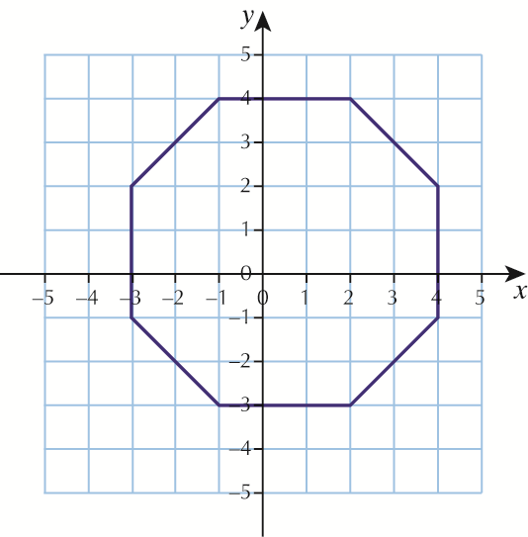

Octagon

**3 a** (−3, −2) **b** (0, 0)

**4 a** The *y*-coordinate is one more than the *x* -coordinate

**b** The *y*-coordinate is three less than the *x*-coordinate

**Chapter 3 Ratio, proportion and rates of change**

**3.1 Ratio**

**1 a** 2 : 1 **b** 1 : 4 **c** 8 : 1

**2 a** 1 : 2 **b** 2 :1 **c** 1 : 1 **d** 3 : 1 **e** 2 : 3 **f** 20 : 1

**g** 50 : 1 **h** 1 : 5  **i** 4 : 1  **j** 5 : 2 **k** 2 : 3 **l** 6 : 1

**3 a** 1 : 2 **b** 3 : 1 **c** 2 : 1 **d** 3 : 2

**4** 2 : 3

**5** 1 : 3

**6** 4 : 1

**7** 11 : 1

**8 a** 5 : 1 **b** 5 : 3

**3.2 Proportion**

**1** £11.28

**2** £10.32

**3** £610

**4** 138 miles

**5** 7.2 miles

**6** £117

**7** 80 minutes

**8** £2.88

**9** £36.75

**10** The missing costs are £70.50, £282, £423, £564

**Chapter 4 Geometry and measures**

**4.1 Symmetry**

**1**

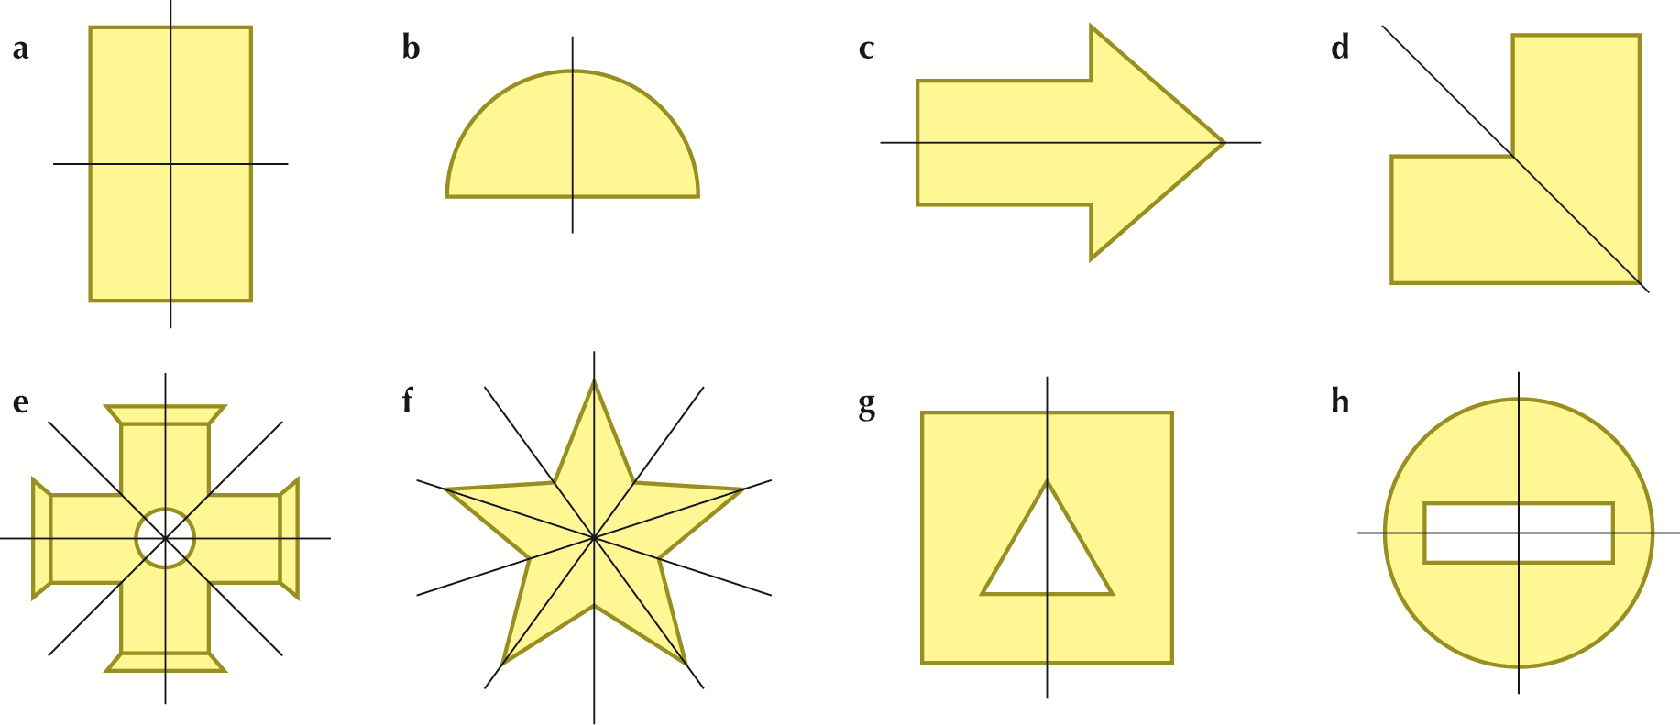

**2 a** cross **b** tick **c** tick **d** cross **e** tick **f** cross

**3**

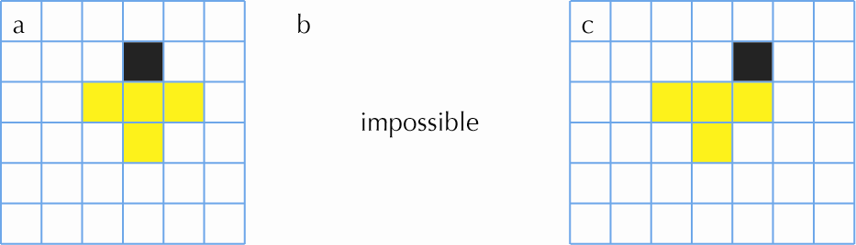

Other squares are possible for part **c**.

**4 a**

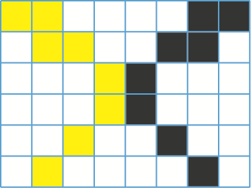

**b**

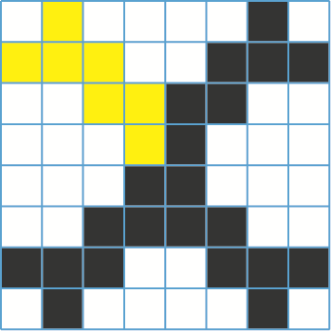

**5 a** 2 **b** 3 **c** 2 **d** 2 **e** 4 **f** 5

**6 a** 2 **b** 1 **c** 2 **d** 3 **e** 1 **f** 2 **g** 1

**7 a** 4 **b** 3 **c** 2 **d** 6 **e** 5

**8**

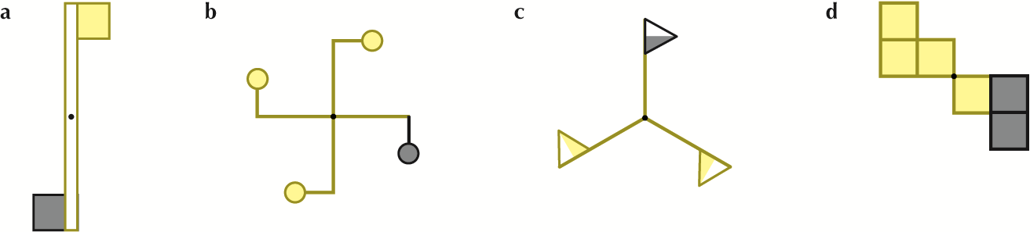

**4.2 3-D shapes**

**1 a** 6 **b** 12 **c** 8

**2 a** 5 **b** 9 **c** 6

**3 a** 6 **b** 12

**4 a** 12 edges and 8 vertices **b** trapeziums

**5 a** 12 **b** 18

**6 a** 17 **b** 7

**7 a** 9 **b** 9 **c** 16

**4.3 Measuring angles**

**1 a** 90° **b** 95° **c** 50° **d** 80°

**2** Allow ± 2° for drawings  **a** 53° and 87° **b** 34° and 91° **c** 17° and 43°

**d** 45° and 65°

**3** Allow ± 2 mm for drawings **a** 5.3 cm **b** 8.2 cm **c** 4.7 cm

**d** 4.3 cm **e** 9.4 cm **f** 6.1 cm

**4.4 Calculating angles**

**1 a** 80° **b** 110° **c** 60° **d** 128° **e** 133° **f** 82°

**2 a** 65° **b** 68° **c** 50° **d** 72° **e** 68° **f** 54°

**3 a** 50° **b** 296° **c** 135° **d** 264° **e** 288° **f** 109°

**4 a** 70° **b** 162° **c** 147° **d** 53° **e** 23° **f** 73°

**5 a** 50° **b** 50° **c** 20°

**6 a** 70° **b** 40° **c** 75° **d** 30°

**4.5 Area and perimeter**

**1 a** 21 **b** 25 **c** 60 **d** 32 **e** 33 **f** 35

**2 a** 20 cm **b** 20 cm **c** 32 cm **d** 24 cm **e** 28 cm **f** 27 cm

**3** 77 cm², 60 m², 250 cm², 52 km², 384 cm²

**4 a** 41 **b** 31 **c** 88

**5 a** 30 cm **b** 28 cm **c** 42 cm

**6 a** 3 **b** 6 **c** 8 **d** 9

**Chapter 5 Probability**

**5.1 Probability scales**

**1 a** and **b** depend on where you live **c** impossible **d** about even

**e** unlikely **f** certain **g** depends on you

**2 a** A **b** E **c** C **d** D

**3 a** R **b** V **c** T **d** Q **e** W **f** S

**4**

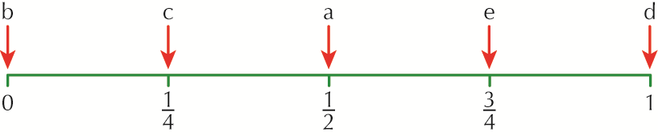

**a**  **b** 0 **c**  **d** 1 **e** 



**5.2 Equally likely outcomes**

**1 a**  **b** 



**2 a**  **b** 



**3 a**  **b** 



**4 a**  **b** 



**5 a**  **b** 



**6 a**  **b** 



**7 a**  **b** 



**8 a**  **b** 



**9 a**  **b**  **c** 



**10** 



**Chapter 6 Statistics**

**6.1 Statistical measures**

**1 a** 20 **b** 5.5 **c** 4.6 **d** 65  **e** 45

**2 a** median = 1.8 kg, range = 1.7 kg **b** They are all different – there is no mode

**3 a** mode = £100, median = £100, mean = £200

**b** The mode or the median because most people earn that.

**4 a** mode = 0 days, range = 5 days **b** mode = 39 g, range = 5 g

**6.2 Statistical diagrams**

**1 a** 30 **b** 10%

**2 a** football **b** 25%

**3 a** UK **b**  **c** 68% **d** 30 **e** 150



**4 a** Germany **b** Germany **c** France **d** Italy

**5 a** About 8 million **b** About 17 million **c** About 63 million

**d** There are approximately the same number of men and women under 21 and 60 or less. There are more women than men over 60.

**6 a** Cannot Say **b** False **c** True **d** True **e** Cannot Say

**f** True

**6.3 Line graphs**

**1 a** 9 °C **b** 14 °C **c** 09:00

**2 a** 154 cm **b** Thursday **c** 25 cm

**d**

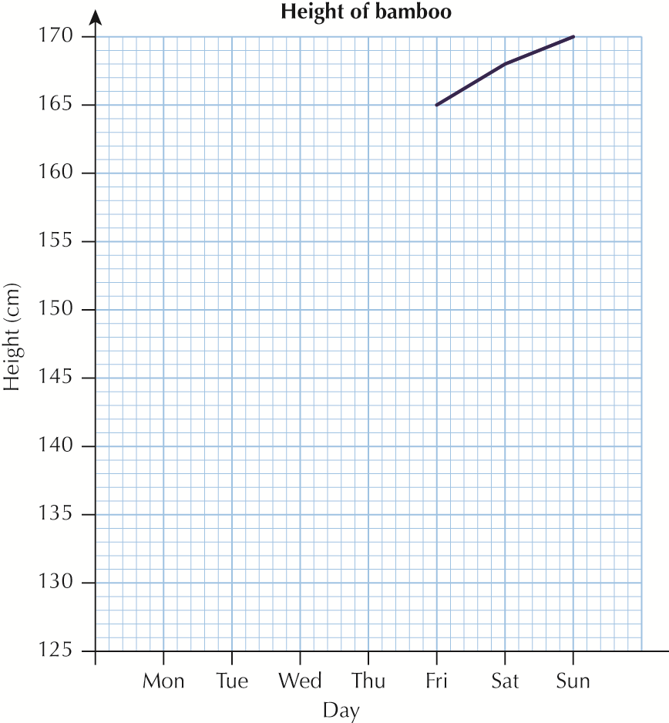

**3 a** 15 mph **b** 32 mph

**c**

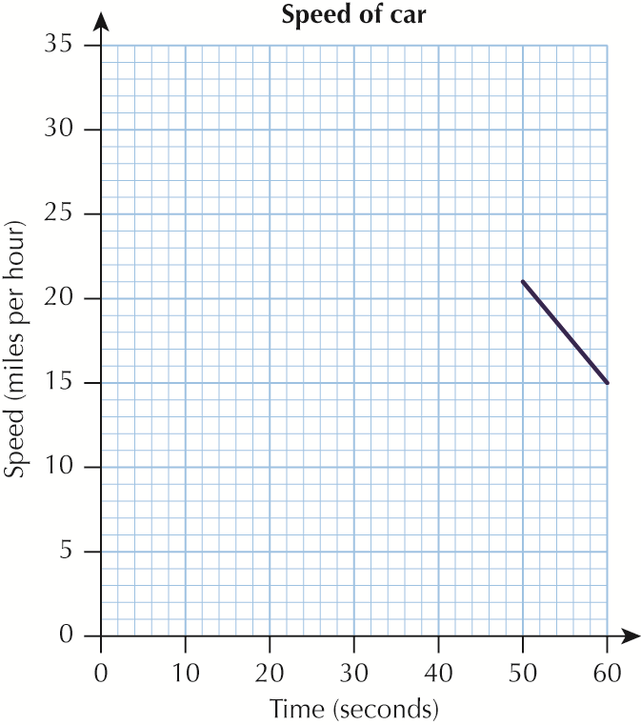

**4 a**

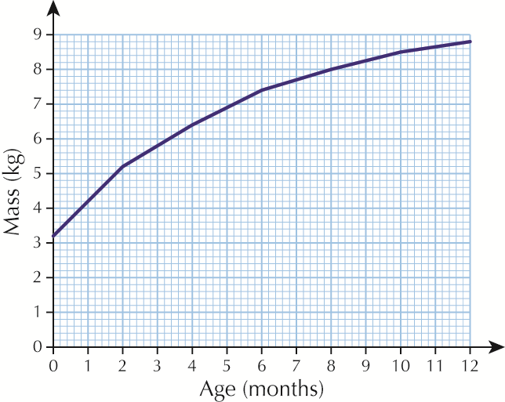

**b i** 5.8 kg **ii** 8.7 kg **c i** 4.2 kg **ii** 1.5 kg

**5 a** About 2.3 hours

**b** 31 miles in the first 1½ hours and 39 miles the second 1½ hours so further in the second.