**Step 2 Answers**

**Chapter 1 Number**

**1.1 Using place value to multiply and divide whole numbers by 10 or 100**

**1**

|  |  |  |  |  |  |  |
| --- | --- | --- | --- | --- | --- | --- |
| **×** | **10** | **100** |  | **×** | **10** | **100** |
| 8 | 80 | 800 |  | 5 | **50** | **500** |
| 59 | **590** | **5900** |  | 70 | **700** | **7000** |
| 40 | **400** | **4000** |  | 200 | **2000** | **20 000** |
| 71 | **710** | **7100** |  | 19 | **190** | **1900** |

|  |  |  |  |  |  |  |
| --- | --- | --- | --- | --- | --- | --- |
| **×** | **10** | **100** |  | **×** | **10** | **100** |
| 6 | **60** | **600** |  | **2** | 20 | **200** |
| **3** | 30 | **300** |  | **40** | 400 | **4000** |
| **7** | **70** | 700 |  | **8** | **80** | 800 |
| **24** | 240 | **2400** |  | **90** | **900** | 9000 |

**2 a** 10 **b** 47 **c** 60 **d** 5 **e** 27 **f** 215 **g** 60 **h** 70 **i** 800

**3 a** 500 **b** 1800 **c** 4000

**4 a** 90 **b** 320 **c** 600

**5 a** 4 **b** 52 **c** 190 **d** 40

**6 a** 30 **b** 145 **c** 700

**1.2 Putting decimals in order**

**1 a** 2.6, 5.6, 6.3, 7.3 **b** 5.2, 6.8, 9.2, 9.7 **c** 13, 13.6, 14, 14.8

**d** 78.1, 78.3, 87, 87.4 **e** 22.6, 23, 25.1, 26.7 **f** 20.5, 21, 22.6, 22.9

**2 a** 3.45, 4.1, 4.25, 4.3 **b** 0.6, 1.6, 6.0, 6.6 **c** 11.3, 13.3, 13.9, 19.3

**d** 34.4, 34.6, 46.4, 63.4

**3 a** £8.81, £1.80, £1.08, £0.88 **b** £4.13, £3.61, £3.41, £3.14

**c** £64.04, £61.42, £60.40, £60.24 **d** £0.87, £0.85, £0.78, £0.58

**4 a** 0.7 **b** 4.3 **c** 12.6 **d** 11.1 **e** 4.4 **f** 8.5 **g** 9.4

**h** 4.71 **i** 5 **j** 0.7 **k** 0.3 **l** 0.9

**5 a** 0.652 **b** 4.711 **c** 9.005 **d** 3.25 **e** 4.42 **f** 7.77

**g** 9.4 **h** 4.815 **i** 5

**6 a** 7.251, 7.505, 7.512 **b** 8.885, 9.075, 9.125 **c** 4.425, 4.500, 4.615

**d** 7.25, 7.275, 7.35 **e** 2.125, 2.25, 2.5 **f** 5.875, 5.9, 6.125

**1.3 Using mental methods**

**1 a** 79 **b** 67 **c** 72 **d** 119 **e** 127 **f** 132

**2 a** 61 **b** 29 **c** 37 **d** 13 **e** 54 **f** 32

**3** 48, 124, 68, 132, 110, 56, 144, 160, 90

**4** 64, 68, 75, 72, 97, 78, 89, 91

**5 a** 42 **b** 96 **c** 123 **d** 96 **e** 110 **f** 186 **g** 68 **h** 90 **i** 162 **j** 248 **k** 155

**l** 144

**6 a** 21 **b** 31 **c** 32 **d** 31 **e** 21 r 1 **f** 22 r 1

**7 a** 132 **b** 164 **c** 197 **d** 127 **e** 78 **f** 427

**8 a** £9.98 **b** £2.01

**1.4 Multiplication and division facts**

**1 a** 5 **b** 4 **c** 9 **d** 6 **e** 7 **f** 5 **g** 4 **h** 8 **i** 7

**2 a** 1 and 30 or 2 and 15 or 3 and 10 or 5 and 6

**b** 1 and 40 or 2 and 20 or 4 and 10 or 5 and 8

**c** 1 and 25 or 5 and 5 **d** 1 and 63 or 3 and 21 or 7 and 9

**e** 1 and 28 or 2 and 14 or 4 and 7

**f** 1 and 90 or 2 and 45 or 3 and 30 or 5 and 18 or 6 and 15 or 9 and 10

**g** 1 and 35 or 5 and 7 **h** 1 and 64 or 2 and 32 or 4 and 16 or 8 and 8

**3 a** 63 **b** 72 **c** 48 **d** 35 **e** 45 **f** 70

**4 a** 8 r 1 **b** 6 r 2 **c** 7 r 4 **d** 9 **e** 7 r 5 **f** 6 r 6

**5 a**

|  |  |  |  |  |
| --- | --- | --- | --- | --- |
| × | 3 | **7** | 5 | **8** |
| 6 | **18** | 42 | **30** | **48** |
| 2 | **6** | **14** | **10** | **16** |
| **4** | **12** | **28** | 20 | **32** |
| **9** | 27 | **63** | **45** | **72** |

**b**

|  |  |  |  |  |
| --- | --- | --- | --- | --- |
| × | **10** | 6 | 3 | 8 |
| **6** | **60** | **36** | **18** | 48 |
| **7** | **70** | **42** | 21 | **56** |
| **4** | **40** | 24 | **12** | **32** |
| 8 | 80 | **48** | **24** | **64** |

**1.5 Written methods**

**1 a** 836 **b** 1043 **c** 459 **d** 135 **e** 109 **f** 1337

**2 a** £8.99 **b** £3.82 **c** £14.16 **d** £9.09 **e** £11.64 **f** £13.27

**3 a** 13.2 **b** 22.6 **c** 88.0 **d** 130.7 **e** 11.81 **f** 133.2

**4 a** £3.04 **b** £5.16 **c** £4.58 **d** £11.86 **e** £15.97 **f** £3.14

**5 a** 128 **b** 57 **c** 321 **d** 227 **e** 489 **f** 187

**6 a** 10.8 **b** 17.7 **c** 12.4 **d** 30.7 **e** 3.2 **f** 8.8

**7 a** 165 **b** 230 **c** 192 **d** 192 **e** 261 **f** 294

**8 a** 69 **b** 57 **c** 118 **d** 13 r 4 **e** 76 r 3 **f** 57 r 5

**1.6 Multiplying decimals**

**1 a** 17.2 **b** 31.2 **c** 22.4 **d** 49.5 **e** 23.2 **f** 31.0

**g** 44.1 **h** 29.4 **i** 4.5

**2 a** 24.5 **b** 171.2 **c** 230.4 **d** 24.24 **e** 295.2 **f** 19.65

**g** 31.59 **h** 24.48 **i** 13.2

**3 a** 228 **b** 13.8 **c** 14.22 **d** 12.8 **e** 92 **f** 47.6

**g** 128.4 **h** 101.6 **i** 43.2

**1.7 Solving problems**

**1 a** £95 **b** £13 **c** £144

**2 a** £7.02 **b** £4.68 **c** £17.55

**3** 16

**4 a** 63 **b** 14

**5 a** £14.65 **b** £31.91 **c** £11.64

**6 a** 12 **b** 2

**7 a** £28.39 **b** £2.59

**8** 92

**9** £48

**1.8 Number patterns**

**1 a** 6, 7 **b** 11, 13 **c** 18, 21 **d** 5, 4 **e** 10, 8 **f** 75, 70

**g** 54, 64 **h** 40, 38 **i** –3, –4 **j** –60, –70

**2 a** 7, 11, 15, 19 **b** 17, 15, 13, 11 **c** 13, 18, 23, 28

**d** 44, 38, 32, 26 **e** 17, 24, 31, 38 **f** 73, 63, 53, 43

**g** 23, 19, 15, 11 **h** –3, –2, –1, 0

**3 a** 8, 16 **b** 10, 5 **c** 27, 81 **d** 4, 1

**4 a** 32, 64 **b** 96, 192 **c** 2, 1

**1.9 Number relationships**

**1 a** 1 and 18 or 2 and 9 or 3 and 6 **b** 1 and 32 or 2 and 16 or 4 and 8

**c** 1 and 21 or 3 and 7 **d** 1 and 42 or 2 and 21 or 3 and 14 or 6 and 7

**2 a** 8, 10, 12, 14, 16, 18, 20 **b** 12, 15, 18, 21, 24, 27, 30

**c** 15, 25, 30, 40, 45, 50 **d** 30, 40, 60, 70, 80, 90

**3 a** 4, 8, 10, 18 and 20 **b** 15, 18, 21 and 27

**c** 10, 15, 20 and 35 **d** 10 and 20

**4 a** 1 and 8; 2 and 4 **b** 1 and 21; 3 and 7

**5 a** 1, 3, 5, 15 **b** 1, 2, 3, 6, 9, 18 **c** 1, 2, 4, 5, 10, 20 **d** 1, 3, 7, 21

**e** 1, 5, 25 **f** 1, 2, 4, 7, 14, 28 **g** 1, 2, 3, 5, 6, 10, 15, 30 **h** 1, 31

**6 a** 1 and 3 **b** 1, 2, 3 and 6 **c** 1 and 5

**7 a** 21, 24, 27 **b** 24 **c** 21 **d** 24 **e** 27

**1.10 Square numbers and prime numbers**

**1 a** 16 **b** 25 **c** 100 **d** 9 **e** 36

**2 a** 9 **b** 36 **c** 81

**3** 11, 13, 17, 19

**4 a** 37 **b** 36

**5** 121, 144, 169, 196

**6** 97

**Chapter 2 Algebra**

**2.1 Coordinates**

**1 a**

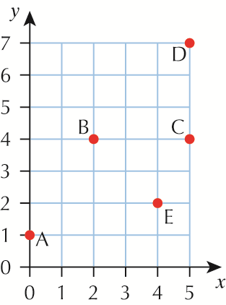

**b** Join B and C **c** Join C and D

**d**

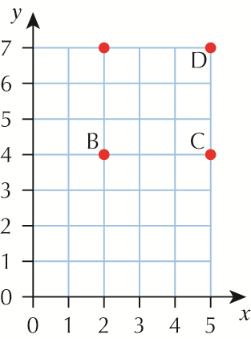

**e** (2, 7)

**2 a** (1, 1), (3, 1), (3, 3), (1, 3) in any order **b** (6, 1), (8, 1), (8, 3), (6, 3) in any order

**c** (2, 2) **d** (7, 2)

**3 a** (1, 1), (3, 2), (1, 3)

**b** and **c**

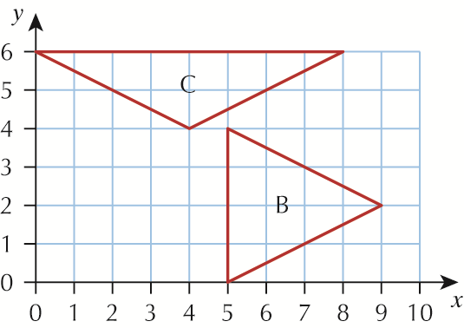

**4 a**

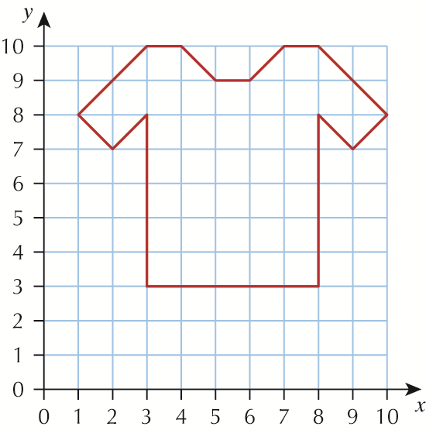

**b**

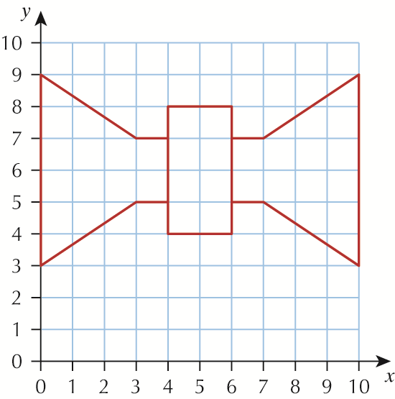

**2.2 Formulae**

**1 a** 60 minutes **b** 100 minutes **c** 400 minutes

**2 a** £15 **b** £30 **c** £48

**3** 3 cars to £7.50, 5 cars to £12.50, 2 cars to £5 and 10 cars to £25

**4 a** £11 **b** £16 **c** £18

**5 a** 140 miles **b** 350 miles

**6 a** £110 **b** £190

**7 a i** 60 **ii** 120 **iii** 360 **b** 5

**8 a i** 2 **ii** 5 **iii** 8 **b** 12

**9 a i** £14 **ii** £21 **iii** £33 **b** £22

**Chapter 3 Ratio, proportion and rates of change**

**3.1 Fractions and percentages**

**1 a** 50% =  **b** 25% =  **c** 20% =  **d** 80% =  **e** 70% =  **f** 30% = 

**g** 40% =  **h** 10% =  **i** 1% = 

**2** 10% = , 75% = , 25% = , 90% = , 50% = , 20% = 

**3** 10% = 0.1, 75% = 0.75, 25% = 0.25, 90% = 0.9, 40% = 0.4, 50% = 0.5, 20% = 0.2, 80% = 0.8



**4 a**  = 50% **b**  = 25% **c**  = 75% **d**  = 10% **e**  = 1% **f**  = 20%

**5 b** 70% **c** 50% **d** 20% **e** 75% **f** 90% **g** 40%

**h** 23% **i** 35% **j** 28% **k** 82% **l** 25%

**6 b**  **c**  **d**  **e**  **f**  **g** 



**h**  **i**  **j**  **k**  **l** 



**3.2 Ratio**

**1 a** 60, 80, 100, 200 **b** 1 to 20

**2 a** 9, 15, 45, 60 **b** 3 **c** 3 to 1

**3 a** 4 to 1 **b** 32, 40

**4 a** 2 **b** 2 to 1

**5 a** 4 **b** 4 to 1

**6** 3 to 1

**7** 6 to 1

**8** 35

**9** 8 m

**10** 105 kilometres per hour

**Chapter 4 Geometry and measures**

**4.1 Properties of 2D and 3D shapes**

**1** trapezium, rectangle, parallelogram, square

**2 a** *B* and *D* **b** *p* and *s*, *q* and *r*

**3 a** square **b** parallelogram

**4** square, kite, rhombus

**5 a** cube **b** cuboid **c** pyramid

**6 a** rectangles **b** 5

**7 a** equilateral, 3 **b** isosceles, 2 **c** right-angled

**4.2 Drawing 2D shapes**

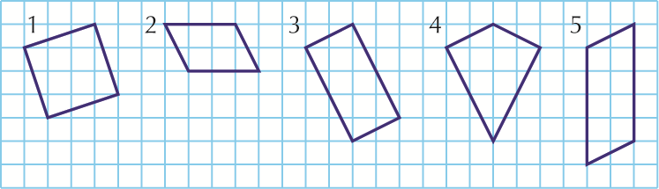

**6 a**

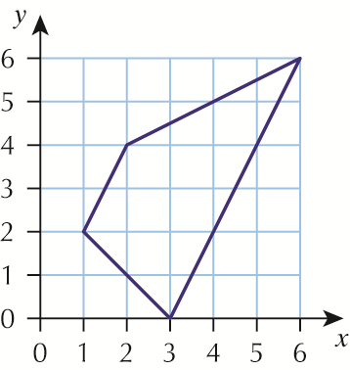

**b** trapezium

**7 a**

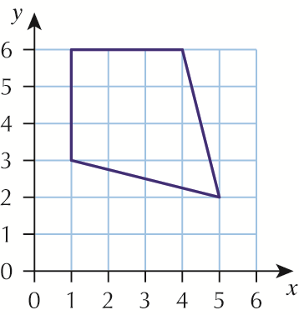

**b** kite

**8 a**

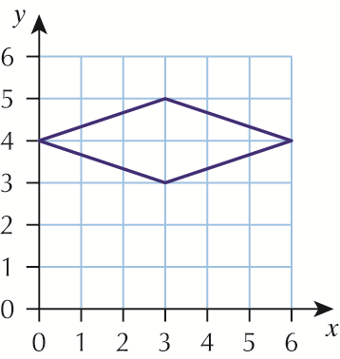

**b** rhombus

**4.3 Reflections and rotations**

**1**

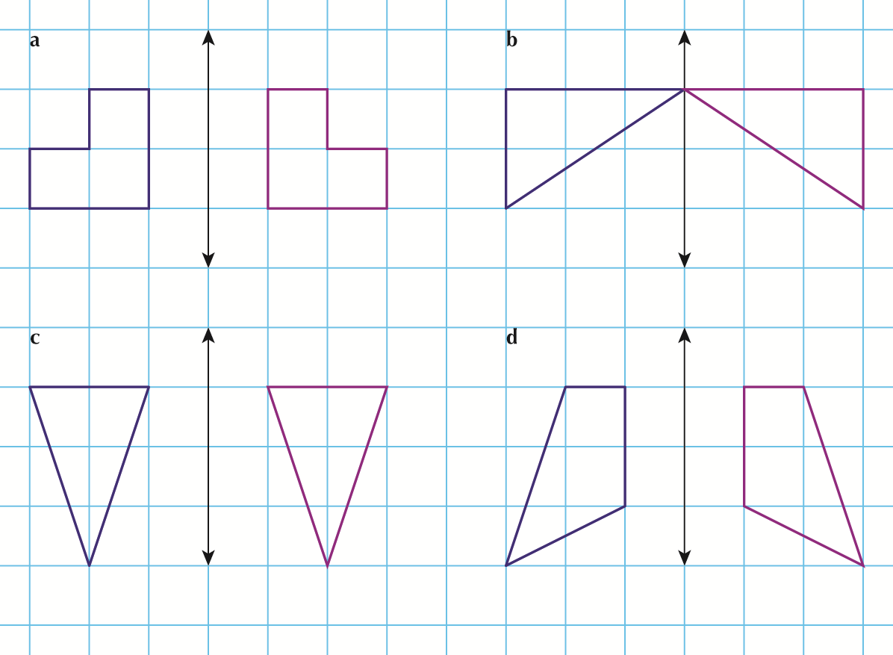

**2**

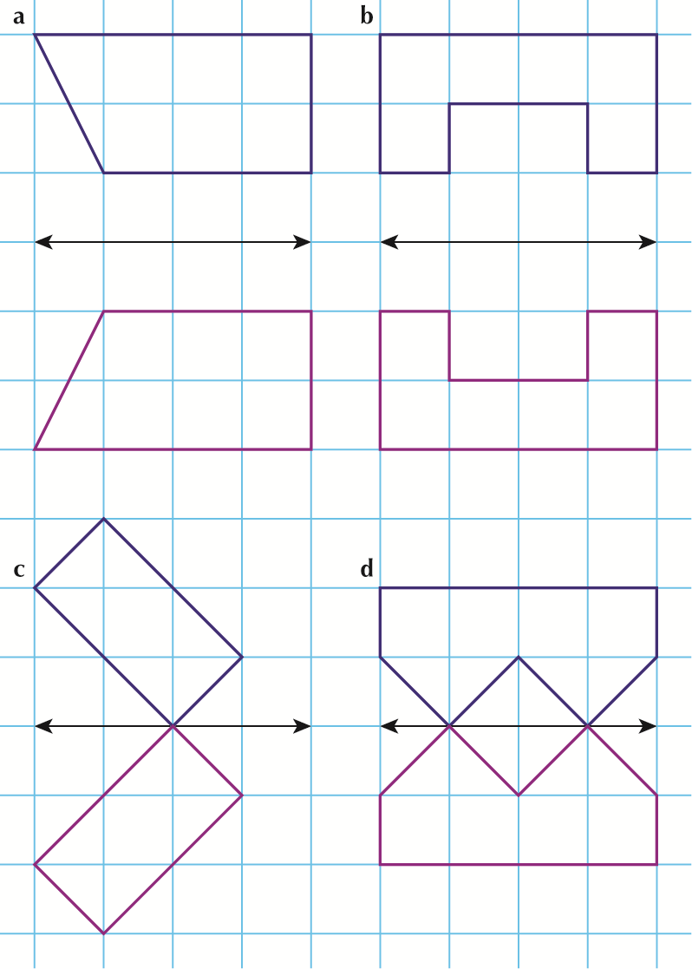

**3 a** and **b**

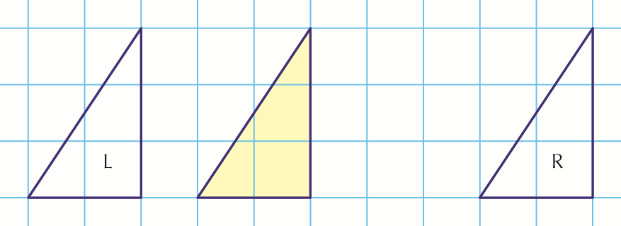

**4 a** and **b**

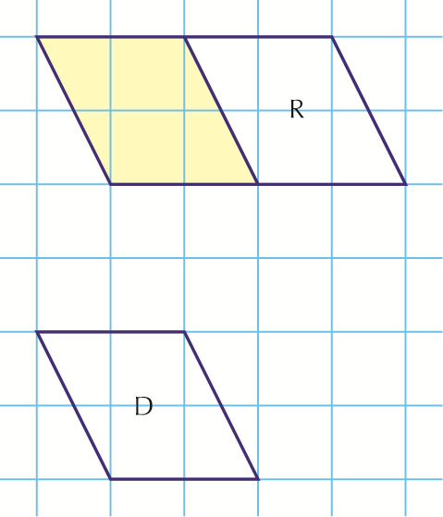

**5 a**, **b** and **c**

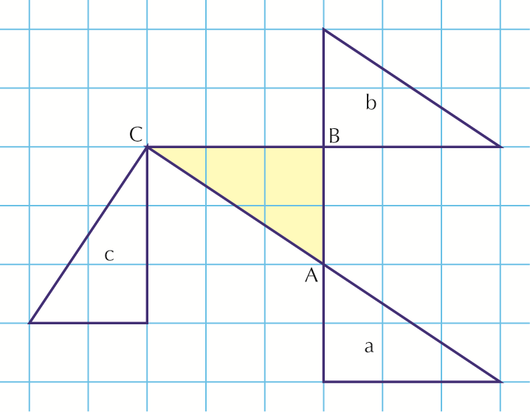

**4.4 Measurement**

**1 a** metre **b** centimetre **c** kilometre **d** millimetre

**2 a** g **b** ml **c** km **d** cm or mm **e** kg **f** l

**g** cm **h** g

**3 a** 45 **b** 73 **c** 128 **d** 14

**4 a** 4.5 **b** 7.3 **c** 12.8 **d** 1.4

**5 a** km **b** l **c** cm **d** g **e** mm **f** kg

**6 a** 1000 **b i** 2000 **ii** 6000 **iii** 4500 **iv** 3000

**7** Approximately 29.7 cm and 21.0 cm

**8 a** 2 **b** 15 000

**9** 4

**4.5 Reading measuring instruments**

**1 a** 3.5 kg **b** 1.75 kg **c** 54 mph **d** 27 kph **e** 26°C

**f** 4:15 or equivalent **g** 45 degrees **h** 90 degrees **i** about 3.3 cm

**j** about 2.4 cm

**2 a** 30 g **b** 110 g **c** 165 g **d** 1.5 kg **e** 2.2 kg **f** 3.7 kg

**3 a** 300 ml **b** 160 ml **c** 80 ml **d** 420 ml

**4.6 Perimeter and area**

**1 a** 6 cm **b** 8 cm **c** 14 cm

**2 a** 10 cm **b** 10 cm **c** 16 cm

**3** 14 m

**4 a** 12 cm² **b** 10 cm²

**5** 20 m²

**6 a** 4 cm² **b** 6 m² **c** 4 cm² **d** 5 m² **e** 16 m² **f** 16 cm²

**7** **a** and **c** have the same area

**8 a** 8 cm **b** 25 cm **c** 24 cm

**Chapter 5 Statistics**

**5.1 Recording data**

**1** The frequencies are 2, 3, 5, 2, 3, 5

**2** The frequencies are 2, 3, 4, 2, 6, 3

**3**

|  |  |  |  |  |
| --- | --- | --- | --- | --- |
| **Symbol** |  |  |  |  |
| **Frequency** | 8 | 3 | 9 | 10 |

The columns can be in any order.

**4**

|  |  |  |  |  |
| --- | --- | --- | --- | --- |
| **Age** | 7 | 8 | 9 | 10 |
| **Frequency** | 8 | 14 | 8 | 2 |

**5** Odd 6; Even 14

**6** Frequencies 2, 12, 10, 8, 5, 7, 1

**5.2 Grouping data**

**1** Frequencies are 4, 6, 4, 5, 7, 4

**2** Frequencies are 3, 6, 6, 5

**3** Frequencies are 2, 4, 5, 9

**4** Frequencies are 11, 6, 8, 5

**5**

|  |  |  |  |  |  |  |
| --- | --- | --- | --- | --- | --- | --- |
| **Length** | 21–25 | 26–30 | 31–35 | 36–40 | 41–45 | 46–50 |
| **Frequency** | 3 | 9 | 7 | 11 | 8 | 5 |

**5.3 Carroll diagrams and Venn diagrams**

**1 a** 3, 6, 9, 12, 15, 18

**b**

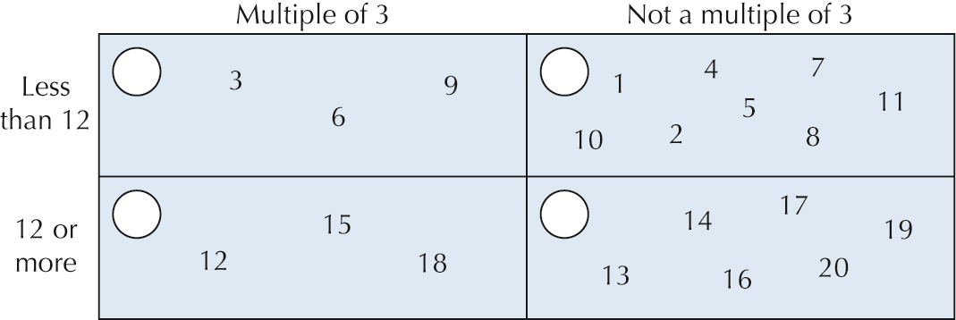

**2**

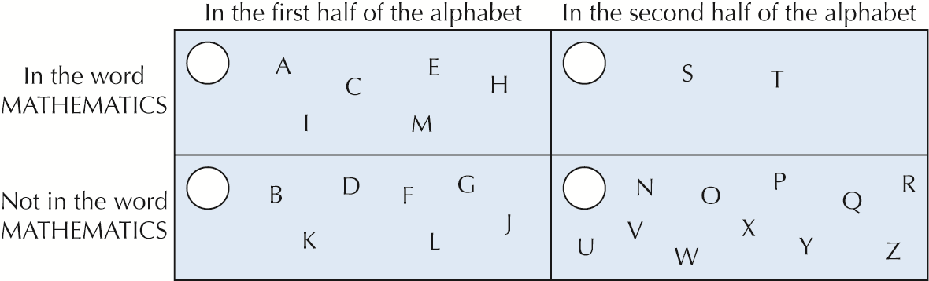

**3 a** 10 **b** 20 **c** 18

**4 a** 14 **b** 159 **c** 204

**5 a** 19 **b** 21 **c** 4 **d** 30

**6 a** 9 **b** 12 **c** 20

**7 a** 5

**b**

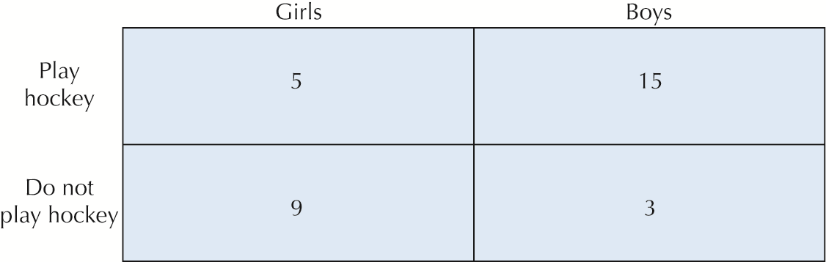

**5.4 Frequency diagrams and line graphs**

**1 a**

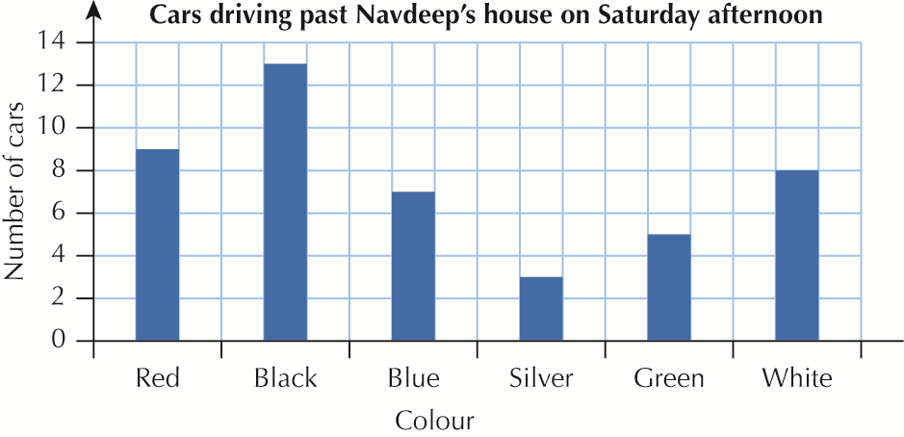

**b** Black **c** 45

**2 a** 17 °C **b** At 10 pm **c** At 9 pm **d** 11 °C **e** 4 am

**3 a** 16 °C **b** 11:30 am

**c**

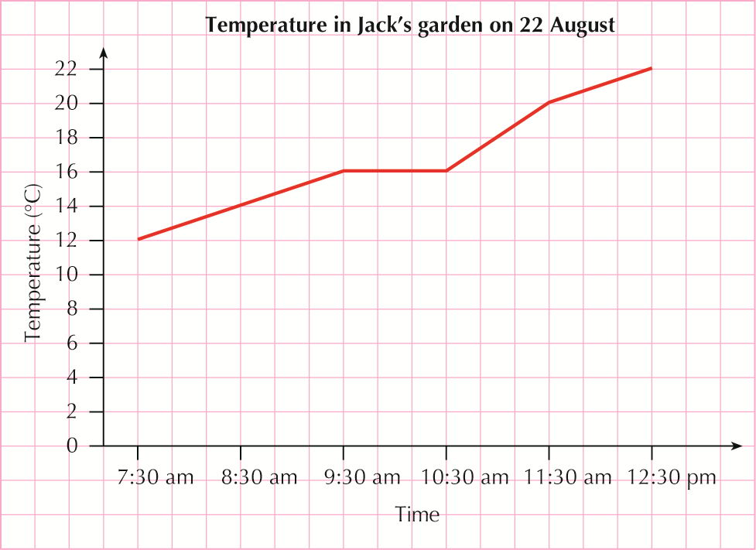

**4**

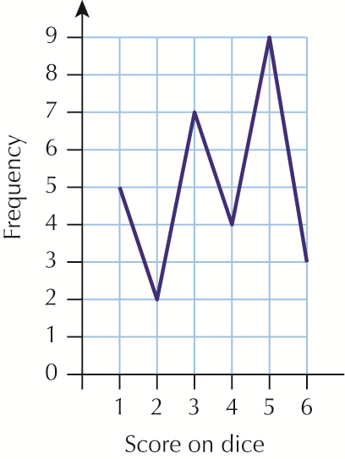

**5 a**

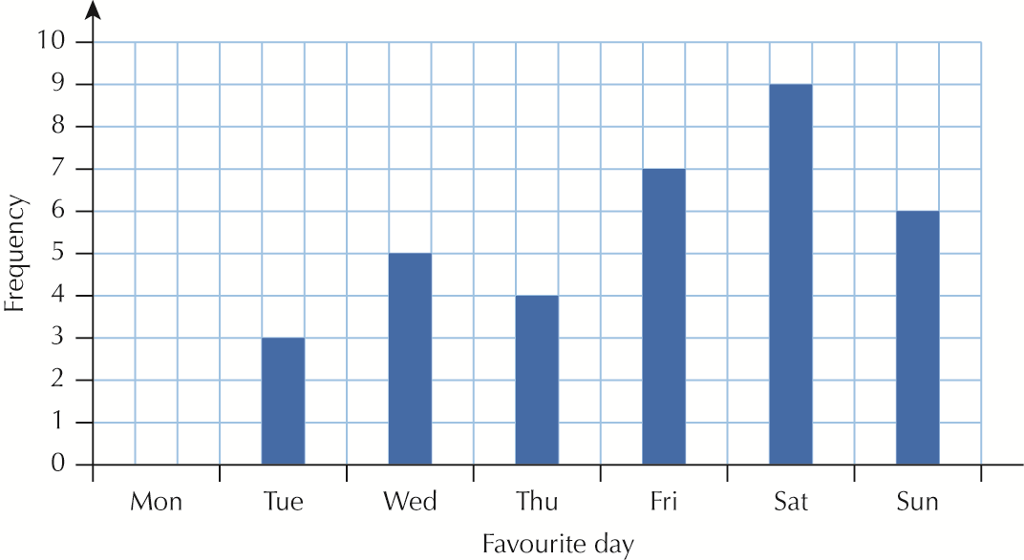

**b** Saturday **c** 6

**5.5 Statistical measures**

**1 a** 2 **b** 10 **c** 8 marks **d** 5 marks **e** 8 **f** 7

**2 a** 30 **b** 57

**3 a** Mode: 8; Range: 9 **b** Mode: 22; Range: 8

**4 a** 2 **b** 1 **c** 1 and 4 **d** 4 **e** 4

**5 a** Mode: 7; Range: 8 **b** Mode: 1; Range: 9 **c** Mode: 20; Range: 8

**6 a** Mode: 4; Range: 8 **b** Mode: 12; Range: 14

**7 a** Mode: £2; Range: £15 **b** Mode: 4 cm; Range: 12 cm