**Step 1 Answers**

**Chapter 1 Number**

**1.1 Using place value to make approximations**

**1 a** 60 **b** 70 **c** 90 **d** 20 **e** 70 **f** 10 **g** 30 **h** 30 **i** 30 **j** 80 **k** 70 **l** 30

**2** **a** 700 **b** 600 **c** 200 **d** 800 **e** 900 **f** 200 **g** 100 **h** 200 **i** 600 **j** 300 **k** 700

**l** 400

**3 a** 3000 **b** 1000 **c** 8000 **d** 9000 **e** 6000 **f** 7000 **g** 9000 **h** 6000 **i** 7000 **j** 3000 **k** 5000

**l** 1000

**4** To the nearest £10: 180, 720, 530, 890, 220, 670. To the nearest £100: 200, 700, 500, 900, 200, 700.

**1.2 The connection between division and multiplication**

**1** 8, 7

**2** 12, 6

**3** 75 ÷ 5 = 15 and 75 ÷ 15 = 5

**4** 7, 13, 16, 7

**5** 50, 20, 10, 25, 2, 5

**1.3 Add and subtract two-digit numbers**

**1 a** 68 **b** 92 **c** 94 **d** 130 **e** 81 **f** 88 **g** 113 **h** 121 **i** 117

**2 a** 26 **b** 22 **c** 30 **d** 22 **e** 13 **f** 24 **g** 31 **h** 55 **i** 75

**3 a** 104 **b** 36 **c** 89 **d** 43 **e** 85 **f** 7 **g** 88 **h** 46

**1.4 Addition and subtraction using written methods**

**1 a** 249 **b** 473 **c** 739 **d** 331 **e** 574 **f** 921 **g** 408 **h** 542 **i** 981

**2 a** 144 **b** 531 **c** 684 **d** 117 **e** 213 **f** 125 **g** 651 **h** 357 **i** 146

**1.5 Multiplication and division**

**1 a** 74 **b** 95 **c** 69 **d** 186 **e** 296 **f** 275 **g** 232 **h** 256

**i** 432

**2 a** 24 **b** 15 r 1 **c** 15 **d** 12 r 3 **e** 18 **f** 12 r 2 **g** 23 r 3 **h** 15

**i** 43 r 1

**1.6 Using known addition and subtraction facts**

**1 a** 19 **b** 27 **c** 19 **d** 74 **e** 85 **f** 69 **g** 229 **h** 364 **i** 270

**2 a** 12 **b** 12 **c** 4 **d** 60 **e** 43 **f** 32 **g** 52 **h** 76 **i** 74

**3 a** 31 **b** 41 **c** 20 **d** 30 **e** 24 **f** 44

**4 a** 11 **b** 9 **c** 24 **d** 27 **e** 14 **f** 45

**5 a** 40 and 60 **b** 60 and 140 or 40 and 160 **c** 120 and 160 or 50 and 90

**d** 70 and 160 or 50 and 140

**1.7 Whole number problems**

**1 a** 7 r 1 **b** 6 r 1 **c** 7 r 1 **d** 6 r 2

**2** 5 with 3 left over

**3** 40

**4** 8

**5 a** £103 **b** £43 **c** 9 **d** £3550

**6 a** 180 **b** 7 with 1 left over **c** 17

**7** 21

**8** 7

**1.8 Place value**

**1 a** 27 **b** 34 **c** 152 **d** 308 **e** 740 **f** 1203

**2 a** thirty-five **b** one hundred and seventy-nine **c** two hundred and four

**d** nine hundred and ninety **e** one thousand six hundred and seventy-eight

**3 a** 1 **b** 0 **c** 7

**4 a** £2500 **b** £1199 **c** £2099

**5** Car **b**

**1.9 Negative numbers**

**1 a** –3, –2, 0, 2, 3, 7 **b** –7, –5, 2, 4, 6 **c** –5, –3, 0, 4, 6, 9 **d** –3, –2, –1, 4, 6, 9

**2 a** 9°C **b** –2°C **c** 2°C **d** 4°C

**e** 0°C **f** 5°C **g** –10°C **h** 9°C

**3** 25, 20, 10, 0, –5, –10, –20, –25

**4 a** –9, –6, –2, 3, 7 **b** –10, –8, –6, –4, –1, 0, 6, 7 **c** –18, –14, –6, 0, 8, 16

**d** –90, –60, –50, –10, 40, 70

**1.10 Recognising fractions**

**1 a**  **b**  **c**  **d**  **e**  **f**  **g**  **h**  **i** 



**2 a** 2 coloured **b** 6 coloured **c** 2 coloured **d** 6 coloured **e** 6 coloured

**f** 3 coloured

**3 a** Colour 2 parts **b** Colour 1 part **c** Colour 3 parts **d** Colour 3 parts

**e** Colour 4 parts

**4 a** Colour 1 part **b** Colour 2 parts **c** Colour 3 parts

**5** **a** Colour 1 part **b** Colour 2 parts **c** Colour 3 parts

**6** **a** Colour 1 part **b** Colour 2 parts **c** Colour 3 parts

**1.11 Using decimals in context**

**1 a** and **b** £7.02, £7.20 – largest, £6.67 – smallest, £6.94

**2 a** £2.50 **b** £4.08 **c** £12.87 **d** £40.00

**3 a** 700p **b** 1250p **c** 80p **d** 5p

**4 a** 2.3 cm **b** 5.1 cm **c** 6 cm or 6.0 cm **d** 0.8 cm

**5 a** 62 mm **b** 125 mm **c** 250 mm **d** 2 mm

**6** 0.3, 0.4, 0.5, 0.6, 0.7, 0.8, 0.9

**7** **b** 5.6, 5.7, 5.8, 5.9, 6.0, 6.1, 6.2, 6.3, 6.4 **c** 3.3, 3.4, 3.5, 3.6, 3.7, 3.8, 3.9, 4.0, 4.1

**d** 29.7, 29.8, 29.9, 30.0, 30.1, 30.2, 30.3, 30.4, 30.5

**8** 0.03, 0.04, 0.05, 0.06, 0.07, 0.08, 0.09

**9 b** 5.51, 5.52, 5.53, 5.54, 5.55, 5.56, 5.57, 5.58, 5.59

**c** 31.41, 31.42, 31.43, 31.44, 31.45, 31.46, 31.47, 31.48, 31.49

**Chapter 2 Algebra**

**2.1 Sequences of numbers**

**1 a** 30, 32 **b** 27, 32 **c** 18, 15 **d** 55, 45 **e** 16, 32

**2 a** 11, 13 **b** 50, 52 **c** 50, 55 **d** 25, 31 **e** 28, 25

**f** 26, 20 **g** 54, 65 **h** 104, 100

**3 a** 20 and 36 **b** 32, 37 and 57 **c** 90, 84 and 75 **d** 38, 34, 30 and 14

**2.2 The equals sign**

**1 a** 9 = 3 + 6 **b** 12 + 2 = 14 **c** 6 + 1 = 7 **d** 11 = 3 + 8

**2 a** 9 – 3 = 6 **b** 12 = 14 – 2 **c** 6 = 7 – 1 **d** 11 – 3 = 8

**3 a** 12 + 3 = 18 – 3 **b** 3 + 8 – 5 = 6 **c** 10 = 6 + 8 – 4

**4 a** 3 + 5 = 2 × 4 **b** 3 × 5 = 8 + 7 **c** 6 + 3 = 3 × 3

**5 a** 24 = 4 × 6 **b** 24 ÷ 4 = 6 **c** 19 = 12 + 7 **d** 19 – 12 = 7

**6 a** 12 = 3 + 4 + 5 **b** 4 × 3 = 2 × 6 **c** 5 – 4 = 8 – 7 **d** 2 × 5 = 6 + 4

**e** 5 + 1 = 12 ÷ 2 **f** 50 – 8 = 25 + 17

**Chapter 3 Geometry and measures**

**3.1 Classify 2D and 3D shapes**

**1** These are possible answers. There are others.

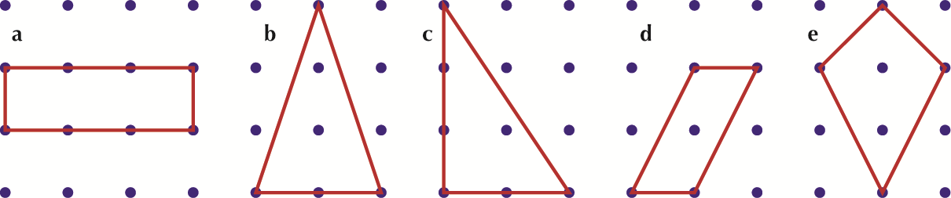

**2** **a**, **b** and **e** have a line of symmetry; **d** does not; **c** may, depending on the drawing.

**3**

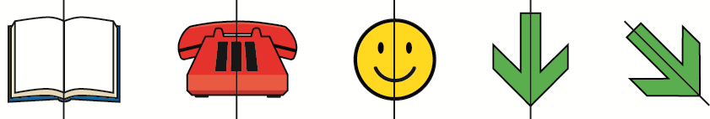

**4**

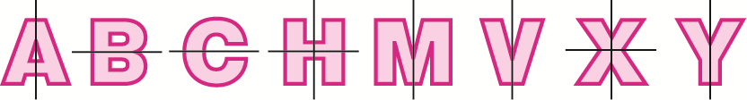

**5**

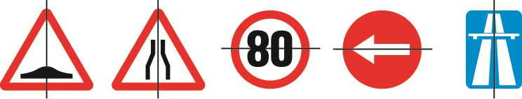

**6 a** Cube **b** Cuboid **c** Pyramid **d** Tetrahedron

**7 a** 6 faces, 8 vertices, 12 edges **b** 5 faces, 5 vertices, 8 edges

**c** 4 faces, 4 vertices, 6 edges

**3.2 Nets of 3D shapes**

**1** Net **c**

**2**

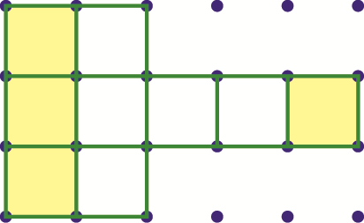

Add one of the four shaded faces.

**3**

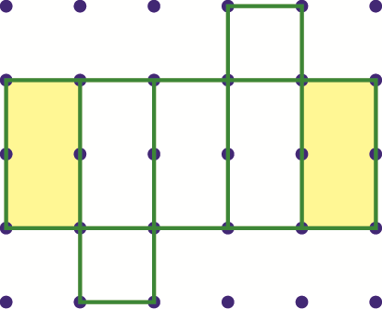

Add either of the shaded rectangles.

**4**

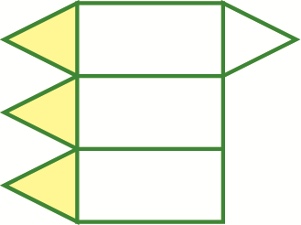

Add one of the three shaded triangles.

**5** **a** Pyramid **b** Isosceles

**6** B

**3.3 Working with 2D shapes**

**1**

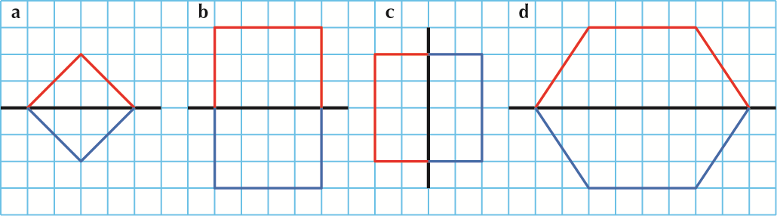

**2**

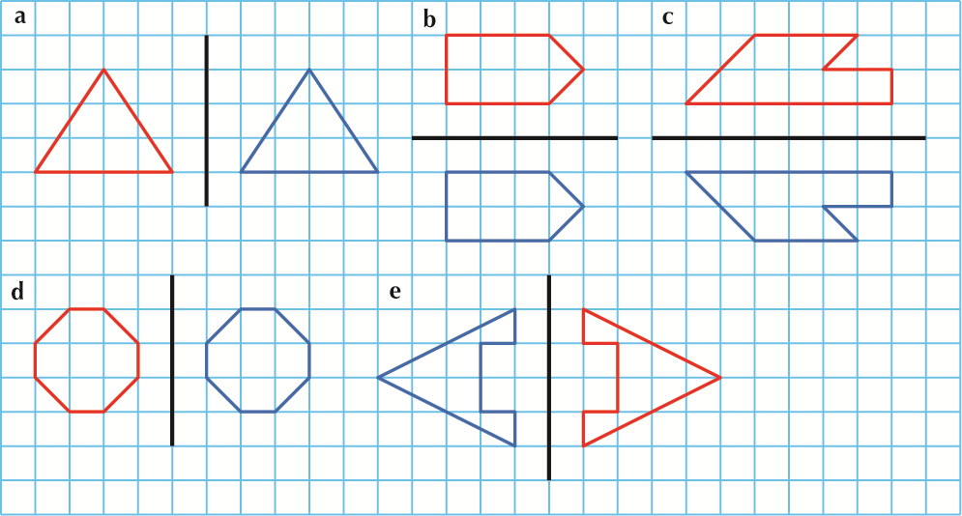

**3**

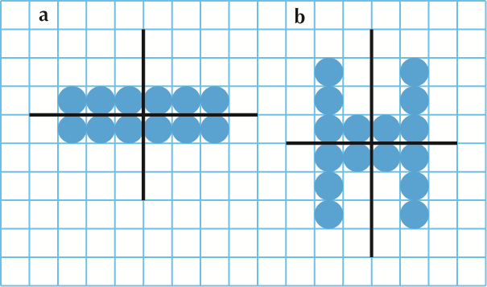

**3.4 Position and movement**

**1** **a** 3 right **b** 2 up **c** 3 left

**2 a** and **b**

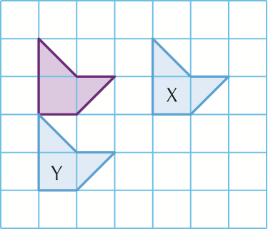

**c** 3 left **d** 2 up

**3 a** and **b**

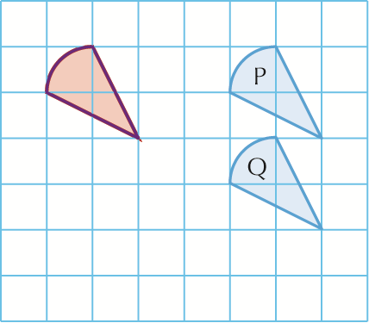

**c** 4 left and 2 up

**3.5 Measuring**

**1 a** kg **b** mm **c** litres **d** km **e** g **f** m

**2 a** mm **b** m **c** kg **d** g

**3 a** 70 **b** 40 **c** 110

**4 a** 7 **b** 4 **c** 11

**5 a** 200 **b** 2000

**6** 2

**7** **a** True **b** True

**8** **a** False **b** True

**9** 5000

**3.6 Time**

**1 a** 10.30 **b** 5.15 **c** 2.45

**2 b** 21:45 **c** 22:35 **d** 09:30 **e** 23:52 **f** 14:56

**3 a** 7 pm **b** 2.54 pm **c** 4.45 pm **d** 3.25 pm **e** 9.45 am **f** 1.56 pm

**4**

|  |  |  |
| --- | --- | --- |
| **Time** | **12-hour clock** | **24-hour clock** |
| Half past 6 in the morning | 6.30 am | 06:30 |
| **2 in the afternoon** | **2 pm** | 14:00 |
| **Half past 8 in the evening** | 8.30 pm | **20:30** |
| 10 o’clock in the evening | **10 pm** | **22:00** |
| **Quarter past 7 in the morning** | **7.15 am** | 07:15 |
| **2 in the morning** | 2.00 am | **02:00** |
| **Half past 11 at night** | **11.30 pm** | 23:30 |
| Half past midnight | **12.30 am** | **00:30** |
| **Quarter to 4 in the afternoon** | 3.45 pm | **15:45** |
| **10 to 3 in the morning** | **2.50 am** | 02:50 |

**5** 60, 120, 180, 240, 300, 360

**Chapter 4 Statistics**

**4.1 Gathering information**

**1** 6, 10, 4, 3, 1

**2** 28, 13, 7, 15, 11

**3 a** Soap operas **b** 28

**4 a** News **b** 7

**5** 11

**6** 13

**7** 17

**4.2 Statistical diagrams**

**1**

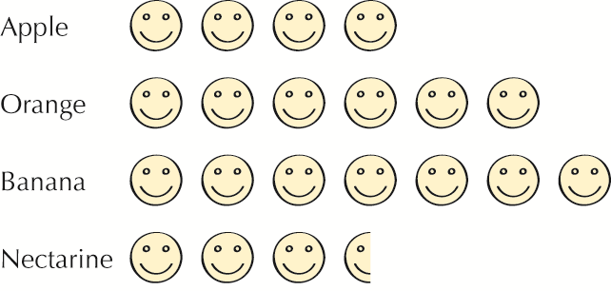

**2**

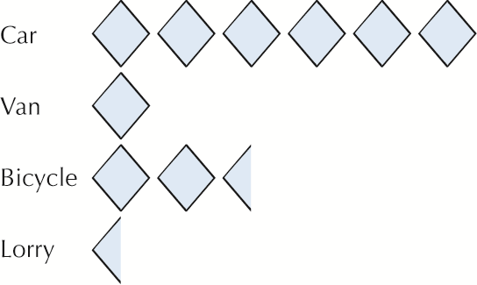

**3** **a** 8, 7, 11, 2, 1

**b**

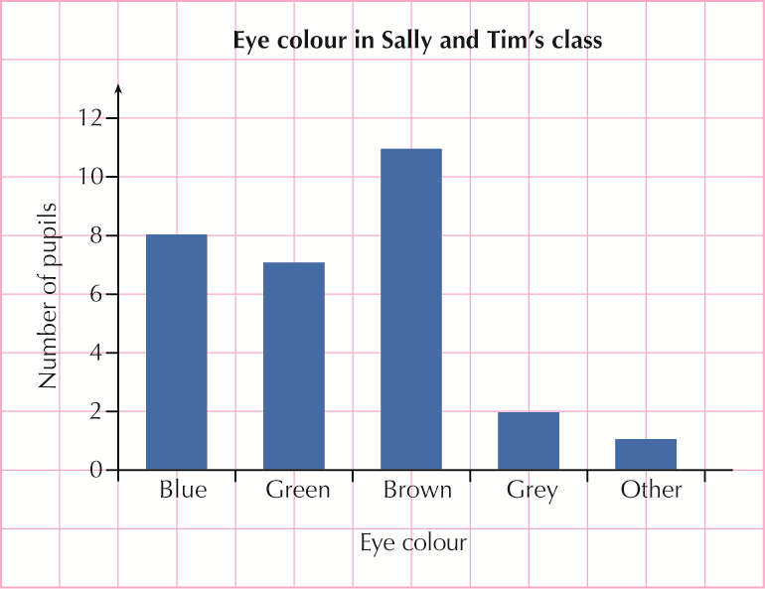

**4 a** and **b**

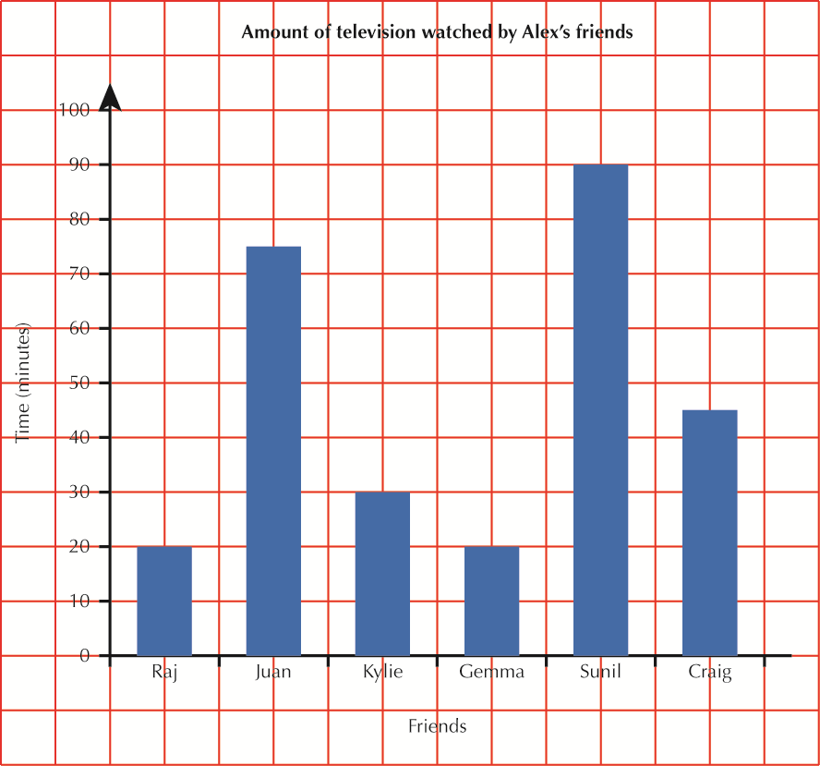

**c** Sunil **d** Raj and Gemma

**4.3 Sorting and classifying information**

**1 a** and **b**

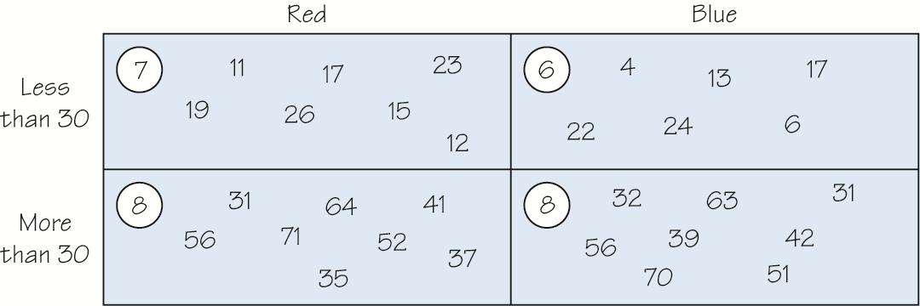

**c** 16 **d** 6 **e** 15

**2 a** and **b**

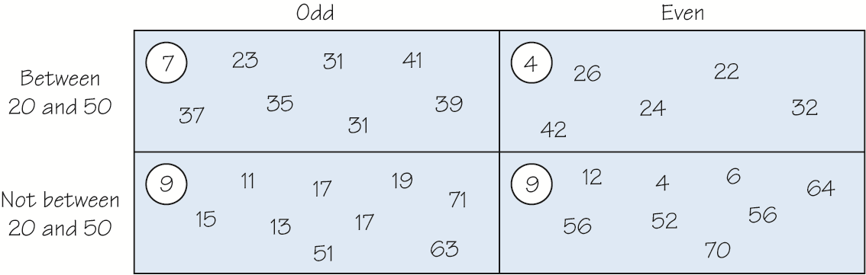

**c** 16 **d** 12 **e** 5 **f** 9

**3** **a** 9 **b** 8 **c** 7 **d** 19

**4.4 Interpreting information**

**1 a** 8 **b** Spain **c** 7 **d** 47

**2 a** 150 **b** 208 **c** 398 **d** Cardiff, York **e** Edinburgh, York

**f** London, Edinburgh

**3 a** 5 **b** Redbay **c** 5 **d** 24

**4** **a** 0908 **b** 0838 **c** 0931 **d** 0947 **e** 7 **f** 39

**5 a** 40 **b** 8 **c** 8 **d** 9 **e** Sport **f** Reading