Maths Frameworking Pupil Book 3.1 Answers

**Exercise 1A**

1 a £1.50 b £3.50 c £8 d £21

e £12 f £22 g £24 h £6

2 a £2.25 b £1.75 c £1.05 d £2.15

e £20.80 f £43.20 g £4.80 h £42.60

3 **a** £30 **b** £52.50

4 a £60 b £130

5 a £135 b £4770

6 a £51.10 b £883.30

7 £5544

8 a £108 b £408 **c** £34

**9** a £810 b £1560 **c** £130

**d** pupils’ own answers; for example, a loan shark as the interest rates are very high

10 Gabriel pays more (£12 × 12 = £144) than Joshua (£120).

11 yes, 0.5% × 12 = 6%

**Challenge: Using a formula**

A £150

B **a** £56 **b** £360 **c** £2800

**Exercise 1B**

1 a 1.04 **b** 1.06 **c** 1.09 **d** 1.1 **e** 1.12

**f** 1.15 **g** 1.2 **h** 1.35 **i** 1.17

2 a 0.98 **b** 0.97 **c** 0.95 **d** 0.92 **e** 0.9

**f** 0.85 **g** 0.8 **h** 0.7 **i** 0.75

3 a £13.20 **b** £21 **c** £31.20  **d** £108 **e** £224

**4** a £16.20 **b** £29.10 **c** £47 **d** £135 **e** £320

**5** a 96 cm **b** 1 m 15 cm (115.2 cm)

**6** a 49.5 kg **b** 54.45 kg

**7** a £530 **b** £561.80

**8** a 2.4 mg **b** 2.88 mg

**9** a 13 500 **b** 14 580

**10** a 300 megalitres **b** 180 megalitres

**11** a £10 200 **b** £8670

**12** £124 848

**13** × 1.1 × 0.9 = 0.99 so a 1% decrease overall

**Challenge: Population change**

A 5760

B 5760 × 1.2 = 6912

C 8294

D 2017 (11 944)

**Exercise 1C**

1 a 1.05 b 1.07 c 1.11 d 1.13 e 1.18

f 1.25 g 1.4 h 1.55 **i** 1.34

2 a 0.96 b 0.97 c 0.95 d 0.92 e 0.9

f 0.85 g 0.8 h 0.7 i 0.55

3 a £30 b £16 c £36 d £44 e £120

4 a £60 b £70 c £80 d £50.50 e £10.80

5 a 100% + 5% = 105% = 105 ÷ 100 = 1.05

b original height × 1.05 = new height, so original height = new height ÷ 1.05

c 120 cm

6 a 100% + 10% = 110% = 110 ÷ 100 = 1.1

b mass at 1 month old × 1.1 = mass at 2 months old, so mass at 1 month old = mass at 2 months old ÷ 1.1

c 5.5 kg d 5 kg

**Challenge: Trees**

A 5.0625 m

B 1 m

C after 6 years

**Exercise 1D**

1 a 0.75 b 0.8 c 0.8 d 0.875

e 0.35 f 0.36 g 0.37 h 0.16

2 a 75% b 85% c 38% d 17%

e 70% f 90% g 15.5% h 75.5%

3 a 80% b 75% c 62.5% d 27%

e 62% f 35% g 87.5%

4  = 0.5 = 50%

 = 0.25 = 25%

 = 0.875 = 87.5%

 = 0.6 = 60%

 = 0.7 = 70%

 = 0.65 = 65%

5 64%, 90%, 60%, 60%, 70%

6 a 70%, 95%, 70%, 67.5%, 80%

b onions, leeks and cauliflower, as none of these is 80% or more

7 a i  =  ii 0.04 iii 4%

b 25.6%

c The total number of pupils is 100, so the percentage is 3%.

8 Sophia is correct, as  =  = 85%.

9 40%

10 a 200 b i  ii 30%

c 16% d 54%

**Challenge: Different representations**

**A** Check pupils’ answers.

**B** for example, 54% of the year are boys or the fraction of pupils in the year who are girls is

**C** for example, 48% of the school are girls or the fraction of pupils in the school who are boys is 

|  |
| --- |
| **Chapter 1: Answers to Review questions** |

1 a £0.60 b £2 c £7.50 d £3.80

e £7.20 f £36 g £29.40 h £41

2 a £48 b £70.67

3 a 1.03 b 1.05 c 1.08 d 1.11

**e** 1.14

f 1.18 g 1.22 h 1.45 **i** 1.33

4 a 0.96 b 0.98 c 0.93 d 0.91

e 0.88

f 0.82 g 0.75 h 0.65 **i** 0.67

5 a £8.32 b £31.20 c £21 d £53

e £345

6 a £19 b £38.40 c £55.20 d £225

e £264

7 a 30 kg b 36 kg

8 a 60% b 25% c 37.5% d 39%

e 84%

f 45% g 62.5%

9 a £11 200 b £8960

10 a £576 b £1176 c £98

d for example: a loan shark as the interest paid is very high

11 a £30 b £14 c £32 d £39

e £110

12 a 100% + 4% = 104% = 104 ÷ 100 = 1.04

b original height × 1.04 = new height so original height = new height ÷ 1.04

c 125 cm

13 a 200 b i 1/5 ii 20%

c 14% d 66%

14 a £50 b £30 c £40 d £60

e £20.30

|  |
| --- |
| **Chapter 1: Answers to Progress solving – The Royal Albert Hall** |

**1 a** 1971 **b** 2021

**2** 4400

**3 a** 9 hours **b** 16 443 hours

**4** £18 600 000

**5** £27.2 million

**6** Rounding the values gives 2 000 000 × 100 = 200 000 000, which is less than a billion, so Helen is right.

**Exercise 2A**

**1 a** 7*x* **b** 7*a* **c** 8*t* **d** 8*y*

**e** 6*m* **f** 3*k* **g** 4*n* **h** –4*p*

**2 a** 10*m* **b** 7*y* **c** 9*t* **d** 11*p*

**e** 13*n* **f** 9*p* **g** 6*t* **h** 7*e*

**i** 6*k* **j** 5*h* **k** 5*m* **l** 6*t*

**3 a** *P* = 8*T* **b** *P* = 8*N* **c** *P* = 14*m*

**d** *P* = 13*k* **e** *P* = 18*w* **f** *P* = 13*n*

**4 a** 5*b* + 3 **b** 7*x* + 6 **c** 6*q* + 3 **d** 7*k* + 7

**e** 2*x* + 5 **f** 6*k* + 3 **g** 2*p* + 1 **h** 3*d* + 2

**i** 2*m* – 2 **j** 2*t* – 3 **k** 3*w* – 7 **l** 4*g* – 5

**m** 7*t* + *k* **n** 9*x* + 3*y* **o** 7*k* + 2*g* **p** 5*h* + 4*w*

**q** 3*t* + 3*p* **r** 2*n* + 3*t* **s** *p* + q **t** 2*n* + *p*

**5 a** 8*x* **b** 12*a* **c** 10*t* **d** 6*y* **e** 24*k*

**f** 15*t* **g** 12*x* **h** 12*m* **i** 12*t* **j** 35*y*

$10d×5$**6 a** 3*t* + 12 **b** 3*x* + 15 **c** 2*m* – 6 **d** 4*k* – 8

**e** 6 + 2*x* **f** 12 – 3*k* **g** 24 – 4*y* **h** 15 – 5*x*

**7** **a** *A* = 5*x* + 15 **b** *A* = 3*t* + 6 **c** *A* = 2*m* − 2 **d** *A* = 20 + 4*k*

**8 a** 2*m* + 6 **b** 3*k* – 12 **c** 3*a* + 6 **d** 15 – 5*p*

**e** 6*x* + 8 **f** 10*x* + 15 **g** 8*t* – 4 **h** 20*m* + 35

**i** 6*x* + 3 **j** 12*k* – 8 **k** 10*b* + 6 **l** 14 – 28*m*

**m** 24 + 8*p* **n** 20 – 5*t* **o** 12 – 18*g* **p** 16 + 24*t*

**q** 18*k* – 54 **r** 10*m* + 15 **s** 9*t* – 6 **t** 6 – 8*y*

**9** **a** *A* = 3*x* + 6 **b** A = 4*x* + 10 **c** *A* = 15*m* + 20

**d** *A* = 35*k* + 7*p* **e** *A* = 12*t* + 8 **f** *A* = 6*x* + 15

**10** 3(4*x* – 2) = 12*x* − 6 and 6(2*x* − 1) = 12*x* − 6

**11** He has only multiplied the 5 by the 2*x*. He should also multiply it by the 3.

**Challenge: Code breaker**

**A–G** pupils’ own work

**H** APRIL FOOL

**Exercise 2B**

**1 a** 1, 2, 3, 4, 6, 12 **b** 1, 3, 5, 15 **c** 1, 2, 3, 6, 9, 18 **d** 1, 2, 4, 5, 10, 20

**e** 1, 2, 3, 4, 6, 8, 12, 24 **f** 1, 2, 5, 10 **g** 1, 2, 4, 8 **h** 1, 2, 3, 5, 6, 10, 15, 30

**2 a** 2, 3, 4, 12 **b** 5, 10, 20, 35 **c** 2, 10, 12, 20, 4, 8, 18, 24

**d** 5, 35 **e** 3, 5, 11, 7, 21, 35 **f** 2, 5, 10, 20, 4, 8

**3 a** 2 **b** 3 **c** 6 **d** 6

**4 a** 3(*x* + 2) **b** 2(*t* + 3) **c** 4(*n* + 2) **d** 2(*q* + 4)

**e** 3(*x* – 3) **f** 4(*p* – 1) **g** 5(*y* – 2) **h** 3(*t* – 4)

**i** 2(4 + *x*) **j** 4(3 + *k*) **k** 6(2 – *t*) **l** 3(5 – *k*)

**5 a** 3(*t* + 3) **b** 2(*m* + 2) **c** 5(*p* + 1) **d** 4(*m* + 3)

**e** 6(*k* – 3) **f** 3(*n* – 2) **g** 2(*x* – 4) **h** 3(*q* – 5)

**i** 5(2 + *x*) **j** 4(4 + *h*) **k** 3 (4 – *t*) **l** 6(3 – *k*)

**6 a** 4 **b** 2*t* + 1 **c** 2 **d** 3 − 2*y*

**7 a** 4(*x* + 2) **b** 6(*t* + 2) **c** 4(3 − 2*p*) **d** 4(5 − 4*t*)

**8 a** 2(2*t* + 3) **b** 3(2*x* + 3) **c** 2(4*t* + 3) **d** 3(3*x* + 2)

**e** 3(3*x* – 1) **f** 5(2*t* + 1) **g** 4(2*x* + 1) **h** 3(4*t* + 3)

**i** 4(3*t* + 2) **j** 2(4*x* + 1) **k** 3(5*t* + 4) **l** 8(3*x* – 2)

**9 a** 2(8*x* + 5) **b** 7(2*x* – 1) **c** 5(3*y* + 5) **d** 5(2*y* – 1)

**e** 3(5*m* – 6) **f** 4(2*t* + 5) **g** 4(3*t* – 2) **h** 4(3 + 4*k*)

**i** 2(5 – 6*y*) **j** 6(5 – *m*) **k** 5(7 + 2*k*) **l** 7(3*q* + 2)

**10 a** She hasn't used the HCF.

**b** It is a correct factorisation but it isn't fully factorised.

**Investigation: Interesting numbers**

**A–D** Answers will vary depending on the numbers chosen.

**E** 22

**F** **a** pupils’ own work

**b** The answer is always 22.

**Exercise 2C**

**1 a** *m* = 4 **b** *y* = 12 **c** *k* = −4 **d** *n* = 15

**e** *k* = 8 **f** *x* = 11 **g** *y* = 8 **h** *t* = 9

**2 a** *t* = 3 **b** *t* = 10 **c** *m* = 9 **d** *x* = 0

**e** *y* = 1 **f** *p* = 10 **g** *t* = 6 **h** *k* = 7

**i** *q* = 8 **j** *t* = 1 **k** *m* = 11 **l** *g* = 10

**m** *t* = 15 **n** *n* = 11 **o** *y* = 2 **p** *q* = 14

**3 a** *m* = −1 **b** *t* = −2 **c** *n* = −5 **d** *q* = 3

**e** *t* = −2 **f** *k* = −2 **g** *p* = −5 **h** *t* = −2

**i** *a* = −1 **j** *t* = −1 **k** *h* = −1 **l** *p* = 4

**m** *d* = −4 **n** *x* = −4 **o** *t* = −2 **p** *m* = −4

**4 a i** 2(*x* + 5) = 24 **ii** *x* = 7 **b i** 2(*x* + 5) = 36 **ii** *x* = 13

**c i** 5*x* = 75 **ii** *x* = 15 **d** 42 cm

**5** **a i** 5(8 + *t*) = 85 **ii** *t* = 9 **b i** 5(8 + *t*) = 90 **ii** *t* = 10

**c i** 5(8 + *t*) = 15 **ii** *t* = 7 **d** *t* = 12

**6 a i** 180(*n* − 2) = 180 **ii** *n* = 3 **iii** triangle

**b i** 180(*n* − 2) = 1080 **ii** *n* = 8 **iii** octagon

**c i** 180(*n* − 2) = 1260 **ii** *n* = 9 **iii** nonagon

**d** 12

**Challenge: Primes from primes**

**A** Yes, all prime numbers greater than 2 are odd so adding them together will give an even number. No even number greater than 2 is prime.

**B** yes, for example 3 + 5 + 11 = 19

**Exercise 2D**

**1 a** *t* = 5 **b** *m* = 4 **c** *y* = 4 **d** *p* = 11 **e** *x* = 5 **f** *q* = 4

**g** *n* = 8 **h** *a* = 3 **i** *h* = 12 **j** *n* = 6 **k** *x* = 4 **l** *q* = 9

**2 a** *x* = 20 **b** *x* = 27 **c** *x* = 12 **d** *x* = 25

**e** *x* = 8 **f** *x* = 8 **g** *x* = 21 **h** *x* = 20

**3 a** *t* = 7 **b** *x* = 8 **c** *m* = 10 **d** *x* = 7

**e** *k* = −1 **f** *t* = 17 **g** *x* = 9 **h** *y* = 28

**4 a** *t* = 7 **b** *x* = 8 **c** *m* = 7 **d** *t* = 6

**e** *k* = 3 **f** *t* = 45 **g** *x* = 5 **h** *y* = 19

**5 d** is the odd one out with a solution of *x* = −6. All the rest have the solution *x* = 6.

**6 a**  **b**  = 7 **c** *n* = 21

**7 a**  **b**  = 3 **c** *n* = 13 **d** 28

**8** Multiplying by  and dividing by 5 are the same. In both cases the solution is *x* = −3.

**Mathematical reasoning: Making equations**

**A** pupils’ own checks

**B a** *x* = 9

*x* − 5 = 4

2(x − 5) = 8

 = 2

**b** pupils’ own checks

**C** pupils’ own equations

**Exercise 2E**

**1 a** 12 cm **b** 6 cm **c** 39 cm

**2 a** 540° **b** 720°

**3 a** £44 **b** £70

**4 a** £30 **b** £43

**5 a** £17 000 **b** £16 000 **c** £10 000

**6 a** 200 m/s **b** 330 m/s

**7 a** 10 cm² **b** 42 m²

**8 a** £270 **b** £210

**Activity: Using a flowchart**

**A** pupils’ own checks

**B** The next 8 values are 6.6875, 6.265625, 5.94921875, 5.711914063, 5.533935547, 5.40045166, 5.300338745 and 5.225254059.

**C** The answer is getting closer to 5 each time.

**D** no

|  |
| --- |
| **Chapter 2:** **Answers to Review questions** |

**1 a** 8*p* **b** 9*x* **c** 11*q* **d** 11*t*

**e** 12*n* **f** 9*p* **g** 6*m* **h** 6*a*

**i** 7*h* **j** 3*g* **k** 3*n* **l** 5*t*

**2 a** *P* = 3*t* + 8 **b** *P* = 4*x* + 9 **c** *P* = 11*m* + 8

**3 a** 3, 5, 15 **b** 3, 15, 18, 9, 36 **c** 25, 4, 9, 36, 49

**d** 2, 3, 5, 7, 31 **e** 2, 3, 5, 10, 15, 4 **f** 2, 5, 10, 25, 4

**4 a** *t* = 4 **b** *x* = 16 **c** *m* = 7 **d** *p* = 13

**e** *t* = 10 **f** *y* = 8 **g** *n* = 6 **h** *q* = 11

**5 a** *m* = 6 **b** *p* = 6 **c** *x* = 5 **d** *q* = 9

**e** *x* = 12 **f** *x* = 20 **g** *x* = 27 **h** *x* = 24

**6 a** 3*m* + 15 **b** 3*t* + 21 **c** 2*x* – 10 **d** 4*t* – 12

**e** 14 + 2*y* **f** 12 – 4*h* **g** 20 – 4*t* **h** 10 – 5*t*

**7 a** 2(3*t* + 2) **b** 3(3*x* + 4) **c** 4(*t* + 2) **d** 4(3*x* + 2)

**e** 3(3*x* – 2) **f** 5(3*t* + 1) **g** 2(*x* + 3) **h** 7(2*t* + 1)

**i** 6(3*t* + 2) **j** 2(5*x* + 3) **k** 4(4*t* + 3) **l** 3(2*x* – 3)

**8 a** 3 **b** 4*t* + 3 **c** 5(2 − 3*t*)

**9 a** *m* = 1 **b** *t* = 15 **c** *x* = 4 **d** *y* = 27

**e** n = 2 **f** k = 23 **g** *x* = −1 **h** *t* = 23

**10 a**  **b**  = 2 **c** *n* = 5 **d** *n* = 25

**11 a** £25 **b** £38.50

|  |
| --- |
| **Chapter 2: Answers to Financial skills – Wedding day** |

**1** £505

**2** £764

**3** £17 970

**4** £3395

**5** £22 634

**Exercise 3A**

1 a hexagon **b** decagon **c** pentagon

**d** octagon **e** nonagon **f** heptagon

2 **a** yes, pentagon **b** no **c** yes, octagon

**d** no **e** yes, heptagon

3 **a** no **b** yes **c** yes **d** yes **e** no

4 a convex b convex c concave d concave c convex

5 a for example b for example

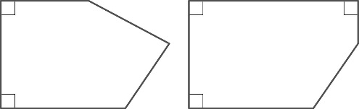

**c** You would end up with a rectangle or a square.

6 a AB is parallel to ED and AF is parallel to CD and BC is parallel to FE.

**b** AB is parallel to FE and BC is parallel to GF and CD is parallel to HG and DE is parallel to AH.

**Investigation: Overlapping squares**

A Polygon A is a quadrilateral, polygon B is a triangle and polygon C is a hexagon.

B Polygon A is a hexagon, polygon B is a quadrilateral and polygon C is a hexagon.

**C** for example: triangle, quadrilateral, pentagon, hexagon and heptagon

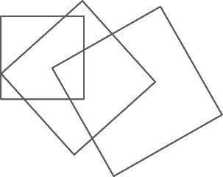

**Exercise 3B**

1 A hexagon can be split into 4 triangles.

So the sum of the interior angles of a hexagon is given by: 4 × 180° = 720°

2 A heptagon can be split into 5 triangles.

So the sum of the interior angles of a heptagon is given by: 5 × 180° = 900°

3 An octagon can be split into 6 triangles.

So the sum of the interior angles of an octagon is given by: 6 × 180° = 1080°

4

|  |  |  |  |
| --- | --- | --- | --- |
| **Name of polygon** | **Number of sides** | **Number of triangles inside polygon** | **Sum of interior angles** |
| Triangle | 3 | 1 | 180º |
| Quadrilateral | 4 | 2 | 360° |
| Pentagon | 5 | 3 | 540° |
| Hexagon | 6 | 4 | 720° |
| Heptagon | 7 | 5 | 900° |
| Octagon | 8 | 6 | 1080° |
| Nonagon | 9 | 7 | 1260° |
| Decagon | 10 | 8 | 1440° |

5 The sum of the interior angles of a hexagon is 720°.

So *a* = 720° – 150° – 70° – 140° – 130° – 120° = 110°.

6 **a** 100° **b** 125 **c** 290°

7 120

**Problem solving: Polygons and diagonals**

A

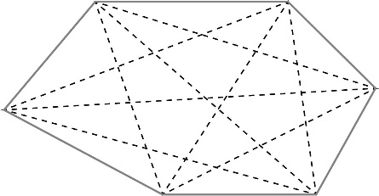

B a *d* =  =  =  = 14 b *d* =  =  =  = 20

C

|  |  |  |
| --- | --- | --- |
| Number of sides | Name of polygon | Number of diagonals |
| 3 | triangle | 0 |
| 4 | quadrilateral | 2 |
| 5 | pentagon | 5 |
| 6 | hexagon | 9 |
| 7 | heptagon | 14 |
| 8 | octagon | 20 |
| 9 | nonagon | 27 |
| 10 | decagon | 35 |

**Exercise 3C**

1 a 720° **b** 120°

2 **a** 1080° **b** 135°

3

|  |  |  |  |
| --- | --- | --- | --- |
| **Name of polygon** | **Number of sides** | **Sum of interior angles** | **Size of each interior angle** |
| Triangle | 3 | 180° | 60° |
| Quadrilateral | 4 | 360° | 90° |
| Pentagon | 5 | 540° | 108° |
| Hexagon | 6 | 720° | 120° |
| Octagon | 8 | 1080° | 135° |
| Nonagon | 9 | 1260° | 140° |
| Decagon | 10 | 1440° | 144° |

4 a 108° b isosceles c 36° d 36° e 36°

5 30°

6 a 10 b 10 × 180° = 1800° c 1800° ÷ 12 = 150°

**Challenge: Interior angles in a regular heptagon**

128°

|  |
| --- |
| **Chapter 3: Answers to Review questions** |

1 a **i** hexagon **ii** pentagon **iii** decagon **iv** octagon

**b i** convex **ii** concave **iii** convex **iv** concave

2 **c** is the odd one out as it is the only regular hexagon.

3 **a** no **b** yes **c** yes **d** yes **e** no

4 a i**i** 720° **iii** 900° **iv** 1080°

**b i** 140° **ii** 100° **iii** 130° **iv** 117°

5 67.5°

6 36°, 72°, 108°, 144°, 180°

|  |
| --- |
| **Chapter 3: Answers to Activity – Regular polygons and tessellations** |

1 no

2 yes

3 no

4 yes, yes, no, yes, no

**Exercise 4A**

1 a positive correlation b no correlation

2 a positive correlation b no correlation

3 a negative correlation

b negative correlation

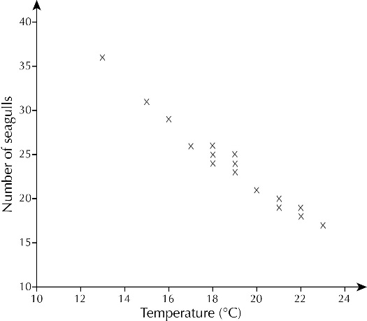4 a

b negative correlation

c Draw a line of best fit through the points on the graph and see what temperature corresponds to 22 gulls.

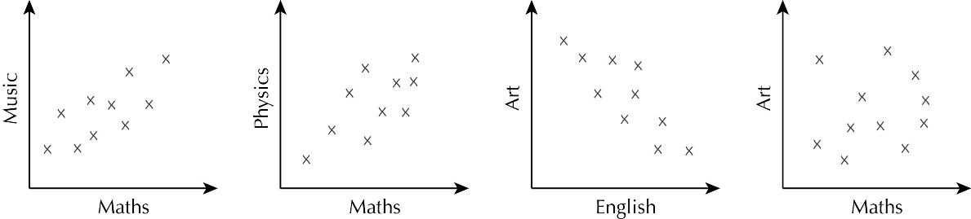5



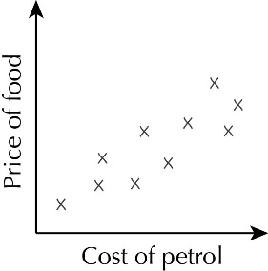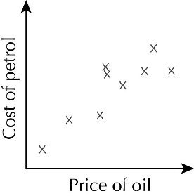6 a b

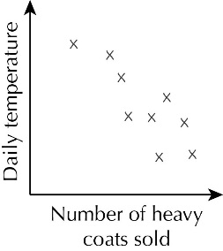7

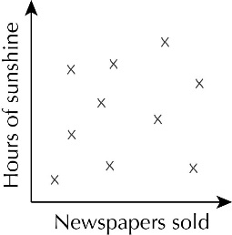

8

**Investigation: Comparing marks**

pupils’ own answers, for example: Mathematics/Science positive correlation, Mathematics/Art positive correlation

**Exercise 4B**

1 a 3 km b 30 minutes

c This section of the graph is steeper.

d He has missed the return journey, which is also 8 km.

2 a 6 b 12

c He could be correct, as the shortest throw is between 0 and 1 metre.

d Yes, the total number of throws is 21.

3 a No, just under half of the pie chart represents daffodils.

b You would need to measure the angles for crocuses and anemones.

4 a Andy b Duncan

c We only know percentages, not the actual number of games.

d David, as he has the lowest percentage of wins and the highest number of losses.

e for example, the number of games may vary greatly between each of the managers; also, the levels of the matches being played could be very different

5 a Daisy Down Farm and Bannerdale b Dale farm

c Yes, even though two of the farms had decreased in size, the total number of cows had increased by 202.

**Challenge: Off their trolley**

pupils’ own diagrams

**Exercise 4C**

1 a 3 b 1 c Neil and Paul

2 a Philip and Kevin b Brian and Malcolm – Brian won c Pete and David

3 a 3 b 28 c 15 d 7

4 a Reikie b Jana c It is easy to see how many games each person won.

d It allows you to see which games each person won. e pupils’ own tables

5 a As the pupils get older, the number having school lunch decreases.

b Between Y7 and Y8 the reduction is 23, which is the greatest change.

c For example, 68. This reduces the number again but by a smaller amount than between Y8 and Y9.

6 a The differences (boys − girls) are: 4%, 3%, 3%, −3%, −3%, −2%.

b At age 10 a higher percentage of boys have android phones, but from age 13 a higher percentage of girls have them.

**Activity: A tall story**

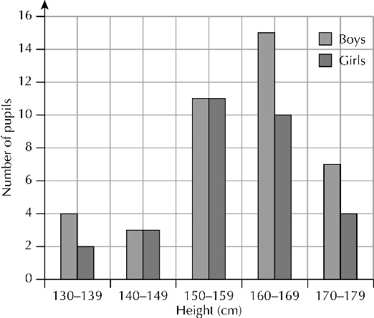A

B Yes, as there are more boys in the two tallest categories (although it could be argued that this is just because there are more boys than girls overall).

**Exercise 4D**

1 a 14 b winter c Yes, as 6 girls chose spring but only 2 boys did.

2 a Both plants had 42 tomatoes.

b The blue light had no effect on the overall number of tomatoes.

3 a Yes, both schools have the same number of pupils and the cycling sector for Conchord Park is slightly larger than for Bradway school.

b The sector for 'Walk' is twice the size.

c For example, pupils live closer to the school or the school is not on a bus route.

4 For example, a higher proportion of children attended the brass band than the rock band.

5 The pupils found the reading test harder, as there were less high marks recorded for this test.

6 a The highest percentage of buses are late between 9 am and 12 noon. This percentage decreases as the day goes on.

b You would expect the majority of buses to be on time.

7 a Peppa Pig b The Beano c pupils’ own diagrams

**Activity: How many?**

A

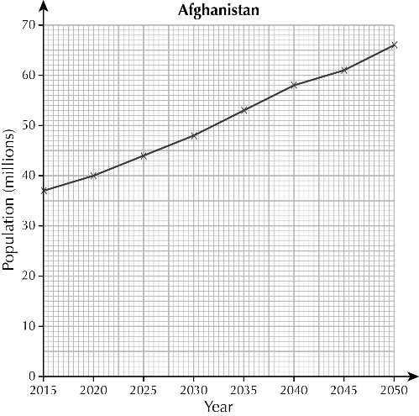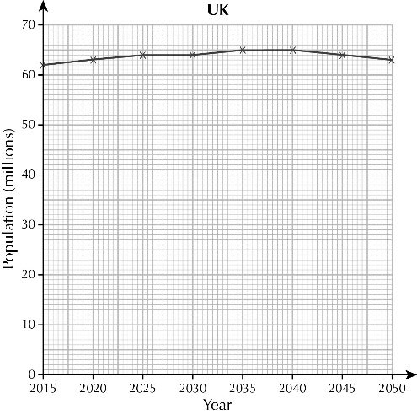

B Around 2048

C UK around 62 million, falling slowly; Afghanistan around 70 million, increasing rapidly

**Exercise 4E**

**Science plan**

**1** investigate

**2** car

**3** engine

**4** not

**5** books

**7** petrol, bias

**9** nearest

**Geography plan**

**1** compare

**3** housing

**4** incomes

**5** internet

**6** average

**8** information

**12** sample, mean

**Investigation: On your bike**

pupils’ own work

|  |
| --- |
| **Chapter 4: Answers to Review questions** |

1 a Iain had more pupils vote yes and Duncan had more pupils vote no.

b Charts will vary but the frequencies used should be Yes 27, No 22, Don't know 11.

2 a Yes, the sector for Indian men is twice the size of the sector for Indian women.

b No,  of the visitors are female and are male.

3 a 100

b Nearly half of the seeds produced 8–9 potatoes when grown in straw, so growing in straw was effective.

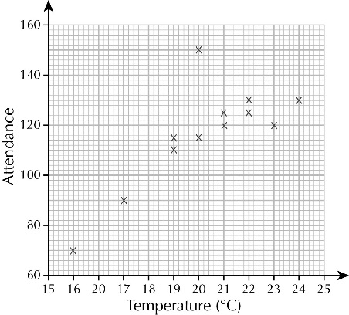4 a

b positive correlation

c around 100

d (20, 150) for the last match – suitable reason such as the last match of the season

|  |
| --- |
| **Chapter 4: Answers to Challenge – Rainforest deforestation** |

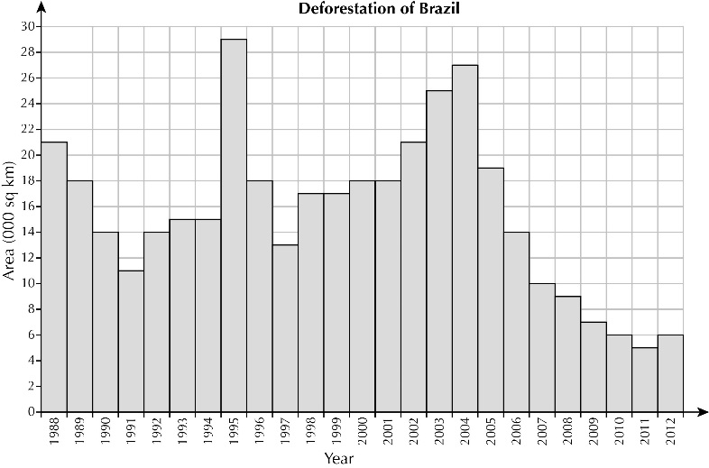**1**

**2** It was decreasing every year.

**3** It was increasing every year.

**4 a** economic growth **b** economic slowdown

**5** As the economy grows so does the rate of deforestation.

**6** cattle ranches

**7** 20%

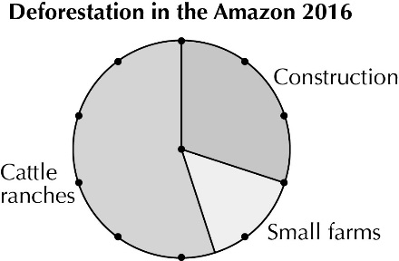**8**

**Exercise 5A**

**1 a** 9.4 cm **b** 17.3 cm **c** 21.4 cm

d 6.3 m e 11.0 m f 13.5 m

2 **a** 18.8 cm **b** 22.0 cm **c** 45.2 cm

d 31.4 m e 40.8 m f 54.7 m

3

|  |  |  |
| --- | --- | --- |
| **Coin** | **Diameter (mm)** | **Circumference** |
| 1p | 20.3 | 64 mm |
| 2p | 25.9 | 81 mm |
| 5p | 18 | 57 mm |
| 10p | 24.5 | 77 mm |
| £1 | 22.5 | 71 mm |
| £2 | 28.4 | 89 mm |

4 200 m

5 The square has the greatest perimeter. It is 4 × 5 = 20 cm while the circle is

6 ×  = 18.8 cm.

6 239 m

**Problem solving: To calculate the perimeter of a semicircle**

**A** 7.7 cm

**B** 25.7 cm

**Exercise 5B**

1 a 12.6 cm² b 78.5 cm² c 162.9 cm²

d 3.1 m² e 0.3 m² f 91.6 m²

2 a 19.6 cm² b 38.5 cm² c 55.4 cm²

d 28.3 m² e 95.0 m² f 113.1 m²

3 254 mm²

4 Jenny has used the circumference formula.

Area =  × r²

=  × 16

= 16 cm²

5The areas are 28.27 cm² and 113.10 cm², so Jackson is wrong. The area of his circle is 4 times the area of Finlay’s circle.

6 346 cm²

7 31 cm²

**Problem solving: Area of a semicircle**

**A** 14.1 cm²

**B** 39.3 c

**Exercise 5C**

1 18.8 m

2 4.5 m²

3 40 200 km

4 2 bottles

5 a 11 310 cm² b 1.13 m²

6 400 m

|  |
| --- |
| **Chapter 5: Answers to Review questions** |

1 a i 31.4 cm ii 78.5 cm²

b i 37.7 cm ii 113.1 cm²

c i 25.1 m ii 50.3 m²

2 a 12.6 cm b 12.6 cm²

Only the units are different.

3 1260 m

4 The circle – it has an area of 201 cm², while the area of the rectangle is 200 cm².

5 a 9.4 cm **b** 530

6 15.9 cm

|  |
| --- |
| **Chapter 5: Answers to Financial skills – Athletics stadium** |

**1 a** 6.3 m **b** 3.1 m² **c** £99

**2 a** 353 m² **b** £21 000

**3 a** 3200 m² **b** £11 500

**4 a** 12 m³ **b** £540

**5 a** 1.6 m³ **b** £80

**Exercise 6A**

1 a 3 **b** 2 **c** 4 **d** 5

2 **b**, they are the only pair that are enlargements of each other

3 DE = 12 cm, EF = 9 cm, DF = 12 cm

4 EF = 10 cm, FG = 16 cm, GH = 22 cm, HE = 16 cm

5 a rectangle B

b rectangle C, 4 × 5 cm = 20 cm, but 4 × 9 cm = 36 cm, not 32 cm

6 10

**Challenge: Algebra with enlargements**

A *x* = 8 cm

B *x* = 5 cm

**Exercise 6B**

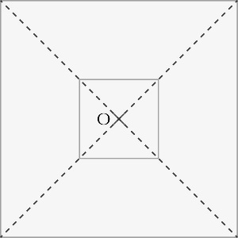**1 a b 5**

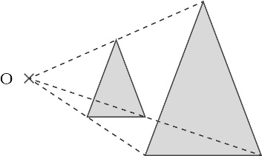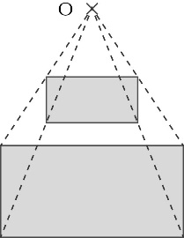

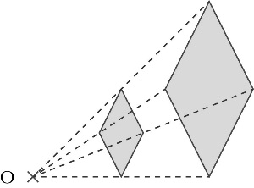

**c Reasoning: Reductions  
 A**

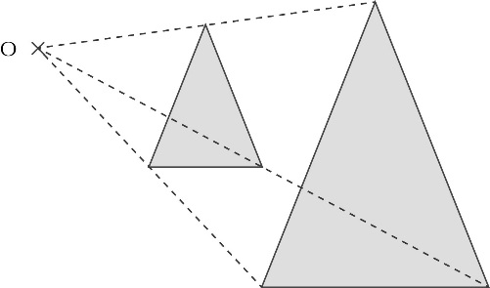

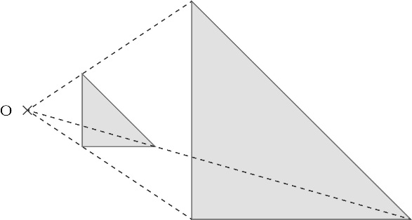

**2**

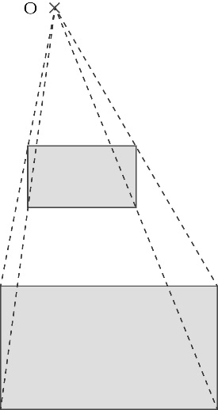 **B**

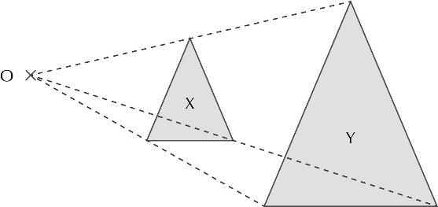**3**

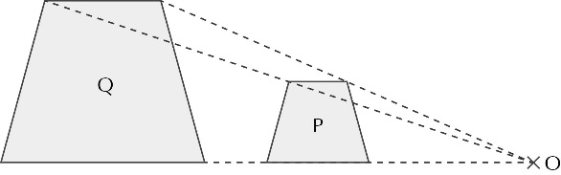**4**

**Exercise 6C**

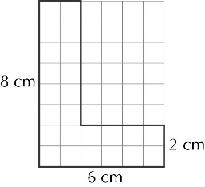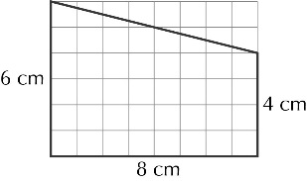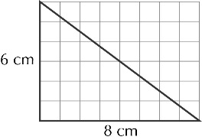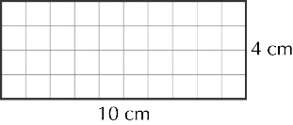1 a **b c d**

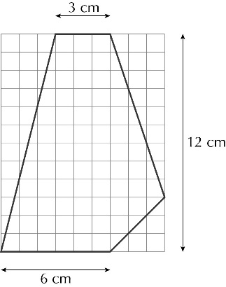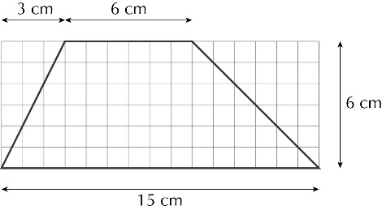**2 a b**

3 a vertices at (8, 6), (8, 2), (4, 2)

**b** DE = 12 cm, EF = 9 cm, DF = 12 cm

c vertices at (3, 9), (6, 9), (6, 6), (9, 6), (9, 9), (12, 9), (12, 3), (3, 3)

**d** vertices at (0, 8), (8, 8), (8, 12), (12, 6), (8, 0), (8, 4), (0, 4)

4 vertices at (6, 12), (12, 12), (9, 3), (3, 3)

5 a 2 b (9, 1)

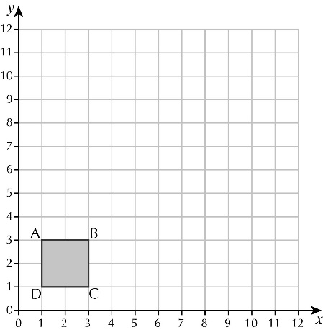6 a

b 4 cm2 **c** 16 cm2 **d** 36 cm2 **e** 64 cm2

**f** the area scale factor is the square of the scale factor

**Activity: Enlarged stickmen**

Check pupils’ posters.

|  |
| --- |
| **Chapter 6: Answers to Review questions** |

1 a 2 b 4

2 C is the odd one out. A, B and D are all enlargements/similar.

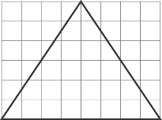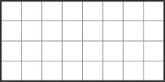3 a **b**

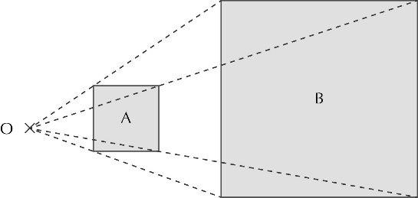**4**

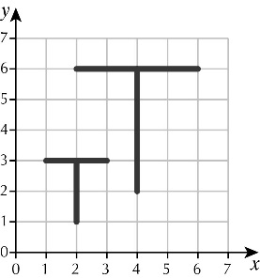**5**

6 a A(2, 4), B(4, 4), C(4, 2), D(2, 2 **b** Check pupils’ drawings.

**c** Aʹ(4, 8), Bʹ(8, 8), Cʹ(8, 4), Dʹ(4, 4)

**d** Aʹʹ(6, 12), Bʹʹ(12, 12), Cʹʹ(12, 6), Dʹʹ(6, 6)

|  |
| --- |
| **Chapter 6: Answers to Problem solving – Photographs** |

1 £191.25

2 a 13 square inches **b** 11 square inches **c** 22 square inches

3 12ʹʹ × 8ʹʹ and 6ʹʹ × 4ʹʹ, with a scale factor of 2

4 a 6ʹʹ × 4ʹʹ and 7ʹʹ × 5ʹʹ **b** Fast Print, £4.50

5 a

|  |  |  |  |
| --- | --- | --- | --- |
| 6ʹʹ × 4ʹʹ | 6 : 4 | 6 ÷ 4 = 1.5 | 1.5 : 1 |
| 7ʹʹ × 5ʹʹ | 7 : 5 | 7 ÷ 5 = 1.4 | 1.4 : 1 |
| 8ʹʹ × 6ʹʹ | 8 : 6 | 8 ÷ 6 = 1.33 | 1.33 : 1 |
| 12ʹʹ × 8ʹʹ | 12 : 8 | 12 ÷ 8 = 1.5 | 1.5 : 1 |
| 13ʹʹ × 8ʹʹ | 13 : 8 | 13 ÷ 8 = 1.625 | 1.625 : 1 |

b the 13ʹʹ × 8ʹʹ print

**Chapter 7 answers**

**Exercise 7A**

1 a  b  c  d 

e  f  g  h 

2 a  b  c  d  e  = 

f  =  g  =  h  =  i  = 

3 a  b  c  d  e  = 

f  =  g  =  h  =  i  = 

4 a  b  +  =  =  c  +  = 

d  +  =  e  +  =  f  +  = 

g  +  =  h  +  =  i  +  = 

5 a  −  =  b  −  =  c  −  = 

d  −  =  e  −  =  f  −  = 

g  −  =  h  −  =  i  −  =  = 

6 a  b  c  d 

e  f  g  h 

7 a  b 100

8 a  b 200

9 a  b 

10 The perimeter is  +  =  m, so Eve is correct.

11 a  b  c  d 

**Challenge: Interesting fractions**

A **a**  **b**  **c** 

B 

C a  b  c 

D  +  = 

**Exercise 7B**

1 a 9 b 23 c 30 d 7

e 11 f 7 g 9 h 7

2  of 30 → 10

 of 24 → 6

 of 35 → 7

 of 27 → 18

 of 36 → 27

3 a 4 b 8 c 10 d 30

e 2 f 10 g 2 h 14

4 £200

5 18

6 a  b  c  d 

e  f  g  h 

7  ×  = , which is bigger than  ×  = .  
8 Andrew is correct:  of  = , while  of  = .

**Investigation: Multiplication of fractions**

A a  b  c 

B a  b  c 

C a  b  c 

D a  b  c 

E a  b  c 

F a 1000 b 1000 c 

**Exercise 7C**

1 a  b  c 

d  ×  =  e  ×  =  f  ×  = 

g  ×  =  h  ×  =  i  ×  = 

2 a  b  c 

d  ×  =  e  ×  =  f  ×  = 

g  ×  =  h  ×  =  i  ×  = 

3 a 5 ×  =  = 10 b 4 ×  =  = 12 c 3 ×  =  = 15

d 6 ×  =  = 24 e 8 ×  =  = 40 f 3 ×  =  = 12 $3÷\frac{1}{5}$

g 7 ×  =  = 42 h 5 ×  =  = 15 $3÷\frac{3}{5}$

4 a 5 ×  =  b 7 ×  =  c 4 ×  =  d 8 ×  = 

e 10 ×  =  f 4 ×  =  g 6 ×  =  h 9 ×  = 

5 a 7 ×  =  b 4 ×  =  c 8 ×  =  d 9 ×  = 

e 5 ×  =  f 5 ×  =  g 4 ×  =  h 7 ×  = 

6 a ii has the smallest answer of  (3).

b i and iii both have the largest answer of  (6).

7 12 lengths

8 no, as 25 ÷  = 27 (or 30 × cm = 27 cm)

9 5 ÷  = 5 ×  = 15 ≠ , so James is correct.

**Challenge: Algebra with fractions**

A a 200 b 300 c 50

B a 300 b 800 c 12.5

|  |
| --- |
| **Chapter 7:** **Answers to Review questions** |

1 a  b  =  c  = 

d  =  e  =  f  = 

2 a 7 b 24 c 32 d 10

e 12 f 5 g 12 h 9

3  of 24 → 8

 of 12 → 3

 of 60 → 6

 of 25 → 10

 of 20 → 15

4 a  b  c  d  e 

f  ×  =  g  ×  =  h  ×  =  i  ×  = 

5 a 8 ×  =  b 2 ×  =  c 3 × =  d 6 ×  = 

e 11 ×  =  f 5 × =  g 9 ×  =  h 10 ×  = 

6 a  b  c  d 

e  f  g  h 

7  of  = , which is bigger than  of  ().  
8 a  b 840

9 120 ×  = 90 m, so she has enough wire.

10 David is correct as  ×  =  ×  = .

|  |
| --- |
| **Chapter 7: Answers to Problem solving – The 2016 Olympic Games in Rio** |

**1** 17 days

**2** **a** nearly 5250 **b** almost 7875 **c** about 2625

**3** 

**4** 

**5 a i** 18 **ii** 12 **iii** 3

**b** 

**6** $216 million

**7** 

**8** 3 300 000

**Exercise 8A**

**1** **a** 7*x* **b** 10*a* **c** 9*t* **d** 9*y*

**e** 6*m* **f** 4*k* **g** 6*n* **h** –4*p*

**2** **a** 10*m* **b** 9*y* **c** 12*t* **d** 14*p*

**e** 14*n* **f** 9*p* **g** 11*t* **h** 6*e*

**i** 6*k* **j** 3*h* **k** 2*m* **l** 6*t*

**3** **a** 9*x* b 12*a* **c** 20*t* **d** 12*y* **e** 15*k*

**f** 12*t* **g** 21*x* **h** 10*m* **i** 24*t* **j** 24*y*

**4** **a** 4*t* + 12 **b** 2*x* + 12 **c** 16*m* – 8 **d** 10*k* – 15

**e** 9 + 6*x* **f** 20 – 12*k* **g** 14 – 6*y* **h** 15 – 3*x*

**5** **a** *xy* + 2*x* **b** 3*am* + 2*m* **c** 2*kp* + 4*k* **d** 6*mn* + 3*n*

**e** 5*t* + 4*qt* **f** 3*g* + 4*gh* **g** 7*h* + 5*gh* **h** 3*k* + 2*dk*

**i** 4*ab* – 3*a* **j** 5*c* – 4*cd* **k** 2*f* – 3*fm* **l** 5*b* – 4*ab*

**m** 5*ad* + *3d* **n** 7*ef* + 3*e* **o** 3*xy* + 2*y* **p** 2*pq* + 5*p*

**q** 3*q* – 4*pq* **r** 6*t* – 3*st* **s** 8*w* – 5*kw* **t** 3*n* – 2*mn*

**6** **a** *A* = *xy* + 5*y* **b** *A* = 2*mx* + 3*m* **c** *A* = 6*d* + 3*ad*

**d** *A* = 2*ak* + 3*k* **e** *A* = 3*n* + 5*ny* **f** *A* = 5*pq* + 6*q*

**7** **a** 4*x*² **b** 5*a*² **c** 6*t*² **d** 4*y*² **e** 2*k*²

**f** 5*t*² **g** 8*x*² **h** 3*m*² **i** 4*t*² **j** 5*y*²

**8** **a** *x*² + 2*x* **b** 3*m*² + 2*m* **c** 4*k*² + *k* **d** 4*n*² + 3*n*

**e** 6*t* + 2*t*² **f** *g* + 4*g*² **g** 3*h* + 5*h*² **h** 2*d* + 3*d*²

**i** 5*a*² – 2*a* **j** 3*c* – 4*c*² **k** 5*t* – 3*t*² **l** 7*b* – 4*b*²

**m** 8*d*² + 7*ad* **n** 5*e*² + 3*e* **o** 2*xy* + 3*y*² **p** 5*p* + 4*p*²

**q** 7*q*² – 5*q* **r** 2*t*² – 5*t* **s** 3*w*² – 4*w* **t** 8*n*² – 5*n*

**9** **a** *A* = 4*m*² + 3*m* **b** *A* = 6*t* + 3*t*² **c** *A* = 3*k*² + *k*

**d** *A* = 4*x* + 3*x*² **e** *A* = 2*g*² + 7*g* **f** *A* = 3*n* + 2*n*²

**10** 3x² and 5x are not like terms, so cannot be added together

**Challenge: Mixed letters**

**A** 9

**B** *x* − 1

**Exercise 8B**

1 **a** 1, 2, 3, 4, 6, 8, 12, 24 **b** 1, 5, 7, 35 **c** 1, 2, 4, 5, 8, 10, 20, 40

**d** 1, 2, 4, 7, 14, 28 **e** 1, 2, 3, 4, 6, 9, 12, 18, 36 **f** 1, 2, 3, 6, 9, 18

**g** 1, 2, 4, 7, 14, 28 **h** 1, 2, 5, 10, 25, 50

2 **a** 1, 2, *x*, 2x **b** 1, 3, *m*, 3m **c** 1, 2, 4, *t*, 2*t*, 4t **d** 1, 5, *y*, 5y

**e** 1, 3, *x*, 3*x*, *x*², 3x2 **f** 1, 2, *m*, 2*m*, *m*², 2m2 **g** 1, 5, *t*, 5*t*, *t*², 5t2 **h** 1, 3, *k*, 3k

3 **a** t **b** q **c** x **d** a

**e** t **f** q **g** x **h** a

4 **a** m(x + 2) **b** m(t + 3) **c** p(n + 2)

**d** x(x – 3) **e** p(p – 1) **f** y(y – 2)

**g** k(4 + x) **h** k(3 + k) **i** x(2 – t)

5 **a** t(3 + m) **b** x(2 + y) **c** p(5 + q)

**d** k(6 – k) **e** n(*n* – 5) **f** x(*x* – 8)

**g** *x*(5 + x) **h** *h*(1 + *h*) **i** *t*(2 – 3*t*)

**6** **a** *x* **b** *p* **c** *t* + 5 **d** 4 − *y*

**7** **a** *x*² + 5*x* = *x*(*x* + 5) **b** 6*m* + *mt* = *m*(6 + *t*) **c** 3*y*² + 2*y* = *y*(3*y* + 2)

**8 a** *t*(4*t* + 5) **b** *x*(6*x* + 1) **c** 2(3*t* + 2)

**d** *x*(3*x* – *m*) **e** *t*(5*t* + *k*) **f** 3(3*x* + 2)

**g** *t*(5 + 8*t*) **h** *x*(3*x* – 2) **i** 5(2*t* + 3)

**9** For example, find the highest common factor, which is *p*, and write this outside the brackets. Then divide 12*p*² and 5*p* by *p* to get the terms in the brackets.

So 12*p*² + 5*p* = *p*(12*p* + 5).

**Investigation: An age-old problem**

Andrew’s grandpa was 27 when Andrew’s dad was born.

**Exercise 8C**

**1 a** 10*m* **b** 12*y* **c** 8*t* **d** 16*p*

**e** 12*n* **f** 13*p* **g** 8*t* **h** 4*e*

**i** 0 **j** –*h* **k** –2*m* **l** 6*t*

**2 a** 10*t* + 8*g* **b** 9*x* + 5*y* **c** 6*m* + 4*k* **d** 6*x* + 8*y*

**e** 3*m* + 3*p* **f** 4*n* + 9*t* **g** 9*k* + 2*g* **h** 3*d* + 6*b*

**i** 3*q* + 2*p* **j** 8*g* + 2*k* **k** 8*x* – 6*y* **l** 2*e* – 4*d*

**3** **a** 4*y* + 12 **b** 6*a* + 8 **c** 10*p* + 15 **d** 6*m* + 9

**e** 4*t* + 3*qt* **f** 2*g* + 5*gh* **g** 3*h* + 7*gh* **h** 4*k* + 3*dk*

**i** 3*a*² – 3*a* **j** 4*c* – *c*² **k** 2*f* – 3*f* ² **l** 5*b* – 4*b*²

**m** 15*a* + 10 **n** 5*ef* + *e* **o** *y*² + 4*y* **p** 2*p*² + 3*p*

**4 a** 9*x* + 14 **b** 20*k* + 33 **c** 16*t* + 23 **d** 18*q* + 11

**e** 26*h* + 8 **f** 34 + 9*f* **g** 18 + *y* **h** 27*t* – 36

**5 a** 4*x* + 9 **b** 2*k* + 18 **c** 12*t* + 9 **d** 2*q* + 5

**e** 4*h* + 46 **f** *w* + 37 **g** 11*x* – 9 **h** 6*t* – 21

**6 a** 6*x*² + 8*x* **b** 5*p*² + 5*p* **c** 7*k*² + 7*k* **d** 5*d*² + 8*d*

**e** 8*n*² + *n* **f** 8*f* ² + *f* **g** 3*p*² – 9*p* **h** 9*y*² – 5*y*

**7 a** 4*x*² + 4*x* **b** 3*p*² + 3*p* **c** 2*k*² + *k* **d** 3*f* ²+ 9*f*

**e** 4*n*² + 7*n* **f** 3*f* ²+ 9*f* **g** 3*p*² + 4*p* **h** 2*y*² + 4*y*

**8** yes, 3(*x* + 5) + *x*(*x* + 5) = 3*x* + 15 + *x*² + 5*x* = *x*² + 8*x* + 15

**Challenge: All legs and heads**

There are 22 more cows (36) than chickens (14).

|  |
| --- |
| **Chapter 8: Answers to Review questions** |

**1 a** 8*p* **b** 13*x* **c** 12*q* **d** 9*t*

**e** 10*n* **f** 10*p* **g** 6*m* **h** 4*a*

**i** *h* **j** –2*g* **k** *n* **l** –3*t*

**2 a** 8*x* + 3 **b** 12*t* − 1 **c** 10*t* + 13

**3 a** 2*m* + 8 **b** 4*t* + 20 **c** 3*x* – 21 **d** 5*t* – 10

**e** 3*m* + *my* **f** 3*t* – *th* **g** 5*x* – 2*tx* **h** 2*k* –3*kt*

**4 a** *A* = 3*t* + 12 **b** *A* = *tx* − 3*t* **c** *A* = *m*² + 4*m* **d** *A* = *t*² + 3*t*

**5 a** 2(3*t* + 5) **b** 3(*x* + 2) **c** *t*(5 – 2*m*)

**d** *x*(6 – *y*) **e** *t*(4 – 5*p*) **f** *x*(3 + *m*)

**g** *t*(5 + 3) **h** *x*(2*x* + 7) **i** *t*(4*t* – m)

**6 a** *t* **b** *x* + 4 **c** *m* − *p*

**7 a** *t*(*t* − 8) = *t*² − 8*t*

The correct factorisation is *t*(8 − *t*).

**b** The common factor is *p*, not *m*.

The correct factorisation is *p*(3*m* + 2*p*).

**c** This one is correct.

**8 a** 11*x* + 23 **b** 14*k* + 21 **c** 18*t* + 16 **d** 13*q* + 21

**e** 2*h* + 13 **f** –*w* + 18 **g** 6*x* – 2 **h** 2*t* + 8

**9** **a** 8*x*² + 8*x* **b** 9*p*² + 5*p* **c** 7*k*² + 7*k* **d** 5*d*² + 8*d*

**e** 3*n*² + 2*n* **f** 3*f* ²+ 7*f* **g** *p*² + *p* **h** 2*y*² + 3*y*

**10** Find the common factor, which is t, and write this outside the brackets. Then work out what you need to multiply this by to get 5*t*² − 2*t*. So *t*(5*t* − 2).

|  |
| --- |
| **Chapter 8: Answers to Challenge – California Gold** |

**1** **a** 128 years **b** 167 years

**2** **a** 30 grams **b** 15*x* grams **c** 21 405 grams (21.4 kg)

**3 a** £56 **b** £28*y* **c** £599 340

**4 a** £1 200 000 **b** £600 000*w* **c** £856 200 000

**5** Mrs T is correct, as the total value could be £0.856 billion.

**6** The coins are worth more as they are. Each coin is worth more than the total value as gold.

**Chapter 9 answers**

**Exercise 9A**

1 a 199.2 b 199.2 c 19.92 d 0.1992

2 a 80 b 80 c 8 d 0.8

3 **a** 13 **b** 20.4 **c** 19.64 **d** 30.6

**e** 220.5 **f** 179.2 **g** 87.6 **h** 76.4

4 **a** 5 **b** 7 **c** 30 **d** 6

**e** 7 **f** 80 **g** 10 **h** 40

**5 a** 20 **b** 14 **c** 60 **d** 30

**e** 28 **f** 240 **g** 40 **h** 200

6 **a** 0.18 **b** 0.25 **c** 0.63 **d** 0.36

**e** 0.72 **f** 0.42 **g** 0.4 **h** 0.16

**i** 0.49 **j** 0.27 **k** 0.32 **l** 0.06

7 a 492 b i 0.492 ii 0.492

8 a 1.26 m² b 2.53 m²

9 £20.60

10 £187.50

**Investigation: Mystical multiplication**

A a 1 b 0.49 c 0.09 d 0.4 e 0.4

B They are the same.

C pupils’ own work

D In each case **d** and **e** give the same answer. When *x* + *y* = 1, then *x*² − *y*² = *x* – *y.*

**Exercise 9B**

1 **a** 570 **b** 6900 **c** 78 000

**d** 714 000 **e** 80 200 **f** 3150

2 **a** 74.8 **b** 3.29 **c** 0.473

**d** 0.058 **e** 0.85 **f** 1.7

3 **a** 143 **b** 3620 **c** 57 300

**d** 32 140 **e** 1285 **f** 391.7

4 **a** 0.634 **b** 0.473 **c** 0.0663

**d** 0.0027 **e** 0.0376 **f** 7.193

5 **a** 115 **b** 0.637 **c** 42 300

**d** 0.003 65 **e** 107 **f** 0.914

**g** 41 **h** 0.038 **i** 7400

6 a 0.1 b 0.01 c 0.001

d 0.000 01 e 0.000 001

7 a 10–2 b 10−3 c 10−1 d 10−4 e 10−7

8 **a** 960 **b** 18 **c** 20 460 **d** 1297

9 **a** 8160 **b** 710 **c** 824 600 **d** 29 660

10 **a** 0.77 **b** 0.063 **c** 51.46 **d** 23.58

11 **a** 0.186 **b** 0.0184 **c** 2.185 **d** 0.346

12

|  |  |  |
| --- | --- | --- |
|  | Population | Land mass per person (km2) |
| Singapore | Five million | 14.2 × 10–5 = 0.000 142 |
| Hong Kong | Seven million | 15.7 × 10–5 = 0.000 157 |
| Belgium | Eleven million | 27.3 × 10–4 = 0.00 273 |
| Japan | 127 million | 29.9 × 10–4 = 0.00 299 |

**Activity: Prefixes**

A Use suitable prefixes to write each quantity in a simpler form.

a 3 megawatts b 5 kilometres c 3 gigabytes

d 7 centigrams e 4 millimetres f 5.5 microlitres

B approximately 30 centimetres

**Exercise 9C**

1 **a** 1.3 **b** 24.2 **c** 9.0 **d** 31.1

**e** 1.9 **f** 5.1 **g** 2.0 **h** 4.3

2 **a** 3.26 **b** 35.19 **c** 7.04 **d** 42.14

**e** 2.89 **f** 6.15 **g** 3.97 **h** 7.26

3 **a** i 1.3 ii 1.28 **b i** 46.2 **ii** 46.17

**c i** 6.8 **ii** 6.84 **d i** 17.1 **ii** 17.14

**e i** 4.0 **ii** 4.00 **f i** 7.1 **ii** 7.07

**g i** 2.8 **ii** 2.75 **h i** 2.2 **ii** 2.15

4 **a** 4 + 8 = 12 **b** 8 + 2 = 10 **c** 7 – 2 = 5 **d** 7 – 3 = 4

**e** 6 × 8 = 48 **f** 9 × 9 = 81 **g** 8 ÷ 2 = 4 **h** 9 ÷ 3 = 3

5 **a** 30 + 70 = 100 **b** 70 + 30 = 100 **c** 80 – 30 = 50 **d** 60 – 20 = 40

**e** 70 × 70 = 4900 **f** 80 × 80 = 6400 **g** 60 ÷ 30 = 2 **h** 80 ÷ 20 = 4

6 **a** 300 + 100 = 400 **b** 800 + 40 = 840 **c** 800 – 100 = 700

**d** 500 – 80 = 420 **e** 200 × 100 = 20 000 **f** 300 × 40 = 12 000

**g** 200 ÷ 40 = 5 **h** 400 ÷ 20 = 5

7 Note that each answer must be accompanied by a sensible reason.

a ii, 60 mph b ii, 23° c i, 50 kg d ii, 4 minutes

e i, 12.8 seconds f ii, 2 km

**Activity: Rounding**

8.3 × 3.9 = 32.37, as 8 × 4 = 32

11.4 ÷ 1.5 = 7.6, as 12 ÷ 2 = 6

9.3 × 6.1 = 56.73, as 9 × 6 = 54

84 ÷ 3.2 = 26.25, as 90 ÷ 3 = 30

**Exercise 9D**

1 **a** 0.2 **b** 0.3 **c** 0.6 **d** 0.7

**e** 0.3 **f** 0.6 **g** 0.6 **h** 0.8

2 **a** 0.18 **b** 0.09 **c** 0.04 **d** 0.05

**e** 0.04 **f** 0.09 **g** 0.09 **h** 0.07

3 **a** 1.21 **b** 0.65 **c** 1.61 **d** 0.95

**e** 0.87 **f** 0.89 **g** 0.61 **h** 0.32

4 **a** 9.01 **b** 7.59 **c** 5.76 **d** 5.46

**e** 3.06 **f** 11.02 **g** 2.36 **h** 1.28

5 **a** 8.05 **b** 1.46 **c** 3.3 **d** 1.88

**e** 8.65 **f** 4.825 **g** 5.24 **h** 2.65

6 1.08 cm

7 £0.47

8 2.08 km/h

9 0.46 m

10 £1.35

**Investigation: Spot the link**

A a 6.85 b 685 c 6.85 d 0.685

B a 46 b 4.6 c 0.46 d 46

**Exercise 9E**

1 any two odd numbers with a sum of 48, for example: 1 and 47 or 23 and 25

2 42

3 4

4 a 5 b 5 c 7 or 23

d any two numbers with a difference of 15, for example: 3 and 18 or −1 and 14

5 6 × 45p = £2.70, so the multipack is the cheaper way to buy them.

6 53 years old

7 the mass of the odd-numbered counters → 5 × 6

the total mass of the counters → 10 × 6

the mass of the counters that are not green → (5 + 2) × 6

8 60

9 £1

10 Rebecca is 12 years old and Oliver is 24.

11 1.5p

**Investigation: Magic square**

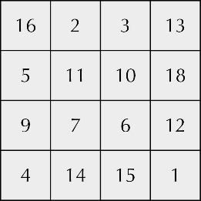A

B the four centre squares

If you split the 4 by 4 square into four 2 by 2 squares along its axes of symmetry, then each of the 2 by 2 squares adds up to the magic number.

the middle 2 squares of the top row plus the middle 2 squares of the bottom row

the middle 2 squares of the left hand column plus the middle two squares of the right hand column

|  |
| --- |
| **Chapter 9: Answers to Review questions** |

1 **a** 680 **b** 7400 **c** 92 000 **d** 71 300

**e** 85.9 **f** 1.18 **g** 0.584 **h** 3.9

2 any two odd numbers that add up to 56, for example: 1 and 45 or 23 and 33

3 **a** 2.4 **b** 23.2 **c** 8.2 **d** 38.4 **e** 4.0

4 **a** 3.37 **b** 35.08 **c** 7.15 **d** 42.03 **e** 1.00

5 a 1.6 m b 1.35 m c 160 cm

6 The six-pack is a better value at 21.7p per tin. The four-pack costs 22.5p per tin.

7 Brushup is cheaper (£25) than Kleengo (£29).

8 **a** 18.5 **b** 25.8 **c** 23.28 **d** 36.2

**e** 9 **f** 30 **g** 70 **h** 80

9 a 10–3 b 10−1 c 10−2 d 10−5 e 10−6

10 a 0.28 b 0.64 c 0.45 d 0.21 e 0.99

11

|  |  |  |
| --- | --- | --- |
|  | **Population** | **Land mass per person (km2)** |
| Vatican City | 826 | 53.3 × 10–5 = 0.000 533 |
| Gibraltar | 31 000 | 21.9 × 10–5 = 0.000 219 |
| Monaco | 33 000 | 59 × 10–6 = 0.000 059 |
| Bermuda | 65 000 | 8.2 × 10–4 = 0.000 82 |

12 Answers may vary from those given provided each answer is accompanied by a valid reason.

a ii 90 km/h b ii 75° c ii 1.2 kg d ii 30 minutes

|  |
| --- |
| **Chapter 9: Answers to Mathematical reasoning – Paper** |

**1** 2500

**2** 10 cm

**3**

|  |  |  |  |  |  |
| --- | --- | --- | --- | --- | --- |
| A0 | A1 | A2 | A3 | A4 | A5 |
| 1188 | 840 | 594 | 420 | 297 | 210 |
| 840 | 594 | 420 | 297 | 210 | 149 |

**4** 16

**5** **a** £10.80 **b** £14 **c** £14.40

**6** £33.60

**Chapter 10 answers  
Exercise 10A**

1 (2 × 4 × 3) + (2 × 4 × 2) + (2 × 3 × 2) = 24 + 16 + 12 = 52 cm2

2 There are 6 square faces and each one has an area of 4 × 4 = 16 cm2.

So the surface area of the cube is 6 × 16 = 96 cm2.

3 a 72 cm2 b 92 cm2 c 192 cm2 d 46 cm2

4 94 cm2

5 a 6 cm2 b 24 cm2 **c** 150 cm2 **d** 216 cm2

6 13.5 m2

7 700 cm2

8 39 m2

**Investigation: An open box problem**

A 2 × 2 = 4 cm2, 4 × 4 = 16 cm2, 192 – 16 = 176 cm2

B

|  |  |  |
| --- | --- | --- |
| Size of squares cut out | Area of the four squares (cm2) | Surface area of box (cm2) |
| 1 cm by 1 cm | 4 cm2 | 188 cm2 |
| 2 cm by 2 cm | 16 cm2 | 176 cm2 |
| 3 cm by 3 cm | 36 cm2 | 156 cm2 |
| 4 cm by 4 cm | 64 cm2 | 128 cm2 |
| 5 cm by 5 cm | 100 cm2 | 92 cm2 |

**Exercise 10B**

1 6 × 5 × 4 = 120 cm3

2 5 × 5 × 5 = 125 cm3

3 a 168 cm3 b 360 cm3 c 3 m3

**4** a 64 cm3 b 216 cm3 c 1728 cm3

5 a 16 *l*  b 30 *l*  **c** 120 *l*

6 48 m3

7 a 3 cm b 8 cm **c** 8 m

8 10 cm

**Investigation: Painted cubes**

A a 0 b 0 c 0d 8

B a 1 b 6 c 12 d 8

**C** a 8 b 24 c 24 d 8

**D**

|  |  |  |  |  |  |
| --- | --- | --- | --- | --- | --- |
| **Size of**  **yellow cube** | **Number**  **of cubes** | **No faces**  **painted red** | **One face**  **painted red** | **Two faces**  **painted red** | **Three faces painted red** |
| 2 by 2 by 2 | 8 | 0 | 0 | 0 | 8 |
| 3 by 3 by 3 | 27 | 1 | 6 | 12 | 8 |
| 4 by 4 by 4 | 64 | 8 | 24 | 24 | 8 |

**Exercise 10B**

1  =  = 84 cm3

2  =  = 864 cm3

3 a 90 cm3 b 100 cm3 c 288 cm3

**4** 800 cm3

5 a 0.3 m3 b 0.72 tonnes

6 6 cm

**Problem solving: Surface area of triangular prisms**

A 36 cm2

B 360 cm2

|  |
| --- |
| **Chapter 10:** **Answers to Review questions** |

**b** 6 × 4 × 3 = 72 cm3

2 a i 174 cm2 **ii** 135 cm3

**b** **i** 3 m3 **ii** 210 m3

**c** **i** 48 cm2 **ii** 20 cm3

3 1.5 litres

**4**  =  = 360 cm3

5 1.8 m3

6 a 5 cm b A = 112 cm2 and B = 94 cm2, so cuboid A

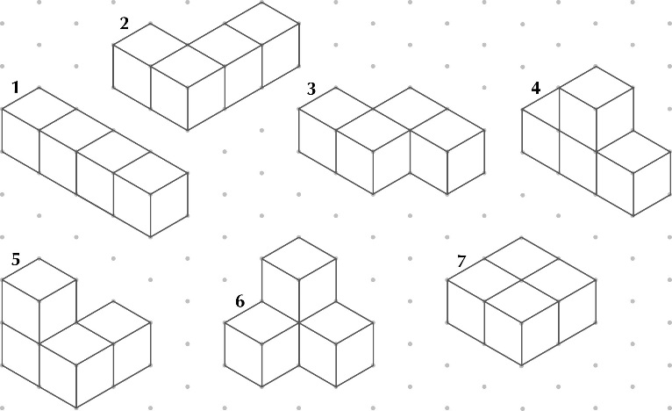**1**

|  |
| --- |
| **Chapter 10:** **Answers to Investigation – A cube investigation** |

2

|  |  |  |  |  |  |  |  |
| --- | --- | --- | --- | --- | --- | --- | --- |
| **3D shape** | **1** | **2** | **3** | **4** | **5** | **6** | **7** |
| **Surface area** | 18 cm2 | 18 cm2 | 18 cm2 | 18 cm2 | 18 cm2 | 18 cm2 | 16 cm2 |

3 Shape 7 has the least surface area and the rest have the same surface area. More surfaces are in contact with each other in shape 7.

**4** 22 cm2 and 20 cm2

**Exercise 11A**

**1 a**

|  |  |  |  |  |
| --- | --- | --- | --- | --- |
| ***x*** | 0 | 1 | 2 | 3 |
| ***y = x* + 1** | 1 | 2 | 3 | 4 |
| ***y = x* + 2** | 2 | 3 | 4 | 5 |
| ***y = x* + 3** | 3 | 4 | 5 | 6 |
| ***y = x* + 4** | 4 | 5 | 6 | 7 |

**b–c e**

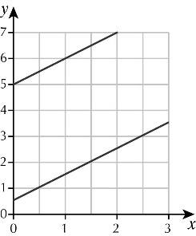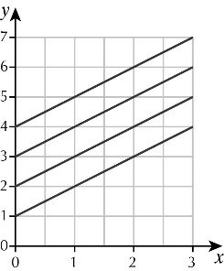

**d** parallel and cut the *y*-axis at the value added to *x*

**2 a**

|  |  |  |  |  |
| --- | --- | --- | --- | --- |
| ***x*** | 0 | 1 | 2 | 3 |
| ***y* = 2*x* + 1** | 1 | 3 | 5 | 7 |
| ***y* = 2*x* + 2** | 2 | 4 | 6 | 8 |
| ***y* = 2*x* + 3** | 3 | 5 | 7 | 9 |
| ***y* = 2*x* + 4** | 4 | 6 | 8 | 10 |

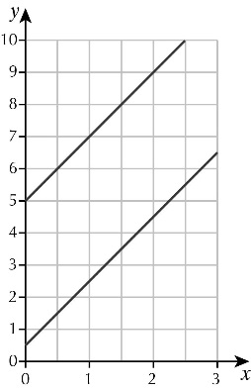 **b–c** **e**

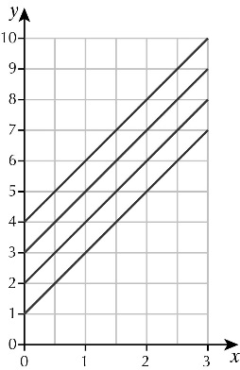

**d** parallel and cut the *y*-axis at the value added to 2*x*

**3 a**

|  |  |  |  |  |
| --- | --- | --- | --- | --- |
| ***x*** | 0 | 1 | 2 | 3 |
| ***y* = *x*** | 0 | 1 | 2 | 3 |
| ***y* = 2*x*** | 0 | 2 | 4 | 6 |
| ***y* = 3*x*** | 0 | 3 | 6 | 9 |
| ***y* = 4*x*** | 0 | 4 | 8 | 12 |

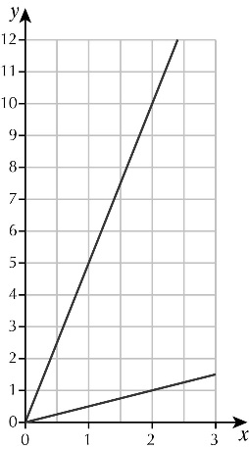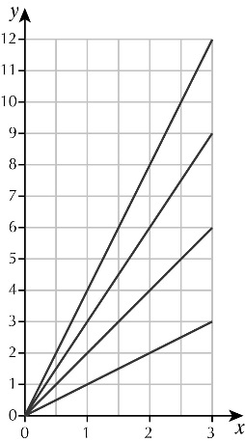**b–c e**

**d** They all pass through the origin and they get steeper as the value in front of *x* increases.

**4 a**

|  |  |  |  |  |
| --- | --- | --- | --- | --- |
| ***x*** | 0 | 1 | 2 | 3 |
| ***y* = *x* + 4** | 4 | 5 | 6 | 7 |
| ***y* = 2*x* + 4** | 4 | 6 | 8 | 10 |
| ***y* = 3*x* + 4** | 4 | 7 | 10 | 13 |
| ***y* = 4*x* + 4** | 4 | 8 | 12 | 16 |

**b–c f**

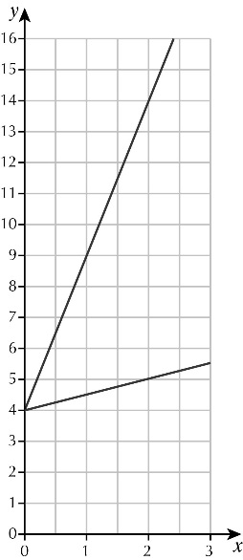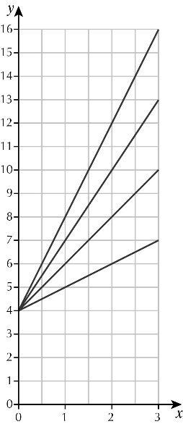

**d** They all cut the *y*-axis at (0, 4) and they get steeper as the value in front of *x* increases.

**e** how steep it is – the gradient

**Investigation: The graph of *x* + *y* = *c***

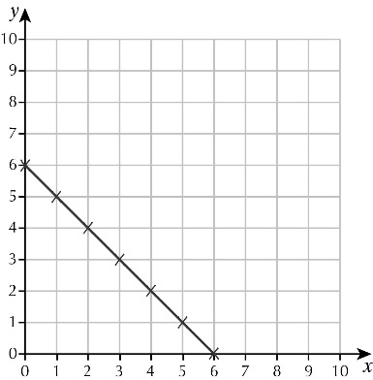A–B

C (0, 5), (1, 4), (2, 3), (3, 2), (4, 1), (5, 0)

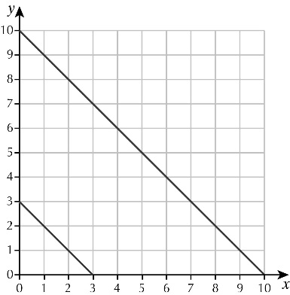D

**Exercise 11B**

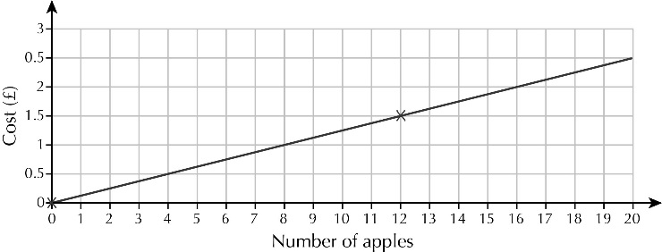1 a

b i 50p ii £1.25 iii £2.50

c i 6 ii 14 iii 22

2 a

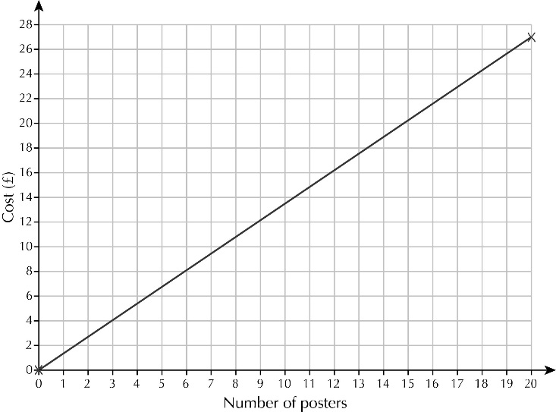

b i £8.10 ii £16.20 iii £21.60

c i 12 ii 8 or 9 iii 17

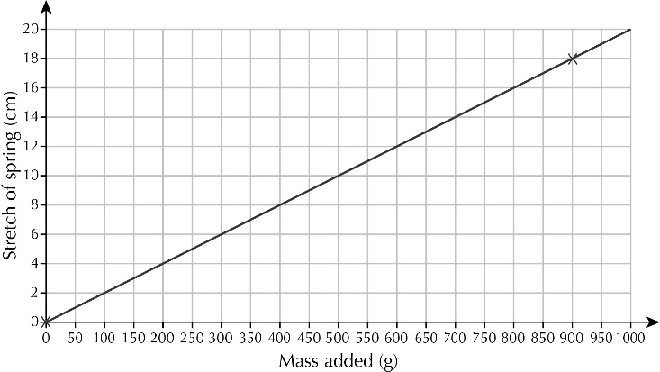3 a

b i 4 cm ii 6 cm iii 20 cm

c i 100 g ii 250 g iii 700 g

4 a

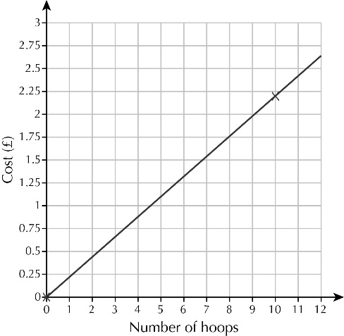

b i 66p ii £1.76 iii £2.64

c i 4 ii 5 iii 11

5 a

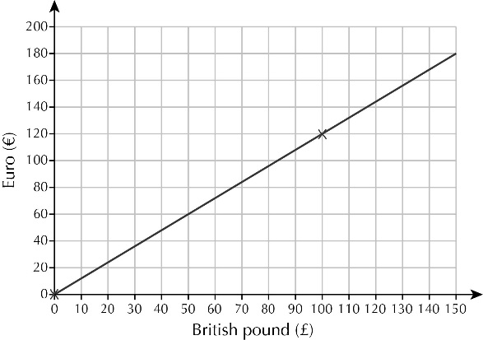

b i €24 ii €60 iii €156

c i £33 ii £67 iii £133

**Challenge: Strolling sisters**

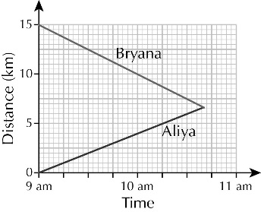

A 10:40 am

B 6.6 km

**Exercise 11C**

**1 a** Check pupils’ graphs. **b** 1.25 **c** 0.7 and −2.7

**d** *y* = −1 **e** 0.4 and −2.4

**2 a** Check pupils’ graphs. **b** −1.25 **c** 0.8 and −3.8

**d** *y* = −2.25 **e** 0.3 and −3.3

**3 a** Check pupils’ graphs. **b** 3.75 **c** 1.6 and −0.6

**d** *y* = −0.25 **e** 2.8 and −1.8

**4 a** Check pupils’ graphs. **b** −0.75 **c** 2.7 and −0.7

**d** *y* = −1 **e** 3.6 and −1.6

**5 a** Check pupils’ graphs. **b** −1.25 **c** 3.6 and −0.6

**d** *y* = −2.25 **e** 3.8 and −0.8

**Investigation: You can’t solve them all**

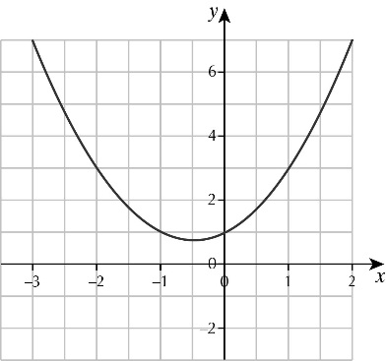**A**

**B** **a** 1.6 and −2.6 **b** 0.6 and −1.6

**C** The graph does not cut the *x*-axis.

**D** pupils’ own work

**Exercise 11D**

1 a

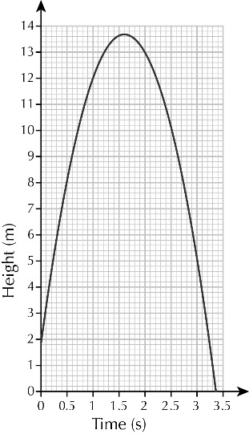

b 13.5 m

c 1.5 seconds

d 3.5 seconds

2 a

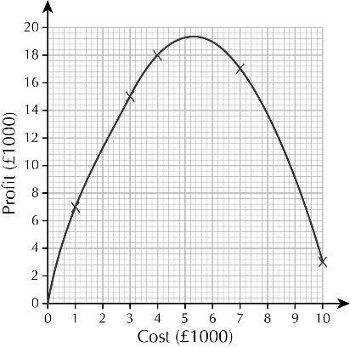

b around £19 000

c around £5200

d about £1600 or £8600

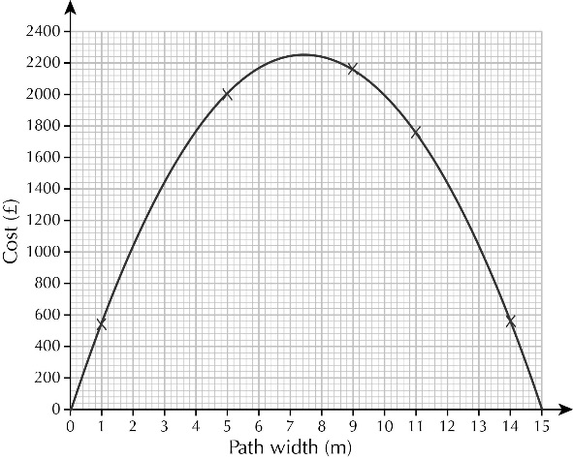3 a

b approx. £2350

c about 7 m

d about 2.2 m and 13 m

4 a

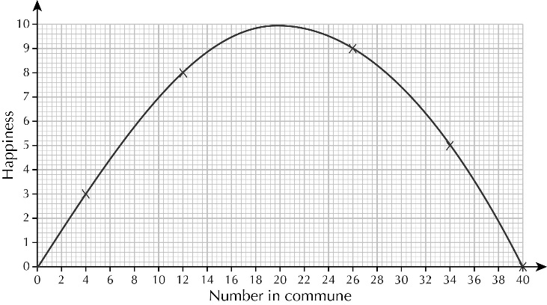

b 20

c 9

d between 8 and 32

**Investigation: Cooling pies**

A by drawing a graph of the data in the table and joining them with a smooth curve; then draw a line from the time up to the curve, then across to the temperature axis

a 30 °C b 23 °C c 19 °C

B between 2 minutes and 4 minutes after being taken out of the oven

|  |
| --- |
| **Chapter 11: Answers to Review questions** |

1 a

|  |  |  |  |  |
| --- | --- | --- | --- | --- |
| **x** | 0 | 1 | 2 | 3 |
| **y = 3x + 1** | 1 | 4 | 7 | 10 |
| **y = 3x + 2** | 2 | 5 | 8 | 11 |
| **y = 3x + 3** | 3 | 6 | 9 | 12 |
| **y = 3x + 4** | 4 | 7 | 10 | 13 |

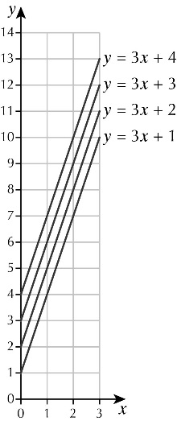 **b–c**

d They are parallel and cut the *y*-axis at the value added to the 3*x*.

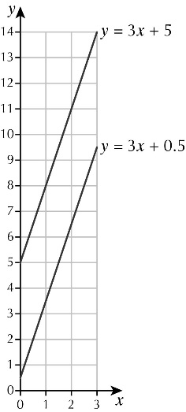 e

2 a y = 29 b y = −11

c y = x2 and y = x2 – 4 because 5² and (−5)² are both equal to 25.

3 a *A* = *lb* = 8 × 2 = 16 cm²

b for example, rectangles of 1 cm × 9 cm, 3 cm × 7 cm, 4 cm × 6 cm

c The rectangles above have areas of 9 cm², 21 cm², 24 cm².

d pupils’ own values, for example:

|  |  |  |  |  |
| --- | --- | --- | --- | --- |
| **Longest side (cm)** | 8 | 9 | 7 | 6 |
| **Area (cm2)** | 16 | 9 | 21 | 24 |

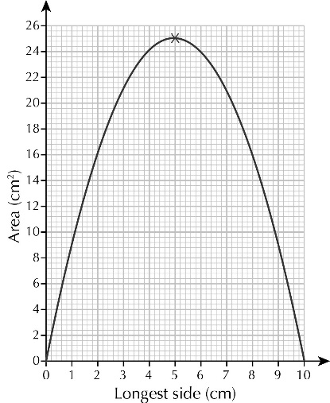 e

f 25 cm² g 5 cm

4 a Check pupils’ graphs.

b −1.75 c 4.4 and −0.4

d y = −4 e 4.2 and −0.2

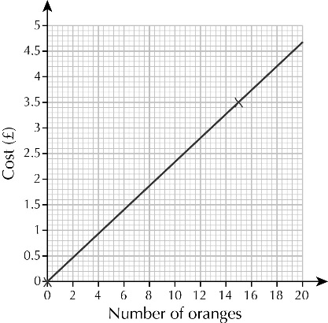5 a

b i 93p ii £2.10 iii £4.67

c i 4 ii 6 iii 19

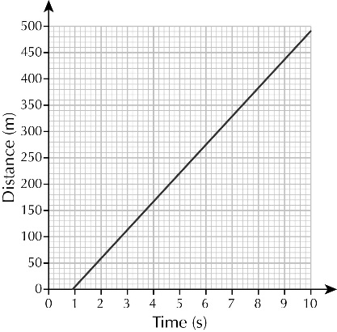6 a

b about 8 seconds

c about 78 m

7 6.2 cm

|  |
| --- |
| **Chapter 11: Answers to Problem solving – Squirrels** |

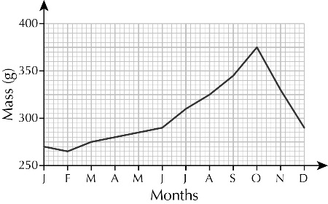**1 a**

**b** June and July

**c** January/February and May

**d** preparing for winter hibernation

**e** for example:

* grey squirrels are heavier all year round
* red squirrels start to increase in mass earlier in the year
* grey squirrels increase their mass by a bigger proportion than red squirrels

**2 a** around 185–190 mm

**b** positive correlation

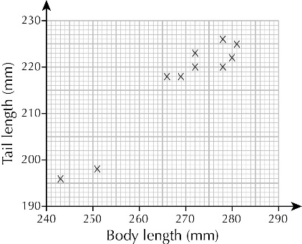 **c i**

**ii** around 260 mm

**iii** This is outside the range of the data supplied.

**Exercise 12A**

1 a *d* = 120 × 2 = 240 km

b *d* = 120 × 4 = 480 km

c *d* = 120 × 5 = 660 km

2 **a** 80 km **b** 105 km **c** 30 km **d** 32 km

3 36 km

4 1920 km

5 20 km

6

|  |  |  |  |  |
| --- | --- | --- | --- | --- |
|  | **Speed** | **Time** | **Time as a decimal** | **Distance travelled** |
| **a** | 40 km/h | 1 hours | 1.5 hours | 60 km |
| **b** | 60 km/h | 2 hours | 2.25 hours | 135 km |
| **c** | 100 km/h | hour | 0.75 hours | 75 km |
| **d** | 80 km/h | 2 hours  15 minutes | 2.25 hours | 180 km |
| **e** | 10 km/h | 30 minutes | 0.5 hours | 5 km |
| **f** | 4 km/h | 3 hours 45 minutes | 3.75 hours | 15 km |

7 **a** speed = 40 km/h **b** speed = 60 km/h

time = 30 minutes time = 1 hour 30

*d* = *s* × *t*  *d* = *s* × *t*

= 40 × 0.5 = 60 × 1.5

= 20 km = 90 km

8 a

|  |  |  |  |  |  |
| --- | --- | --- | --- | --- | --- |
| Time (h) | 0 | 1 | 2 | 3 | 4 |
| Distance (km) | 0 | 20 | 40 | 60 | 80 |

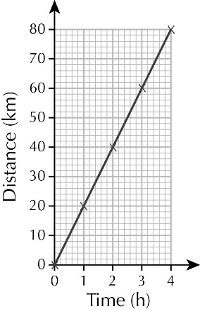**b**

9 a 20 km/h

b The motorcyclist has stopped.

c 25 km/h

**Challenge: Changing kilometres into miles**

A a 15 miles b 50 miles

**c** 62miles **d** 112miles

B 60 miles

**Exercise 12B**

1 a *s* = 300 ÷ 4 = 75 km/h b *s* = 300 ÷ 5 = 60 km/h c *s* = 300 ÷ 6 = 50 km/h

2 **a** 4 km/h **b** 10 km/h **c** 30 km/h **d** 50 km/h

**3** 800 km/h

**4** 40 km/h

**5** 1080 million km/h

**6** 6 km/h

7 a 40 km/h b 20 km/h c The speed is halved.

**Challenge: Road signs in France**

A 19 mph

B 31 mph, 56 mph

C 81 mph, 69 mph

**Exercise 12C**

1 a *t* = 40 ÷ 10 = 4 hours b *t* = 40 ÷ 20 = 2 hours c *t* = 40 ÷ 16 = 2 hours

2 **a** 5 hours **b** 4 hours **c** 3 hours **d** 3 hours

**3 a** 3 hours **b** 4 hours

**4 a** 3 hours **b** 2 hours

**5** 12:30 pm

|  |  |  |  |  |
| --- | --- | --- | --- | --- |
| Time (h) | 0 | 1 | 2 | 3 |
| Distance (km) | 0 | 12 | 24 | 36 |

**6** a

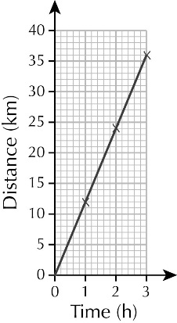 **b**

**7** 10 seconds

**Challenge: The distance, speed and time triangle**

A 2 hours

B 100 km/h

C 360 km

D 4 hours

E 100 km/h

F 135 km

|  |
| --- |
| **Chapter 12:** **Answers to Review questions** |

1 a *d* = 80 × 2 = 160 km b *d* = 80 × 3 = 240 km c *d* = 80 × 4 = 360 km

**2** a *s* = 400 ÷ 5 = 80 km/h b *s* = 400 ÷ 8 = 50 km/h c *s* = 400 ÷ 4 = 100 km/h

3 a *t* = 36 ÷ 6 = 6 hours b *t* = 36 ÷ 3 = 12 hours c *t* = 36 ÷ 4 = 8 hours

**4** 310 km

**5** a

|  |  |  |  |  |  |  |
| --- | --- | --- | --- | --- | --- | --- |
| Time (h) | 0 | 1 | 2 | 3 | 4 | 5 |
| Distance (km) | 0 | 5 | 10 | 15 | 20 | 25 |

**b**

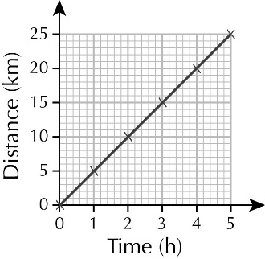

**c** 12 km

**6** 20 km/h

**7** 1220 km/h

|  |
| --- |
| **Chapter 12: Answers to Financial skills – Shopping at the market** |

1 Gina

2 **a** For George: 800 g costs £6.00, so 100 g costs  = 75 p

**b** For Natasha: 500 g costs £4.00, so 100 g costs  = 80 p

**c** George pays 75 p for 100 g and Natasha pays 80 p for 100 g, so George gets a better deal.

3 **a** For Mrs Seager: 1 kg costs £12.00, so  kg costs  = £4.00

**b** For Mr Mir: 2 kg costs £14.00, so  kg costs  = 3.50

**c** Mrs Seager pays £4.00 for  kg and Mr Mir pays £3.50 for  kg, so Mr Mir gets a better deal.

4 **a** For Nathan: 1 kg costs 90 p

**b** For Lily: 1 kg costs 80 p

**c** So Lily gets a better deal.

**5 a** £1.30 and £1.20 **b** the second one

**6** the large tin, as 3 × 59 p = £1.77

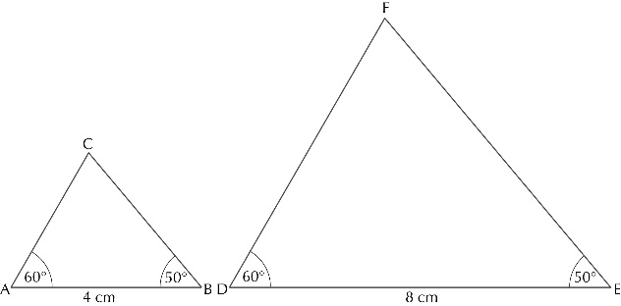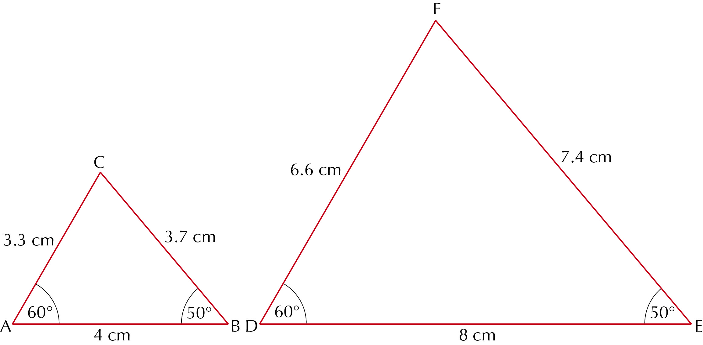**Exercise 13A**

1 a **b**

c  =  = 2,  =  = 2,  =  = 2

d All the answers are equal to or very close to 2.

2 a **b**

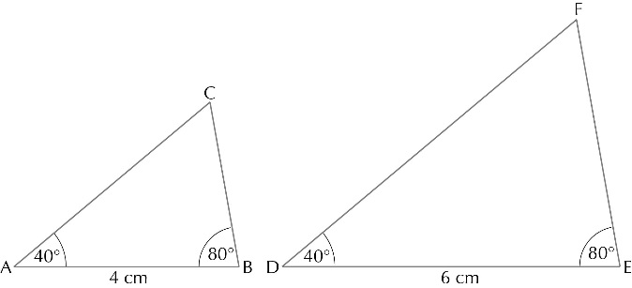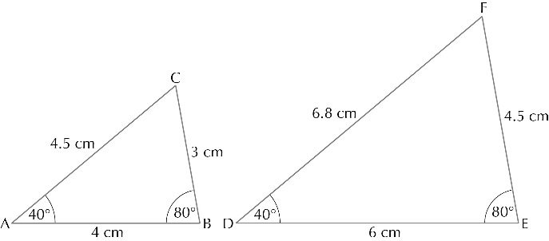c  =  = 1.5,  =  = 1.5,  =  = 1.5

d All the answers are equal to, or very close to 1.5.

3 a, b

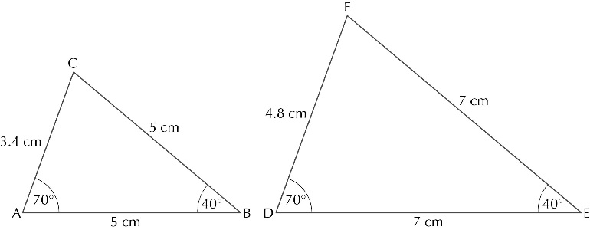

c  =  = 1.4,  =  = 1.4,  =  = 1.4

d All the answers are equal to or very close to 1.4.

4 a–c pupils’ own answers

d All answers in part c should be the same or very close to each other.

**Investigation: Angles and ratios**

Pupils’ own answers – they should find that they get the same value for all 6 triangles in each of the last 2 columns.

**Exercise 13B**

1 a  =  =  **b**  =  = 

**c**  =  =  **d**  =  = 

2 a FE = 7.5 cm, AC = 2.4 cm **b** KL = 3.2 cm, GH = 6.25 cm

c QS = 6 cm, PN = 6.25 cm d YZ = 25 cm, TW = 8.4 cm

3 18 m

4 40 m

5 120 m

**Investigation: Nested triangles**

**A** ∠A = ∠B, ∠E = ∠D and both triangles share ∠C, so the triangles are similar.

**B** AB = 12.5 − 5 = 7.5 cm

**Exercise 13C**

**1** 284 cm

**2** 328 m

**3** 82 m

**4** A ship sails on a direction of N75°E for 150 km.

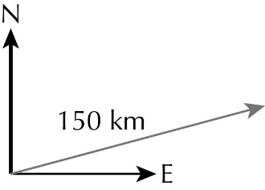 **a**

**b** 145 km

**5** 4 m

**6** **a** 150 km **b** 260 km

**Investigation: Skewed triangles**

**A** ∠A = ∠E, ∠B = ∠D and ∠C is the same for both triangles, so they are similar.

**B** AE = 14.45 cm, BD = 19.43 cm

|  |
| --- |
| **Chapter 13: Answers to Review questions** |

**1 a** = = **b**  =  = 



**c**  =  =  **d**  =  = 

**2** **a** DE = 8 cm, BC = 7.5 cm **b** JK = 5.6 cm, HI = 6.25 cm

**c** QR = 7.33 cm, NP = 7.5 cm **d** XY = 22.4 cm, TW = 2.81 cm

**3** 73.3 m

**4** 869 m

**5** **a** He could sketch an accurate similar triangle and use the measurements from this to work it out.

**b** 14.6 m

**6 a** 73° **b** 73.6 m

|  |
| --- |
| **Chapter 13: Answers to Investigation – Barnes Wallis and the bouncing bomb** |

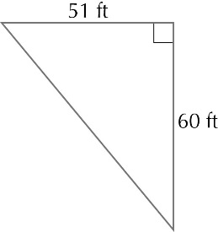**1**

**2** 50°

**3** 56°

**4** 63°

**5** **a** Check pupils’ drawings. **b** 4 cm **c** 400 m

**6** 17 cm

|  |
| --- |
| **Chapter 14: Answers to Practice** |

1 a half **b** less than a third **c** more than a quarter

2 **a** 567 **b** 161

3 **a** 5.19 m **b** 22.65 km

4 

5 £55.50

6 134.4

7 **a i** about 25% **ii** about 45%

**b i** about 30% **ii** about 60%

8 82 kg

9 £106.60.

10 60%, 0.6, , 

11 a  **b**  **c** 4

12 £34

**Exercise 14B**

1 **a** 471 **b** 379 **c** 264 **d** 22

**2** **a i** 50 **ii** 48

**b** +12

**3** **a** 440 **b** 860 **c** 8 **d** 401 **e** 297

**f** 311

**4** **a i** £3.95 **ii** £6.05

**b** no, 15 p short

5 a 9 + 6 = 20 – 5

**b** 15 – 3 = 4 × 3

**c** 5 × 2 = 15 – 5 or 5 – 2 = 15 ÷ 3

**d** 8 ÷ 4 = 4 – 2 or 8 ÷ 4 = 4 ÷ 2

**6** £31.36

7 a −6 and 5 or −4 + 3 or −2 + 1 **b** −11 **c** −8 – 5 = −13

8 **a** 508.4 **b** 2.5 **c** 12.5 **d** 10.4

**9** 17 bins (with £7 left over)

**10** £18

11 a 15 **b** £56 175 **c** £80.25

12 a 52 mph **b** 4 hours 30 minutes

**Exercise 14C**

1 **a** £70 **b** 4 hours

**2** **a** *x* = 2 **b** *x* = 4 **c** *x* = 16

**3** **a** 6*x* **b** £5*y* **c** £*xy*

**4** **a** (10, 9) **b** The first number has to be even.

**5** **a** *x* + 4 **b** *y* – 2

**6 a** b *=* 2a,  = 35, *a* = 30, *b* + *c* = 75 **b** 60 kg and 15 kg

|  |  |  |
| --- | --- | --- |
|  | *n* | 4 |
| *n* | *n*2 | 4*n* |
| 4 | 4*n* | 16 |

**7 a**

**b** *n*2 + 8*n* + 16

8 **a** 4*x* – 20 **b** 11*x* + 3 **c** 5*x* + 2 **d** 17*x* + 16 **e** 5*x* + 22

9 **a i** 21 **ii** 10 **iii** 50

**b i** *z* = 3 **ii** *z* = 22 **iii** *z* = –1

**10** 6*x* + 3 = 12, *x* = 1.5

**Exercise 14D**

1 a cross added at(4, 5) **b** (3, 5), (4, 5), (5, 5) and (6, 5)

**c** The *y*-coordinate is always 5.

**2** **a** (3, 3) **b** (1, 1)

**3** **a** A(2, 1) and B(0, 3) **b** (5, 4)

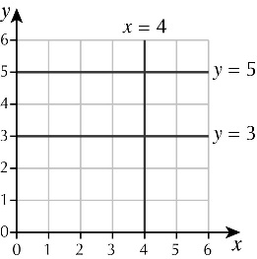**4**

**5** **a** l3 **b** l4  **c** l2 **d** l1

**6** **a** 10 minutes **b** 3.5 miles

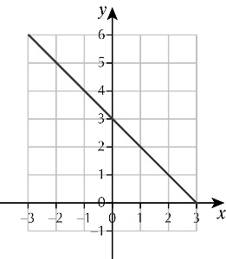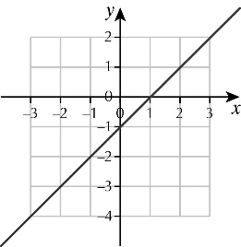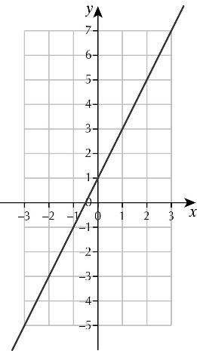**7 a**  **b c**

**8** yes, 2 × 20 – 10 = 30

**9 a ii** and **iv**

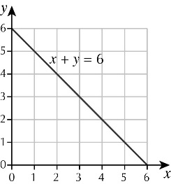 **b**

**Exercise 14E**

1 a i 2 **ii** 2

**b i** 6 **ii** 6

**c i** 0 **ii** 2

2 a i rectangle **ii** kite **iii** parallelogram

**b i** 4 **ii** 2 **iii** 2

**3** **a** 21 cm2 **b** 7.5 cm2 **c** same area as the rectangle, 21

**4 a** *a* – acute, *b* – obtuse, *c* – acute, *d* – right-angled, *e* – reflex and *f* – obtuse

**b** smaller because CD is parallel to AB and CB is not parallel to AF

|  |  |  |  |  |  |  |
| --- | --- | --- | --- | --- | --- | --- |
|  |  | Number of lines of symmetry | | | | |
|  |  | 0 | 1 | 2 | 3 | 4 |
| Order of rotational symmetry | 1 |  | A |  |  |  |
| 2 | F |  | B, C, D |  |  |
| 3 |  |  |  | G |  |
| 4 |  |  |  |  | E |

**5 a**

**b** rectangle or rhombus

**6** **a** Check pupils’ diagrams. **b** 82°

**7** *a* = 54°, *b* = 82°, *c* = 152°

**8 a** 80 **b** No, it is just over 60 mph.

**c** 50 km is approximately 31 miles, so 150 km is approximately 93 miles.

**9 a** 288 cm2**b** 4 **c** 16 : 1

**Exercise 14F**

1 **a** 13 **b** 4 **c** 18

2 **a** 7 **b** 11 **c** 2

**3 a** 

**b** (H, 1),(H, 2),(H, 3),(H, 4),(H, 5),(H, 6),(T, 1),(T, 2),(T, 3),(T, 4),(T, 5),(T, 6)

**c** 

4 **a** 2 **b** 3 **c** 4 **d** 6

5 **a** Q **b** R **c** P and R, angles are the same

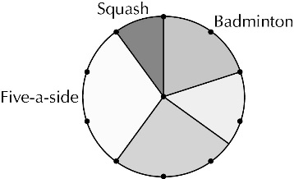**6 a**

**b i** 25% **ii**15%

**c i** 54 **ii** 36

**d** 30% of 180 = 54 and 20% of 280 = 56

**7 a** **b** 

**c i**

|  |  |  |  |  |  |
| --- | --- | --- | --- | --- | --- |
|  | | Score on first die | | | |
| 1 | 2 | 3 | 4 |
| Score on second die | 1 | 1 | 2 | 3 | 4 |
| 2 | 2 | 4 | 6 | 8 |
| 3 | 3 | 6 | 9 | 12 |
| 4 | 4 | 8 | 12 | 16 |

**ii** 1

**8** two numbers in the ratio 2 : 1, for example: 20 red and 10 blue

**9** 0.3

|  |
| --- |
| **Chapter 14: Answers to Revision** |

**Exercise 14G**

1 **a** 25 **b** 10 **c** 12 **d** 12 **e** 12

**f** 37

2 **a** 30 **b** 3 **c** 9 **d** 12 **e** 4

**f** 12

3 **a** 8 **b** 49 **c** 11 **d** 3 **e** 3

**f** 32 **g** 13 **h** 23 **i** 4 **j** 50

**k** 48 **l** 20

4 **a** 4 × (3 + 7) = 40 **b** 10 ÷ (2 + 3) = 2 **c** 18 ÷ (3 + 3) = 3

**d** (5 – 2) × 4 = 12 **e** (20 – 5) × 2 = 30 **f**  5 × (12 – 8) = 20

**g** (10 – 22) × 2 = 12 **h** 10 – (22 × 2) = 2 **i** (20 – 42) × 5 = 20

**5 a** 30 **b** 22 **c** 21 **d** 12 **e** 7

**f** 81

**Exercise 14H**

**1**

|  |  |  |  |
| --- | --- | --- | --- |
| Transaction | Amount paid in | Amount paid out | Balance |
|  |  |  | £64.37 |
| Standing order |  | £53.20 | £11.17 |
| Cheque | £32.00 |  | £43.17 |
| Direct debit |  | £65.50 | –£22.33 |
| Cash | £20.00 |  | –£2.33 |
| Wages | £124.80 |  | £122.47 |
| Loan |  | £169.38 | –£46.91 |

2 **a** 20 °C **b** 82 °C **c** 128 °C **d** 72 °C

**e** 108 °C **f** 62 °C **g** 56 °C **h** 46 °C

3 **a** 8 **b** –5 **c** –13 **d** 8 **e** 7

**f** –5 **g** –6 **h** –2 **i** 12 **j** –2

**k** –9 **l** –1 **m** –10 **n** 17 **o** 12

**p** –16

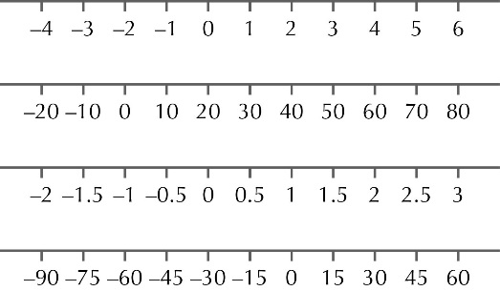**4 a**

**b**

**c**

**d**

**5 a** –2 **b** 4 **c** –3 **d** –2 **e** –9

**f** 3 **g** –15 **h** 4 **i** 7

**Exercise 14I**

1 **a** 4, 8, 12, 16, 20 **b** 9, 18, 27, 36, 45 **c** 12, 24, 36, 48, 60

**d** 25, 50, 75, 100, 125

**2 a** 3, 15, 18, 24, 36, 39, 45, 48, 69, 90, 120 **b** 15, 45, 90, 120

**c** 8, 24, 36, 48, 64, 120 **d** 24, 36, 48, 120

**3 a** 48 **b** 48 **c** 45 **d** 45

**4 a** 2, 3, 5, 7, 11, 13, 17, 19  **b** prime numbers

**5 a** 1, 2, 3, 4, 6, 8, 12, 16, 24, 48 **b** 1, 2, 4, 13, 26, 52

**c** 1, 2, 3, 4, 5, 6, 10, 12, 15, 20, 30, 60 **d** 1, 3, 5, 15, 25, 75

**e** 1, 2, 4, 5, 10, 20, 25, 50, 100 **f** 1, 2, 5, 10, 13, 26, 65, 130

**6** The numbers left are: 2, 3, 5, 7, 11, 13, 17, 19, 23, 29, 31, 37, 41, 43, 47, 53, 59. They are prime numbers.

**Exercise 14J**

1 **a** 49 **b** 81 **c** 121 **d** 169 **e** 225

**f** 361 **g** 576 **h** 625 **i** 1024 **j** 2809

2 **a** 6 **b** 8 **c** 10 **d** 12 **e** 14

**f** 6.32 **g** 8.94 **h** 10.95 **i** 22.36 **j** 28.28

3 **a** 1024 **b** 1728 **c** 28 561 **d** 9261

**4 a** 141.421 36 **b** 447.2136 **c** 1414.2136

**5 a i** 1 **ii** 1 **iii** –1 **iv** –1

**b** −1, as the power is an odd number

**Exercise 14K**

1 £4359.33

**2** £11.22

**3** 12.9 cm

**4** 0.590 kilograms

5 £252.08

**6** £9000.61

7 7.5 cm

8 £484.83

**Exercise 14L**

1 **a** £106.80  **b** £72.84  **c** £1908  **d** £1023.30

**2** £37.35

**3** £20.23

**4** 730.8 cm

5 £2312.20

**6** £125.80

7 £69.75

8 £246.60

**Exercise 14M**

1 810 words

**2** 36

**3** **a** 43 buses **b** 33 000

**4** **a** 814 **b** £5.60

5 **a** 58 **b** 4

**6** 990 grams

7 **a** £255 **b** 250 **c** £50.21

**Exercise 14N**

1 **a i** 12 cm **ii** 9 cm2

**b i** 18 cm **ii** 20 cm2

**c i** 44 mm **ii** 120 mm2

**d i** 34 m **ii** 60 m2

2 **a** 4 cm2 **b** 20 cm2 **c** 300 mm2 **d** 14 m2

3 **a** 66 cm2 **b** 96 cm2 **c** 12 m2 **d** 80 m2

4 **a i** 62 cm2 **ii** 30 cm3

**b i** 150 cm2 **ii** 125 cm3

**c i** 28 cm2 **ii** 8 cm3

**5** 20 cm2

**Exercise 14O**

1 **a** 2 **b** 2 **c** 6 **d** 4 **e** 5

2 **a** 2 **b** 1 **c** 1 **d** 4

3 **a** 2 **b** 2 **c** 5 **d** 4 **e** 2

4 **a** 4 **b** 3 **c** 4 **d** 2

5 **a** 1

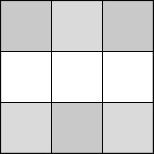 **b**

**Exercise 14P**

**1 a i** 1 **ii** 4 **iii** 8

**b i** 5 **ii** 6 **iii** 6

**c i** £4.50 **ii** £3.25 **iii** £3.40

**d i** 18 **ii** 20 **iii** 21

2 **a**

|  |  |  |  |  |
| --- | --- | --- | --- | --- |
|  | Boys | | Girls | |
|  | Tally | Frequency | Tally | Frequency |
| 12 ≤ T < 14 | | | | 2 | | | | 2 |
| 14 ≤ T < 16 | | | | | | 4 | | | 1 |
| 16 ≤ T < 18 | | | | | 3 | | | | 2 |
| 18 ≤ T < 20 |  | 0 | | | | | | 4 |
| 20 ≤ T < 22 | | | 1 | | | 1 |

**b** 14 ≤ T < 16

**c** 18 ≤ T < 20

**3** as you get older, the longer it takes to finish, or good positive correlation

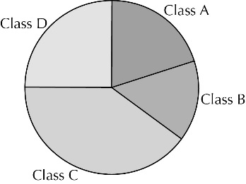**4 a**

**b** There may be a different number of pupils in the two classes.

**Exercise 14Q**

1 **a**   **b**   **c**   **d** 

2 **a** 4: HH, HT, TH, TT  **b**   **c**   **d** 

3 **a**   **b** 

**c** Not fair: you would expect the spinner to land on each number about 10 times.

|  |
| --- |
| **Answers to GCSE-type questions** |

1 **a** 27 and 73  **b** 15 and 55 **c** 27 and 72 **d** 42

2 **a** £3.07  **b** 5

**3** 3 × 1.6 = 4.8 km, so, yes, as 4.7 km ˂ 3 miles.

**4** 19 656

**5 a** 17 and 81

**b i** 69 **ii** 81

6 **a** multiple **b** square root  **c** cube **d** factor **e** square

7 **a** 1, 2, 3, 6, 9, 18  **b** any multiple of 10  **c** 15

**d** 

8 **a** 16 °C **b** 4 °C

9 **a** 14, 77, 104, 140, 147  **b** –8, –4, –2, 0, 2

**c** 0.09, 0.091, 0.9, 0.901, 0.91 **d** , 0.55, 60%, 

**10** no, 6² = 6 × 6 = 36

**11 a**

|  |  |  |  |
| --- | --- | --- | --- |
|  | Theme Park | Blackpool | Total |
| Boys | 25 | 18 | 43 |
| Girls | 17 | 30 | 47 |
| Total | 42 | 48 | 90 |

**b i**   **ii** 

**12** 175° + 115° + 95° = 385°; the total should be 360°.

**13 a** 33 **b** an odd number

**14 a** £6.00 **b** They work out to be the same total price.

**15 a** 9 feet **b** 4.8 m

**c** 5 m is just less than 16 feet, so Helen has the higher record.

**16** 19

**17** Check pupils’ constructions.

**18 a** 5  **b** 300 cm2

**19 a i** 135 **ii** 60

**b** 160°

**c** 105