Maths Frameworking Pupil Book 2.3 Answers

**Exercise 1A**

**1 a** 1 **b** -11 **c** 8 **d** -1 **e** -7   
**f** -12 **g** -12 **h** -5 **i** -21 **j** -3

**2 a** −12 **b** −20 **c** −18 **d** 28 **e** −36 **f** −30

**g** 20 **h** 14 **i** −9 **j** −3 **k** 4 **l** −17

**m** 12 **n** −4 **o** 9 **p** 10

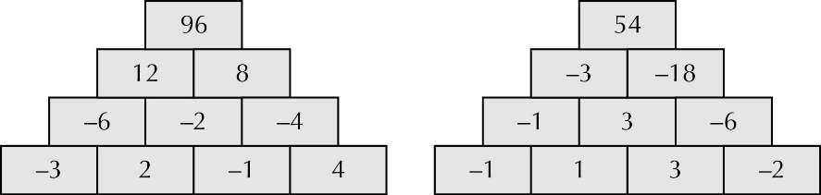**3a**

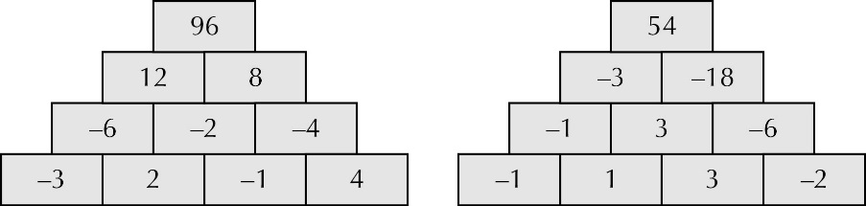 **b**

**4** for example −2 × 12, −12 × 2, 4 × −6,   
−4 × 6, −3 × 8

**5 a** −5 **b** −7 **c** −8 **d** 21

**e** 5 **f** 9 **g** 9 **h** 7

**i** −4.5  **j** −1.5 **k** −7.5 **l** −4.5

**m** 7.5 **n** −10 **o** 10.5 **p** 10

**6 a** −63  **b** 6 **c** −13 **d** 60

**e** 63 **f** 11 **g** −2 **h** 4

**i** −36 **j** 4 **k** −1 **l** −48

**m** −4 **n** −15 **o** −3.2

**7 a** **i** 1 **ii** 25 **iii** 49 **iv** 81

**b** Because same sign multiplied gives positive, but a negative always comes from different signs, hence no square root of a negative number

**8 a** 48 **b** 75 **c** −3 **d** −4

**e** −20 **f** −9 **g** −12 **h** −12

**9 a** 3 × (−6 + 2) **b** (−3 + −4) × 2

**c** 8 – (4 − 1)

**10 a** −2 × −2 × −2 **b** −3 × −3 × −3

**c** −5 × −5 × −5

**Challenge: Multiplication square**

|  |  |  |  |  |
| --- | --- | --- | --- | --- |
| × | 3 | 5 | −6 | −8 |
| 2 | 6 | 10 | −12 | −16 |
| −4 | −12 | −20 | 24 | 32 |
| 7 | 21 | 35 | −42 | −56 |
| 9 | 27 | 45 | −54 | −72 |

**Exercise 1B**

**1 a** 1, 2, 4, 8, 16 **b** 1, 2, 11, 22 **c** 1, 2, 3, 4, 6, 9, 12, 18, 36

**d** 1, 3, 5, 9, 15, 45 **e** 1, 3, 5, 15, 25, 75

**2 a** 2 **b** 4 **c** 9 **d** 15

**3** 5s and 7s

**4 a** 1, 2, 4, 8, 10, 20, 40 **b** 1, 2, 3, 4, 6, 9, 12, 18, 36

**c** 1, 2, 5, 10, 25, 50 **d** 1, 2, 3, 5, 6, 10, 15, 30

**e** 1, 2, 4, 5, 10, 20, 25, 50, 100 **f**  1, 2, 3, 4, 6, 12, 24

**g** 1, 3, 9 h 1, 2, 5, 10 **h** 1, 2, 5, 10

**5 a** 6 **b** 12 **c** 8 **d** 20 **e** 14 **f** 12 **g** 9 **h** 9

**6 a** 40 **b** 18 **c** 8 **d** 56 **e** 30 **f** 72 **g** 20 **h** 75

**7 a**  **b**  **c**  **d**  **e**  **f**  **g** **h**

**8 a** 10 **b** 12 **c** 16 **d** 14 **e** 50 **f** 15 **g** 18 **h** 17

**9** 7 groups of 8

**10** 50 cm

**11** 16 and 80 or 32 and 96

**Challenge: Remainders**

**A** 49

**B** 499

**C** 4999

**D** 49 999

**Exercise 1C**

**1 a** 18 **b** 40 **c** 42 **d** 144

**e** 45 **f** 48 **g** 50 **h** 42

**2 a**  **b**  **c**  **d** 

**3 a** 12 **b** 60 **c** 168 **d** 504

**e** 24 **f** 240 **g** 126 **h** 72

**4** 672

**5** 90 seconds

**6** 120 cm

**7** six

**8 a** 3, 54 **b** 4, 24 **c** 5, 75

**9 a i** 1, 40 **ii** 1, 63 **iii** 1, 39

**b** There is no common factor other than 1.

**10 a i** 5, 15 **ii** 9, 27 **iii** 5, 35

**b** It’s a multiple of the smaller.

**11 a** 189, 3, 63; 22, 3, 84; 432, 6, 72

**b** The product is also the product of the HCF and the LCM.

**Investigation: Triangular numbers**

**A** True

**B** True

**C** True

**D** True

**E** True

**Exercise 1D**

**1**

|  |  |  |  |  |  |  |  |  |  |
| --- | --- | --- | --- | --- | --- | --- | --- | --- | --- |
| 16 | 25 | 36 | 49 | 64 | 81 | 100 | 121 | 144 | 169 |
| 64 | 125 | 216 | 343 | 512 | 729 | 1000 | 1331 | 1728 | 2197 |

**2 a** 3 **b** 5 **c** 8 **d** 11 **e** 13

**f** 2 **g** 4 **h** 6 **i** 9 **j** 11

**3 a** −7, 7 **b** −13, 13 **c** −9, 9 **d** −1.1, 1.1 **e** −15, 15

**f** −1.2, 1.2 **g** −1.3, 1.3 **h** −20, 20

**4 a** 289 **b** 4913 **c** 361 **d** 6859 **e** 529

**f** 12 167 **g** 3.61 **h** 6.859 **i** 19.683 **j** 12.25

**k** 3375 **l** 2.744

**5 a** 32 **b** 729 **c** 243 **d** 128 **e** 102 **f** 125

**g** 1296 **h** 343 **i** 2187 **j** 1024 **k** 4096 **l** 177 147

**6 a** 2500 **b** 64 000 **c** 216 000 **d** 24 300 000  **e** 6400 **f** 27 000 000

**7** 104, 106, 108

**8 a i** 1 **ii** 1 **iii** 1 **iv** 1 **v** 1 **b** 1

**9 a i** 1 **ii** −1 **iii** 1 **iv** −1 **v** 1 **b i** −1 **ii** 1

**10 a,b** 1, 64, 729, 4096

**Investigation: Square numbers**

**A** None

**B** None

**C** None

**D** 144, 3844, 7744

**E** None: no square number ends in a double digit apart from 44

**Exercise 1E**

**1 a** 18 **b** 60 **c** 90 **d** 540 **e** 1800

**f** 45 **g** 350 **h** 315

**2 a** 22 × 3 × 7 **b** 22 × 3 × 5 **c** 22 × 32 **d** 24 × 3 **e** 22 × 13

**f** 22 × 11 **g** 32 × 5 **h** 23 × 32 **i** 23 × 3 × 5 **j** 2 × 3 × 52

**3 a** 24 × 32 **b** 2 × 32 × 5 **c** 35 **d** 2 × 52 × 7 **e** 2 × 32 × 52

**4 a** 23 × 52 **b** 2 × 52 **c** 23 × 53 **d** 26 × 56

**5 a** 6, 360 **b** 10, 450 **c** 12, 336

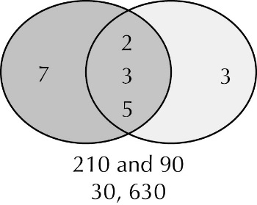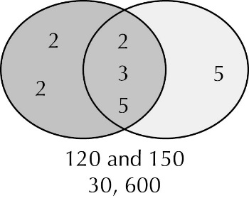**6 7**

**8**

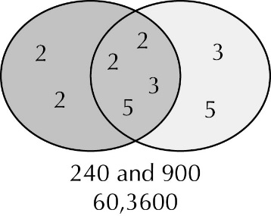

**9 a** 25, 1400 **b** 8, 2520 **c** 21, 210

**10 a** 280 **b** 532 **c** 288

**Challenge: Factors**

**A** 1, 2, 3, 4, 5, 6, 10, 12, 15, 20, 30, 60; for example 84 and 96

**B** 1, 2, 3, 4, 6, 9, 12, 18, 36; 4, 9, 16, 25, 49, 64, 81; all square numbers

**C** 247, 364, 481, 832

**Chapter 1: Answers to Review Questions**

**1 a** −3, 5 **b** 3, −5 **c** −5

**2 a** 32, 24, 52, 33 **b** 78 125

**3** 37, 41, 43

**4** 2.5

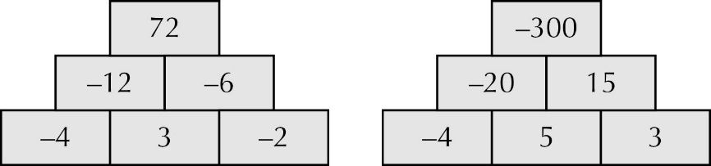**5**

Note that in the brick wall on the right, the bottom row could also be 4, −5, −3

**6 a** 144 m **b** 3 m

**7 a** All cube numbers **b** £27, 8 cm tall, 1 cm cube; £125, 64 cm tall, 27 cm cube

**8 a** 24 × 3 × 5 **b** 24 × 33 **c** 48 **d** 2160

**9 a** 9.8 **b** 90 **c** Yes, −2 × 8 = −16, no square root of a negative number

**Chapter 1: Answers to Challenge – Blackpool Tower**

**1** 1994

**2** 2 years 8 months

**3** 17

**4** 1974

**5** 7111 gallons

**6** 24 °C

**7 a**  **b** 2p

**8** ≈ 1786

**9 a** The Eiffel Tower, by 61p **b** 2 times **c** 10 times **d** 5 years

**10** 96 years

**11** 158 m

**12** 14

**13** 793 times

**14** 3580 miles

**15** 437 cm²

**16** £78 840

**17 a** 190 000 000 cm³ **b** 6.57 m

**18** No, you can only see a distance of 39.5 km

**Exercise 2A**

**1 a** *a* = 70° **b** *b* = 75°, *c*= 85°

**c** *d* = 90°, *e* = 42°

**d** *f* = 65°, *g* = 115°, *h* = 65°, *i* = 115°

**e** *j* = 98°, *k* = 33°, *l* = 147°, *m* = 98°

**f** *n* = 35°, *o* = 83°, *p* = 118°, *q* = 118°

**2 a** 80° **b** 20° **c** 15° **d** 45° **e** 10°

**3 a** 128° **b** 30° **c** 20° **d** 15° **e** 25°

**4**

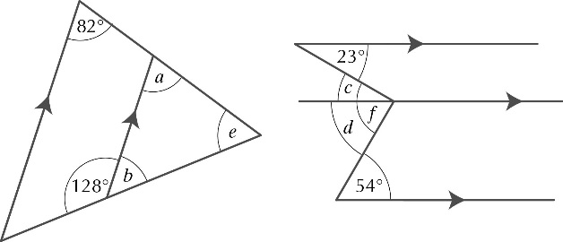

*a* = 82°

*a* = 82°

(corresponding angles)

*b* = 52°

(angles on a line)

so *e* = 46°

*a* = 82°

(corresponding angles)

*b* = 52°

(angles on a line)

so *e* = 46°

(corresponding angles)

*b* = 52°

split angle *f* into angles *c* and *d*

*c* = 23° (alternate angles)

*d* = 54° (alternate angles)

so *f* = 77°

**5** *a* = 122°, *b* = 58°, *c* = 122°

**6 a** 48° **b** 70° **c** 115°

1. Let the angle adjacent to *x* be *z*.

Then *x + z =* 180°(angles on a line) and *z = y* (corresponding angles).

So *x + y =* 180°

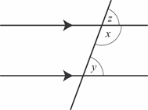

1. Draw in the diagonal AD. Then *a = c* (alternate angles) and *b = d* (alternate angles).

So *a + b = c + d*, or ∠A = ∠D

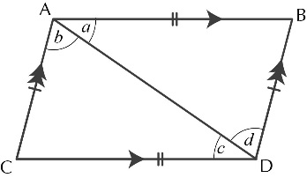

**Exercise 2B**

**1**

|  |  |  |  |  |  |
| --- | --- | --- | --- | --- | --- |
|  |  | **Number of lines of symmetry** | | | |
|  |  | **0** | **1** | **2** | **4** |
| **Order of rotational symmetry** | **1** | Trapezium | Kite, Arrowhead |  |  |
| **2** | Parallelogram |  | Rectangle, Rhombus |  |
| **4** |  |  |  | Square |

**2 a** A square has 4 right angles; a rhombus has no right angles.

**b** A rectangle has 4 right angles; a parallelogram has no right angles.

**c** A trapezium has only one pair of parallel sides; a parallelogram has two**.**

**3** Rectangle, parallelogram, rhombus

**4** Square, rectangle, trapezium, kite, arrowhead

**5** Draw the line of symmetry AC on the kite. So triangle ADC is identical to triangle ABC. So ∠*p* = ∠*q*.

**6** Triangle ABX is equilateral with ∠BAX = 60°. So ∠DAX = 30°; Triangle ADX is isosceles, so ∠ADX = 75° and ∠XDC = 15°; Triangle DXC is isosceles, so

∠DXC = 150°.

**7** Triangle AXY is isosceles with ∠ XAY = 45°. So ∠ AXY = 67°. In triangle BYX, ∠YBX = 45° and ∠XYB = 112°. So ∠BXY = 22° So ∠ AXY = 3 × ∠BXY

**Investigation: Rectangles into squares**

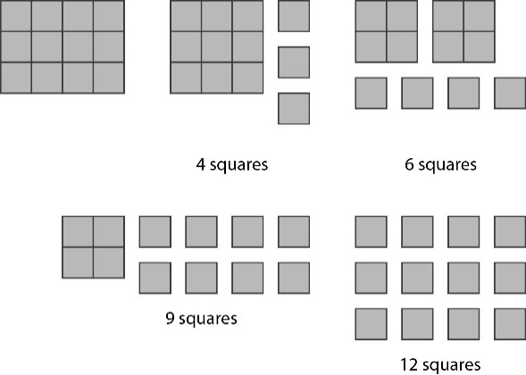For example**,** for a 4 by 3 rectangle, 4 different ways

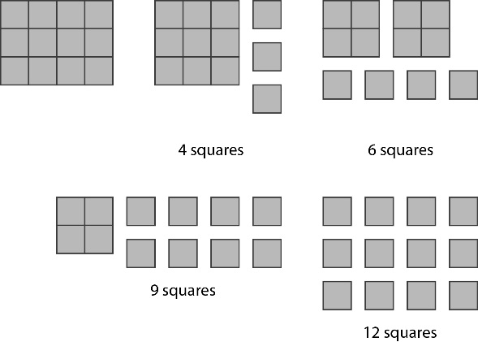

**Exercise 2C**

**1 a** 6 units right

**b** 3 units left and 3 units down

**c** 7 units right and 1 unit up

**d** 7 units right and 5 units down

**e** 3 units left and 3 units up

**2 a** A(1, 4), B(4, 2), C(1, 2)

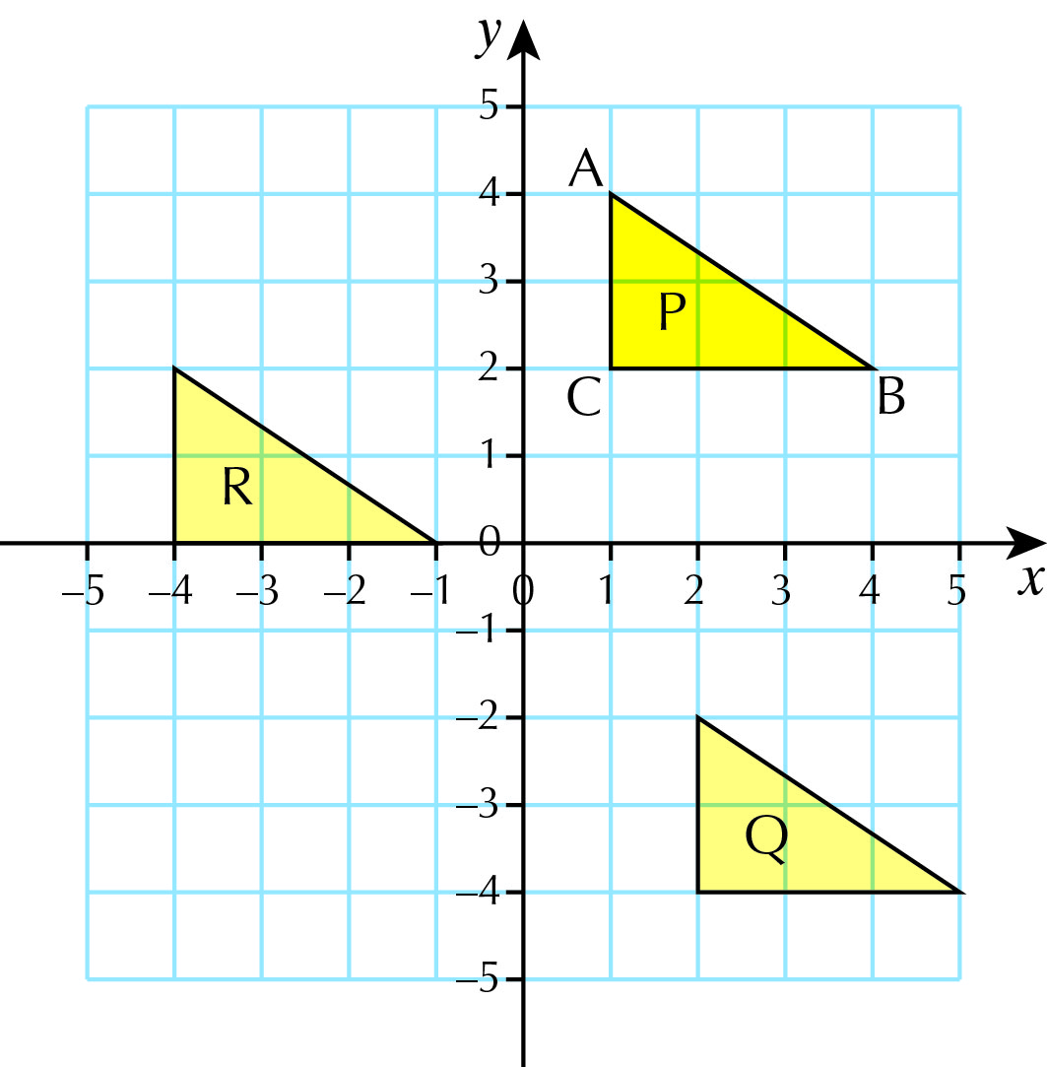 **b** and **d**

**c**  (2, –2), (5, –4), (2, –4)

**e** (–4, 2), (–1, 0), (–4, 0)

**f** 5 units right and 2 units up

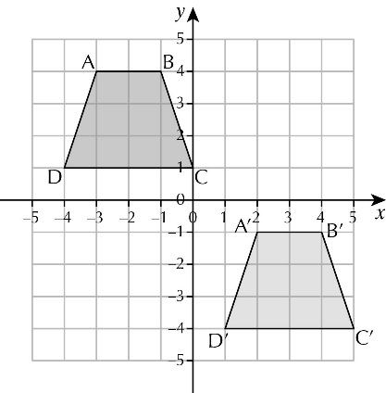**3 a**

**b** A' (2, –1), B' (4, –1), C' (5, –4),

D' (1, –4)

**c** Only the position has changed. The size and orientation of the trapezium have stayed the same.

**4 a** A (−3, 4), B (−1, 4), C (−2, 1), D (−4, 1)

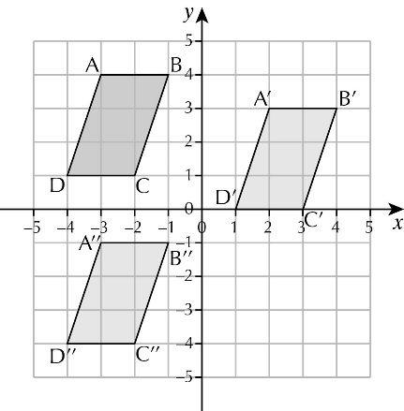 **b** and **d**

**c** A' (2, 3), B' (4, 3), C' (3, 0), D' (1, 0)

**e** A'' (−3, −1), B'' (−1, −1), C'' (−2, −4),   
D'' (−4, −4)

**f** Translation 5 units up

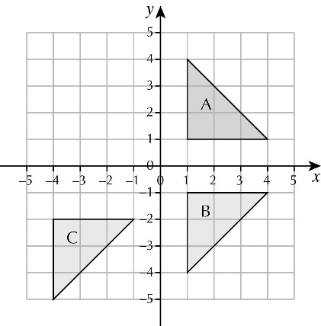**5 a** and **b**

**c** Translate triangle C 5 units right and 1 unit up back to triangle B and then rotate triangle B through 90° anticlockwise about the origin *O* back to triangle A.

**6 a** 3 **b** 8 **c** (*n* – 1)2 – 1

**Activity: Translations and vectors**

**A a**  **b**  **c**  **d** 

**e**  **f** 

**B a**  **b**  **c** 

**Exercise 2D**

**1 a** D **b** C: 4 × 5 cm = 20 cm,

but 4 × 9 cm = 36 cm

**2** Pupils’ own answers

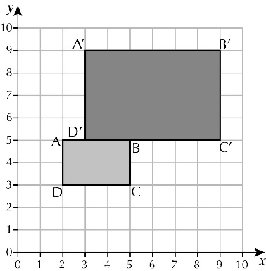**3 a, b**

**c** A’(3, 9), B’(9, 9), C’(9, 5), D’(3, 5)

**d** Double each coordinate and subtract 1

**4 a** Vertices at (8, 6), (8, 2), (4, 2)

**b** Vertices at (4, 6), (8, 4), (4, 2), (0, 4)

**c** Vertices at (3, 9), (6, 9), (6, 6), (9, 6), (9, 9), (12, 9), (12, 3), (3, 3)

**d** Vertices at (0, 8), (8, 8), (8, 12), (12, 6), (8, 0), (8, 4), (0, 4)

**5 a** 2 cm2

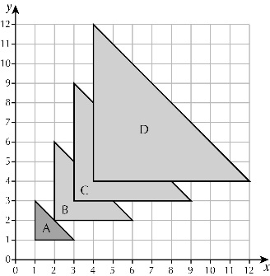**b ii** 8 cm2 **iii** 4

**c ii** 18 cm2 **iii** 9

**d ii** 32 cm2 **iii** 16

**e** It is the square of the scale factor

**6 a** 4 **b** 2 **c** 1 **d** 1

**7** *x* = 6

**Reasoning: Finding the centre of an enlargement**

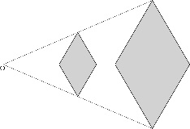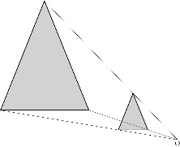**A a b**

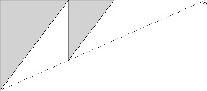 **c**

**B** Scale factor = 2; centre of enlargement = (10, 0)

**Exercise 2E**

**1 – 4** Pupils’ own answers

**5 a** and **b**

On the perpendicular draw a line CD 5cm long with mid-point A, XCYD is a rhombus

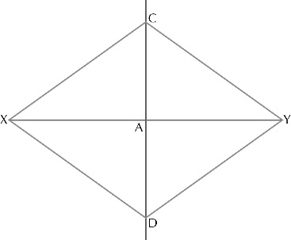

**6 – 9** Pupils’ own answers

**10 b** 9.5 m **c** 73°

**11** 7.1 cm (construct the perpendicular from C to XY)

**Reasoning: Constructing angles**

**A** bisect ∠ YAX to get an angle of 30°

**B** bisect the 30° angle to get an angle of 15°

**C** Construct an angle of 90° and then construct an angle of 15° on one of the sides.

**Chapter 2: Answers to Review Questions**

**1** **a** A translation of 3 units right and 3 units up

**b** A reflection in the *y*-axis

**c** A rotation of 180° about the origin

**d** A rotation of 90° clockwise about the origin

**e** A translation of 2 units left and 3 units down

**2** *a*=115° (alternate angles)

*b*=54° (corresponding angles)

*c*=39° (allied angles)

*d*=96° (corresponding angles)

**3** Construct a perpendicular from C and then bisect the 90° angle

**4**

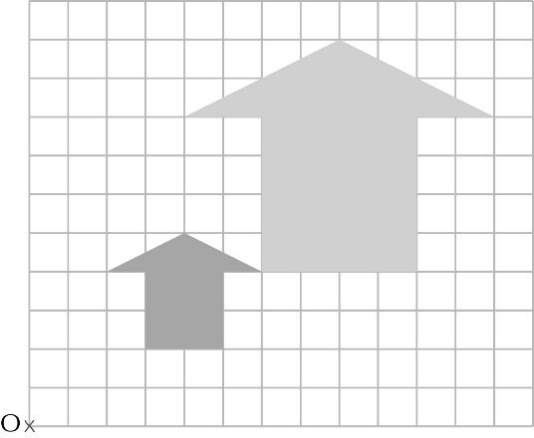

**5** Draw the perpendicular bisector of XY.

**6 a** 24° **b** 36°

**7** The four interior angles are 180° – *a*, 180° – *b,* 180° – *c* and 180° – *d*

these angles sum to 360°, so 180° – *a* + 180° – *b +* 180° – *c* + 180° – *d =* 360°

720° – *a* – *b* – *c* – *d =* 360°. So *a* + *b* + *c* + *d* = 360°

**Chapter 2: Answers to Challenge – More Constructions**

Check pupils’ constructions

**Exercise 3A**

**1 a** **b** No, 5 is common to both. **c** 

**2 a b** No, 11, 13, 17 and 19 are in both. **c**

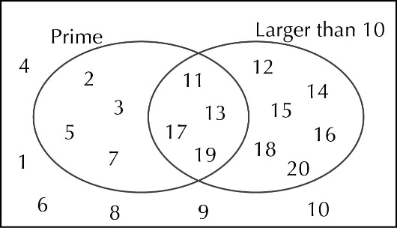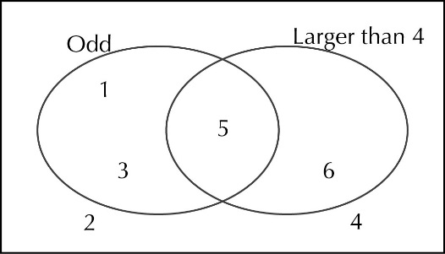

**3** b, d, g and j are mutually exclusive, all the rest are not.

**4 a** 0.4 **b** 0.3 **c** 0.95 **5 a**  **b**  **c**  **d** 

**6 a** 0.55 **b** 0.45 **c** 0.75 **d** 0.25

**7 a** 5p, 10p, 15p, 50p, 55p, 60p, 65p **b** More likely to lose more as the probability is 4/7

**8 a** 35p, 65p, 75p, 80p, £1.15, £1.25, £1.30, £1.55, £1.60, £1.70, £2.15, £2.25, £2.30,

£2.55, £2.60, £2.70, £3.05, £3.10, £3.20, £3.50

**b** More, there are 9 ways to get less and 10 ways to get more.

|  |  |  |
| --- | --- | --- |
| 2 | 4 | 6 |
| −1 | −2 | −3 |
| −1 | −3 | −4 |
| −1 | 4 | 3 |
| −3 | −2 | −5 |
| −3 | −3 | −6 |
| −3 | 4 | 1 |

**9 a**

**b** Negative, as 5 negatives and only 3 positives **c** odd, as 5 odd and only 3 even

**10 a** No, as another colour may just not have yet appeared

**b** i and iii

**Challenge: Choose a winner**

The 5 × 5 as it has the highest probability of 0.28, the 6 × 6 has 0.278 and the 10 × 10 has 0.27.

**Exercise 3B**

**1 a** H, 1; H, 2; H, 3; H, 4; H, 5; H, 6; T, 1; T, 2; T, 3; T, 4; T, 5; T, 6

**b i** **ii**  **iii** 

**2 a** B, B; B, G, G, B; G, G

 **b** Because there are four possible ways of choosing, so should it be

**3 a** GC, GP, CP

**b** There are more plums than cherries.

|  |  |  |  |  |
| --- | --- | --- | --- | --- |
| **4** | **a** | | plain | extra cheese |
|  | |  | meat | plain |
|  | |  | meat | meat |
|  | |  | meat | extra cheese |
|  | |  | extra cheese | plain |
|  | |  | extra cheese | meat |
|  | |  | extra cheese | extra cheese |

|  |  |  |  |  |  |  |  |  |
| --- | --- | --- | --- | --- | --- | --- | --- | --- |
| **5** | **a** | + | 1 | 2 | 3 | 4 | 5 | 6 |
|  |  | 1 | 2 | 3 | 4 | 5 | 6 | 7 |
|  |  | 2 | 3 | 4 | 5 | 6 | 7 | 8 |
|  |  | 3 | 4 | 5 | 6 | 7 | 8 | 9 |
|  |  | 4 | 5 | 6 | 7 | 8 | 9 | 10 |
|  |  | 5 | 6 | 7 | 8 | 9 | 10 | 11 |
|  |  | 6 | 7 | 8 | 9 | 10 | 11 | 12 |

**b i**  **ii**   **iii**  **iv**  **v**  **vi** 

**vii**  **viii** 

**b** 7

**c i**  **ii**  **iii** 0 **iv**  **v** 

**vi**  **vii**  **viii**  **ix**  **x** 

**6 a**

|  |  |  |  |  |  |  |
| --- | --- | --- | --- | --- | --- | --- |
| × | −2 | −1 | 0 | 1 | 2 | 3 |
| −3 | 6 | 3 | 0 | −3 | −6 | −9 |
| −2 | 4 | 2 | 0 | −2 | −4 | −6 |
| −1 | 2 | 1 | 0 | −1 | −2 | −3 |
| 0 | 0 | 0 | 0 | 0 | 0 | 0 |
| 1 | −2 | −1 | 0 | 1 | 2 | 3 |
| 2 | −4 | −2 | 0 | 2 | 4 | 6 |

**b** 0 **c** 

**7** 

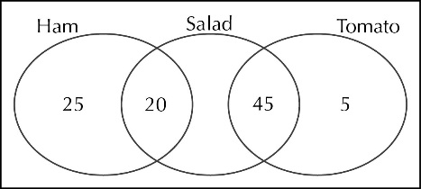**8 a**

**b** 

**Problem solving: T-shirts and shorts**



**Exercise 3C**

**1 a** 0.1, 0.09, 0.082   
**b**0.082 – based on more items

**2 a** Carry out more trials **b** 208 **c** 167

**3 a**

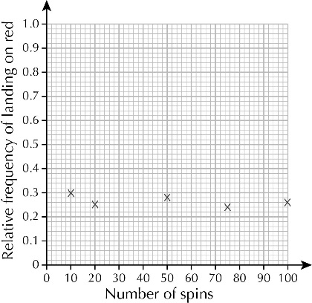

**b** 260 **c** No, would expect it to land on red around 333 times

**4 a** 0.32 **b** Yes, would expect all the frequencies to be close to 25 **c** 160

**5 a** 0.65, 0.67, 0.6, 0.64 **b** 0.64 **c** 128

**6 a** 0.32, 0.3, 0.28 **b** 0.28 **c** 21

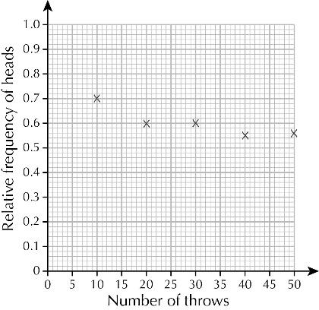**7 a** 0.6, 0.6, 0.55, 0.56

**b**

**c** 0.56

**d** 112

**e** Yes, would expect a probability of 0.5

**8 a** 3, 4, 6, 7

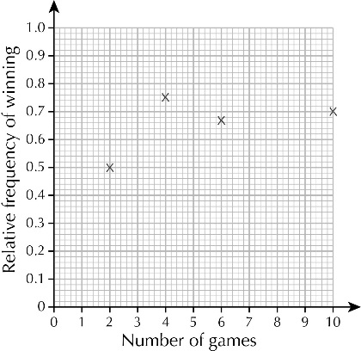 **b**

**c** We only know that it was one of the first two games.

**d** 0.7

**Problem solving: Darts**

**A** 6

**B** 0.65

**C** 65 (accept any reasonable assumptions, for example: throwing from the same

distance, same size of target)

**D** We don’t have the relative frequency

for 15.

**Chapter 3: Answers to Review questions**

**1 a**  **b**  **c** 

**2 a** , , , , , , , , , , , , , , 

**b** 

**3 a** 4% **b** 

**4 a** 0.73 per journey **b**  **c** 7

**5 a** Blue would be 2.5 counters and green would be 22.5 counters.

**b** 1, 6, 9, 4

**6** No, her experimental probability is 55%, which is less than 56%.

**7 a** 0.89, 0.85

**b** Ravi – twice the number of seeds

**Chapter 3: Answers to Financial Skills – Fun in the fairground**

**1** £160

**2** **a**  **b**  **c** 

**3** **a**  **b** 

**4** **a** £6.25 **b** 

**5 a** 4 watches, 16 £10 notes and 8 £1 coins **b** £625 **c** £385

**6 a**  **b**  **c** 

**7** 

**8 a** 5 **b** £2

**9 a** 250 **b** 5 or 6 **c** 50

**10 a** 625 **b** 14 **c** 125 **d** 486 **e** £137.94

**Exercise 4A**

**1** Test 1: 80%, Test 2: 74%, Test 3: 70%; Test 1 is the best mark

**2** **a** 60% **b** 30% **c** 20% **d** 15%

**3** **a** 15% **b** 90% **c** 85%

**d** 30% **e** 24.9% **f** 0.5%

**4** **a** 4% **b** 60% **c** 10% **d** 65%

**5** **a** 40% **b** 40% **c** 4%

**d** 60% **e** 29% **f** 10%

**6** **a** 40% **b** 92% **c** 120%

**d** 160% **e** 180%

**7** **a** 150% **b** 120% **c** 160% **d** 250%

**8 a** 47.1% **b** 5.7% **c** 92.0%

**d** 88.2% **e** 8.8% **f** 63.6%

**9** **a** 66.7 % **b** 150% **c** 59.6%

**d** 167.9% **e** 7.5% **f** 1333%

**10** **a** 13.5% **b** 6.6%

**11** **a** 1.9% **b** 18.7% **c** 186.5%

**12** **a** 34.0% **b** 43.1%

**c** Increased by 9.1 which is 26.8%

**13** **a** 24.7% **b** 19.8%

**14 a i** 39.3% **ii** 60.7% **b** 64.8%

**15 a** 40.8% **b** 244.9%

**16 a** 19.9% **b** 39.7%

**17 a i** 78.1% **ii** 20.9% **iii** 0.9% **b** 26.8%

**Challenge: Waste percentages**

|  |  |  |  |
| --- | --- | --- | --- |
| **A** | **Type of waste** | **Smith family** | **Jones family** |
|  | Kitchen scraps | 31.4% | 31.8% |
|  | Plastics | 10.1% | 6.6% |
|  | Card or paper | 6.1% | 5.0% |
|  | Other | 52.4% | 56.5% |

**B** The Smith family because the percentage of their total waste is higher

**C** Compound bar chart, for example:

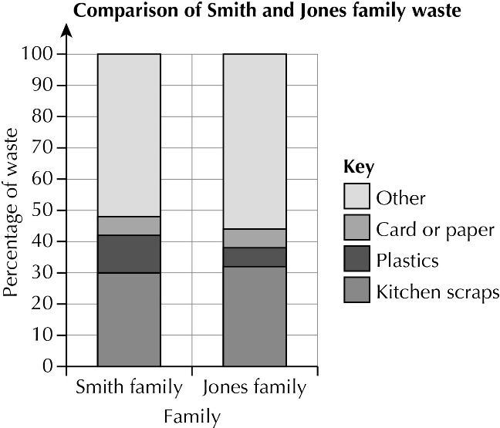

**Exercise 4B**

**1** £105.60

**2** **a** £38.40 **b** £73.20 **c** £220.80 **d** £11.28

**3** **a** 1.3 **b** 1.7 **c** 1.99 d 2.0 **e** 2.2

**4** **a** £51.75 **b** £65.25 **c** £83.25 **d** £87.75

**5** **a** £16.25 **b** £52.83 **c** £299.14 **d** £4346.82

**6 a** 49.56 kg **b** 57.12 kg **c** 75.18 kg  **d** 87.36 kg **e** 119.7 kg

**7 a** 442.9 cm **b** 872.9 cm **c** 670.8 cm **d** 1100.8 cm **e** 1530.8 cm

**8 a** £53.55 **b** £44.63 **c** £222.70 **d** £50.99

**9 a** 0.65 **b** 65%

**10 a** £77.40 **b** £20.70 **c** £11.70 **d** £48.72

**11 a** £49.53 **b** 84.68 kg **c** 50.96 minutes **d** 5.135 litres **e** 686 m **f** 140 hours

**12 a** 71 380 **b** 100 620 **c** 186 620 **d** 272 620

**Financial skills: Percentage reduction**

|  |  |  |  |  |
| --- | --- | --- | --- | --- |
| **A** | **Normal price** | **Price after a 10% reduction** | **Price after a 30% reduction** | **Price after a 65% reduction** |
|  | £70 | £63 | £49 | £24.50 |
|  | £95 | £85.50 | £66.50 | £33.25 |
|  | £145 | £130.50 | £101.50 | £50.75 |
|  | £420 | £378 | £294 | £147 |

**B** Yes, it is. **C** No, because the percentage is lower people could think the price is lower.

**Exercise 4C**

**1** **a** 368 ÷ 320 = 1.15 **b** 15%

**2** 60%

**3** 46%

**4** 147.5%

**5** 114.3%

**6** 10.4%

**7** 122.6%

**8** **a** 0.956 **b** 4.4%

**9** 13.7%

**10** **a** 58% **b** 31% **c** 12.2%

**11** **a** 12.5% decrease **b** 11.4% increase **c** 239% increase **d** 58.5% decrease

**12** 3.4%

**13** Red Party: 92.7% increase; White Party: 72.6% decrease; Blue Party: 8.8% decrease

**14** **a** **i** 10% **ii** 10.3% **iii** 19.3% **b** 2 hours 54 minutes (and 24 seconds)

**15** **a** 8 cm **b** 12.8 cm

**16** **a** £33 280 **b** £34 611.20

**Problem solving: Five go on a diet**

**A** Jack 88 kg, Oliver 97 kg, Charlie 113 kg, James 127 kg, George 142 kg

**B** Jack 88.4 kg, Oliver 96.8 kg, Charlie 111.9 kg, James 125 kg, George 139.1

**C** Pupils’ own answers, suitably justified, e.g. 6% because there is a big difference in the masses of the men

**Chapter 4: Answers to Review Questions**

**1** Maths 8.2%, Science 85.3%, English 78.9%; Science is the best score

**2** 50.9%

**3** 20.6%

**4** New ticket price = £25.36, £8.30 extra per week

**5** £80.15

**6** **a** 80.7% **b** 137.4%

**7** **a** 20% **b** 12.5% **c**  × 100%

**8** **a** add 21 (or 21*n*) **b** **i** 210% **ii** 67.7% **iii** 28.8% **iv** 18.3%

**9** **a** 5% **b** 10.25% **c** 15.8%

**10** Increase as a decimal = 

To turn it into a multiplier, add 1

So multiplier = 1 + 

**11** **a** 36.2% **b** 38.0%

**12** **a** 61.5% **b** £75 400

**Chapter 4: Answers to Challenge – Changes in Population**

**1 a** 19% **b** 115% **c** 1960-1970(6.3%)

**d** 1960-1970(21.4%) **e** Check pupils’ diagrams

**2 a** 98.7%, 94.2%, 28.6%, 36.6%

**b** 1901-1951; war **c** 72.4 million

**3 a i** 18.75% **ii** 12.7% **iii** 137.5%

**b** 36.5%, just under half

**4 a** 24.7% **b** 21.4% **c** 55.2% **d** 34.1%

**5 a** 19.8%, 27.3%, 36.7%, 145%

**b** Southern Asia; no, West Africa has the largest predicted percentage increase

**Exercise 5A**

**1 a** Yes **b** No **c** Yes **d** No **e** No **f** Yes

**2** A and F, B and I, D and H

**3** Shape B as it is not congruent to the others

**4 a** Two different isosceles triangles, two different parallelograms, a rectangle and a kite

**b** A parallelogram **c** A rhombus

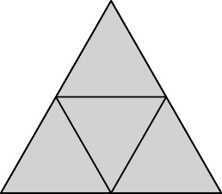**5**

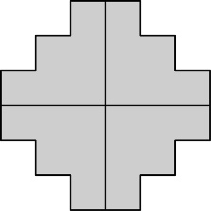**6**

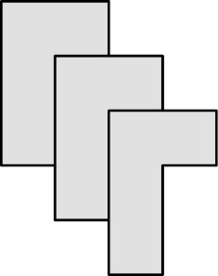**7**

**Investigation: Congruent shapes on grids**

**A** Examples of two congruent shapes:

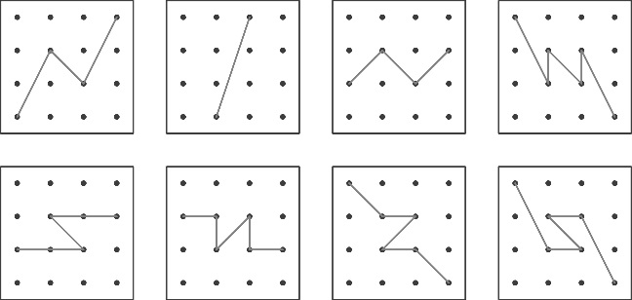

**B** Examples of four congruent shapes:

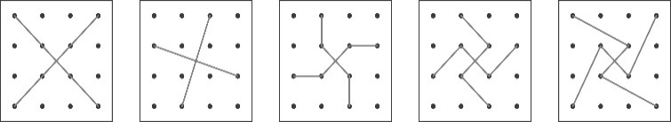

**Exercise 5B**

**1 a** ∠C = ∠D, BC = DE, AC = DF (SAS)

**b** GH = KL, GI = JL, HI = JK (SSS)

**c** ∠N = ∠R, ∠O = ∠P, NO = PR (ASA)

**d** ∠T = ∠V = 90°, SU = WX, TU = VX (RHS)

**2** ∠X = 40° (angles in a triangle), so ∠B = ∠X, ∠C = ∠Y, BC = XY (ASA)**.**

**3** Angles are the same, but no sides are given. So one triangle could be an enlargement of the other and therefore would not be congruent.AAA is not a condition for congruency.

**4** ∠ADB = ∠ADC = 90°, AB = AC, AD is common (RHS)

**5** ∆ACD ≡ ∆ABC ≡ ∆ABD ≡ ∆BCD, ∆AXB ≡ ∆CXD, ∆AXD ≡ ∆BXC

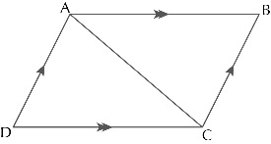**6** Draw the diagonal AC. Consider ∆ABC and ∆ACD. AC is common, AD = BC, AB = DC, so ∆ABC   
≡ ∆ACD (SSS).

Hence ∠B = ∠D.

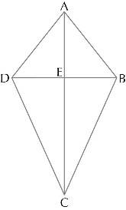 Similarly ∠A = ∠C by drawing the diagonal BD

**7 a** AC is common

AB = AD (given)

BC = DC (given), so

∆ABC ≡ ∆ADC (SSS).

**b** ∆ADE ≡ ∆ABE and

∆DEC ≡ ∆BEC

**Problem solving: Constructing triangles**

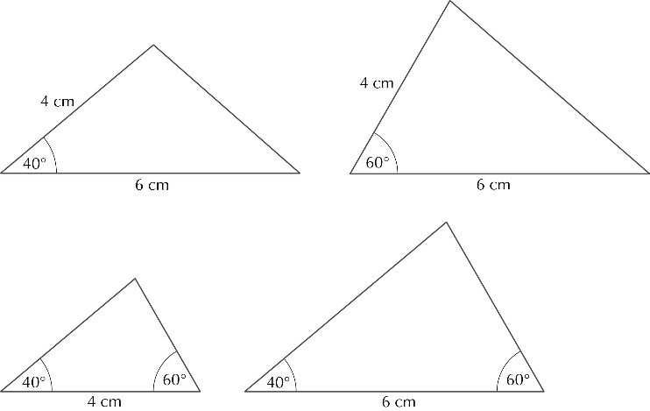

**Exercise 5C**

**1** PS is common

RS **=** PQ (given)

∠RSP = ∠QPS (alternate angles)

So ∆PRS ≡ ∆PQS (SAS)

**2** BD is common

AB = BC (given)

∠BAD = ∠BCD = 90°

So∆ABD ≡ ∆BCD (RHS)

**3** Consider ∆XYP and ∆XZP.

XP is common to both triangles

XY= XZ (given)

PY = PZ (given)

So ∆XYP ≡ ∆XZP (SSS)

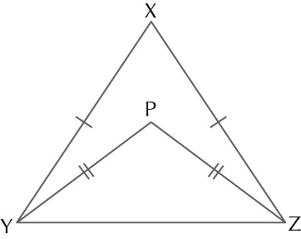Hence ∠XYP = ∠XZP

**4** Consider ∆ABD and ∆BCD.

BD is common to both triangles

AB = BC (given)

AD = CD (given)

So ∆ABD ≡ ∆BCD (SSS)

Hence ∠A = ∠C

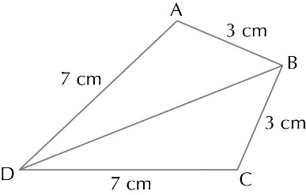

**5** AB = CD (given)

∠BAD = ∠CDA (alternate angles)

∠ABC = ∠BCD (alternate angles)

So ∆AXB ≡ ∆CXD (ASA)

**6 a** XY **b** ∠ZXY

**Challenge: Looking for congruent triangles**

**A** AO is common

∠XAO = ∠YAO (given)

∠AXO = ∠AYO = 90°

So ∆AXO ≡ ∆AYO (ASA)

Hence OX = OY

**B** ∆BZO ≡ ∆CZO

OZ is common

BZ = CZ (given)

∠BZO = ∠CZO = 90°

So ∆BZO ≡ ∆CZO (SAS)

and

∆OXB ≡ ∆OYC

∆BZO ≡ ∆CZO so OB = OC

OX = OY (proven in A)

∠OXB = ∠OYC = 90°

So ∆OXB ≡ ∆OYC (RHS)

**Chapter 5: Answers to Review Questions**

**1** B - The other three are congruent

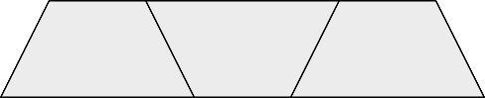**2**

**3 a** SAS **b** RHS **c** SSS **d** ASA

**4** Yes (SAS)

**5** PR = RT (given)

QR =∠ RS (given)

∠PRS = ∠QRT (opposite angles)

So ∆PRS ≡ ∆QRT (SAS)

**6** AB = CD (equal sides of a parallelogram)

∠BAC = ∠ACD (alternate angles)

∠ABD = ∠BDC (alternate angles)

So ∆AXB ≡ ∆CXD (ASA)

Hence AX = XC and BX = XD, so the diagonals bisect each other

**7 a** AB = CD (given)

∠BAD = ∠ADC (alternate angles)

∠ABD = ∠BCD (alternate angles)

So ∆ABE ≡ ∆CDE (ASA)

**b** Pupils’ own explanations

**Chapter 5: Answers to Problem Solving: Using scale diagrams to work out distances**

**1** 7.9 km or 8.0 km

**2 a** AX = DX (given)

BX = CX (given)

∠AXB = ∠CXD = 50°

So ∆AXB ≡ ∆CXD (SAS)

**b** 31 m

**3 a** BC = CD (given)

AC = CE (given)

∠BAC = ∠CED = 90°

So ∆ABC ≡ ∆CED (RHS)

**b** 13 m

**Exercise 6A**

**1 a** 700 mm2 **b** 56 000 cm2 **c** 40 000 m2 **d** 8 cm2 **e** 2 m2 **f** 4.8hectares

**2 a** 3000 mm3 **b** 8700 mm3 **c** 500 mm3 **d** 7 cm3 **e** 4 m3 **f** 0.6 cm3

**3 a** 2000 cm3 **b** 9000 *l* **c** 3400 cm3 **d** 1.5 *l* **e** 4.3 m3 **f** 0.72 *l*

**4 a** 8300 m2 **b** 7.3 cm2 **c** 1.5 m3 **d** 3700 *l* **e** 5.5 *l* **f** 240 000 cm2

**5** 1.02 ha

**6** 30 000 *l*

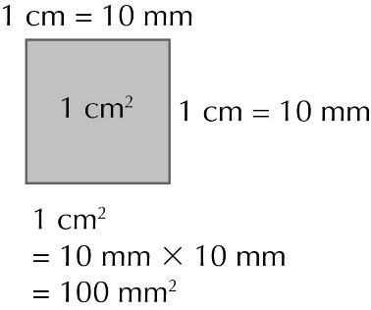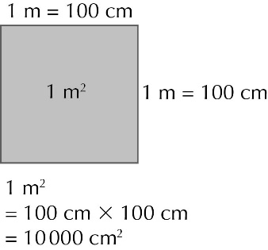**7 a**  **b**

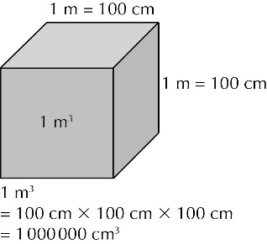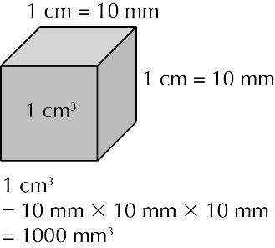 **8 a**  **b**

**Reasoning: Ares and acres**

**A a** 3.36 ha **b** 336 ares **c** 8.30 acres

**B** 161.9 ha

**Exercise 6B**

**1 a** 132 cm2 **b** 336 cm2 **c** 183 m2

**2** 996 cm2

**3** 730 cm2

**4** 589.2 cm2

**5 a** 21 690 cm2 **b** 21 690 cm2 = 2.169 m2, so yes

**6 a** 59 m2 **b** 368.4 m2

**7** 2.2 m2

**Challenge: Calculating lengths in triangular prisms**

**A** 6 cm

**B** 15 cm

**Exercise 6C**

**1 a** 864 cm3 **b** 72 m3 **c** 960 cm3

**2 a** 8400 mm3 **b** 8.4 cm3

**3** 56 cm3

**4 a** 240 000 cm3 **b** 0.24 m3

**5 a** 55 m2 **b** 825 m3 **c** 825 000 litres

**6** 6 cm

**7** 80 cm

**Problem solving: Volume of a pyramid**

**A** 75 cm3

**B** 93 cm3

**C** 18.75 cm3

**Chapter 6: Answers to Review Questions**

**1 a** 2.4 hectare **b** 9.2 cm2 **c** 46 000 cm2

**2 a** 6.5 m3 **b** 7600 *l* **c** 8.4 *l*

**3 a** 192 cm2 **b** 144 cm3

**4 a** 40 cm2 **b** 160 cm3

**5 a** 125 cm2 **b** 1150 cm2 **c** 1875 cm3

**6 a** 240 cm2 **b** 3000 cm2 **c** 8640 cm3 **d** 6.48 kg

**7** 25 cm

**Chapter 6: Answers to Investigation: A cube investigation**

**1** (Ignoring any rotations or reflections)

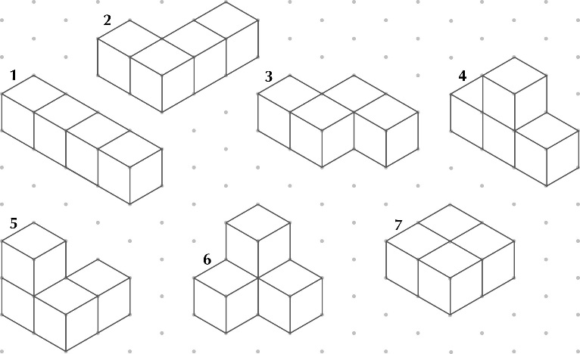

|  |  |  |  |  |  |  |  |
| --- | --- | --- | --- | --- | --- | --- | --- |
|  |  |  |  |  |  |  |  |
| |  |  |  |  |  |  |  |  | | --- | --- | --- | --- | --- | --- | --- | --- | | **3D shape** | **1** | **2** | **3** | **4** | **5** | **6** | **7** | | **Surface area** | 18 cm2 | 18 cm2 | 18 cm2 | 18 cm2 | 18 cm2 | 18 cm2 | 16 cm2 |   **2** |  |  |  |  |  |  |  |

**3** 16 cm2. Shape 7 has the least surface area and the rest have the same surface area.

The shape with the least surface area has four pairs of faces touching, so leaving 16 faces exposed. The other six have three pairs of faces touching, so leaving 18 faces exposed.

**4** A shape made from five cubes must have four or five pairs of faces touching, so the surface areas are either 20 cm2 or 22 cm2.

For all the shapes in this investigation so far, the surface area is an even number of square centimetres. Two cubes have 12 faces in total, so if one pair of faces is touching, then 10 faces are exposed. Three cubes have 18 faces in total, so if two pairs of faces are touching, then 14 faces are exposed.

A shape made from four cubes must have three or four pairs of faces touching, so either 16 or 18 faces are exposed.

**5** 22 cm2

**Exercise 7A**

**1a** *y*-values: −5, −3, −1, 1, 3, 5 **2a** *y*-values: −6, −2, 2, 6 **3a** *y*-values: 10, 8, 6, 4, 2, 0

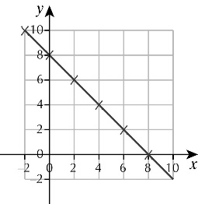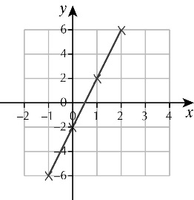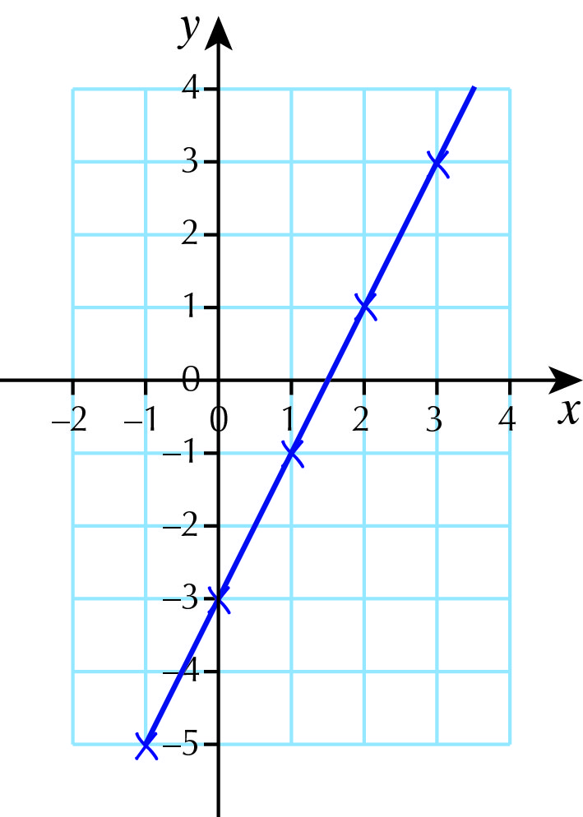 **b** and **c b** and **c b** and **c**

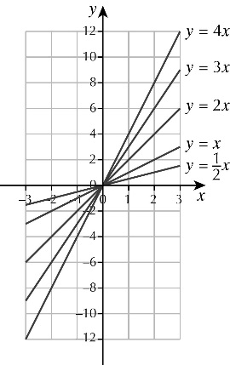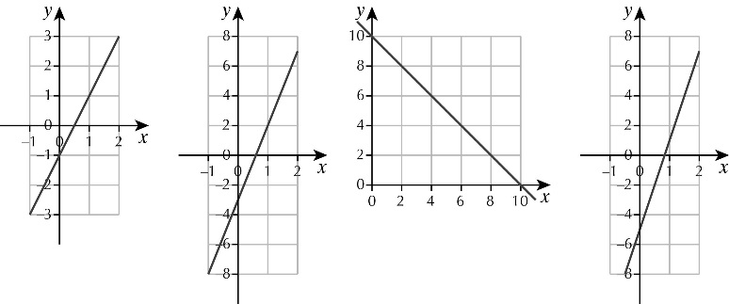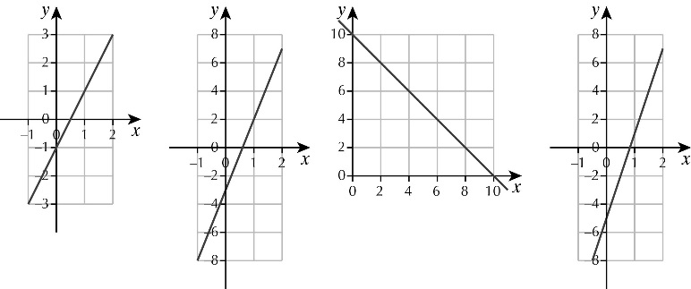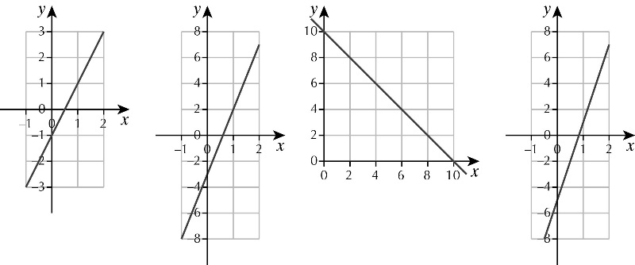**4a b c d 5a,b,d c** All pass through (0,0). As the coefficient of *x* increases, the line gets steeper.

**6a,b,d c** The lines are parallel. They cut

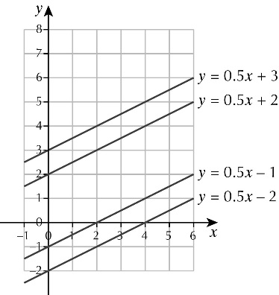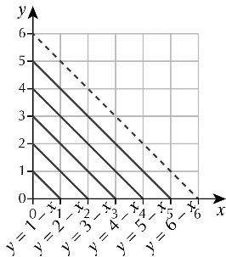 both axes at the same value. **Challenge: Sloping graphs**

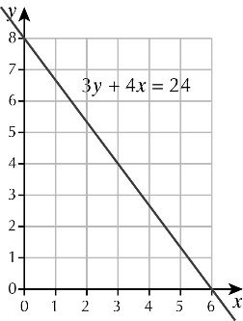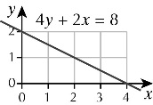 **7 8**

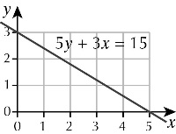 **9**

**Exercise 7B**

**1 a** 1 **b** 3 **c** 2 **d** 5

**2 a** *y* = 4*x* + 7 **b** *y* = 5*x* + 1 **c** *y* = 6*x* + 2 **d** *y* = 9*x* + 13

**3 a i** 2 **ii** 1 **b i** 3 **ii** −4 **c i** 4 **ii** 1 **d i** 5 **ii** −3 **e i** 1 **ii** 2 **f i** 0.5 **ii** 7

**4 a** (0, 1) **b** 2 **c** *y* = 2*x* + 1

**5 a** (0, −2) **b** 4 **c** *y* = 4*x* − 2

**6 a** *y* = 3*x* + 3 **b** *y* = 2*x* + 3 **c** *y* = 2*x* + 1 **d** *y* = 3*x* + 2 **e** *y* = 4*x* − 1 **f** *y* = 3*x* – 2

**Challenge: Different equations**

**A** For example: *y* = 5, *y* = *x* + 5, *y* = 3*x* + 5 etc.

**B** For example: *y* = 2, *x* = 2, *y* = *x*, *y* = 3*x* − 4 etc.

**C** For example: *y* = 7, *x* = 3, *y* = 2*x* + 1, *y* = 3*x* − 2 etc.

**Exercise 7C**

**1 a** *y*-values are 14, 9, 6, 5, 6, 9, 14

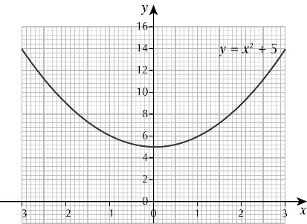 **b** and **c**

**2 a** *y*-values are 13, 8, 5, 4, 5, 8, 13

**b** and **c**

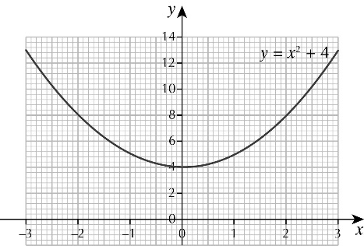

**3 a** U-shaped curves cutting through the *y*-axis at the number added to the *x*2

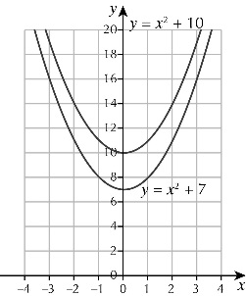**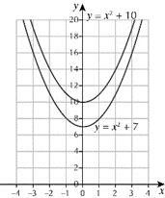**

**c** The curve will intersect the *y*-axis below the *x*-axis.

**d** Pupils’ own answers

**4 a** *y*-values are 6, 2, 0, 0, 2, 6

**b** and **c**

**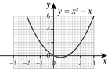**

**5 a** *y*-values are 9, 2, −1, 0, 5, 14

**b** and **c**

**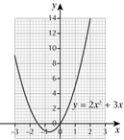**

**d** *x* = −1.8 and 0.3 **e** *y* = −1.1

**6 a** and **b** Pupils’ own answers

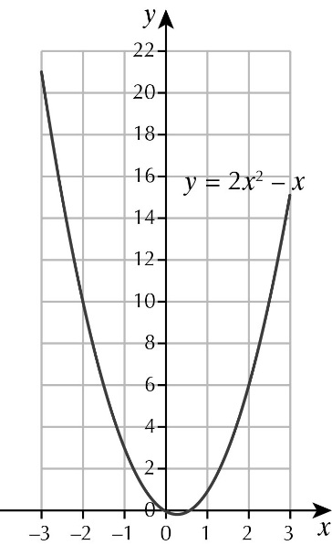 **C**

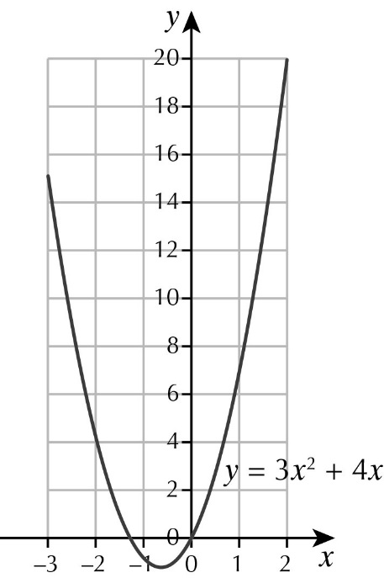**d** *x* = −1 and 1.5 **e** *y* = −0.1

**7**

**Challenge: The chase**

Pupils’ own answers

**Exercise 7D**

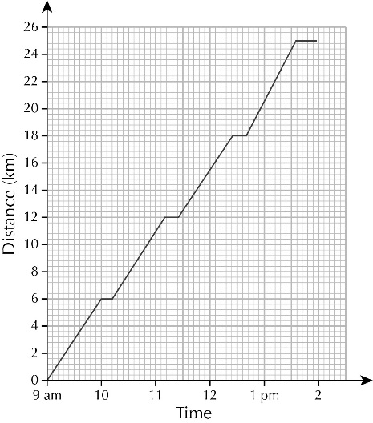**1 a** Travelled at 60km/h for 20 minutes, stopped for 10 minutes then continued at 24km/h **b** 9:00 am **c** 9:20 am

**2 a**

**b** 1:58 pm

**3** 1:05 pm

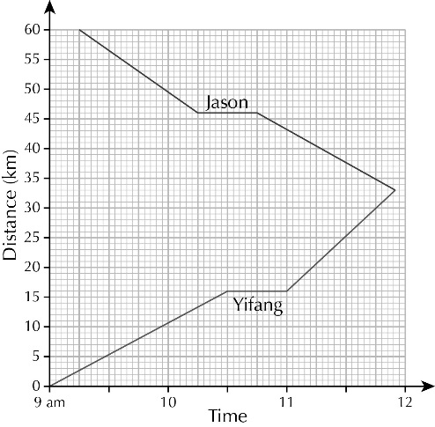**4 a**

**b** Just after five to twelve **c** Yifang

**5 a** 11:15 **b** 11:20 **c** 11:25

**6** 2 days 9 hours

**Problem solving: Meeting in the middle**

**A** 10:48

**B** Our accuracy would suggest five times Alfie

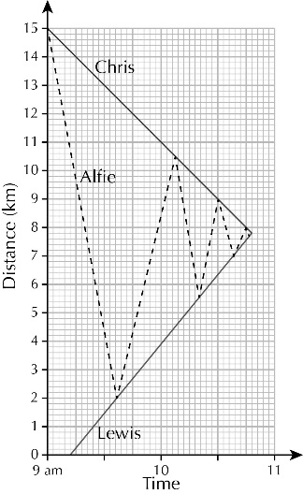

**Chapter 7: Answers to Review Questions**

**1** D She was walking at a steady speed

**2 a** 3 **b** Yes, because 3 × 25 = 75

**3 a** 6 km/h **b** 20 minutes **c** 3 km/h

**4 a** 146 **b** 18

**c** Yes, because if you substitute *x* = −10 into *y* = 3*x* – 4 you get −34

**5 a** Parallel to the given line **b** 20 **c** *y* = 5*x* + 10

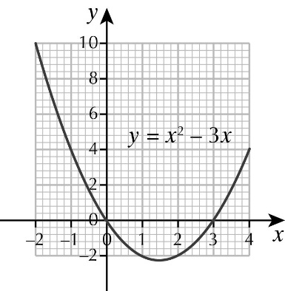**6**

**Chapter 7: Answers to Challenge – The M25**

**1 a** 9 **b** 31

**2 a** 13 miles **b** 20 miles

**3** 93.6 miles

**4 a** 160 000 **b** 58 400 000

**5** Pupils’ own graphs

**6** 1 hour 40 minutes

**7** 187 km

**8** 18.8%

**9** **a** 18.6 miles **b** 19.4 miles, 13.4 miles, 5.6 miles

**10** 9400

**Exercise 8A**

**1 a** 767 **b** 36.4 **c** 3830

**d** 470.02 **e** 9.3

**2 a** 9.78 **b** 0.156 **c** 0.0348

**d** 0.005 74 **e** 13.54

**3 a** 0.758 **b** 7.029 **c** 0.0643

**d** 0.009 106 **e** 0.000 68

**4 a** 1358 **b** 684 **c** 68.5

**d** 1570 **e** 358 100

**5 a** 5140 **b** 0.0678 **c** 34.9

**d** 34 000 **e** 8.23 **f** 794

**g** 5760 **h** 798 **i** 38

**j** 64 **k** 700 **l** 54 300

**6 a** 72 **b** 567

**c** 450 **d** 0.045

**e** 7.12 **f** 0.008 05

**g** 4678 **h** 0.796

**i** 27  **j** 0.0048

**k** 600 **l** 0.006 54

**7 a** 3 × 102 **b** 76 × 102

**c** 24 × 10−3 **d** 75 × 10−2

**e** 2 × 103 **f** 502 × 10−3

**g** 57 × 10−4 **h** 36 × 101

**i** 49 × 10−5 **j** 4 × 104

**k** 35 × 101 **l** 413 × 10−6

**8 a** 92 × 10−29

**b** 184 × 10−23

**c** 276 × 10−20

**9 a** 16 738 × 10−28 **b** 1031

**10 a** 10−2 **b** 10−3

**c i** 10−4 **ii** 10−5 **iii** 10−6 **iv** 7 × 10−2 **v** 9 × 10-6

**Investigation: Very large numbers**

**A** 99

**B** 31 years 259 days 1 hour 46 minutes 40 seconds

**Exercise 8B**

**1 a** 4 **b** 9 **c** 320 000 000

**d** 118 000 000 **e** 70 000 000 **f** 8 110 000

**2 a** 4 **b** 2 **c** 3 **d** 3 **e** 3

**3 a** 300 **b** 5000 **c** 50 **d** 0.8 **e** 200

**f** 200 **g** 80 **h** 3000 **i** 0.6 **j** 0.08

**4 a** 6400 **b** 39 **c** 8.0 **d** 640 **e** 0.072

**f** 850 **g** 460 **h** 80 **i** 0.39 **j** 0.030

**5 a** 4.3 **b** 6.4 **c** 300 **d** 28.3

**e** 0.75 **f** 1.01 **g** 20 **h** 4.21

**i** 0.060 **j** 0.03  **k** 0.0078 **l** 0.92

**6** **a** 0.67 **b** 0.7143 **c** 0.231 **d** 0.235

**e** 11 **f** 2.07 **g** 2.545 **h** 2.31

**i** 1.11 **j** 2.7  **k** 5.82 **l** 2.9

**7** 36 499, 35 500

**8** 2 499 999, 1 500 000

**9 a** 89 998 **b** 88 000

**10** For example: 0.25 and 0.75

**Investigation: Patterns in calculations**

**A** Each division gives a recurring decimal fraction with repeated multiples of 9.

**B** 0.45454545454545454545

**C** 5

**Exercise 8C**

**1 a** 8.75 × 103 **b** 3.17 × 106 **c** 8.27 × 105 **d** 5.29 × 104

**e** 2.854 × 108 **f** 6.72 × 102 **g** 9.5 × 101 **h** 7.8 × 109

**2 a** 7.8 × 106 **b** 3.4 × 103 **c** 1.7 × 107 **d** 7.8 × 104

**e** 3.47 × 108 **f** 6.38 × 105 **g** 4 × 108 **h** 5 × 108

**3 a** 9.7 × 109 **b** 2.3 × 1010 **c** 2.65 × 1011 **d** 2 × 1011

**e** 8.52 × 109 **f** 1.73 × 1010 **g** 3 × 1012 **h** 1 × 1018

**4 a** 34 000 000 **b** 5670 **c** 7 800 000 **d** 24 800 **e** 80 000 000

**f** 3 070 000 **g** 10 360 **h** 962 000 000 **i** 5 300 000 **j** 2 740 000 000

**k** 530 000 000 **l** 45 800 000 000

**5 a** 4.9 × 105 **b** 1.369 × 107 **c** 7.84 × 104 **d** 9.61 × 108 **e** 2.89 × 104

**f** 6.25 × 108  **g** 1.6 × 1013 **h** 5.29 × 1012

**6 a** 8.2 × 107 **b** 4.37 × 104 **c** 8.9 × 106 **d** 1.48 × 105 **e** 5.01 × 108

**f** 4.03 × 107  **g** 2.569 × 107 **h** 2.762 × 1010 **i** 6 × 104 **j** 1.8 × 109

**k** 4 × 106 **l** 7.5 × 107

**7 a** 4.6 billion years **b** 4.6 × 109

**8** 1.09 × 1030

**Activity: Masses of planets**

Masses are as follows:

**Planets**

Mercury: 3.301 × 1023 kg

Venus: 4.867 × 1024 kg

Earth: 5.972 × 1024 kg

Mars: 6.417 × 1023 kg

Jupiter: 1.899 × 1027 kg

Saturn: 5.685 × 1026 kg

Uranus: 8.682 ×1025 kg

Neptune: 1.024 × 1026 kg

**Dwarf planets and asteroids**

Pluto: 1.471 × 1022 kg

Ceres: 9.3 × 1020 kg

Vesta: 2.6 × 1020 kg

Pallas: 2.0 × 1020 kg

**Exercise 8D**

**1 a** 6.3 × 105 **b** 1.5 × 108  **c** 9.2 × 108

**d** 1.6 × 1014 **e** 3.76 × 1019 **f** 4.8 × 1014

**g** 1 × 107 **h** 6 × 109 **i** 4.2 × 1011

**j** 1.4 × 1010 **k** 7.2 × 1011 **l** 2.5 × 107

**2 a** 1.674 × 1010 **b** 2.175 × 108 **c** 9.69 × 109 **d** 1.036 × 109

**e** 6.132 × 109 **f** 2.378 × 1011  **g** 3.654 × 106 **h** 2.686 × 1017

**i** 2.89 × 104 **j** 9.216 × 1011

**3 a** 1.84 × 1011 **b** 1.46 × 108 **c** 7.59 × 109 **d** 3.39 × 108

**e** 5.40 × 1013 **f** 7.92 × 1010   **g** 4.54 × 1015 **h** 2.64 × 1018

**i** 7.99 × 1013 **j** 1.33 × 109

**4** 6.4 × 1011

**5 a** 3.76 × 1025 **b** 2.18 × 1033 **c** 3 sf

**6** 2.5 × 105 = 250 000, 2.5 × 106 = 2 500 000,

250 000 + 2 500 000 = 2 750 000 = 2.75 × 106

**Challenge: Mega memory**

**A** 1 × 103, 1 × 106, 1 × 109, 1 × 1012, 1 × 1015, 1 × 1018, 1 × 1021, 1 × 1024

**B** 1 × 1024

**C** 1.8 × 1025

**Chapter 8: Answers to Review Questions**

**1 a** 1 **b** 3 **c** 520 000 **d** 7.2 × 106 **e** 1 000 000

**2** 2.7 × 1010 mm3

**3** £18 000  
**4 a** 67 497 **b** 64 500  
**5** 500 million, 50 billion, 5 trillion  
**6 a i** 54.6% **ii** 5.47×106 **iii** 32.7

**b** 175002, 2 999 999 999, 3.3×109, 3 trillion

**7 a** 8.05 × 107 **b** 8.5 × 107 **c** 4.5 × 106  
**8** 1.9 × 1014  
**9 a** 5.676 × 1013 **b** 161 9 86 years  
**10 a** 4.5 × 1019 **b** 3 × 109 **c** 8.1 × 1037

**Chapter 8: Answers to Challenge – Space – to see where no one has seen before**

**1** 5.87 × 1013 miles   
**2** 8.1 × 1023 miles  
**3** 14 billion, 93 billion, 46 billion  
**4** 1.68 × 1011   
**5** 1.80 × 1010   
**6** 3.02 × 1021       
**7** 905 cm3  
**8** 113 cm3  
**9** 7.02 × 1071 miles3

**Exercise 9A**

**1** Because he travels 60km away from the start and then travels 60km back again.

**2** Angles are 155°, 133°, 40°, 18°, 14°

**3 a** Yes, because it’s between 5 m and 6 m.

**b** No, since the median is the 24th place in order and that occurs in the 3–4 class.

**c** Because the lowest throw is most unlikely to be 0

**4 a** Theft is less than 50%

**b** For example: Theft is the most common crime; there is more violent crime than

drug crime

**5 a** A **b** B **c** On 3 out of the 4 farms, the numbers are decreasing

**6 a** Yewlands is 120 as opposed to Rossington’s 367. 367 is more than 120

**b** Because one shows 2200 pupils and the other only 850, yet the size of the pie chart is the same

**Activity: Published statistical diagrams**

Pupils’ own answers

**Exercise 9B**

**1 a** 1.15 : 1 **b** 1 : 1.26 **c** 1 : 1.06 **d** 1 : 1.2

**2 a** 4 : 9 **b** 25 : 16 **c** 25 : 49 **d** 64 : 81 **e** 9 : 25

**3 a** 96 **b** 176 **c** 272 **d** 250 **e** 375 **f** 875

**4 a i** 6 cm **ii** 7.5 cm **b i** 6 cm **ii** 10 cm

**5 a i** 125 **ii** 75 **iii** 300 **b** 8.9 cm **c** 180, 72, 108

**6 a i** 81 **ii** 81 **iii** 54 **iv** 108 **b** 12.5 cm

**c i** 72 **ii** 180 **iii** 108

**7 a i** 72 **ii** 24 **iii** 36 **b** 6 cm **c** 66, 48, 30, 102, 114

**8** KS4 4 cm angles 200, 160 KS3 4.9 cm angles 160, 120, 80

**Activity: Tourism on Whit Island**

1986: 3 cm radius, angles at 288, 72

2000: 4.2 cm radius, angles at 252, 108

2014: 5.2 cm radius, angles at 216, 144

**Exercise 9C**

1. **i** Positive correlation showing the more goals scored, the more points gained

**ii** Negative correlation, showing the more goals conceded, the fewer points gained

**2 A** positive correlation, showing the more pages a book has the more it will cost;   
**B** No correlation; **C** Negative correlation, the more illustrations a book has the fewer pages it seems to have

**3 a A** positive correlation, the higher the mark in music, the higher the mark in maths; **B** No correlation; **C** Negative correlation, the higher the score in music, the lower the score in history; **D** Positive correlation, the higher the score in geography, the higher the score in maths

**b** Because there is no correlation between history and geography, which is the link graph between maths and history.

**4 A** Negative; **B** No correlation; **C** Positive

**5 a** **A** Positive correlation, showing the greater the distance, the higher the cost;

**B** No correlation; **C** Negative correlation, showing the quicker the time to post, the more expensive it will be; **D** No correlation

**b** No, because there is a different correlation for each one

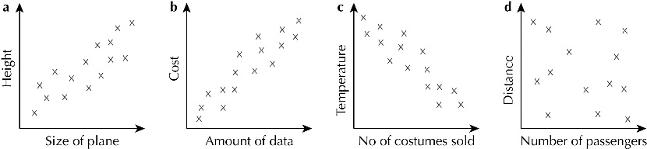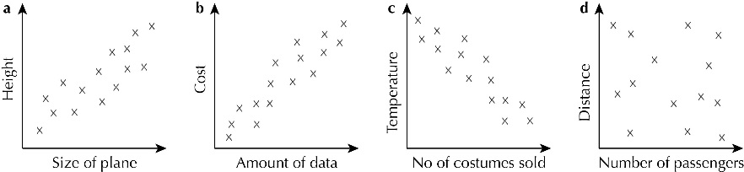**6**

**7** Isaac C, Andrew A, Lewis B

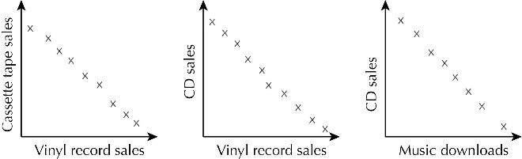**8**

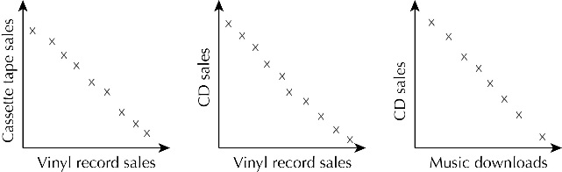

**Activity: Correlation in circles**

You should have found a positive correlation between the circumference and the diameter.

**Exercise 9D**

Note – values read from graphs may vary from these answers, depending on the pupils’ line of best fit.

1. **a** Pupils’ own answers **b** The older the child the more money they tended to have on them, positive correlation **c** Pupils’ own answers **d** 12
2. **a** Pupils’ own answers **b** The more time spent playing games, the less time spent on homework, negative correlation **c** Pupils’ own answers **d** 10 hours
3. **a** Pupils’ own answers **b** As the bikes get older their value reduces, negative correlation **c** Pupils’ own answers **d** £5725 **e** After 8 years

**4** Charly 6 on test B, Lawrie 47 on test A, Una 30 on test A, Ian 52 on test B

**Challenge: Jasmine’s garden**

Pupils’ own answers

**Chapter 9: answers to Review Questions**

**1 a** 190 **b** Positive **c** 90

**2** Boys: angles 45, 315; radius 5 cm girls: angles 30, 330; radius 4.3 cm

**3 a** angles 30, 240, 90 **b** 24 **c** 6.1 cm

**4 a** Check pupils’ work **b** Negative **c** Check pupils’ work **d** 11 minutes

**5 a** Negative **b** 12 **c** 2900

**Chapter 9: Answers to Challenge – Football attendances**

**1** Wed L1 32%, L2 47%, L3 21%; Untd L1 5% L2 90% L3 5%

**2** Pupils can choose their own radius. Radius for Sheffield Wednesday should be √1.23

times the radius of Sheffield United. For example:

SW radius of 5.5 cm with angles, 114, 170, 76

SU radius 5 cm angles 19, 322, 19

**3** SW L1 26 249, L2 22 058, L3 21 147

SU L1 30512, L2 18 132, L3 18 611

**4** Pupils’ own answers – comments may include that attendance is greater when the team

is playing at the higher level

**Exercise 10A**

**1** **a** 3*n* – 4 **b** 4*c* + 7 **c** 2*x* + 5 **d** 3 + 2*y*

** e**  **f** + 5 **g** 6 –  **h** 3 + 

**2 a** 4*ab* **b** 4 + *ab* **c** 4*a* + *b* **d** *a* – 4*b*

**e**  + 4 **f** *a* –  **g**  **h** *a* – *b* – 4

**3 a i** 20 **ii** 3 **iii** 1 **iv** 5

**b i** 32 **ii** 4 **iii** 2 **iv** 3

**4** a and d

**5** **a** *t*2 **b** 2*y*2 **c** *n*3 **d** *a*2 – *b*2

**e**  **f**  **g** 4*x*2 **h** 

**6 a** , *e*

**b** , , + , (*a* + 1)

**c** , ,  – 10, *e* – 10

**d** , , 28 – , 28 – *c,* (12 *– c*)

**7 a** *a* + *bc* **b** 2*x*2 **c** 9*y*2 **d** 6*t*2

**e** *t*2 **f** 1 +  **g**  + *n* **h**

**8 a** 54 **b** 9 **c** 4.5 **d** 13.5

**9 a** *m*2 **b** 0.5*d*2 **c** 3*p*2 **d** 6*k*2

**10** a, b and d

**Challenge: Square roots**

**A a** 7 **b** 10 **c** 10

**B a** 7, 12, 12 **b** 8, 12, 12

**C a** False because the same calculations in A and B do not give the same answer

**b** True because the same calculations in A and B give the same answer

**D** **a** False, any suitable example, e.g.

 =  = 5.4;

 +  +  = 2 + 3 + 4 = 9

**b** True, any suitable example, e.g.

 =  = 24;

 ×  ×  = 2 × 3 × 4 = 24

**Exercise 10B**

**1** **a** 16*x* **b** –8*t* **c** 14*ab* **d** –4*pq* **e** 6*x* **f** –5*t* **g** 2*ab* **h** 4*x*2

**2 a** 0.9*n* **b** 2*t* **c** *x* **d**  **e**  **f**  **g**  **h** 

**3 a**  **b**  **c**  **d** 

**4 a** 4*x* + 6*y* **b** 4*x* – 6*y* **c** 7*a* – 6 **d** *t* + 20 **e** 5*w*2 + 6 **f** 8*n* – 2*n*2 **g** *x*2 + 1

**5 a** Cannot be simplified **b** 3*a* + 2*ab* **c** *pr* – *pq* **d** 2*x*2

**e** Cannot be simplified **f** 2*a*2 + 2*b*2 **g** 2*x* + 1

**6 a i** 5, 6, 7, 8 **ii** 23, 24, 25, 26 **b** 4*n* + 6

**7 a i** 3, 5, 7, 9 **ii** 23, 25, 27, 29 **b** 8*n* + 8

**c** Both terms are a multiple of 8

**Challenge: Algebraic fractions**

**A**

|  |  |  |  |  |
| --- | --- | --- | --- | --- |
| ***n*** | ***n* + 2** | ***n* – 2** |  |  |
| 3 | 5 | 1 | 4 | 5 |
| 4 | 6 | 2 | 2 | 3 |
| 5 | 7 | 3 | 1 | 2 |
| 6 | 8 | 4 | 1 | 2 |

**B** Both decrease as you go down the table, with the difference getting smaller as *n* increases

Also,  −  = 1

**C** 1 **D** 1

**Exercise 10C**

**1 a** 2*a* + 8 **b** 2*a* + 8*b* **c** 6*x* – 9 **d** 15*y* + 10*z*

**2 a** 5*t* – 15 **b** 12*n* + 20 **c** 4*v* – 1 **d** 6*e* – 15*f*

**e** 6*a* + 9*b* – 3*c* **f** 4 – 2*p* – 8*pq* **g** 8*x*2 – 2*x* + 4 **h** *a* – *b* – c

**3 a** *x*2 – 2*x* **b** 2*y*2 + 14*y* **c** 6*t*2 – 3*tu* **d** 4*n*2 + 6*n*

**e** 4*w* – 6*kw* **f** 12*ae* – 18*be* + 24*e* **g** 100*r* – 16*r*2

**4 a** 3*x* + 15 **b** –3*x* – 15 **c** 3*x* – 15 **d** 15 – 3*x*

**e** 2*t*2 – 3*t* **f** –6*d*2 – 3*d* **g** 16*r*2 – 4*r* **h** 10*e* – 15*e*2

**5 a** 5*a* – 12 **b** 4*a* – 2*b* **c** 3*t*2 – 6*t* **d** 5*e*2 – 7*e*

**6 a** 6*x* + 2 **b** 6*x* – 2 **c** *x* − 1

**d** *y* – 1 **e** 20 **f** –5*d* – 9

**7 a** 12*p* **b** 7*x* + 2*y* **c** *m* – 12*n* + 10

**8 a** 3*x*2 – 4*x* **b** 2*n* **c** 5*y*2

**Investigation: Finding patterns**

**A a** 6*x* + 5 **b** 8*x* + 7 **c** 10*x* + 9

**B** The numbers in both terms go up by 2 each time.

**C** 7(6*x* + 5) – 6(5*x* + 4); 12*x* + 11

**Exercise 10D**

**1 a** 2(*t* + 10) **b** 2(*n* + 7) **c** 2(*k* + 3)

**2 a** 4(*x* + 2) **b** 4(*w* – 1) **c** 4(*t* + 3)

**3 a** *x*(*x* + 4), *w*(*w* – 2), *t*(*t* + 6) **b** *x*2 + 4*x*, *w*2 – 2*w*, *t*2 + 6*t*

**4 a** 3*t* + 6 **b** 4*k* + 8 **c** 4*c* + 16 **d** 3*a* + 24 **e** 5*x* + 10

**5 a** 3(*t* + 2) **b** 4(*k* + 2) **c** 4(*c* + 4) **d** 3(*a* + 8) **e** 5(*x* + 2)

**6 a** 6*y* **b** 3*y* **c** 10*y* + 12 **d** 2(5*y* + 6)

**7 a** 8(*x* + 1) **b** 2*x*(*x* – 1) **c** 2*x*(*x* + 5) **d** 4*x*(*x* + 2)

**8 a** 2*x* + 21, 2(*x* – 3) + 27 **b** 2(*x* – 3) + 27 = 2*x* – 6 + 27 = 2*x* + 21

**9** *A* = , = ** +  = 

**10 a** 54 **b** *t*(2*u* + *at*) = *t* × 2*u* + *t* × *at* = *ut* + *at*2

**11 a** 4(*x* – 1); other two bricks are: 2*x* – 1 and 2*x* – 3

**b** 4(*x* + 3); other bricks are 2*x* + 7 and 2*x* + 5

**c** 5(*x* + 2); other bricks are 3*x* + 6 and 2*x* + 4

**Investigation: Top ten**

**A** *a* + 2*b* + c

**B** Possible sets of values for *a*, *b* and *c* are all integers from 1 to infinity.

**Exercise 10E**

**1 a** 6*x*3 **b** 40*t*3 **c** 8*a*2*b* **d** 9*n*3

**e** 30*xy*2 **f** 120*p*2*q* **g** *x*2*y* **h** 64*r*3

**2** 4*j* is 4 × *j* whereas *j* 4 is *j* × *j* × *j* × *j*

**3 a** *t*4 **b** 30*x*4 **c** *n*4 **d** 16*n*4

**4 a** 54 **b** 216 **c** 18 **d** 54 **e** 6561

**5 a** 2*x*3 **b** 4*t*3 **c** 24*n*3

**6 a** 4*x*2 **b** 4*x* **c** 2*x*2 + 16*x* **d** 2*x*(*x* + 8)

**7**

|  |  |  |  |
| --- | --- | --- | --- |
| × | *p* | 2*pq* | 3*p*2 |
| *p* | *p*2 | 2*p*2*q* | 3*p*3 |
| 3*pq* | 3*p*2*q* | 6*p*2*q*2 | 9*p*3*q* |
| 2*q*2 | 2*pq*2 | 4*pq*3 | 6*p*2*q*2 |

**8** **a** 6*a*2 + 2*a*3 **b** 6*n*3 – 2*n*4 **c** *p*2*q*2 – *p*3*q* **d** 8*a*3*b* – 6*ab*3

**e** 2*x*2*y* + 5*x*3 **f** 6*a*3 + 2*a*2*b* **g** 6*s*3*t* + 18*s*2*t*2 – 12*st*3 **h** 4*x*3 – 4*x*2

**Investigation: Squares and cubes**

**A i** 2 **ii** 98 **iii** 49 **iv** 64

**B** Pupils’ own answers

**C** (*a* + *b*)² − (*a*³ – *b*³)/(*a* – *b*) = *ab*

**Chapter 5: Answers to Review Questions**

**1 a**  + 2 **b**  **c** *a*2 – *b*2

**d** 2*pq* **e** 7*tu* **f** *ab* + 7 **g** 

**2 a** 5*ab* – 2*a* **b** 7*x*2 – 6*xy* **c** + 

**3 a** 6*x* + 9 **b** 15*x* – 6*x*2 **c** 5*x*3 + *x*2

**d** *15ab*² – 25*a*2*b* **e** 8*x* – 12 **f** *a*3*b* + *a*2*b*2 + *ab*3

**4** Pupils’ own answers

**5 a** 6*a*2 **b** 125*x*3 **c** 2*st*2 **d** 24*x*3*y*2

**6 a** *x* + 15 **b** *x*2 – 5*x* **c** 10*a* + *b* **d** –2*x*2 **e** 8*x*2 – 7*xy* **f** *dx*

**7** *x* + 1

**8 a** 60*a*3 **b** 20*a*2 **c** 12*a*2 **d** 94*a*2

**9** *A* = 7, *B* = 1; 7(*x* + 1)

**10** Missing expressions, from left to right: *x*(*x* – 9), 5*x*(*x* + 2), *x*(3*x* + 7)

**11 a** (*w* + *x* + *y* + *z*)/4 **b** 20

**12** 6*t*3

**13 a** 4*x*² **b** 6*x* + 32 **c** 2*x*² + 16*x*

**Chapter 5: Answers to Mathematical reasoning – Writing in algebra**

Note that letters used by pupils may differ from those used here.

**1 a** *p* = *vc* **b** *v* = 

**2 a** *d* = *st* **b** *s* = 

**3 a** *v* =  **b** × 

**4 a** a = 1.72s² **b** *s* = 

**5 a** *v* = 0.79*d*²*h* **b** 790 cm³

**6 a** *h* = 5*t*² **b** 11.25 m

**7** *B* = 

**8** *k* = 

**9** a *c* = 90*d* + *Ck* **b** divide result by 90

**Exercise 11A**

**1 a** 3 : 8 **b** 1 : 9 **c** 2 : 5 **d** 1 : 6 **e** 4 : 25

**2 a** 1 : 2 **b** 1 : 1 **c** 1 : 2 **d** 1 : 1 **e** 1 : 2

**3 a** 2 : 5 **b** 2 : 5 **c** 4 : 25

**4 a i** 1 : 2 : 3 **ii** 1 : 4 : 9 **b** They are enlargements of each other.

**5 a** 4 : 9 **b** 4 : 5

**6 a** 4.2 ha **b** 6.6 ha **c** 7 : 11 **d** 

**7** 16cm

**8 a** 2400 l **b** 1 : 1.2

**9** 9 cm

**Investigation: Area and volume scale factors**

**A a** 1 : 2 **b** 1 : 3 **c** 1 : 4 **d** 1 : 9 **e** 1 : 8 **f** 1 : 27

**B a** 1 : *k* **b** 1 : *k*2 **c** 1 : *k*3

**Exercise 11B**

**1** Pupils’ own diagrams

**2** **a** Vertices at (3, 5), (5, 3), (1, 3) **b** Vertices at (1, 3), (3, 3), (3, 2), (1, 2)   
**c** Vertices at (1, 3), (3, 2), (1, 2)

**3** **a**  **b** (2, 2) **c** 16 cm2 and 4 cm2 **d** 4 : 1 **e** 

**4 a**  **b** (– 5, – 6) **c** All corresponding sides are in the same ratio 1 : 3

**5** A’(2, 8), B’(8, 8), C’(8, 4) and D’(2, 4)

**6** 

**Reasoning: Similar triangles**

**A a** Yes **b** No **c** Yes **d** No

**B** **a** The angles are the same in both triangles. **b** 8 cm

**C** **a** The angles are the same in both triangles. **b** 12 cm

**D** 40 m

**Exercise 11C**

**1 a** 1 : 100 000 **b** 1 : 500 000 **c** 1 : 1 250 000 **d** 1 : 50 000

**2 a** 45 km **b** 25 km **c** 12 km **d** 77 km

**3** 20 km

**4**  12.5 km

**5** 5.5 cm

**6 a** ≈ 2 km **b** ≈ 1.75 km **c** ≈ 1.5 km  **d** ≈ 1.6 km

**7 a** 10.5 km (±0.5 km) **b** 10 km (±1 km)

**8** ≈ 4.85 km to 5 km

**Problem solving: Imperial map scales**

**A** 63 360

**B** 1 : 63 360

**C** 158 400, 1 : 158 400

**Chapter 11: Answers to Review Questions**

**1** A: 8 cm by 10 cm, B: 2 cm by 10 cm

**2 a** 7 : 12 **b** 

**3 a** ≈ 210 km **b** ≈ 225 km **c** ≈ 141 km **d** ≈ 105 km

**4** 40.5 cm

**5**  **a** Triangle Y is an enlargement of triangle X by a scale factor 2 about (0, 0)

**b** Triangle X is an enlargement of triangle Y by a scale factor  about (0, 0)

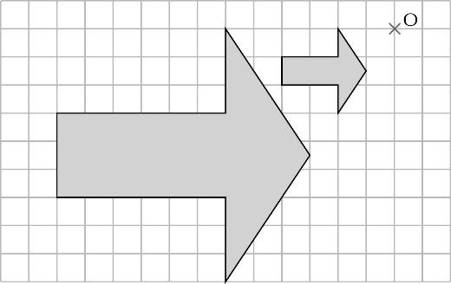**6**

**7** 5 cm

**Chapter 11: Answers to activity – Map reading**

**1**

|  |  |  |  |  |
| --- | --- | --- | --- | --- |
| From | To | Road or Footpath | Distance on map  (±2 mm) | Distance on ground  (±0.05 km) |
| A | B | Road | 9.6 cm | 2.4 km |
| B | C | Road | 3.5 cm | 0.875 km |
| C | D | Road | 3.2 cm | 0.8 km |
| D | E | Road | 1.9 cm | 0.475 km |
| E | F | Road | 7 cm | 1.75 km |
| F | G | Road | 2 cm | 0.5 km |
| G | H | Road | 1 cm | 0.25 km |
| H | I | Footpath | 6.2 cm | 1.55 km |
| I | J | Footpath | 3.8 cm | 0.95 km |
| J | K | Road | 2.8 cm | 0.7 km |
| K | A | Road | 9.8 cm | 2.45 km |

**2** **a** ≈ 10 km **b** ≈ 2.5 km

**3** ≈ 3 h 20 min

**4** ≈ 2:50 pm

**5** **a** 3.6 cm × 2 = 7.2 cm = 1.8 km **b** 3.6 km/h

|  |  |  |  |  |
| --- | --- | --- | --- | --- |
| **6 a** | 37761_Ch11Ans_002 |  | **b** | **37761_Ch11Ans_003** |

**Exercise 12A**

**1 a** 1 **b** 2 **c** 3 **d** 3

**e** 6 **f** 13 **g** 4 **h** 2

**2 a**  **b** 2 **c** 2 **d** 

**e** 3 **f** 3 **g** 4 **h** 2

**3** **a** 6 **b** 5 **c** 3 **d** 2

**4** **a** 23 **b** 29 **c** 9 

**5** **a** 1 **b** 2 **c** 5 **d** 3

**6** **a** 3 **b** 2 **c** 2 **d** 4

**7** **a** 10 **b** 11 **c** 11

**8** 6 cm

**9** **a**  **b** 1 **c** 4

**10** **a** 1 **b** 1 **c** 2

**11** 3 and 1

**Investigation: Dissecting a square**

**A** , , 

**B**

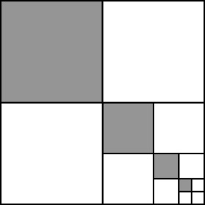

**C** 

**D** 

**Exercise 12B**

**1 a** 1 **b** 5 **c** 12 **d** 8

**2** **a** 2 **b** 1 **c** 7 **d** 10

**3** **a** 2 **b** 2 **c** 4 **d** 9 **e** 9 **f** 2

**g** 11 **h**  **i** 2 **j** 18 **k** 13 **l** 4

**4 a** 2 **b** 2 **c** 3 **d** 3

**5** **a** 6 **b** 14 **c** 11 **d** 15

**e** 15 **f** 15 **g** 7 **h** 32

**6** **a** 4 **b** 18 **c** 94 **d** 129

**e** 65 **f** 35 **g** 13 **h** 48

**7** **a** 8 **b** 26 **c** 106

**8** **a** 3 **b** 18 **c** 15 **d** 40 **e** 31  **f** 38 

**9** **a** 10 **b i** 20 **ii** 40 **iii** 5 **iv** 2

**10** **a** 13 **b i** 26 **ii** 6 **iii** 3 **iv** 13

**Investigation: Rounding errors**

**A a i** 6 **ii** 5.94 **b i** 18 **ii** 18.09 **c i** 6 **ii** 6.09 **d i** 16 **ii** 15.84

**e i** 40 **ii** 40.08 **f i** 92 **ii** 92.12 **g i** 290 **ii** 289.8 **h i** 112 **ii** 111.96

**B** **a** G has the largest error **b** Pupils’ own answers

**Exercise 12C**

**1 a** 2 **b** 2  **c** 4 **d** 5

**2 a** 12 **b** 10 **c** 12 **d** 50

**3** **a**  **b**  **c**  **d** 2 **e**  **f** 2 **g**  **h** 

**4 a** 1 **b** 5 **c**  **d** 6

**5** **a**  **b** 5 **c** 5 **d**  **e** 14 **f** 1 **g** 17 **h** 

**6** **a** 1 **b** 1 **c**  **d** 

**7** 18

**8** 1cm

**9** **a** 12 **b** 6

**10** **a** 14 **b** 4

**11** **a** *x* = 1 **b** *y* = 11 **c** *t* =  **d** *w* = 9

**Reasoning: Division patterns**

**A** 3 × 5 = 15; 10 ÷ 2 × 3 = 15

**B** **a** 12 ÷ 2 × 3 = 18 **b** 12 ÷ 3 × 4 = 16 **c** 12 ÷ 4 × 7 = 21 **d** 12 ÷ 3 × 8 = 32

**Exercise 12D**

**1 a** 32 000 **b** 32 **c** 3200 **d** 0.032

**2 a** 18 **b** 25 000 **c** 21 **d** 0.054

**e** 0.012 **f** 0.081 **g** 1.6 **h** 200 000

**3 a** 0.99 **b** 6 **c** 8400  **d** 9.6

**e** 1.68 **f** 44 000 **g** 52 **h** 0.77

**4 a** 400 **b** 0.25 **c** 490 000 **d** 0.0036

**e** 1.21 **f** 10 000 **g** 0.0049

**h** 0.000 009

**5 a** 1250 cm2 **b** 125 000 mm2

**c** 0.125 m2

**6 a** 9600 **b** 45 000 **c** 14  **d** 0.3 **e** 4.8

**f** 0.027 **g** 60 **h** 84 000 **i** 0.66

**7 a** 840 **b** 0.084 **c** 840 **d** 840

**8 e** 320 × 0.06; All the others are equal

to 1.92

**10 a** 64 000 **b** 0.729 **c** 1.331

**d** 0.000 027

**11 a** 125 cm3 **b** 125 000 mm3

**c** 0.000 125 m3

**12** 300 000 litres

**13 a** 15.625 **b** 0.015 625

**Challenge: Throwing coins**

**A** *h* = 4 × 0.2 – 5 × 0.22 = 0.8 – 5 × 0.04 = 0.8 – 0.2 = 0.6 m

**B**

|  |  |  |  |  |  |
| --- | --- | --- | --- | --- | --- |
| **Time (s)** | 0 | 0.1 | 0.2 | 0.3 | 0.4 |
| **Height (m)** | 0 | 0.35 | 0.6 | 0.75 | 0.8 |
| **Time (s)** | 0.5 | 0.6 | 0.7 | 0.8 |
| **Height (m)** | 0.75 | 0.6 | 0.35 | 0 |

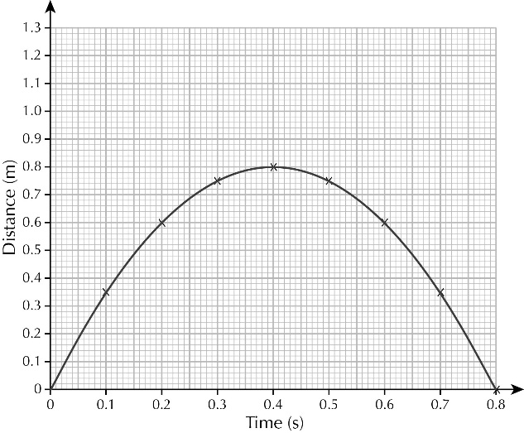

**C**

**D** It has come back to the ground

**Exercise 12E**

**1** **a** 60 **b** 40 **c** 300 **d** 200

**e** 3 **f** 0.2 **g** 0.6 **h** 200

**2** **a** 1500 **b** 400 **c** 500 **d** 140

**e** 400 **f** 200 **g** 5000 **h** 250

**3** **a** 0.2 **b** 0.006 **c** 0.06 **d** 5000

**e** 0.03 **f** 5 **g** 0.5 **h** 7.5

**4** **a** 0.12 **b** 0.012 **c** 12 000 **d** 1200

**5 a** 8 **b** 8 **c** 0.02 **d** 50 **e** 0.008 **f** 1000

**6 a** *x* = 0.015 **b** *t* = 50 **c** *y* = 0.25 **d** *w* = 0.2

**7 a** Yes, because multiplication is commutative/order of multiplication does not matter.

**b** No, because division is not commutative/order of division does matter.

**8 a** 0.0025 **b** 1 0.0025

**9 a** 1000 **b** 160 **c** 1000

**10 a** 42 **b** 0.042 **c** 0.42 **d** 650

**11** 0.006

**12** 3.6

**13** **a** 30 **b** 0.3 **c** 0.03 **d** 3

**14** **a** 40 **b** 5 **c** 50 **d** 0.006

**e** 30 **f** 40 **g** 20 **h** 0.05

**15** **a** *A* = 20*x*, dividing through by 20 gives *x* =  **b** 0.02 **c** 50

**16** **a** 1.3 **b** 0.13 **c** 1.3 **d** 130

**Challenge: A cuboid**

0.024 m3

**Chapter 12: Answers to Review Questions**

**1** **a** 5 **b**  **c** 

**2** **a** 5 **b** 8 **c** 

**3** **a** 21cm **b** 26cm2

**4** 3 cm

**5** **a** 7cm² **b** m²

**6** **a** 2 **b** 2

**7** **a** 1 **b** 32 **c** 64 **d** 20

**8** **a** 288 000 **b** 28.8

**9** 1

**10** **a** 2 **b**  **c** 5

**11** **a** 75 **b** 42 **c** 4.2 **d** 7.5

**12** **a** 4900 **b** 24 **c** 0.000 512 **d** 600

**13** **a** 40 **b** 0.005 **c** 250 **d** 0.2

**14** **a** 0.06 **b** 0.048 **c** 54

**15** 0.192 m3 or 192 000 cm3

**16** **a** 500 **b** 1.25

**17** 4

**Chapter 12: Answers to Challenge – Guesstimates**

**1** 5000 m², 0.2 m², 5000 ÷ 0.2 = 25 000

**2-10** Pupils’ own guesstimates

**Exercise 13A**

**1**

|  |  |  |  |  |  |
| --- | --- | --- | --- | --- | --- |
| **Time taken (minutes)** | 5 | 10 | 20 | 30 | 45 |
| **Distance (km)** | 12 | 24 | 48 | 72 | 108 |

**2** **a** £1.68 **b** 12 pence **c** 60 pence **d** £1.20

**3** **a** 14 g **b** 168 g **c** 224 g **d** 11.2 g

**4** **a** 3.75 kg **b** 160 small loaves

**5**

|  |  |  |  |  |  |  |
| --- | --- | --- | --- | --- | --- | --- |
| **Miles** | 5 | 25 | 80 | 12.5 | 62.5 | 31.25 |
| **Kilometres** | 8 | 40 | 128 | 20 | 100 | 50 |

**6 a** 5.7 m **b** 33.9 m **c** 3.1 m **d** 31.4 m

**7 a** 350 drips per hour **b** 2 hours, 51 minutes and 26 seconds

**8 a i** £1.80 **ii** £7.20 **iii** 22 pence **b i** 200 g **ii** 278 g **iii** 417 g

**9 a**

|  |  |  |  |  |
| --- | --- | --- | --- | --- |
| **Pounds (£)** | £43 | £164 | £129 | £107.50 |
| **US dollars (US$)** | $65 | $247.91 | $195 | £162.50 |

**b** $1.51 **c** £0.66

**10 a**

|  |  |  |  |  |  |
| --- | --- | --- | --- | --- | --- |
| **Bar** | 0.7 | 1.75 | 0.28 | 8.4 | 10.5 |
| **psi** | 10 | 25 | 4 | 120 | 150 |

**b** 0.07 bar **c** 14.3 psi

**11** **a** 184 kg **b** 54.3 m

**12** **a** NS$240 **b** 1 : 2.5 **c** 1 : 2.5

**13** **a** 57 kcal **b** 160 : 240 = 1 : 1.5; 38 : 57 = 1 : 1.5, so the ratios are the same

**14** No, because when you divide the temperature in degrees Celsius by the temperature in degrees Fahrenheit, the answer is not constant – it changes

**Investigation: Age, height and mass**

|  |  |  |  |  |
| --- | --- | --- | --- | --- |
| **Height ÷ age** | 15.5 | 9.25 | 7 | 5.625 |
| **Mass ÷ age** | 14.2 | 9.0 | 7.7 | 7.15 |
| **Mass ÷ height** | 0.92 | 0.97 | 1.1 | 1.27 |

**A** No, because the result of dividing height by age does not stay the same

**B** No, because the result of dividing mass by age does not stay the same

**C** No, because the result of dividing mass by height does not stay the same

**Exercise 13B**

**1 a** *y* values: 8, 16, 24, 32, 40

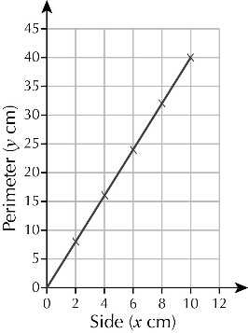**b**

**2 a i** £13.00 **ii** £32.50

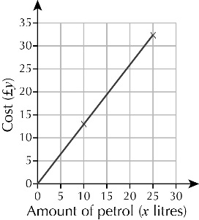 **b**

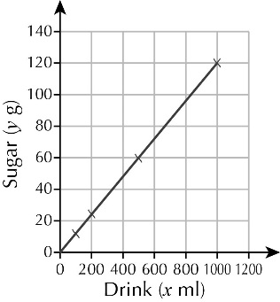

**3 a** *y* values: 24, **c**

12, 60, 120

**b** 12 ÷ 200 = 0.12,

so 12 = 0.12 × 200

so *y* = 0.12*x*

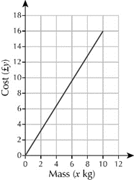**4 a** £4.80 **c**

**b** *y* = 1.6*x*

**5 a** *y* values: 240, 480, 960, 1200

**b** *y* = 12*x* **c** HK$15 840 **d** £658.33

**6 a**

|  |  |  |  |  |  |
| --- | --- | --- | --- | --- | --- |
| **Distance (*x* km)** | 50 | 120 | 100 | 75 | 43 |
| **Petrol (*y* litres)** | 5 | 12 | 10 | 7.5 | 4.3 |

**b** *y* = 0.1*x* **c** £22.17

**7 a** 36 km/h **b** *y* = *x* or *y* = 3.6*x*

**c** 360 km/h **d** 115 m/s

**8 a** *y* values: 7, 14, 21, 28, 35

**b** *y* = 1.4*x* **c** 44.8 mm **d** 45 mm

**9** **a** *y* = 2*x* **b** *x* = 0.5*y*

**c** *y* value: 11.4; *x* value 12.15 or 12.2

**d** 1 : 2 **e** Pupils’ own answers

**Financial skills: Exchange rates**

**A** *y* = 1.7*x* **B** 0.59 rupees

**C** 1.7 yen **D** *x* = 0.59

**Exercise 13C**

**1 a** 6 hours **b**

|  |  |  |  |  |  |
| --- | --- | --- | --- | --- | --- |
| **Speed (*x* km/h)** | 100 | 150 | 120 | 200 | 300 |
| **Time (*y* hours)** | 6 | 4 | 5 | 3 | 2 |

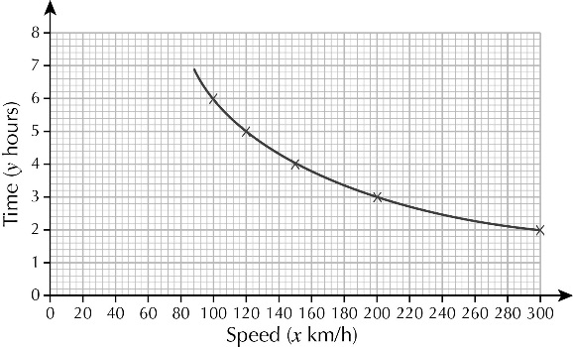**c** *xy* = 600

**d, e**

**2 a** 100 books **b** 200 books

**c** *y* values: 500, 250, 200, 100, 50, 40

**d** When the number of books is multiplied by the cost of a book, the total cost is always £1000 **e** *xy* = 1000

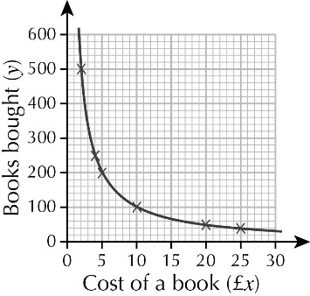**f** and **g**

**3 a** 800 km/h **b** *xy* = 4000 **c** 8 hours

**4 a** 200

**b** *n* values: 200, 167, 143, 125, 111, 100

**c** When the number of paces is multiplied by the length of a pace, the total distance is always 100 m **d** *pn* = 100 **e** 0.77 m

**5 a** 0.5*bh* = 100 or *bh* = 200

**b** *h* values: 20, 13.3, 10, 8, 6.7, 5.7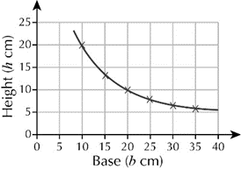

**c**

**d** 50 cm **e** 14.1 cm

**6 a** *c* values: 4500, 2250, 1500, 1125, 900

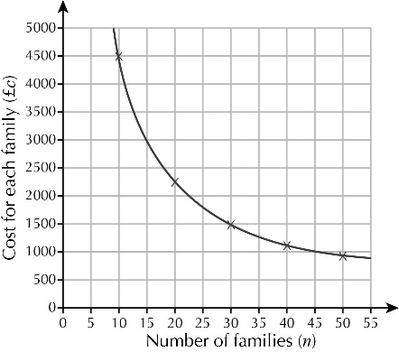**b** *nc* = 45 000; the total cost is fixed and is shared between the number of families

**c**

**d** 57 families

**Activity: Different rectangles, same area**

**A** Pupils’ own answers

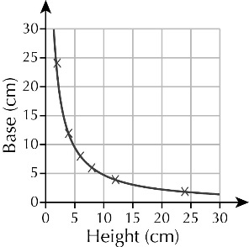**B** Pupils’ own answers

**C**

**D** *bh* = 48 where *b* = base in cm and

*h* = height in cm

**E** 6.9 cm

**Exercise 13D**

**1 a** *d* = 75*t* **b** 2137.5 m

**2 a** The distance is fixed so if Anne increases her walking speed it will take her less time to cover the distance

**b** *tw* = 40

**3 a** Direct proportion, because when *y* is divided by *x*, the answer is always the same; *y* = 3.5*x*

**b** Inverse proportion, because when *c* and *d* are multiplied together, the answer is always 180; *cd* = 180

**c** Does not show direct or inverse proportion because no relationship between values of *f* and *r*

**d** Inverse proportion, because when *u* and *v* are multiplied together, the answer is always 0.36; *uw* = 0.36

**4** No, because the graph does not go through (0, 0)

**5** No, because *xy* does not equal a constant/the same number

**6** **a** *y* = 0.003*x* or *y* =  **b** *xy* = 12

**7** *y* = 0.06*x*

**8** *xy* = 40

**9** **a** As the number of panels increases, the length of each panel decreases. The product of the length and number is a constant, 200

**b** 1.5 m panel: £1152.40; 1.8 m panel: £1114.40; 2.4 m panel: £936.60; the 2.4 me panel is the cheapest

**10 a** *xy* = 5 **b** 0.3

**11 a i** 0.045 **ii** *s* = 0.0375*r*

**b i** 0.08 **ii** *rs* = 0.096

**Reasoning: Looking for proportion**

**A** Perimeter = 2*l +* 2*w*; 20 = 2*l* + 2 × 3; 20 = 2*l* + 6; 14 = 2*l*; *l* = 7

**B** Possible pairs are:

1 cm and 9 cm, 2 cm and 8 cm, 4 cm and 6 cm, 5 cm and 5 cm

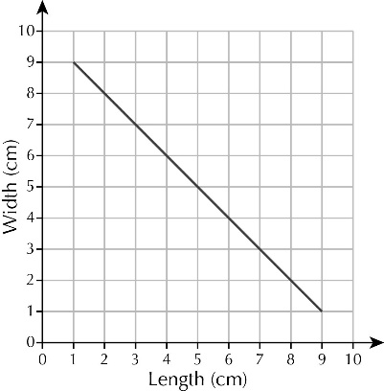**C**

**D** No, because as the length of one side increases, the other decreases

**E** No, because the product of the two side lengths is not a constant

**Chapter 13: Answers to Review Questions**

**1** 25.5 minutes, 55.25 minutes

**2**

|  |  |  |  |  |  |
| --- | --- | --- | --- | --- | --- |
| **Width** | 10 cm | 15 cm | 50 cm | 62.5 cm | 2.5 m |
| **Length** | 16 cm | 24 cm | 80 cm | 1 metre | 4 m |

**3** 27.84 kg

**4** £3.64

**5** **a i** £1.61 **ii** £6.90 **iii** £83.95 **b** *c* = 0.23*n*

**6** **a** Yes, because as the distance increases, the cost increases by the same factor and when the distance is zero the cost is zero. **b** £10.56 **c** 14.8 km

**d** Pupils’ sketches with distance on *x*-axis, cost on *y* axis, going through the points (0, 0) and (10, 16.50)

**7 a** The graph is a straight line and it goes through the point (0, 0). **b** *y* = 3.6*x* **c** 68.4 cm

**d** 23.6 cm **e** Pupils should show that the area divided by the radius is not a constant.

**8** 302 people

**9** **a** 5.625 hours, 3.75 hours **b** *xy* = 450

**10** **a** *st* = 278.4 **b** 2.0 m/s

**11** **a** 15 cm **b** 120 cm **c** *xy* = 1200

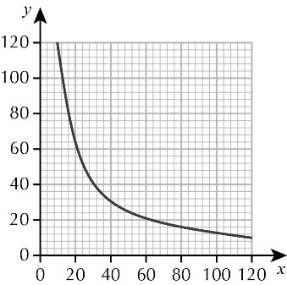 **d**

**Chapter 13: Answers to Challenge – Planning a trip**

**1 a** £18.87 **b** £40

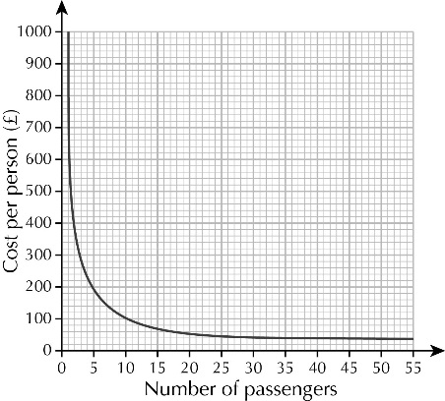 **c**

**2 a** 57 km **b** 9.5 km **c** *y* = 1.9*x*

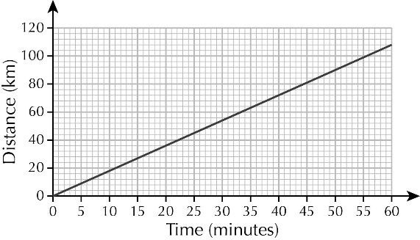**d**

**3 a** 3 hours **b** *y* = 240/*x*

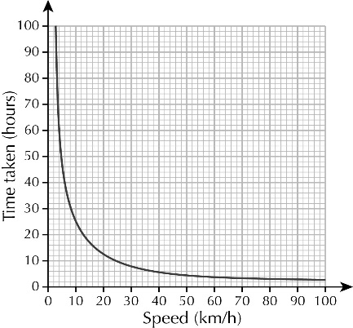 **c**

**4 a** direct proportion **b** *f* = 0.384*d*

**c** neither

**Exercise 14A**

Circumference divided by diameter is slightly larger than 3. A simple relationship is *C =* 3*d.*

**Activity: Making nets for cones**

**D** As the size of the removed sector increases, so does the height of the cone.

**Exercise 14B**

Note: answers could be slightly different if value of  is taken as 3.14

**1** **a** 15.7 cm **b** 37.7 mm **c** 7.2 m **d** 9.4 cm **e** 23.9 cm

**2** 503 m

**3** 2 413 000 km

**4** **a i** 32.97 cm **ii** 32.991 cm **iii** 33 cm

**b** Different approximations for  will lead to different answers.

**5** 3.2 cm

**6** 200 m

**7** 25.7 cm

**8 a** 18.3 m **b** 43.7 cm **c** 28.3 cm

**Activity: A mnemonic for** 

Count the number of letters in each word of the sentence provided: 3 1 4 1 5 9 2 7, which leads to 3.1415927.

**Exercise 14C**

Note: answers could be slightly different if value of  is taken as 3.14

**1** **a** 28.3 cm2 **b** 113.1 mm2 **c** 2.5 m2

**d** 13.9 cm2 **e** 141.0 m2

**2** **a** 25 cm2 **b** 64 mm2

**c** 49 cm2 **d**  m2

**3** 87 cm2

**4** 531 mm2

**5** 3657 m2

**6** 3.4 cm

**7** 6.2 cm

**8 a** 100.5 cm2 **b** 38.9 cm2

**c** 15.8 cm2

**Problem solving: Circles and ellipses**

**A** *A* = *r*2 =  ()2 = 

**B a** 6 cm2 **b** 26 m2

**c** 30 cm2 **d** 10.5 m2

**Chapter 14: Answers to Review Questions**

**1 a i** 31.4 mm **ii** 78.5 mm2 **b i** 20.4 cm **ii** 33.2 cm2 **c i** 13.2 m **ii** 13.9 m2

**2** **a** 22 cm **b** 38 cm2

**3** She has used the formula for the circumference of the circle, the correct formula is *A* = *r*2. The correct answer is 28.3 cm2 (1 dp).

**4** 120 cm

**5** 14 cm2

**6** 49.1 cm2

**7** 5.6 m

**8** 31.8 cm2

**Chapter 14: Answers to Financial skills – Atheltics stadium**

**1** **a** 3.58 m2 **b** £114.56

**2** **a** 245.44 m2 **b** £11 044.66

**3** **a** 400 m **b** 1000 litres **c** £1375

**4** **a** 12 m3 **b** 20 tonnes **c** £732

**5** **a** 1.08 m3 **b** £51.84

**6 a** 2620 m2 **b** £9432

**Exercise 15A**

**1 a** 13 **b** 14 **c** –3

**2 a** *t* = 6 **b** *m* = –1 **c** *w* = 8 **d** *x* = –4

**e** *m* = 5 **f** *r* = –6 **g** *p* = **h** *k* = –1

**3 a** *a* = 10 **b** *a* = 5 **c** *n* = 6  **d** *t* = 4

**e** *t* = –1 **f** *p* = –2 **g** *x* = 2 **h** *a* = 47

**4 a** *y* = 26 **b** *t* = 24 **c** *y* = 60 **d** *t* = 9

**e** *x* = –1 **f** *t* = 7 **g** *t* = 19 **h** *x* = 42

**5 a** *x* = 4 **b** *x* = 4 **c** *x* = 7 **d** *x* = 6

**e** *y* = 5 **f** *t* = 14 **g** *t* = 15 **h** *r* = 17

**6 a** *x* = 8 **b** *y* = 5 **c** *d* = 10 **d** *t* = 9

**e** *b* = 3 **f** *d* = –3 **g** *v* = 4 **h** *t* = 2

**7 a** 6*x* – 9 = 40 **b** *x* = 8

**8 a** *x* = 10 **b** *x* = 16 **c** *h* = 4 **d** *r* = –2

**e** *x* = 3 **f** *u* = 10 **g** *y* = 26  **h** *r* = 11

**9** **a** *x* = 3.13 **b** *y* = 6.83 **c** *t* = 84.71 **d** *r* = 2

**e** *t* = –5.7 **f** *n* = 23.63 **g** *f* = 1.65 **h** *q* = –4

**Challenge: Odd one out**

 = 8 is the odd one out. It has a solution *x* = 3.5, but the other equations have the solution *x* = –4.5

**Exercise 15B**

**1 a** 15 **b** 15 **c** 12 **d** 11

**2 a** 9 **b** 6 **c** 4.5 **d** 18

**3 a** 20 **b** 7 **c** 11 **d** 5.5

**4 a** 8 **b** 21 **c** 6 **d** 8

**5 a** 18 **b** 10.5 **c** 3 **d** 34 **e** 26 **f** 

**g** 2 **h** 8 **i** 7 **j** 13 **k** 5 **l** 20

**6 a** 2*x* + 35 = 3*x* + 12 **b** *x* = 23 **c** 81

**7 a** *n +* 75 **b** *n +* 75 = 4*n* **c** *n* = 25; Ann has £25, Carrie has £100

**8 a** 14 **b** 9 **c** 10 **d** 5 

**9 a** 12 **b** 8 **c** 6 **d** 4

**10 a** 15 **b** 9 **c** 4 **d** 12

**e** 4 **f** 24 **g** 2 **h** 5

**11 a** 4 **b** 2 **c** 6 **d** 3

**Challenge: Muddying the waters**

**A** Missing numbers are 21, 26, 17, 32

**B** Missing expressions are 17 + 5*x*, 17 + 9*x*, 17 + 14*x* and 15*x* + 4

**Exercise 15C**

**1 a** *x* = 19 **b** *z* = 7 **c** *t* = 19 **d** *k* = –6 **e** *m* = 4

**f** *y* = 8 **g** *p* = 13 **h** *k* = 52 **i** *x* = –6

**2 a** 5(*x* – 6) = 3(*x* + 3) **b** *x* = 19, line length is 67 cm

**3 a** 6(*t* – 8) = 4(*t* + 6)

**b** *t* = 36, side length of hexagon = 28 units, side length of square = 42 units

**4** *x* = 15, area = 46 square units

**5** **a** *x* = –11 **b** *y* = 4 **c** *r* = 10 **d** *t* = 8 **e** *m* = 8

**f** *w* = 22 **g** *x* = 2 **h** *t* = 1 **i** *n* = 10

**6** **a** *t* – 5 = (*t* + 10) **b** 50 years old

**7** *y* = ±3

**8** **a** *x* = ±2 **b** *x* = ±10 **c** *t* = ±9 **d** *y* = ±12

**9** **a** *x* = ±4 **b** *x* = ±7 **c** *x* = ±6 **d** *x* = ±11 **e** *d* = ±5 **f** *n* = ±6 **g** *k* = ±8 **h** *v* = ±5

**Challenge: How many solutions?**

**A a** *x* = ±2 **b** *x* = ±0.5 **c** *x* = 0 **d** No solution

**B a** *x* = 2 **b** *x* = 2 **c** *x* = 0 **d** *x* = –2

**Exercise 15D**

**1 a** *x* = *y* – 4 **b** *x* =  **c** *x* = 

**d** *x* = 4*y* **e** *x* = 10 – *y* **f** *x* = 3*y* + 6

**g** *x* = 2*y* – 7 **h** *x* =  **i** *x* =  – 3

**j** *x* = 12 –  **k** *x* = 10 –  **l** *x* = 

**2 a** *p* =  **b** *q* = 

**3 a** *t* =  **b** *a* = 

**4 a** *v* = ±6.5 **b** *s* = 

**5 a** *x* =  **b** *y* = 

**6 a i** *b* =  **ii** *a*2 =  **iii** *a* = 

**b** *b* = 

**7** *C* = (*F* – 32)

**Chapter 15: Answers to Review Questions**

**1 a** *x* = 16 **b** *t* = –4 **c** *t* = 6 **d** *x* = 21 **e** *n* = 7 **f** *k* = 4 **g** *t* = –4 **h** *y* = 7

**2 a** *x* = 10 **b** *x* = 10 **c** *y* = 3 **d** *w* = 6 

**3 a** *x* = 14 **b** *y* = 14 **c** *t* = 1 **d** *m* = 34 **e** *y* = 22 **f** *t* = 5

**4 a** 5(3*x* + 1) = 95 **b** *x* = 6

**5 a** 4*x* + 8 = 180 **b** 43°, 61° and 76°

**6 a** Area of A = 4(*a* + 4), area of B = 6*a* **b** 4(*a* + 4) = 6*a*

**c** *a* = 8, area of A = area of B = 48 square units

**d** No, perimeter of A is 32 units and perimeter of B is 28 units.

**7 a i** *x* = 6 **ii** check by substituting into the original equation

**b i** *x* = –1 **ii** check by substituting into the original equation

**8 a** *x* = 3 **b** *y* = 3 **c** *x* = 24

**9 a** *x* = ±4 **b** *y* = ±6 **c** *t* = ±5 **d** *n* = ±10

**10 a** *a* = 3*m* – *b* – *c* **b** *b* = 3*m* – *a* – *c*

**11** *x =* 

**12 a i** *h* =  **ii** *r* =  **b i** *r*2 =  **ii** *r* = 

**Chapter 15: Answers to Reasoning – Using graphs to solve equations**

**1 a** *x* = 3

**b** 2(*x* – 4) = −8, −6, −4, −2, 0, 2; 1 – *x* = 1, 0, −1, −2, −3, −4

**c**

**d** Pupils’ own graphs

**e** *x* = 3

**2 a** *x* = 2 **b** *x* = 2 **c** *x* = −2 **d** *x* = 2.5 **e** *x* = −6 **f** *x* = 4

**3** *y* = *x* + 2 and *y* = 2*x* + 1

**Exercise 16A**

**1 a** 10 < *T* ≤ 20 **b** angles 60°, 216°, 84°

**2 a** Frequencies are 1, 2, 5, 8, 4 **b** angles 18°, 36°, 90°, 144°, 72

**3 a** Fequencies are 2, 4, 5, 6, 1 **b** 6 < *M* ≤ 7 **c** 2/9 **d** 40°, 80°, 100°, 120°, 20°

**4 a** Saturday 30 < *P* ≤ 40 Sunday 40 < *P* ≤ 50

**b** Sat radius 4.5 cm, angles 24°, 96°, 144°, 84°, 12°;

Sun radius 5 cm angles 24°, 132°, 144°, 60°

**c** Sunday people were getting ready for the next week at work.

**5 a** Questionnaire/experiment **b** Experiment **c** Questionnaire

**6 a** Needs ages and sexes separating **b** Too many classes

**c** Biased to sports people **d** Both tests should be at the same time.

**Activity: Planning data collection**

Pupils’ own answers

**Exercise 16B**

**1** Check pupils’ diagrams are correct and have a title.

**2 a** 2° **b** 13° **c** 2 **d i** 6° **ii** April

**3** Class A radius 4.5 cm, angles 48, 84, 60, 84, 84  
Class B radius 5 cm, angles 12, 48, 96, 84, 84, 36

Class C radius 4.8 cm, angles 24, 72, 60, 84, 108, 12

**Activity: Comparing populations**

Pupils’ own comparisons

**Exercise 16C**

**1** A greater percentage of the attendance are children at the rock concert.

**2** Boys chose sport as their favourite while girls chose reading.

**3** The science test was the more difficult as we see the maths scores are higher than the science scores.

**4 a** The trains are not late as often in the early afternoon, but at all other times there are more trains late than on time, with the earlier in the morning and the later at night the more frequent is the lateness.

**b** The frequency of trains on time to be about 5%.

**5 a** The people in the UK tended to prefer meat to anything else. The people in Iceland preferred fish to meat but never preferred vegetables.

**b** Because the sizes of the pie charts are the same but the sizes of the populations are very different, so the Iceland pie chart should have a radius about 7% of the size of the UK radius to reflect this difference.

**Activity: Comparing chocolate bars**

**A** Chunky: mean 404 g, range 6 g; Choctastic: mean 403 g, range 19 g

**B** Pupils’ own answers

**C** The chunky bar: I know I’ll get more than 400 g.

**Exercise 16D**

**1 a** The group sizes are all different. Either the data should be placed into equal class sizes or the diagram created on a continuous time scale with the area of the bar reflecting the frequency.

**b** Each icon is a different size and no scale shown. The scale for each icon should be shown that reflects the relative frequency of each or the icons all to be the same width if representing the same number of people.

**c** The vertical scale only starts at 2 and hence the differences shown in height are exaggerations of the true differences. The vertical axis should be redrawn starting at 0.  
**d** The vertical axis does not go up uniformly so you cannot get a true representation of the differences. The vertical axis should be redrawn with a linear axis as we usually use in graphs.

**2 a** Pupils’ own answers

**b** Drawn a chart with the sales axis starting at 3600. This will emphasise the differences.

**3 a** create a bar chart with same width bars but class sizes of 0–10, 11–20, 21–50, 41–50 and 51–60

**b** Pupils’ own answers

**4** Create a bar chart where the vertical axis for the number of people is not linear, for example it can start at 0, then have the 10 at 10 cm high with the 490 at 15 cm high.

**5 a** The radii are the same even though the numbers are very different.  
**b** Grange Mound have 150 pupils going on to university; Blue Star have over a third of their pupils going on to university.  
**c** The sketch should show the radius of Grange Mound to be just under twice as large as Blue Star.

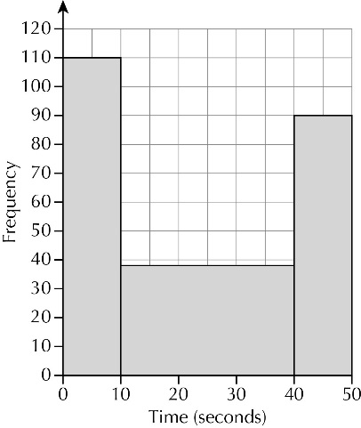**6 a** The vertical scale does not start at 0 and the horizontal axis does not have a linear (evenly spaced) scale.

**b**

**Activity: Creating misleading charts**

Pupils’ own answer

**Chapter 16: Answers to Review Questions**

**1** A smaller proportion of males to females attended the classical concert, but a greater

proportion of males attended the rock concert.  
**2 a** 6, 5, 7, 4, 3, 1 **b** Check pupils’ diagrams. **c** 21–25  
**3 a** Check pupils’ drawings  **b i** £90 **ii** 90 cm  
**4 a** Any 2 of 0, 1 and 6 **b** –1 **c** 30.4  
**5 a** 31.4 cm **b** 135 cm2 **c** 75, 12  
**6 a** True, the smallest male is between 126 and 130 mm, while the smallest female is

between 121 and 125 mm.

**b** not enough information  
**7 a** The frequency axis starts at 200, so the area of the bars do not reflect the correct

relative size of data.

**b** redraw to combine 10–30 into a single bar of height 710

**Chapter 16: Answers to Problem solving – Why do we use so many devices to watch TV?**

**1 a** Their lengths do not reflect the data, for example the top bar, 60% is more than double

the bottom bar, 30%.

**b** For example, video on demand 12 cm, Video recorder 10 cm, Electronic p’ guide 9 cm,

Social Media 8 cm, TV guide 6 cm  
**2 a** The areas are in the same ratio as the percentages shown.

**b** 7.1 cm and 3.3 cm  
**3 a** The area of the shapes is in the same ratio as the percentages shown.  
 **b i** The radii should be in the ratio 1 : 0.92 **ii** Angles 144, 108, 90, 18  
**4 a** The class sizes are not all the same.

**b** Can create a chart similar to the ‘What do we watch on potable devices?’ chart above, say using an iPod shape as the basis, then the relative area of each in the same ratio as current percentages shown.