Maths Frameworking Pupil Book 2.2 Answers

**Exercise 1A**

**1 a** 1 **b** –9 **c** 7 **d** 0 **e** –8 **f** –10 **g** –10 **h** 1 **i** –18 **j** –2

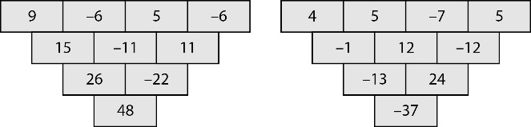**2 3 a** –6 **b** –12 **c** –10 **d** 18

**e** –24 **f** –20 **g** 12 **h** 6

**i–**14 **j** –16 **k** 60 **l** –32

**m** 30 **n** –18 **o** 16 **p** 56

**4** For example 3 × –4, –2 × 6, –1 × 12, 12 ÷ –1, –12 ÷ 1

**5 a** –4 **b** –6 **c** –3 **d** 2 **e** –4 **f** –8 **g** 8 **h** 6

**i**–3.5 **j** 2 **k** –6 **l** 2 **m** 7.5 **n** –9 **o** 4 **p** –4.5

|  |  |  |  |  |
| --- | --- | --- | --- | --- |
| × | –1 | –3 | 4 | –6 |
| –2 | 2 | 6 | –8 | 12 |
| –4 | 4 | 12 | –16 | 24 |
| 5 | –5 | –15 | 20 | –30 |
| 7 | –7 | –21 | 28 | –42 |

|  |  |  |  |  |
| --- | --- | --- | --- | --- |
| × | –5 | 6 | 7 | –8 |
| –2 | 10 | –12 | –14 | 16 |
| 3 | –15 | 18 | 21 | –24 |
| 4 | –20 | 24 | 28 | –32 |
| –5 | 25 | –30 | –35 | 40 |

**6 a** **b** **c**

|  |  |  |  |
| --- | --- | --- | --- |
| 6 | –9 | 12 | –15 |
| –12 | 18 | –24 | 30 |
| 4 | –6 | 8 | –10 |
| –10 | 15 | –20 | 25 |

**7 a** –6 **b** 4 **c** –3 **d** 75 **e** 24 **f** 8 **g** –2 **h** 6

**i**–6 **j** 8 **k** –2 **l** –8 **m** –2 **n** –4 **o** 7

**8** **a** i4 **ii** 16 **iii** 9 **iv** 36 **b** Because –ve × –ve = positive and +ve × +ve = positive

**9** **a** –2 **b** 2 **c** –14 **d** –4 **e** 26 **f** –10 **g** 4 **h** 3

**10 a** 2×(–5+4) **b** (–2+ –6)×3 **c** 9 – (5 – 2)

**Challenge: Algebraic magic squares**

**A** 3*c* **B C**

|  |  |  |
| --- | --- | --- |
| 9 | –14 | 11 |
| 4 | 2 | 0 |
| –7 | 18 | –5 |

|  |  |  |
| --- | --- | --- |
| –6 | –1 | –8 |
| –7 | –5 | –3 |
| –2 | –9 | –4 |

**Exercise 1B**

**1 a** 1, 3, 5, 15 **b** 1, 2, 4, 5, 10, 20 **c** 1, 2, 4, 8, 16, 32

**d** 1, 5, 7, 35 **e** 1, 2, 3, 4, 5, 6, 10, 12, 15, 20, 30, 60

**2 a** 5 **b** 15 **c** 20 **d** 4

**3** 2, 3, 4, 6, 9, 12, 18

**4 a** 1, 2, 4 **b** 1, 2, 3, 4, 6, 12 **c** 1, 5 **d** 1, 3, 5, 15

**e** 1, 2, 5, 10 **f** 1, 2, 4, 8 **g** 1, 3 **h** 1, 7

**5 a** 3 **b** 4 **c** 2 **d** 4 **e** 2 **f** 2 **g** 9 **h** 1

**6 a** 20 **b** 9 **c** 4 **d** 28 **e** 15 **f** 36 **g** 50 **h** 40

**7 a**  **b**  **c**  **d**  **e**  **f**  **g**  **h** 

**8** Seven groups of nine pupils

**Investigation: Tests for divisibility**

**A** It ends in an even number

**B** The digits will add up to a multiple of 3

**C** If it ends with a 0, 4 or 8 and the tens digit is 0 or even – or if it ends with a 2 or 6 and the tens digit is odd

**D** Ends in a 0 or a 5

**E** If it’s even and a multiple of 3

**F** The digits will add up to a multiple of 9

**G** **a** 108, 390, 4503, 111111 **b** 108, 220, 580, 12716 **c** 108, 390, 12716 **d** 108

**Exercise 1C**

**1** **a** 10,4,18,8,72,100 **b** 18,69,81,33,72 **c** 10,65,100 **d** 18,81,72

**2** **a** 4,8,12,16,20,24,28,32,36,40 **b** 5,10,15,20,25,30,35,40,45,50

**c** 8,16,24,32,40,48,56,64,72,80 **d** 15,30,45,60,75,90,105,120,135,150

**e** 20,40,60,80,100,120,140,160,180,200

**3** **a** 40 **b** 20 **c** 30 **d** 40

**4** **a** 45 **b** 25 **c** 24 **d** 12 **e** 24 **f** 60 **g** 63 **h** 77

**5** **a** 30 **b** 60 **c** 120 **d** 90 **e** 24 **f** 240 **g** 252 **h** 231

**6** 480

**7**  112 seconds

**8** 630cm

**9** 4 or 5 depending on when they were first all together  
**Challenge: LCM and HCF**

**A** **a** 2 and 14 **b** 3 and 18 **c** 5 and 60  
**B** **a i** 1, 35 **ii** 1, 12 **iii** 1, 22 **b** *xy*  
**C** **a i** 5, 10 **ii** 3, 18 **iii** 4, 20 **b** *y*

**Exercise 1D**

|  |  |  |  |  |  |  |
| --- | --- | --- | --- | --- | --- | --- |
| 16 | 25 | 36 | 49 | 64 | 81 | 100 |
| 64 | 125 | 216 | 343 | 512 | 729 | 1000 |

**1**

**2** **a** 2 **b** 8 **c** 9 **d** 10 **e** 5 **f** 3 **g** 5 **h** 10 **i** 8 **j** 9

**3 a** 169 **b** 2197 **c** 225 **d** 3375 **e** 441 **f** 9261 **g** 1.96

**h** 5.832 **i** 12.167 **j** 20.25 **k** 1728 **l** 3.375

**4 a** 16 **b** 243 **c** 81 **d** 32 **e** 256 **f** 625 **g** 2401 **h** 512 **i** 128

**j** 512 **k** 1024 **l** 59049

**5 a** 400 **b** 27000 **c** 125000 **d** 3200000 **e** 4900 **f** 8000000

**6** 104, 105, 106, 107

**7 a** ±6 **b** ±11 **c** ±12 **d** ±1.5 **e** ±14 **f** ±2.4 **g** ±1.6 **h** ±60

**8** All answers are 1  
**9 a i** 1 **ii**–1 **iii**1 **iv**–1 **v** 1 **b i** –1 **ii** 1

**10 a** 729 **b** 163

**Challenge: Squares on a chessboard**

204

**Exercise 1E**

**1 a** 12 **b** 90 **c** 36 **d** 270 **e** 150

**2 a** 2 × 2 × 2 **b** 2 × 5 **c** 2 × 2 × 2 × 2 **d** 2 × 2 × 5 **e** 2 × 2 × 7

**f** 2 × 17 **g** 5 × 7 **h** 2 × 2 × 13 **i** 2 × 2 × 3 × 5 **j** 2 × 2 × 3 × 3 ×5

**3 a** 2 × 3 × 7 **b** 3 × 5 × 5 **c** 2 × 2 × 5 × 7 **d** 2 × 5 × 5 × 5 **e** 2 × 2 × 2 × 2 × 2 × 3 × 5

**4** 2→2, 3→3, 4→2 × 2, 5→5, 6→2 × 3, 7→7, 8→2 × 2 × 2, 9→3 × 3, 10→2 × 5, 11→11, 12→2 × 2 × 3, 13→13, 14→2 × 7, 15→3 × 5, 16→2 × 2 × 2 × 2, 17→17, 18→2 × 3 × 3, 19→19, 20→2 × 2 × 5

**5 a** 2,3,5,7,11,13,17,19 **b** Prime numbers

**6 a** 23 × 52 **b** 2 × 52 **c** 23 × 53 **d** 26 × 56

**7 a** 2 × 5 = 10 **b** 2 × 3 × 5 = 30

**8 a** 25 **b** 26 **c** 27 **d** 210

**9 a** 2² × 3 × 5 **b** 2² × 5² **c** 300 **d** 2² × 3 × 5²

**10** 420

**Challenge: LCM and HCF in Venn diagrams**

**A a** 6, 360 **b** 10, 450 **c** 12, 336

**B** **C**

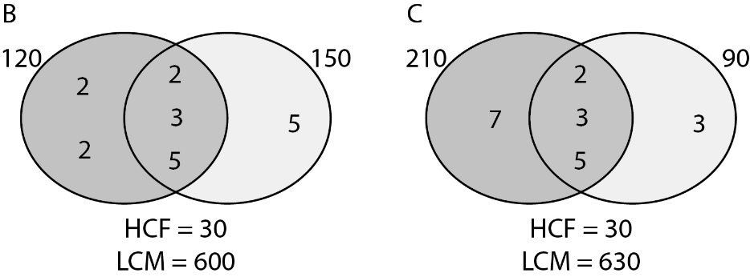

**Chapter 1: Answers to Review Questions**

**1** b, d and e

**2** **a** 24, 52, 33 **b** 16384

**3** For example 2 × –5 and 20 ÷ –2

**4** **a** –4, 7 **b** 4, –7 **c** 5, 6

**5** 50cm

**6** **a** 144m **b** 3m

**7** **a** 25 × 25 × 36, £225 **b** 49 × 49 × 64, £289

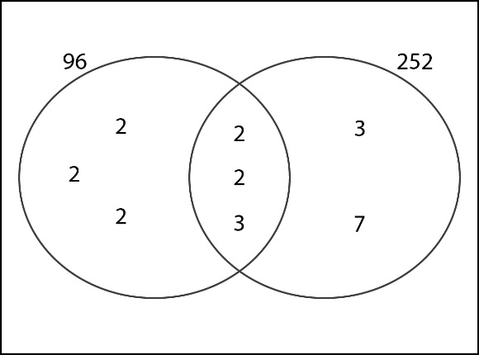**8** **a** 210 **b** 17

**9** **a**

**Chapter 1: Answers to Challenge – Blackpool Tower**

**1** 7111 gallons

**2** **a**  **b** 2 p

**3** **a** The Eiffel Tower was cheaper by 61p, at £8.89 **b** 2 times **c** 13 times

**4** 437 cm²

**5** £78 840

**6** **a** 190 million **b** 6.57 m

**7** No, D = 39.5 km and the Isle of Man is 42 km away

**Exercise 2A**

**1 a** *e* **b** *f* **c** *g* **d** *h* **e** *d* **f** *c*

**2 a** *a* = 70º **b** *b* = 125º **c** *c* = 160º **d** *d* = 48º

**e** *e* = 75º **f** *f* = 57º **g** *g* = 121º **h** *h* = 34º

**3** b, the other two show a pair of alternate angles

**4** c, the other two show a pair of corresponding angles

**5** a, the other two show a pair of allied angles

**6 a** *a*= 50º (alternate angles) **b** *b*= 62º (corresponding angles)

**c** *c*= 108º (alternate angles ) **d** *d*= 41º (alternate angles)

**e** *e*= 124º (corresponding angles) **f** *f*= 63º (corresponding angles)

**7 a** *a*= 122º (angles on a line), *b* = 58º (corresponding angles or allied angles),

*c* = 58º (opposite angles)

**b** *d* = 60º (opposite angles), *e* = 60º (corresponding angles), *f* = 120º (allied angles)

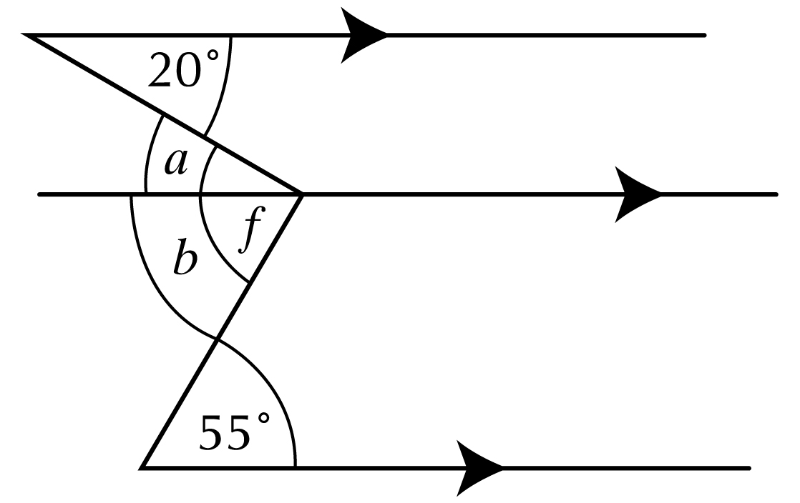**8** *x* and *y* are allied angles and add up to 180°

**9**

Extend the middle parallel line to split angle *f* into 2 angles *a* and *b*

*a* = 20° (alternate angles are equal)

*b* = 55° (alternate angles are equal)

So *f* = 20° + 55° = 75°

**Mathematical reasoning: More about parallel lines**

*Note: other reasons are possible*

**A** *a* = 85o (corresponding angles are equal), *b* = 75o (corresponding angles are equal),

*c* = 85o (alternate angles are equal)

**B** *d* = 90o (alternate angles are equal), *e* = 42o (alternate angles are equal)

**C** *f* = 65o (corresponding angles are equal)*, g =* 115o (angles on a line add up to 180°)

*h* = 65o (corresponding angles are equal), *i* = 115o (allied angles add up to 180°)

**D** *j* = 98o (angles on a line add up to 180°), *k* = 33o (alternate angles are equal),

*l* = 147o (angles on a line add up to 180°), *m* = 98o (allied angles add up to 180°)

**E** *n* = 35o (angles on a line add up to 180°, then angles in a triangle add up to 180°),

*o* = 83o (corresponding angles are equal, then angles on a line add up to 180°),

*p* = 118o (opposite angles are equal), *q* = 118o (corresponding angles are equal)

**Exercise 2B**

**1 No lines of One line of Two lines of Four lines of**

**symmetry symmetry symmetry symmetry**

Parallelogram Kite Rectangle Square

Trapezium Arrowhead Rhombus

**2 Rotational symmetry Rotational symmetry Rotational**

**of order one of order two symmetry of order four**

Kite Rectangle Square

Arrowhead Parallelogram

Trapezium Rhombus

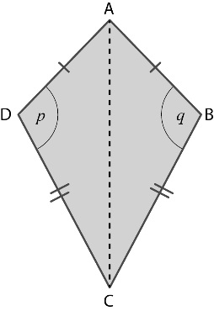**3** Rectangle **4** Parallelogram

**5** Wrong, it could be a rhombus

**6** Wrong, it could be a parallelogram or a rhombus

**7** Parallelogram, rhombus

**8** Use the line of symmetry   
AC on the kite.

So triangle ADC is   
identical to triangle ABC.

So *p* = *q*.

**Investigation: Rectangles into squares**

For example, for a 4 by 2 rectangle, 3 different ways

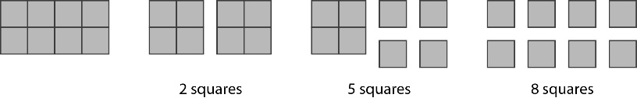

4 by 2

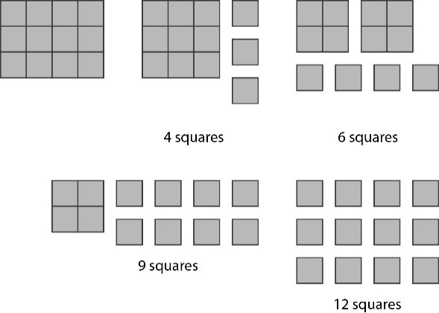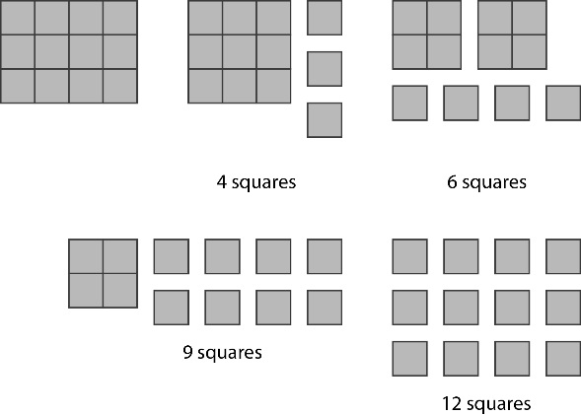For example**,** for a 4 by 3 rectangle, 4 different ways

4 by 3

**Exercise 2C**

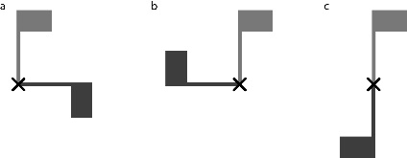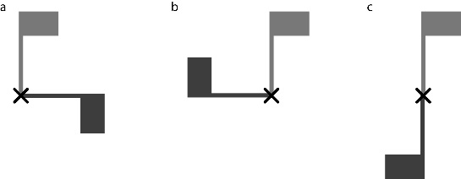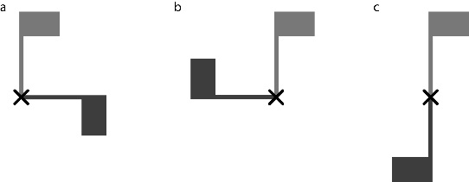**1 a b c**

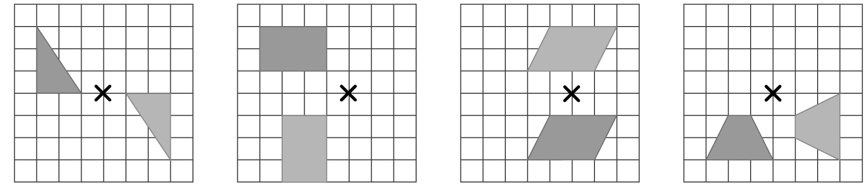**2 a b c d**

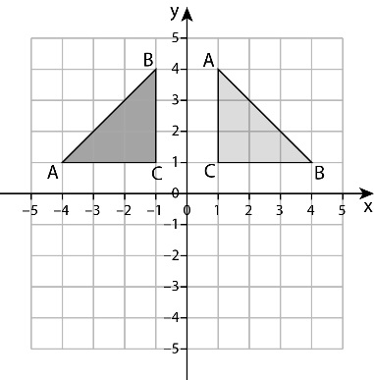**3 i a**

**b** A(1, 4), B(4, 1), C(1, 1) **c** A’(−4, 1), B’(−1, 4), C’(−1, 1)

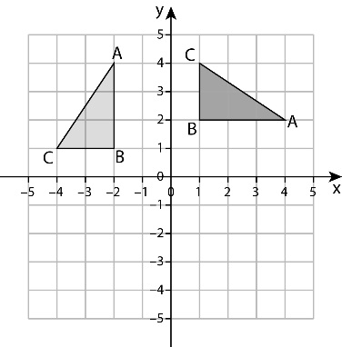**ii a**

**b** A(−2, 4), B(−2, 1), C(−4, 1) **c** A’(4, 2), B’(1, 2), C’(1, 4)

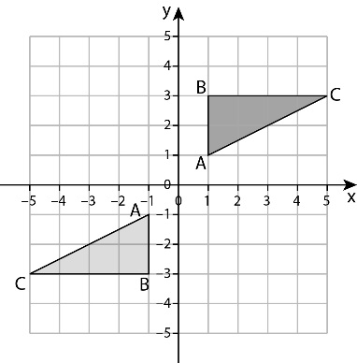**iii a**

**b** A(−1, −1), B(−1, −3), C(−5, −3) **c** A’(1, 1), B’(1, 3), C’(5, 3)

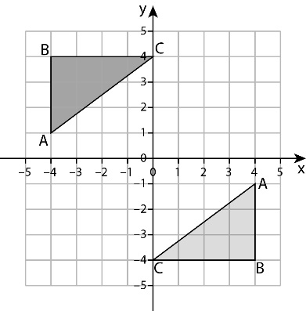**iv a**

**b** A(4, −1), B(4, −4), C(0, −4) **c** A’(−4, 1), B’(−4, 4), C’(0, 4)

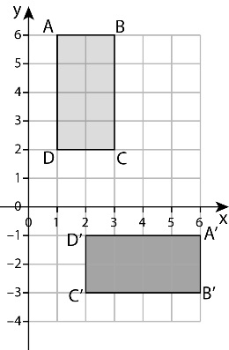**4 a   
 b** A’(6, −1), B’(6, −3), C’(2, −3), D’(2, −1) **c** A rotation through

90° anticlockwise about the origin O

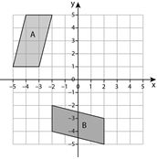**5 a**

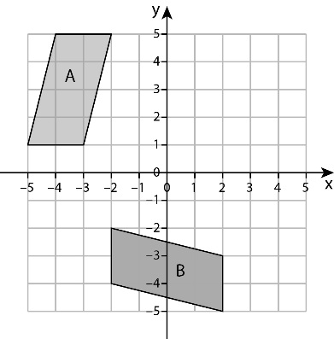

**b** A rotation through 90° clockwise about the point (2, 1) or a rotation through 270° anticlockwise about the point (2, 1)

**Challenge: Finding the centre of rotation**

**A** A rotation of 90° anticlockwise (or 270° clockwise) about the point (2, 0)

**B** A rotation of 180° clockwise (or anticlockwise) about the point (1, 0)

**C** A rotation of 90° clockwise (or 270° anticlockwise) about the point (1, −1)

**Exercise 2D**

**1 a** 6 units right

**b** 3 units right and 3 units down

**c** 6 units down

**d** 7 units right and 5 units down

**e** 6 units left and 6 units down

**f** 4 units right and 2 units down

**g** 7 units right and 1 unit up

**h** 7 units left and 5 units up

**2 a** A(1, 4), B(4, 2), C(1, 2)

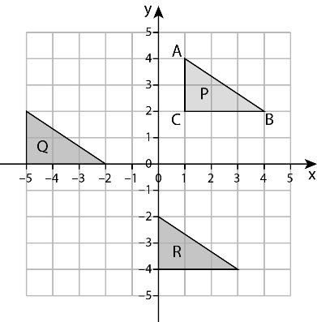 **b** and **d**

**c** (–5, 2), (–2, 0), (–5, 0)

**e** (0, –2), (3, –4), (0, –4)

**f** 1 unit right and 6 units up

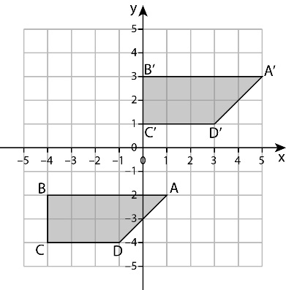**3 a**

**b** A’ (5, 3), B’ (0, 3), C’ (0, 1), D’ (3, 1)

**c** Only the position has changed. The size and orientation of the trapezium have stayed the same.

**4 a** A (3, −1), B (2, −3), C (3, −5), D (4, −3)

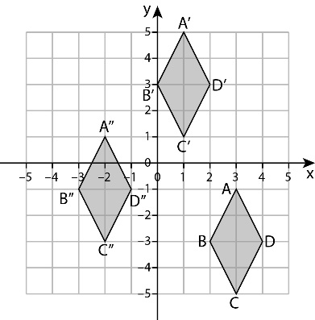 **b** and **d**

**c** A’ (1, 5), B’ (0, 3), C’ (1, 1), D’ (2, 3)

**e** A’’ (−2, 1), B’’ (−3, −1), C’’ (−2, −3),

D’’ (−1, −1)

**f** Translation 5 units right and 2 units down

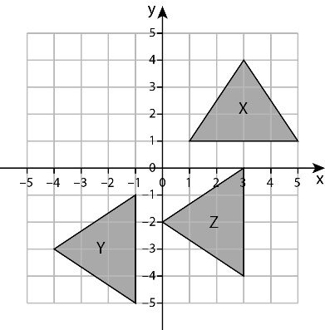**5 a** and **b**

**c** Translate triangle Z 4 units left and 1 unit down back to triangle Y and then rotate triangle Y through 90° clockwise about the origin *O* back to triangle X.

**Investigation: Dotty translations**

Check pupils’ answers

**Exercise 2E**

Check pupils’ drawings.

**Activity: Construct a line parallel to a given line and passing through a given point**

Check pupils’ drawings

**Chapter 2: Answers to Review Questions**

**1 a b c**

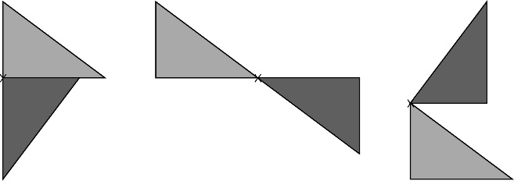

**2 a** and **b c** 1 unit left and 3 units up

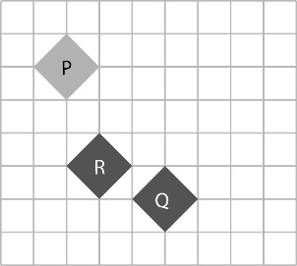

**3 a** *a* = 112° (alternate angles are equal) **b** *b* = 56° (corresponding angles are equal)

**c** *c* = 43° (allied angles add up to 180°) **d** *d* = 98° (corresponding angles are equal)

**4 a** ∠CBD and∠ABH (alternate angles)

**b** 50° (the two other angles in the isosceles triangle are equal)

**c** 95° (allied angles add up to 180°)

**5 a** 110° (allied angles add up to 180°)

**b** 360° – 3 × 70° = 150°, *m* = 150° ÷ 3 = 50° or 360° ÷ 3 = 120°, *m* = 120° – 70° = 50°

**6 a** A(1, 4), B(3, 4), C(3, 1)

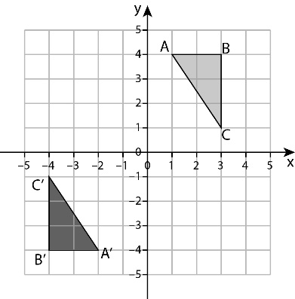**b**

**c** A’(−1, −4), B’(−3, −4), C’(−3, −1)

**d** They are the same as triangle ABC, but with a minus sign for each coordinate.

**e** P’(−2, −1), Q’(−3, −5), R’(−4, −1)

**Chapter 2: Answers to Challenge – More constructions**

Check pupils’ constructions.

**Exercise 3A**

**1 a**  =  **b**  =  **c**  =  **d**  = 

**e**  =  **f**  **g**  **h**  =  **i**  = 

**2** 24,  of 32 is 8 so there are 8 black counters

**3 a** 0.25 **b** 0.2 **c** 0.4 **d** 0.1 **e** 0.05 **f** 0.9

**4 a i**  **ii**  **b i**  **ii** 

**5 a**  **b** 3

**6 a**  **b** green

**7** Not A→0.8, not B→0.7, not C→0.4, not D→0

**8** A =  B =  C =  D =  E =  F =  G = 

**9 a**  =  **b**  =  **c**  =  **d**  =  **e**  = 

**f**  =  **g**  =  **h**  =  **i**  =  **j**  =  **k** 

**10 a**  =  **b**  =  **c**  =  **d** 0

**e**  =  **f**  =  **g**  =  **h** 1

**Exercise 3B**

**1 a** Check pupils’ diagrams

**b** Not exclusive due to 3 and 5 being in the intersection **c**  = 

**2 a** Check pupils’ diagrams

**b** Not exclusive due to 2 and 3 being in the intersection **c**  = 

**3 a** Yes **b** No **c** No **d** No **e** No **f** No

**g** Yes **h** No **i** No **j** Yes **k** No **l** No

**4 a** No, any other colour may simply have not appeared in the sample **b** i, iii

**5 a** 1p, 2p, 3p, 5p, 6p, 7p, 8p **b** More because chance

**c** 1p, 2p, 3p, 5p, 6p, 7p, 8p, 10p, 11p, 12p, 13p, 15p, 16p, 17p, 18p

**d** Same chance as each other of 

**6 a** 3p, 6p, 7p, 11p, 12p, 15p, 21p, 22p, 25p, 30p, 51p, 52p, 55p, 60p, 70p, £1.01, £1.02, £1.05, £1.10, £1.20, £1.50, £2.01, £2.02, £2.05, £2.10, £2.20, £2.50, £3.00

**b** More than 60p, chance of  = 

**7 a**

|  |  |  |
| --- | --- | --- |
| +2 | +1 | 3 |
| +4 | 0 | 4 |
| +4 | –1 | 3 |
| +4 | +1 | 5 |
| –3 | 0 | –3 |
| –3 | –1 | –4 |
| –3 | +1 | –2 |

**b i** Positive () **ii** Odd ()

**Challenge: Four men run a race**

Check pupils’ answers

**Exercise 3C**

**1 a** Check pupils’ drawings

**b i**  **ii**  =  **iii**  =

**2 a** BB, BG, GB, GG **b** Because it’s 

**3 a** AA, AB, AP, BB, BP, PP **b** More pears in the bag than bananas

**4 a**

|  |  |
| --- | --- |
| Plain | Beans |
| Cheese | Plain |
| Cheese | Cheese |
| Cheese | Beans |
| Beans | Plain |
| Beans | Cheese |
| Beans | Beans |

**b i**  **ii**  **iii**  **iv**  **v**  **vi**  **vii**  **viii** 

**5 a** 7 **b i**  = **ii**  =  **iii** 0 **iv**  **v**  = 

**vi**  =  **vii**  =  **viii**  =  **ix**  =  **x**  = 

**6 a** Check pupils’ drawings **b** 12 **c**  = 

**7** 

**8 a** Check pupils’ diagrams **b**  = 

**Problem solving: Odd socks**



**Exercise 3D**

**1 a** Greater chance to crash as it has a chance higher than 

**b** The 250 days as there are more results **c** 175 ÷ 250 **d** 0.7

**2 a** Yes, the 19 fives is much higher than you would expect

**b** Do more trials **c** 0.12 **d** 0.23 **e** 0.81

**3 a-c** Check pupils’ charts **d** It should be getting closer to 0.5

**4 a** Check pupils’ tables **b**  = **c**  = 

**d** Take it over a longer period of time

**5 a** 17 weeks and 6 days

**b** It is too small a sample

**c**  **d** Yes, as 80% of the bulbs did last longer than 3000 hours

**Problem solving: Roll the dice!**

Answers will vary.

**Chapter 3: Answers to Review Questions**

**1 a** 0.5 **b** 0.3 **c** 0.1 **d** 0.4

**2 a** triangles with angles 10,80,90 ; 20,90,70 ; 30,100,50 ; 40,110,30 ; 50,120,10

**b i**  **ii**  **c** 

**3** 

**4 a** , , , , , , , , , , , , , , 

**b**  = 

**5 a** 10% **b** 0.2

**6 a**  **b** 

**7** For example –6, –5, –3, –1, 2, 4

**8 a** 2 **b**  = 

**Chapter 3: Answers to Financial Skills – Fun in the fairground**

**1** £160

**2 a**  **b**  **c** 

**3 a**  **b** 

**4 a** £6.25 **b** 

**5 a** 4 watches, 16 £10 notes, 8 £1 coins **b** £625 **c** £393

**6 a**  **b**  **c** 

**7** 

**8 a** 5 **b** £2

**9 a** 250 **b** 6 **c** 50

**10 a** 625 **b** 486 **c** 125 **d** 14 **e** £137.94

**Exercise 4A**

**1 a** 50% **b** 80% **c** 90% **d** 70% **e** 85% **f** 56% **g** 95% **h** 76% **i** 38%

**2 a** 30% **b** 15% **c** 12% **d** 10% **e** 6% **f** 3%

**3 a** 75% **b** 54% **c** 75% **d** 40% **e** 65% **f** 45%

**4 a** 10% **b** 60% **c** 90% **d** 70% **e** 20% **f** 5%

**5 a** 4% **b** 10% **c** 32% **d** 80% **e** 20%

**6 a** 40% **b** 40% **c** 4% **d** 60% **e** 29% **f** 10%

Answers are given to the nearest whole number

**7 a** 46% **b** 25% **c** 92% **d** 86% **e** 9% **f** 38%

**8 a** 58% **b** 58% **c** 68% **d** 35% **e** 37% **f** 37%

**9** 8%

**10 a** 68%, 74% and 70% **b** Maths has the highest percentage

**11 a** 48% **b** 87% **c** 9%

**12** 35%

**13** 25%

**14 a** 39% **b** 61%

**15 a** 43% **b** 57%

**16 a** 18% **b** 25%

**17 a** 78% **b** 21% **c** 1%

**18 a** Yes. 20% of 50 = 10

**b** No. There are 60 people in the room and 20% of 60 is 12, not 10

**Challenge: What is in the waste?**

**A** These are the percentages:

|  |  |  |
| --- | --- | --- |
|  | Smith family | Jones family |
| Kitchen scraps | 32% | 29% |
| Plastics | 8% | 4% |
| Card or paper | 4% | 20% |
| Other | 56% | 47% |

**B** Pie charts or a sectional bar chart are good choices

**Exercise 4B**

**1 a** 1.2 **b** £103.20

**2 a** £38.40 **b** £73.20 **c** £220.80 **d** £11.28

**3 a i** 1.3 **ii** 1.36 **iii** 1.43 **iv** 1.06

**b i** £93.60  **ii** £97.92 **iii** £102.96 **iv** £76.32

**4 a** £48.30 **b** £56.70 **c** £77.70 **d** £81.90

**5 a** £16.47 **b** £53.31 **c** £173.24 **d** £469.82

**6 a** 49.98 kg **b** 58.38 kg **c** 66.78 kg **d** 80.64 kg

**7 a** 272.7 cm **b** 353.7 cm **c** 407.7 cm **d** 461.7 cm

**8 a** 0.85 **b i** £53.55 **ii** £44.63 **iii** £222.70 **iv** £50.99

**9 a** 0.9 **b** 0.7 **c** 0.63 **d** 0.57 **e** 0.25

**10 a** £69 **b** £23.40 **c** £17.70 **d** £45.48

**11 a** £24.44 **b** 17.6 kg **c** 38.08 minutes

**d** 418.5 ml **e** 237.65 m **f** 125 hours

**12** 360 × 1.1 = 396 and 396 × 0.9 = 356.4 so the price is £356.40

**13 a** 54 720 **b** 59 280

**Financial skills: Percentage reduction**

**A** First row: 36, 28, 16; second row 67.50, 52.50, 30; third row 112.50, 87.50, 50; last row 315, 245, 140

**B** No, 60% off is better. People might make a mistake because 30 is less than 60 and confuse the amount off with the amount left after the reduction

**Exercise 4C**

**1 a** The multiplier is 378 ÷ 360 = 1.05 **b** 5%

**2 a** 1.6 **b** 60%

**3 a** 1.41 **b** 41%

**4** 65%

**5** 47%

**6** 7%

**7** 45%

**8 a** 0.97 **b** 3%

**9 a** 0.74 **b** 26%

**10 a** 62% **b** 34% **c** 17%

**11 a** 26% **b** 7% **c** 27%

**12**  5%

**13** Red 5% increase, White 55% decrease, Blue 6% increase

**14 a** 8 cm **b** 12.8 cm

**15 a** £33 280 **b** £34 611.20

**Problem solving: Five go on a diet**

**A** 85 kg, 92 kg, 106 kg, 118 kg, 133 kg

**B** 85.5 kg, 92.15 kg, 105.45 kg, 116.85 kg, 131.1 kg

**C** Pupils’ own answer, with reason. Answers may vary.

**Exercise 5A**

**1 a** 3, 8, 13, 18, 23, 28, 33, 38, 43

**b** 10, 100, 1000, 10 000, 100 000, 1 000 000, 10 000 000

**c** 1, 4, 9, 16, 25, 36, 49, 64, 81, 100, 121

**d** 1, 3, 6, 10, 15, 21, 28, 36

**2** Powers of 10

**3** Square numbers

**4** Triangle numbers

**5 a** Add 3

**b** Multiply by 4

**c** Increases by 3, 4, 5, 6, 7, … or add consecutive whole numbers starting at 3

**d** Increases by 3, 5, 7, 9, … or add consecutive odd numbers starting at 3

**6** For example 1, 5, 9, 13, 17 (add 4); 1, 5, 25, 125, 625 (multiply by 5);

1, 5, 11, 19, 29 (add consecutive even numbers starting at 4)

**7 a** Increases 1, 2, 3, 4, 5, … 61, 68 **c** Increases 2, 4, 6, 8, 10, … 43, 57

**b** Goes down 1, 2, 3, 4, … 69, 62 **d** Increases 4, 6, 8, 10, 12, … 56, 72

**8 a** 1, 3, 9, 27, 81, 243

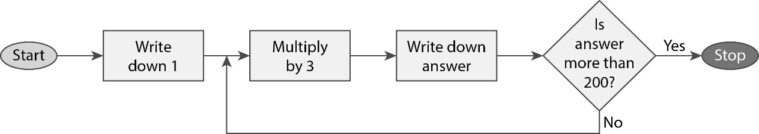

**b** 2, 4, 8, 16, 32, 64

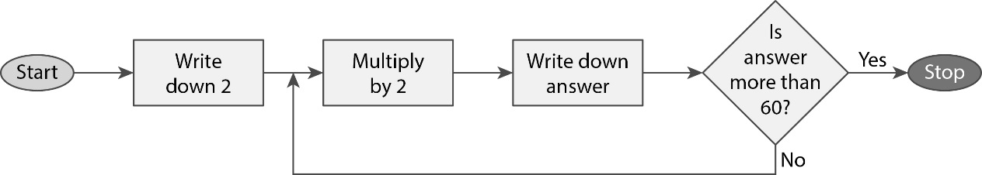

**c** 16, 8, 4, 2, 1, ½

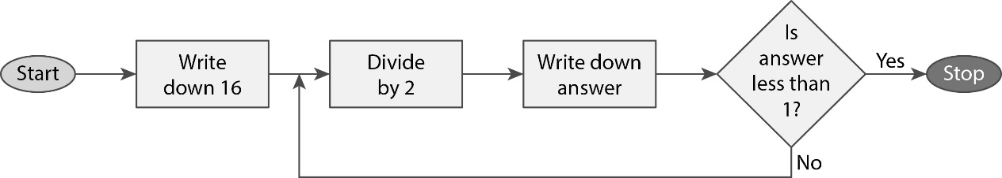

**d** 4, 1, −2, −5, −8, −11

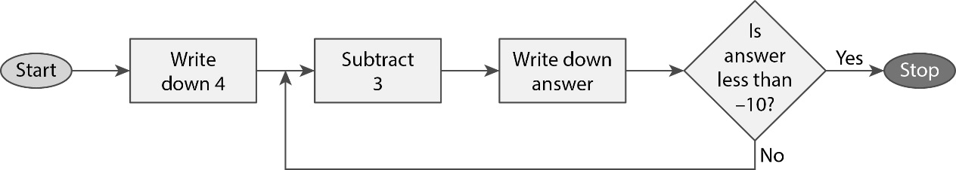

**9 a** 25, 36, 49, 64 **b** 15, 21, 28, 36 **c** 16, 32, 64, 128 **d** 30, 42, 56, 72

**Problem solving: Algebraic flow diagrams**

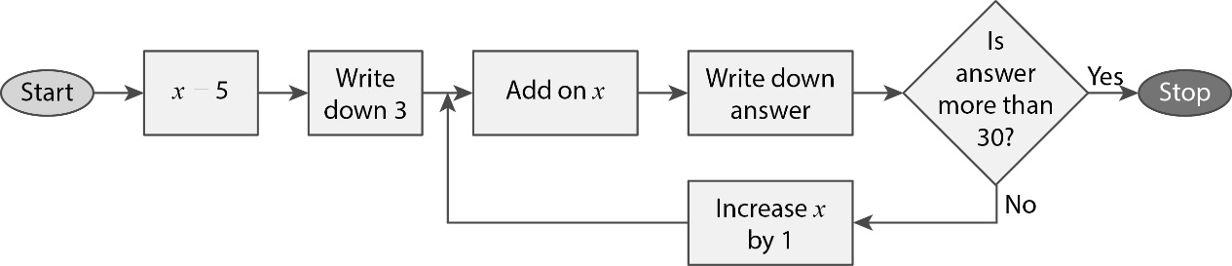**A**

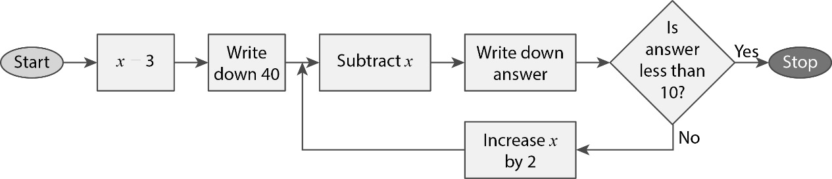**B**

**C**

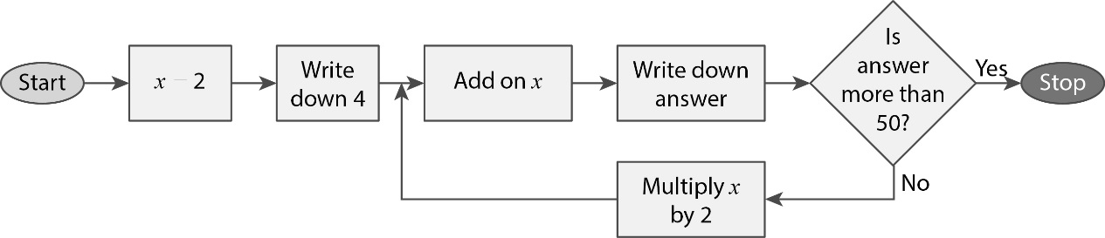

**Exercise 5B**

**1 a i** 7, 9, 11 **ii** 205 **b i** 3, 7, 11 **ii** 399 **c i** 2, 7, 12 **ii** 497

**d i** 5, 8, 11 **ii** 302 **e i** 9, 13,17 **ii** 405 **f i** 11, 21, 31 **ii** 1001

**g i** 2, 3, 3 **ii** 52 **h i** 6, 13, 20 **ii** 699 **i i** , , 1 **ii** 49

**j i** 9, 8, 7 **ii** −90 **k i** 18, 16, 14 **ii** −180 **l i** 4, 1, −2 **ii** −293

**2 a i** 3, 5, 7, 9 **ii** 3 **iii** 2 **b i** 4, 6, 8, 10 **ii** 4 **iii** 2

**c i** 5, 7, 9, 11 **ii** 5 **iii** 2 **d i** 6, 8, 10, 12 **ii** 6 **iii** 2

**3 a i** 4, 9, 14, 19 **ii** 4 **iii** 5 **b i** 7, 12, 17, 22 **ii** 7 **iii** 5

**c i** 1, 6, 11, 16 **ii** 1 **iii** 5 **d i** 8, 13, 18, 23 **ii** 8 **iii** 5

**4 a i** 2, 5, 8, 11 **ii** 3 **b i** 6, 10, 14, 18 **ii** 4

**c i** 2, 8, 14, 18 **ii** 6 **d i** 13, 23, 33, 43 **ii** 10

**5** They are the same.

**6 a** *a* = 4, *d* = 5 **b** *a* = 1, *d* = 2 **c** *a* = 3, *d* = 6 **d** *a* = 5, *d* = –2

**7 a** 1, 8, 15, 22, 29, 36, … **b** 3, 5, 7, 9, 11, 13, … **c** 5, 9, 13, 17, 21, 25, …

**d** 0.5, 2, 3.5, 5, 6.5, 8, … **e** 4, 1, –2, –5, –8, –11, … **f** 2, 1.5, 1, 0.5, 0, –0.5, …

**8 a** 22 **b** 5*n* + 2 **c** 252

**Investigation: An *n*th term investigation**

**A**

|  |  |  |  |  |  |
| --- | --- | --- | --- | --- | --- |
| **Sequence** | **First term, *a*** | **Difference, *d*** | ***n*th term** | **Coefficient**  **of *n*** | **Constant**  **term, *c*** |
| 5, 7, 9, 11, 13, … | 5 | 2 | 2*n* + 3 | 2 | 3 |
| 8, 11, 14, 17, 20, … | 8 | 3 | 3*n* + 5 | 3 | 5 |
| 8, 12, 16, 20, 24, … | 8 | 4 | 4*n* + 4 | 4 | 4 |
| 7, 13, 19, 25, 31, … | 7 | 6 | 6*n* + 1 | 6 | 1 |
| 4, 9, 14, 19, 24, … | 4 | 5 | 5*n* – 1 | 5 | -1 |
| 2, 6, 10, 14, 18, … | 2 | 4 | 4*n* – 2 | 4 | -2 |

**B** *d* = coefficient of *n*

**C** *c* = *a* – *d*

**Exercise 5C**

**1 a** 6*n* – 2 **b** 3*n* + 6 **c** 6*n* + 3 **d** 3*n* – 1 **e** 7*n* – 5

**f** 2*n* + 6 **g** 4*n* + 6 **h** 8*n* – 5 **i** 10*n* – 1 **j** 9*n* – 5

**2 a i** 4*n* + 1 **ii** 201 **b i** 5*n* + 1 **ii** 251 **c i** 3*n* – 1 **ii** 149 **d i** 7*n* + 1 **ii** 351

**3 a**

|  |  |  |
| --- | --- | --- |
| Pattern | Number of blue squares | Number of red squares |
| 1 | 1 | 2 |
| 2 | 3 | 4 |
| 3 | 5 | 6 |
| 4 | 7 | 8 |

**b** 2*n* – 1  **c** 2*n* **d** 4*n* – 1

**4 a** 95 – 5*n* **b** 50 – 7*n* **c** 31 – 3*n* **d** 52 – 8*n*

**5 a** 0.5*n* + 2 **b** 2.5*n* + 8 **c** 0.1*n* + 3 **d** 8.2 – 0.2*n*

**6 a i** 4*n* **ii** 3*n +* 1 **iii** 7*n* + 1 **b i** 80 **ii** 61 **iii** 141

**7 a** £31 **b** £(3*n* +1)

**8** These are examples. Other answers are possible:

**a** *a*= 2, add 2,*l* =10: 2, 4, 6, 8, 10 **b** *a*= 1, add 2,*l* = 9: 1, 3, 5, 7, 9

**c** *a*= 5, add 5,*l* = 25: 5, 10, 15, 20, 25 **d** *a*= 1, add 2, 3, 4, …,*l* = 15: 1, 3, 6, 10, 15

**e** *a*= 1, add 10, *l*= 51: 1, 11, 21, 31, 41, 51 **f** *a*= 1, add 3,*l* = 13: 1, 4, 7, 10, 13

**g** *a*= 1, multiply by –2, *l*= 16: 1, –2, 4, –8, 16

**Mathematical reasoning: Square sequences**

**A** *n*2

**B** *n*2 + 1

**C** *n*2 – 1

**D** *n*2

**E** *n*2 + *n*

**Exercise 5D**

**1** 1, 1, 2, 3, 5, 8, 13, 21, 34, 55, 89, 144, 233, 377, 610

**2** 1, 144

**3** 1, 3, 21, 55

**4** 2, 3, 5, 13, 89, 233

**5 a** 26**,** 42, 68, 110 **b** 39, 63, 102, 165 **c** 29, 47, 76, 123 **d** 42, 68, 110, 178

**6 a i** 4 **ii** 7 **iii** 12

**b T**he answers are all 1 less than two terms further on in the sequence

**7** e.g. Take 5, 8, 13 21. 5 × 21 = 105, 8 × 13 = 104. Difference = 1.

Take 21, 34, 55, 89. 21 × 89 = 1869. 34 × 55 = 1870. Difference = 1.

Take 2, 3, 5, 8. 2 × 8 = 16. 3 × 5 = 15. Difference = 1. The rule always works

**8 a**

|  |  |  |
| --- | --- | --- |
| Term | Previous term | Answer |
| 1 | 1 | 1 |
| 2 | 1 | 2 |
| 3 | 2 | 1.5 |
| 5 | 3 | 1.66666… |
| 8 | 5 | 1.6 |
| 13 | 8 | 1.625 |
| 21 | 13 | 1.61538… |
| 34 | 21 | 1.61904… |
| 55 | 34 | 1.61764… |
| 89 | 55 | 1.61818… |

**b** The numbers are getting closer to the decimal 1.618 …. This number is known as the ‘Golden ratio’ and is1.618 033988 749894 84820 to 20 decimal places

**Investigation: Steps and stairs**

**A** 3 (1+1+1, 1+2, 2+1)

**B** 5 (1+1+1+1, 1+1+2, 1+2+1, 2+1+1, 2+2)

|  |  |
| --- | --- |
| Number of stairs | Number of ways |
| 1 | 1 |
| 2 | 2 |
| 3 | 3 |
| 4 | 5 |
| 5 | 8 |

**C**

**D** The numbers are in the Fibonacci sequence

**E** There are 377 ways of going up 13 stairs. The sequence is 1, 2, 3, 5, 8, 13, 21, 34, 55, 89, 144, 233, 377

**Chapter 5: Answers to Review Questions**

**1 a** 3, 5, 7, 9, 11, 15, 17, 19 **b** 10, 5, 0, –5, –10, –15, –20, –25

**c** 1, –2, 4, –8, 16, –32, 64, –128, 256 **d** 5000, 500, 50, 5, 0.5, 0.05

**2 a** 3, 8, 13, 18, 23, 28 **b** 4, 6.5, 9, 11.5, 14, 16.5

**c** 10, 6, 2, −2, −6, −10 **d** −5, −8, −11, −14, −17, −20

**3 a** £420 **b** £440 **c** £460 **d** £480 **e** 20*n* + £400

**4 a** 6*n* – 3 **b** 3*n* + 7 **c** 6*n* + 1 **d** 3*n* – 1

**5 a** 5*n* + 1 **b** 51 **c** 20 **d** 39, 4

**6 a i** Add 1 **ii** 4*n* + 2 **b i** Divide by 2 **ii** 3*n* + 3

**c i** Subtract 4 **ii** 19 – 3*n* **d i** Multiply by2 **ii** 10*n* – 6

**7 a i** 2, 5, 10, 17 **ii** 401 **b i** 4, 9, 16, 25 **ii** 441

**c i** 4, 7, 12, 19 **ii** 403 **d i** 4, 10, 18, 28 **ii** 460

**e i** 4, 11, 30, 67 **ii** 8003

**Chapter 5: Answers to Investigation – Pond borders**

**A a** 18 **b** 2*n* + 6 **c** 46

**B a** 22 **b** 2*n* + 8 **c** 48

**Exercise 6A**

**1 a** 35 cm2 **b** 108 cm2 **c** 24.5 cm2 **d** 6m2 **e** 28m2

**2 a** 15 cm2 **b** 60 cm2 **c** 270mm2

**3 a** 17.5 cm2 **b** 30m2 **c** 120mm2

**4 a** 15cm2 **b** 28cm2 **c** 27.5m2 **d** 8mm **e** 7m

**5 a** 6cm2 **b** 10 cm2 **c** 6cm2 **d** 12 cm2

**6 a** 6m2 **b** 45 cm2 **c** 12m2

**7** 72 m2

**8** Triangles for which the product of the base and the height is 72

e.g., 1 × 72, 2 × 36, 3 × 24, 4 × 18, 6 × 12, 8 × 9

**Investigation: Compound triangles**

**A** *A* = 1 + 3 + 6 + 10 = 20cm2

**B** The sequence is 1, 3, 6, 10 and the rule for the sequence is ‘add on 1 more each time’. The next number in the sequence is 15

**C** The area of the new shape is 20 + 15 = 35cm2

**Exercise 6B**

**1 a** 36 cm2 **b** 150 cm2 **c** 768mm2

**2 a** 80 cm2 **b** 49m2 **c** 80 cm2

**3 a** 88.2 cm2 **b** 30 cm2

**4 a** 32 cm2 **b** 204 cm2 **c** 40m2 **d** 4mm **e** 3.5m

**5 a** 20 cm2 **b** 15 cm2 **c** 24 cm2

**6** 4.5 cm

**7** 6.25cm

**8 a** 34cm **b** 57cm2

**9** 6cm

**Challenge: Area of a rhombus**

**a** 38.5 cm2 **b** 96 cm2 **c** 720mm2

**Exercise 6C**

**1 a** 72 cm2 **b** 25 cm2 **c**3m2 **d** 22m2 **e** 325mm2

**2 a** 15 cm2 **b** 66 cm2 **c**30m2 **d** 4cm **e** 10cm **f** 10m

**3** 30m2

**4** 56cm2

**5** 44 cm²

**6** *a* = 6 cm, *b* = 14 cm

**7**  75 cm²

**8** 72cm2

**9** 8 cm

**10** Values of *a*, *b* and *h* with (*a* + *b*) × *h* = 12 and *b* >*a*

(for example, *a* = 1, *b* = 5, *h* = 2; *a* = 2, *b* = 4, *h* = 2; *a* = 1, *b* = 2, *h* = 4)

**Problem solving: Pick’s formula**

**A**

|  |  |  |  |
| --- | --- | --- | --- |
| **Shape** | **Number of dots on perimeter of shape** | **Number of dots inside shape** | **Area of shape (cm2)** |
| **a** | 8 | 1 | 4 |
| **b** | 12 | 3 | 8 |
| **c** | 8 | 3 | 6 |
| **d** | 4 | 2 | 3 |
| **e** | 9 | 4 | 7.5 |
| **f** | 10 | 4 | 8 |
| **g** | 11 | 3 | 7.5 |
| **h** | 14 | 4 | 10 |

**B** *A* = *P* + *I* – 1

**C** Check pupils’ shapes

**Exercise 6D**

1. **a** 208cm2 **b** 164cm2 **c** 290 cm2 **d** 40cm2
2. 214cm2
3. **a** 96cm2 **b** 216cm2 **c** 384cm2 **d** 486cm2
4. **a** 6cm2 **b** 150cm2 **c** 600cm2 **d** 864cm2

**5** 1238cm2

**6** 62m2

**7** 16 400cm2

**8** 44m2

**Investigation: An open box problem**

**A**

|  |  |  |
| --- | --- | --- |
| **Size of square cut off** | **Area of the four squares** | **Surface area of box** |
| 1cm by 1cm | 4cm2 | 248cm2 |
| 2cm by 2cm | 16cm2 | 236cm2 |
| 3cm by 3cm | 36cm2 | 216cm2 |
| 4cm by 4cm | 64cm2 | 188cm2 |
| 5cm by 5cm | 100cm2 | 152cm2 |
| 6cm by 6cm | 144cm2 | 108cm2 |

**B** The width of the card would be 0

**C a** 12, 20, 28, 36, 44 **b** add 8 **c** 8*n* + 4

**Chapter 6: Answers to Review questions**

**1 a** Pack of 24 **b** 1300cm2

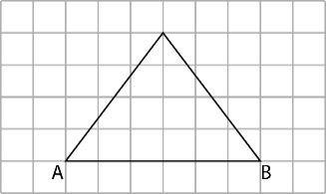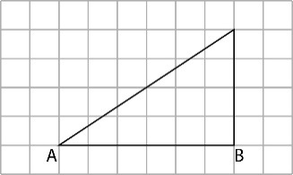**2 a** For example: **b**

**3 a** 31.5cm2 **b** 25cm2 **c** 12m2

**4** 24cm2

**5 a** 13.5m2 **b** 70cm2 **c** 60cm2

**6 a** *l* = 5cm; *h* = 4cm; *w* = 3cm **b** 94cm2

**Chapter 6: Answers to Investigation – A cube investigation**

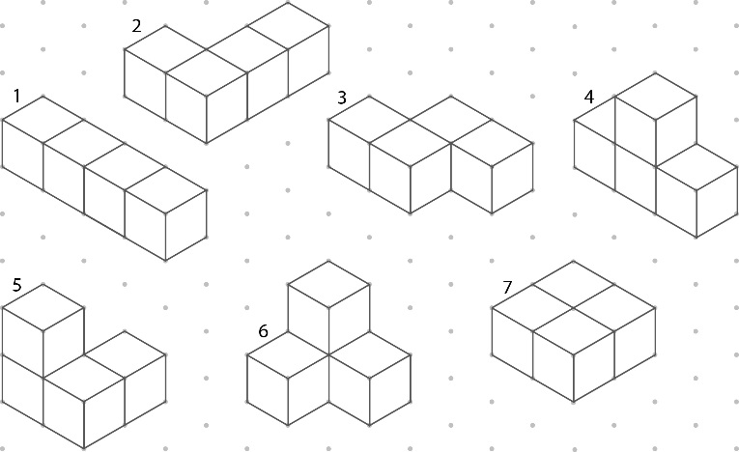**1**

**2**

|  |  |  |  |  |  |  |  |
| --- | --- | --- | --- | --- | --- | --- | --- |
| **3D shape** | **1** | **2** | **3** | **4** | **5** | **6** | **7** |
| **Surface area** | 18cm2 | 18cm2 | 18cm2 | 18cm2 | 18cm2 | 18cm2 | 16cm2 |

**3** Shape 7 has the least surface area and the rest have the same surface area. The shape with the least surface area has four pairs of faces touching, so leaving 16 faces exposed.

The other six have three pairs of faces touching, so leaving 18 faces exposed.

**4** A shape made from five cubes must have four or five pairs of faces touching, so the surface areas are either 20cm2 or 22cm2.

For all the shapes in this investigation, the surface area is an even number of square centimetres.

Two cubes have 12 faces in total, so if one pair of faces is touching, then 10 faces are exposed.

Three cubes have 18 faces in total, so if two pairs of faces are touching, then 14 faces are exposed.

A shape made from four cubes must have three or four pairs of faces touching, so either 16 or 18 faces are exposed.

**Exercise 7A**

**1 a** 1, 2, 3, 4, 5, 6 **b** and **c** Graph with straight line through (–2, 1) and (3, 6)

**2 a** –4, –3, –2, –1, 0, 1

**b** and **c** Graph with straight line through (–2, –4) and (3, 1)

**3 a** –6, –3, 0, 3, 6, 9 **b** and **c** Graph with straight line through (–2, –6) and (3, 9)

|  |  |  |  |  |  |
| --- | --- | --- | --- | --- | --- |
| –2 | –1 | 0 | 1 | 2 | 3 |
| –4 | –2 | 0 | 2 | 4 | 6 |
| –8 | –4 | 0 | 4 | 8 | 12 |

**d**

**f** All straight and pass through (0,0)

**g i** Graph with straight line through (–2,

–5) and (3, 7.5) **ii** graph with straight

line through (–2, –1) and (3, 1.5)

|  |  |  |  |  |  |
| --- | --- | --- | --- | --- | --- |
| –8 | –4 | 0 | 4 | 8 | 12 |
| –7 | –3 | 1 | 5 | 9 | 13 |

**4 a**

**b** and **c** Graph with straight line through

(–2, –7) and (3, 13)

|  |  |  |  |  |  |
| --- | --- | --- | --- | --- | --- |
| –8 | –4 | 0 | 4 | 8 | 12 |
| –9 | –5 | –1 | 3 | 7 | 11 |

**5 a**

**b** and **c** Graph with straight line through (–2, –9) and (3, 11)

|  |  |  |  |  |  |
| --- | --- | --- | --- | --- | --- |
| 3 | 4 | 5 | 6 | 7 | 8 |
| 1 | 2 | 3 | 4 | 5 | 6 |
| –1 | 0 | 1 | 2 | 3 | 4 |
| –3 | –2 | –1 | 0 | 1 | 2 |
| –5 | –4 | –3 | –2 | –1 | 0 |

**6 a**

**d** All straight and parallel to each other

**e i** Graph with straight line through (–2, 0.5) and (3, 5.5)

**ii** Graph with straight line through (–2, –3.5) and (3, 1.5)

**7 a**

|  |  |  |  |  |  |
| --- | --- | --- | --- | --- | --- |
| –4 | –2 | 0 | 2 | 4 | 6 |
| 0 | 2 | 4 | 6 | 8 | 10 |

**c** Graph with straight line through (–2, 0) and (3, 10)

**d**

|  |  |  |  |  |  |
| --- | --- | --- | --- | --- | --- |
| –4 | –2 | 0 | 2 | 4 | 6 |
| –2 | 0 | 2 | 4 | 6 | 8 |
| –6 | –4 | –2 | 0 | 2 | 4 |
| –8 | –6 | –4 | –2 | 0 | 2 |

**f** All straight and parallel to each other

**g i** Graph with straight line through (–2, –1.5) and (3, 8.5)

**ii** Graph with straight line through (–2, –6.5) and (3, 3.5)

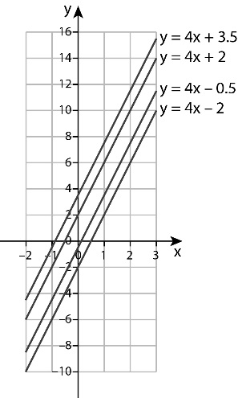**Challenge: Sloping graphs**

Graph opposite

**Exercise 7B**

**1 a** 3 **b** 2 **c** 4 **d** 1

**2 a** *y* = 3*x* + 5 **b** *y* = 2*x* + 7 **c** *y* = *x* + 4 **d** *y* = 7*x* + 15

**3 a** (0, 1) **b** 2 **c** *y* = 2*x* + 1

**4 a i** 2  **ii** (0, 3) **iii** *y* = 2*x* + 3 **b i** 3  **ii** (0, 1)  **iii** *y* = 3*x* + 1

**c i** 4  **ii** (0, 2**) iii** *y* = 4*x* + 2 **d i** 2/3 **ii** (0, 3) **iii** *y* = *x* + 3

**5 a** (0, 4) **b** 2 **c** *y* = 2*x* + 4

**6 a** 3 **b** (–1, 0) **c** *y* = 3*x* – 1

**7 a** *y* = 3*x* + 2 **b** *y* = 4*x* – 1 **c** *y* = 2*x* + 1

**Challenge: Lines through points**

**a** For example *y* = *x* + 4 , *y* = 2*x* + 4 , *y* = 3*x* + 4

**b** For example *y* = *x* , *y* = 2*x* – 1 , *y* = 3*x* – 2

**c** For example *y* = *x* + 3 , *y* = 2*x* + 1 , *y* = 3*x* – 1

**Exercise 7C**

**1 a** 10, 5, 2, 1, 2, 5, 10 **b** and **c** Check pupils’ graphs

**2 a**

|  |  |  |  |  |  |  |
| --- | --- | --- | --- | --- | --- | --- |
| 9 | 4 | 1 | 0 | 1 | 4 | 9 |
| 12 | 7 | 4 | 3 | 4 | 7 | 12 |

**b** and **c** Check pupils’ graphs

**3 a**

|  |  |  |  |  |  |  |
| --- | --- | --- | --- | --- | --- | --- |
| 11 | 6 | 3 | 2 | 3 | 6 | 11 |
| 13 | 8 | 5 | 4 | 5 | 8 | 13 |
| 14 | 9 | 6 | 5 | 6 | 9 | 14 |

**b**, **c** and **d** Check pupils’ graphs

**d** each line is curved and parallel to each other

**4 a**

|  |  |  |  |  |  |  |
| --- | --- | --- | --- | --- | --- | --- |
| 18 | 8 | 2 | 0 | 2 | 8 | 18 |

**b** and **c** Check pupils’ graphs

**5 a**

|  |  |  |  |  |  |  |
| --- | --- | --- | --- | --- | --- | --- |
| 9 | 4 | 1 | 0 | 1 | 4 | 9 |
| 27 | 12 | 3 | 0 | 3 | 12 | 27 |

**b** and **c** Check pupils’ graphs

**6 a**

|  |  |  |  |  |  |  |
| --- | --- | --- | --- | --- | --- | --- |
| 36 | 16 | 4 | 0 | 4 | 16 | 36 |
| 45 | 20 | 5 | 0 | 5 | 20 | 45 |
| 54 | 24 | 6 | 0 | 6 | 24 | 54 |

**b**, **c** and **d** Check pupils’ graphs

**d** each one is a curve with the graph getting more squashed as the number next to the *x* gets larger

**7 a** Check pupils’ graphs **b** 18 km **c** 44 km

**Exercise 7D**

**1 a** and **b** Check pupils’ graphs **c** 2 pm

**2 a** and **b** Check pupils’ graphs **c** S = D ÷ T = 20 ÷ = 60 km/h

**3 a** Check pupils’ graphs **b** 0, 40, 100, 160, 200 **c** 70 cm **d** Check pupils’ explanations

**4 a** Check pupils’ graphs **b** 5:10 pm

**5 a** 7400, 5800, 4200, 2600, 1000, X **b** Check pupils’ graphs

**c** About 280 minutes (4 hours 40 minutes)

**Problem solving: Meeting in the middle**

**A** Check pupils’ graphs

**B a** About 12:17 **b** About 11:48 am

**Chapter 7: Answers to Review questions**

**1 a** Ground (0), and 20 **b** 62 seconds **c** Straight line from (70, 20) to (105, 0)

**2 a** 19 **b** –11 **c** *y* = *x*2

**3 a** 17 cm **b** 450 cm²

**4 a** *y* = *x* + 3 **b** *y* = *x* – 3 **c** *y* = –*x* + 3 **d** *y* = –*x* – 3

**5 a** Check pupils’ graphs **b** 56 cm **c** 1.7 seconds

**Chapter 7: Answers to Challenge – the M25**

**1** 14 years

**2 a** 31 **b** 5 **c** Surrey

**3 a** 13 miles **b** 20 miles

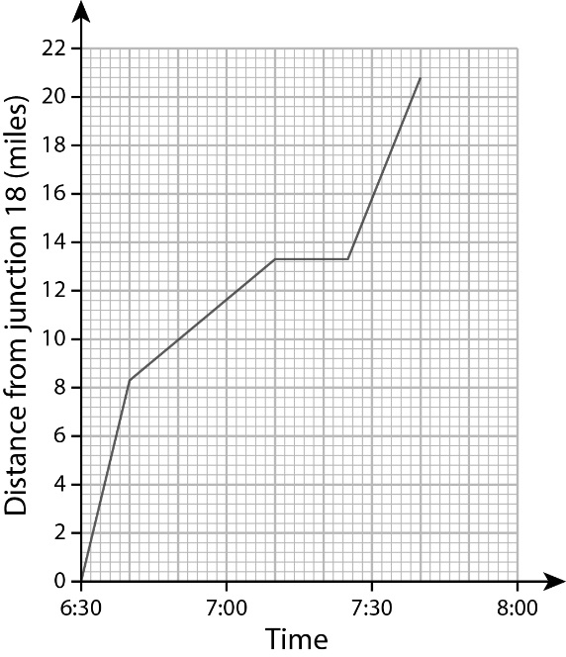**4**

**5 a** 732 miles  
**b**

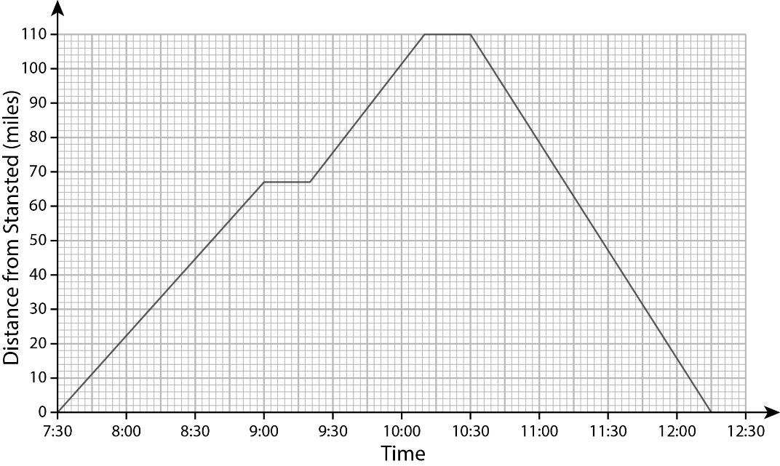

**6** 1 hour 40 minutes

**7** 187 km

**8** 19%

**Exercise 8A**

**1 a** 530 **b** 79 **c** 2400 **d** 506.3 **e** 0.3

**2 a** 0.83 **b** 0.041 **c** 4.57 **d** 0.0604 **e** 347.81

**3 a** 6430 **b** 685 **c** 35 200 **d** 8074 **e** 2.1

**4 a** 0.941 **b** 0.00523 **c** 0.568 **d** 0.000 715 **e** 45.892

**5 a** 31 **b** 678 **c** 560 **d** 0.034 **e** 8.23 **f** 0.009 06

**g** 5789 **h** 0.6878 **i** 38 **j** 0.0037 **k** 500 **l** 0.005 43

**6 a** 4250 **b** 567 **c** 451 **d** 0.023 **e** 7.12 **f** 0.008 05

**g** 4670 **h** 0.689 **i** 27 **j** 0.000 0049 **k** 600 **l** 0.004 32

**7 a** 0.000 000 000 000 000 000 000 911 g

**b** 0.000 000 000 000 000 000 911 g

**8 a** 10 000 000 000 000 000 000 000 000 000

**b** 600 000 000 000 000 000 000 000 000

**9 a i** 300 000 **ii** 30 000 **b** 417

**Investigation: Multiplying 9109**

**A** 9109, 18 218, 27 327, 36 436, 45 545, 54 654, 63 763, 72 872, 81 981

**B** Apart from the first answer, you get the first two digits repeated at the end with the middle number the number you have multiplied by

**Exercise 8B**

**1** Spain 40 million, Germany 75 million, Italy 57 million, France 56 million, Ireland 4 million,

Denmark 6 million

**2 a** 3 550 000 **b** 9 720 000 **c** 3 050 000 **d** 15 700 000

**3 a** 4 700 000 **b** 8 600 000  **c** 4 200 000 **d** 26 800 000

**4 a** 2 million **b** 7 million **c** 3 million **d** 37 million

**5** The government, as the figure rounds to 2 million. However, both are actually incorrect, as they should both round to 2.5 million

**6** Highest 6499; lowest 5500

**7** Highest 8 499 999; lowest 7 500 000

**8** Highest 10 547; lowest 8450

**9** Micky gets 7500 and Jenna gets 7499

**Investigation: Strange addition**

**A** 123456790123456790 …

**B** 246913580246913580 …

**C** 37037037070370370 …

**Exercise 8D**

**1 a** 5.69 × 103 **b** 1.2 × 106 **c** 9.38 × 105 **d** 7.78 × 104

**e** 3.965 × 108 **f** 5.61 × 102 **g** 7.3 × 101 **h** 4.3 × 109

**2 a** 3.4 × 106 **b** 5.6 × 103 **c** 2.6 × 107 **d** 4.5 × 104

**e** 2.58 × 108 **f** 5.47 × 105 **g** 2.0 × 108 **h** 5.0 × 105

**3 a** 8.0 × 109 **b** 1.2 × 1010 **c** 1.5 × 1011 **d** 1.0 × 1011

**e** 6.7 × 109 **f** 1.55 × 1010 **g** 1.0 × 1012 **h** 1.0 × 1018

**4 a** 2 300 000 **b** 456 **c** 675 000 **d** 3590

**e** 9 000 000 **f** 2 010 000 **g** 34 780 **h** 87 300 000

**i** 670 000 **j** 38 500 000 000 **k** 780 000 000 **l** 5 390 000 000

**5 a** 2.5 × 105 **b** 1.764 × 107 **c** 1.369 × 105 **d** 8.1 × 107

**e** 4.225 × 105 **f** 9 × 108 **g** 2.5 × 1013 **h** 2.25 × 1012

**6 a** 7.3 × 107 **b** 2.56 × 104 **c** 7.7 × 106 **d** 2.59 × 105

**e** 9 × 108 **f** 7.01 × 107 **g** 3.478 × 107 **h** 1.873 × 1010

**i** 7 × 104 **j** 8.5 × 109 **k** 8 × 106 **l** 8.6 × 107

**7** 3 × 108

**8** 1.09 × 1030

**Activity: Astronomical numbers**

Answers will vary depending on measurement found.

**Exercise 8E**

**1 a** 8 × 105 **b** 1.2 × 108 **c** 8 × 107

**d** 9 × 1013 **e** 3.2 × 1018 **f** 4.2 × 1014

**g** 2.1 × 107 **h** 1.0 × 1010 **i** 5.6 × 1011

**j** 2.25 × 1010 **k** 1.12 × 1012 **l** 3.6 × 107

**2 a** 9.46 × 109 **b** 1.152 × 108 **c** 1.288 × 1010 **d** 5.51 × 108 **e** 4.672 × 109

**f** 1.674 × 1011 **g** 2.99 × 106 **h** 1.311 × 1017 **i** 1.296 × 105 **j** 6.561 × 1011

**3 a** 9.82 × 1010 **b** 7.28 × 107 **c** 7.27 × 109 **d** 2.35 × 108 **e** 4.05 × 1013

**f** 5.84 × 1010 **g** 2.95 × 1015 **h** 1.56 × 1018 **i** 6.13 × 1013 **j** 6.42 × 108

**4** 2.56 × 1011

**5** 6.6 × 106 litres

**Challenge: Mega-memory**

**A**

|  |  |
| --- | --- |
| 1 × 103 | KB |
| 1 × 106 | MB |
| 1 × 109 | GB |
| 1 × 1012 | TB |
| 1 × 1015 | PB |
| 1 × 1018 | EB |
| 1 × 1021 | ZB |
| 1 × 1024 | YB |

**B** 1 × 1018 (an exabyte)

**C** 5 × 1030

**Chapter 8: Answers to Review questions**

**1** 1 m3 or 1 000 000 000 mm3

**2** £21 000

**3** For example 67 000 fans which is 70 000 to 1 sf

**4** A hundred million, ten billion, a trillion

**5 a i** 43.5% **ii** 4.35 × 106 **iii** 4.36 **b** 899 999, 5 million, 22502, 4.3 × 107

**6** 1.6 × 1012

**7 a** 145 000 and 154 999 **b** 15 000

**8 a** 3.99 × 1013 km **b** 114 000 × 365 × 24 × 40 000 = 3.99 × 1013

**9** Take 1.5, which rounds to 2, a difference of 0.5, which is one third of 1.5

**Chapter 8: Answers to Challenge – Space – to see where no one has seen before**

**1** 9.45 × 1012 km

**2** 1.3 × 1023

**3** Both 2 × 1011, speed of light from question 1 is 3 × 108

**4** 1.52 × 1011

**5** 1.64 × 1011

**6** 2.5 × 1022

**7** 2144 cm³

**8** 268 cm³

**9** 3.7 × 1080

**Exercise 9A**

**1 a** 225 **b** 150 **c** 525

**2 a** 75 **b** 75 **c** 50 **d** 100

**3 a** 45 **b** 45 **c** 60 **d** 90 **e** 75 **f** 135 **g** 90

**4 a** 10 **b** 5 **c** 15

**5 a** 6 hrs **b** 6 hrs **c** 4 hrs **d** 8 hrs

**6 a** 60 **b** 20 **c** 100 **d** 30 **e** 30

**7 a** 45 **b** 72 **c** 45 **d** 54

**8** Y7-560, Y8-420, Y9-280, Y10-210, Y11-210

**9** Northern Ireland - 19, Wales - 93, Scotland - 100, England - 420

**Activity: Population in a pie chart**

**A** 80+

**B** 0–19 … 1 247 000, 20–39 … 1 546 280, 40–59 … 1 197 120, 60–79 … 847 960, 80+ … 149 640

**Exercise 9B**

**1** Angles of 120°, 70°, 80°, 40°, 50°

**2** Angles of 99°, 72°, 54°, 81°, 18°, 36°

**3** Angles of 45°, 60°, 105°, 75°, 60°, 15°

**4** Angles of 102°, 48°, 126°, 18°, 66°

**5 a** The angles for 4 and 5 rooms would be far too small

**b** 1 room – 112°, 2 rooms – 233°, 3+ rooms- 15°

**c** Check pupils’ pie charts

**6** Angles of 14°, 18°, 40°, 133°, 155°

**Challenge: World energy consumption**

**A** Oil 38, hydro 8, nuclear 5, coal 30, gas 20

**B** Estimating

**C** Angles of 137°, 29°, 18°, 108°, 72°

**Exercise 9C**

**1 a** Positive, warmer weather so more deckchairs needed

**b** Negative, wet weather so less deckchairs needed

**c** Positive, more umbrellas sold when it is wet

**d** Negative, less ice creams sold when it is wet

**e** Positive, more ice creams sold when it is warm

**f** None, sale of umbrellas unaffected by temperature

**2 a** Positive, “the taller you are, the larger shoe the shoe size”  
**b** No correlation between weight and shoe size  
**c** Positive, “the higher the mass, the larger the collar size”  
**d** No correlation between height and collar size

**3 a** Positive, the higher the score in test A, the higher the score in test B   
**b** No correlation between maths and English results  
**c** Positive, the higher the score in maths, the higher the score in science  
**d** Negative, the higher the score in English, the lower the score in science

**4 a** Negative, the higher the price, the fewer goals let in **b** No correlation between age and goals let in  
**c** Negative, the higher the price, the fewer goals let in  
**d** Negative, the older the goalkeeper, the fewer goals let in

**5 a** No correlation between distance and cost  
**b** Positive, the higher the weight, the greater the cost  
**c** Positive, the longer the distance, the longer the time  
**d** No correlation between mass and time

**6** Billy – graph C, Terry – graph A, Suzie – graph B

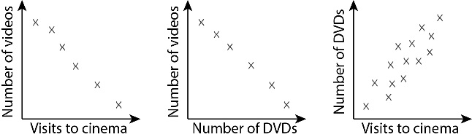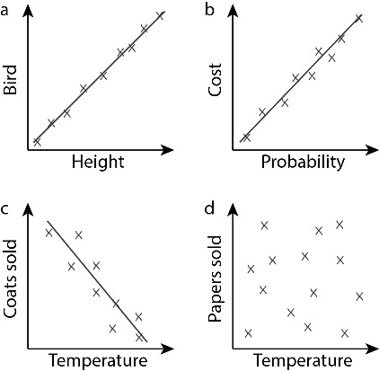**7 8**

**Activity: Correlation in circles**

Yes, there is positive correlation between diameter and circumference

**Exercise 9D**

**1 a** Check pupils’ graphs

**b** The older the pupil the more money they spend **c** Around 13 years old

**2 a** Check pupils’ graphs

**b** The more time they spend on homework the less tv they watch **c** 10 hrs

**3 a** Check pupils’ graphs

**b** The older the car the less it is worth **c** £9000

**4** Celia-8 on test B, Ida-50 on test B,

Les-50 on test A, Ulla-30 on test A

**Problem solving: Fish food**

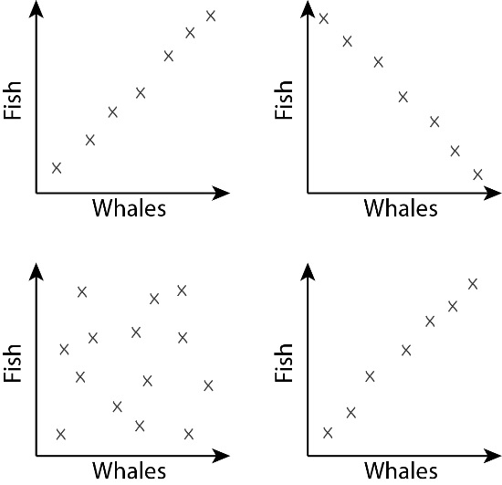

**Chapter 9: Answers to Review questions**

**1 a** 36 and 324 **b** Not possible to tell

**2 a** Angles 60°, 180°, 120° **b** 24

**3 a** N **b** True **c** 70

**4 a** Check pupils’ graphs **b** Negative correlation **c** Just over 3 minutes

**Chapter 9: Answers to Challenge – Football attendances**

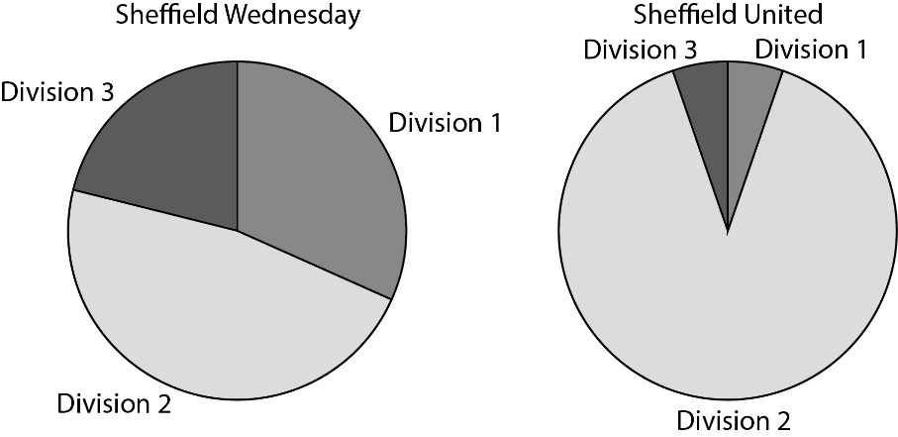**1**

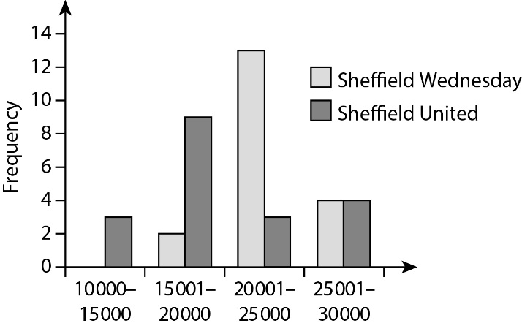**2**

For example, most of the Sheffield Wednesday attendances are higher than 20 000, and

most of the Sheffield United attendances are less than 20 000.

**3** Sheffield Wednesday = 10 889; Sheffield United = 17608

**4** Sheffield Wednesday = 1.9; Sheffield United = 2

**5** Check pupils’ scattergraphs.

**Exercise 10A**

**1 a** 4*k* **b** 3*t* **c** 2*x* **d** 20*y* **e** *ab* **f** *nm* **g** *e* or **h** *r* or

**2 a** 2*ab* **b** 40 **c** 10*e* **d** 80*w* **e** *abc* **f** 3*n* **g** 7.5*x* **h** *bh*

**3 a** *a*2 **b** 4*x*2 **c** 9*n*2 **d** 1.4*t*2 **e** 3.2*a* **f** *d*2 **g** *x*2 **h** *m*2

**4 a** 2(*n* + 1) **b** 4(*t* + 12) $4(t+12)$**c** 8(3 + *k*) $8(3+k)$**d** 0.5(*t* – 6.4) $0.5(t-6.4)$

**e** 4(*k* + 2) $4(k+2)$**f** 2(12 – *y*) $2(12-y)$**g** 8(*x* – 2) $8(x-2)$**h** 6(40 – *y*) $6(40-y)$

**5 a** 2 + 3*a* **b** 9*x* **c** 7.7*w* **d** *ab* – 1.4 **e** 5 + 4*a* **f** 8.5*d* **g** 12 – 7*n* **h** 13*f* + 9

**6** **a** 6*n* **b** 20*b* **c** 2*d* **d** 0.5*q* **e** 10*k* **f** 24*g* **g** 12*t* **h** *h*

**7 a** 4*n*² **b** 12*d*² **c** 8*p*² **d** 3*a*²

**8 a** Answers given in Pupil Book **b $\frac{y}{4}$**  **c $\frac{t}{1.5}$**  **d $\frac{24}{n}$** 

**9 a** Answers given in Pupil Book **b** *m* **c** *n* **d** *ab*

**10 a** 3*y* + 2*x* **b** 5*xy* **c** 6*xy* **d** *x* + 5*y*

**Challenge: Is it true?**

**A** i and iii

**B** Substitute values of *a* and *b* that give different answers

**Exercise 10B**

**1 a** 11h **b** 5*p* **c** 6*u* **d** 2*b* **e** 5*j* **f** 5*pr*

**g** 6*k* **h** 8*y*² **i** 5*d*² **j** 7*i* **k** 3*b* **l** 17*ab*

**m** 9*xy* **n** 11*p*² **o** 5*ab* **p** 4*a*² **q** 6*fg*

**2 a** 8*h* + 5*g* **b** 2*g* + 8*m* **c** 8*f* + 10*d* **d** 11*x* + 5*y* **e** 6 + 2*r* **f** 4 + 2*s*

**g** 3*c* + 3 **h** 14*b* + 7 **i** 14*w* – 7 **j** 6*bf* + 5*g* **k** 7*d* + 3*d*² **l** 4*t*² + 5*t*

**m** 2*t* – 3*s* **n** 2*h* – 2*h*² **o** 4*y* – 9*w*

**3 a** 16*e* + 6 **b** 19*u* – 6 **c** 4*b* + 3*d* **d** 7 + 7*c* **e** 6 – *g*

**f** 2*h* + 2 **g** *p*² + 5 **h** 14*j*² – 2*j* + 9 **i** 4*t*² – 3*t* – 6 **j** 2 – 4*t* + 3*t*²

**k** *q* – 2*p* **l** 8 – 4*e*

**4** a and d are 6*x* – 3y; b and c are 5*x* – *y*

**Investigation: Four expressions**

**A a** 21, 23, 25, 27 **b** 8*n* + 16 **c** 96 **d** 96

**B a** 27, 29, 31, 33 **b** 12*n* **c** 120 **d** 120

**Exercise 10C**

**1 a** 5*p* + 10 **b** 4*m* – 12 **c** 2*t* + 2*u* **d** 4*d* + 8

**e** 5*b* + 25 **f** 6*j* − 24 **g** 10 + 2*f* **h** 10 – 10*n*

**2 a** 2*a* + 2*b* **b** 3*q* – 3*t* **c** 4*t* + 4*m* **d** 5*x* – 5*y*

**e** 2*f* + 2*g* **f** 6 – 4*f* **g** 1.5*h* + 15 **h** 14 – 4*f*

**3 a** 5*w* + 2 **b** 3*d* + 10 **c** 9*h* + 15 **d** 6*x* + 12 **e** 2*m* – 13 **f** 4 + 3*q*

**4 a** 6*a* + 8 **b** 8*i* + 22 **c** 5*p* + 4 **d** 8*d* – 7

**e** 6*e* + 2 **f** 8*x* + 2 **g** 8*m* – 3 **h** 9*u* – 22

**5 a** 4*a*² + 6 **b** 6*x* − 15 **c** 12*t* + 20 **d** 50*n* − 30

**e** 30+ 12*a* **f** 8 – 12*y* **g** 60+ 80*r* **h** 35 – 10*m*

**6 a** 0 **b** 20, −24 and 4 add up to 0

**Challenge: Equivalent expressions**

a, d, e, h and i are equivalent to 4*x* + 12; b, c, f and g are equivalent to 4*x* + 8

**Exercise 10D**

**1 a** 4*t* + 2 **b** 6*w* **c** 6*m* + 2

**2 a** *t*(*t* + 1) **b** 2*w*² **c** *m*(2*m* + 1)

**3 a** 3*t* + 6 **b** 4*k* + 8 **c** 4*c* + 16 **d** 3*a* + 24 **e** 5*x* + 10

**4** Expand the brackets in each case

**5 a** 9*x* **b** 10*ab* **c** 16*t*²

**6 a i** 4*x* **ii** 4(*x* + 4) **iii** 2(*x* + 1) **iv** 2(*x* + 3)

**b** Expand brackets and simplify

**c** **i** 2*x* + 8 **ii** 2*x* + 16 **iii** 2*x* + 6 **iv** 2*x* + 10

**d** Expand brackets and simplify

**7 a i** 5(*a* + 2) **ii** 4(*a* + 2) **iii** 9*a* **iv** 9(2*a* + 2) or an equivalent expression

**b i** 2*a* + 14 **ii** 2*a* + 12 **iii** 2*a* + 18 **iv** 4*a* + 22

**8 a** 2*x* + 21 **b** 2(*x* – 3) + 27 **c** Expand brackets and simplify

**9** Own demonstration showing 3*x* + 8 + 3*x* + 4 = 6*x* + 12

**10** Own demonstration showing 4*x* + 6 + 4*x* + 10 = 4*x* + 16

**11** Own demonstration showing 2*x* + 9 + 3*x* + 6 = 5*x* + 15

**12** Own demonstration showing 3*x* – 5 + 3*x* – 1 = 6*x* − 6

**Challenge: Fill in the bricks**

There are many possible answers.

**Exercise 10E**

**1 a** *a*4 **b** *r*3 **c** *b*5 **d** *m*6 **e** 12*a*² **f** 2*p*² **g** 12*g*³ **h** 24*k*4

**2 a** 5*f* **b** *w*4 **c** 7*c* **d** *k*4 **e** 6*d*

**3** 5*j* = *j* + *j* + *j* + *j* + *j* and *j*5 = *j × j × j × j × j*

**4** 6, 12, 15; 8, 64, 125; 24, 192, 375

**5 a** *a*2*b* **b** 6*xy*2 **c** *t*2*u*2 **d** 2*d*2*c* **e** 2*ab*2 **f** 2*xw*2 **g** 4*t*2*u* **h** 6*e*2*f*

**6 a** 75 **b** 250

**7 a** 4*x*² **b** *y*³ **c** 2*t*³ **d** 4*k*³ **e** 6*n*³

**8 a** *t*4 **b** 6*t*4 **c** *t*4 **d** 30*t*4

**Challenge: Matching multiples**

First row: 2*a*, 2*b*, 2*a*², 2*b*², 2*ab*; second row: *a*², *ab*, *a*³, *ab*², *a*²*b*; third row: *ab*, *b*², *a*²*b*, *b*³, *ab*²

**Chapter 10: Answers to Review questions**

**1 a** 2 + 3*t* **b** 20*d* **c** 2*a* + 4*b* **d** *c*²

**e** 2*r* − 12 **f** 20 – 3*q* **g $\frac{2a}{b}$**  **h** 6*km*

**2 a** 4*h* **b** a + 3*b* **c** 4*p* – 2 **d** 7*x* – 8

**e** 4*x*² **f** 7 – 2*a* **g** 2*d* + 3*d*² **h** *r* – 8 + 5*r*²

**3 a** 3*t* + 3 **b** 7*x* **c** 6*m* – 2

**4 a** 2*x* + 20 **b** 4*y* + 2 **c** 4*m* – 6

**5 a** 10*x* **b** *y*(*y* + 1) **c** *m*(*m* − 3)

**6 a** 10*ab* **b** *b*(*a* + 10) or *ab* + 10*b*

**7 a** 2*a* + 16 **b** 3*f* – 18 **c** *t* + 5

**8 a $\frac{w+x+y+z}{4}$**  **b** 20

**9** 6*t*³

**10 a** 4*x*² **b** 6*x* + 32 **c** 2*x*² + 16*x* or an equivalent expression

**Chapter 10: Answers to Mathematical reasoning – Writing in algebra**

**1** Power = *vc*

**2** Distance = *st*

**3** Volume = *sh*

**4** Area = 1.72*l*²

**5** Volume = 0.79*d*²*h*

**6** Height = 5*t*²

**7** bmi = 

**8** Kinetic energy = *s*2*m*

**9** Cost = 90*d* + *nc*

**Exercise 11A**

**1 a** yes; **b** no; **c** yes; **d** yes; **e** no; **f** yes

**2 a** and **e**; **b** and **j**; **c** and **k**; **d** and **f**

**3 a** and **c**

**4 a** Two different isosceles triangles, two different parallelograms, a rectangle and a kite

**b** A parallelogram and a rhombus

**c** A rhombus

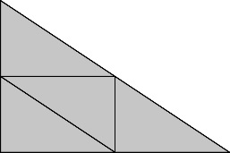**5**

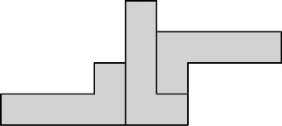

**6**

**7 a** Examples of two congruent shapes:

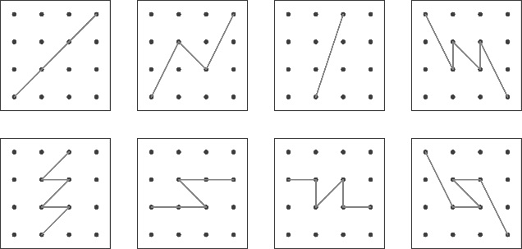

**b** Examples of four congruent shapes:

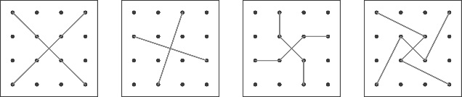

**8 a**  BC = DE, AC = DF (SAS)

**b** GH = KL, GI = JL, HI = JK (SSS)

**c**   NO = PR (ASA)

**d**   BC = XY (ASA)

**Reasoning: Combined transformations**

The following are possible examples for a combined transformation:

**1 a** A reflection in the *y*-axis followed by a translation of 6 units down

**b** A rotation of 90° anticlockwise about the origin followed by a translation of 1 unit down

**c** A reflection in the *x*-axis followed by a translation of 7 units left and 5 units down

**d** A rotation of 90° clockwise about the origin followed by a translation of 1 unit left and 6 units up

**e** A rotation of 90° anticlockwise about the origin followed by a translation of 6 units left and 6 units up

**Exercise 11B**

**1** Check pupils’ answers

**2 a** Vertices at (8, 6), (8, 2), (4, 2) **b** Vertices at (4, 6), (8, 4), (4, 2), (0, 4)

**c** Vertices at (3, 9), (6, 9), (6, 6), (9, 6), (9, 9), (12, 9), (12, 3), (3, 3)

**d** Vertices at (0, 8), (8, 8), (8, 12), (12, 6), (8, 0), (8, 4), (0, 4)

**3** Vertices at (8, 12), (10, 8), (8, 2), (6, 8)

**4 a** A′(3, 7), B′(7, 7), C′(7, 3), D′(3, 3) **b** A″(2, 8), B″(8, 8), C″(8, 2), D″(2, 2)

**c** A″′(1, 9), B″′(9, 9), C″′(9, 1), D″′(1, 1)

**d** For example, the *x*-coordinate and the *y*-coordinate are the same or they add up to 10

**5 a** 2 **b** (9, 1)

**6 b** 4 cm2 **c** 16 cm2 **d** 36 cm2 **e** 64 cm2

**f** The area scale factor is the square of the scale factor **g** yes

**Activity: Enlarged stickman**

Check pupils’ posters

**Exercise 11C**

**1 a** 2 : 5 **b** 1 : 10 **c** 4 : 5 **d** 1 : 5 **e** 1 : 4

**2 a** 1 : 3 **b** 1 : 3 **c** 1 : 9

**3 a i** 1 : 2 : 3 **ii** 1 : 2 : 3 **iii** 1 : 4 : 9 **b** They are enlargements of each other

**4 a** 1 : 1 **b** 1 : 5 **c** 2 : 5 **d** 1 : 2

**5 a** 1 : 8 **b **

**6 a** 1200 m2 **b i** 30 000 m2 **ii** 3 hectares

**c** 1 : 5 **d** 1 : 25 **e **

**7 a** 24litres **b** 18litres **c** 3 : 4

**8 a** 1 : 2 **b** 1 : 4 **c** 1 : 8 **d i** 1 : 9 **ii** 1 : 27

**Activity: Paper sizes**

**A** A5: 210 mm × 148 mm, A4:297 mm × 210 mm, A3: 420 mm × 297 mm

**B** They are the same

**C** 1 : 1.4 (actual ratio 1 : √2), they are the same ratio

**Exercise 11D**

**1 a** 20 m **b** 50 m **c** 35 m **d** 78 m **e** 63m

**2 a** 25 m **b** 15 m **c** ≈ 29 m

**3 a** 1 cm to 2 m **b** 6 m **c** 48 m2

**4 a** 16 cm **b** 6 cm **c** 2 cm **d** 3 m **e** 2.5 m **f** 1.2 m

**5 a i** 6 m by 4 m **ii** 4 m by 2 m **iii** 6 m by 4 m **iv** 5 m by 4 m **b** 88 m2

**6** For example 1 cm to 10 yards

**7 a** 1 km **b** 1.4 km **c** 2.25 km **d** 1.75 km

**Reasoning: Map ratios**

**A** 1 : 10 000

**B** 1 : 12 500

**C** 1 : 100 000

**D** 1 : 50 000

**E** 1 : 1 000 000

**Chapter 11: Answers to Review questions**

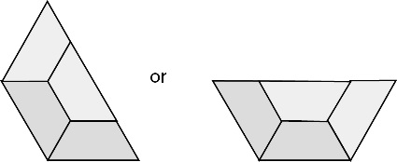**1 a b**

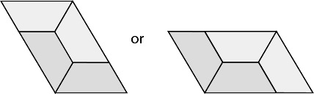

**2 a b**

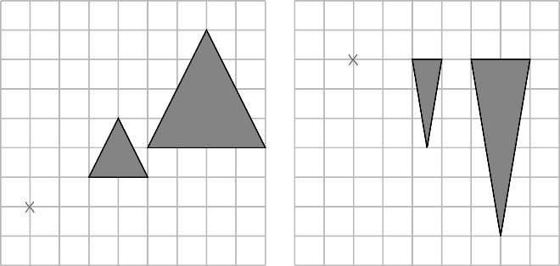

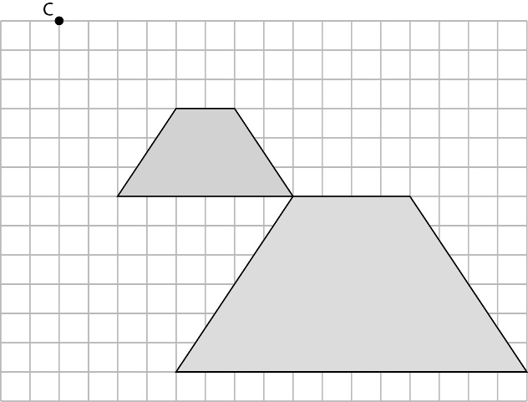**3**

**4 a** 13:25 **b** 48%

**5 a** 210 km **b** 225 km **c** 141 km  **d** 105 km

**6 a** 4(*x* + 3) +10(*x* + 3) + 20 = 118, 4*x* + 12 + 10*x* + 30 + 20 = 118, 14*x* + 62 = 118

**b** *x* = 4 **c** 70 cm3 **d** 80.5 cm3

**7** A and C, three equal sides (SSS)

**Chapter 11: Answers to Problem solving – Photographs**

**1** £183.96

**2 a** 5.1” × 3.5” and 17.7” × 11.8”

**b** 6 sq in, 24 sq in, 35 sq in, 48 sq in, 80 sq in, 96 sq in

**c** 6” × 4” and 8” × 6”, 8” × 6” and 12” × 8”

**3 a** 13 sq in **b** Frame B – 6” × 4”, Frame C – 10” × 8”

**4** 3” × 2” and 6” × 4” SF = 2, 6” × 4” and 12” × 8” SF = 2, 3” × 2” and 12” × 8” SF = 4

**5 a** 6” × 4”, 7” × 5” and 8” × 6” **b** FastPrint, £3.60 **c** 12p **d** 10%

**6 a** 3 : 2 = 1.5 : 1, 6 : 4 = 1.5 : 1, 7 : 5 = 1.4 : 1, 8 : 6 = 1.33 : 1, 10 : 8 = 1.25 : 1,

12 : 8 = 1.5 : 1

**b** 3” × 2”, 6”× 4” and 12”× 8”

**Exercise 12A**

**1 a**  **b** 1 **c** 1 **d** 1 **e** 1 **f** 1 **g** 1 **h** 1

**2 a** 1 **b** 2 **c** 2 **d** 3 **e** 4 **f** 5 **g** 13 **h** 5

**3 a**  **b**  **c**  **d**  **e**  **f**  **g**  **h** 

**4 a** 1 **b** 1 **c** 1 **d**  **e** 1 **f** 2 **g** 2 **h** 2

**5 a**  **b** 1 **c**  **d** 1

**6 a** 1 **b** 1 **c** 3 **d** 2

**7 a** 2 **b** 2  **c** 3 **d** 5

**8 a** 13 cm **b** 10 cm **c** 9 cm

**9** 7 cm

**10 a i**  **ii**  **iii**  **b i**  **ii** Pupils check own answer

**11 a**  **b** 

**Challenge: Magic square**

**A** 1 **B** The three rows are: , , ; , , ; , , 

**Exercise 12B**

**1 a** 2 **b** 3 **c** 1 **d** 2

**2 a** 3 **b** 4 **c** 2 **d**  **e** 1 **f** 1 **g** 1 **h** 

**3 a** 1 **b** 2 **c** 2 **d** 1 **e** 3 **f** 3 **g** 2 **h** 2

**4 a** 3 **b** 6 **c** 3 **d** 8 **e** 11 **f** 8 **g** 6 **h** 4

**5 a** 12 cm² **b** 31 cm² **c** 8 cm²

**6 a** 2 **b** 21 cm²

**7 a** 38 **b** 49 **c** 31 **d** 92 **e** 102 **f** 101 **g** 166 **h** 80

**8 a** 8 **b** 11 **c** 20

**9 a** 1 **b** 4 **c** 11

**10 a** 3 **b** 6 **c** 17

**Challenge: Multiplication table**

Top row: 4, 7, 10, 15

Second row: 6, 11, 15, 22

Third row: 11, 18, 25, 36

Fourth row: 12, 20, 29, 41

**Exercise 12C**

**1 a**  **b**  **c**  **d** 

**2 a**  **b**  **c**  **d** 

**3 a**  **b**  **c**  **d**  **e**  **f**  **g**  **h** 

**4 a**  **b** 1 **c** 1 **d** 1

**5 a**  **b**  **c** 1 **d** 1 **e**  **f** 1 **g** 1 **h** 

**6 a** 1 **b** 1 **c**  **d** 

**7** 3 cm

**8** 3 cm

**9 a** 8 **b** 10 **c** 9 **d** 8

**10 a** 16 **b** 24 **c** 40 **d** 64

**11 a** 20 **b** 20 **c** 20 **d** 20

**12** 

**13** 90 seconds

**Challenge: Cycle race**

**A a** 15 **b** 20

**B** **a** 168 **b** 224

**Exercise 12D**

**1 a** 1200 **b** 1200 **c** 12 000 **d** 120 000

**2 a** 4000 **b** 4200 **c** 72 000 **d** 72 000

**3 a** 3.2 **b** 0.09 **c** 0 035 **d** 0.45

**e** 0.008 **f** 0.036 **g** 0.0072 **h** 0.066

**4 a** 400 **b** 1600 **c** 3600 **d** 90 000

**e** 0.09 **f** 0.81 **g** 0.0004 **h** 0.0064

**5 a** 600 cm² **b** 200 mm and 300 mm **c** 60 000 mm²

**d** 0.2 m and 0.3 m **e** 0.06 m²

**6 a** 1.8 **b** 24 **c** 27 **d** 200

**e** 64 **f** 6.6 **g** 630 **h** 1.5

**7 a** 12 **b** 120 **c** 1.2 **d** 12

**8 a** 4800 cm² **b** 0.48 m²

**9 a** 63 **b** 6.3 **c** 63 000 **d** 0.063

**10 a** 52 900 **b** 5.29 **c** 0.0529

**11 a** 24 **b** 240 **c** 2400 **d** 0.24

**12 a** 0.16 m³ **b** 160 000 cm³

**Challenge: Falling down**

**A** The missing values are 0.05, 0.2, 0.8, 1.25.

**B** Check pupils’ graphs.

**Exercise 12E**

**1 a** 30 **b** 20 **c** 30 **d** 30

**e** 50 **f** 30 **g** 40 **h** 50

**2 a** 150 **b** 50 **c** 200 **d** 200

**e** 2000 **f** 300 **g** 500 **h** 200

**3 a** 20 **b** 2 **c** 0.2 **d** 0.02

**4 a** 7 **b** 0.7 **c** 0.07 **d** 0.07

**5 a** 0.4 **b** 0.2 **c** 0.7 **d** 0.03

**e** 0.2 **f** 0.04 **g** 0.3 **h** 0.05

**6 a** 0.06 **b** 0.03 **c** 0.02 **d** 0.01

**7 b** 270 ÷ 90 = 3, the rest are 30

**8 d** 0.8 ÷ 0.2 = 4, the rest are 0.4

**9 a** 30 **b** 0.03 **c** 0.3 **d** 3000

**10 a** 30 **b** 0.3 **c** 0.03 **d** 3; order is c, b, d, a

**11 a** 40 **b** 5 **c** 50 **d** 0.006

**e** 30 **f** 40 **g** 20 **h** 0.05

**12 a** Changing the subject of the formula *A* = 20*x* gives *x* =.

**b** 0.02 **c** 50

**13 a** 1.3 **b** 0.13 **c** 1.3 **d** 130

**Reasoning: Fraction or decimal?**

**A a** Answer given in Pupil Book

**b** 40 **c** 320 **d** 120 **e** 15 **f** 70

**B** Check pupils’ answers

**Chapter 12: Answers to Review questions**

**1 a** 3 **b** 2 **c** 

**2 a** 2 **b** 3 **c** 3

**3 a** 21 cm **b** 26 cm²

**4 a**  **b** 4

**5 a** 1 **b** 7 **c** 14 **d** 12

**6 a** 4900 **b** 100 000 **c** 90 000 **d** 2400

**7 a** 20 **b** 0.064 **c** 0.06 **d** 81

**8 a** 1400 cm² **b** 0.14 m²

**9 a** 30 **b** 80 **c** 40 **d** 400

**10 a** 30 **b** 40 **c** 0.4 **d** 0.06

**11 a** 288 000 **b** 28.8

**12**  1

**13 a** 2 **b**  **c** 5

**14 a** 75 **b** 42 **c** 4.2 **d** 7.5

**Chapter 12: Answers to Challenge – Guesstimates**

**1** 5000, 0.2, 5000 ÷ 0.2 = 25 000

**2-9** Answers will vary. Check that they are sensible and backed up with working.

**Exercise 13A**

**1** Missing numbers are 26, 52, 78 and 117

**2 a** £1.68 **b** £2.52 **c** 42p **d** 28p

**3 a** 54 g **b** 108 g **c** 216 g **d** 13.5 g

**4 a** 6 kg **b** 24

**5** 15, 25 and 125 on the top row, 64 and 160 on the bottom row

**6 a** 22 m **b** 33 m **c** 110 m **d** 5.5 m

**7 a** 320 **b** 2 hours

**8 a i** £1.92 **ii** £3.20 **iii** 16p

**b i** 200 g **ii** 1 kg **iii** 50 g

**9** 82 and 410 on the top row, 315 and 504 on the bottom row

**10** 0.7 and 1.4 on the top row, 120 and 180 on the bottom row

**11 a** 32.8 kg **b** 30 m

**12 a** 288 **b** 1 : 3 **c** 1 : 3

**13 a** 190 **b** Both are 1 : 5

**14** No. A possible explanation is 50 × 2 = 100 but 122 × 2 ≠ 212.

**Investigation: Age, height and mass**

**A** No. Own explanation

**B** No. Own explanation

**C** No. Own explanation

**Exercise 13B**

**1 a** 8, 20, 28, 32, 40 **b** Check pupils’ graphs

**2 a** 1.3 × 10 = 13 **b** 13, 26, 32.5, 39, 52 **c** Check pupils’ graphs

**3 a** 10, 50, 100 **b** Check by multiplying **c** Check pupils’ graphs

**4 a** 24, 72, 144 **b** 48 **c** *y* = 48*x* **d** £3.60 **e** Check pupils’ graphs

**5 a** 300, 600, 900, 1200 **b** *y* = 12*x* **c** HK$15 240

**6 a** 3, 6, 7, 8.5, 11 **b** *y* = 0.1*x* **c** 43 litres

**7 a** 36 km/h **b** 3.6 **c** *y* = 3.6*x*

**8 a** 14, 21, 28 and 35 **b** *y* = 1.4*x* **c i** 16.8 mm **ii** 26.6 mm **iii** 43.4 mm

**9 a** *y* = 2*x* **b** 9.4 and 3.2 on the top, 10.4 and 25.8 on the bottom

**c** Check pupils’ drawings

**Financial skills: Exchange rates**

**A** *y* = 1.7*x*. This follows from choosing a point on the graph, such as (10, 17)

**B** Multiply number of rupees by 1.7

**C** Yes, divide number of yen by 1.7

**Exercise 13C**

**1 a** 6 hours **b** 4 hours **c** 6, 4, 5, 3, 2 **d** Product is always 600

**e** *xy* = 600 **f and g** Check pupils’ graphs

**2 a** 100 **b** 200 **c** 500, 400, 200, 100, 50, 40

**d** Product is always the same, 1000 **e** *xy* = 1000

**f and g** Check pupils’ graphs

**3 a** 5 hours **b** 1000 km/h **c** *xy* = 4000

**4 a** 24 **b** 24, 20, 12, 10 **c** Product is always 12 **d** *pn* = 12

**5 a** *bh* = 200 **b** 12.5, 16, 20, 25 **c** Check pupils’ graphs

**d** About 13.3 **e** Formula gives 13

**6 a** £1500 **b** £1000 **c** 3000, 1500, 1000, 750, 600, 500

**d** Yes, the product is always the same (30000). **e** Check pupils’ graphs

**f** About 38 **g** *nc* = 30 000 The formula gives 37.5, which means 38 people

**Activity: Different rectangles, same area**

**A** Check pupils’ drawings

**B** 12, 9.6, 8, 6, 4.8, 4

**C** Check pupils’ graphs

**D** *xy* = 48

**E** About 6.9 cm

**Exercise 13D**

**1 a** Yes **b** *d* = 80*t* **c** 680 m

**2 a** 4 hours **b** 2.5 hours **c** speed = 20 ÷ time so speed × time is always 20 **d** *tw* = 20

**3 a** Neither **b** Inverse *cd* = 90 **c** Direct *r* = 13.5*f* **d** Neither

**4** The line does not go through the origin

**5 a** (4, 5) and (7, 2) **b** 4 × 5 = 20 but 7 × 2 = 14; they are not the same

**6 a** *y* = 0.25*x* or *y* =  *x* **b** *xy* = 400

**7 a** Any two points, such as (10, 400) and (5, 200) **b** *y* = 40*x*

**8 a** Possible points are (12, 1), (1, 12), (3, 4) and (6, 2) **b** *xy* = 12

**Reasoning: Looking for proportion**

**A** 2 × (3 + 7) = 20

**B** Possible answers are 1 and 9, or 2 and 8, and so on

**C** Check pupils’ graphs

**D** No, the line does not go to the origin

**E** No, it is not a curved line

**Chapter 13: Answers to Review questions**

**1** 34 and 85

**2** 8 cm, 32 cm, 80 cm, 2.4 m, 6.4 m

**3** 540

**4 a i** £1.40 **ii** £6 **iii** £73 **b** *c* = 0.2*n*

**5 a** 28, 70, 7 **b** *y* = 3.5*x* **c** Check pupils’ graphs

**d** Straight line through the origin

**6** 9 and 3

**7** **a** 400 seconds **b** 67 seconds

**8 a** length × width is always 1200 **b** 30 cm **c** *xy* = 1200 **d** Check pupils’ graphs

**9 a** 100, 75, 60 **b** *ln* = 180

**10 a i** (5, 1) **ii** (10, 0.5) **iii** (2, 2.5) **iv** (1, 5) **b** *xy* = 5 **c** 0.2

**11 a** 32 **b** 2

**Chapter 13: Answers to Challenge – Planning a trip 1**

**a** 20, 25, 32, 40

**b** *xy* = 800

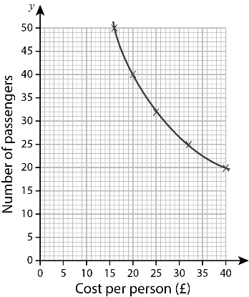 **c**

**2 a** 45 km

**b** 15 km

**c** 15, 30, 45, 60, 75, 90

**d** yes, *d* = 1.5*t*

**e**

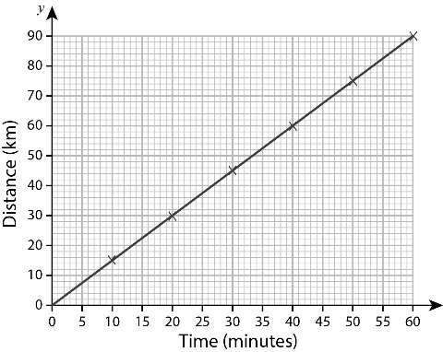

**3 a** 3.2, 3, 2.4

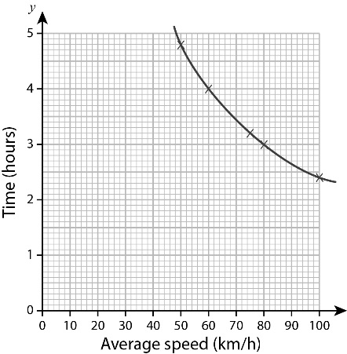 **b** *xy* = 240

**c**

**4 a** i direct proportion

**b** *d* = 2.5*f*

**c** iii neither. Check pupils’ reasons

**Exercise 14A**

**1** **a** 1.5 cm, 3 cm **b** 2 cm, 4 cm **c** 3 cm, 6 cm

**2-4** Check pupils’ drawings.

**5** **a** 360° ÷ 6 = 60° **b** **i** 360° ÷ 5 = 72° **ii** 360° ÷ 8 = 45° **iii** 360° ÷ 10 = 36°

**Activity: Finding the centre of a circle**

Check pupils’ drawings.

**Exercise 14B**

Circumference divided by diameter is slightly larger than 3. A simple relationship is *C =* 3*d.*

**Activity: Making nets for cones**

As the size of the removed sector increases, so does the height of the cone.

**Exercise 14C**

(note: answers could be slightly different if value of  is taken as 3.14)

**1** **a** 22.0 cm **b** 34.6 mm **c** 66.0 mm **d** 15.1 m **e** 8.8 cm

**2** 82 mm

**3** 377 m

**4** 400 m

**5** 942 million km

**6** 12.9 cm

**7** 47.1 cm

**8** 32 m

**Activity: A mnemonic for** 

Count the number of letters in each word:

3 1 4 1 5 9 2 7 which leads to 3.1415927

**Exercise 14D**

(note: answers could be slightly different if value of  is taken as 3.14)

**1** **a** 3.1 cm2 **b** 153.9 mm2 **c** 3.5 m2 **d** 38.5 cm2 **e** 95.0 m2

**2** 346 cm2

**3** 20 mm, 314 mm2

**4** He has worked out the circumference of the circle and the units are wrong.

Area =  × *r*2 =  × 16 = 16 cm2

**5** 8163 m2

**6** 169 cm2

**7** 47.5 cm2

**8** 25 cm2 and 100 cm2 No, the area is 4 times larger.

**Problem solving: Circle problems**

**A** **a** 75.4 cm2 **b** 60.7 cm2 **c** 63.3 cm2

**B** 8.0 m

**C** 17.9 cm2

**Chapter 14: Answers to Review questions**

(note: answers could be slightly different if value of  is taken as 3.14)

**1** Check pupils’ drawings

**2 a i** 56.5 mm **ii** 254.5 mm2 **b i** 22.0 cm **ii** 38.5 cm2

**c i** 15.1 m  **ii** 18.1 m2

**3** **a** 44 cm **b** 154 cm2

**4** **a** 157.1 cm **b** 134 m

**5** **a** 9.4 cm **b** 1060

**6 a** 66 cm **b** 207 cm **c** 4830

**7** 30.5 cm2

**8 a** 200 **b** 25 cm2 **c** 12.6 cm2 **d** 49.6%

**Chapter 14: Answers to Financial skills – Athletic stadium**

(note: answers could be slightly different if value of  is taken as 3.14)

**1** **a** 6.72 m **b** 3.60 m2 **c** £115.20

**2** **a** 353.4 m2 **b** £20 320

**3** **a** 399.34 m (or 400 m) **b** 2000 litres **c** £2635

**4** **a** 10 400m2 **b** £37 440

**5** **a** 9.6 m3 **b** 16 tonnes

**6** **a** 0.9 m3 **b** £43.20

**Exercise 15A**

**1 a** 33 **b** 48 **c** 6 **d** 4

**2 a** 13 **b** 9 **c** 5 **d** 5 **e** 7 **f** 3 **g** 2 **h** 4

**3 a** 11 **b** 3 **c** 18 **d** 7 **e** 15 **f** 7 **g** 17 **h** 44

**4 a** 48 **b** 36 **c** 45 **d** 32

**5 a** 36 **b** 18 **c** 30 **d** 58 **e** 6 **f** 13 **g** 27 **h** 22

**6** Both give *x* = 8

**7 a** 6 **b** 5 **c** 6 **d** 1 **e** 2 **f** 3 **g** 6 **h** 6

**8 a** 3*x +* 12 = 37 **b** *x* = 8

**9 a** 3.6 **b** 7.1 **c** 12.4 **d** 2.8 **e** 16.1 **f** 3.8 **g** 0.4 **h** 62.5

**Challenge: Odd one out**

The odd one out is 5*x* – 30 = 75. This has the answer 21, the rest are all 19.

**Exercise 15B**

**1 a** 15 **b** 15 **c** 12 **d** 11

**2 a** 9 **b** 6 **c** 4.5 **d** 18

**3 a** 20 **b** 7 **c** 11 **d** 5.5

**4 a** 8 **b** 21 **c** 6 **d** 8

**5 a** 18 **b** 10.5 **c** 3 **d** 34 **e** 26 **f** 

**g** 2 **h** 8 **i** 7 **j** 13 **k** 5 **l** 20

**6 a** 2*x* + 35 = 3*x* + 12 **b** *x* = 23 **c** 81

**7 a** *n +* 75 **b** *n +* 75 = 4*n* **c** *n* = 25; Ann has £25, Carrie has £100

**8 a** 14 **b** 9 **c** 10 **d** 5 

**9 a** 12 **b** 8 **c** 6 **d** 4

**10 a** 15 **b** 9 **c** 4 **d** 12

**e** 4 **f** 24 **g** 2 **h** 5

**11 a** 4 **b** 2 **c** 6 **d** 3

**Challenge: Muddying the waters**

**A** Missing numbers are 21, 26, 17, 32

**B** Missing expressions are 17 + 5*x*, 17 + 9*x*, 17 + 14*x* and 15*x* + 4

**Exercise 15C**

**1 a** 9 **b** 8 **c** 18 **d** 2

**2 a** 24 **b** 9 **c** 8 **d** 21 **e** 22 **f** 8 **g** 7 **h** 8

**3 a** Top row 14, 16, 18, 20 bottom row 12, 15, 18, 21 **b** *x* = 8 **c** Pupils check own

**4 a** Top row 16, 20, 24, 28 bottom row 30, 27, 24, 21 **b** *x* = 4 **c** Pupils check own

**5 a** 24 **b** 21 **c** 14 **d** 8

**e** 16 **f** 6 **g** 5 **h** 0 **i** 20.5

**6 a** 5(*x* – 4) = 3(*x* + 2) **b** *x* = 13 **c** 45 cm

**7 a** 3(*t* + 6) **b** 4*t* **c** 3(*t* + 6) = 4*t* **d** *t* = 18

**e** Triangle 24 units, square 18 units

**8 a** 2(*x* + 5) **b** 4(*x* – 2) **c** 2(*x* + 5) = 4(*x* – 2) **d** *x* = 9 **e** 28 square units

**9 a** 11 **b** 12 **c** 4 **d** 8

**e** 13 **f** 18 **g** 23 **h** 32 **i** 28

**10 a** *a* + 6 **b**  (*x* + 6) = 12 **c** 18 years old

**Challenge: Three shapes**

30 units

**Exercise 15D**

**1 a** 70 **b** 40 **c** 40 **d** 40

**2 a** *t* = 5 – 2*s* **b** *t* = *w* + 6.5 **c** *t* =  **d** *t* =2*m*

**3 a** *n* = *T* – *m* **b** *n* = *q* – *t* + 12 **c** *n* =  (*y* – *a*) **d** *n* =  – 1

**4 a** 8 **b** 131 **c** 2*m* = *x* + *y*, *x* = 2*m* – *y*

**d** 34 **e** *y* = 2*m* – *x* **f** 10.7

**5 a** *u* = *v* – 10*t* **b** 11.4 **c** *t* = (*v* – *u*) **d** 2.4

**6 a i** 58 **ii** 110 **b** *x* =  (*a* – 30)

**c i** 5 **ii** 10

**7 a** *x* = (*y* – 12) **b** *x* = 3(*y* + 2) **c** *x* = 50 – *y*

**d** *x* = (*y* – 45) **e** *x* = 20 – 3*y* **f** *x* = (18 – *y*)

**8 a** *a* = *k* – 3*b* + 1  **b** *b* = 

**9 a** 25 **b** *t* =  **c** 6

**10 a** *a =* *P* - *b*  **b** *b =* *P* - *a*  **c** *a* =   **d** *b* = 

**11 a** The perimeter is the sum of the three sides

**b** 38 **c** *y* = *p* – 2*x*  **d** *x* = 

**12 a** *p* = (*t* – 20*q*) **b** *q* = (*t* – 10*p*)

**Financial skills: Paying interest**

**A a** £72 **b** £472

**B a** £60 **b** £2060

**C a** *R* =  **b** 16%

**Chapter 15: Answers to Review questions**

**1 a** 4.5 **b** 21 **c** 45 **d** 3.5

**2 a** 8 **b** 17 **c** 6 **d** 4.5

**3 a** 22 **b** 10 **c** 20 **d** 34

**4 a** 18 **b** 20 **c** 23 **d** 8

**5 a** *x* + *x* + 18 + 2(*x* – 5) = 180 **b** 43°, 61° and 76°

**6 a** A is 4(4 + *a*); B is 6*a* **b** 4(4 + *a*) = 6*a*

**c** *a* = 8; area = 48 **d** No, perimeters are 32 and 28

**7 a** *b* =   **b** *h* = 

**8** *c* = 

**9** *x* = 2(*y* – 5)

**10 a** *a* =  **b** *b* = 

**11 a** *a* = 2*m* – *b* **b** *b* = 2*m* – *a*

**Chapter 15: Answers to Reasoning – Using graphs to solve equations**

**1 a** *x* = 2

**b** Middle row: 2, 4, 6, 8, 10, 12; bottom row: 8, 7, 6, 5, 4, 3

**c-e**

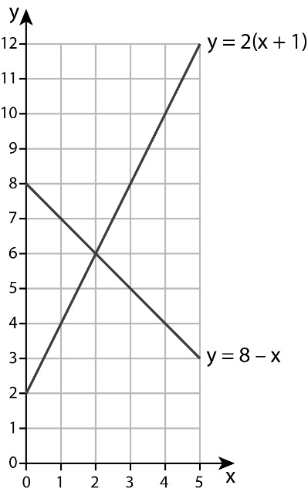

**2 i a** *x* = 1 **b** *x* = 8 **c** *x* = 2 **d** *x* = 7.5  
 **ii** Pupils’ check own answers

**Exercise 16A**

**1 a** 10 < *T* ≤ 20 **b** 0 < *T* ≤ 12

**2 a** Frequencies are 2, 4, 6, 6, 2 **b** 1.70 < *h* ≤ 1.80

**3 a** Frequencies are 4, 2, 1, 3, 2, 2 **b** 0 < *M* ≤ 1 **c** 

**4 a** Frequencies are 3, 5, 3, 3, 2 **b** 10 < *T* ≤ 12 **c** 9°

**5** 35 < P ≤ 40

**6 a** Dr Speed and Dr Bell did

**b** For example Dr Speed good range, Dr Bell too many long consultations with none under five minutes, Dr Khan quicker with none over ten minutes and nearly twice as many under five minutes as between five and ten.

**Activity: Textbook text**

Answers will vary.

**Exercise 16B**

**1** Check pupils’ diagrams

**2 a** City A **b** City B **c** 10 **d** 5°

**3** Check pupils’ diagrams

**Activity: Comparing holiday destinations**

Answers will vary.

**Exercise 16C**

**1 a** 17 min **b** 16.4 min

**2 a** 10, 11, 12.5, 13.5

**b** For example, the further north the county was, the colder and smaller the range.

**3** Matt scores consistently well, where Jon’s scores vary a lot.

**4 a** Everlast 6 hrs, 2; Powercell 4.2 hrs, 3; Electro 8.8 hrs, 1  
**b** For example Electro – lasts the longest and very reliable. Powercell – cheap, just a third of the cost of Electro but last about half as long.

**5** Cardiff 13.6, 14; Edinburgh 11.8,12; London 13.8, 16. Edinburgh is generally the coldest, with London being slightly warmer than Cardiff but a more variable temperature.

**Activity: Comparing populations**

Answers will vary.

**Exercise 16D**

**1 a i** 5.8 **ii** yes **b i** 2 **ii** yes **c i** 8 **ii** yes

**d** **i** 10 **ii** no **e i** 2 **ii** no **f i** 8.7 **ii** no

**2 a** 14 < *T* ≤ 16 **b** No individual mode

**3 a** 9, yes **b** 9, no, majority 10 **c** 9, no, ten is an outlier

**d** 9, yes **e** 9, yes **f** 12, yes

**4 a** Frequencies are 7, 2, 5, 5, 3, 6 **b** 0 < *M* ≤ 1 **c** $2.90

**d** The median is a single value, so it is better to choose the modal class

**5 a** Mode **b** Mean

**c i** Mode as that is what most workers will be paid  
 **ii** The mean as it takes their higher wages into account also  
 **iii** The median as it shows middle of the range but skewed to the bottom end

**6** Craig 5.3,5 ; Len 7.1,2 ; Darcy 6.6,3 ; Bruno 7.4,3  
 Craig is the lowest scoring but has the largest range of scores.  
 Bruno is the highest scorer with the same range as Darcy. Len’s scores vary the least.

**7 a** Highest average score **b** Can score higher than Joe

**c** Joe as he is more consistent and a higher mean

**Chapter 16: Answers to Review questions**

**1 a** No, no numbers to calculate with

**b** Yes, Lady Gaga appears more times than any other

**2 a** 7.5 **b** For example 3, 3 and 6 **c** For example 1, 4, 6, 7, 7

**3 a** Nothing **b** Nothing **c** 796 kg

**4 a** Check pupils’ graphs **b i** £35 **ii** 21cm

**5 a** 10 < *T* ≤ 15 **b** 5 < *T* ≤ 10 **c** 

**6 a** Gary highest mean score of 45.5 **b** Mark has the two highest scores

**c** Gary, as he is the more consistent with the highest mean

**7 a** Check pupils’ tables

**b** Check pupils’ diagrams **c** 16 – 20

**8 a** 5 **b** ≥7 **c** 3

**9 a** 17 cm **b** 12.5 cm2

**Chapter 16: Answers to Problem solving – Technology questionnaire**

**1** Frequencies should be as follows:

|  |  |  |
| --- | --- | --- |
|  | Boys | Girls |
| Baseball | 1 | 0 |
| Bowling | 4 | 19 |
| Boxing | 13 | 0 |
| Golf | 5 | 4 |
| Tennis | 2 | 2 |

**2** Pie charts showing frequencies from question 1

**3** Check that the class sizes used are sensible

**4** Frequency chart to match pupils’ tables from question 3

**5** **a**  **b**  **c**  **d** 