**Step 5 Answers**

**Chapter 1 Number**

**1.1 Multiplying and dividing decimals**

**1 a** 7.2 **b** 0.72 **c** 7.2 **d** 0.72

**2 a** 14 **b** 1.4 **c** 0.14 **d** 1.4

**3 a** 0.4 **b** 0.33 **c** 1.5 **d** 1.23

**4 a** 0.49 **b** 9 **c** 2.6 **d** 1.1

**5 a** 408 **b** 40.8 **c** 40.8 **d** 40.8

**6 a** 6 **b** 60 **c** 600 **d** 0.6

**7 a** 60 **b** 0.7 **c** 9 **d** 500

**8 a** 50 **b** 200 **c** 14 **d** 35

**9 a** 300 **b** 400 **c** 15 **d** 250

**10 a** 270 **b** 2700 **c** 27 **d** 2.7

**11 a** 9.6 **b** 15 **c** 0.96 **d** 1.5

**12 a** 17.6 **b** 110 **c** 1.76 **d** 11

**1.2 Multiplying and dividing fractions**

**1 a**  **b**  **c**  **d** 

**2 a**  **b**  **c**  **d** 

**3 a**  **b**  **c**  **d** 

**4 a** 2 **b** 3 **c** 3 **d** 2

**5 a** 1 **b**  **c** 1 **d** 1

**6 a**  **b** 3 **c**  **d** 1

**7 a** 2 **b** 4 **c**  **d** 

**8 a**  **b** 1 **c** 1 **d** 1

**9 a**  **b** 1 **c**  **d** 

**10 a** 5 **b** 2 **c** 5 **d** 

**1.3 Rounding and estimates**

**1 a** 300 **b** 27 **c** 0.7 **d** 6000

**2 a** 1800 **b** 1000 **c** 210 **d** 4 **e** 280 000 **f** 0.64

**3 a** 10 **b** 2 **c** 700 **d** 12 **e** 0.8 **f** 100

**4 a** 200 **b** 40

**5 a** 180 **b** 2700

**6** 20

**1.4 Errors**

**1 a** 34.5 cm and 35.5 cm **b** 615 m and 625 m **c** 7.35 cm and 7.45 cm

**d** 69.5 kg and 70.5 kg **e** 65 kg and 75 kg **f** 49.5 ml and 50.5 ml

**g** 45 ml and 55 ml

**2** **a** 19.5 cm and 22.5 cm **b** 345 cm and 375 cm

**c** 24.6 cm and 25 cm **d** 67.5 m and 72.5 m

**3 a** 56.25 and 72.25 **b** 63.2025 and 64.8025

**4 a** 278 and 282 **b** 4430.25 and 4570.25

**Chapter 2 Algebra**

**2.1 Expanding brackets**

**1 a** *x*2 + 8*x* + 15 **b** *x*2 + 6*x* + 8 **c** *x*2 + 7*x* + 6 **d** *x*2 + 13*x* + 40

**2 a** *x*2 – 2*x* – 15 **b** *x*2 + 5*x* – 14 **c** *x*2 + *x* – 20 **d** *x*2 + 2*x* – 48

**3 a** *x*2 – 7*x* + 12 **b** *x*2 – 12*x* + 20 **c** *x*2 – 7*x* + 6 **d** *x*2 – 9*x* + 20

**4 a** *x*2 + 4*x* + 4 **b** *x*2 + 14*x* + 49 **c** *x*2 – 8*x* + 16 **d** *x*2 – 20*x* + 100

**5 a** *x*2 + *x* – 30 **b** *x*2 – 13*x* + 36 **c** *x*2 – 2*x* + 1 **d** *x*2 + 10*x* + 21

**e** *x*2 – 4*x* – 96 **f** *x*2 + 24*x* + 144

**2.2 Sequences**

**1 a** 40 **b** 64 **c** 243 **d** 7.5

**2 a** 108 **b** 1.5 **c** 18 **d** 2.5

**3 a** 7 and 23 **b** 10 and 160 c 48 and 1.5 **d** 1200 and 75

**4 a** 15 and 21 **b** **i** 17 and 23 **ii** 45 and 63

**5 a** 21 and 34 **b** 45 and 73

**6 a**  and  **b**  and 

**7 a** 30 and 42 **b** 61 and 91

**8** **a** 1, 4, 9 and 16 **b** 100

**9** 80 square units

**2.3 Quadratic graphs**

**1 a** The missing numbers are 5, 0, −4, −3, 0

**b**

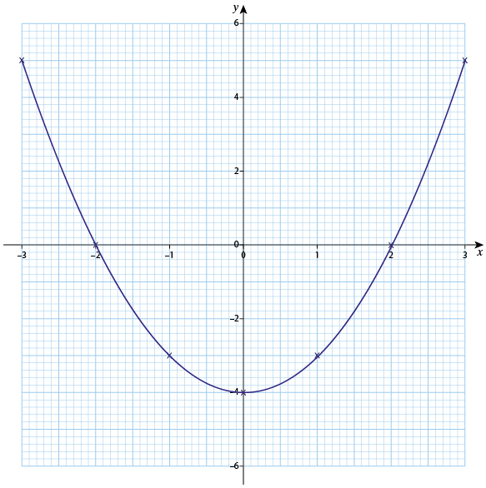

**c** 2.4 and −2.4

**2 a** The missing numbers are −3, 2, 5, 5, 2

**b**

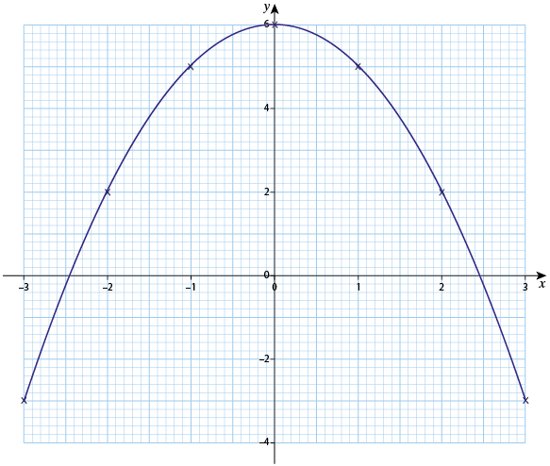

**c** 1.4 and −1.4 **d** 2.8 and −2.8

**3 a** The missing numbers are 10, 0, −2, 0, 4, 10

**b**

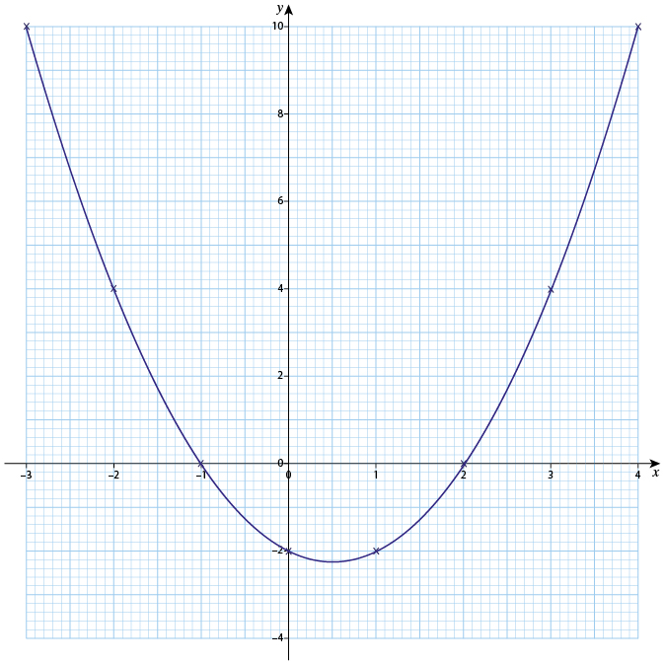

**c** 3.4 and −2.4

**4 a** The missing numbers are 8, 2, 2, 4 and 8

**b**

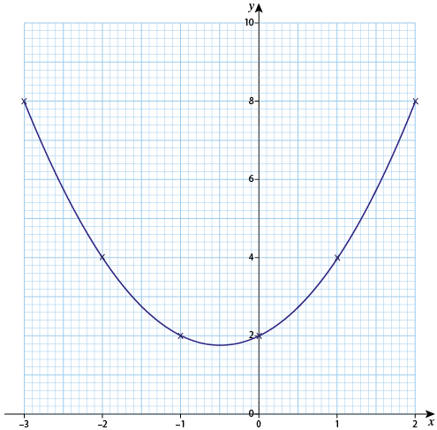

**c** 1.3 and −2.3

**5 a** The missing numbers are 1, −5, −5, −3, 1 and 7

**b**

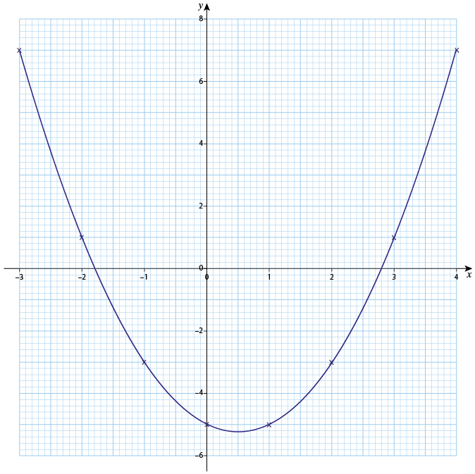

**c** 1.6 and −0.6

**2.4 Solving simultaneous equations**

**1 a** *x* = 2 and *y* = 4 **b** *x* = 5 and *y* = 3 **c** *x* = 6 and *y* = 2

**2 a** and **b**

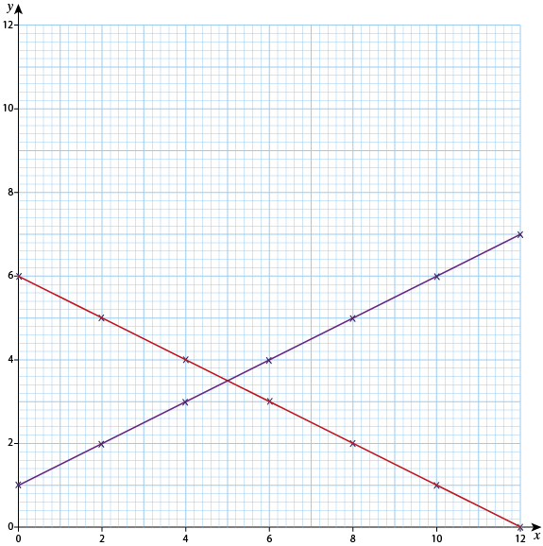

**c** *x* = 5 and *y* = 3

**3 a** and **b**

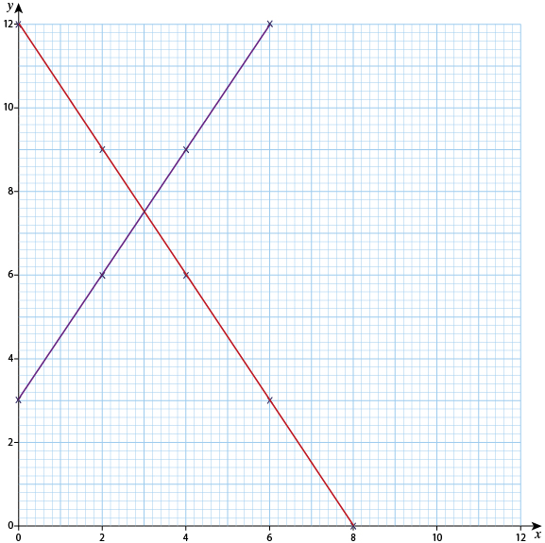

**c** *x* = 3 and *y* = 7.5

**4 a** and **b**

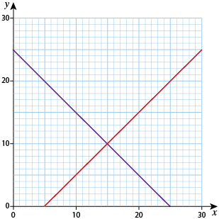

**c** *x* = 15 and *y* = 10

**5 a** *x* = 10 and *y* = 20 **b** *x* = 15 and *y* = 10

**6**

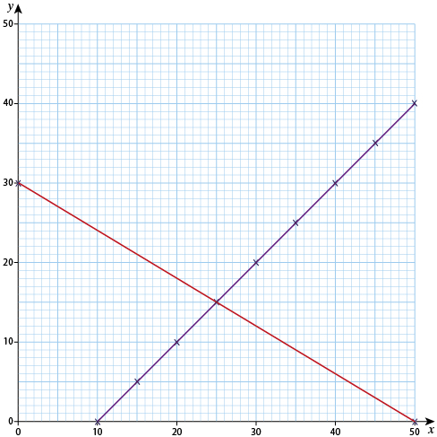

*x* = 25 and *y* = 15

**2.5 Formulae**

**1 a** 31 **b** 8 **c** 74

**2 a** 34 **b** 58 **c** 101 **d** 60 **e** 40 **f** 15

**3** The missing numbers are 50, 98, 2, 32

**4 a** 36 **b** 144 **c** 49

**5 a** 60 **b** 1.2

**6 a** 3 **b** 6 **c** 12 **d** 10 **e** 4 **f** 6

**7** 26

**8 a** 50 **b** 14

**9** 90

**10** 94

**Chapter 3 Ratio, proportion and rates of change**

**3.1 Inverse proportion**

**1** 25

**2 a** 75 **b** 30 **c** 15 **d** 7.5

**3 a** 80 **b** 20 **c** 120

**4 a** 48 **b** 12 **c** 8

**5** Top row 6.3 and 37.8; bottom row 1.2

**6** Top row 12.5 and 8; bottom row 3 and 1.5

**3.2 Proportional change**

**1** 49.02

**2** 0.81

**3 a** 1.35 **b** 2.34 **c** 0.61

**4.a** 15.50 **b** 38.16

**5 a** 5.72 **b** 2.27

**6** Top row 37.594 g; bottom row £226.10 and £31.92

**7 a** 26 **b** 180 **c** 150

**8 a** 43.75 **b** 14.29

**3.3 Compound units**

**1** 78.3

**2 a** 72 **b** 2 hours 20 minutes (or 2 hours)

**3 a** 3.6 minutes **b** 278

**4** 6.3

**5 a** £0.74 **b** £7.40

**6 a** £1.43 **b** 1.43 **c** 70 (or 69.8)

**7 a** 42p **b** 238

**8** 4.05

**9** 2.61

**10 a** 44.1 **b** 2.38

**Chapter 4 Geometry and measures**

**4.1 Pythagoras’ theorem**

**1 a** 5 **b** 13 **c** 17 **d** 20 **e** 25 **f** 35

**2** 6.5

**3** 11.7

**4 a** 3.9 **b** 7.4 **c** 7.8 **d** 8.7

**5** 8 cm

**6 a** 3 **b** 24

**7 a** 4.8 **b** 8.4 **c** 7.5 **d** 4.0

**4.2 Area**

**1 a** 300 **b** 270 **c** 64

**2 a** 100 **b** 120 **c** 68

**3** 147 m²

**4** 360 cm²

**5** 92 m²

**4.3 Prisms and cylinders**

**1** 1080

**2** 261

**3** 80

**4** 3927

**5** 503

**6** 423

**7** 7.56

**Chapter 5 Statistics**

**5.1 Scatter graphs**

**1 a**

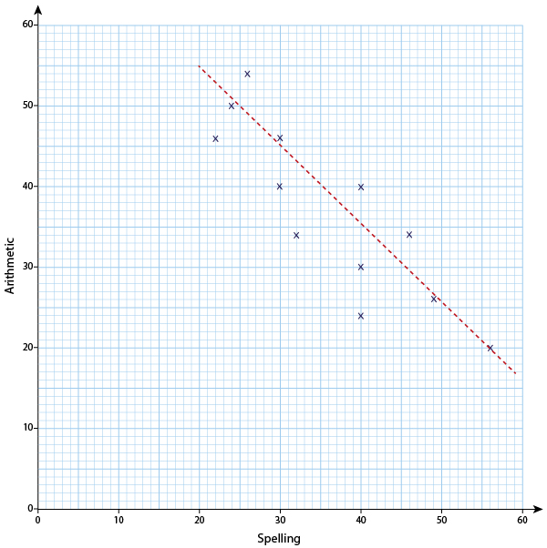

Other scales are possible.

**b** Negative correlation (or high scores on spelling go with low scores on arithmetic and vice versa)

**c** A possible line is shown in part a.

**2 a**

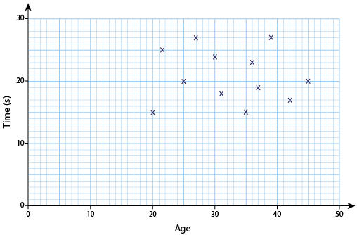

Other scales are possible.

**b** There is no relationship **c** No line of best fit.

**3 a**

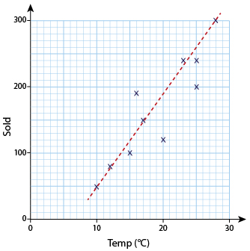

Other scales are possible.

**b** Positive correlation (or sales are higher when the temperature is higher and lower when the temperature is lower)

**c** A possible line is shown in part a.

**5.2 Grouped data**

**1 a** 26 –30 g **b** 31–35 g **c** 32.5 g

**2 a** 60–69 s **b** 50–59 s **c** 53.9 s

**3 a** At least 60 and less than 80 **b** At least 60 and less than 80 **c** 74 mm

**4 a** 80 **b** 45% **c** 69.375 miles per hour (or round off)

**5.3 Comparing distributions**

**1 a** Soil A 30–34 cm and Soil B 10–14 cm

**b** Soil A because it has more in the classes for larger heights and none in the classes for smaller heights

**c** Soil B because it covers seven classes and soil A only covers five classes.

**2 a** Group Z because it has a higher mean

**b** Group X because the range is 15. For the other two it is only 11.

**3 a** Panthers 16, Tigers 13 **b** Both 14 **c** Panthers 5 years and Tigers 6 years