Chapter 1 Percentages
1.1 Simple Interest
1 a £480 b £12.50 c £30 d £133 e £450 f £108
2 a 7 b 11 g c 15 cm d 3 m e $9 f 6 hours
3 a £40 b £8 c £20 d £16 e £60 f £56
4 a £49.45 b £5.78 c £725.40 d £2.21 e £62.72 f £0.18
5 a £30 b £240
6 a £89.60 b £537.60 c £896
7 a £2331 b £6993
8 a £1176 b £336
9 Ntuse pays most
(Rebecca £158.76 Ntuse £171.36 Kezia £165.90)
10 2.4% per month
11 Ciara pays a higher rate by 0.2%
(Peggy 1.7%, Ciara 1.9%)
12 a 0.8% per month b 19.2%

Brainteaser
£3750

1.2 Percentage Increases and Decreases
1 a 4 b £44 c £36
2 3900
3 a £420 b £280 c £392 d £308 e £577.50
f £122.50
4 a £168 b £31.20 c £69.60 d £408
5 a £329 b £245 c £980 d £574
6 a £98.60 b £79.05 c £106.25 d £72.25
7 a £478.40 b £377.30 c £467.23 d £235.80
8 a Increase of 40% b Decrease of 44%
c Decrease of 87% d Increase of 180%
9 a £30 800 b £50 400 c £70 000 d £98 000
10 59.3% to 1 decimal place
11 70%
12
Place | Percentage change | Population in 1980 | Population in 2000
Smallville | 30% decrease | 1857 | 1300
Lansbury | 8% increase | 46 000 | 49 680
Gravelton | 2% decrease | 20 204 | 19 800
Smithchurch | 48% increase | 97 297 | 144 000
Deanton | 19% increase | 28 000 | 33 320
Tanwich | 5% decrease | 680 | 646

Brainteaser
Romain’s final payment will be on June 1st 2017
Anais’ final payment will be on July 1st 2016
They will have the same amount left to pay during September 2015

1.3 Calculating the original value
1 a £20 b £60
2 a 1.22 b 1.48 c 1.06
d 1.085 e 2.2 f 4.33
3 a 0.78 b 0.52 c 0.94 d 0.915
4 a £84 b £324 c £225 d £675
5 150 litres per day
6 70
7 175 miles
8 74 kg
9 a 41 875 b 34 337
10 A = C = 280, B = F = 290, D = E = 300
11 a £45 b £7.92 c £70.03

1.4 Using percentages
1 a 144 b 44%
2 a 64% b 220 c 31%
3 a i £7.60 ii £45.60 b £11.73
4 a 62.5% b 60% c 435 d £8439
5 a 25% b 55% c 60%
6 a 40% b 13 000 c 5200 km
7 Bamboo (Bamboo 132 cm, Willow 130.2 cm)
8 a 24% b £51.30 c £22.50
9 a 480 b 520 c 25%

Brainteaser
a £3283.20
b £3456.15
c £438.20

Chapter 2 Equations and formulae
2.1 Expanding brackets
1 a 12p b 30q c –16r d 35t
2 a 5d + 10 b 14p – 7 c 12 + 4m d 50 – 30i
3 a –3a + 2 b 8h – 24 c –4w + 6 d 30 + 36x
4 a 4 (3s + 5) = 12s + 20 b 104 cm = 1.04 m
5 a 2x + 20 b 12y + 2 c 4t – 12 d 15 – 5x e 7g – 6 f 5p – 8
6 a 6x + 8 b 8i + 1 c 22n – 12 d 2r + 14 e 4k + 1 f 2j – 1 g 11f + 26 h 23u + 6
7 a i a = x – 2y ii b = 3x – 2
b i 3xy ii 2a iii 3xy + ab

Brainteaser
a £16
b 4(f + c)
c or 70%
d £11.80 ÷ 4 = £2.95
e 20 : 21
f x 100 = 5%

2.2 Factorisation
1 a 5 b 6 c 8 d 18
2 a 5(m + 4) b 3(x – 7) c 7(5 + k) d 11(1 – 5h)
3 a 4(2m – 3n) b 3(2p + 3q) c 9(3a – 2b) d –8(3f + 2g)
4 a 5(a + 3) b 2(4x – 5) c 6(5y + 1) d 4(x – 2) e 5(p + 3)
f –6(1 + y)
5 3x + 5
6 a i 10a ii 100a
b 20a + a = 21a c 21, 42, 84 d 21a is a multiple of 21
7 a Triangle = 4t + 8; Rectangle = 6r + 9; Pentagon = 5p + 30
b Triangle = 4(t + 2); Rectangle = 3(2r + 3); Pentagon = 5(p + 6)

Brainteaser
a i 7 gaps = 7m + 6 small windows + 1 large one = (8x + 7)m
ii 3 gaps + 3 windows + (3y + 6)m
b 17.4m wide and 11.4m high
c 8x + 7 = 20 3y + 6 = 9.6
8x = 13 3y = 3.6
x = 1 y = 1.2m
x = 1.625m

2.3 Equations with brackets
1 a w = 3 b x = 1.5 c y = –2 d z = 1
2 a 23 b 0 c 6 d 3
e 10 f -15 g 25 h 9
3 a 8 b 4 c 5 d
4 a 6x + 7 b 5
5 a 13x – 19 b 3
6 i (12h + 6) ÷ 6 or factorise 12h + 6; 6(2h + 1) ii 48 cm iii 2 cm
7 a 5x – 15 – 4x + 8 = x – 7 b x – 7 = 10; x = 17 c x – 7 = – 7; x = 0
8 a 7m + 5 = 52 ; m = 6 b 3d + 12 = 21; d = 3
c 8t + 6 = 0; t = – d 2b + 17 = 33; b = 8
9 a 7v + 21 = 5v + 35; 2v = 14; v = 7
b 4d + 8 = 8d – 28; 36 = 4d; d = 9
c 3x – 6 = – 2x – 38; 5x = –32; x = – 6.4 or -6
d 10 – 4k = 3 + 6k; 7 = 10k; k =

2.4 Equations involving fractions
1 a 16 b 21 c –50 d 0.12
2 a 14 b 40 c 3 d –51
3 a 10 b –3 c –15 d 7
4 a 4 b 11 c 6 d –1
e 14 f 14 g –24 h –20
5 a area = length x width, so divide area by width to find length.
b = 13; 3n + 4 = 65; 3n = 61; n = 20
6 a 10 b 3 c d 8
e 9.5; 9 f 6 g 12 h 16
7 a 19 b 7 c 11 d 13
e 9 f 7 g 4 h 10

Brainteaser
a 8, 11, 3, 6
b x + x + 3 + x – 5 + 2x = 5x –2 Divide by 4 to find the mean.
c = 12; 5x = 50; x = 10
d 10, 13, 5, 20
e 15

2.5 Re-arranging formulae
1 a m = L – n b h = c s = vt d t = e R = x – D
2 a v = 15 + 49 = 64 b t = c t = = 0.375;
d t = –= –0.285714
3 a 52 mins
b 80 mins; 1 hour 20 mins
c W = 25(T – 20)
d 1750 g; 1.75 kg
4 a p = b 45 people
5 a 4.5 b 99 c 3m = x + (y + z); 3m – (y + z) = x
d 32 e y = 3m – (x + z) f 2.3
6 a Area 1 = 3c x b = 3bc; Area 2 = 3 x 4 = 12
Take Area 2 from Area 1; A = 3bc – 12
b b = c b = = 9 cm
7 a £13.50 b R = c 7.5% d 4 years

Brainteaser
a E = = 4 units
b 5 =; = = 360 cm
c 2 =; 98 = 2x²; x² = 49; x = 7 cm

Chapter 3 Polygons
3.1 Angles in polygons
1 a Octagon b Heptagon c Pentagon d Decagon
2 a 6 b 12 c 9 d 4
3 a 18 b 3240°
4 a 14 b 16
5 160°
6 a 105° b 59° c 80°
7 a 141° b 72°
8 40°
9 a a = 130°, b = 50°, c = 50°, d = 90°, e = 90°
b 130 + 50 + 90 + 90 = 360
10 100°, 120°, 73°, 114°, 133°
11 310°
12 a 39 b 55 c 73

3.2 Angles in Regular Polygons
1 a 180° b Equilateral triangle c 60°
2 a 360° b Square c 90°
3 a 7 b 1260° c 140°
4 a 10 b 1800° c 150°
5 360°
6
Number of sides | Sum of exterior angles | Size of each exterior angle | Size of each interior angle
15 | 360° | 24° | 156°
16 | 360° | 22.5° | 157.5°
18 | 360° | 20° | 160°
20 | 360° | 18° | 162°
30 | 360° | 12° | 168°
7 a 36 b 360 c 3 600 d 360 000
8 a a = 120°, b = 30°, c = 30°
b EAB = FAB – FAE = 120° – 30° = 90°
DBA = CBA – CBD = 120° – 30° = 90°
AED = FED – FEA = 120° – 30° = 90°
BDE = CDE – CDB = 120° – 30° = 90°
9 a 90 b 40 c 13
10 a = 135°, b = 22.5°, c = 90°, d = 45°, e = 45°
11 228°
12 x = 77.1°, y = 25.7°

Brainteaser
If the interior angle is an integer then so is the exterior angle
The exterior angles must be factors of 360.
360 has 24 factors: 1, 2, 3, 4, 5, 6, 8, 9, 10, 12, 15, 18, 20, 24, 30, 36, 40, 45, 60, 72, 90, 120, 180, 360
The factor of 3 corresponds to an equilateral triangle, the factor of 4 corresponds to a square, etc.
Each of the factors will correspond to a regular polygon apart from 1 and 2.

There are 22 regular polygons which have an interior angle which is an integer number of degrees

3.3 Regular Polygons and Tessellations
1 a, b, c All triangles tessellate
2 a, b, c All quadrilaterals tessellate
3 Check pupils’ tessellations.
4 Check pupils’ tessellations.
5 Check pupils’ tessellations.
6 Check pupils’ tessellations.
7 Check pupils’ tessellations.
8 a
Polygon | Interior Angle | Exterior angle
Triangle | 60° | 120°
Quadrilateral | 90° | 90°
Pentagon | 108° | 72°
Hexagon | 120° | 60°
Heptagon | 128.6° | 51.4°
Octagon | 135° | 45°
Nonagon | 140° | 40°
Decagon | 144° | 36°
b The interior angle has to be a factor of 360. Only 60, 90 and 120 satisfy this requirement.

Chapter 4 Using Data
4.1 Scatter Graphs and Correlations
1 a negative correlation
b positive correlation
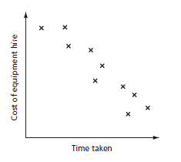
c

2 No correlation expected between the time spent writing and the marks obtained. Writing talent is the overriding factor.
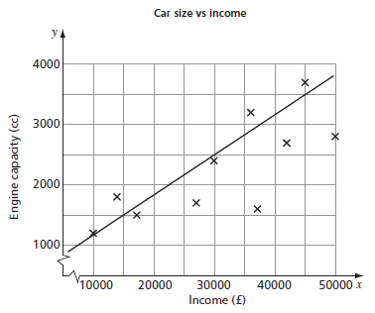
3 a

b Higher income, higher engine size
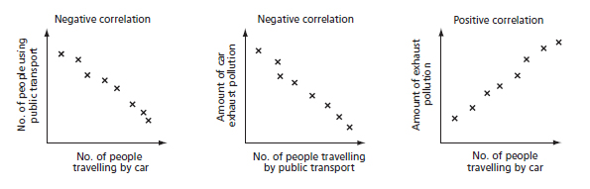
4

5 a and b
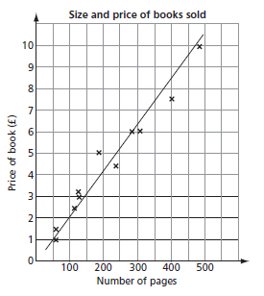

c i approximately £5.50
ii approximately 75 pages
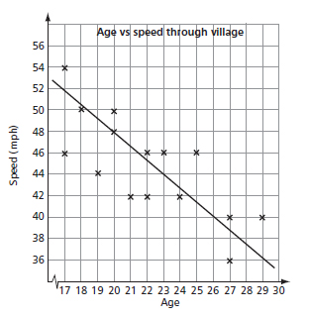
6 a

b i 22 years old
ii 40 mph

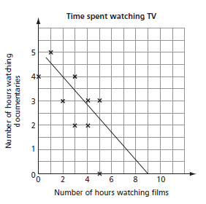
Brainteaser
a and b

c The number of films watched is negatively correlated with the number of documentaries watched.
d i 3 hours ii 0 hours
e The more fiction adults watch, the less non-fiction they watch.
f The sample is very small and not representative of the general adult population and so any conclusion based on the data may be incorrect.
g Answers will vary.

4.2 Time Series
1 a 7th June b 3rd and 4th June
c i 4 days ii 0.25 m
d When it was emptied, indicated by steepness of the graph.
2 a 1930’s b 5%
c During the world wars everybody had to do something to replace the people who were away fighting.
d They’re very close (%,%), so he’s got a good point.
e About 25 years (1945 – 1970). Possibly 30 years (until 1975).
3 a i coal ii petroleum
b hydropower c 1950 d 27.5% e 53%
f decreased until 1975, increased during the next 5 years, then levelled off until the end of the century
g nuclear power
h increased from 2.5% to 32.5% until 1970, decreased to about 25% over the next 15 years, then levelled off
i i 1 000 000 000 000 000 000 000 000
ii 40% of 82 quadrillion = 32.8 quadrillion units
4 a SW b JJY (range = $4 vs $3.50)
c $1.50 between 3.30pm and 4.00pm for SW
d i JJY ii between 11am and 12 noon iii $4
e $12 – $9 = $3
f volume slumped during the middle of the day (perhaps because traders went to lunch)
g JJY 1.30pm to 2.30pm, SW 1.30pm to 2.30pm
h 10 000 × $11 = $110 000
i $802 500 between 9.30am and 10am
5 a October 2005
b April 2006, nearly 5000
c 6 months – until December 2006
d About 29 000
e November 2005; the line is at it’s steepest
f Not really. Book sales were already decreasing before downloads became available, and they remained fairly level even after the big increase of downloads at the end of 2006.

4.3 Two Way Tables
1 a = 21.6% b Medium c Green d = e £570
2 a
M | F | totals
 |  | 27
 |  | 33
 |  | 30
43 | 47 | 90
b Tennis c = 38.3% d e 10%
3 a 80 b , 5%
c No; China 15, USA 18 d Cape Canaveral
4 a
 | M | F | totals
<40 | 2 | 2 | 4
40-44 | 3 | 1 | 4
45-49 | 4 |  | 4
50-54 | 1 |  | 1
55-59 | 1 |  | 1
60+ | 1 |  | 1
totals | 12 | 3 | 15

b ; 20%
c Pudsey Pacers, 19,
Saddleworth Runners, 16, so Saddleworth won.
d Most runners were men and all were over 40, so the magazine is correct based on this one race, but you would need to look at other results to be more valid, including ages/gender of people not in the top 15 here.
5 a FirstBank 3300 ÷ 400 = £8.25 each,
Pin Wheel 853 ÷ 50 = £17.06 each,
PowerCo 3720 ÷ 2000 = £1.86 each, so PowerCo were cheapest.
b £872.19 c £1.71
6 a two-weeks AI holiday to Tenerife from 21st March or 28th March
b £389 – £149 = £240 c 21st March
d one-week holidays to Gran Canaria increase in price with date; HB are always more expensive than S/C holidays; S/C holidays are more expensive in Gran Canaria than Tenerife, etc.
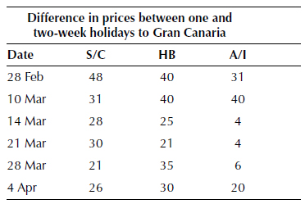
e

Overall, the difference between one and two-week all-inclusive holidays is less than that for self-catering and half board holidays.
f All-inclusive (smallest range for one-week and two-week holidays)

4.4 Comparing two or more sets of data
1 a June 2007 b Rainfall doubled c 2013
d 2000 - 79.5%, 2007 - 118%, 2014 - 42.5%
e 80%, 120%, 40%; 2 : 3 : 1
2 a 23.2% b Under 25, 55-64, and 65-74 c 75+ d 65-74 e More people of all ages own computers, with older age groups increasing fastest.
3 a A -, B - b A - 40%, B - 52%
c A - £201-300, B - £301-400, modal wage
d Office B generally pays more people a higher wage, but does that mean conditions are better? Perhaps, more stress? What about holidays, hours worked per week, relationship with employees etc?
4 a or more b 100 c 5%
d 67%send between 1 and 3 messages, so yes, he’s correct.
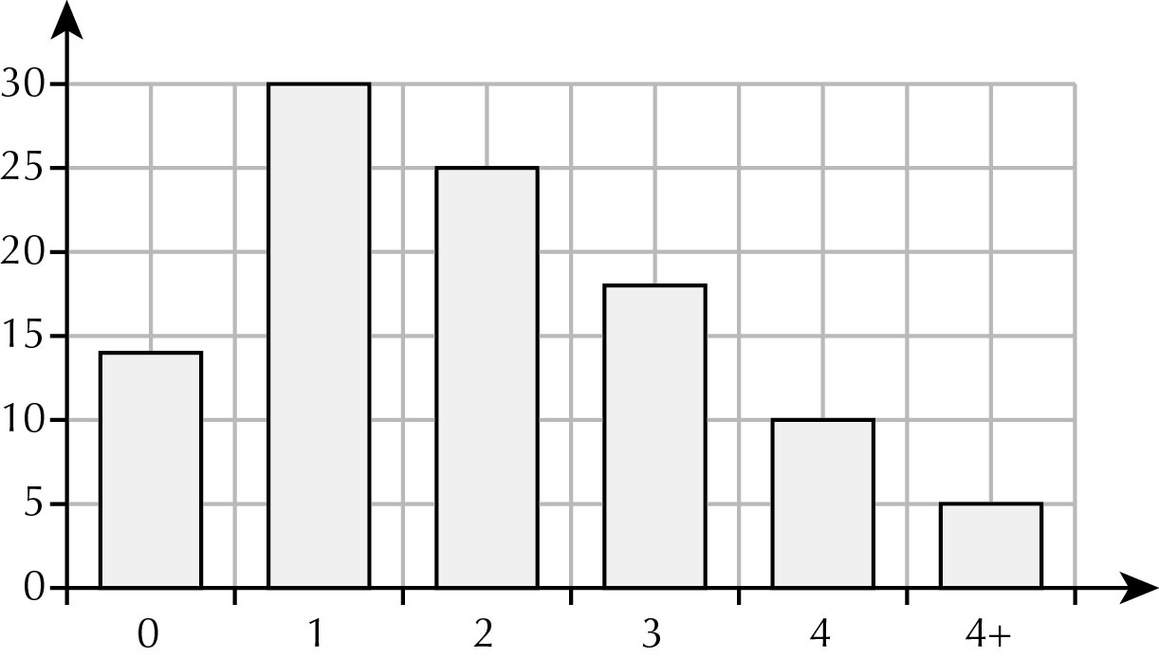
e No – only 28% send 4 or more messages (including the 5 missed out).
f

g 85% phone at least once, but 95% text at least once, so she’s wrong.
h Own observations
5 a Farm C
b Farm A went down 29%, but Farm D has gone down by 36%.
c charts with angles of 155 (1⁰ has to be lost, so take it off the largest sector)/62/30/113 (2009) and 132/99/43/86 (2014). Farm B’s share shows a big increase.
d accurate charts using sensible scale on y-axis (perhaps intervals of 20 or 25),
e Overall numbers are decreasing. The two farms that have increased stock have not gone up by a lot, whereas the farms getting smaller have lost a larger proportion.
f The bar chart probably shows the overall picture better.

Brainteaser
a Manchester Utd (94, 96, 99) Arsenal (98, 2002) Chelsea (2010)
b 4 – Everton, Liverpool, Portsmouth, Wigan
c Modal score was 1-0 (9 times). 2-0 and 2-1 occurred 4 times. Once each for 3-0, 4-0 and the draws.
d Including the 0-0 draw, 17 teams did not score in open play. If you take this as 17 out of 40 teams that took part, the percentage is 42.5%. However if you only count each team once, regardless of how many appearances they made, the percentage is 17 out of 16, which shows how careful you must be with statistics!
e Including the replay, 44 goals were scored in 21 games, giving a mean of 2.1 per game. Ignoring the replay, hardly changes this – try it.
f so far
h Manchester and Blackburn account for 14 Premier titles: 70%. Arsenal, Chelsea and Portsmouth won 12 Cups in the same period: 60%. So there is truth in what Ethan says.

4.5 Statistical investigations
Pupils own investigations.
Chapter 5 Applications of Graphs
5.1 Step Graphs
1 a £10 b £10 c £13 d 16 hours
2 a £3
b i £3 ii £4 iii £5 iv £6 v £6.50
3 a 3 weeks
b i £0.80 ii £2.40 iii £8.00
c i 5 weeks ii 7 weeks iii 8 weeks
4 a £4
b i £16 ii £9
c 6 miles
5 a i Nothing ii £4.50 iii £10
b i £4 ii £4 iii £6
c i Short stay ii Long stay iii Long stay
6 a £3.50
b 7 kg
c £14
7 a 50p
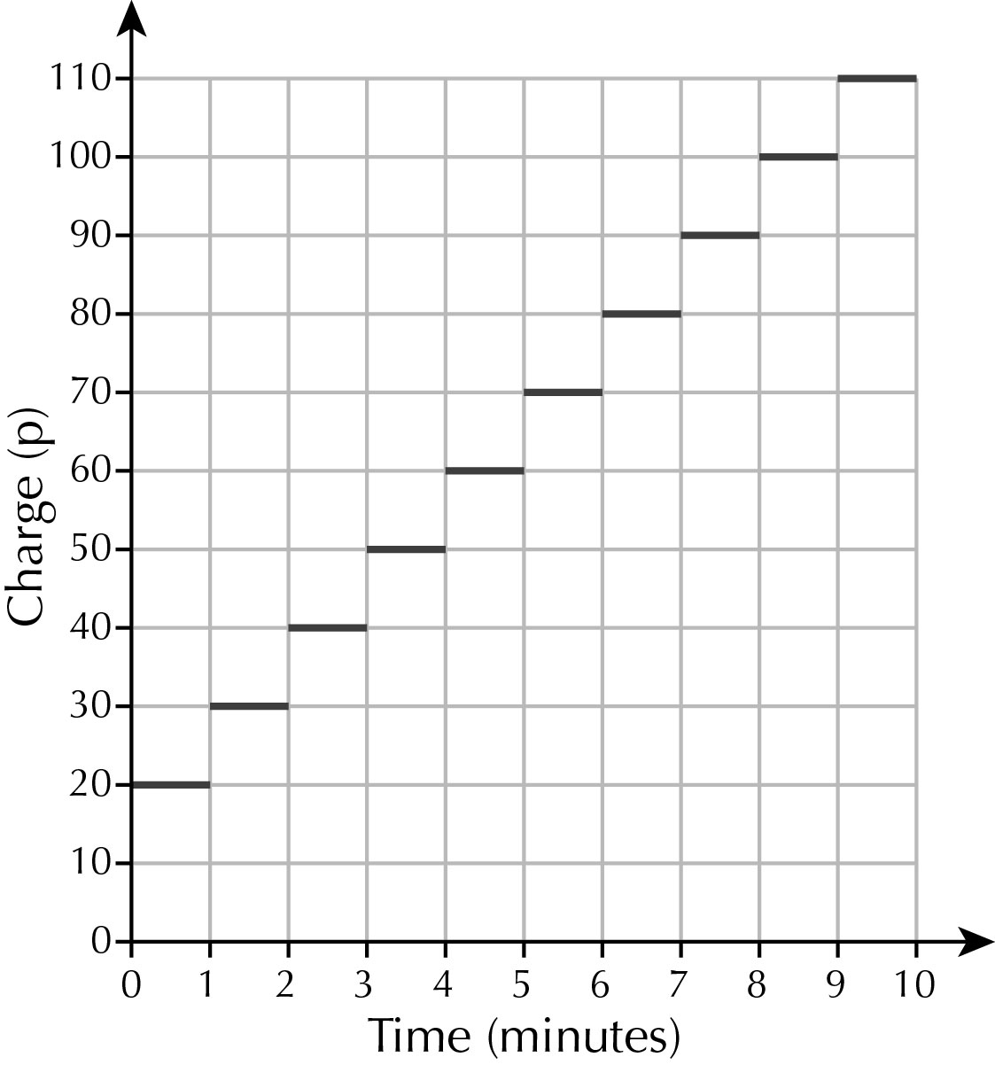
b

8 a
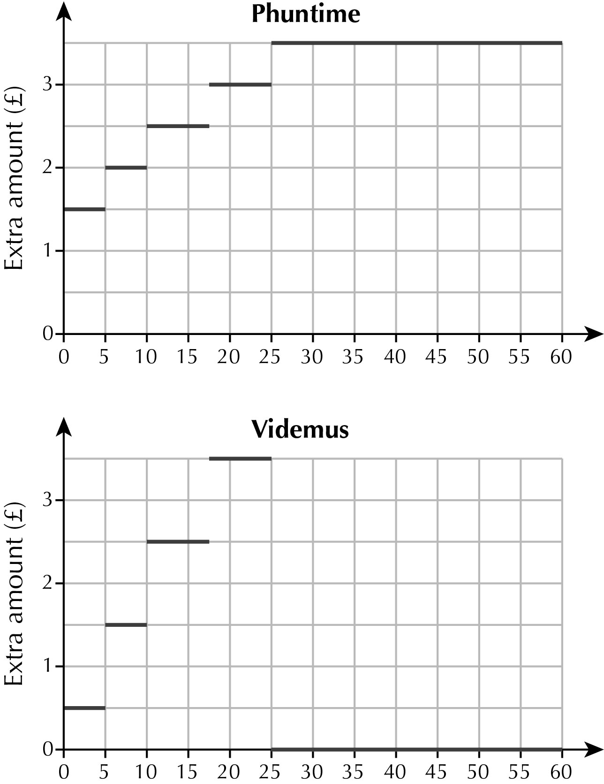

b Videmus
c Phuntime
d Videmus
e i Videmus ii either iii either iv Phuntime v Videmus

5.2 Time Graphs
1 a Coach A b Coach B c 3 hours
2 a b c
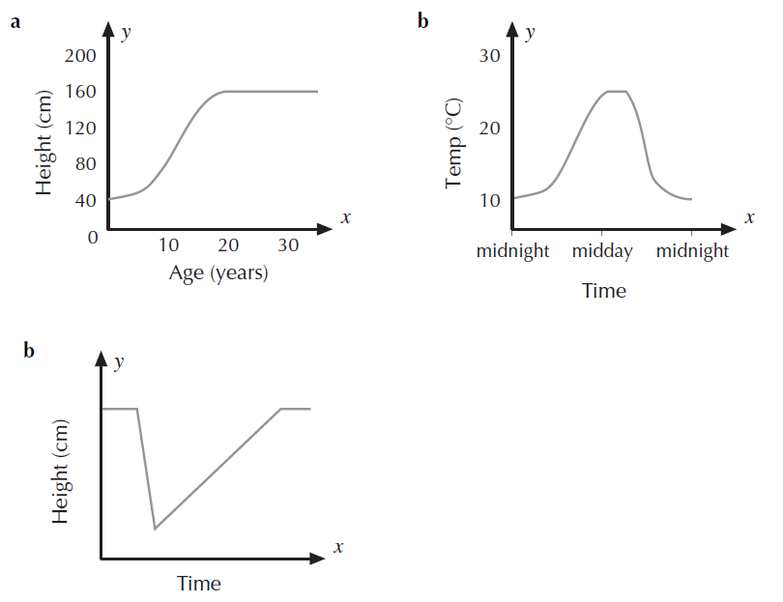

3 a iii b iv c ii d i
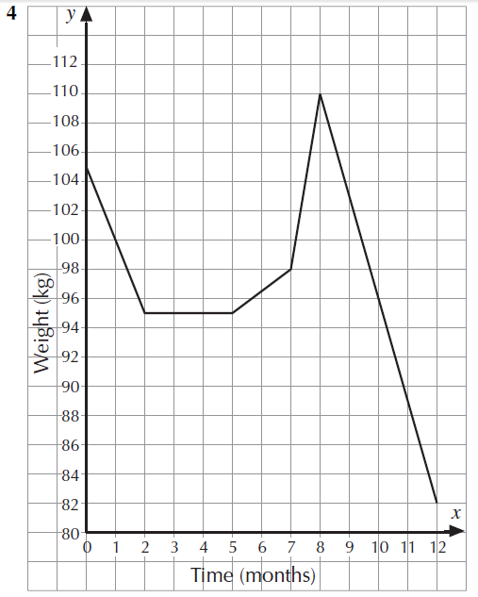
4
5 a Gurjit cycled because of steeper gradients.
b i 9.03am ii 500 m iii 2 minutes
c 500 m
d Up the hill between 9.05am and 9.08am
e Down the hill between 9.02am and 9.03am
f Answers will vary.
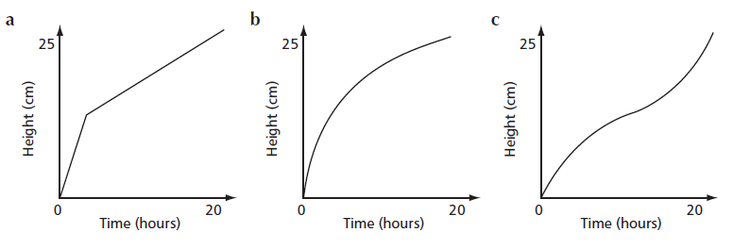
6

7 a C b A c B d D
8
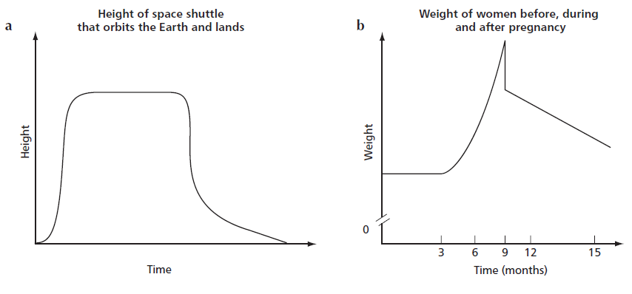

Brainteaser
Verlassen to Ziel: 120 miles, £50, 5% off
Ziel to Mittagess: 40 miles, £10, no reduction
Mittagess to Verlassen: 80 miles, £30, 5% off
Total: £47.50 + £10 + £28.50 = £86

5.3 Exponential Growth Graphs
1 a 1.5 b 1.5 c Each population is 1.5 times the previous
2 a 800 b about 1200 c 24 d about 1800
3 a about 500 b about 5100 c 180 seconds
4 a about £13 500 b about £52 000 c 47 d 26
5 a 4 b 17 c 69 d 281
e about 1150 f 69 days
6 a 85°C b 46°C c 24°C
d 20 minutes e 4 minutes f 20°C
7 a
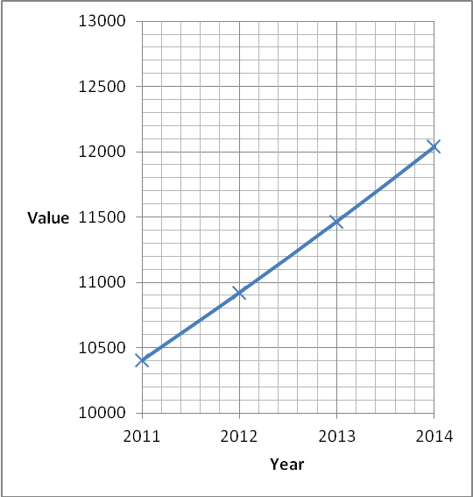
b £12 640
8 a 3 b 24 c 5
9 a 4 b 5 c 100
Chapter 6 Pythagoras’ theorem
6.1 Introduction
1 a
a | b | c | a² | b² | c² | a² + b²
3 | 4 | 5 | 9 | 16 | 25 | 25
6 | 8 | 10 | 36 | 64 | 100 | 100
9 | 12 | 15 | 81 | 144 | 225 | 225
12 | 16 | 20 | 144 | 256 | 400 | 400
b C is the hypotenuse
2 a i 30 ii 28 iii 40, 50 iv 60,100 v 300, 400
b 3 : 4 : 5
3 a 7, 24, 25 9, 40, 41 11, 60, 61
b Successive odd numbers on smallest side. Other 2 sides add up to the smallest side squared
4 a No b Yes c No d No e Yes f Yes
5
a | b | c | a² | b² | a² + b² | c²
2 | 3 | 3.6 | 4 | 9 | 13 | 13
10 | 9 | 13.5 | 100 | 81 | 181 | 181
8 | 15 | 17 | 64 | 225 | 289 | 289
12 | 18 | 21.6 | 144 | 324 | 468 | 468
6 a No b No c Yes d Yes
7
a | b | c | a² | b² | a² + b² | c²
1.2 | 2.3 | 2.6 | 1.4 | 5.3 | 6.7 | 6.7
5.7 | 5.3 | 7.8 | 32.5 | 28.3 | 60.8 | 60.8
6.6 | 12.5 | 14.1 | 43.7 | 156.3 | 200 | 200
1.5 | 2 | 2.5 | 2.25 | 4 | 6.25 | 6.25

6.2 Calculating the hypotenuse
1 a 8.5 cm b 9.1 mm c 2.1 m d 130 mm
2 a b Pupils’ own answers
3 a 66 + 88 = 154 m, diagonal = √12100 = 110 m. So 44 m shorter
b 31.68 seconds
4 a 32² + 18² = 1348; 36.7²; TV classed as 37”
b 42² − 37² = 395; 19.87. So 20” high
c £630
5 a 75 km b Journey is 180 km, 10% or
6 a AB = 360 m BC = 100 m AC = 420 m
b AB = 410 m BC = 450 m AC = 300 m
c AB = 500 m BC = 280 m AC = 540 m

Brainteaser
a AB = 3.2
b EF
c CD
d (3,0)
e i AB ii CD and GH

6.3 Calculate the length of the shorter sides
1 a 13.7cm b 9.4 mm c 360.6 mm d 3.4 m
2 305² − 300² = 3025. Box needs to be (√3025) 55 mm deep
3 Apex is 1.96 m above sides, 20 3.76 m in total
4 a 3.46 m b Needs to be 3.66 up the wall; needs to be 39 cm nearer the wall
5 a 54 m b 4 sections: (3 x 15 m + 9 m) or (4 x 13.5 m) or similar
6 2x² = 12² So x² = 72, x = 8.48 cm P = 12 + 16.9 = 28.9 cm
7 Triangle P = 6 + 8 + 10 = 24 cm Rectangle P = 6a = 24 ∴ a = 4 cm
Area = 4 x 8 = 32 cm²

6.4 Solving problems using Pythagoras’ theorem
1 a x = 14.8 mm y = 4.9 mm
b x = 132.3 cm y = 269.3 cm
2 a d = 153 m to nearest metre b x = 97 cm to nearest cm
3 a 949 mm b 0.83 m c 89 cm d x = 50 mm, y = 64 mm
4 a BC = 7cm PQ = 25.2
b Ratios of sides are the same (AC : BC = 6 : 7, PR : RQ = 42 : 49 = 6 : 7)
5 a = 4 m
So ladder is 8 m in total, which means:
b = 1 m c = 95 cm d = 2 m e = 1.3 m
6 a The triangles have equal angles: S and Q are both right angles. P is common to
both, so T and R must be the same (AAA).
b ST = x 2.5 = 0.714 m
c PQ² = 72 – 2.5² = 42.75, so PQ = 6.538 m
ST is of the way up the sail; x 6.538 = 4.67 m
Chapter 7 Fractions
7.1 Adding and subtracting
1 a 6 b 10 c 12 d 36
2 a b c d 1
3 a 4 b 5 c 5 d 8
e 2 f 2 g 2 h 4
4 a 8 b 9 c 4 d 4
e 2 f 2 g 2 h 4
5 a 11oz b 4oz
6 a 3 b 7 c 2 d 6
7 a 2 b 3 c 2 d
8 a b c 1

Brainteaser
a
b
c 240 ml
d
e 4tins × 600 ml = 2750 ml = 2.75 litres

7.2 Multiplying
1 a 15 b 24 c 9 d 6 e 9
2 a 4 tins b 7 hours
3 a 22 b 18 c 18 d 36 e 18
4 a Red – 8 ml, Blue – 6 ml, Yellow – 22 ml
b 6 ml is of 8 ml, so of the total ink is used; 27 ml.
5 of 21 → 7, of 40 → 10, of 25 → 5,
of 21 → 14, of 40 → 30, of 30 → 24
6 a Jamie – 18 m², Ollie – 12 m² b Jamie - £54, Ollie - £36
c d
7 a b c d
8 a b c d

Brainteaser
a 60 minutes
b 88 minutes – not quite a whole game
c
7.3 Multiplying with mixed numbers
1 a b c 1 d
e 5 f 2 g 4 h 1
2 a 5hours = 330 minutes b 170 minutes c 168 minutes (2h 48m)
3 a 1 b c 1
4 a 3 b 9 c 16 d 7
5 a 3 b 12 c 1 d 38
6 c² = 16 → c = 4.1 or 4

7.4 Dividing fractions and mixed numbers
1 a 10 b 12 c 80
2 a second answer is the reciprocal (or inverse) of the first
b bigger
c smaller
3 17 stones
4 a b 1 c
5 a b c d 1 e 1 f
6 a 636 mph
b They are both right – multiplying by 1 () is the same as dividing by
→ 1017.6 km/h
7 a 2 b c d 5 e f 1
8 a 11 times (with remainder)
b

Brainteaser
a 548 Paralympians
b 45 countries
c Proportion of Paralympic athletes in most countries is much smaller than for ‘ordinary’ athletes. As facilities and understanding develops, this proportion should improve over the years.
Chapter 8 Algebra
8.1 More about brackets
1 a 12s b 5t c 16u d v
e 16w f 15x g 6y h 3z
2 a 8p b 24p c 30p d 77p
3 a 5d + 10 b 14p – 7 c 12 + 4m d 50 – 30i
e –18a – 12 f –8H + 24 g –4w – 6 h –30 + 36x
4 a a² + 5a b 4b + b² c 9c – c² d d² + 4d
e 3e + 3f f g² – 8g g h² + hi h 4j – j²
i 8m² + 8m j 12u – 3u² k 2p² + 3p l 5x – 2x²
m 3i² + 2in n –2d² + 3d o –5xy + 4y² p –5h² – h
5 a 7x(x + 3) = 7x² + 21x
b correct
c x(3x + 5y) = 3x² + 5xy
d 2t(t – 9) = 2t² – 18t
e 11m(m – w) = 11m² – 11mw
6 a i s + 5 ii 6(s + 5) iii n(s + 5)
b ii 6s + 30 iii ns + 5n
7 a i b + 10 ii 3(b + 10) iii b(b + 10)
b ii 3b + 30 iii b² + 10b
8 a
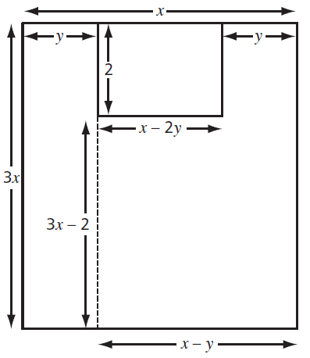
b yellow 3xy, white 2(x – 2y) or 2x – 4y
9 a g² + 4g b g² – g c 3g² – 9g d 4g – g²
10 a 25q² b 49q² c 121q²
11 a 9x² + 15x b 8x³ + 36x c 55x² – 5x³ d 60x³ – 42x²
12 a 27t³ b 64u⁶ c 32v³⁰
13 a 14y⁵ – 8y³ b 48y⁷ + 72y¹²

8.2 Factorising expressions containing powers
1 a 5(m + 4) b 6(2x – 3) c 2(15 + 4k) d 7(2 – 3h)
2 a a(m – n) b 8(2p + q) c 9(3s – 2b) d –10(2f + g)
3 a a(b + 2) b m(n – 1) c s(2t + 5) d d(e + f)
e 4i(j + 1) f 3r(3 – 2w) g 5p(3q + 4r) h 6u(h+ 2i)
4 a w(w – 8) b x(x + 5) c y(y – 13) d z(2 – z)
5 a d(d + 3) b t(4 – t) c y(y – 9) d i(1 + 6i)
e p(p – 1) f d(2 + d)
6 a a(5 + a) b not possible c c(4c – 5) d 4(d + 3)
e not possible f 8(f² – 3) g g(8 – g) h 7(h – 2)
i not possible
7 a 105 b u(4u + 1) c 5 × 21 = 105
8 a 5u(u + 1) b 3e(e – 3) c 4p(2p + 3) d 6h(2g + 3)
e 2w(5w – 1) f c(7d + 4) g 5n(2 – 5n) h –7m(m + 2)
9 a k(k² + 6) b 4k(k² + 2) c 5k(2 + 3k²)
d k²(k + 2) e 2k²(4 – 3k)
10 a 4b²(2 + 3b³) b 7b(2b⁵ – 1) c 5b⁷(7b⁴ + 5) d 7b⁴²(6 + 7b⁷)

Brainteaser
a 3x + 3
b 3(x + 1)
c When 3 is multiplied by an integer, the answer is always a multiple of 3
d No [4x + 6 = 2(2x + 3) is not a multiple of 4]
e Yes [5x + 10 = 5(x + 2) is always a multiple of 5]
f The sum of n consecutive integers is only a multiple of n if n is odd

8.3 Expanding the product of two brackets
1 a 3x + 15 b 2x – 18 c 4x + 32
d 18 – 6x e 20x + 70 f 35 – 21x
2 a de + 6d + 5e + 30 b uv + 10u + 3v + 30
c yz + 8y + 2z + 16 d pq – 7p + 5q – 35
3 a This is the length of the blue triangle (s + t) multiplied by the length of the blue triangle (u – v).
b This is the area of the whole shape (su + tu) minus the area of the yellow rectangle (sv + tv).
4 a 156 b x² + 5x + 6 c 156
d (10 + 3)(10 + 2) = 13 × 12
5 a x² + 4x + 3 b x² + 11x + 18 c x² + 9x + 20
d x² – 8x + 15 e x² – 11x + 10 f x² + 3x – 10
g x² – 3x – 28 h x² – 10x + 24 i x² + x – 72
6 a i c² – 25 ii f² – 16 iii t² – 81
b The middle terms cancel each other out as one is positive and the other is negative.
7 a (a + 5)(a – 2) = a² + 3a – 10
b (b + 7)(b + 8) = b² + 15b + 56
c (c – 3)(c – 7) = c² – 10c + 21
d (4 + d)(9 + d) = d² + 13d + 36
e (e + 11)(e + 5) = e² + 16e + 55
f (f – 9)(f + 1) = f² – 8f – 9
8 (x + 3)² = (x + 3)(x + 3) = x² + 6x + 9
9 a x² + 10x + 25 b x² + 8x + 16 c x² – 14x + 49
d x² – 16x + 64 e x² + 200x + 10 000 f x² – 400x + 40 000

Chapter 9 Decimal numbers
9.1 Powers of 10
1 a i 70 ii 700 iii 7000 b i 840 ii 8400 iii 84000
c i 2730 ii 27300 iii 273000 d i 9500 ii 95000 iii 950000
e i 58000 ii 580000 iii 5800000 f i 4.2 ii 42 iii 420
g i 8740 ii 87400 iii 874000 h i 126 ii 1260 iii 12600
i i 0.53 ii 5.3 iii 53 j i 0.004 ii 0.04 iii 0.4
2 a i 800 ii 80 iii 8 b i 39000 ii 3900 iii 390
c i 463900 ii 46390 iii 4639 d i 5800 ii 580 iii 58
e i 8 200 000 ii 820 000 iii 82 000 f i 430 ii 43 iii 4.3
g i 0.06 ii 0.006 iii 0.0006 h i 2.37 ii 0.237 iii 0.0237
i i 0.0054 ii 0.000 54 iii 0.000 054 j i 1 359.9 ii 135.99 iii 13.599
3 a i 600 000 ii 6 000 000 000 iii 60 iv 0.6
b i 5 000 ii 50 000 000 iii 0.5 iv 0.005
c i 23 000 000 ii 230 000 000 000 iii 2300 iv 23
d i 600 ii 6 000 000 iii 0.06 iv 0.0006
e i 25 200 ii 252 000 000 iii 2.52 iv 0.0252
4 0.01 = 10^{–2} and 100 = 10²
Multiplying by 0.01 is the same as dividing by 100
5 a 58 000 b 330 c 0.051188 d 950 000 000
e 710 000 000 f 0.000 002 g 234 h 0.00119
6 a 0.0067 km² b 150
7 23
8 France, Portugal, Switzerland, Belgium, Netherlands

9.2 Standard Form
1 b, c, d
2 a 2100 b 400 000 000 c 3 900 000 d 9 900 000 000
e 0.079 f 0.000 000 7 g 0.000 46 h 0.000 018
3 a 3.2 × 10³ b 9 × 10⁵ c 4.2 × 10² d 8 × 10⁹
e 5.4 × 10^{–2} f 7 × 10^{–6} g 3 × 10^{–1} h 4.4 × 10^{–3}
i 2.7 × 10³ j 7 × 10⁵ k 4 × 10^{–3} l 1.3 × 10^{–3}
4 a 2.5 × 10¹ b 3.6 × 10⁴ c 9 × 10^{–6} d 1.44 × 10^{–8}
5 a 9.9 × 10¹⁰ b 6.7 × 10⁴ c 2.8 × 10⁹ d 7.8 × 10⁷
e 7.1 × 10^{–1} f 3.0 × 10^{–2}
6 3 × 10⁸ = 300 000 000. 2 × 10⁷ = 20 000 000.
300 000 000 + 20 000 000 = 320 000 000, which does not equal 5 × 10¹⁵
7 a 1.1 × 10¹³ b 6.2 × 10⁷
8 a 9.1 × 10^{–28} g b 1.82 × 10^{–27} g c 1.1 × 10²⁷
9 a 8 × 10⁵ b 2.8 × 10¹⁰ c 2 × 10⁴ d 1.75 × 10^{–2}
10 233 333
11 510 seconds

Brainteaser
a 5.2 × 10¹⁰¹
b 6.8 × 10¹⁰³
c 7 × 10¹⁰⁶
d 2.5 × 10⁹⁹
e 3 × 10⁹⁸
f 4.3 × 10⁹⁴
g 1 × 10²⁰⁰
h 6.4 × 10²⁰³
i 2.7 × 10³⁰¹
j 2 × 10^{–100}

9.3 Rounding appropriately
1 a i 6.7 ii 6.72 b i 4.0 ii 3.95 c i 4.3 ii 4.29
d i 7.0 ii 7.04 e i 1.9 ii 1.90 f i 0.1 ii 0.06
g i 21.0 ii 20.96 h i 0.5 ii 0.51 i i 334.6 ii 334.59
2 a iii mass will be approximate
b ii speed will be measured more accurately
3 a 6 + 9 = 15 b 9 – 3 = 6 c 4 × 9 = 36
d 10 ÷ 2 = 5
4 a 40 + 90 = 130 b 60 – 30 = 30 c 50 × 80 = 4000
d 80 ÷ 20 = 4
5 a i 7 ii 6.7 b i 4 ii 4.0
c i 4 ii 4.3 d i 7 ii 7.0
e i 2 ii 1.9 f i 0.06 ii 0.055
g i 20 ii 21 h i 0.5 ii 0.51
i i 300 ii 330
6 a 40 b $300 c 500 d 30
e 1200 f 30 g 5 h 120
7 a 1.83 m b 700 000 000 bytes (700 MB) or 690 000 000 bytes (690 MB)
c 73 litres
d 59 000 000 words (59 million words) or 60 000 000 words (60 million words)
e 83 seconds
8 a 54 640 000 b 0.714 c 56.3 d 157
9 a anything greater than or equal to 18.45 and up to 18.5
b Grace 1 significant figure (or nearest 10)
Victoria 2 significant figures (or nearest integer)
Zeenat 3 significant figures (or 1 decimal place)
10 a i £400 ii £0.027 ≈ £0.03 iii £120 iv £200
b i 20 kg ii 500 kg iii 30 000 g = 30 kg iv 10 g

9.4 Mental calculations
1 a £20.93 b £43.78 c £29.40
2 £1.14
3 a 20 000 b 4 100 c 14 d 1.24 e 210 f 480 g 73 h 1 324 i 250 j 60
4 a 200 000 b 656 c 1.4 d 1 240 e 2 100 f 48 000 g 0.73 h 1 324 000 i 25 000 j 0.06
5 a 20 000 b 4 100 c 0.14 d 12 400 e 210
f 480 000 g 0.0073 h 13 240 i 2 500 j 6
6 a 30 000 b 432 c 375 d 300 000 000 e 4.44
7 a 525 kg b £16.83 c £36 d 43
8 146 cm
9 15 × 25 = 375. 119 × 3 = 357. She has enough.
10 a 22.2 b 1250 c 6300
11 3000 miles
12 £12 000

Brainteaser
Approximate measurements for cuboid are 3 m, 4 m and 6 m
Surface area = 2(3 × 4 + 3 × 6 + 4 × 6) = 108 m²
Total surface = 25 × 108 = 2700 m²
Each can of paint coats approximately 20 m²
2700 ÷ 20 = 135, so 120 cans is not enough

9.5 Solving problems
1 16
2 a 35 cl b 25 cl
3 a €296 b 15 cases 3 bottles c i €0.50 ii £0.34
4 The ‘extra value’ pack is the best value for money as the price per biscuit is the lowest (3.4p per biscuit)
b is the best value
5 a 455 ÷ 65 = 7 weeks
b 14 episodes of Wacko Magic, 7 episodes of Country Facts
6 5 : 4
7 Box of 200: 0.86p per tea bag. Box of 300: 0.87p per tea bag. Box of 200: 0.89p per tea bag.
Box of 200 is the best value
8 a 3, 5, 9
b 3, 3, –2, 4, 5, 7, 16, 28, 51, 95, 174
c 4th term is 21, 5th term is 39. Units digit from 1 + 1 + 9 is 1, so each group of consecutive terms will end in two 1s and a 9.

Chapter 10 Prisms and Cylinders
10.1 Metric units for area and volume
1 a 50 000 cm² b 700 cm² c 83.4 cm² d 0.16 cm²
2 a 0.3 m² b 0.0125 m² c 1.3499 m² d 8 000 000 m²
3 a i 3 600 m² ii 0.36 hectare
b 15.75 m²
4 a 2 000 000 cm³ b 500 000 cm³ c 0.078 cm³ d 9.3 cm³
5 a 8 m³ b 0.000675 m³ c 0.025 m³
6 a 8.4 L b 0.065 L c 4.8 cm³ d 0.2 L e 9 000 cm³
f 3 750 ml g 1 500 L h 0.275 m³
7 a 2 500 m² b c 3.5% L
8 105 cm³; 1.05 % L
9 a 2 300 cc b 1.5 L

Brainteaser
a 20 ml
b 1%
c £2
d 2.64 L
e Cans – 11.478 ml/p
Bottle – 11.1 ml/p
So 8 cans is better value.

10.2 Volume of prisms
1 a 24 m³ b 30 000 cm³ or 0.03 m³ c 4 500 cm³
2 a 24 000 L b 30 L c 4.5 L
3 a 3 375 cm³ = 3 375 ml = 3.375 L b 20 cm
4 8 cm
5 756 000 cm³ = 756 L
6 a 300 ml b 8 × 6 = 48
c 8 dozen = 96, so 2 layers means height = 24 cm
d 28.8 L e £1.15 × 96 = £110.40
7 a 1 : 2 : 3
b Mini = 288 cm³ Medium = 2 304 cm³ Giant = 7 776 cm³
c 1 : 8 : 27
d Ratio of volumes is the cube of the heights ratio
e i 8 ii 27
f Capacity and volume are the same ratios
g 1 : 6 : 15
h Prices get cheaper for bigger sizes, to encourage people to buy bigger.

Brainteaser
a Dodecagon
b 1 252.46 mm³ → 1 252 mm³
c 1 252 ÷ 360 = 3.48 mm
d 0.00759 g/mm³; £2 volume = 1 581 mm³; area = 632.4 mm²
r² = 201.3; r = 14.188 mm
So diameter = 14.2 mm

10.3 Surface area of prisms
1 a (24 + 36 + 96) × 2 = 312 cm²
b 30 × 2 + 125 + 300 + 325 = 810 mm²
2 a 0.312 m² b 0.0081 m²
3 (60 × 20 + 30 × 20) × 2 = 3 600 cm²
4 a 12 × 45 = 540 cm²
b 540 × 80 = 43 200 cm³
c 43.2 L
d (540 × 2) + (80 × 13 × 2) + (50 × 80) + (40 × 80) = 10360 cm² = 1.036 m²
5 a [(8 × 3) + (12 × 3) + (12 × 8)] × 2 = 312 cm²
[(16 × 6) + (24 × 6) + (24 × 16)] × 2 = 1 248 cm²
[(24 × 9) + (36 × 9) + (36 × 24)] × 2 = 2 808 cm²
b 1 : 4 : 9
c Look at the working in part a
i.e. dimensions for Medium are all (2 × 2) larger, and for Giant are (3 × 3) larger. 2 × 2 = 4, 3 × 3 = 9
d Yes, every dimension is multiplied by the same scale factor.
6 a 1.3 m (Pythagorean Triple: 5, 12, 13)
b (1.3 × 2.4) × 2 + (0.5 × 1.2) × 2 + (1 × 2.4) = 9.84 m²
c Use Pythagorean Triple: 3, 4, 5 → 9, 12, 15
Top height = 1.2 m
Add 0.5 m → Total height = 1.7m
d (0.5 × 2.8) × 2 + (1.5 × 2.8) × 2 + (1.8 × 0.5) × 2 + (0.9 × 1.2) × 2
= 2.8 + 8.4 +1.8 + 2.16
= 15.16 m²
e Volume of Tom’s tent = 0.6 × 2.4 = 1.44 m³
Volume of Scout tent = (1.8 + 2.16) × 2.8 = 11.088 m³
Extra space = 9.648 m³

Brainteaser
a Triangle area = × 10 × 12 = 60 cm²
Hexagon area = 2 trapezia
= 2 × [ × (7+13) × 4]
= 2 (40)
= 80 cm²
b 12 × 60 = 720 cm²
720 ÷ 80 = 9 So Hexagonal Prism is 9 cm long.
c 15 × 80 = 1 200 cm²
1200 ÷ 60 = 20 So Triangular Prism is 20 cm long.
d Cross-sectional areas are in ratio 3 : 4,
So Triangular Prism height = Hexagon Prism length
and Hexagonal Prism length = Triangular Prism height
e SA Triangle = 13h × 2 + 10h + 6 × 2 = 36h + 120
SA Hexagon = 7L × 2 + 5L × 4 + 80 × 2 = 34L + 160
h = L, so 36 × L + 120 = 34L + 160
48L + 120 = 34L + 160
14L = 40
L = = 2 = 2cm

10.4 Volume of a cylinder
1 a 45 cm³ b 6 m³ c 4.32 cm³
2 a 502.7 cm³ b 117.8 m³ c 169.6 cm³ d 415.6 m³
3 4.241 m³ = 4241 litres = 4 200 L ; × 4 200 = 2 800 L
4 a 12 cm b 1.4 m c 40 cm
5 a i 20 cm ii 1 257 cm² iii 0.1257 m³ iv 126 L
b 126 × 0.8 × 60 × 60 = 362 880 L
6 a 8607 mm³ b 28.275% → → c 252 × 0.717 = 180.7 g
7 a 111 600 cm³ b 0.1116 m³
8 a 18 096 ml b 15 834 ml c = 87.5%
d One cup of each = 45 ml 15 834 ÷ 45 = 351.8…
So 351 cups of each.

10.5 Surface area of cylinders
1 a 351.8 cm² b 133.5 m² c 791.7 cm² d 308.7 m²
2 2.523 m = 252 cm
3 12π × 2 = 75.4 m
4 a 12.06 m² b or 20%
5 415 cm² of packaging
6 1.22 m²
7 55 cm²

Brainteaser
a 10 m
b 90 m² of bricks
c 134 m²
d 35%

Chapter 11 Solving Equations Graphically
11.1 Graphs from equations in the form ay ± bx = c
1 a 8 b 4 c –5 d –11
e 6 f 3 g –9 h –2
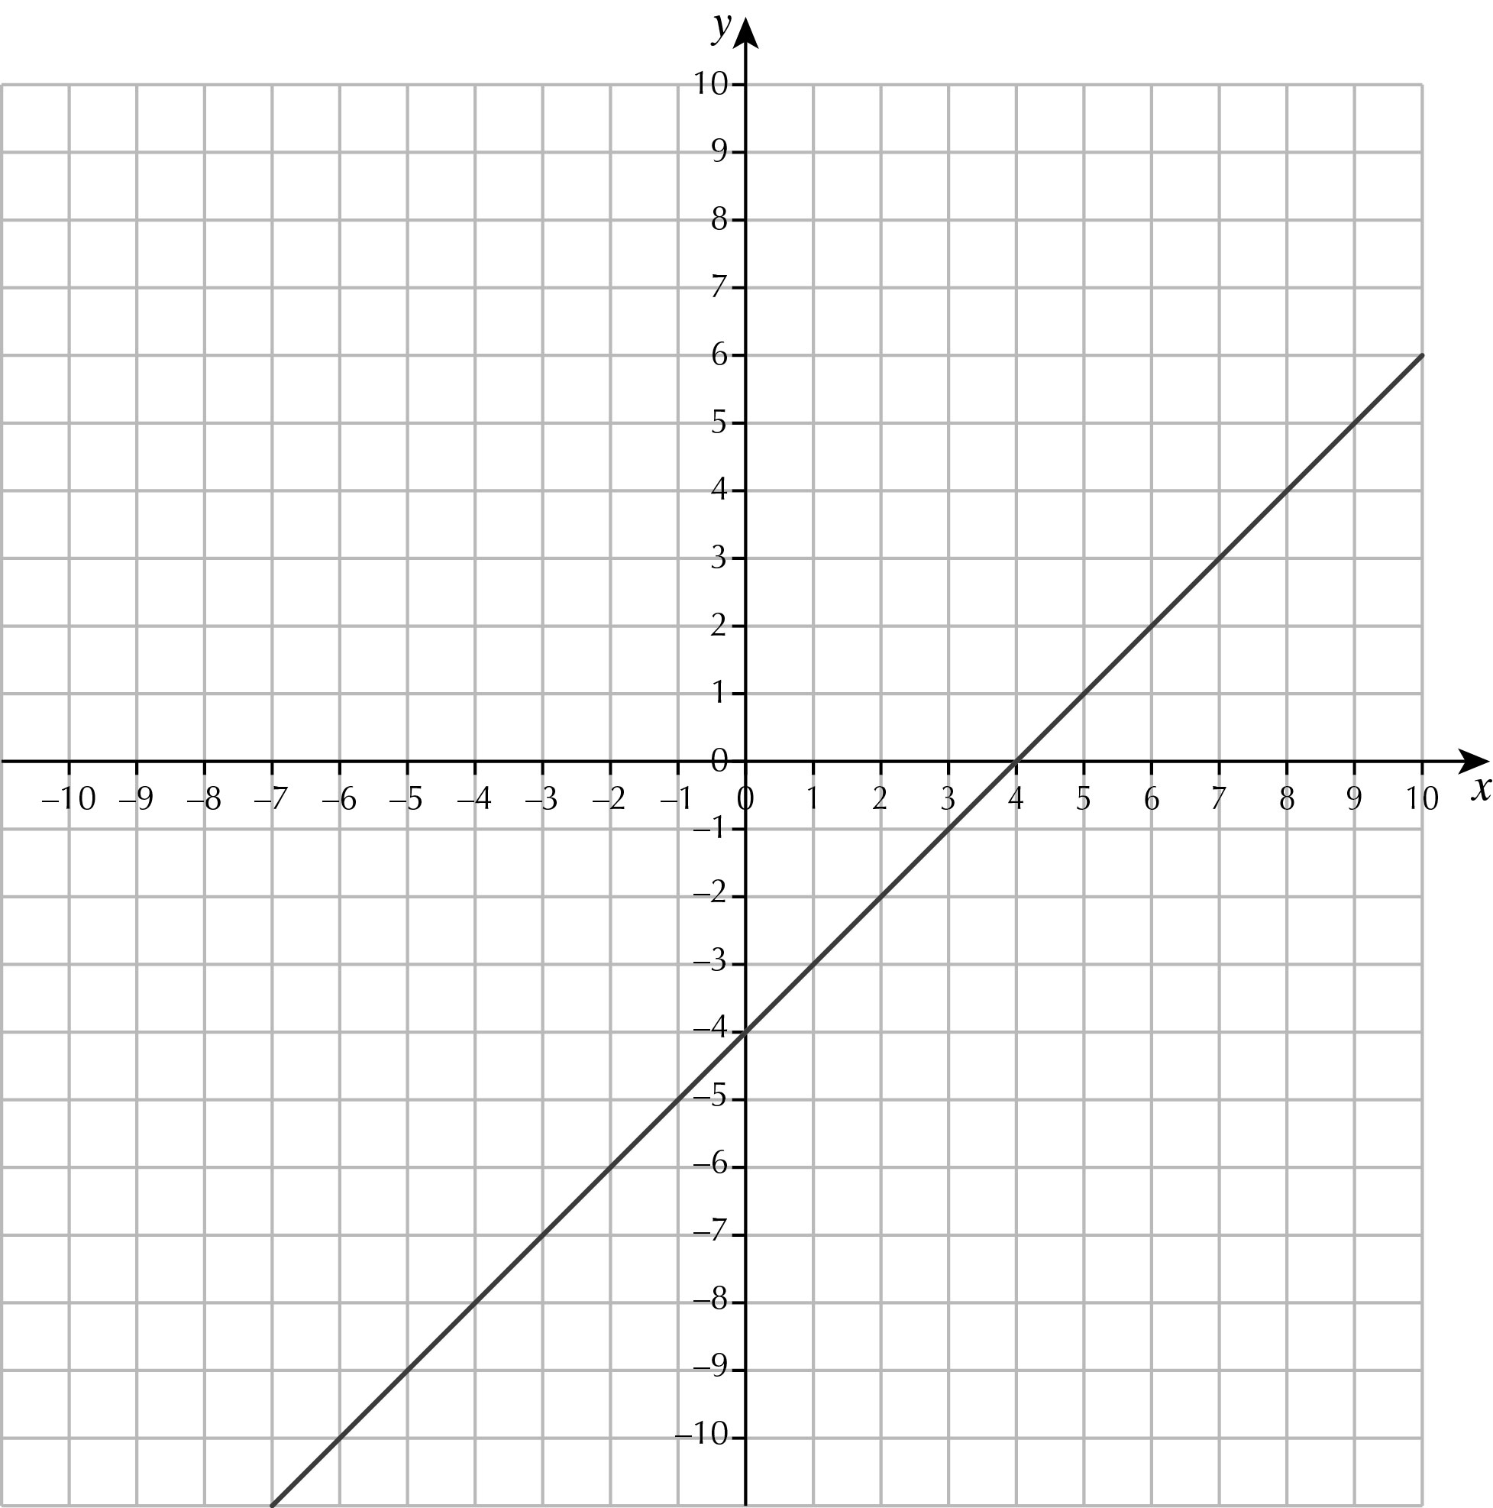
2 a b
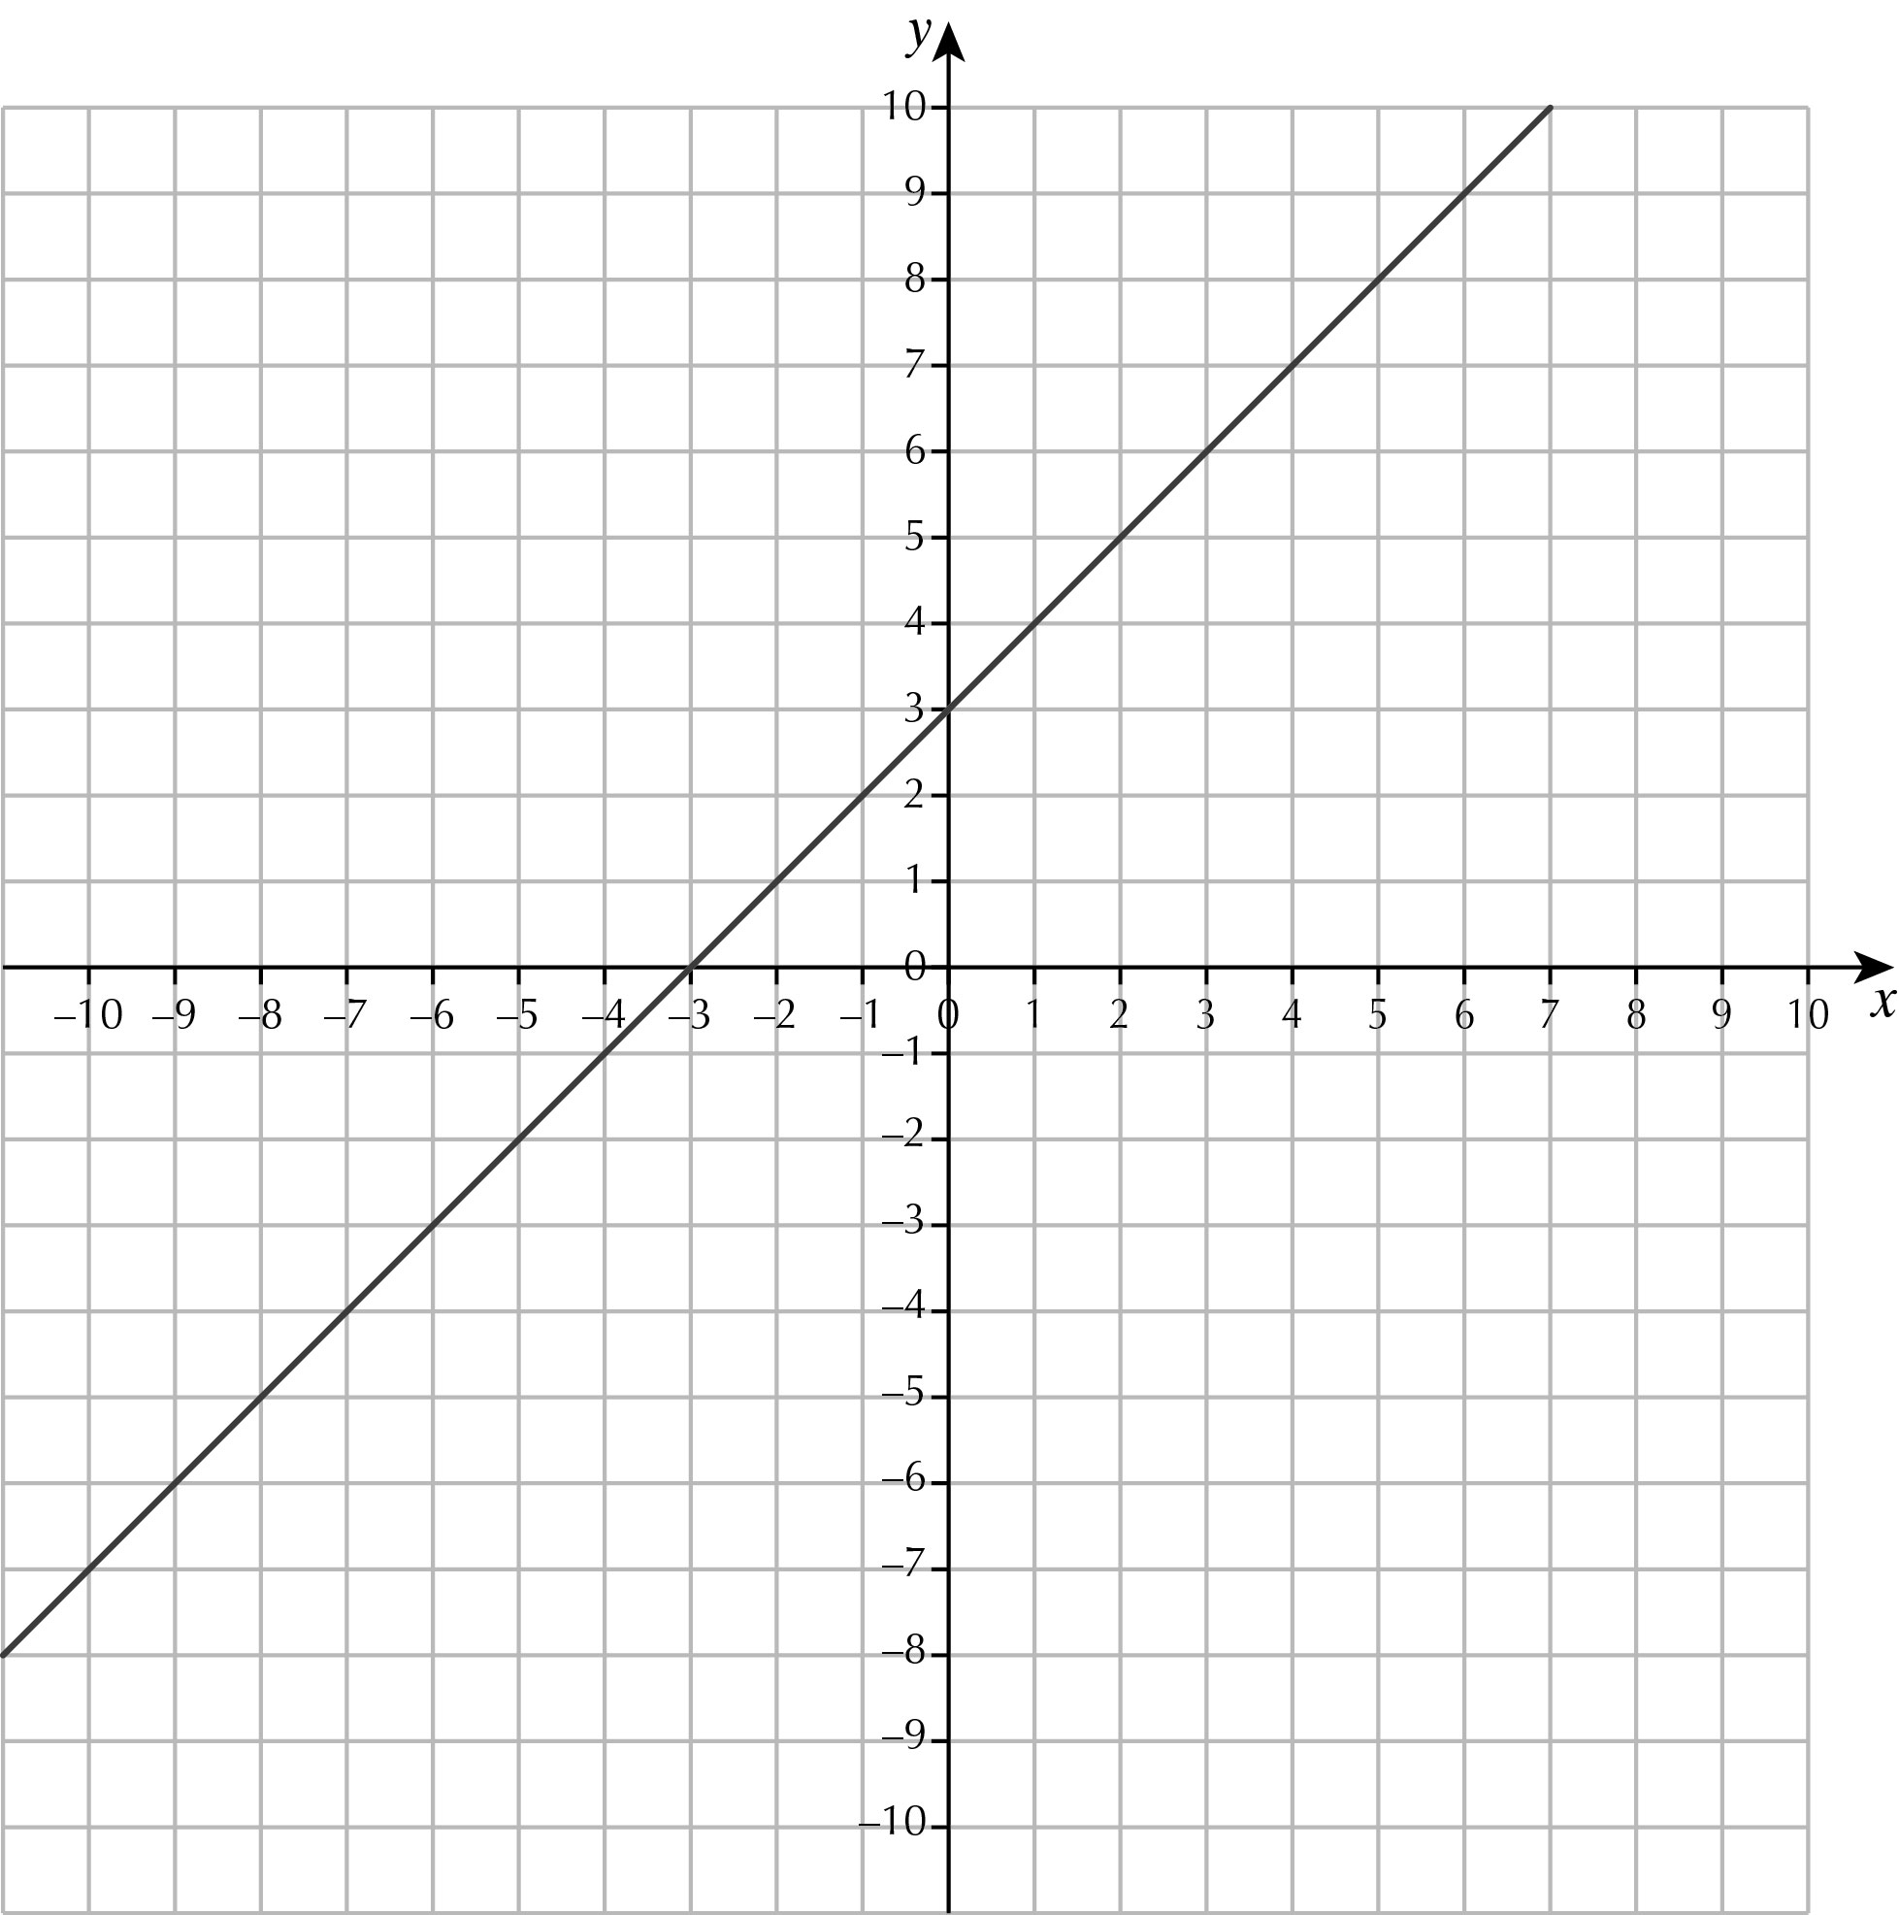

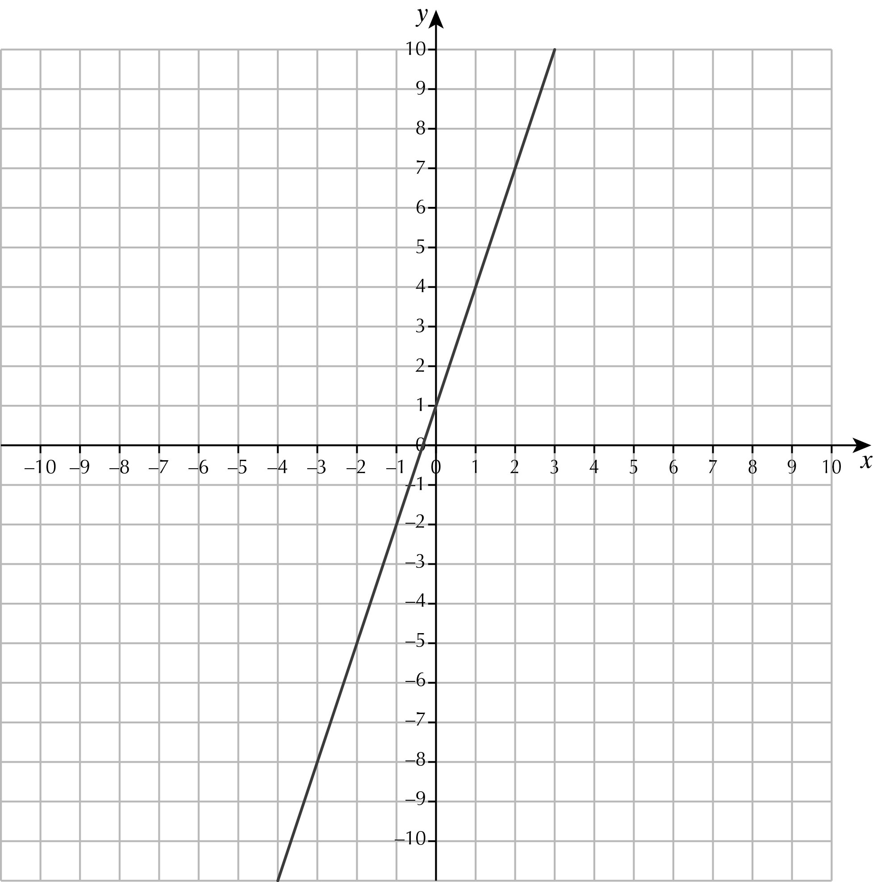
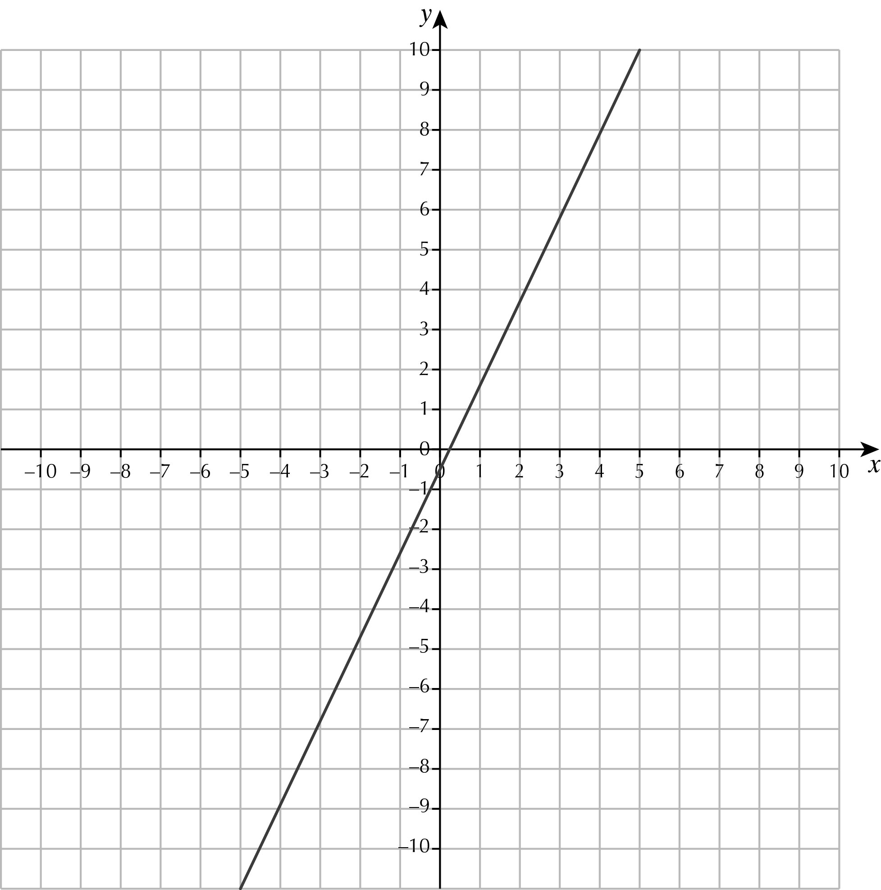
c d

3 a
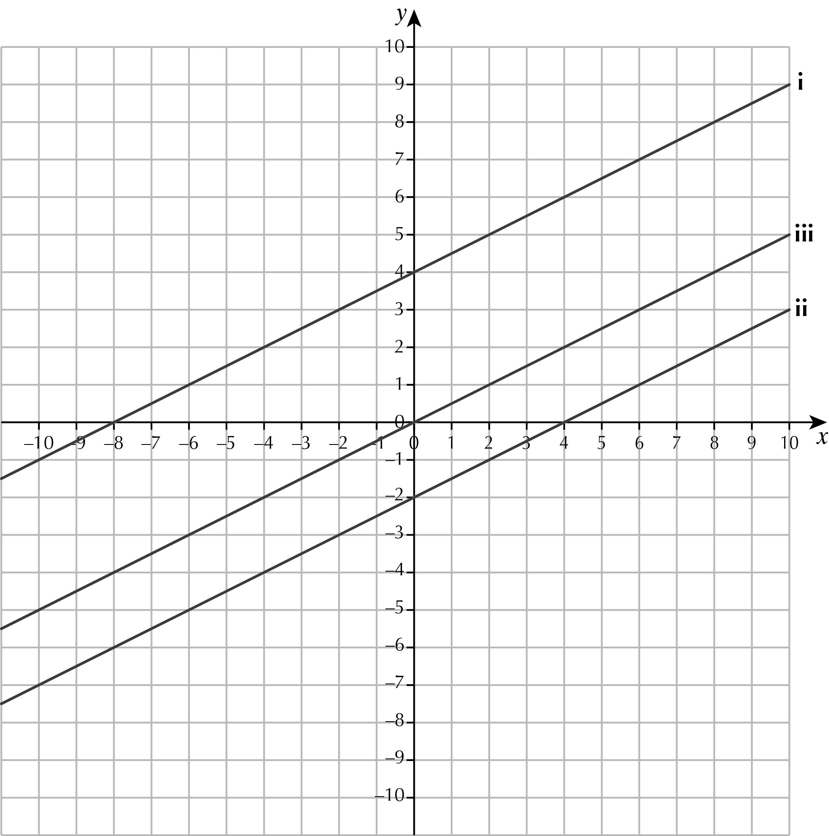

b Same slope/gradient/parallel c Parallel line passing through (0, 6)
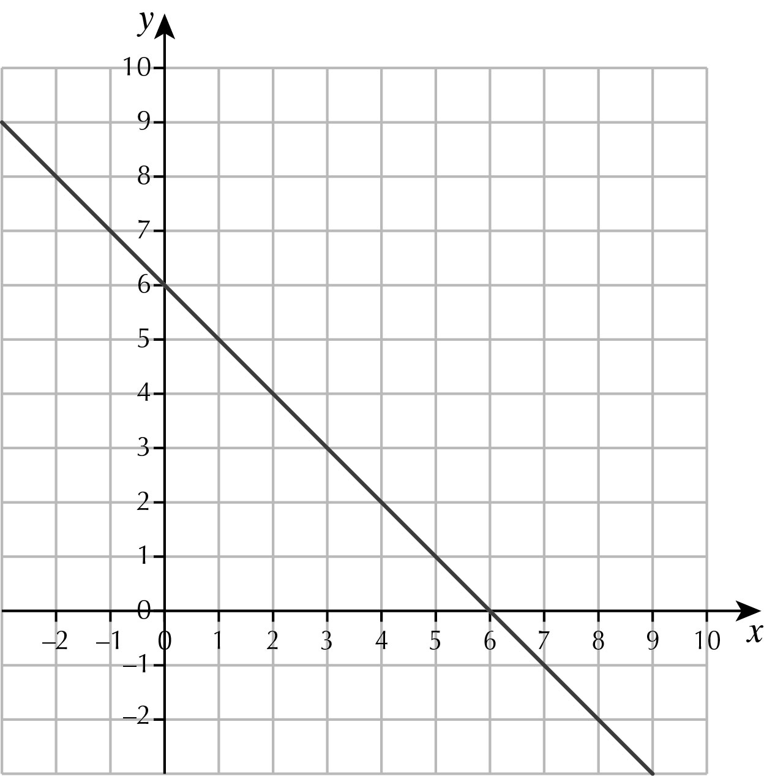
4

5 a (0, 6) (9, 0) b (0, 3) (–15, 0) c (0, –7) (4, 0)
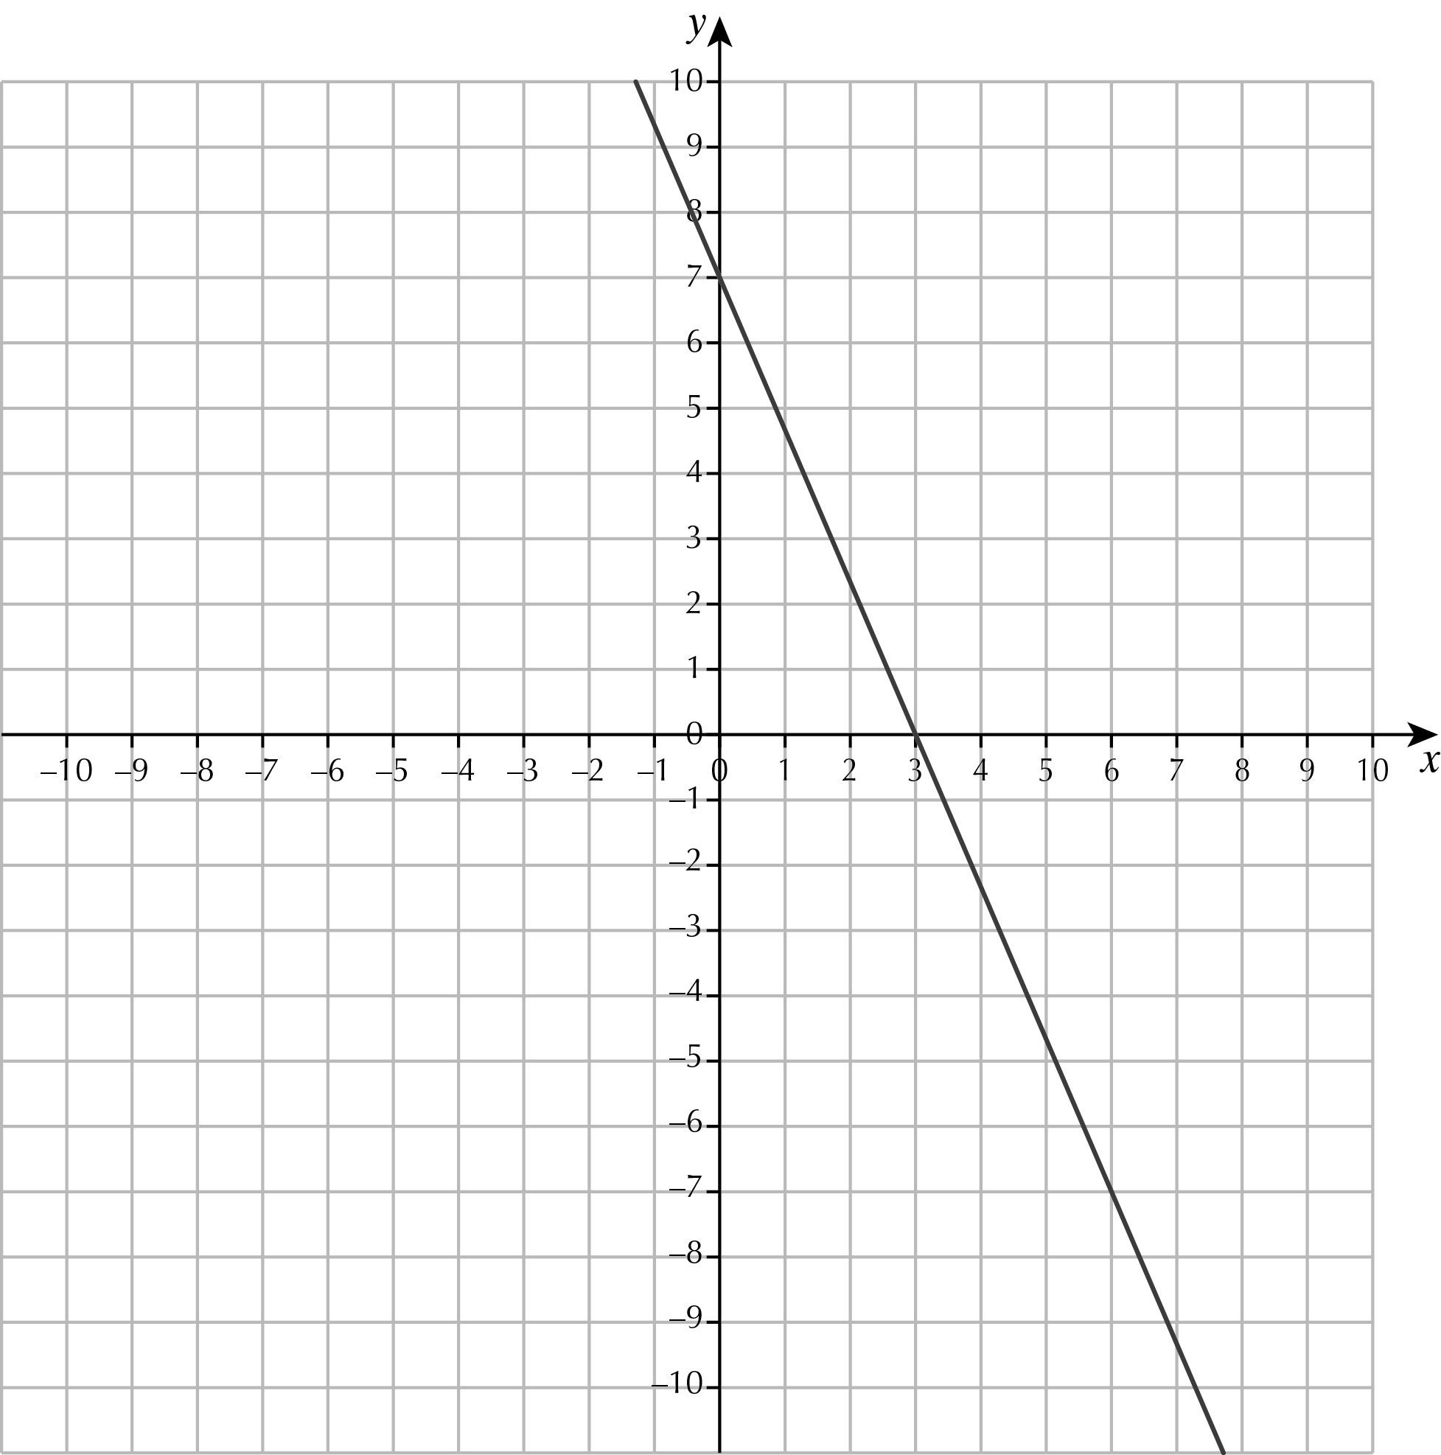
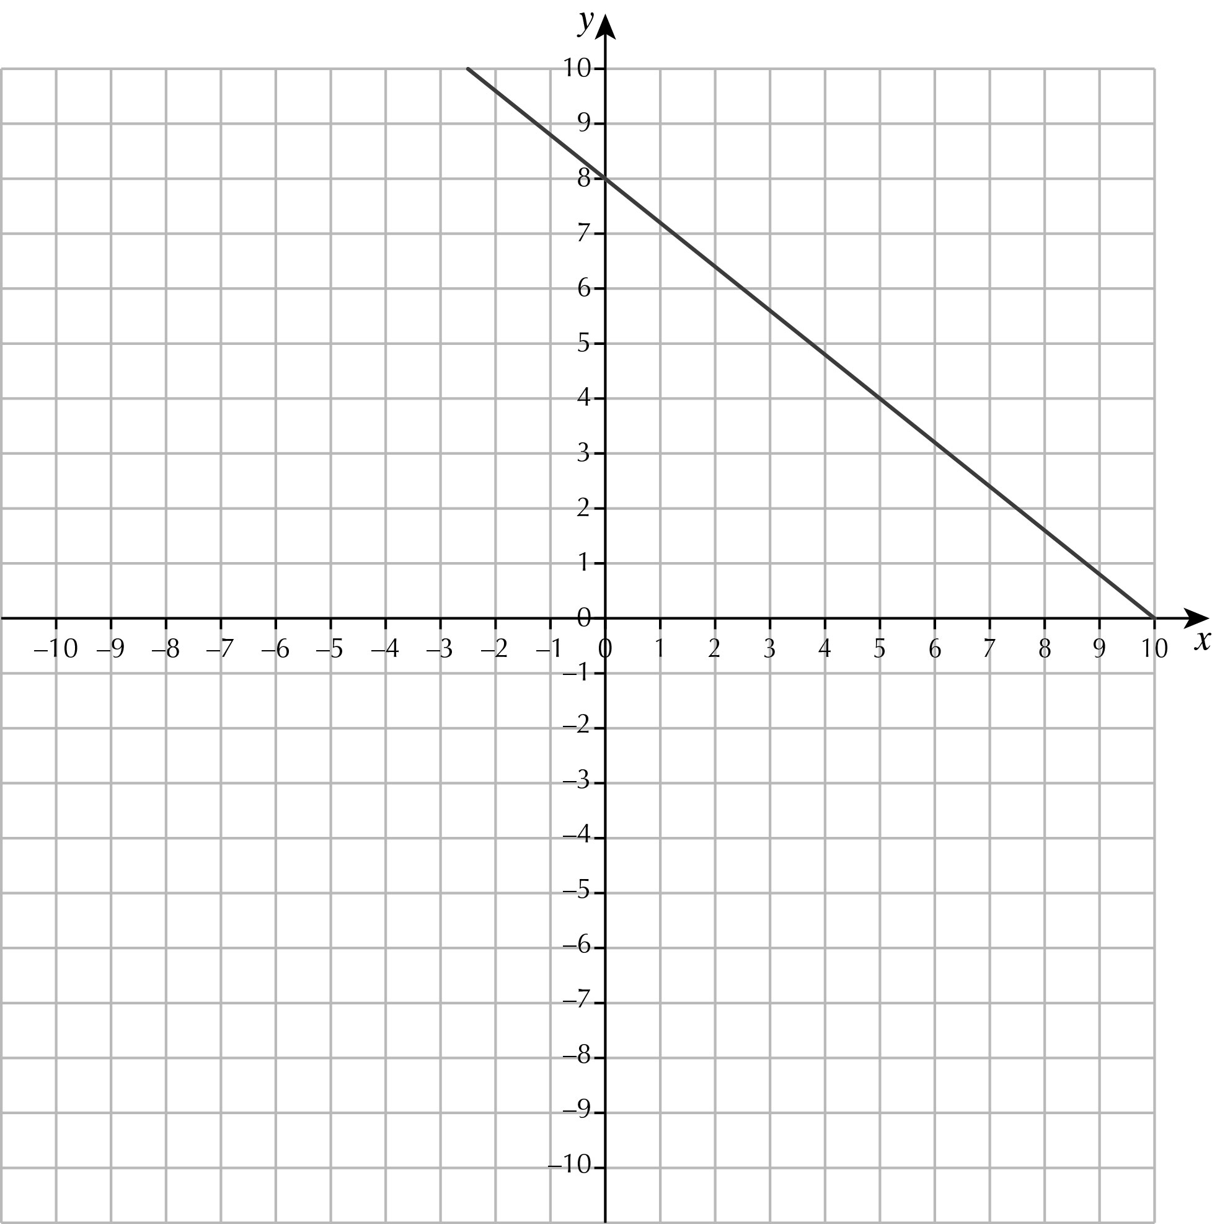
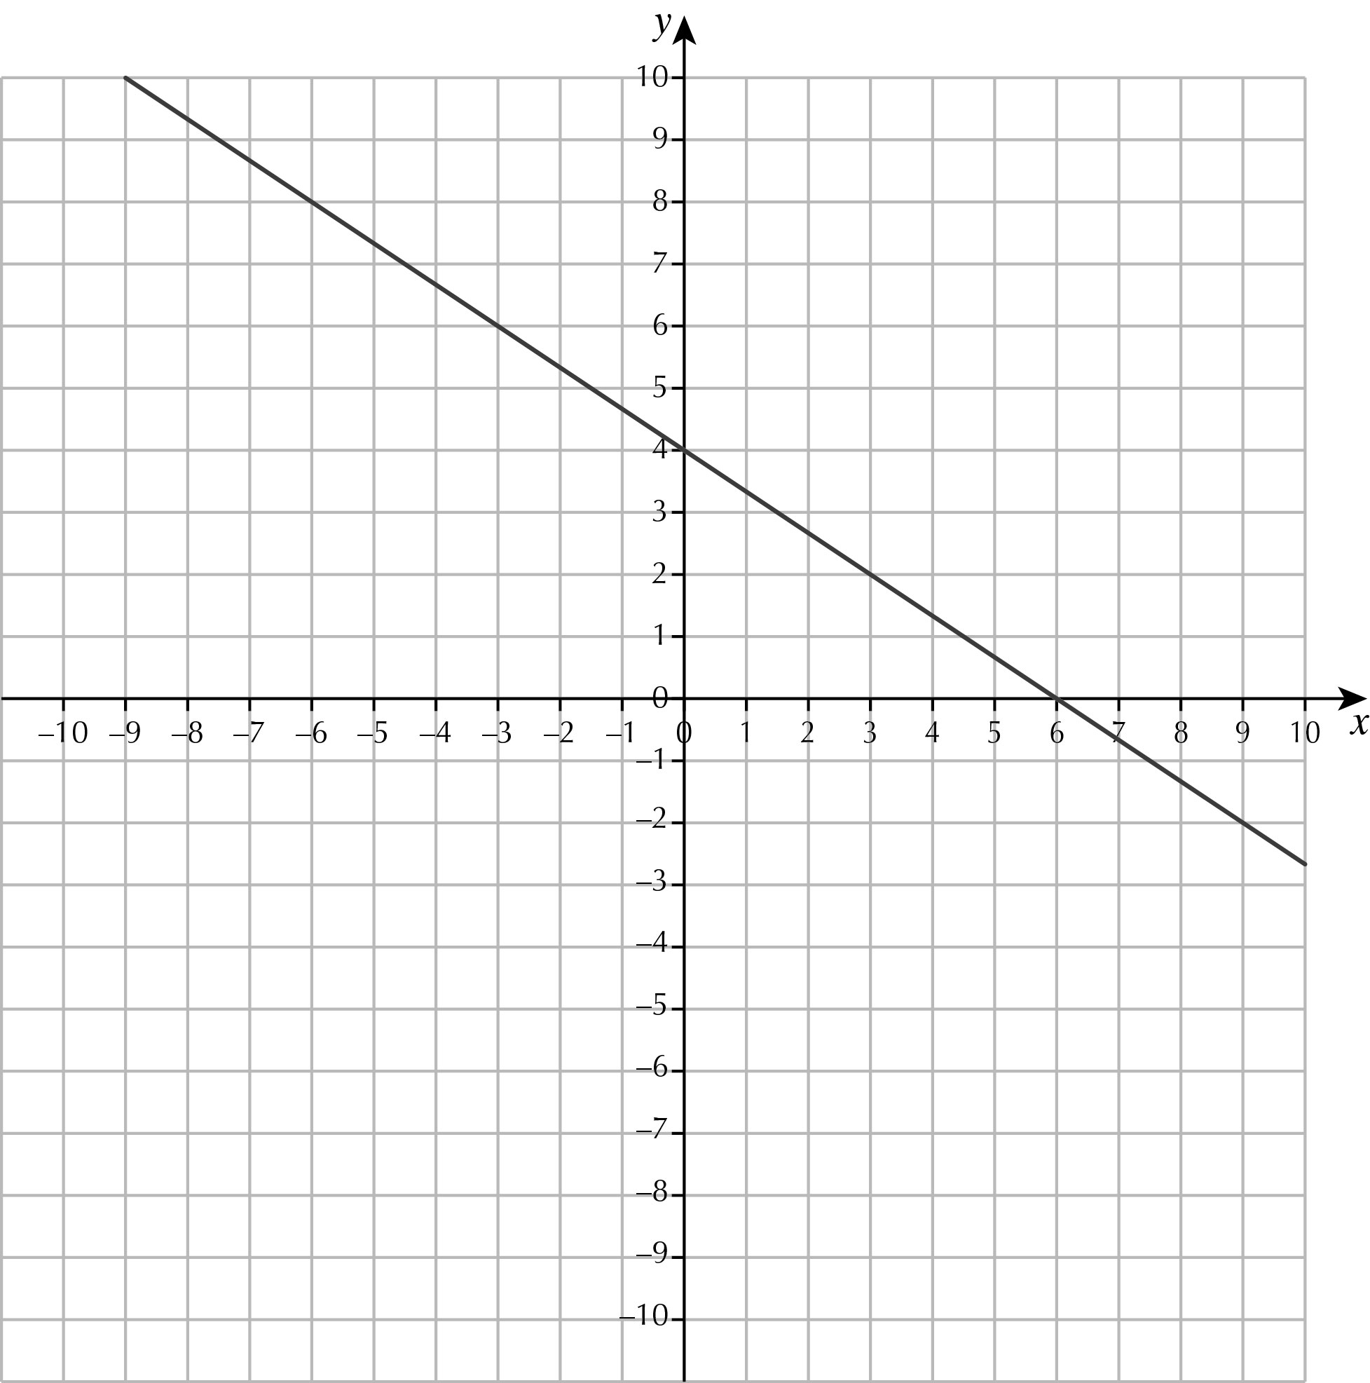
6 a b

c d
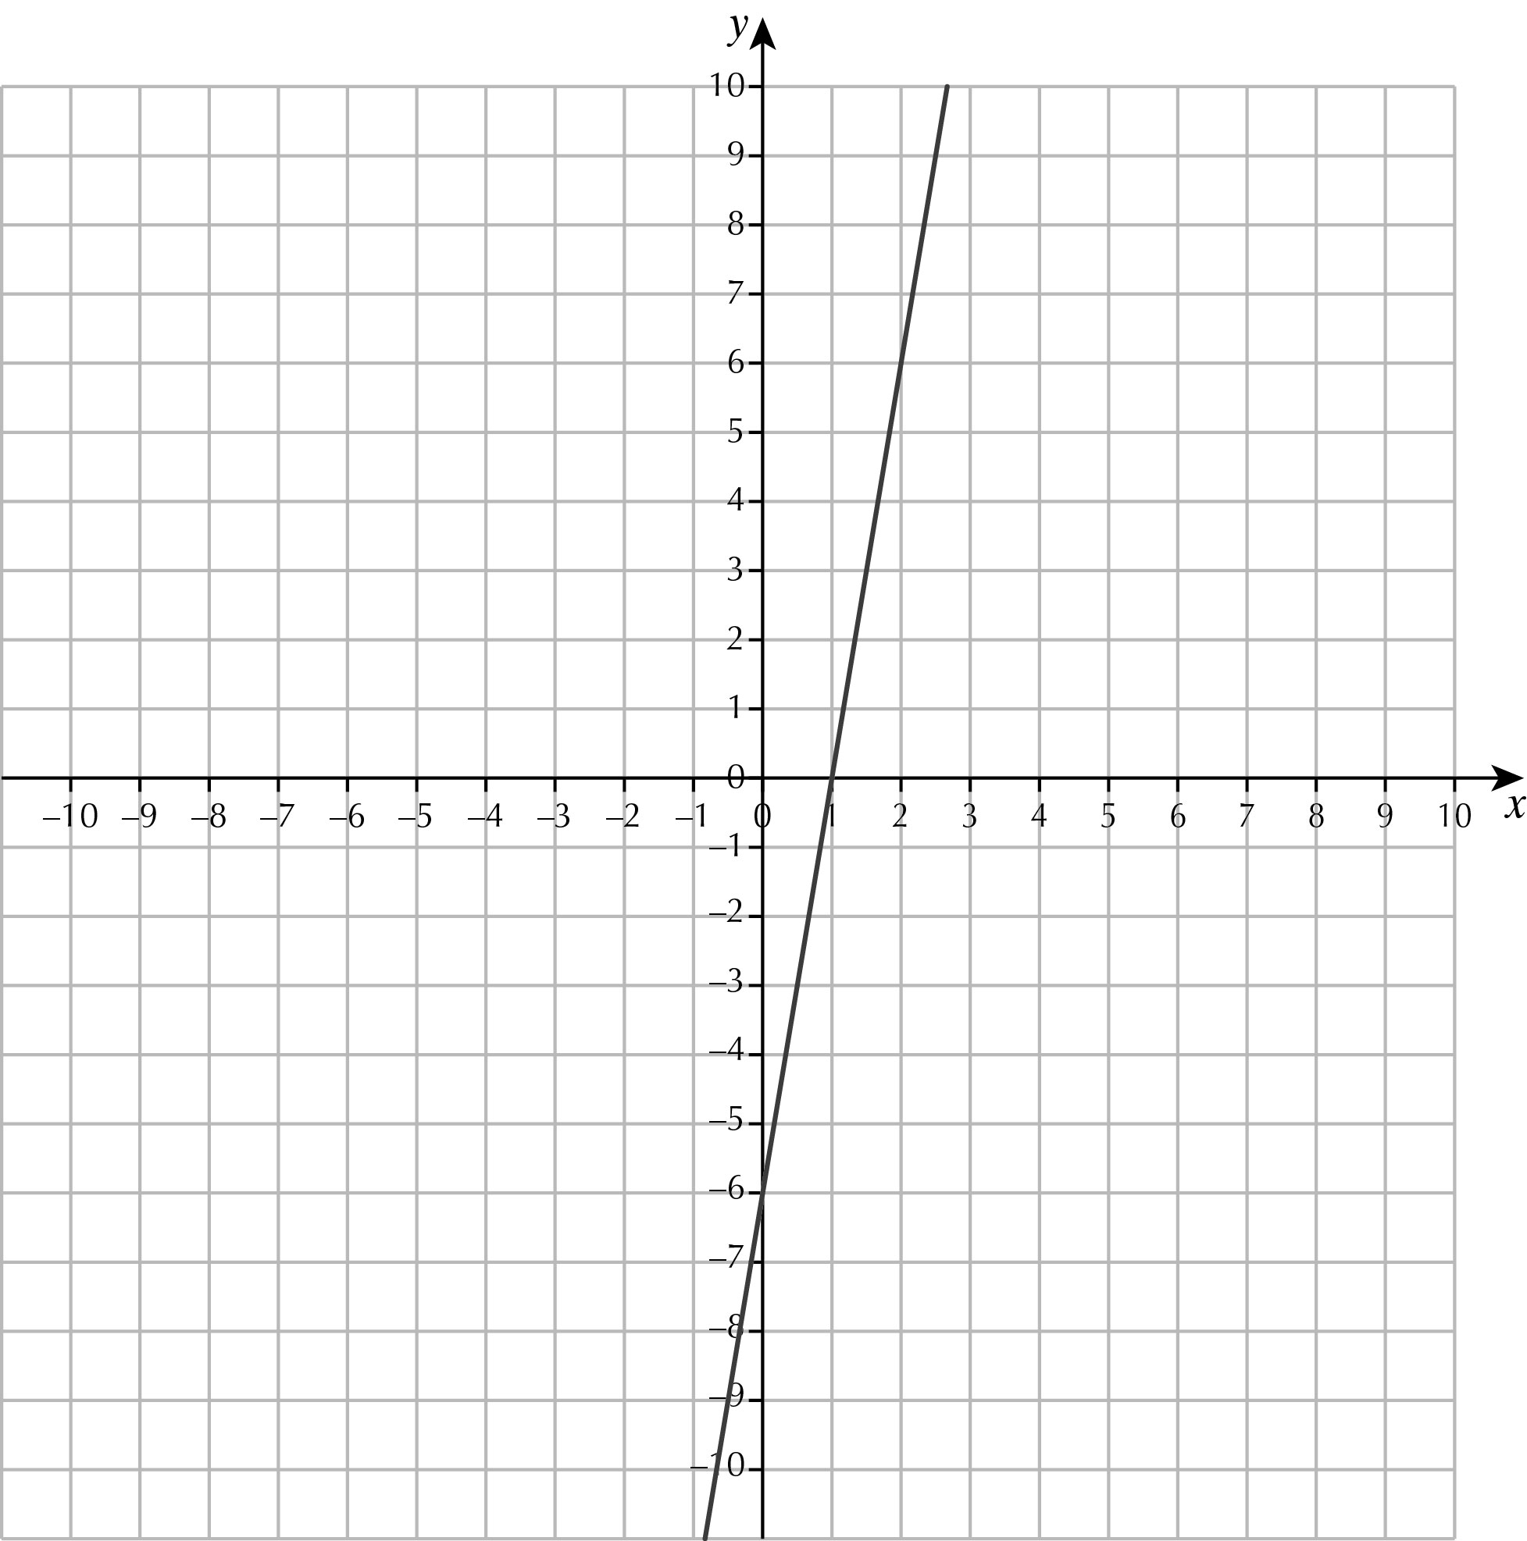

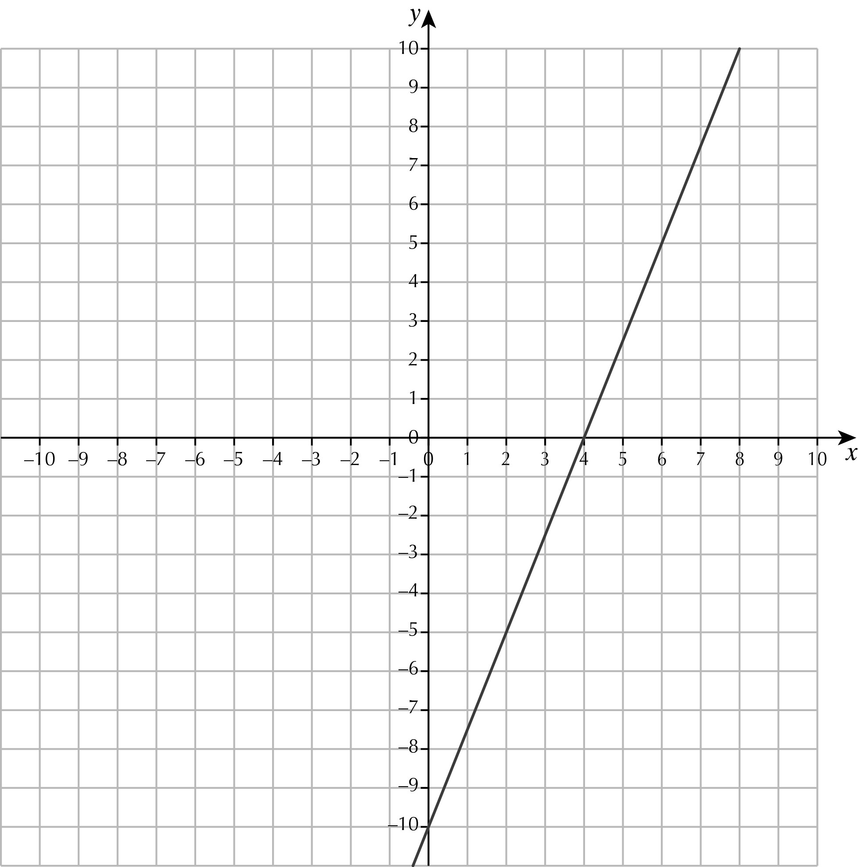
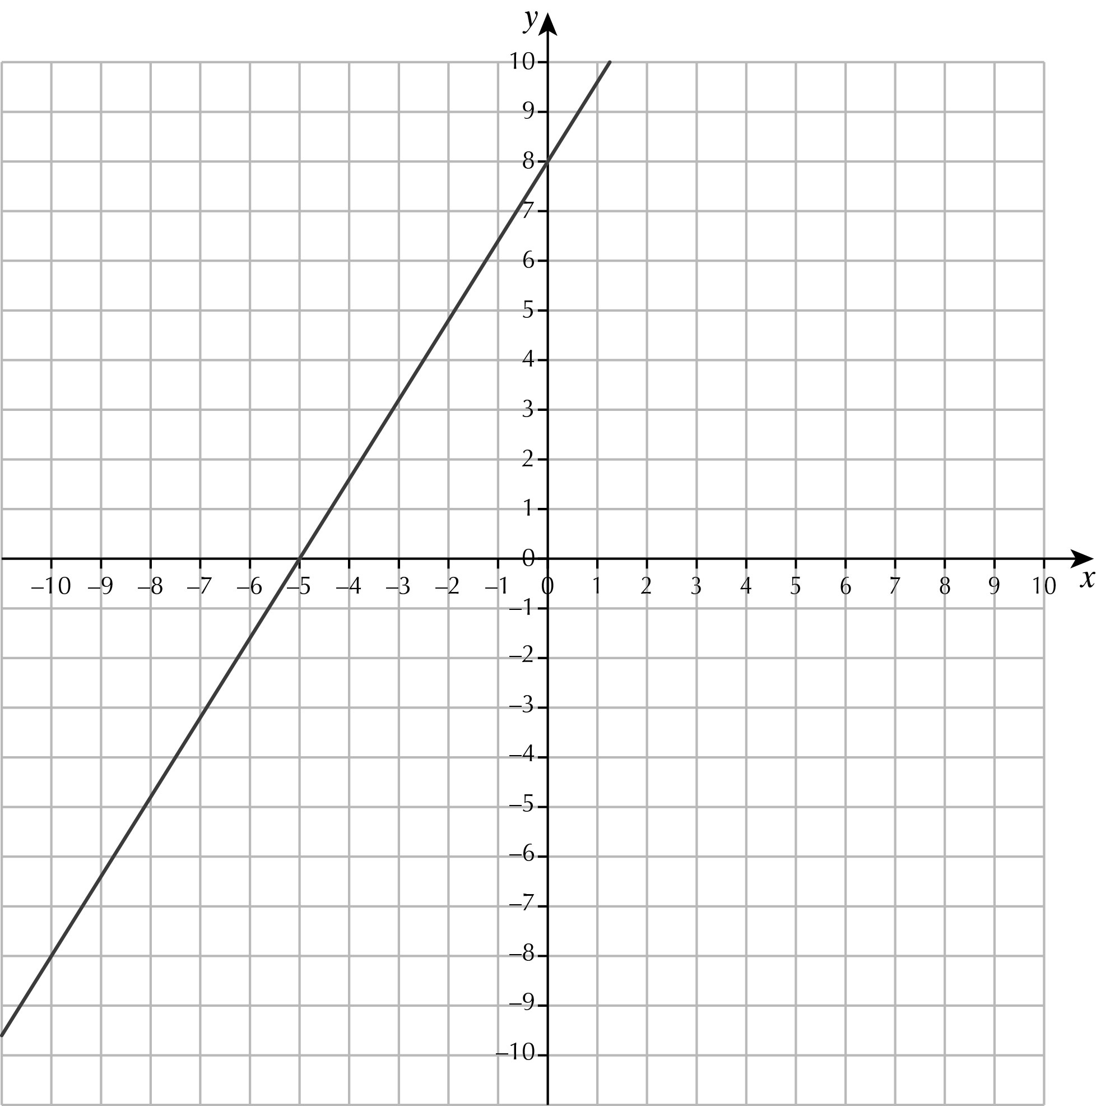
e f

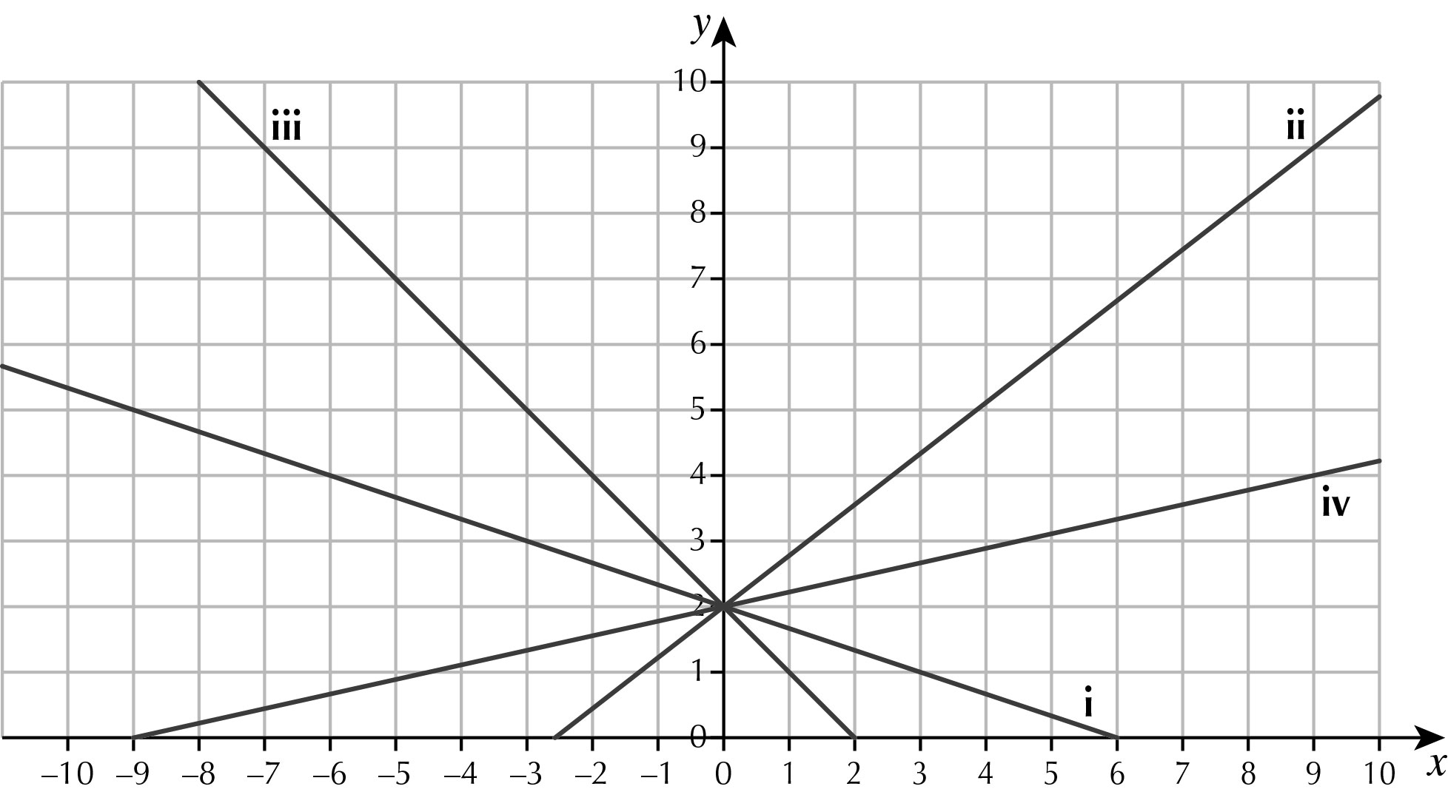
7 a

b All the graphs intersect at (0, 2)
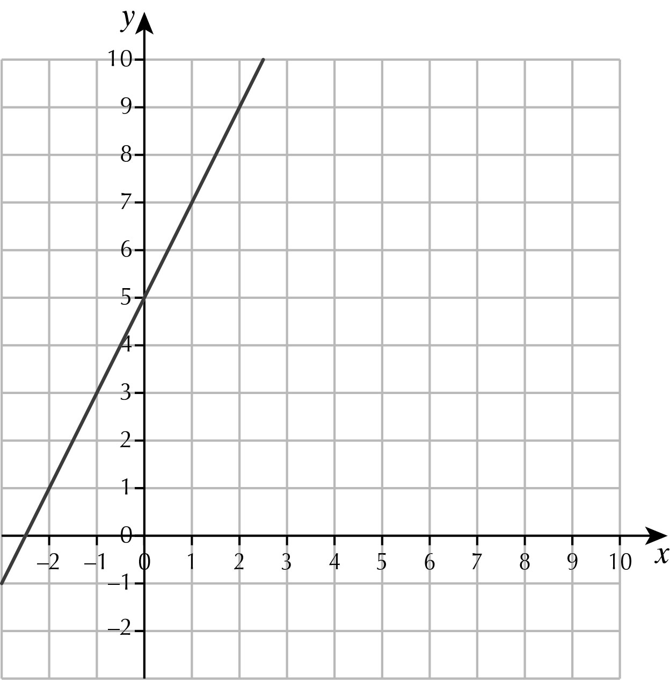
8 a

b i – ii 1 iii 2 iv –1
9 a
x | 1 | 2 | 3 | 4 | 5 | 6
y | 6 | 3 | 2 | 1.5 | 1.2 | 1
b can’t divide by zero
c
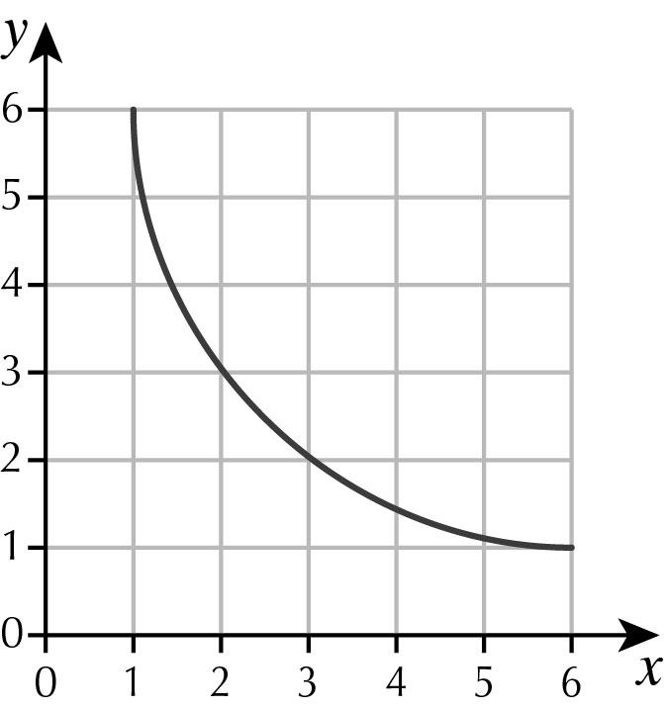

11.2 Graphs from quadratic equations
1
x | –1 | 0 | 1 | 2 | 3
y | 4 | 3 | 4 | 7 | 12
2
x | –1 | 0 | 1 | 2 | 3
x² | 1 | 0 | 1 | 4 | 9
x | –1 | 0 | 1 | 2 | 3
y | 0 | 0 | 2 | 6 | 12
3 a
x | –7 | –6 | –5 | –4 | –3 | –2 | –1 | 0 | 1
x² | 49 | 36 | 25 | 16 | 9 | 4 | 1 | 0 | 1
6x | –42 | –36 | –30 | –24 | –18 | –12 | –6 | 0 | 6
y | 7 | 0 | –5 | –8 | –9 | –8 | –5 | 0 | 7
b and c
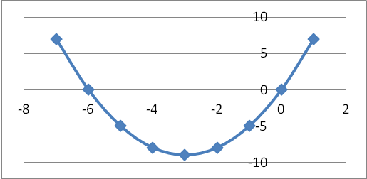
4 a
x | –4 | –3 | –2 | –1 | 0 | 1 | 2
x² | 16 | 9 | 4 | 1 | 0 | 1 | 4
2x | –8 | –6 | –4 | –2 | 0 | 2 | 4
–4 | –4 | –4 | –4 | –4 | –4 | –4 | –4
y | 4 | –1 | –4 | –5 | –4 | –1 | 4
b and c
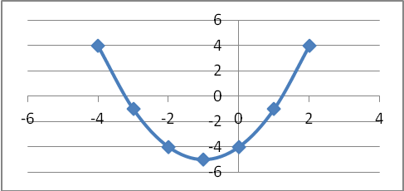
5 a
x | –2 | –1 | 0 | 1 | 2
x² | 4 | 1 | 0 | 1 | 4
2x² | 8 | 1 | 0 | 1 | 8
y | 9 | 2 | 1 | 2 | 9
b and c
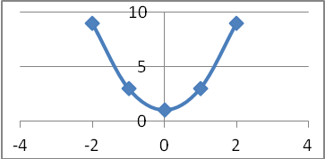
6 a and c
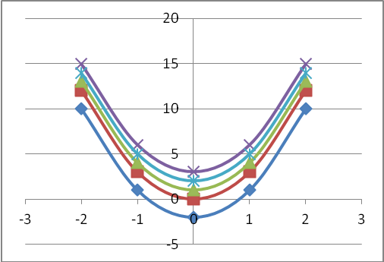
b Translations of each other
7 a
X | –5 | –4 | –3 | –2 | –1 | 0 | 1 | 2 | 3
8 | 8 | 8 | 8 | 8 | 8 | 8 | 8 | 8 | 8
–2x | 10 | 8 | 6 | 4 | 2 | 0 | –2 | –4 | –6
– x² | –25 | –16 | –9 | –4 | –1 | 0 | –1 | –4 | –9
Y | –7 | 0 | 5 | 8 | 9 | 8 | 5 | 0 | –7
b and c
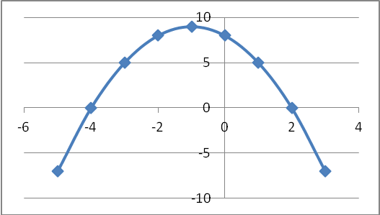
d upside down
8 a
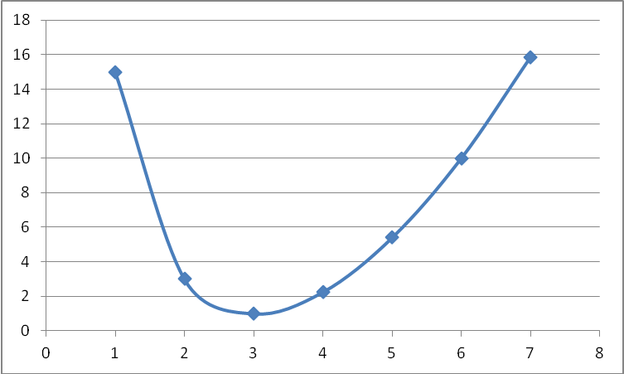
b (3, 1)
9 a
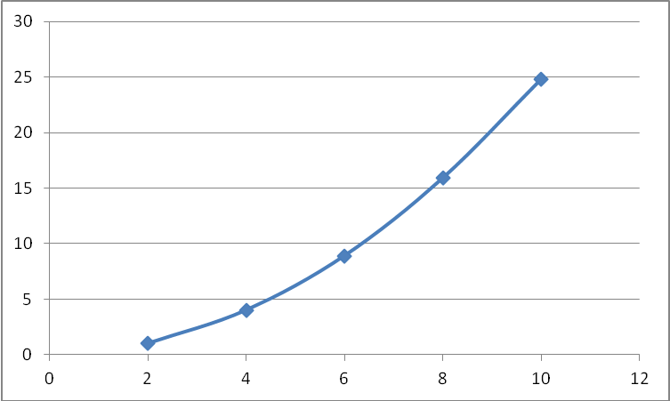
b 7 m
c 4.5 s

Brainteaser
a 3 m
b 27 m²
c C = 2πr = 6r, so r =
A = πr² = 3 × =
d
C | 0 | 6 | 12 | 18 | 24 | 30
A | 0 | 3 | 12 | 27 | 48 | 75
e
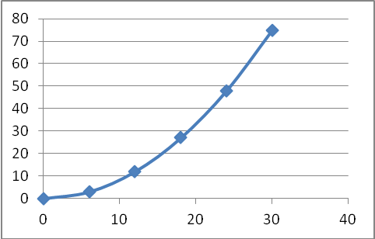
f i 2 cm² ii 19 cm² iii 52 cm²
g 22 cm

11.3 Solving quadratic equations by drawing graphs
1 a
x | –5 | –4 | –3 | –2 | –1 | 0 | 1 | 2 | 3
x² | 25 | 16 | 9 | 4 | 1 | 0 | 1 | 4 | 9
2x | –10 | –8 | –6 | –4 | –2 | 0 | 2 | 4 | 6
–1 | –1 | –1 | –1 | –1 | –1 | –1 | –1 | –1 | –1
y | 14 | 7 | 2 | –1 | –2 | –1 | 2 | 7 | 14
b i –4 and 2 ii –3 and 1 iii –1
2 a

X | –5 | –4 | –3 | –2 | –1 | 0 | 1 | 2
x² | 25 | 16 | 9 | 4 | 1 | 0 | 1 | 4
3x | –15 | –12 | –9 | –6 | –3 | 0 | 3 | 6
Y | 10 | 4 | 0 | –2 | –2 | 0 | 4 | 10

b i x = –3 or 0 ii –5 or 2 iii–2 or –1
c 0.64
3 a
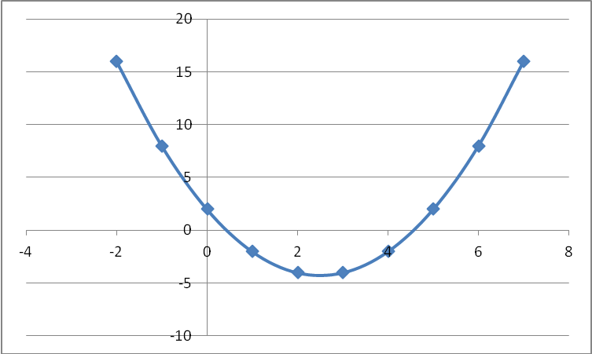
b –0.25
c i 0.4, 4.6 ii –0.5, 5.5 iii –1.3, 6.3
4 a
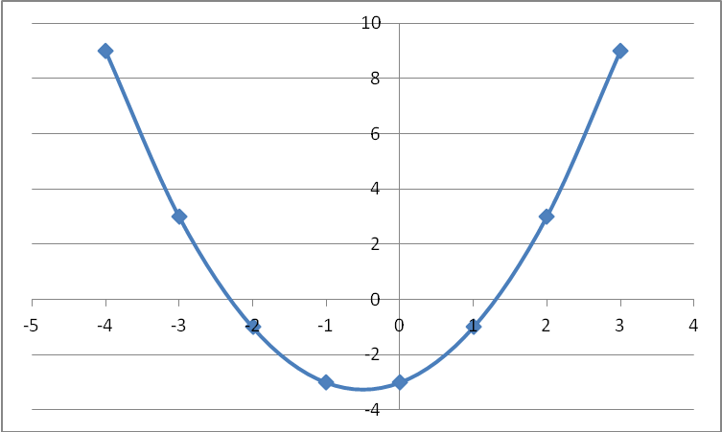
b i –1.6, 0.6 ii –2.8, 1.8 iii –3.4, 2.4
5 a
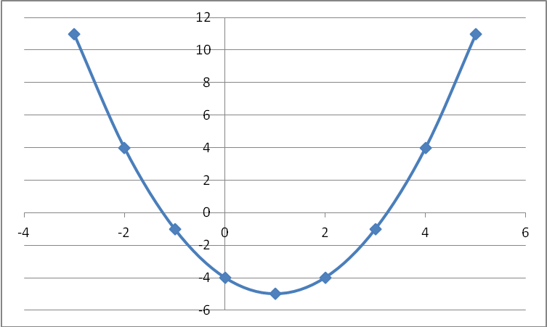
b i –1.2, 3.2 ii –0.4, 2.4 iii –2.3, 4.3
6 a –0.3, 3.3 b –5.5, 1.5 c –2.5, 3.5
7 –0.3, 1.8
8 a
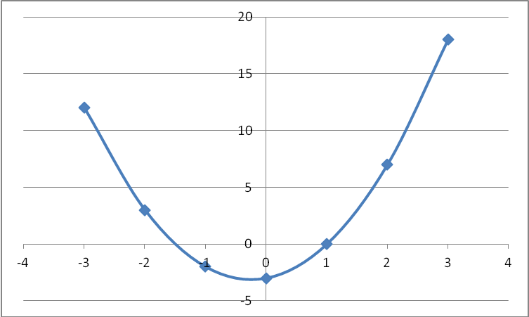
b 1.08
c i –1.5, 1 ii –2.1, 1.6 iii –1.3, 0.8
d i –2, 2 ii –2.4, 1.4

11.4 Solving simultaneous equations by graphs
1 x = 4, y = 5
2 x = –3, y = 3
3 a and ii b and iv c and i d and iii
4 a x = –1, y = 5
b x = –2, y = 1
c x = 6, y = 3
d x = 2, y = 3
e x = 1, y = 3
5 Tiara is correct because 3 × 10 + 5 × 3 = 45 and 10 + 2 × 3 = 16.
Ben’s answer is only correct for 3y + 5x = 45
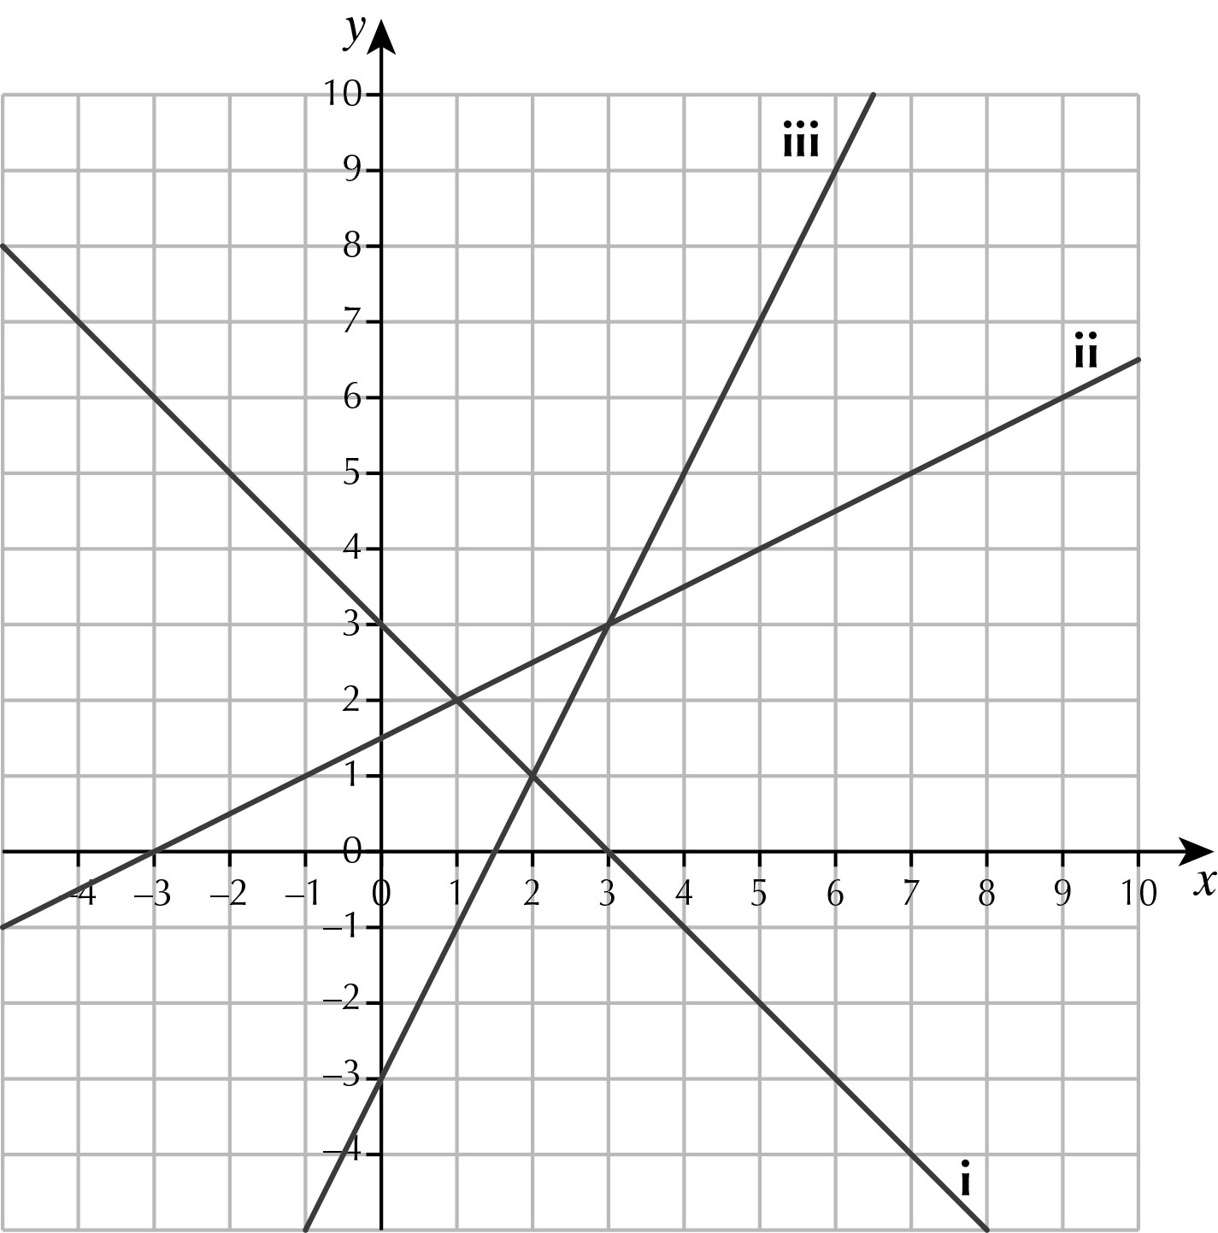
6 a

b x = 1, y = 2
c x = 2, y = 1
d x = 3, y = 3
7 x = –3.1, y = 7.6
x = 1.6, y = 0.6
8 x = 4, y = 4
x = 8, y = 2

Brainteaser
a 2 s, 10 s
b 8 s
c 1.5 s, 6 s
d 3.35 s
e 5 s

Chapter 12 Compound units
12.1 Speed
1 5274 km/h
2 2.6 seconds
3 a 125 miles b 250 ÷ 4 = 62.5 mph
4 a 400 mph b 8 hours c 3960 miles
5 40 mph
5h
10 miles
6 a i 5.5 m/s ii 20 km/h
b 8.8 m/s 32 km/h
c Missing figures are: ’50 – 55’ seconds, ‘1 200 – 1 300’ metres, 2’ minutes,
‘6’ minutes, ’25 – 35’ seconds later.
7 a 8.3 m/s or 30 km/h
b 2 minutes 19 seconds
c 1st Gemma, 2nd Sarah (2m 25s), 3rd Lucy
8 a 264 cm
b 264 × 95 × 23 = 576 607.92 cm = 5.766 km (5766 m) = 5.8 km

Brainteaser
a 0.62, 0.64, , 0.61, , 0.61
b Yes; the distance travelled is always close to the number of winds.
c d = 0.6n or d = or n =
d i × 25 = 15 m ii × 24 = 40 winds

12.2 More about proportion
1 0.86 g/cm³
2 4 571 cm³ (0.004571 m³)
3 a 135 litres b 0.135 × 80p = 10.8p
4 a 2 L/s b 44 L
c 16 gallons = 72.8 L → just over 36 seconds
d 1.39 × 70 = £97.30 1.39 × 44 = £61.16 1.32 × 72.8 = £96.10
The VW is more costly to fill up.
5 a i 9424.778 cm³ ii 9.425 L
b × 60 = 37.7 = 38 seconds
6 a 10 000 kg b 0.4 m³ c 7 500 kg/m³
7 × 8.96 + × 11.4 + × 7.3 = 5.4 + 3.2 + 0.8 = 9.4 g/cm³ to 1 dp

Brainteaser
Planet | Volume (km³) | Mass (kg) | Density (kg/km³) | Density (kg/m³) | Density (g/cm³)
Earth |  |  |  | 5 455 | 5.455
Jupiter |  |  |  | 1 326 | 1.326
Saturn |  |  |  | 687 | 0.687

12.3 Unit costs
1 a 25p b 0.25p c 4 g d 400 g
2 a 9 b 81
3 1 L covers 2.5 m, so 40 ÷ 2.5 = 16 litres
4 £1.45 ÷ 2 = 72.5p/litre
4 pints = × 4.44 L = 2.275 → 1.59 ÷ 2.275 = 69.9p/L, so 4 pints is better value at this price.
5 a → 52 kB/s
b i 2340 kB ii 21 840 kB
6 a 20p
b 60p profit out of £1.20 cost = 50% profit
c per egg → profit
7 a Rapids – costs start at zero, or line goes through origin.
b £6.00 an hour
c H = 6p
d i £27 ii 1h 30 mins

Brainteaser
a Country Fayre: 0.42 0.4257 0.42 0.405 0.41
Farm Fresh: 0.44 0.44 0.44 0.44 0.44
b Farm Fresh; same cost per gram every time.
c C = 0.44W
d i £7.04 ii 1136 g

Chapter 13 Right angled triangles
13.1 Introducing trigonometric ratios
1 a – e Check pupils’ answers
f Whatever values you chose, the end 3 columns should always be the same for A, B and C, or very similar.
e.g. For 10°,
A | 0.1736 | 0.9848 | 0.1763
B | 0.1736 | 0.9848 | 0.1763
C | 0.1736 | 0.9848 | 0.1763

2 a sin 30° = 0.5 = cos 60° and sin 60° = 0.866 = cos 30°
b sin 30° = cos 60° and sin 60° = cos 30°
c hypotenuse = c, base line = a: sin 30° = = and cos 60° = = so they are equivalent.
3 a 0, 0.4226, 0.7071, 0.9397, 1
b 0, 0.4226, 0.7071, 0.9397, 1
c sines and cosines are the inverse of each other.
4 a 0, 0.2679, 0.5773, 1, 1.732, 3.732 Always increases.
b 28.636m, 57.29, 114.589, 286.477, 572.957 Error or ∞
Continues to get larger and larger until it becomes impossible.
c Tangents can go over 1, because the sides at 90° to each other can be any number of times bigger than the other, but neither of these sides can be bigger than the hypotenuse; when they equal the hypotenuse, the ratio is 1 : 1, the maximum for sine/cosine.
5 a 200 b 0 c 100 d 0
e 500 f 250 g 350 h 0 i ∞ (infinity)

13.2 How to find trigonometric ratios
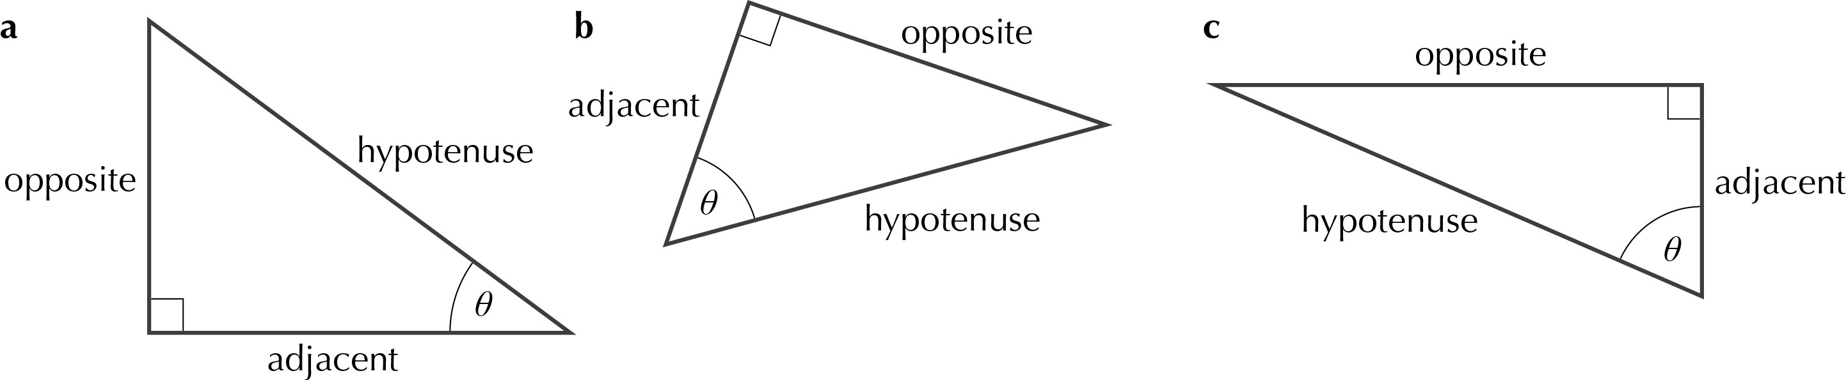
1

2 a d = hyp, e = opp, f = adj b g = hyp, h = adj, i = opp
c j = opp, k = adj, l = hyp
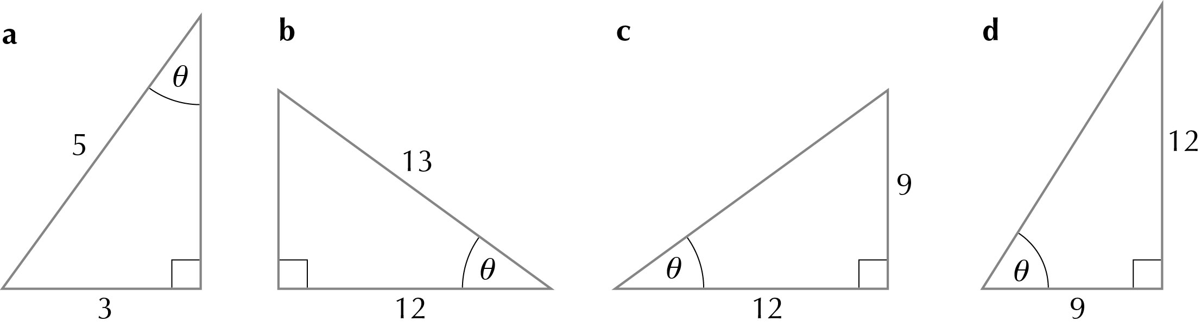
3

4 a sin x = cos x = tan x =
b sin x = cos x = tan x =
c sin x = cos x = tan x =

13.3 Using trigonometric ratios to find angles
1 a 17° b 36° c 38.7° d 62.7°
e 82° f 29° g 62.2° h 71.8°
2 a 30° b 60° c 77.5° d 86.9°
e 33.7° f 60.3° g 86.7° h 53.1°
3 a 53.1° b 64.2° c 30° d 41.5°
4 a 75.5° b 20.4° c 30° d 41.3°
5 a 24° b 33.7° c 23.4° d 45°
6 a b c
d e f
g h
7 a
b
8

Brainteaser
to nearest integer
Therefore, Dinghy could be 180° – 51° or 180° + 51°
= 129° or 231°

13.4 Using trigonometric ratios to find lengths
1 a 0.276 b 0.934 c 0.232 d 0.276 e 0.883
f 0.999 g 0.017 h 0.510 i 1 j 81.847
2 a 9.21 b 5.46 c 1.88 d 3.21 e 5.54
f 0.104 g 1.49 h 1.19 i 1 910
3 a 85 × tan7° = 10.4 mm
b 1.2 × tan50° = 1.43 m
c 3200 × tan36.4° = 2210 km
4
5 horizontal = 320 × cos35.2 = 261
v = 320 × sin35.2 = 184
∴Co-ordinates of B are (284, 242)
6 a 1.7 × tan33° = 1.10 m
b 42 × sin68° = 38.9 mm
7 6 × sin23° = 2.3 km
8 a
b
9 h = 12cos30° = 10.39 cm

Brainteaser
Centre angles = = 45°
a
So distance between opposite corners = 18.276 mm
b
So distance between opposite sides = 16.9 mm
Chapter 14 GCSE Preparation
14.1 Number
1 a Shania 20 468 pence, Sui Main 19 866 pence b 602 pence
2 a £322 b £621 c 24 nights d 12 people
3 a i 36 ii 14 iii 18 iv 16
b =
4 a b 12 pages
5
6 a 5” b 1”
c A and C closest, with difference ”; A and B difference = 0.7125”; B and C difference = 1.396”
7 a 14 392 litres b 12 521 litres
c i 12 346 litres ii 11 834 litres
8 a £112.80 b £48.33
9 3.33 × 10^{–9}
10 a 3.6 × 10⁹ b 2.4 × 10⁹ c 1.8 × 10¹⁷ d 5 × 10¹

14.2 Algebra
1 a 9x + 1 b –2a – 3 c 5y d 5d + e
e –8t f 20x² g 7ab – 7a h 10y² + 3y
2 a 6x – 3 b –4y – 7 c 3x + 2x² d –8 + 20y
e 8 + 6a f 3x + 15 1 g 2de + 5d h 2p2 + 3pq
3 a t = 3 b x = 24 c d = 7 d m = –2
e w = – f p = 5 g x = 9 h y = –4
4 a x = 4 b t = –3 c y = 2 d p = 1 e m = 3
5 a 5(4x + 3) = 80; x = 3.25 b i 4x + 4 = 100; x = 24; ii 60% chose football
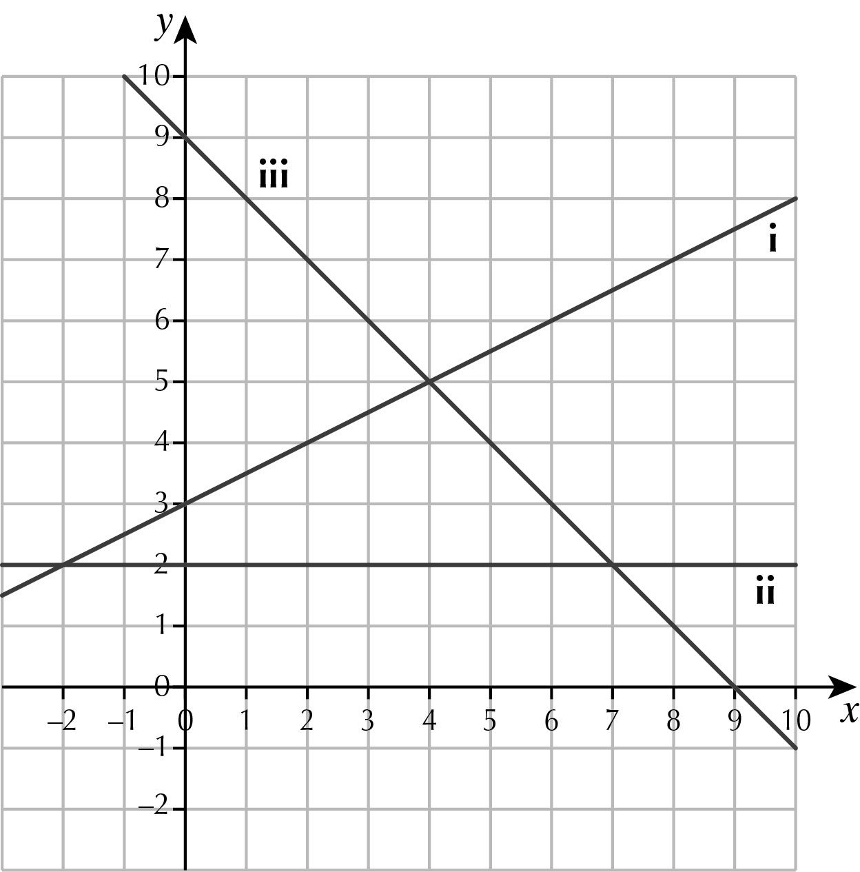
6 a

b i x = 4, y = 5 ii x = 7, y = 2 iii x = –2, y = 2
7 a 7(m – 2) b 4m(3m + 4) c 5(3m + n)
d 2m(10n – 7)
8 a y = 3x – 7 b y = –x + 13
9 x = 8, area = 209
10 a x = –5 or –7 b x = –4 or –5 c x = –3 or –6
d x = 3 or –11 e x = 1 or 13 f x = 4 or –8
g x = 6 or 8 h x = 6
14.3 Ratio, Proportion and Rates of Change
1 a 1026 b 2592 c 6480 d 13 878
2 Family pack ≈ 24p per orange (best value), Value pack ≈ 26p per orange
3 a 17 cl b 15 810 cl c 476 cl
4 a 720 g b 600 g c 135 g butter, 180 g caster sugar, 3 eggs, 150 g flour
5 a 160 ml b 175 ml c 8 jugs
6 a i about 11 kg ii about 6.4 kg b 11 stones 11 pounds
7 558 km
8 a 2 hours 15 min b 6.23 pm
c
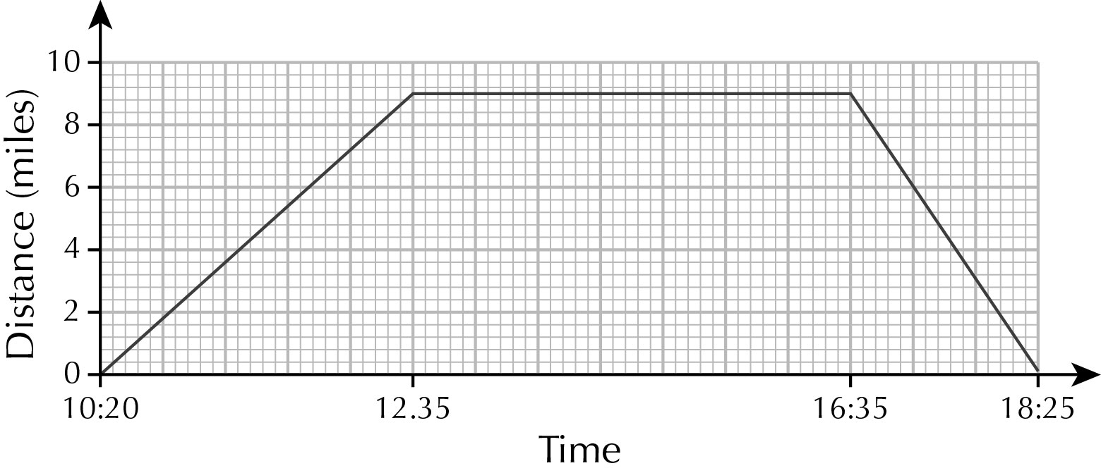

14.4 Geometry and Measures
1 a 1 line of symmetry, order 1 rotational symmetry
b no lines of symmetry, order 2 rotational symmetry
c 2 lines of symmetry, order 2 rotational symmetry
d no lines of symmetry, order 1 rotational symmetry
e no lines of symmetry, order 2 rotational symmetry
f 1 line of symmetry, order 1 rotational symmetry
2 a 71°; angles on a straight line add up to 180°
b 38°; alternate angles are equal
c Because a = 71° and c = 38°, b = 180 – (71 + 38) = 71° (angles in a triangle add up to 180°). Hence A and B are the same, but different to C.
3 36 cm
4 a 5.3 m b Yes. Area of table = 2.27 m²
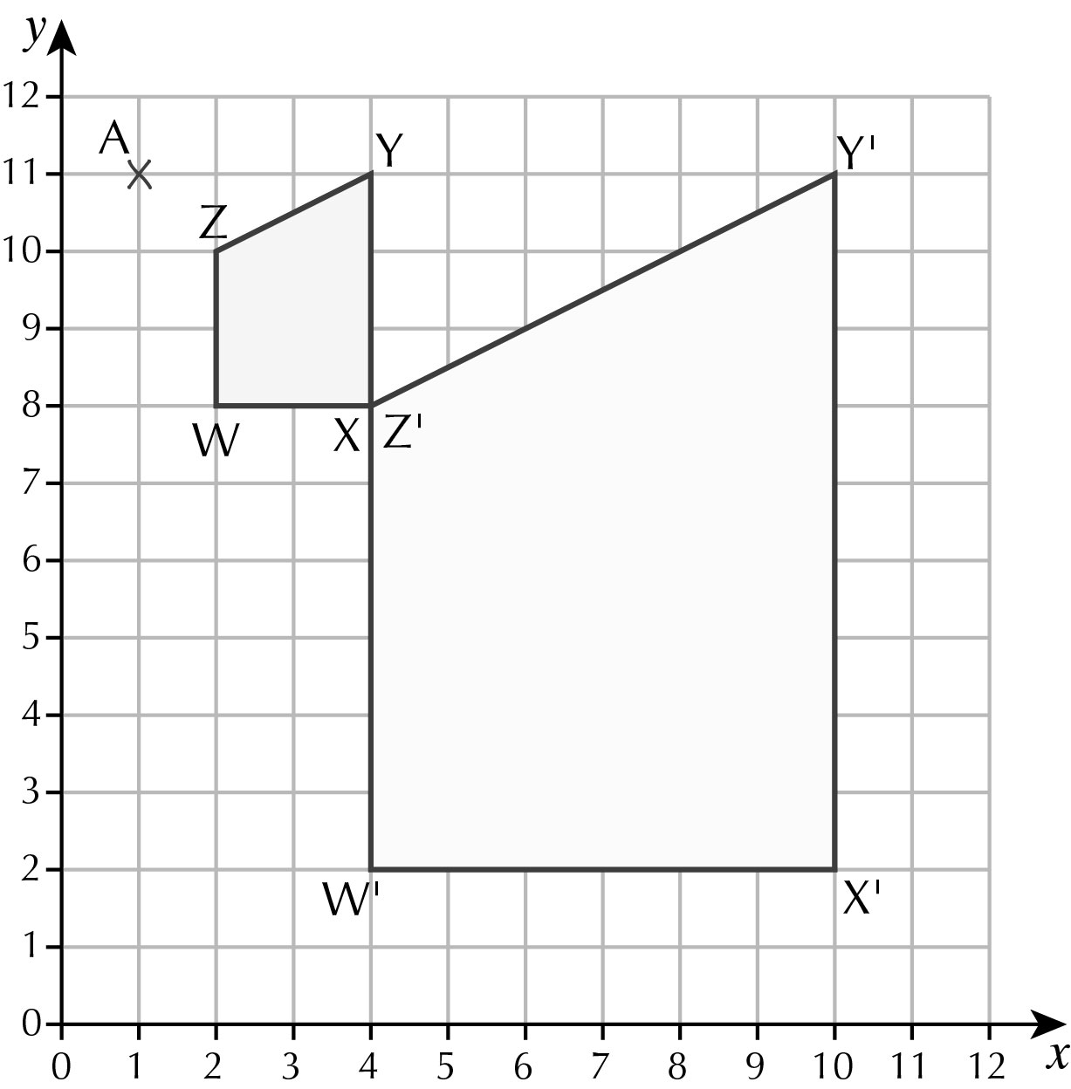
5 a 500 cm³ b 3802 g
6 a

b W’(4, 2) X’(4, 8) Y’(10, 11), Z’(10, 2) c 450 cm²
7 a i Corresponding angles are equal
ii All the angles are identical. Angles AEC and BDC are also corresponding. Angles ACE and BCD are the same angle.
b 18 cm c 21 cm
8 The polygon has 8 sides. The interior angle of the polygon is 135° and the exterior angle is 45°
9 a i 21.5 m ii 68.2°
b i 10.2 m ii 32.6°
10 a 45π m² b (6π + 30) m

14.5 Probability
1 D A E C B
2 a b c 0 d e
3 a 0.05 b 0.55 c 0.65 d 9
4 a
 | 1 | 2 | 3 | 4 | 5
1 | 2 | 3 | 4 | 5 | 6
2 | 3 | 4 | 5 | 6 | 7
3 | 4 | 5 | 6 | 7 | 8
4 | 5 | 6 | 7 | 8 | 9
5 | 6 | 7 | 8 | 9 | 10
b i ii iii iv
5 a
b Anais’ data is most reliable because she performed more experiments.
c (about 30%)
6 a Mutually exclusive. A number cannot be odd and even.
b Not mutually exclusive. 4 is both a square number and an even number.
c Not mutually exclusive. 2 is both a prime number and an even number.
7 120
8 a b c
9 a b c

14.6 Statistics
1
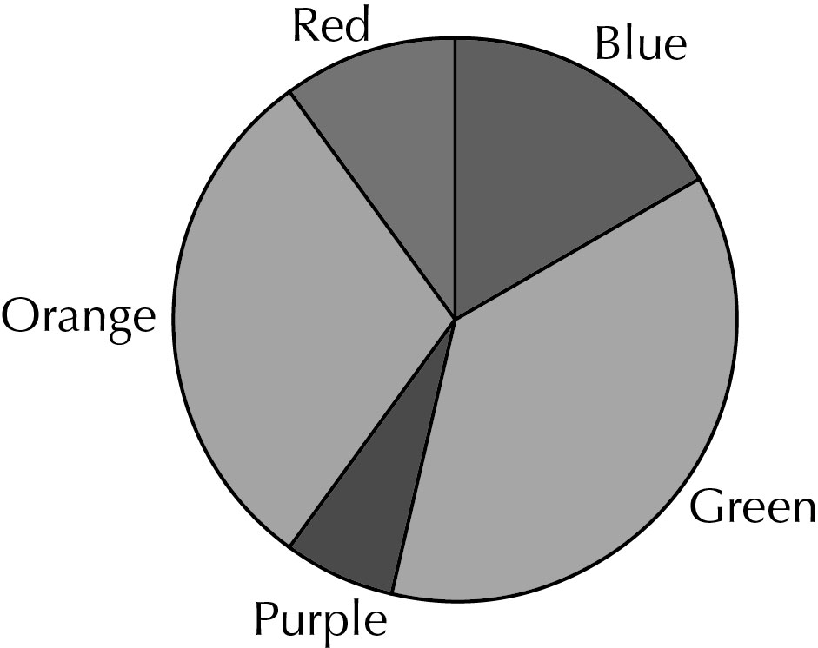

2 a 13 b 14.5 c 13 d 7
3 a Negative b 11 c 3 hours d Outside range of data
4 a Could include ‘no time frame’, ‘overlapping options’ ‘no zero option’ ‘no option
above 10’
b Example: ‘How many times have you been to the cinema in the past month?’
0  1 – 2  3 – 4  5 or more 
5 a 20 b x + 4 c x – 3 d x + 2
6 32, 33, 37, 39, 39
7 a 50 b 0 c 1.32 d 1
8 a 300 ≤ P < 500 b 300 ≤ P < 500 c £390
9 a 4, 14, 49, 71, 78, 80
b
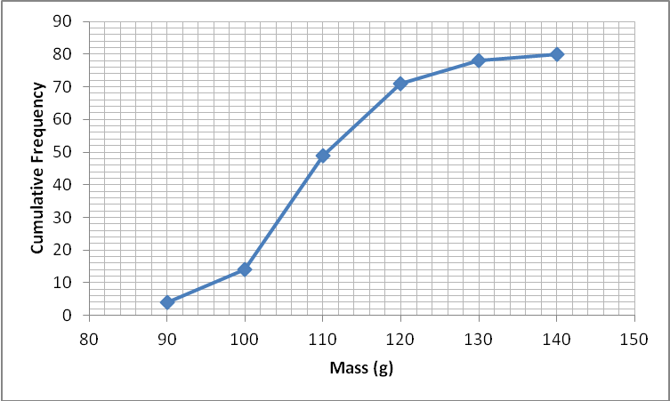
c 107 g d 13 g e 127 g

