**Step 4 answers**

**Chapter 1 Number**

**1.1 Adding and subtracting fractions**

**1 a**  **b**  **c**  **d**  **e**  **f**  **g**  **h** 

**2 a**  **b**  **c**  **d**  **e**  **f**  **g**  **h** 

**3 a**  **b**  **c**  **d**  **e**  **f**  **g**  **h** 

**4 a** 5 **b** 4 **c** 2 **d** 2

**5 a** 4 **b** 3 **c** 4 **d** 3 **e** 2 **f** 4 **g** 1 **h** 2

**6 a** 3 **b** 6 **c** 4 **d** 3 **e** 2 **f** 2 **g** 2 **h** 3

**1.2 Calculations with fractions**

**1 a** £12 **b** £10.50 **c** 175 kg **d** £9.60 **e** 26 kg **f** 12.5 km

**g** £38.50 **h** £680 **i** 1950 kg **j** £11 **k** £64.80 **l** 17.5 kg

**2 a** 2 **b** 4 **c** 3 **d** 1 **e** 2 **f** 5

**g** 4 **h** 3 **i** 6 **j** 4 **k** 7 **l** 3

**3 a** 5 **b** 10 **c** 3 **d** 20 **e** 12 **f** 16

**g** 26 **h** 22 **i** 3 **j** 42 **k** 17 **l** 36

**4 a** 20 **b** 45 **c** 22 **d** 40 **e** 12 **f** 75

**5 a** ÷ **b** × **c** ÷

**1.3 Using fractions, decimals and percentages**

**1 a** 0.28, 0.3, , 35% **b** 2.5%, 20%, 0.225, 2

**c** 1.19, 120%, 1,1.3 **d** 0.929, , 99.5%, 101%

**2** 77%

**3 a** 84% **b** 16%

**4 a** 66% **b** 34%

**5 a** 73% **b** 27%

**6 a** 62% **b** 28% **c** 9%

**7**

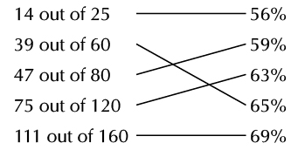

**8** 28%

**9** Tuesday; Monday is 59%, Tuesday is 71%

**10** large box; small 38%, large 41%

**Chapter 2 Algebra**

**2.1 Collecting like terms**

**1 a** 5*t* **b** *a* **c** 3*m* **d** 3*x* **e** −3*n* **f** 0

**2 a** 5*x* + 9 **b** 5*n* – 8 **c** 6 – 6*a* **d** 2*x –* 5 **e** *n* + 4 **f** 4 – 3*k*

**3 a** 6*a* + 2*b* **b** 5*s* – 3*t* **c** 4*x* – 2*y* **d** 5*p* – 4*q* **e** 6*a* – *b* **f** 2*n* – 3*k*

**4 a** 5*x*2 + 4*x* **b** 3*y*2 - *y* **c** 10*a*2 – 3 **d** -2*t*2 **e** 5*n*2 – 9 **f** 2 – 2*x*2

**5 a** cannot simplify **b** *z*2 + *z* – 2 **c** 6*s* + 4*s*2 **d** *a*

**e** cannot simplify **f** 5.5*x*2 + 5

**6**

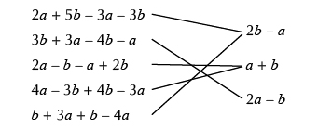

**2.2 Expanding brackets**

**1 a** 3*t +* 15 **b** 4*k* – 12 **c** 8*m* + 16 **d** 2*f* – 6 **e** 12 + 3*t* **f** 21 – 7*g*

**g** *a*2 + a **h** *b*2 – 3*b* **i** *k*2 + 5*k* **j** *t*2 – 8t **k** *w* + *w*2 **l** 5*x* – *x*2

**2 a** 3*a* + 3*b* **b** 5*s* – 5*t* **c** 4*m* + 4*n*

**d** 2*a* – 2*b* + 6 **e** 3*x* + 3*y* – 12 **f** 5*a* + 10 – 5*b*

**3 a** 4*a* – 2 **b** 5*t* + 1 **c** 6*x* + 4 **d** 5*y* – 14

**2.3 Solving equations**

**1 a** *x* = 3 **b** *t* = 7 **c** *n* = 6 **d** *x* = 4 **e** *t* = 8 **f** *m* = 6

**2 a** *x* = 3 **b** *y* = 3 **c** *a* = 4 **d** *y* = 2 **e** *y* = 15 **f** *m* = 2



**3 a** *x* = 8 **b** *y* = 6 **c** *a* = 2 **d** *x* = 4 **e** *y* = 11 **f** *t* = 5

**4 a** *x* = 6 **b** *t* = 7 **c** *a* = 5

**5 a** *x* = 10 **b** *y* = 7 **c** *k* = 7 **d** *y* = 6 **e** *x* = 11 **f** *m* = 3

**6 a** *y* = 3 **b** *y* = 4 **c** *t* = 2

**2.4 Sequences**

**1 a** add 3 **b** add 11 **c** add 20 **d** subtract 4

**2 a** 42 **b** 70 **c** 146 **d** 73

**e** 105 **f** 13 **g** 167 **h** 12

**3 a** 2 **b** 12 **c** 57

**4 a** 18 **b** 88 **c** 158

**5 a** 90 **b** 80 **c** 52

**6** 5, 8, 13, 20, 29

**7** 98, 96, 94, 92, 90

**8** **a** 0 **b** 24 **c** 80

**9** **a** 4 **b** 18 **c** 70

**10 a** 5*n* **b** 5*n* + 3 **c** 5*n* – 4

**11 a** 2*n* + 5 **b** 6*n* + 2 **c** 7*n* – 1 **d** 3*n* + 11 **e** 9*n* – 2 **f** 2*n* + 10

**2.5 Straight line graphs**

**1 a**

|  |  |  |  |  |  |  |  |  |
| --- | --- | --- | --- | --- | --- | --- | --- | --- |
| ***x*** | **-3** | **-2** | **-1** | **0** | **1** | **2** | **3** | **4** |
| *x* – 1 | -4 | -3 | -2 | -1 | 0 | 1 | 2 | 3 |

**b**

|  |  |  |  |  |  |
| --- | --- | --- | --- | --- | --- |
| ***x*** | **-2** | **-1** | **0** | **1** | **2** |
| 2*x* + 1 | -3 | -1 | 1 | 3 | 5 |

**c**

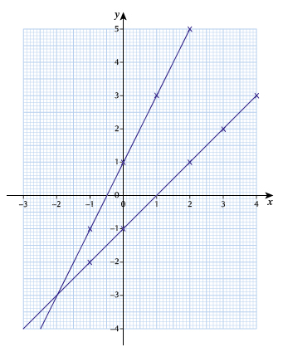

**d** 1 and (0, −1) **e** 2 and (0, 1)

**2 a**

|  |  |  |  |  |  |  |  |
| --- | --- | --- | --- | --- | --- | --- | --- |
| ***x*** | **-3** | **-2** | **-1** | **0** | **1** | **2** | **3** |
| 4*x +* 8 | -4 | 0 | 4 | 8 | 12 | 16 | 20 |

**b**

|  |  |  |  |  |  |  |  |
| --- | --- | --- | --- | --- | --- | --- | --- |
| ***x*** | **-3** | **-2** | **-1** | **0** | **1** | **2** | **3** |
| 3*x* – 6 | -15 | -12 | -9 | -6 | -3 | 0 | 3 |

**c**

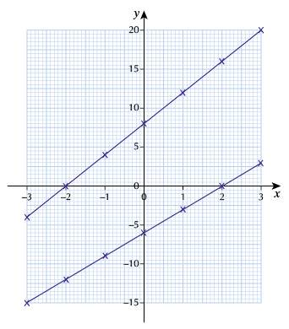

**d** 4 and (0, 8) **e** 3 and (0, −6)

**3 a**

|  |  |  |  |  |  |  |  |
| --- | --- | --- | --- | --- | --- | --- | --- |
| ***x*** | **-3** | **-2** | **-1** | **0** | **1** | **2** | **3** |
| 2 – *x* | 5 | 4 | 3 | 2 | 1 | 0 | -1 |

**b**

|  |  |  |  |  |  |  |  |
| --- | --- | --- | --- | --- | --- | --- | --- |
| ***x*** | **-3** | **-2** | **-1** | **0** | **1** | **2** | **3** |
| *x* – 1 | -2 | -2 | -1 | -1 | - | 0 |  |

**c**

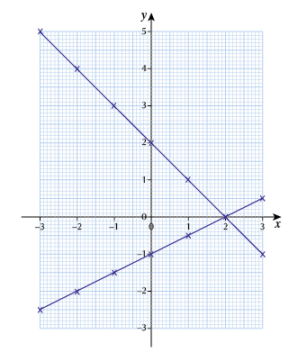

**d** −1 and (0, 2) **e**  and (0, −1)

**2.6 Real-life graphs**

**1 a** 2 **b** 15

**c**

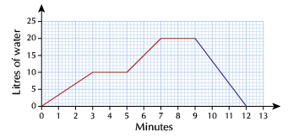

**2 a** 0900 **b** 2 hours

**c**

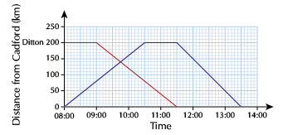

**3 a** 4 hours **b** 1 hour

**c**

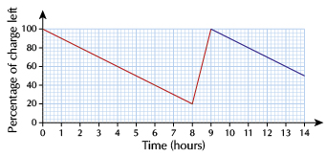

**4 a** 5 minutes **b** 60p

**c**

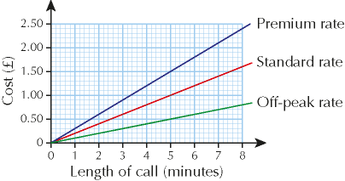

**Chapter 3 Ratio, proportion and rates of change**

**3.1 Percentage change**

**1 a** £69

**2 a** 28.8 kg **b** 32.4 kg **c** 39.12 kg

**3** £385

**4** 837

**5** 78

**6 a** £77.40 **b** £64.50 **c** £34.40

**7** £413.60

**8** 117

**9 a** £89.60 **b** €409.60 **c** 24.32 kg

**10 a** £27.50 **b** 192.5 litres **c** 3.575 kg

**11 a** 54 kg **b** 90 kg **c** 99 kg

**12 a** £126 **b** £157.50 **c** £182.70

**3.2 Ratio**

**1** £320 and £80

**2** £25 and £10

**3** $12 and $1.20

**4** 150 kg and 120 kg

**5** £0.75 and £1.50 and £2.25

**6** Ann 24, Jo 36

**7** £18

**8** 700 ml

**9** 375 g

**10** 3 kg and 9 kg

**11** 60

**3.3 Direct proportion**

**1** £8.64

**2** £13.68

**3** £585

**4** £28.08

**5** **a** 63.5 **b** 21.59

**6** **a** £612 **b** £153 **c** 60 **d** 20

**7** **a** 160 **b** 62.5

**8** **a** 27.5 **b** 300

**9** **a** 94.5 **b** 157.5 **c** 5

**10** **a** 875 ml **b** 48 g

**11** €375

**Chapter 4 Geometry and measures**

**4.1 Properties of quadrilaterals**

**1 a** square **b** rectangle and rhombus **c** kite

**2 a** a possible shape is

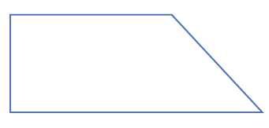

**b** 0

**3** parallelogram

**4**

|  |  |
| --- | --- |
| rhombus, parallelogram |  |
| rectangle | square |

**5 a** never **b** sometimes **c** always **d** sometimes

**6**

|  |  |  |
| --- | --- | --- |
| X | X |  |
|  | X |  |
| X |  | X |

**7** kite, parallelogram, rectangle

**8** parallelogram, trapezium, rhombus

**4.2 Parallel lines**

**1 a** 66 opposite angles **b** 66 corresponding angles **c** 114 angles on a straight line

**2 a** 80, corresponding angles **b** 60, corresponding angles **c** 40, angle sum of a triangle

**3 a** 72, corresponding angles **b** 72, alternate angles **c** 108, angles on a straight line

**4 a** 43 alternate angles **b** 112, angles on a straight line **c** 112 alternate angles

**5** The alternate angles are not equal

**6 a** alternate angles **b** alternate angles **c** *d + c + e =* 180

(angles on a straight line) so *a + b + c =* 180

**7 a** corresponding angles **b** alternate angles **c** *e + g + h =* 180

(angles on a straight line) so *e + f + d =* 180

**4.3 Angles of polygons**

**1** 103°

**2** 76°

**3** 144°

**4** 140

**5** **a** 720° **b** 120°

**6** **a** 135° **b** 8 × 45 = 360

**4.4 Translations**

**1** **a** 4 right **b** 3 down **c** 4 left, 3 down

**2**

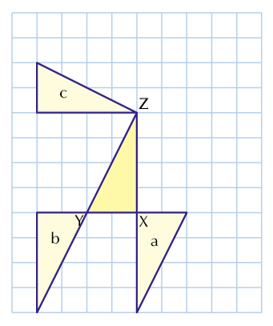

**3 a** True **b** False **c** True

**4 a** rotation 90° clockwise **b** rotation 180° **c** rotation 90° anticlockwise

**5**

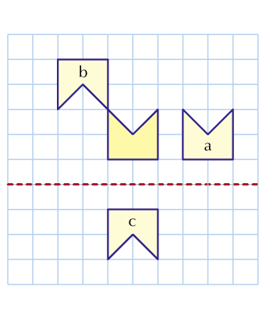

**6 a** rotation **b** reflection **c** none of these **d** translation **e** reflection

**7 a** Q to R or the reverse **b** Q to S or the reverse

**c** P to S or the reverse

**4.5 Enlargement**

The diagrams in answers could be drawn in different positions

**1**

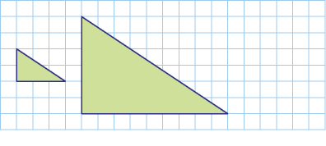

**2**

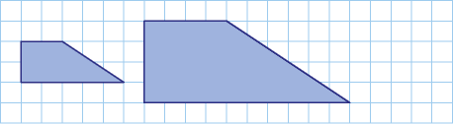

**3**

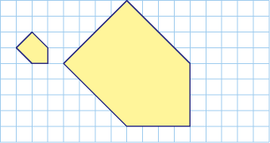

**4 a** Yes. All the sides are twice as long. **b** No. The width is × 3 but the length is × 2.5

**5 a** 3 **b** 2

**6**

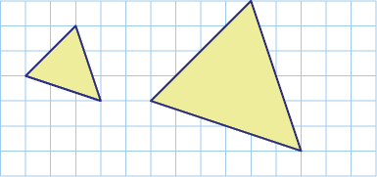

**7**

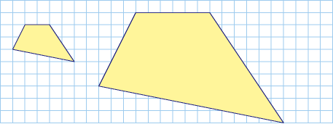

**4.6 Three-dimensional objects**

**1**

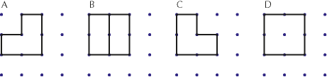

**2**

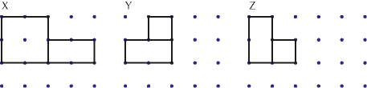

**3 a** 5 **b** 5 **c** 8

**4 a** 5 **b** 6 **c** 9

**5 a** 17 **b** 7

**6** 10

**4.7 Constructions with a straight edge and compasses**

**1**

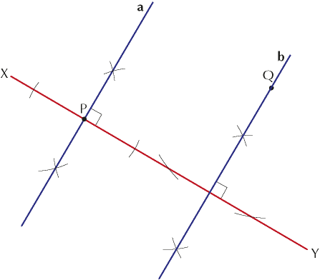

**2**

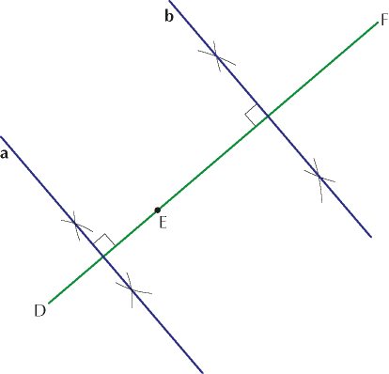

**3**

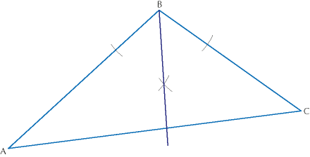

**4**

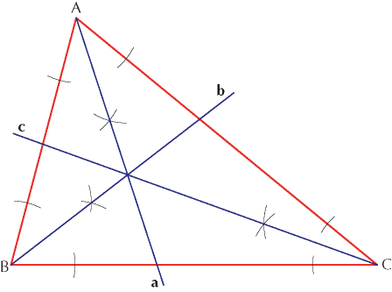

Check all three lines meet at one point.

**5**

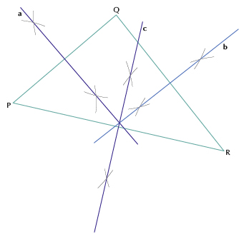

Check all three lines meet at one point.

**6**

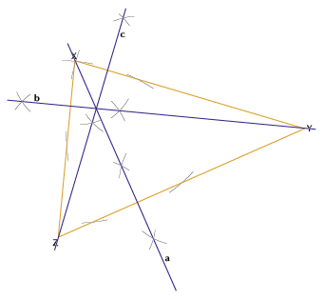

Check all three lines meet at one point.

**4.8 Areas of triangles and parallelograms**

**1** 77

**2** 108

**3** **a** 6 **b** 14

**4** 96

**5** 57

**6** 8

**7** 10

**8** 84

**4.9 Volumes of cuboids**

**1 a** 108 **b** 96

**2 a** 25 cm² **b** 20 cm² **c** 100 cm³

**3** 3840 cm³

**4** 729 cm3

**5** 4.2 m³

**6** 5.5

**7** 4

**8** 216

**4.10 The circumference and area of a circle**

**1 a** 37.7 cm **b** 21.4 cm **c** 276 cm **d** 88 m

**2 a** 50.3 cm² **b** 278 cm² **c** 227 cm² **d** 11.3 m²

**3 a** 32.7 cm **b** 84.9 cm²

**4 a** 88.4 cm² **b** 38.6 cm

**Chapter 5 Probability**

**5.1 Calculating probabilities**

**1 a** 0.87 **b** 0.76 **c** 0.63

**2 a** 0.4 **b** 0.65 **c** 0.05

**3** 0.58

**4 a**  **b**  **c**  **d** 

**5 a i** 0.88 **ii** 0.54 **b** 0.21

**6 a** 0.9 **b** 0.8 **c** 0.7

**7** 0.3

**8 a** 0.96 **b** 0.21 **c** 0.79 **d** 0.58

**5.2 Sample spaces**

**1 a**  **b**  **c** 

**2 a**  **b** 

**3 a**

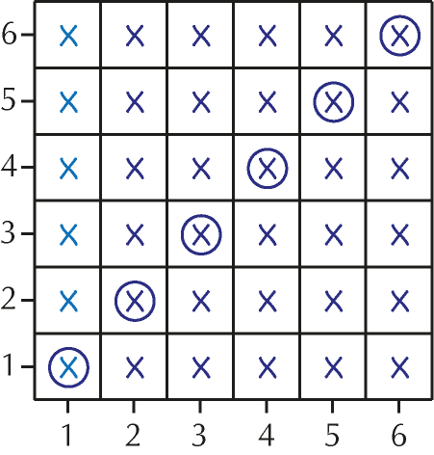

**b i**  **ii** 

**4 a**

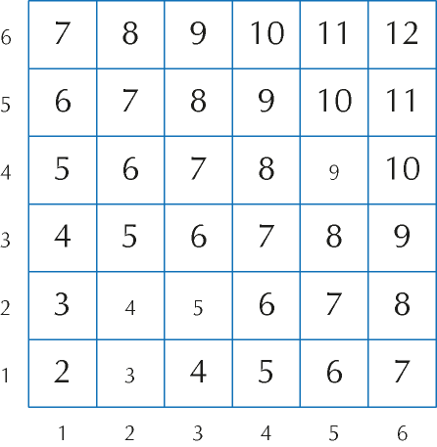

**b i**  **ii**  **iii**  **iv**  **v** 0

**c** 7 **d** 

**5 a**

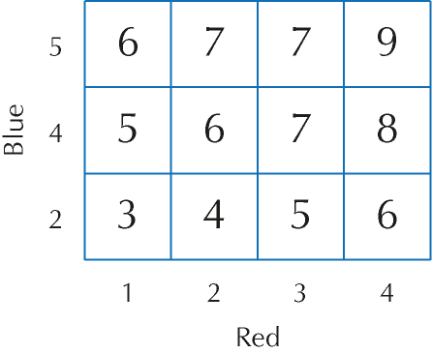

**b i**  **ii**  **iii**  **iv** 

**Chapter 6 Statistics**

**6.1 Constructing charts and diagrams**

**1 a** 69°, 120°, 156°, 15°

**b**

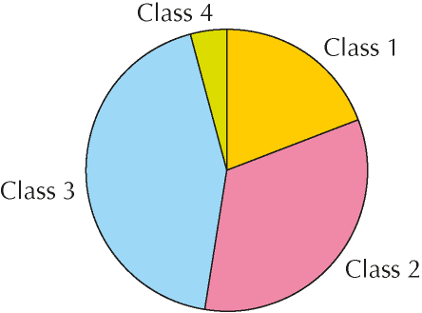

The sectors can be in any order.

**2 a** 166°, 115°, 79°

**b**

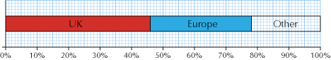

**3**

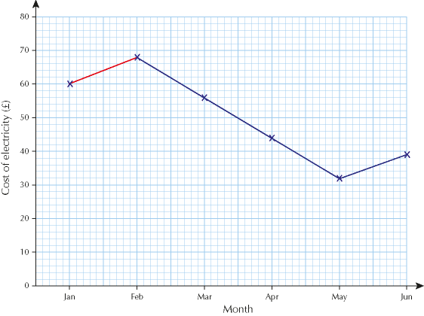

**4**

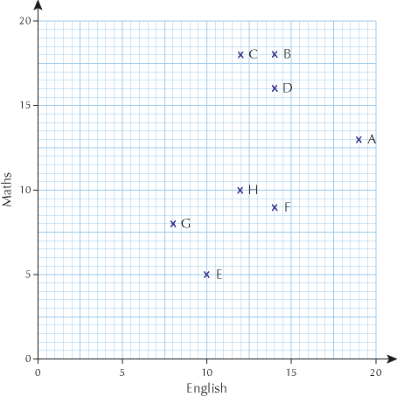

**6.2 Appropriate graphical representation**

**1 a** bar chart **b** time graph **c** pie chart **d** bar chart

**2 a** Yes **b** No **c** Yes **d** No

**3** In any order:

**1** The frequency axis does not start at 0 so it should have a break in it.

**2** The age classes are unequal.

**3** There is no title.

**4 a** Draw a time graph or a bar chart. A pie chart is not the best choice.

**b** Draw a pie chart or a sectional bar chart. A normal bar chart is not a good choice.