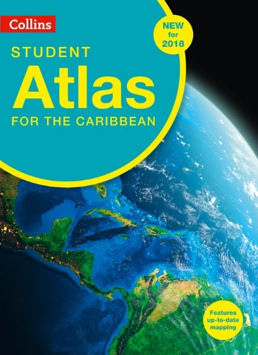
Caribbean Student
Atlas Introduction
Exercise

ISBN – 978-000-821-432-6

This is a fun exercise designed to help familiarise yourself with our new Atlas. And to ensure you get the most out of it when using on class. Please use your copy of the New Collins “Student Atlas for the Caribbean” to answer the questions below. All answers are found within the Atlas – Tip, use the contents page as a guide to where you think the answers are most likely to be found.

1: If it is 9am in Barbados, what time is it in Mexico City?
2: Between 1692 and 2010 there have been 10 major earth quakes in the Caribbean, two of which reached a magnitude of 8.1 on the Richter scale. Which two countries experienced 8.1 magnitude earthquakes?
3: As of 2015, what was the total population of Jamaica?
4: What is the national animal of the Turks and Caicos Islands?
5: As of 2015, which Caribbean country produces the 2nd largest amount of oil?
6: The highest point in Belize is called Doyle's Delight. What is the total height in metres?
7: The national flower of Barbados has bright red, yellow and Orange Petals, but what is its name?
8: The active volcano in Grenada last erupted in 2001. What is the name of this volcano?
9: Mercury is the closest planet to the Sun. How many earth days does it take for a year to pass on Mercury?
10: What is the capital of Tajikistan?

Answers:
1 – 6am
2- Haiti 1841, Dominican Republic 1946 – bonus point for answering with Guadeloupe (8.0-8.5 – 1843)
3 – 2,697,983
4 – Rock Iguana
5 - Cuba
6 – 1124m
7 – Pride of Barbados
8 – Kick’em Jenny, Grenada
9 – 88 days
10 – Dushanbe

