Selim-Hassan the Seventh

and The Wall: Band 17/Diamond Band

Pages 28–32

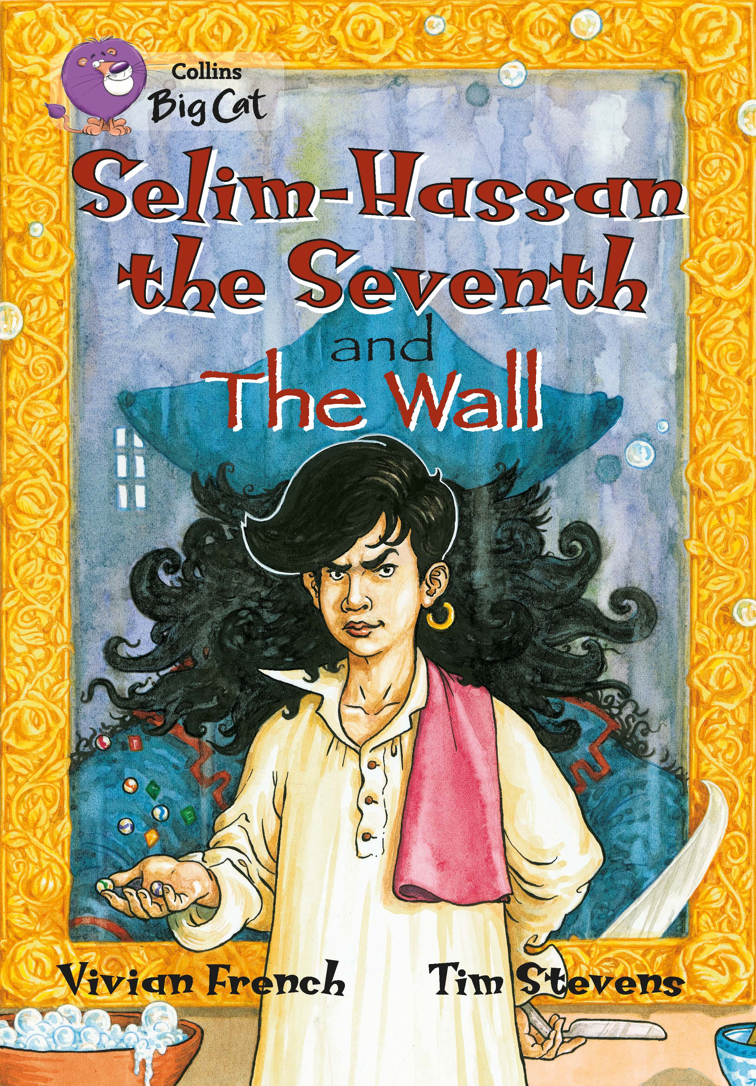
An extract has been selected to mimic the challenge of a reading comprehension paper.

Below are example questions that model some crucial question-types, followed by teaching suggestions (shown in purple font) which pre-empt potential pitfalls and misconceptions. As with all resources, apply professional judgement to guide your use of these examples; you may want to devise similar, or indeed entirely different, questions for other parts of the book.

Page 28

Which words give the impression that the wall is alive in some way?

A useful way of personifying inanimate objects is to ascribe active-sounding verbs to them. Demonstrate, noting the verbs linked to the wall on this page: it stormed…and stretched…I could see it marching… Each of these not only suggests that it is alive; they also give it a particular character. Model also how you are not side-tracked by the snakes and dragons: these are said to live beyond the wall – they don’t describe the wall itself. Note also that monstrous barricade is a very effective noun phrase, but does not imply ‘alive-ness’, despite the connotations of monsters.

Page 28

What do the words monstrous barricade suggest about the wall?

Explain that the story is written as a first-person account, so the viewpoint of Little Rabbit should be considered. Imagine the young girl standing beside a wall that is a monstrous barricade. If the children do not know one or both of those words, look together at the evidence given of its size (the height and the length). Monstrous is related to ‘monster’, clearly; be clear that it doesn’t just suggest great size, but also a

scary kind of size! And what word/s does barricade remind them of? They may have encountered it as verb: “They barricaded themselves in…” Not all walls are barricades! So we have a scarily large barrier for protection or defense, and this suggests danger and threat. Note that we don’t yet know which side is being defended (though the brothers offer an explanation).

Page 30

Identify five things that the wall does.

This basic retrieval question could confuse because on page 28, active verbs are used for figurative effect, whereas on page 30, the description is more of the wall’s function. Reread the page together to make this clear and note that the statement, the wall was like the earth, or the trees, or the moon, is not a statement of fact, but a (refuted) opinion; furthermore, this does not describe something the wall does. Note also that it had been built by men is a statement of fact, but isn’t something that the wall does. Revisit the page again and methodically note the facts about what the wall does:

- It gives shade from the sun;
- It marks the end of the safe land;
- It enables Little Rabbit always to find her way home, by following it back;
- It provides shelter from winter winds.

Explain that these are the hard facts about the wall given here, and that we can understand how the wall does these things by virtue of its great size. There is another detail, given earlier on the page, which we cannot explain at this point – but it is still a fact: it makes the father angry.

Pages 31–32

What evidence is there of Little Rabbit being unhappy in her family?

This is a retrieval question that requires inference as well as literal understanding. Reread each page and coach the children through literal understanding into inference about feelings:

What are the brothers explaining on page 31? (Who is the old one?) In what tone are they explaining things and how does this make Little Rabbit feel? She thinks she might

not want to be a true daughter, but she doesn’t want to say this aloud because her brothers were too big – what does this tell us?

What facts are we told about father on page 32? What does he use to discipline the horses? Who is he quickest to beat? Why does Little Rabbit believe that she is worth less than the horses?

What does the sentence Sometimes I thought my grandmother and I would have an easier life if we’d had four hooves and a mane and a tail tell us about Little Rabbit’s feelings?

Pull all of this understanding together to build a clear picture of Little Rabbit’s unhappiness. Note how there is no clear statement that she is unhappy – it is all in the details.

Independent work suggestions

- Children read the whole of ‘The Wall’ and summarise what each chapter is about in no more than 10 words per chapter.

- While reading the story, children record unfamiliar words – but don’t allow them to look up meanings; instead, the children must infer from context (using the techniques you have taught earlier - see above). Have children record how they have arrived at these meanings using evidence from the text.

- Throughout the story, have children note, “I know that X is feeling Y because on page…the author has written… This tells the reader that…”

- Have children compose true and false questions to ask each other; e.g. The wall was built to keep the horses safe – true or false?

These independent suggestions can be applied to the other story in this book, ‘Selim-Hassan the Seventh’.

