Guidance on the use of codes for this mark scheme
M | Method mark
A | Accuracy mark
B | Mark awarded independent of method
cao | Correct answer only
oe | Or equivalent
ft | Follow through

Question | Working |  | Answer | Mark | AO | Notes | Grade
1 a  b  c |  |  | (b, –a)  (–a, –b)  (–b, a) | B1  B1  B1 |  | B1 cao  B1 cao  B1 cao | B
 |  |  |  | 3
2 |  |  | E.g.  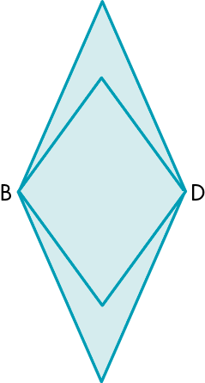 | B3 | 3 | B1 for correct reflection of small lengths  B1 for correct reflection of large lengths  B1 for complete correct diagram | B
 |  |  |  | 3
3 a  b | 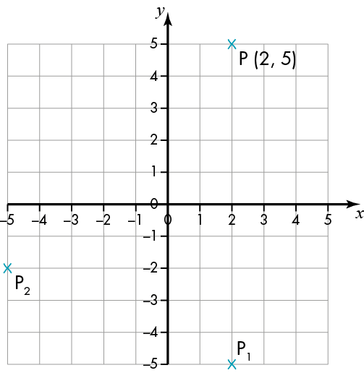 |  | (–5, –2)  (–b, –a) | M1  A1  A1 |  | M1 process of drawing a grid to assist  A1 cao  A1 cao | B
 |  |  |  | 3
4 a  b | (4, 3) → (–4, –3) in first reflection  (–4, –3) → (–4, 3) in second |  | (–4, 3)  (–a, b) | M1  A1  A1 |  | M1 finding first reflected point  A1 cao  A1 cao | B
 |  |  |  | 3
5 | Divide all points by 2 to give |  | (1, 1)  (3, 1)  (3, 2) | M1  A2 | 3 | M1 for method of halving all points  A2 if all three correct  A1 if only two are correct | B
 |  |  |  | 3
6 a  b  c i  ii  iii |  |  | E.g. A rectangle is a special quadrilateral that has four right angles, and the opposite sides are of equal length.  The mathematically important words are: quadrilateral, right angles, equal.  Yes  A square is a special type of rectangle, because it fits the definition in part a.  Two sides and two angles the same.  All sides and angles the same.  All sides and angles different. | B1  B1  B1  B1  B1  B1  B1 | 2 | B1 for an accurate description  B1 for suitable key words such as parallel,  perpendicular, right angles, equal  B1 for yes  B1 for clear explanation  B1 for a correct statement  B1 for a correct statement  B1 for a correct statement | B
 |  |  |  | 7
7 a i  ii  iii  iv  b  c  d |  |  | A kite has two pairs of equal adjacent sides.  A parallelogram has opposite sides parallel and equal in length.  A rhombus has four equal sides.  A trapezium has a pair of opposite sides parallel. It is an Isosceles trapezium if the sides that are not parallel are equal in length and both angles coming from a parallel side are equal.  A rhombus has 4 equal sides with opposite sides parallel so this fits the definition of a parallelogram.  Although opposite sides in a parallelogram must be equal, all four sides do not have to be equal so a parallelogram is not necessarily a rhombus.  There are two pairs of allied angles. Each pair adds up to 180°. So if you change the obtuse angle to acute, the other angle becomes obtuse.  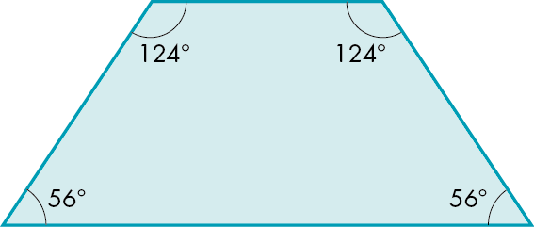  Irregular (see example). If it was not irregular as one angle decreases the other would increase (see part c)  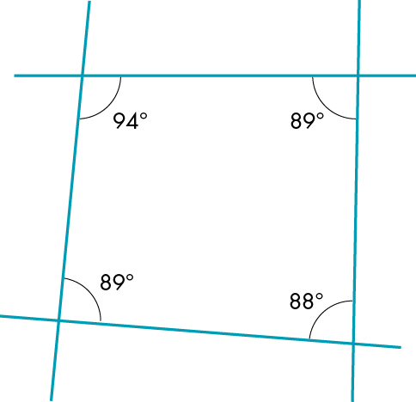 | B1  B1  B1  B1  B2  B2  B2 | 2  3 | B1 for a correct statement.  B1 for a correct statement  B1 for a correct statement  B1 for a correct statement  B1 for rhombus being parallelogram  B1 for parallelogram not being rhombus  B1 for a correct statement  B1 for use of diagrams to help  B1 for a correct statement  B1 for use of diagrams to help | B
 |  |  |  | 8
8 a i  ii  iii  iv  b |  |  | Suitable sketch of a quadrilateral that has:  1 line of symmetry  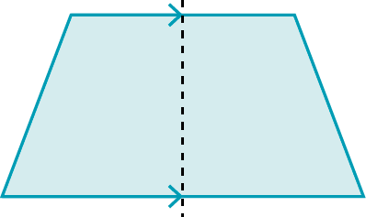  2 lines of symmetry  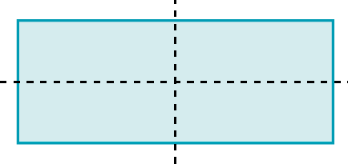  3 lines of symmetry  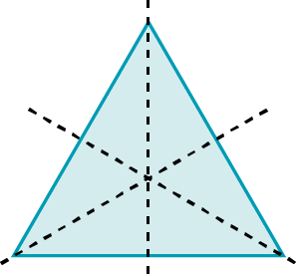  no lines of symmetry  1 line of symmetry – order 1  2 lines of symmetry – order 2  3 lines of symmetry – order 3  no lines of symmetry – order 1 | B1  B1  B1  B1  B1  B1  B1  B1 | 2 | B1 for a correct shape  B1 for a correct shape  B1 for a correct shape  B1 for a correct shape  B1 cao  B1 cao  B1 cao  B1 cao | B
 |  |  |  | 8
9 a  b |  | Find the perimeter by adding up the distance around the edge.  i.e. 10 + 2 + 5 + 3 + 2 + 3 + 3 + 2 = 30 cm  Two different ways of working out the area of the shape for example:  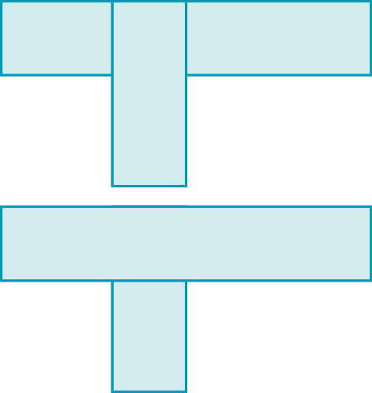 |  | B2  B2 | 2  3 | B1 for clear explanation  B1 for also showing it done  B1 for first example.  B1 for second example | B
 |  |  |  | 4
10 a  b | Length of side = x  Then, using Pythagoras, x² + x² = 20²  2x² = 20²  x = 20 ÷  = 14.142136  Perimeter = 4x  = 56.568542 | 56.6 cm  Side length x, so, using Pythagoras, 2x² = 8² = 64  Area = x² = 64 ÷ 2 = 32 cm² |  | M1  A1  M1  A1  M1  A1 | 3 | M1 for using Pythagoras’ theorem  A1 for answer to at least 3 dp  M1 for multiplying x by 4.  A1 for answer to either 1 or 2 dp  M1 for process of using Pythagoras’ theorem  A1 for clear presentation showing given result | B
 |  |  |  | 6

11 a  b  c |  | Stays the same – orientation, lengths and angles.  Changes – the position on any grid.  Stays the same – lengths and angles.  Changes – the position on any grid, orientation.  Stays the same –lengths and angles.  Changes – the position on any grid, orientation. | B1  B1  B1  B1  B1  B1 | 2 | B1 for a clear statement  B1 for a clear statement  B1 for a clear statement  B1 for a clear statement  B1 for a clear statement  B1 for a clear statement | B
 |  |  | 6
12 |  | E.g. The trapezium has only one pair of opposite sides parallel, the parallelogram has two pairs of opposite sides parallel.  The trapezium has rotational symmetry of order 1, the parallelogram has rotational symmetry of order 2. | B1  B1 | 2 | B1 for a correct statement  B1 for another correct statement | B
 |  |  | 2
13 |  | No.  Need to know if it is the single angle or one of the repeated angles (see diagrams).  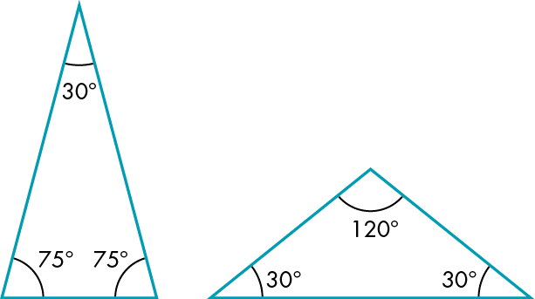 | B1  B1 | 2 | B1 for no  B1 for clear explanation | B
 |  |  | 2
14 |  | A is the only one with all the angles are the same/the only equilateral triangle.  B is the only one with a right angle/the only right-angled triangle.  C is the only scalene triangle. | B1  B1  B1 | 2 | B1 for any possible reason  B1 for any possible reason  B1 for any possible reason | B
 |  |  | 3

15 | Split the shape as shown in the diagram.  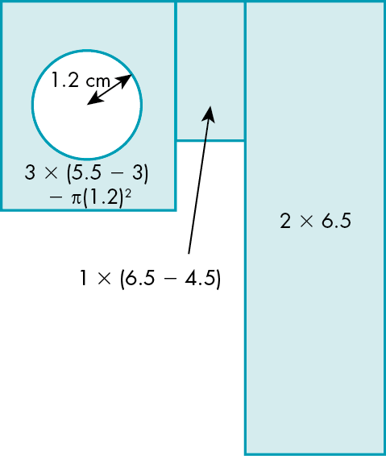  Area = 3 × 2.5 – π(1.2)²+ 1 × 2 + 2 × 6.5  = 7.5 - 4.52389 + 2 + 13  = 17.97611 cm² | 18.0 cm² | M1  M1  A1  A1 | 3 | M1 for process of splitting shape up  M1 for method of finding area of each part  A1 for answer to at least 3 dp  A1 for answer to either 0, 1 or 2 dp | B
 |  |  | 4
16 a  b  c |  | e.g. 1 cm × 1 cm × 24 cm  1 cm × 2 cm × 12 cm  2 cm × 3 cm × 4 cm  e.g. 2 cm × 3 cm × 4 cm  e.g. base 2 cm, height 12 cm  base 4 cm, height 6 cm | B3  B1  B1 | 2  3 | B1 for each cuboid with a volume of 24 cm³.  B1 for any a, b, c where 2(ab + bc + ac) = 52.  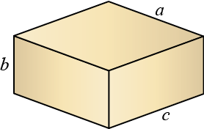  B1 for two lengths ad where ab = 12 | B
 |  |  | 5
17 | Using angles on a straight line: angle ADB = 180° – 2x  Using angles in a triangle in triangle ADB:  x + 34° + 180° – 2x = 180°  –x + 34° = 0  x = 34°  Using angles in a triangle in triangle BCD:  2x + 74° +angle BCD(A) = 180°  angle BCD(A) = 180° – 2x – 74°  = 180° – 68° – 74°  = 38° | Angle BCA = 38° | M1  A1  M1  A1 | 2 | M1 for finding x using angles in triangle and creating an equation  A1 for x = 34°  M1 for using angles in a triangle to find angle BCD  A1 cao | B
 |  |  | 4

18 |  | A is the only 6 sided shape/the only one with all sides the same shape.  B is the only one not a prism/the only pyramid.  C is the only one with a rectangular base. | B1  B1  B1 | 2 | B1 for a valid reason  B1 for a valid reason  B1 for a valid reason | B
 |  |  | 3
19 |  | For example, split the compound shape into different shapes.  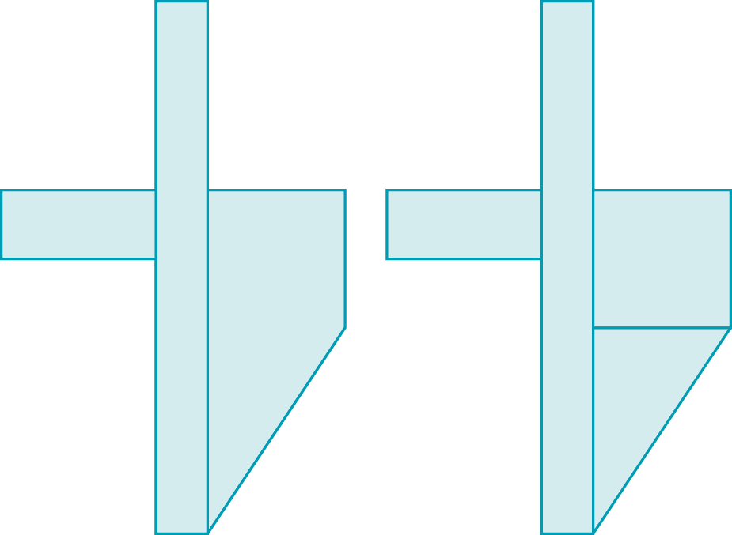  Work out the area of the large rectangle and subtract the areas that have been cut away.  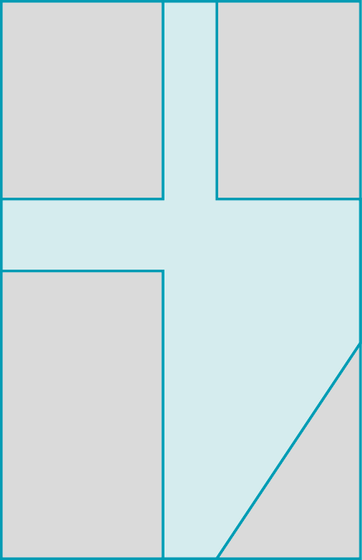 | B1  B1  B1 | 3 | B1 for first way.  B1 for another way using a different shape to the first.  B1 for a different way to the first two | B
 |  |  | 3
20 a  b |  | False  The missing lengths of the diagram have not been found to add on to the lengths given.  False  The parts have been assumed to have the same area, but they do not. | B1  B1  B1  B1 | 2 | B1 for false  B1 for clear explanation  B1 for false.  B1 for clear explanation | B
 |  |  | 4
21 | Based on the diagram  3 × 4 = 12 tables  Room around length of tables is 20 – (4 × 3) = 8 m  8 m ÷ 5 gaps = 1.6 m which is more than 1.5 m  Room around width of tables is 18 –(4 × 2) = 10 m  10 m ÷ 4 gaps = 2.5 m which is more than 1.5 m. So plenty of space around each table.  12 × 7 people = 84 people can be seated  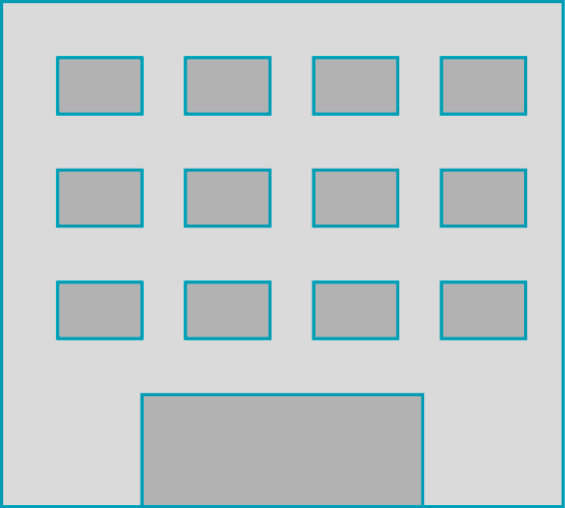 | So based on the layout there would be enough seats. | M1  A1  A1  M1  A1  A1 | 3 | M1 for process of looking for a suitable design and testing it  A1 for a solution that works  A1 for showing the solution works  M1 for process of finding out number of people who can be seated  A1 for correct number of people for the layout  A1 for complete solution well explained  Allow variations based on variations that fit with criteria, for example either side of stage | M
 |  |  | 6
22 |  | Height of cylinder and radius or diameter of cross section. | B1  B1 | 2 | B1 for height  B1 for radius | M
 |  |  | 2

23 a  b  c  d | 42° – 25°  = cos 25°  AB = 70 × cos 25°  = 63.441545  = sin 25°  CB = 70 × sin 25°  = 29.583278  = tan 42°  BD = AB × tan 42°  = 57.123024  CD = BD – BC  = 27.539745 | 17°  63.4 m  29.6 m  27.5 m | M1  A1  M1  A1  M1  A1  M1  A1  M1  A1 | 3 | M1 method of subtracting  A1 cao  M1 correct trig statement  A1 63.4 to either 0, 1 or 2 dp  M1 correct trig statement  A1 63.4 to either 0, 1 or 2 dp  M1 correct trig statement  A1 63.4 to either 0, 1 or 2 dp  M1 for process of subtracting  A1 for 27.5 to either 0, 1 or 2 dp | M
 |  |  | 10
24 a i  ii  iii  iv |  | 80π m²: correct  Area = (8² × π) + (4² ×π)  = 64π + 16π = 80π  208π m²: squared values on diagram multiplied by π and added  24π m²: multiplied radii by 2 instead of squaring them  48π m²: subtracting 4²π from 8²π instead of adding. | B1  B1  B1  B1 | 2  3 | B1 for correct.  B1 for valid reason  B1 for valid reason  B1 for valid reason | M
 |  |  | 4

25 |  | 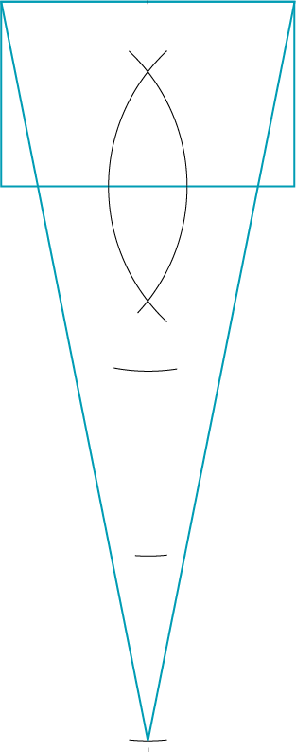 | B1  B1  B1  B1 | 3 | B1 for process of finding triangle with height 4 times greater than the rectangle  B1 for constructing line bisector of base of rectangle  B1 for stepping off 4 heights of rectangle  B1 for completing correct triangle | M
 |  |  | 4
26 a i  ii  iii  iv  v  b |  | True  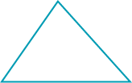  True  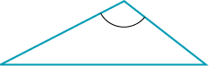  False. Two obtuse angles will add up to more than 180° which is more than the sum of the angles in a triangle.  True  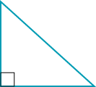  False. Two right angles add up to 180° which is the sum of the angles in a triangle, so the third angle would have to be 0°.  If you draw a line between two parallel lines, the two allied angles formed add up to 180°, which gives nothing left for a third angle. | B1  B1  B1  B1  B1  B1  B1 | 2 | B1 for a clear diagram  B1 for a clear diagram  B1 for clear explanation  B1 for a clear diagram  B1 for clear explanation  B1 for clear explanation  B1 for clarity of the communication | M
 |  |  | 7
27 a  b | x = 180° – (90° + 15°)  = 180° – 105°  Angle ACD = 15°  Alternate angles  BCD = 90° + 15° | 75°  105° | M1  A1  B1  M1  A1 |  | M1 using angles in a triangle  A1 cao  B1 for recognition of alternate angles  M1 for using angles in a triangle and adding  A1 cao | M
 |  |  | 5
28 |  | Their interior angles are 120° and 3 × 120° = 360°  This is the total of the angles around a point. | B1 | 2 | B1 for a clear explanation | M
 |  |  | 1
29 | 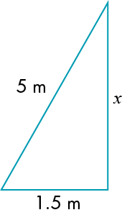  Using Pythagoras  x²+ 1.5² = 5²  x² = 25 – 2.25  x = = 4.734165 | 4.73 m | M1  M1  A1  A1 | 3 | M1 for process of applying Pythagoras theorem  M1 for correct Pythagoras statement  A1 for  A1 for 4.73 correct to 2 or 3 dp | M
 |  |  | 5
30 a  b |  | Scale factor is 3  The side lengths of A are one-third the side lengths of C, so the scale factor will be .  Where the lines cross is the centre of enlargement, this point is (–18, 14) | B1  B1  B1  B1 | 2  3 | B1 cao  B1 for scale factor  B1 for explaining the lines  B1 for correct centre. | M
 |  |  | 4
31 |  | The sum of the areas of the two smaller semicircles is equal to the area of the larger semicircle. | B1 | 2  3 | B1 for a clear explanation | H
 |  |  | 1
32 |  | AC is 5 cm because, triangle ABC is a 5, 12, 13 special right-angled triangle.  Triangle ACD is a right-angled triangle and a 3, 4, 5 triangle, giving CD the length 4. | B1  B1 | 2  3 | B1 for explaining AC as being 5 cm  B1 for completing the explanation for DC to be 4 cm | H
 |  |  | 2

33 | (Horizontal distance in air)² = 300² + 500²  = 340 000  Horizontal distance in air =  = 583.0952 m | 583 m | M1  A1  A1 | 2 | M1 for sorting one length by Pythagoras  A1 for  A1 for answer correct to 1, 2 or 3 sf | H
 |  |  | 3
34 |  | Diameter 5 cm, height 13 cm  Or  Diameter 13 cm, height 5 cm | B1  B1 | 2 | B1 for first correct set  B1 for second correct set | H
 |  |  | 2
35 a  b | 4x = 3(x + 3)  4x = 3x + 9  x = 9  So perimeter of square is 4 × 9 = 36 cm  y =  =  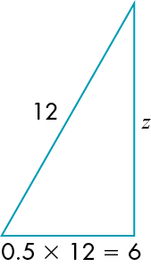  z²=12²- 6²  z² = 144 – 36 = 108  z = | 36 cm  So y is greater | M1  M1  A1  M1  A1  B1  M1  A1  B1 | 2  3 | M1 for process of setting up equation  M1 for x = 9  A1 cao  M1 for using Pythagoras’ theorem  A1 either surd form or answer  B1 for creating suitable diagram to assist  M1 for use of Pythagoras’ theorem  A1 for surd form or answer  B1 cao provided evidence of calculation seen | H
 |  |  | 9
36 |  | Each length is a multiple of 2.5, so by dividing by 2.5 we can see the ratio of all the sides.  This gives us 3, 4, 5 and 6  The sides in the ratio 3, 4 and 5 will make a right-angled triangle, hence the one to be left out is the one that is 6 × 2.5 = 15 cm. | M1  A1  A1 | 2 | M1 for process of finding ratio of sides  A1 for explaining why the three chosen fit  A1 for 15 cm provided explanation alongside | M
 |  |  | 3
37 |  | If all the shapes are congruent then they are identical in size, so they must have tessellated, all joining together and leaving no gaps. | B1 | 2 | B1 for clear explanation
 |  |  | 1
38 |  | Find the factor pairs of 60 to give  1 × 60, 2 × 30, 3 × 20, 4 × 15, 5 × 1,  6 × 10 | M1  A1 | 3 | M1 for process of looking for factor pairs  A1 for all six stated | M
 |  |  | 2
39 | DE = 6 cm, CH = 7 cm, CG = 8 cm  Side length of the square is 10 cm.  Subtract area of triangles DEH, HCG, AEF and BFG from the area of the square.  Area of DEH = 0.5 × 3 × 6 = 9 cm²  Area of HCG = 0.5 × 7 × 8 = 28 cm²  Area of AEF = 0.5 × 4 × 4 = 8 cm²  Area of BFG = 0.5 × 2 × 6 = 6 cm²  Area of square = 10 × 10 = 100 cm²  So area of shaded shape = 100 – (9 + 28 + 8 + 6)= 100 – 51  = 49 cm² | Area = 49 cm² | M1  M1  M1  A1 | 3 | M1 for process of finding missing lengths and marking them on diagram  M1 for method of finding area of a triangle  M1 for subtraction of areas  A1 cao | M
 |  |  | 4
40 | The area of the garden is 6.5 × 4.8  = 31.2 m²  The area of the small blue squares are 0.8² = 0.64 m²  Four of them make one large blue square  There are the equivalent of 12 small blue squares to be covered by topsoil.  Area = 12 × 0.64 = 7.68 m²  The volume of soil needed is  7.68 m² × 0.5 m = 3.84 m³  Number of bags of topsoil needed  = 3.84 ÷0.75 = 5.12  Assume she will need 5 bags.  So will need about 5 bags  Cost of topsoil = 5 × 73.30 = £366.50  4 slabs that cover 4 × 0.64 = 2.56 m²  The grass needed is to cover 31.2 – (7.68 + 2.56) = 20.96 m²  Use approximately 50 g per square metre.  50 g × 20.96 = 1048 g  So assume 2 × 500g bags will be needed which will cost 2 × £19.99 = £39.98  Total cost will be £366.50 + £39.98  But note no cost given for the paving stones. | £406.48 | M1  M1  A1  A1  M1  A1  B1  B1  A1  M1  M1  A1  B1  A1  A1  B1 | 3 | M1 for process of finding area of garden  M1 for finding area of shaded squares  A1 for 7.68  A1 for 3.84  M1 for dividing volume by 0.75  A1 for 5.12  B1 for stating 5 bags needed  B1 for £366.50  A1 for 2.56  M1 for process of finding area of grass  M1 for multiplying area by 50  A1 for 1048  B1 for stating 2 bags needed  A1 for 39.98  A1 cao  B1 for explaining that the stones are not included in the price. | M
 |  |  | 16

41 |  | Sometimes  An example of when not true and an example of when true  Shape A: perimeter = 14 cm, area = 10 cm²  Shape B: perimeter = 16 cm, area = 12 cm²  Shape C: perimeter = 18 cm, area = 8 cm²  Statement true for A and B, but false for B and C  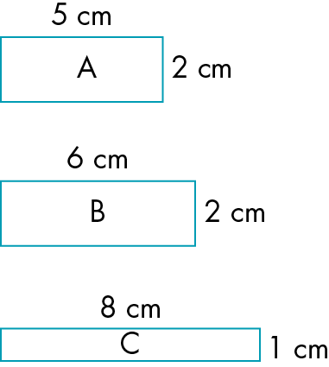 | B1  B2  B1 | 2 | B1 for sometimes  B1 for example that shows it can be true  B1 for example that shown it can be false  B1 for clear communication of both | M
 |  |  | 4
42 |  | True  Demonstration of proof of area triangle equal to half area of rectangle true also for non-right angle triangle.  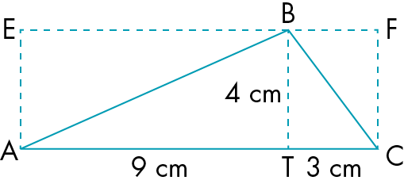  Area of triangle ABT = half of AEBT  = half of 36 cm² = 18 cm²  Area of triangle CTB = half of CTBF  = half of 12 cm² = 6 cm²  Area of triangle ABC = 18 + 6 = 24 cm²  = × 4 × 12 | B1  B1  M1 | 2  3 | B1 for true  B1 for clear explanation  M1 for concise communication with clear diagrams | M
 |  |  | 3

43 | 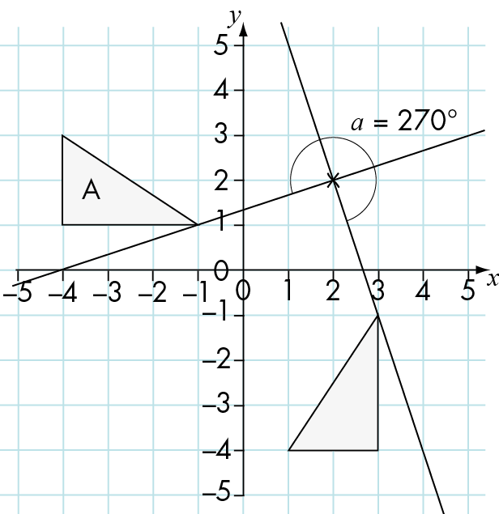 | A rotation of 90°anticlockwise around point (2, 2) | M1  A1  A1  B1 | 3 | M1 for a process of finding the centre of rotation.  A1 for indicating 90° anticlockwise (or 270° clockwise)  A1 for indicating centre of rotation as (2, 2)  B1 for full, clear description providing all information needed | M
 |  |  | 4
44 | Area of front and back = 2 × 12 × 25  = 600 m²  Area of sides = 2 × 12 × 12 = 288 m²  Area of openings = 40 × 2 × 1 = 80 m²  Total area to be painted = 600 + 288 – 80  = 808 m²  With 2 coats of paint area = 2 × 808  = 1616 m²  Number of litres of paint needed  = 1616 ÷ 16 = 101 litres.  Number of cans of paint = 101 ÷ 10 = 10.1  So 11 cans are needed.  Cost of paint = 11 × £25 = £275  Assume painters work 5 days per week.  Number of days = 2 × 5 = 10  Cost of painters = 10 × 3 × 120 = £3600  Total cost = £275 + £3600 + £500 = £4375  Add 10%: £4375 × 1.1 = £4812.50  Add 20% VAT: £4812.50 × 1.2 = £5775 | The builder should charge the council £5775. | M1  M1  A1  M1  A1  M1  A1  M1  A1  A1  M1  M1  A1  C2 | 2  3 | M1 for correct formula for area of rectangle  M1 for correct method of finding total surface area  A1 for 808 cao  M1 for correct method of finding number of cans  A1 for correct number of cans used  M1 for method of finding cost of cans  A1 for 275 cao  M1 for method of calculating cost for two days  A1 for 3600 cao  A1 for 4375 cao  M1 for correct calculation of 10%  M1 for correct calculation of 20%  A1 for correct total cost 5775  C1 for clear explanation marks with structure and technical use of language in explanation and  C1 for stating any necessary assumptions | M
 |  |  | 14
45 a  b  c | Area of face = 4² = 16 m²  Area of circle = πr²  Using π= 3.142, area = π1.2²  = 4.52448 m²  Remaining surface area of front face = 16 – 4.52448 = 11.47552 m²  Total remaining surface area:  front and back =  2 × 11.47552 = 22.95104 m²  Area of other four sides = 4 × 16 = 64 m²  Total = 64 + 22.95104= 86.95104 m²  Volume of original cuboid = 4³ = 64 m³  Volume of cylinder = πrh  = πr²4  = 4.52448 × 4  = 18.09792 m³  Remaining volume = 64 – 18.09792 = 45.90208 m³  Light blue paint = outside area ÷ coverage of 1 litre of paint = 87 ÷ 9 = 9.666  Surface area inside cylinder = 2πrh  2 × 3.142 × 1.2 × 4  =30.1632 m²  30.1632 ÷ 9 = 3.3515 | 87.0 m²  45.9 m³  Light blue = 9.7 litres  Dark blue = 3.4 litres | M1  M1  A1  A1  A1  A1  A1  M1  A1  M1  A1  A1  M1  A1  M1  A1  A1 | 3 | M1 for the correct method of finding area of a rectangle  M1 for correct method of finding area of a circle  A1 for correct area of circle  A1 for correct area of face with circle  A1 for correctly combining front and back  A1 for correct area of the other 4 sides  A1 for correct total area, rounded to 2 ,3 or 4 sf  M1 for correct method for finding volume of cube  A1 for 64  M1 for correct method for finding volume of cylinder  A1 for a correct volume of cylinder (any rounding)  A1 for correct total volume, rounded to 2,3 or 4 sf  M1 for dividing total outside surface by 9  A1 for correct answer rounded to 1,2,3 or 4 sf  M1 for correct method of finding curved surface area  A1 for a correct surface area (any rounding)  A1 for correct answer to 2,3 or 4 sf | M
 |  |  | 17
46 |  | Yes, he is correct  This is one of the conditions for being able to draw a triangle | B1 | 2  3 | B1 for clear communication that he is correct | M
 |  |  | 1
47 |  | 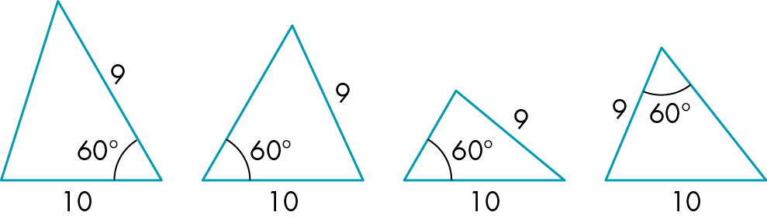 | B4 | 3 | B1 for each different possible triangle shown and clearly labelled | M
 |  |  | 4
48 | Draw the locus. | d The locus is none of these as it is a point. | B1  B1  M1 | 3 | B1 for stating d is the only correct option  B1 for a clear explanation of why  M1 for clear communication using diagrams to illustrate answer | M
 |  |  | 3
49 | Angles in a in triangle add up to 180°  You can split any quadrilateral into two triangles.  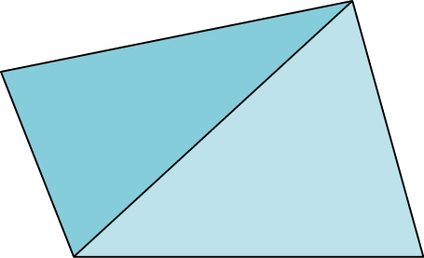  Therefore the interior angles of any quadrilateral = 2 × 180º |  | B1  M1  B1 | 2 | B1 for clear explanation  M1 for communication with clear diagram  B1 for showing inter angles of quadrilateral = 2 × 180° | M
 |  |  | 3
50 |  | A line of symmetry has the same number of vertices on each side of the line so there is an even number of vertices and therefore an even number of sides. | B2  M1 | 2 | B1 for line of symmetry and number of vertices link  B1 for reference to even number of vertices  o.e.  M1 for use of diagram to illustrate answer | M
 |  |  | 3
51 a  b  c |  | Suitable diagram, e.g.  Suitable diagram, e.g. as part a  In a parallelogram opposite sides are equal.  In a trapezium at least one set of opposite sides are parallel.  Therefore every parallelogram is also a trapezium. | B1  B1  B1  M1 | 2  3 | B1 for a correct diagram  B1 for a correct diagram  B1 for a correct diagram of a parallelogram  M1 for a correct explanation alongside the diagram | M
 |  |  | 4
52 |  | Always true  For any polygon to go around the outside of the shape you must turn through 360° to get back to where you started. Therefore the external angles of every polygon sum to 360º. | B1  B1  M1 | 2 | B1 for always true  C1 for a satisfactory explanation  M1 for use of diagram to illustrate answer
 |  |  | 3

53 | Ratio = 6 : 5 : 7  6 + 5 + 7 = 18  Sum of the angles in a triangle = 180°  So 180° ÷ 18 = 10°  Therefore the angles are:  6 × 10° = 60°  5 × 10° = 50°  7 × 10° = 70°  Check  60° + 50° + 70° = 180° | 60°, 50°, 70° | M1  B1  M1  B3  M1 | 2 | M1 for summing parts of ratio  B1 for clear statement regarding angle sum of triangle  M1 for dividing 180° by 18  B1 for each correct angle found  M1 for showing the checking of answer sum to 180°.
 |  |  | 7
54 a  b |  | Interior angle of a equilateral triangle is 60°  Interior angle of a square is 90°  Interior angle of a regular hexagon is 60°  All three are factors of 360º so these shapes will tessellate around a point.  This is not true for other regular polygons as their interior angles are not factors of 360.  Interior angle of a regular octagon is 135º  Interior angle of a square is 90º  Using a similar argument to part a:  2 × 135° + 90° = 270° + 90° = 360º | M1  M1  B1  B1  M1 | 2 | M1 for clear explanation of all three shapes  M1 for use of clear diagrams alongside the explanation  B1 for clear explanation  B1 for clear explanation  M1 for use of clear diagrams alongside the explanation
 |  |  | 5
55 |  | All three sides (SSS)  Two sides and the included angle (SAS)  Two sides and another side angle (SSA)  Two angles and a side (ASA, or AAS) | B4 | 3 | B1 for each correct statement | M
 |  |  | 4

56 a  b  c  d |  | True  In a parallelogram opposite sides are parallel.  In a rhombus opposite sides are parallel and all sides are the same length.  So a rhombus is a type of parallelogram.  In a square all sides are the same length.  So a rhombus with right angles must be a square.  True  A rhombus must be a parallelogram (part a) but a parallelogram does not all sides the same length so it does not have to be a rhombus.  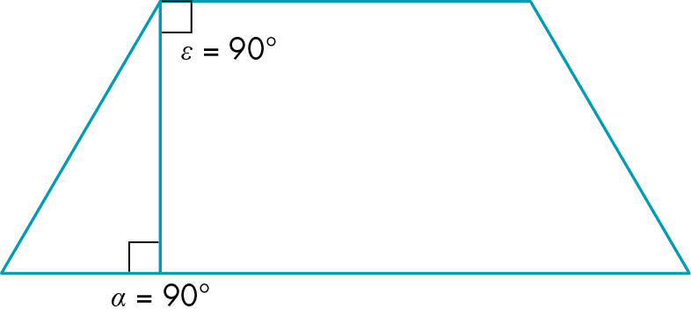  True  Using the diagram of a trapezium above, you see each pair of angles are allied angles, each pair adding up to 180°, so each pair can only have a maximum of one acute angle, hence the whole shape can have no more than two acute angles.  True  A quadrilateral can have three acute angles,  e.g. 80°, 80°, 80° and 120°  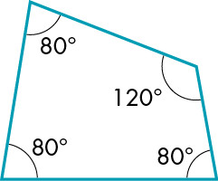 | B1  B1  B1  B1  B1  M1  B1  B1  M1  B1  B1  M1 | 3 | B1 for true  B1 for clear explanation  B1 for clear explanation  B1 for true  B1 for clear explanation  M1 for clear use of diagram alongside the explanation  B1 for true  B1 for clear explanation  M1 for clear use of diagrams alongside the explanation  B1 for true  B1 for clear explanation alongside a clear diagram  M1 for clear use of a correct diagram | M
 |  |  | 12

57 |  | Look at what sides and/or angles you have been given and what you need to calculate.  Use Pythagoras, theorem when you need to work out one side lengths and you know the other two side lengths.  Otherwise use sine, cosine or tangent when you need to work out an angle or a side. | B1  B1 | 3 | B1 for clear Pythagoras explanation  B1 for clear right angled trig explanation | M
 |  |  | 2
58 a i  ii  b i  ii |  | A suitable simple reflection  A mirror line that is parallel to one of the sides of the shape  A suitable simple rotation  A centre of rotation that is not on an extension of one of the sides of the shape. | B1  M1  B1  M1 | 2  3 | B1 for a diagram of a simple reflection  M1 for a clear explanation  B1 for a diagram of a simple rotation  M1 for a clear explanation | M
 |  |  | 4
59 a  b  c |  | The lengths change as does the position of the shape  The angles stay the same.  For example  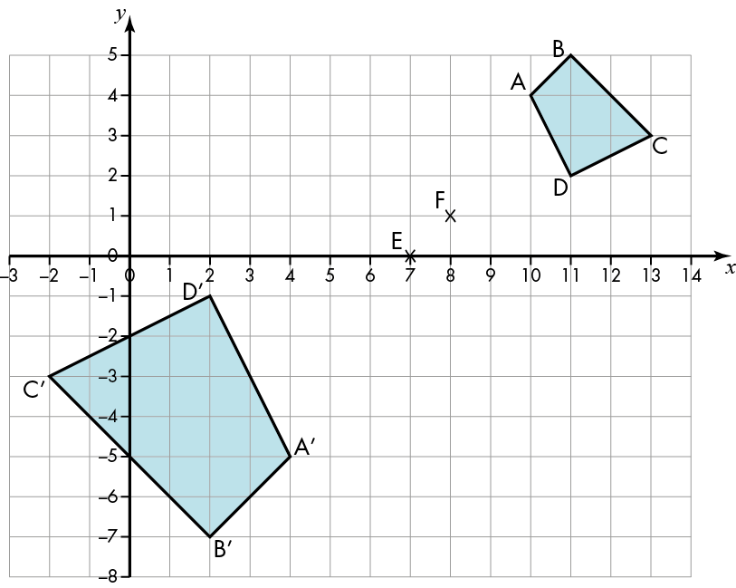  Scale factor and centre of enlargement.  Find the centre of enlargement by choosing two points on the original shape and their image points. Draw straight lines joining these points on the original image and the corresponding points on the image. Where the lines cross is the centre of enlargement.  Work out the scale factor found by dividing the length of a side on the image by the length of the corresponding side on the original shape.  OR by dividing distance of a point on the image from the centre of enlargement by the distance of a corresponding point on the original shape from the centre of enlargement. | B1  B1  B1  B1  B1  B1  B1 | 2 | B1 for clear statement  B1 for clear statement  B1 for use of a clear example  B1 cao  B1 cao  B1 for clear explanation  B1 for clear explanation | B
 |  |  | 7
60 a  b |  | When a shape has been translated the orientation is the same.  When it has been reflected its orientation is different.  Rotating a rectangle about its centre: all the vertices move and the shapes remain superimposed on each other.  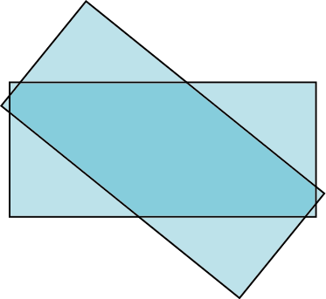  Rotating about one of its vertices: all the other vertices move and as the angle increases the shapes will no longer be superimposed.  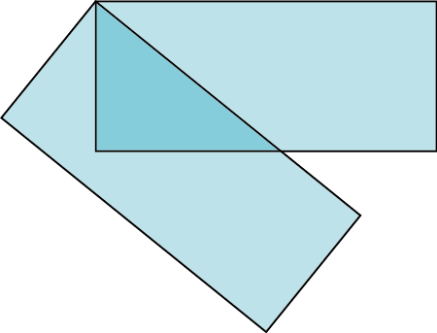 | B2  M1  B1  M1  B1  M1 | 2 | B1 for comment about orientation staying the same in translation  B1 for comment about orientation being different in rotation  M1 for a clear diagram alongside the explanation  B1 for clear explanation  M1 for good diagram alongside explanation  B1 for clear explanation  M1 for use of diagram to illustrate explanation
 |  |  | 7
61 | Cross-sectional area is a quarter of circle with radius 1.5 cm and a rectangle 1.5 cm by 6.5 cm  Area of quarter circle = π1.5²  = 1.7671459 cm²  Area of rectangle 1.5 × 6.5 = 9.75 cm²  Total area = 1.7671459 + 9.75 = 11.517146 cm²  Total volume of wood =11.517146 × 12 000 = 138 205.75 cm²  Convert this to m² by dividing by 1 000 000  = 0.13820575 m² | 138 000 cm² or 0.14 m² | M1  A1  B1  B1  M1  A1 | 2  3 | M1 for method of finding area of the quadrant  A1 for any rounding to 4 or more sf  B1 for 9.75  B1 for any rounding to 4 or more sf  M1 for method of finding volume  A1 for correct answer rounded to either 2 or 3 sf  Accept alternative cubic metre answer given correctly to 2 or 3 sf | M
 |  |  | 6
62 a  b  c | Triangle 11 will move round to sit next to face 13, square 4 will move round to be next to face 12, leaving face 2 opposite to face 13. | 14 faces: the same as the number of polygons in the net.  13  I would create the shape first then draw what I see from above as the plan and from the side as the elevation.  Once created, I can measure the lengths and angles concerned. | B1  B1  B1  B1  M1  B2 | 2 | B1 for the 14 faces  B1 for clear explanation  B1 for face 13  B1 for clear explanation  M1 for use of diagrams alongside the explanation  B1 for an explanation of the plan  B1 for explanation of elevations
 |  |  | 7
63 | Circumference of wheel = πd  = π × 68  = 213.6283 cm  10 km = 10 × 1000 × 100 cm  = 1 000 000 cm  Number of revolutions = 1 000 000 cm ÷ 213.6283 cm = 4681.028 | 4681 complete rotations | M1  A1  B1  M1  A1 | 2 | M1 for method of calculating circumference of wheel  A1 for full unrounded answer  B1 for use of 1 000 000 as a conversion factor either way round  M1 for correct division with common units  A1 for cao | M
 |  |  | 5
64 | 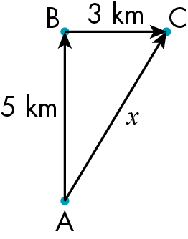  x² = 5² + 3² = 34  x =  = 5.8309519 | x = 5.8 km | B1  M1  M1  M1  A1 | 2 | B1 for use of a correct diagram  M1 for explanation of how and why using Pythagoras’ theorem  M1 for correct application of Pythagoras’ theorem  M1 for correct method of finding hypotenuse  A1 for correct rounding to 2 or 3 sf | M
 |  |  | 5

65 | 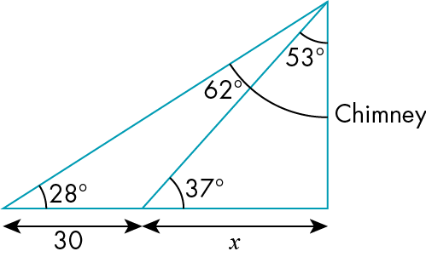  Let c = the height of the chimney  = tan 53°  x = c tan 53°  = tan 62°  30 + x = c tan 62°  x = c tan 62° – 30  Combining equations to eliminate x:  c tan 53° = c tan 62° – 30  Rearrange to get c on one side of the equation  30 = c tan 62° – c tan 53°  30 = c (tan 62° – tan 53°)  c = 30/(tan 62° – tan 53°)  = 54.182761 m | 54.2 m | B1  M1  A1  M1  A1  M1  M1  A1 | 2 | B1 for clear correct diagram used  M1 for correct use of trig with x, c and angle 53° or 37°  A1 for correct equation having x as subject  M1 for correct use of trig with x, c and angle 62° or 28°  A1 for correct equation in format to combine with first equation  M1 for correctly eliminating x  M1 for correct equation with c as subject  A1 for correct answer rounding to 2 or 3 sf | M
 |  |  | 8
66 a  b  c |  | It is always true  If you include the option of 1 × 1 × a then you can build a cuboid for any number of cubes.  You can only make one cuboid for a prime number of cubes because this is the only option as the only factors of a prime number are 1 and itself  You can make more than one cuboid if the individual number of cubes has more than 3 factors not including itself  E.g. 30 (factors 1, 2, 3 and 5) | B1  B1  B1  B1  B1 | 2  3 | B1 for always true  B1 for clear explanation  B1 for clear explanation using primes  B1 for clear explanation for when more than 1 cuboid could be made  B1 for use of examples to illustrate the explanations | M
 |  |  | 5
67 a  b  c |  | Yes  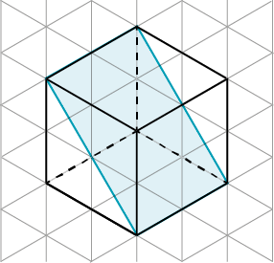  Yes  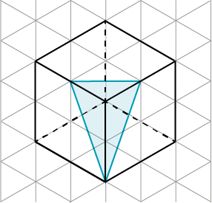  Yes  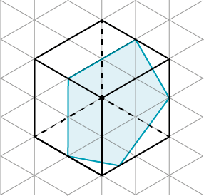  Yes  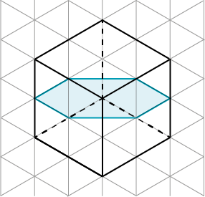 | B1  B1  B1  B1  B1  B1  B1  B1 | 2 | B1 for yes  B1 for clear diagram or explanation  B1 for yes  B1 for clear diagram or explanation  B1 for yes  B1 for clear diagram or explanation  B1 for yes  B1 for clear diagram or explanation | M
 |  |  | 8
68 | If cuboid has dimensions x, y and t  The surface area = 2(xy + xt + yt)  Volume = xyt  Double the lengths gives dimensions as 2x, 2y and 2t  So surface area = 2( 2x × 2y + 2x × 2t + 2y × 2t)  = 2(4xy + 4xt + 4yt)  = 8(xy + xt + yt)  Which is 4 times the first area  And V = 2x × 2y × 2t  = 8xyt  which is 8 times the first volume. | False | B1  M1  M1  M1  B1  B1  B1  B1 | 2 | B1 for false  M1 for surface area with either specific lengths or a generalisation  M1 for volume with either specific lengths or a generalisation  M1 for showing correct follow through of double the lengths  M1 for a correct statement of surface area with their data  B1 for 4 times area  B1 for a correct statement of volume with their data  B1 for 8 times volume | H
 |  |  | 8

69 | 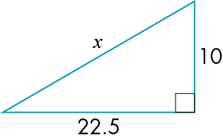  Consider just half the shape, where x is a length of string.  Use Pythagoras  x² = 10² + 22.5² = 606.25  x =  = 24.622145  Two lengths of string will be 49.244289 cm  Subtract the original 45 cm  Gives extension as 4.244289 | 4.2 cm | M1  M1  M1  A1  A1  A1 | 2 | M1 for clear diagram  M1 for correct statement using Pythagoras’ theroem  M1 for correct method of applying Pythagoras  A1 for full answer  A1 for double the initial x  A1 for rounded answer of either 2 or 3 sf | H
 |  |  | 6
70 | Let AC = x, the new length of road.  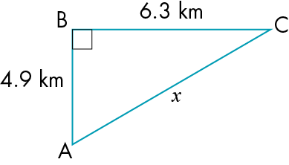  Using Pythagoras  x² = 4.9² + 6.3² = 63.7  x =  = 7.981228  Current distance = 4.9 + 6.3 = 11.2 km  Saving = 11.2 – 7.981228  = 3.218772 km | 3.22 km | M1  M1  M1  A1  B1  M1  A1 | 2 | M1 for use of a diagram to assist the explanation  M1 for clear statement of Pythagoras’ theorem  M1 for correctly applying Pythagoras’ theorem  A1 for full answer  B1 for 11.2  M1 for subtracting lengths  A1 for correct rounding to 2 or 3 sf | H
 |  |  | 7

71 |  | Yes  ϴ = sin^{–1} = 53.13  = 53º to the nearest degree.  = 50° to 1 sf  12 cm has range of 11.5 cm to 12.5 cm  15 cm has range of 14.5 cm to 15.5 cm  Smallest ratio for sine is  sin^{–1} 0.7419, ϴ = 47.9°  Largest ration for sine is  sin^{–1} 0.8621, ϴ = 59.5°  So there are values that round to 12 cm and 15 cm which will give an angle that rounds to 50°. | B1  M1  M1  B1  B1 | 2 | B1 for yes  M1 for showing that using trig and rounding can give 50°  M1 for showing the ranges of lengths of the sides  B1 for showing the least possible value of the angle given the ranges.  B1 for final summary explaining that it is possible | H
 |  |  | 5
72 | AB² = 2² – 1²  = 4 – 1 = 3  AB = | cm | M1  A1  M1 | 2 | M1 for correct statement of Pythagoras theorem  A1 for 3  M1 for a clear communication of the method used | H
 |  |  | 3
73 | 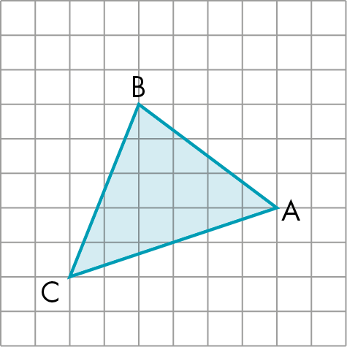 |  | B1  B1 | 2 | B1 for correct diagram  B1 for correct vector | H
 |  |  | 2
74 |  | No  To work out the return vector, multiply each component by –1  The return vector is | B1  B1  B1 | 2 | B1 for no  B1 for a clear explanation of what Joel should have done.  B1 for correct vector | H
 |  |  | 3

