AQA A-Level Physics Year 1 and AS

Student Book Answers

Chapter 1: Measuring the Universe

Assignment 1

**A1** The diameter of the drop is about 0.6 mm, so the radius is about 0.3 mm. That makes the volume of the drop =  = 0.11 × 10–9 m3 = 1.1 × 10–10 m3 to 2 s.f.

**A2** The diameter of the oil film is about 24 cm, so the radius = 12 cm; area = π*r*2 = 0.045 m3

**A3** Volume of oil film = π*r*2 × thickness = 0.045 m3 × thickness. This must equal the volume of the drop, so thickness =  = 2.4 × 10–9 m

**A4** 2.4 × 10–10 m

**A5** Assumed that the chain of 10 molecules is straight and oriented at right angles to the surface of the oil.

Assignment 2

**A1** Students’ own answers. But typically 50–60% in oil drop volume, 20–30% in area. Total uncertainty as much as 90–100%.

**A2** A bigger tray and a bigger drop would reduce the percentage uncertainty. Find a better way of measuring the area of the film, perhaps by doing the experiment in a transparent tray on graph paper. Find a more accurate method to determine the diameter of the oil drop. Level the tray using a spirit level.

Assignment 3

**A1** (Time for one oscillation)2 /s2 (on the *y*-axis) versus Length of pendulum /m (on the *x*-axis).

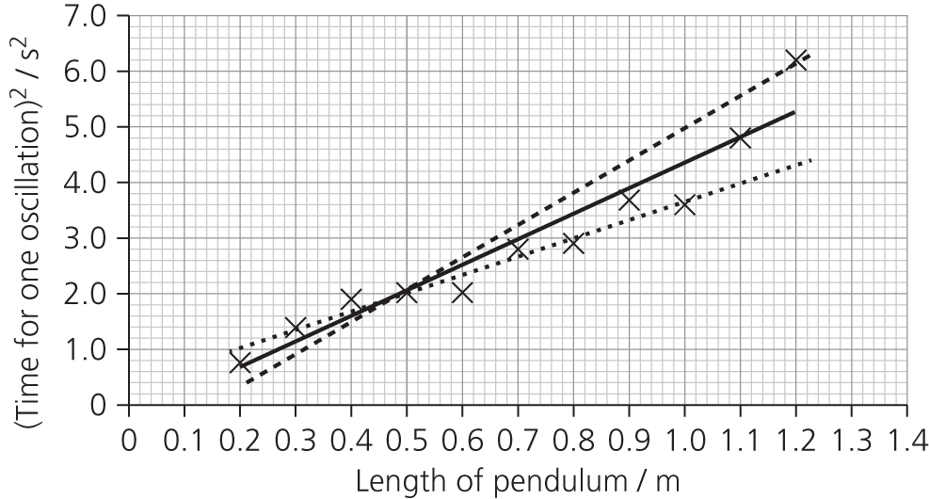

**A2** Gradient of best-fit (solid) line is about 4.6 ± 1.5. Two possible ‘worst’ case lines (dotted) are shown.

**A3**  so  so  gives *g* a value of 8.6 ± 2.9

**A4** Uncertainty of about 30%. We might expect better precision than this. Looking at the graph, the results do not fall on a straight line. Some readings should be repeated.

**A5** Result is accurate in that the accepted value falls within the range of possible answers.

Assignment 4

**A1** Estimate the volume of a shopping bag, approximately 10 litres = 10 × 10–3 m3.

Assume a Jelly Baby is a cylinder about 4 cm long and 1.0 cm diameter.

The volume of a cylinder = π*r*2*h* = 3 × (0.5 × 10–2)2 × 4 × 10–2 = approximately 3 × 10–6 m3.

If the whole volume was full of Jelly Babies, the number of Jelly Babies would equal 10 × 10–3 m3 divided by 3 × 10–6 m3 = 3300 Jelly Babies. But assume a packing fraction of about 0.5, which would give about 1600 Jelly Babies. I happen to know that there are 40 Jelly Babies in a 225 g bag, so 40 of those bags in a carrier bag seems about right!

**A2** How many households are there in the country? (approximately 25 million)

How many mobile phones are there per household? (say 2)

What is the power used by a phone charger? (1 watt, if it is the type that gets warm even when the phone is not plugged in)

Assume the worst case, that the chargers are on 24 hours a day. (0.024 kWh)

So 25 000 000 × 2 × 0.024 = 1.2 million kWh, which sounds a lot. but this represents about 20 minutes’ energy output from just one coal-fired power station (admittedly the largest, Drax power station output ≈ 4 GW).

A kettle is about 2 kW, on for 5 minutes, uses 2/12 kWh.

So the energy to bring 1 million kettles of water to the boil is 166 000 kWh.

The power saved is easily enough to boil 1 million kettles; in fact it could boil 7 million kettles.

But if we use our kettles 5 times a day, that is 5 × 365 × 25 000 000 = 4500 million such boilings a year.

**A3** Assume that the Titanic was a rectangular solid, 250 metres long, by 30 metres wide by 30 metres high, so about 225 000 m3.

The volume of a teaspoon is 5 ml = 5 × 10–6 m3.

225 000/(5 × 10–6) = 4.5 × 1010 teaspoons.

How many teaspoons could you bail in a minute? Say 10.

At that rate, it would take you 85 000 years. Better get some help or a bigger spoon!

**A4** Suppose each household only buys one 1 litre bottle of water per week.

25 million households × 1 bottle per week × 52 weeks.

Mass of a bottle is approximately 50 g.

Total mass approximately 52 × 50 × 25 000 000 g = 65 000 tonnes.

**A5** Students’ own estimations.

PRACTICE QUESTIONS

**1a.** Use a micrometer. Measure the thickness of a large number of sheets (say 100, which makes the working easier!), then divide your measurement by the number of sheets (100).

**1b.** Micrometer will usually measure to the nearest 1/100 mm, that is an uncertainty of ±0.01 mm. But we can divide this by the number of sheets (100), so the uncertainty in the measurement for 1 sheet is approximately equal to 0.1 µm.

**1c.** Measure the length and breadth of one sheet with a ruler. Calculate the area. Find the mass of a large number of sheets (say 100), divide by the number of sheets (100). Divide mass by area.

**2a.** .

**2b.** Systematic. It affects all readings in the same way.

**2c.** Even if the systematic error is ignored, the reaction time of a manual time keeper will be ±0.1 s at best. So time should be written as 12.7 ± 0.1 s.

**3a.** The temperatures all need to be written to the correct number of significant figures. Include units in the column headings.

**3b.**

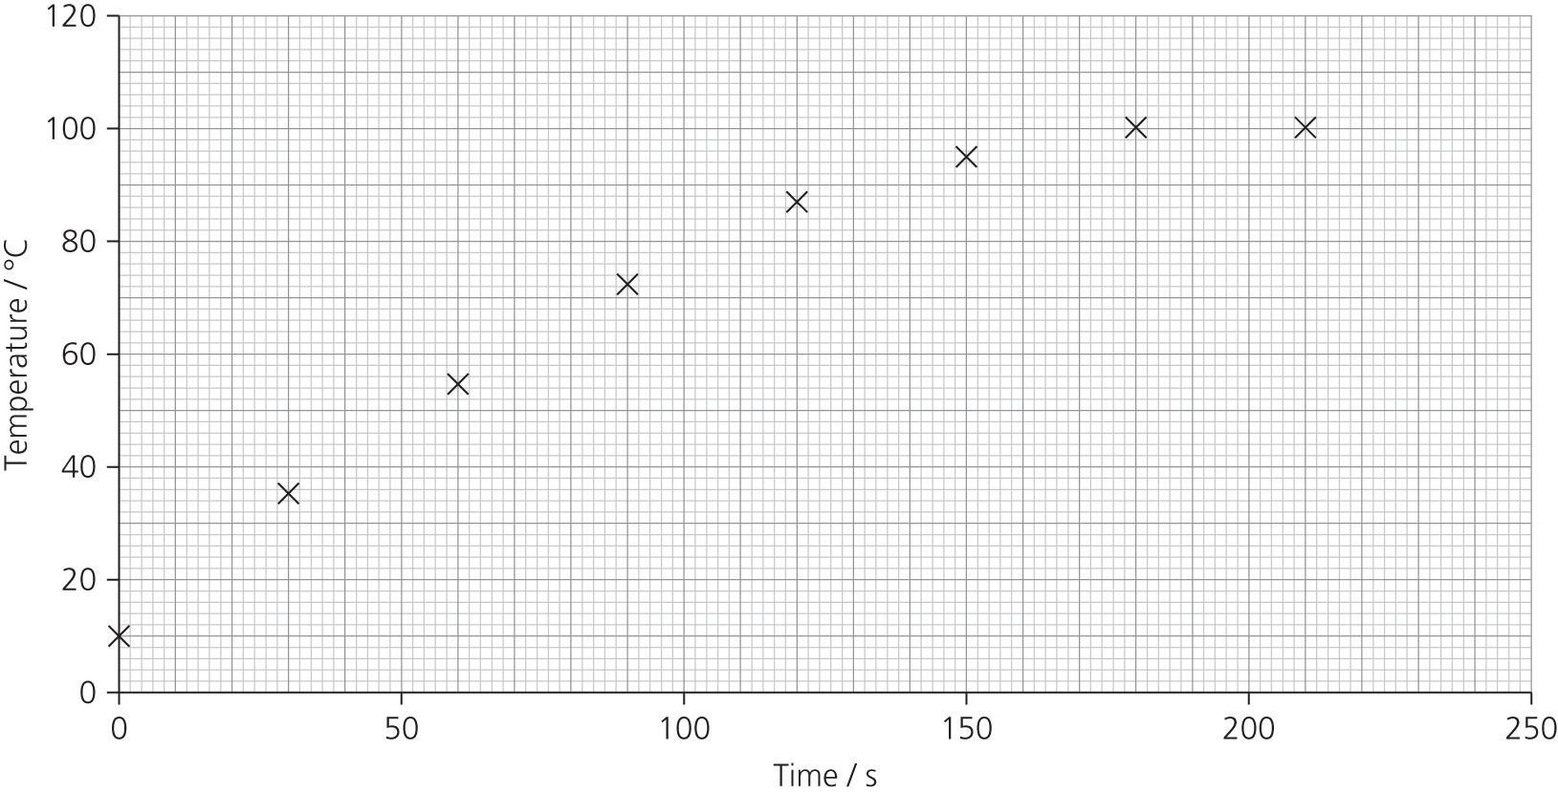

**3c.** The highest rate of temperature increase is at the start of the heating. The gradient is approximately 25/30 = 0.83 °C s–1.

**3d.** If the energy is supplied at a constant rate, the temperature will rise more quickly at first as heat losses are less. When the water reaches boiling point, the temperature no longer rises and the energy is used to change the state from water to steam.

**4.** C

**5.** A

**6.** C

**7.** C

**8.** D

**9.** B

**10.** D

**11.** C

**12.** A (or C)

**13.** D

**14.** B

**15.** A

**16.** B

**17.** B

**18.** D

Chapter 2: Inside the atom

Assignment 1

**A1** Thomson used a magnet to deflect the rays. The rays caused the glass to fluoresce (later versions used fluorescent coatings to enhance the effect). The rays were detected by an electrometer, a device that can detect charge.

**A2** Thomson thought these ‘rays’ were discrete charged particles, as opposed to waves or aether disturbances, which was largely the view taken by German physicists.

**A3** The rays are easily stopped by air. This suggests they have low momentum, perhaps due to low mass?

**A4** A larger deflection indicates a larger electric force. If the electric force is proportional to the potential, it suggests that the charge on the ‘rays’ is constant.

**A5** The early Crookes tube apparatus could not achieve a high vacuum. It took time for the technology to improve. Vacuum pumps were developed that could attain lower pressures, allowing beams of electrons to pass unimpeded down the tube.

Assignment 2

**A1** The cathode rays (electrons) follow a parabolic path when a potential difference is applied across the plates. This is because the electron is subject to a constant force acting in the same direction, rather like a projectile travelling under gravity.

When a magnetic field (alone) is applied, the rays (electrons) follow a circular path. The force always acts at right angles to the electron’s velocity, changing its direction but not its speed (see Book 2 Chapter 7).

**A2** The potential difference used to accelerate the electrons down the tube. The air pressure in the tube.

**A3** Students to compare their own value with the accepted value of *e*/*m* of 1.76 × 1011 C kg−1.

**A4** The experiment could use higher resolution meters for current and voltage. A larger deflection would have lower percentage uncertainty so a longer tube or larger deflecting voltage could be used. A finer beam would help; this needs careful shaping of the anode and focusing magnets.

PRACTICE QUESTIONS

**1a.i.** Nucleon number is the total number of protons and neutrons in the nucleus (also known as the mass number).

Proton number is the number of protons in the nucleus (also known as the atomic number).

**1a**.**ii** 14 – 6 = 8

**1a**.**iii**. Specific charge =  = 4.1 × 107 C kg–1

**1b.i.** Isotopes are forms of an element whose atoms have the same proton/atomic number but a different nucleon number (OR simply atoms with the same number of protons, but a different number of neutrons).

**1b.ii.** 4.8 × 107 =  = 

*A* =  = 12

Number of neutrons = 12 – 6 = 6

**2a.** Protons = 20; neutrons = 28; electrons = 20 – 2 =18

**2b.** +2 × 1.6 × 10–19 = +3.2 × 10–19 C

**2c.** Specific charge =  =  = +4.0 × 106 C kg–1 (3.991 × 106)

(Note: if the electrons’ mass is omitted this can be stated, with the justification that it is negligible. In this question omitting the mass of the electrons would have given the answer:

 = = +3.992 × 106 C kg–1, a difference of approximately 0.1%.)

**3a.** They have a different number of neutrons (and hence different mass). An atom of tritium has two neutrons in its nucleus, whilst an atom of deuterium has one.

**3b.** They have the same number of protons (and the same number of electrons). Both atoms are chemically identical to hydrogen.

**4a.** 88 protons and therefore 88 electrons; 226 – 88 = 138 neutrons.

**4b.** Ionising radiation has sufficient energy to remove/knock off electrons from atoms (and could therefore cause a gas, air for example, to become conducting).

**4c. **(or α)

**5.** Alpha particles have only a short range in air, typically around 5 cm. Alpha particles cannot penetrate very far into the body as they are stopped by the skin. It is easier for a gas to get into the body accidentally. Alpha radiation is much more dangerous inside the body, where all of the energy is transferred to living cells, such as those in the lining of the lungs. There is a link between high radon levels and lung cancer.

**6.** Place the alpha source some distance from a detector (spark counter, electroscope, GM tube, nuclear film). Increase the distance until there is no measured effect.

**7a.** Gamma radiation is more penetrating but less ionising. Rutherford’s detector was not sensitive enough.

**7b.** Use of a magnetic field, or electric field, to deflect the charges. They would deflect in opposite directions.

**7c.** Use different sources and find the charge/mass ratio of the particles emitted by each. Ideally, you might repeat Thomson’s experiment, but for alpha particles, rather than electrons.

**7d.** Rutherford had the composition right: an alpha particle is a helium ion, but it has not picked up two positive charges or lost two negatives. It never had any. The alpha particle is emitted from the nucleus of a radioisotope. However, Rutherford wrote this in 1908 and his experiments, which led to the concept of the nucleus, took place in 1910.

**8.** Points to include:

* Using a source and detector.
* Different thicknesses/types of absorber OR a magnetic field.
* Logical method, that is, less radiation with paper in place, therefore alpha present, etc.
* Might mention background radiation correction.
* Ionising radiation: keep as far away as possible from the source; keep the source in a lead-lined box (in a secure cupboard) when not in use; handle with long-handled tongs (to avoid contamination and increase the distance); work as quickly as possible.

**9.** D

**10.** B

**11.** B

**12.** A

**13.** C

**14.** D

**15a.** Students to plot *r*3 against *A.* The gradient will be *r*03. Students to give the maximum and minimum values of this for possible lines through their points, and indicate that the uncertainty in *r*0from this data is ⅓ the uncertainty in *r*03.

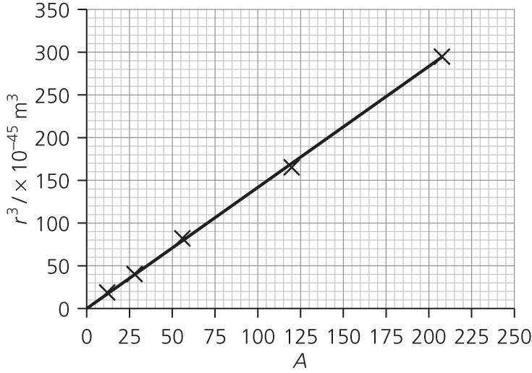

Gradient gives *r*0 = 1.12 × 10–15 m (cf. accepted value of around 1.25 fm.)

**15b.** Density = 

When *A* = 1, *r* = *r*0, so density of 1 nucleon =  = 2.0 × 1017 kg m–3 to 2 s.f.

This is an estimate of the maximum density of nuclear matter.

Assumptions are that the nuclei are spherical and that the nucleons are packed together with no spaces.

Chapter 3: Antimatter and neutrinos

Assignment 1

Students’ own work.

Assignment 2

Students’ own work.

PRACTICE QUESTIONS

**1a.** A correct example of particle, e.g. electron, and a correct example of its corresponding antiparticle, e.g. positron.

**1b.** Correct difference, e.g. opposite charge/other named quantum number.

**2a.** The energy of a gamma ray photon is used to create a particle–antiparticle pair. The gamma ray interacts with matter/named particle (e.g. electron) in such a way as to conserve momentum.

**2b.** The energy of a photon depends on frequency; if energy/frequency is below a certain value there is not enough energy to provide mass/rest energy of particles.

**2c.** Any two of: charge, lepton number, baryon number, strangeness.

**3a.** 4.20 MeV

**3b.** 4.20 – 4.04 = 0.16 MeV or 0.16 × 106 × 1.6 × 10–19 J = 2.56 × 10–14 J

**3c.** Given that there is a certain amount of energy available for a beta decay, it was not clear why the beta particle could be emitted with a range of energies. Where does the rest of the energy go when a beta particle is emitted with a low energy? There was a similar problem with momentum. Beta decay appeared to contravene energy and momentum conservation.

Pauli proposed that beta emission is always accompanied by the emission of a second particle whose energy and momentum add to those of the beta particle so as to conserve the total energy and the total momentum.

**4.** A

**5.** D

**6.** C

**7.** B

**8.** D

**9.** C

**10a.** The positrons are emitted as the nuclei of the radioactive tracer decay, a spontaneous process that is unaffected by being inside the body.

**10b.** When a positron is emitted , it will meet an electron and the two particles annihilate each other, emitting two gamma rays.

**10c.** The colours show the intensity of gamma radiation emanating from that region, and hence the number of positron emissions (and therefore radiotracer concentration) at that point.

**10d.** Students’ own work.

Chapter 4: The standard model

Assignment 1

**A1** Leptons are fundamental particles and not subject to the strong force. Hadrons are not fundamental and do experience the strong nuclear force.

**A2** The electron is lighter than the muon, which is lighter than the tau lepton

**A3**

|  |  |  |  |
| --- | --- | --- | --- |
| **Leptons** | | **Quarks** | |
| Electron | Electron neutrino | Up | Down |
| Muon | Muon neutrino | Charm | Strange |
| Tau lepton | Tau neutrino | Top | Bottom |

**A4** Column 1 are all fundamental particles with the same charge.

Column 2 are all neutrinos; they are all uncharged and only subject to the weak force.

Column 3 are all quarks with the charge of +2/3.

Column 4 are all quarks with charge of –1/3.

**A5** The meson was made of one bottom quark and one anti-bottom quark, so the total bottom = 0.

**A6** In some ways a neutron has ‘hidden charge’ – it carries three charged quarks whose total charge is zero. A meson made of a strange and an anti-strange quark,  would have no explicit strangeness.

**A7**

|  |  |  |  |  |
| --- | --- | --- | --- | --- |
| **Lepton** | **Charge *Q*** | **Electron lepton number** | **Muon lepton number** | **Tau lepton number** |
| Electron | –1 | 1 | 0 | 0 |
| Electron neutrino | 0 | 1 | 0 | 0 |
| Muon | –1 | 0 | 1 | 0 |
| Muon neutrino | 0 | 0 | 1 | 0 |
| Tau lepton | –1 | 0 | 0 | 1 |
| Tau neutrino | 0 | 0 | 0 | 1 |

**A8** There are 6 quarks (and 6 antiquarks). These form 3 families, each with a quark of charge +2/3 and one of charge –1/3. There are other conserved quantities, such as charm, which are associated with the quarks. There are 3 corresponding lepton families, each with a particle that carries the electron charge and a neutrino.

Assignment 2

Students’ own answers.

PRACTICE QUESTIONS

**1a.i.** Any two baryons, e.g. proton, neutron.

**1a.ii.** 

**1b.i.** Contains a strange quark, or longer lifetime than expected, or decays by weak interaction.

**1b.ii**. The second equation is not possible because lepton number is not conserved.

**1c.i.** Weak interaction

**1c.ii.** For charge conservation, charge on right-hand side is –1 + +1 = 0.

**1c.iii.** X must be a baryon, because the baryon number on right-hand side is +1 and this must be conserved.

**1c.iv.** The proton, p.

**2a.i.** Three OR qqq or 

**2a.ii.** Mesons

**2a.iii.** Two from: experience the strong interaction; made up of quarks OR not fundamental; (eventually) decay to a proton.

**2b.**

|  |  |
| --- | --- |
| **Interaction** | **Exchange particle** |
| electromagnetic | (virtual) photon OR γ |
| weak | W+ or W– or Z0 |

**2c.i.**

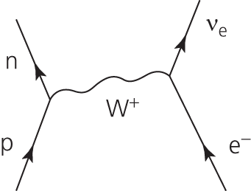

**2c.ii.** Lepton number must be conserved. The electron lepton number is equal to +1 before the decay (LHS) and so the RHS must also equal 1 (an anti-neutrino has *L*e = –1).

**3.** Mention electromagnetic interaction (for particles that are charged).

Give correct examples of both types of particle.

Both hadrons and leptons interact through weak interaction.

Both hadrons and leptons have rest mass.

Give correct quark structure of mesons (quark and anti-quark) and baryons (3 quarks).

**4.** A; a boson is a force-carrying particle, the others are matter particles.

**5.** C; uuu has charge = 2/3 + 2/3 + 2/3 = 6/3 = 2

**6.** C; a tau particle has a mass of 3500 × electron mass, heavier than a proton.

**7.** B

**8.** B

**9.** B

**10.a.** Einstein showed that mass and energy are inter-convertible, so there is no contradiction here.

**10b.i.** Forbidden. Strangeness is not conserved.

**10b.ii.** Forbidden. Baryon number is not conserved.

**10b.iii.** Possible.

**10c.** Students’ own work, but could include:

**i.** Nuclear energy as an example of mass → energy

**ii.** Charge flow round a circuit (as in Kirchhoff’s first law)

**iii.** Radioactive decay (beta decay)

**10d.** Probably not. It is not universal, as some interactions mediated by the weak force are not bound by this conservation law.

Chapter 5: Waves

Assignment 1

**A1** The height of the ripples gets less (i.e. the amplitude of the ripples decreases). The energy in a single ripple is spread out over a larger circle as the ripple grows. The amplitude of the wave, and the energy (per unit length of the ripple) decreases continuously, unless the wave hits an object and transfers some of its energy to that. Some energy is transferred to the water as the wave travels across the surface.

**A2** The Ripple-o-meter measures energy per unit length. This will decrease with distance from the centre of the disturbance. The ripple spreads out in a circle, and since the circumference of a circle is 2π*r*, twice the radius means twice the circumference. For the same energy, a ripple twice as far from the centre of the disturbance, which has twice the length, must have one half as much energy per unit length. Placing the Ripple-o-meter at distances *r*, 2*r*, 3*r* and so on would give readings in inverse proportion.

**A3** The waves do not spread out at all. The waves could have been formed from a point source that is far away, so that the waves appear straight rather than curved, or the waves could have been created by an extended source (a line) rather than a point. The energy from these waves does not spread out – if the waves were perfectly straight and parallel, and no energy was transferred to the medium, the waves would keep going forever. A light beam like this could be formed with a lens or mirror; a suitably designed loudspeaker can do a similar job for sound.

**A4a.** The energy received by the meter, *E*ripple, is just a fraction of the whole energy *E*. If the Ripple-o-meter has length *L*, it will receive ** of the total energy.

**

So, if *E* is a constant, ** is proportional to **.

**A4b.** Plot **(the Ripple-o-meter reading) against **. A straight line would indicate that part **a** is correct.

**A4c.** The gradient of the graph in part **b** is equal to **, since:

** = ** × **

(*y*-axis) (gradient) (*x*-axis)

**A4d.** That the energy in the ripple spreads out uniformly in all directions. (Radiation which is the same in all directions is known as **isotropic)**.

That the wave doesn’t lose any energy as it passes through the medium.

**A4e.** Light from a star spreads out in all directions in three dimensions. The energy is spread out over the surface of a sphere, rather than a circle as in the case of the ripple. For a point source, the energy (per unit area, known as intensity) reduces as 1/*r*2.

**A5a.** For plane waves (parallel wave fronts) the energy per unit length of the waves *E*ripple/*L* does not diminish with distance from the source: it is a constant (provided the wave doesn’t transfer energy as it passes through the medium).

**A5b.** Straight, non-diminishing waves could only be produced from a source of infinite length. In reality the ‘straight-line waves’ would be spreading out from a source that was extended finitely in one direction, for example a fluorescent tube strip lamp in the case of light, or a motorway as an extended source of sound. The waves would spread out, but in the shape of a cylinder rather than a sphere, and the energy per unit area would diminish with distance as the cylinder got larger. (The area of the curved face of a cylinder is equal to the circumference of the base × the height, that is the length of the source. As you go further away from the source along a radius, the energy that that you receive per second will reduce as 1/*r*.)

Assignment 2

**A1** Time of the P–S interval = *t*PS = 36 s

Speed of P-waves =7500 m s–1; speed of S-waves = 4000 m s–1.

Using distance = speed × time:

for P-wave *d* = *v*P × *t*P

for S-wave *d* = *v*S × (*t*P + *t*PS)

These are equal: *v*P × *t*P= *v*S × (*t*P + *t*PS)

Rearranging gives: *t*P = ** = 41 s

*d* = *t*P × *v*P = 41 × 7500 = 310 km

**A2** One reading tells you how far away from the epicentre you are (as in **A1**), but this gives no information on direction. The epicentre could be anywhere on the circumference of a circle, of radius 310 km in this case.

A second reading from a different location generates another circle, and gives two possible answers, i.e. the points where the circles intersect. A reading from a third location identifies the correct intersection.

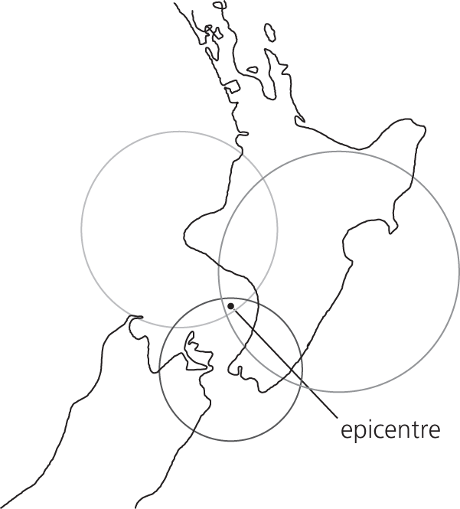

**A3** The amplitude is about 180 mm. A line from 310 km to 180 mm gives about 6.3 on the Richter scale.

**A4** The amplitude will decrease as the distance from the epicentre increases. (The energy in the wave spreads out. Energy will also be absorbed as the wave travels through the Earth.)

**A5**a.

|  |  |
| --- | --- |
| **Value on the Richter scale** | **Maximum amplitude of S-wave / mm** |
| 2 | 0.1 |
| 3 | 1 |
| 4 | 10 |
| 5 | 100 |

**A5b.**

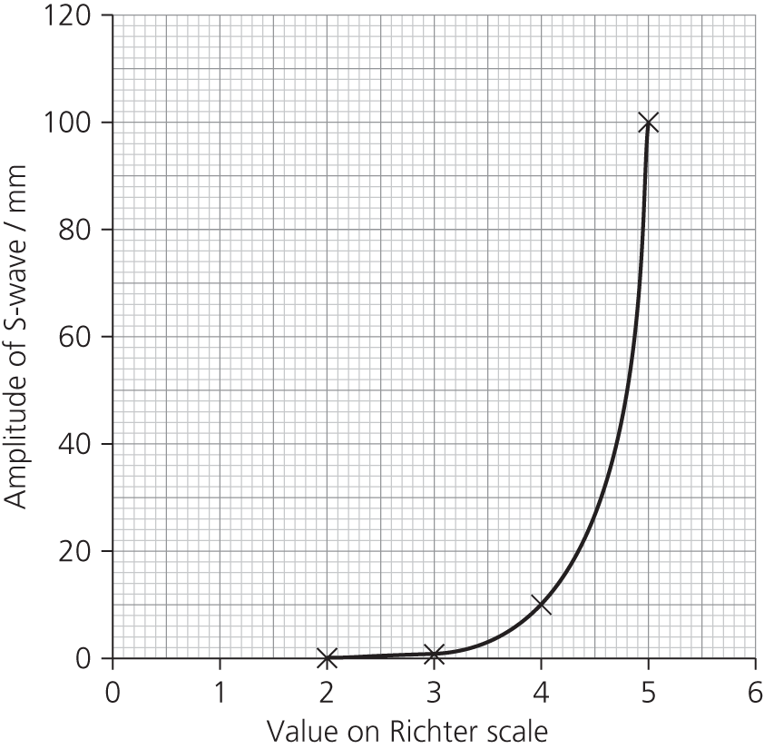

**A5c.** The graph is exponential. Equal increments (for each value on the Richter scale) on the *x*-axis correspond to a factor of 10 increase in the amplitude of the S-wave.

A value of 6 on the Richter scale corresponds to an amplitude of 1000 mm

Assignment 3

Students’ own work.

Assignment 4

**A1** The precision of the method is likely to be lower than that suggested by the records. Although stopwatches usually display time in hundredths of a second, this does not mean that any results will have an uncertainty of ± 0.01 s. The reaction time of the human timekeeper will add further uncertainty, usually estimated as 0.1 s, which, in the example above, would give a percentage uncertainty of 0.1/12, or about 1%.

Bethan’s times are about 0.3 s shorter than the others. This seems likely to be a systematic error; Beth wasn't listening to the instructions properly. She probably started her stopwatch on hearing the sound from the gun, but the sound (approximate speed equals 330 m s–1) took 100 m/330 m s–1 = 0.3 s to reach her. This is a significant, systematic error.

Omit Bethan’s times and find the mean of the rest: first place: 12.21 s, second place: 13.33 s

Uncertainty from the reading error on the stopwatch could be estimated at 0.1 s. (Though in practice, trained timekeepers achieve better than this.) The variation in the readings is 12.25 – 12.17 = 0.08 s, an uncertainty of ± 0.04 s, so an estimate of between ± 0.05 s and 0.1 s seems reasonable. The result to be written at the corresponding level of precision, for example:

first place 12.2 ± 0.1 s, second place 13.3 ± 0.1 s.

To improve the method, some sort of electronic timing is required. The electronic timer should start when the starting gun is fired and stop, perhaps using a light switch or a pressure switch, when each runner crosses the finishing line.

**A2a.** If distance *D* has an uncertainty of ±*d*, the echo distance 2*D* has an uncertainty of ±2*d* so the percentage uncertainty in the distance measurement is unchanged. But with double the distance, the time doubles too. If the uncertainty is ±0.1 s, then the percentage uncertainty is halved. Since the uncertainty in time is the main factor, this will almost halve the uncertainty in the answer.

**A2b.** Ideally you need a short sharp sound, perhaps clapping your hands or bashing two pieces of wood together. If you can synchronise your claps with the returning echo, and time say ten claps, you effectively increase the distance and therefore the time of the measurement. Timing even more claps would increase the precision; repeating would increase the accuracy.

**A3** There is likely to be background noise and echoes which will confuse the signal. Students should keep as quiet as possible.

It is difficult to know which part of the pulses to measure. A short, sharp pulse of sound is needed.

**A4a.** So that the sound wave is confined to moving up, and back down the tube, producing a stationary wave. To cut out echoes from walls, etc. which might confuse the issue.

**A4b.** Measure the period of a wave from the oscilloscope (it will improve your precision if you use the whole screen, even if that is several waves). Use the relationship *f* = 1/*T* to *c*alculate frequency from this; it will probably be more accurate than the scale on the signal generator.

Remember that the distance between adjacent nodes is **half** a wavelength. Measure the wavelength as accurately as you can, by measuring the distance between several nodes.

Calculate the speed of sound using speed = *f* × *λ*.

**A5** The length *l* is found for a range of different frequencies, *f*.

The equation for the speed of sound is speed= *fλ*. Taking account of the end correction, *c*, speed = 4*f*(*l* + *c*).

Giving the speed of sound the symbol *v* and rearranging this into the form *y* = *mx* + *c* (for a straight-line graph) gives:

**

Plotting 1/*f* on the *y*-axis and *l* on the *x-*axis gives a straight line with gradient equal to 4/*v*. Find the gradient and calculate *v*. The intercept on the *y*-axis is 4c/*v*,from which the end correction *c* can be calculated. Drawing a best fit and a ‘worst’ fit gradient will allow you to estimate the uncertainty in your value of *v*.

REQUIRED PRACTICAl QUESTIONS

**P1** A stationary wave will only occur when an exact number of half wavelengths will fit on the string. This will happen when length equals *λ*/2, *λ*, 3*λ*/2, etc.

**P2a.** This is the third harmonic, as there are 3/2 wavelengths on the string.

**P2b.** The string will also vibrate strongly at 25 Hz (first harmonic, one-half of a wavelength on the string), 50 Hz (second harmonic, one wavelength on the string), 100 Hz (fourth harmonic, two wavelengths on the string), etc.

**P3** The markers will help you to locate the centre of each node. It may be helpful to place a marker on each side of the string. This can help to reduce parallax errors if you view along the line of the two pins, keeping the node in the centre on the same line of sight.

**P4** When the vibration transducer produces large amplitude oscillations, it may excite higher harmonics in the string but (more likely) it may also excite oscillations in the string below the pulley which could interfere with your measurement, making it more difficult to pinpoint the correct frequency of the standing wave.

**P5** If the stroboscope flashes each time the string reaches the same position, the string appears to be motionless. This is the same effect which makes car wheels appear to be stationary in the movies. The stroboscope may be flashing at the same rate as the oscillations, or only half as frequently (or other submultiple of the frequency).

**P6** For each value of tension, the frequency of the first few harmonics can be found. For example:

|  |  |  |
| --- | --- | --- |
| **Harmonic** | **Frequency / Hz** | **Multiple of frequency** |
| First harmonic | 25 | *f* |
| Second harmonic | 51 | 2*f* |
| Third harmonic | 73 | 3*f* |
| Fourth harmonic | 100 | 4*f* |
| Total | 249 | 10*f* |

Average value of *f* is 24.9 Hz.

**P7** Velocity = frequency × wavelength. Frequencies are given as in question P6 and wavelengths from doubling the distance between two nodes on the stationary wave.

PRACTICE QUESTIONS

**1a.i.** π/2 (radians) or 90° (degrees)

**1a.ii.** 3π/2 (rad) or 270° (degrees)

**1b.** Particles oscillateperpendicular to the direction of wave (travel / velocity / energy transfer).

Particles at B oscillate from equilibrium to maximum positive displacement, back to equilibrium, then to maximum negative displacement, and back to equilibrium / starting position / rest position.

**1c.** The wave is transverse OR not longitudinal. Only transverse can be polarised OR longitudinal waves cannot be polarised OR oscillations are in one plane.

**1d.i.** Number of waves / complete cycles / wavelengths (passing a point / produced) per second .

**1d.ii.** *v* = *f/λ*, so *λ* = *v/f*; *λ* = ** = 750 m

**2a.** The maximum displacement (of the wave or medium) from the equilibrium (or rest or undisturbed or mean) position.

**2b.** Knot moves vertically downwards (¼ cycle to maximum negative displacement), then upwards (¼ cycle to equilibrium position and ¼ cycle to maximum positive displacement), then down (¼ cycle) to equilibrium position/ zero displacement. Correct reference to either maximum positive or negative displacement or correct reference to fractions of the cycle required.

**2c.** A stationary wave is formed by superposition or interference (of two progressive waves). The knot is at a node / the waves (always) cancel where the knot is.

**3a.** Oscillates / vibrates (or goes up and down / side to side, etc., repeatedly /continuously, etc.) about equilibrium position / perpendicularly to central line.

**3b.i.** Approximately 150° degrees or 5π/6 radians out of phase

**3b.ii.** Approximately 330° or 30°or π/6 radians out of phase

**3c.i.** *v* = *fλ* = 780 ×  OR 780 × 0.16 OR 780 × ******OR 780 × 160 = 125 m s–1 (to 3 s.f.)

**3c.ii.** Time taken is ¼ cycle. *T* =  OR *T* = 1.28 × 10–3 s

So time taken = 0.25 × 1.28 × 10–3 = 3.2 × 10–4 s

Alternatively, use distance of 0.04 m travelled by progressive wave in ¼ cycle divided by speed:

** = 3.2 × 10–4 s

**3d.i.** Antinode

**3d.ii.** 2 × 0.24 = 0.48 m

**3d.iii.** *f* = *v/λ* = 124.8 OR **= 260 Hz

**4.**

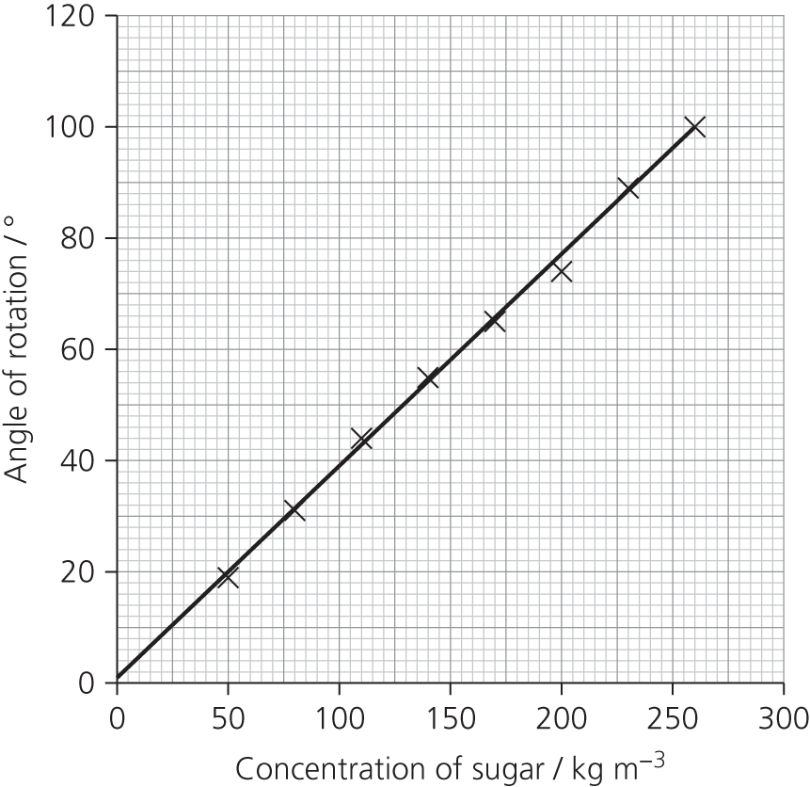

**4b.** Gradient = 0.380 (° kg–1 m2). From the equation *q* = *acl*, the gradient is *al*. If *l* = 0.20 m, then *a* =1.9 ° kg–1 m2

**5.** A

**6.** C

**7.** D

**8.** C

**9.** C

**10.** A

**11a.** Capillary waves (ripples) are transverse. Internal waves are transverse (amplitude given in metres, rather than a pressure or density change). Seismic P-waves are longitudinal waves (referred to as compression waves).

**11b.**

|  |  |  |  |
| --- | --- | --- | --- |
| **Type of wave** | **Velocity / m s–1** | **Wavelength / m** | **Frequency / Hz** |
| Surface | 20 (values vary with wind speed, wavelength and depth of water) | 20 | 1 |
| Capillary waves | > 0.231 | < 0.017 | > 13.5 |
| Internal | of the order of 0.1 | about 10 (variable) | about 0.01 (variable) |
| Seismic P | about 7000 | 700–7000 | 1–10 |

Chapter 6: Diffraction and interference

Assignment 1

**A1** Reducing the wavelength creates interference fringes that are closer together.

**A2** Moving the sources close together (reducing *s*) moves fringes further apart.

**A3a**. 7.5 cm.

**A3b**. Look at the whiteboard through the slits in the hand-held stroboscope. If you spin the stroboscope at the correct speed, the wave’s motion will freeze on the board and you will be able to measure the wavelength.

**A4** High frequency means shorter wavelength and the quiet patches get closer together.

**A5** You need to measure the distance between the speakers (*s*), the distance from a point between the speakers to the line of the sound level meter (*D*) (see Figure A3), the frequency of the sound, and the distance between loud or quiet patches.

You can reduce the percentage uncertainty by increasing the magnitude of the reading relative to the resolution of the instrument. In this experiment you could increase the fringe separation by putting the speakers closer together and moving the sound level meter/microphone further away. Measure the distance between as many fringes as possible, and then divide as appropriate to find the mean.

**A6** *λ* = ** = 0.333 m; *c* = *fλ* =1000 × 0.333 = 333 m s–1

**A7** These are the main points:

* Use microwave transmitter to illuminate the two slits.
* Use the receiver to detect the interference maxima and minima.
* Measure the distance between maxima, *w*, and the slit to screen distance, *D*, and the slit separation, *s*.
* Calculate wavelength *λ* =**.

Assignment 2

**A1**

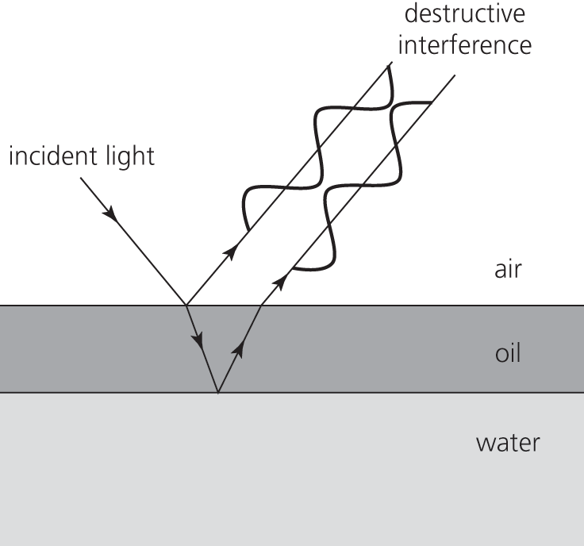

When light is incident on the oil, it is partially reflected. The transmitted wave is refracted in the oil, and is partially reflected at the oil–water interface. The two reflected waves now have a path difference between them. If this difference is equal to an odd number of half wavelengths, the two waves will destructively interfere. At different angles and/or different thicknesses of oil, the path difference will be greater or smaller, destructive interference will occur for different wavelengths. For example, blue light might destructively interfere while red light constructively interferes and green light partially constructively interferes. The resultant colour would be seen as orange.

(The situation is slightly more complex. Light will travel at a different speed in the oil, which will affect the number of wavelengths in the oil film and hence the path difference. There is also a phase change of 180° when light is reflected at an interface with a higher refractive index.)

REQUIRED PRACTICAl QUESTIONS

**P1** In radians, *s*/*r* = *θ*, *s* = 3 km, *r* = 400 000 km, *θ* = 3/400 000 = 7.5 × 10–6 rad. In degrees this is 4.3 × 10–4 °.

**P2** There is no blink or aversion response because you can’t see the beam. It will also have a heating effect on your eye.

**P3** To avoid bright (specular) reflections which could damage someone’s eyesight.

**P4a.** 630 nm

**P4b.** Assume that the distance, *D*, is measured with a ruler to the nearest millimetre, *w* is measured with vernier callipers to the nearest 0.1 mm and *s* is measured with the travelling microscope to the nearest 0.01 mm. That gives percentage uncertainties of:

± = 0.05% in *D*

± = 2% in *w*

±  = 4% in *s*

This gives a total uncertainty in the measurement of the wavelength = 0.05 + 2 + 4 = 6%.

**P4c.** The uncertainty in the measurement of fringe separation could be reduced by measuring 10 fringes and dividing by 10. The largest uncertainty is in the measurement of slit separation.

**P5a.**

|  |  |  |  |  |
| --- | --- | --- | --- | --- |
| ***n*** | ***x* / m** | **tan *θ*** | ***θ*** | **sin *θ*** |
| 0 | 0.00 | 0.00 | 0.0 | 0.00 |
| 1 | 0.20 | 0.07 | 4.0 | 0.07 |
| 2 | 0.40 | 0.13 | 7.5 | 0.13 |
| 3 | 0.60 | 0.20 | 11.5 | 0.20 |
| 4 | 0.77 | 0.26 | 14.5 | 0.25 |
| 5 | 1.03 | 0.34 | 19.3 | 0.33 |
| 6 | 1.20 | 0.40 | 21.7 | 0.37 |

**P5b.**

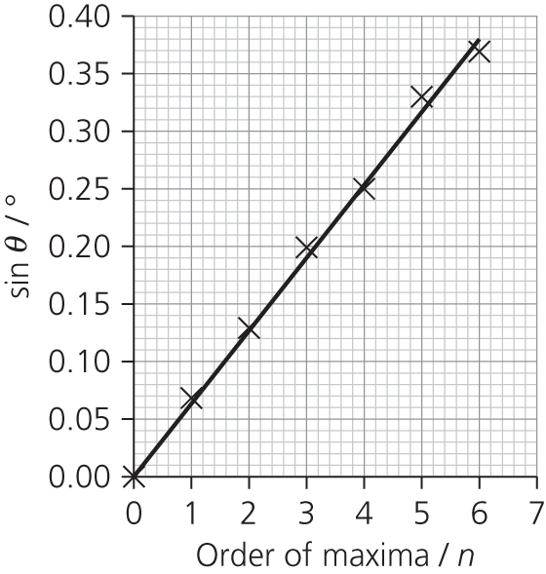

**P5c.** Gradient = sin *θ*/*n* = 0.0633 = *λ*/*d*

*d* = 1.0 × 10–5m; *λ* = 633 nm

**P5d.** Very accurate! Agrees with the accepted result to within 1 nm (better than 0.2%), though the uncertainties in measurement and in calculating the gradient mean that the range of possible results for the practical measurement is at least ± 6%.

**P6** sin *θ* would be greater than 1, which is not possible.

PRACTICE QUESTIONS

**1a.** Single frequency (or wavelength or photon energy).

**1b.** Subsidiary maxima (centre of) peaks further away from centre.

Subsidiary maxima peaks further away from centre AND central maximum twice width of subsidiaries AND

symmetrical.

**1c.** One from:

* don’t shine towards a person
* avoid (accidental) reflections
* wear laser safety goggles
* use a ‘laser on’ warning light outside room
* stand behind laser
* other sensible suggestion
* because eye / skin damage could occur.

**1d.** Points to make:

* central white (fringe)
* each/every/all subsidiary maxima are composed of a spectrum (clearly stated or implied)
* each/every/all subsidiary maxima are composed of a spectrum (clearly stated or implied) AND (subsidiary maxima) have violet (allow blue) nearest central maximum OR red furthest from centre
* fringe spacing less / maxima are wider / dark fringes are smaller (or not present).

**2a.** Same wavelength/frequency with constant phase relationship or constant phase difference.

**2b.i.** *c = fλ*

3.00×108 = (9.4× 109)*λ*

*λ* = (3.00×108)/(9.4×109)

= 3.2×10**–**2 m (2 s.f.)

**2b.ii.** 3.2×10–2 m (one wavelength)

**2c**. Maximum (at position shown)

Constructive interference / reinforcement

The waves meet ‘in step’ / peak meets peak / trough meets trough / path difference is (*n*)*λ* / in phase

**2d.** *s* = *λD/w* = (0.0319×0.42)/0.11 = 0.12 m

**2e**. A maximum; doubling the frequency *f* results in microwaves with wavelength *λ*/2; path difference is an even number of multiples of the new wavelength (2*nλ*new).

**3a**. Central white maximum shown; two equally spaced first-order maxima; central and one first-order labelled correctly; indication of spectra/colours in at least one first-order beam, labelled with violet (indigo or blue) closest to the centre or red furthest away.

**3b**. Dark/black lines/bands or absorption spectrum or Fraunhofer lines (reveal the) composition (of the star’s atmosphere) / atoms or elements in the star.

OR the peak of intensity (is related to) the temperature

OR Doppler (blue or red) shift indicates (speed of) rotation or speed of star (relative to Earth).

**3c.i.** Grating and screen shown with both labelled; laser or laser beam labelled.

**3c.ii.** Procedure:

* use of (*n*)*λ* = *d* sin *θ*
* measure appropriate angle (e.g. ‘to first-order beam’)
* method to measure angle (e.g. tan *θ* = *x*/*D*, spectrometer/protractor)
* explain how *d* is calculated (e.g. *d* = 1/ lines per mm (× 103))

At least one way of improving accuracy/reliability:

* measure between more than one order (e.g. 2*θ*)
* measure *θ* for different orders (for average *λ*, not average angle)
* check or repeat/repeat for different distances (*D*)
* use of spectrometer
* use large distance to screen (*D*)
* protractor with scale intervals of 0.5° (or less)
* graphical method: plot sin *θ* against *n* (gradient = *λ*/*d*).

**4a.** The microphone will detect a series of loud and quiet regions along the line ABC, with a loud region at B.

**4b.** At B, the sound waves have travelled an equal distance, i.e. the path difference is zero between them, and so they arrive in phase with each other. The waves constructively interfere and reinforce each other, giving a loud region. This also happens where the path difference between the waves is a whole number of wavelengths.

At points where the path difference between the waves is half a wavelength, (or an odd number of half wavelengths) the waves will be completely out of phase with each other (there will be a phase difference of 180º or π radians) and the waves will cancel each other out. A quiet region will be observed.

**4c.** At higher frequency, the waves have a shorter wavelength. This means that the distance between loud regions (or between quiet regions) will be shorter.

**4d.** The formula to use is *λ* = *ws*/*D*. *λ* can be found from *c* = *fλ*, *λ* = 340/680 = 0.5 m.   
This gives *w* = *Dλ/s* = 3 × 0.5/1 = 1.5 m between loud regions. So there will be half this distance between B and the first quiet region, giving an answer *BD* =0.75 m.

**5a.** There would be a white central maximum with several spectra on each side of the central maximum, with the violet/blue end of the spectrum closest to the centre. The central maxima is white since all wavelengths arrive at this point in phase; here the path difference of all the waves from each slit is zero. The first diffraction maximum will appear when the path difference for that particular wavelength is equal to *λ*. Wavelength *λ* is shorter for violet light, so this maximum appears first.

(Or consider *nλ* = *d* sin *θ*, sin *θ* = *nλ*/*d*: sin *θ* is smallest for lowest value of *λ*.)

**5b.** Using the diffraction grating equation *nλ* = *d* sin *θ*, gives sin *θ* = *nλ*/*d*.

*d* = 1/number of lines per metre = 1/300 000, and since *n* = 1, this gives:

sin *θ* = 589 × 10−9 × 300 000

= 0.1767

⇒ *θ* = 10.1776º

= 10.2° (to 3 s.f.)

**5c.** The maximum value that *θ* can have is 90°; this means that sin *θ* = 1. This gives *n* = *d*/*λ*. *n* = 5.66, so that there are 5 maxima visible on each side of the central (*n* = 0) maxima. This is a total of 11 maxima.

**5d.** Using *λ* = 589.59 nm gives *θ* = 10.1879°, only 0.01° difference! You would need to use a much finer diffraction grating, for example, 1.5 × 106 lines per m gives an angular separation of just over 0.1°.

**6.** C

**7.** B

**8.** D

**9.** C

**10.** A (1 each side and the central maxima)

**11.** A

**12a.i.** A central white maxima with subsidiary maxima on either side. The subsidiary maxima are split into the spectrum of wavelengths (colours) contained in the white light.

**12a.ii.** Light waves which pass through different slits have a path difference. When this path difference is equal to an integral number of wavelengths, the waves interfere constructively and an interference maximum is formed. The path difference depends on the viewing angle, so different wavelengths (colours) can be seen at different angles.

**12a.iii.** The reflected rays have a path difference, see Figure Q7, which will lead to interference effects.

**12a.iv.** Path difference is affected by viewing angle; at different angles, different wavelengths will interfere constructively.

**12b.** In simple terms, the path difference between waves obliquely reflected from adjacent grooves is approximately 2 × 200 nm, so there will be constructive interference in the blue region of the spectrum. (This is not the full picture because the apparent colour of the butterfly is not dependent on the angle from which it is viewed which would be the case if it was solely caused by the ridges acting as a reflection diffraction grating. Our current understanding of the process is not fully complete as can be found in the following research paper: <http://www.ncbi.nlm.nih.gov/pmc/articles/PMC1691047/>.)

**12c.** The beams are from the same beam of light, so they are bound to be the same frequency and have a fixed phase relationship. (Some of the wave’s energy is reflected earlier, which introduces a path difference between the beams; the waves will not necessarily have the same amplitude, as this depends on the relative amount of reflection from the two surfaces.)

**12d.** You could check whether the colour varies with viewing angle; if it does, then that suggests that interference is involved.

You could take a feather and crush it to a powder; if it retains its colour, then it is due to pigment.

Chapter 7: Refraction and optical fibres

Assignment 1

**A1**

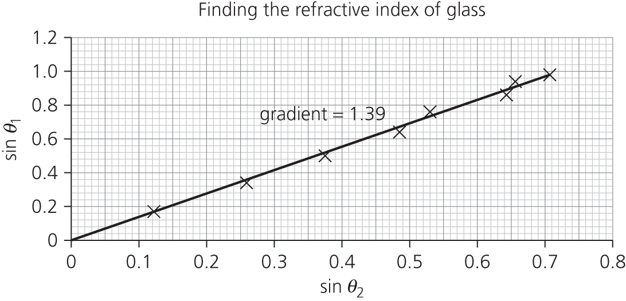

*n* = 1.39

**A2** Measuring the angles precisely is difficult. Errors will arise if the glass block moves even slightly. The width of the beam of light is a problem, especially at large angles of incidence where dispersion splits the white light into its component colours.

**A3** There is an uncertainty of at least ± 1° in the measured angles, probably more than this due to the width of the light beam. You could draw a ‘worst fit’ line to get a second value for gradient which would give you an estimate of the uncertainty in the refractive index.

**A4** Using a narrower beam of light, possibly a laser, would help. A monochromatic light source would avoid the problems of dispersion.

**A5** The main problem with this experiment is that there are multiple refractions. If you put a glass block in a tank of water, with the ray box outside, the light will refract as it passes from air to glass, glass to water, etc. One way around this is to use a circular tank of water and a semicircular block of glass. The tank and the semicircular block should be concentric. If light is incident along the normal, there will be no change of direction except where the refracted ray leaves the glass.

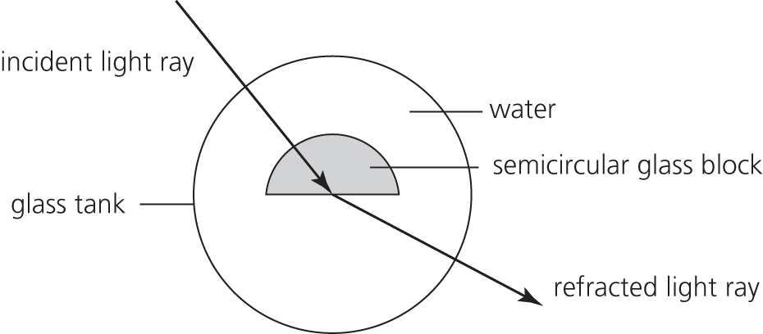

Assignment 2

**A1** *n* = The refractive index of water is 1.33, so the angle of refraction in the drop,  
*θ*2 = sin–1 = 45°

**A2** 45°. Assuming the drop is spherical, the triangle formed by the two radii and the refracted ray is isosceles.

**A3** Critical angle for water–air = sin–1 (1/1.33) = 48.8°. Light is incident on the back of the raindrop at close to the critical angle, so although the reflection is not total, there will be a bright reflected ray.

**A4** 45°

**A5** sin–1 (1.33 sin 45°) = 70°

**A6**

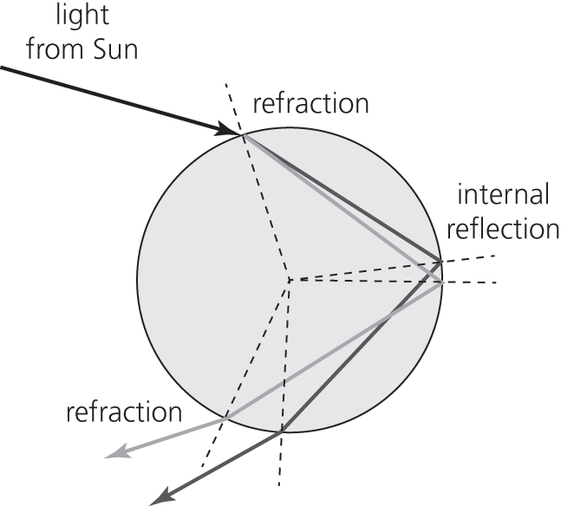

**A7** Each raindrop separates sunlight into the colours of the spectrum as shown in the diagram in A6. Red light appears at a certain angle (42°) to the direction of the Sun; violet light appears at a smaller angle. The other colours of the spectrum appear between these. All points on a coloured band form at the same angle to the Sun and so the rainbow is curved.

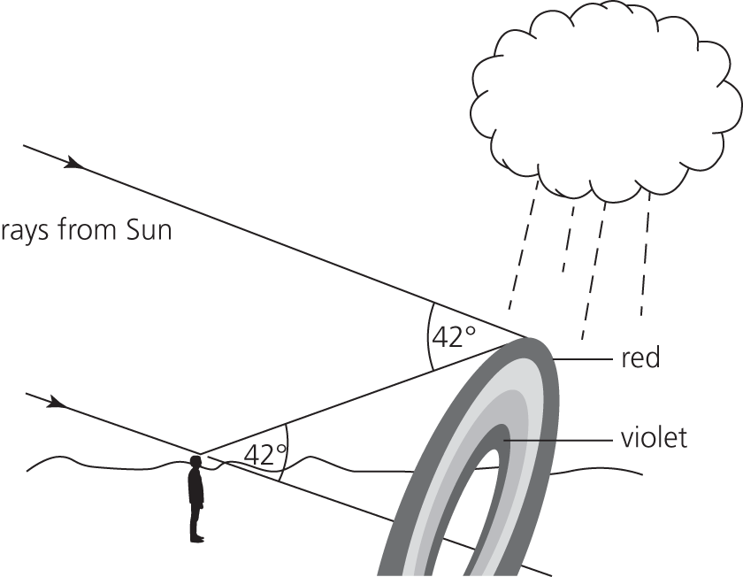

**A8** A secondary rainbow is formed when light from the Sun is refracted by raindrops, and undergoes two internal reflections inside the raindrop. The colours are inverted.

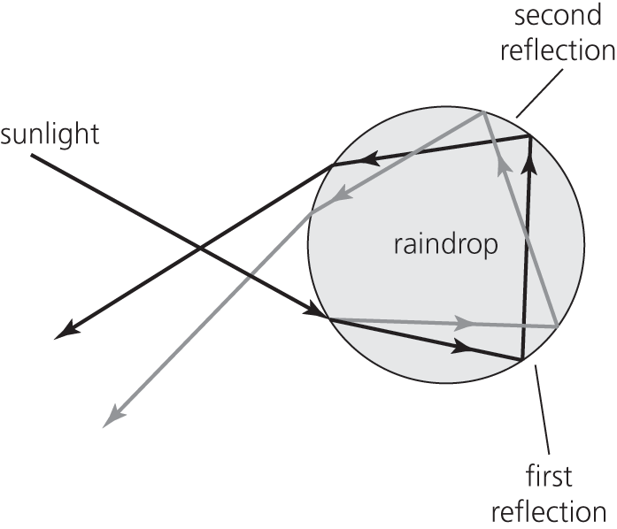

**A9** Raindrop A is the lowest raindrop which can refract blue light into the observer’s eye, after two internal reflections.

Raindrop B is the lowest raindrop which can refract red light into the observer’s eye, after two internal reflections.

Raindrop C is the highest raindrop which can refract red light into the observer’s eye, after one internal reflection.

Raindrop D is The lowest raindrop which can refract blue light into the observer’s eye, after one internal reflection.

In the gap between B and C, any light refracted by raindrops cannot reach the observer’s eye. So this part of the sky appears dark.

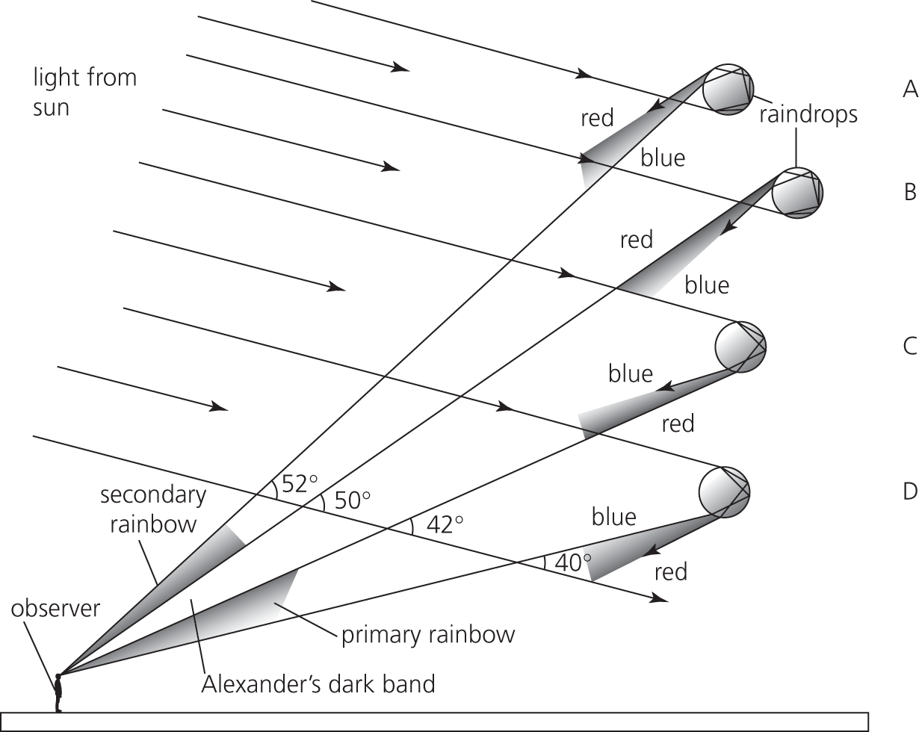

Assignment 3

**A1** 3 = 10 log10(power ratio), so 100.3 = power ratio = 1.9952 to 5 s.f.

3 dB is roughly a doubling of the power. So 2 mW.

**A2** 65 = 10 log10 (2.50 × 10–3/*P*)

Taking inverse logarithms, 106.5 = 2.50 × 10–3/*P* so *P* = 0.79 nW.

**A3** Gain is 60 dB which means *P* = 106 × input power = 30 kW m–2.

**A4** Loss (dB) = 10 log (1/5) = –7 dB which means 7/5 = 1.4 km.

**A5** Graph plotted with trend line and gradient measured.

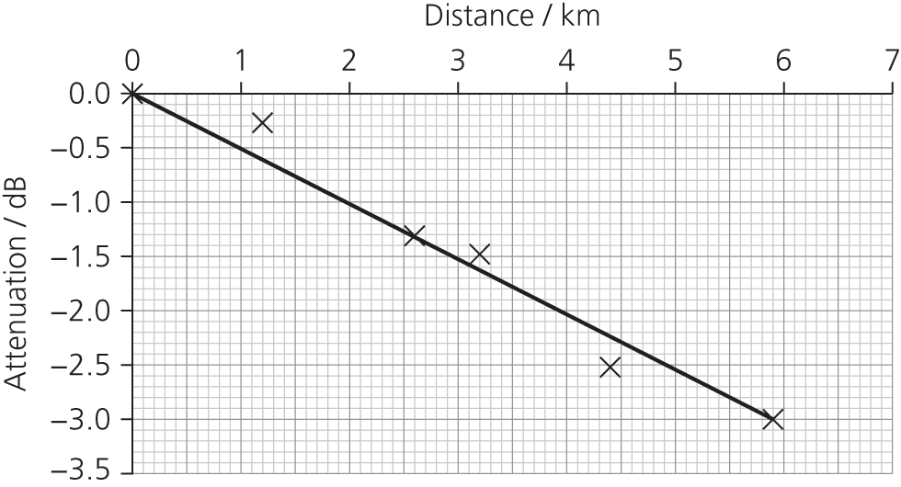

Attenuation coefficient = approximately 0.5 dB per km.

**A6a.** 88–70 = 18 dB or 18 = 10 log (*P*1/*P*2) so the ratio of sound intensities is *P*1/*P*2 =101.8 = 63

**A6b.** Yes (60 – 42 = 18 dB = 63 × the power of the normal voice)

**A6c.** For a ‘normal’ voice the average change is (70 – 42)/(0.3 – 7.3) = 28/(–7) = –4 dB m–1 (and similarly for ‘very loud’ and ‘shouting’).

**A6d.** Using data for normal voice, (ratio of the distances)2 = (0.3/7.3)2 = 1.69 × 10–3.

There is a –28 dB change, which is equal to an intensity ratio given by 10 log (power ratio),

so ratio = 10–2.8 = –1.58 × 10–3.

The suggested relationship could be true as the experimental results agree to within 6% of those calculated. However, further evidence is needed to support or refute the suggested relationship.

**A6e.** The limit of audibility is 0 dB. So at –4 dB per metre, normal voice would be just audible at around 17.5 m, if there were no other noises to confuse matters – which is unlikely.

Assignment 4

**A1** Fibre that has a core diameter great enough to allow different light paths (modes) to travel down it.

**A2** Fibre made with two materials (core and cladding), each with a distinct value of refractive index.

**A3** No. Distances are likely to be small.

**A4** sin *c* = 1.466/1.496 = 0.98, which gives *c* = 78.5°.

**A5** Ratio of longest path to direct path = 1/0.98 = 1.02. So longest path is 1.02 × direct path, which is a path difference of 20 m for every km travelled. This is a time delay of 20 ÷  = 99.7 ns for 1 km.

The percentage uncertainty in the diameter of the core is about 5% (= 3/62.5). If there are no other errors, we would expect the time, and frequency, calculations to also have an uncertainty of 5%.

**A6** Each pulse must have a duration of less than 99.7 ns.

The reciprocal of that gives frequency *f* = 10 megabits per second.

**A7** The data rate is probably sufficient to allow video streaming , providing that there is a dedicated fibre link to each classroom. However, it is probably impractical for each classroom to have an individual link to the server. There is usually a network ‘spine’ to which all the individual classrooms are connected. It would be important for the spine to support higher data transmission rates.

**A8** Graded-index fibre has a refractive index that changes gradually , becoming smaller further from the axis of the fibre. It reduces modal dispersion as the paths that are further from the axis travel quicker.

Assignment 5

**A1** Optical fibres have a much greater signal-carrying capacity (‘bandwidth’). Signal attenuation is less than in electrical signals in metal wires. So less amplification is needed, and fewer ‘booster’ stations are required. It much harder to ‘tap’ an optical fibre than an electrical cable, so there is greater security. Fibres are not prone to external interference from adjacent fibres (‘crosstalk’), they are MUCH lighter, much cheaper per km and much cheaper to install.

Disadvantage: Connecting optical fibres is more difficult than connecting metal wires together.

**A2** The same optical fibre may be used to monitor the temperature at different points, or carry information from several different sensors. This is an obvious advantage in situations where space is limited.

**A3** The sensor can detect strain (temperature, pressure, etc.) at various points along its length, or as an average the entire length of the fibre.

**A4** In a coherent bundle, each fibre carries information about one image point. The more image points, or pixels, there are, the more detailed the image will be. Fine fibres closely packed together will give a high-resolution image. Incoherent bundles just carry light, not image information, and so the fibres can be much thicker.

**A5** Very strong, changing, magnetic fields could induce large potential differences in metallic equipment causing electrical interference in microphones, cables, etc.

**A6** Students’ own answers.

PRACTICE QUESTIONS

**1a.** *n*1 > *n*2 (OR optical density of first medium greater than optical density of second medium)

Angle of incidence > critical angle (*θ*c) (OR critical angle must be exceeded)

**1b**. *c*A = *c*/*n*A = (3.00 × 108)/1.80 = 1.667 × 108 = 1.67 × 108 m s–1

**1c.** sin 72° = 1.80 sin 𝜃

sin *θ* = (sin 72°)/1.80 = 0.52836

*θ* = 31.895° or approx. 32°

**1d.** 1.80 sin 𝜃𝑐 = 1.40

sin 𝜃𝑐 = 1.40/1.80

𝜃𝑐 = 51.058° or approx. 51°

**1e.i.** It is totally internally reflected because the incident angle is 22 + 32 = 54°, which is larger than the critical angle (51°).

**1e.ii.** Reflection at 54° from normal shown.

**2a.** *n* = (sin 14.1°)/(sin 9.54°) = 1.4699 = 1.47 to 3 s.f.

**2b.i.** Ray goes along the boundary and there is partial reflection .

**2b.ii.** 90 – 9.54 = 80.46 or 80.5°

**2b.iii.** *n* = *n*c sin *θ* = 1.47 sin 80.46° = 1.45

**2c.** Two of:

* protect the core (from scratches, stretching or breakage)
* prevent ‘crossover’ of signal / ensure security of data / prevent loss of information/data/signal
* increase the critical angle / reduce pulse broadening/(modal)dispersion / rays with a small angle of incidence will be refracted out of the core
* increase rate of data transfer.

**3a.i.** Cladding

**3aii.** sin *θ*c = 1.41/1.46

*θ*c = 74.96° = approx. 75.0°

**3b.i.** 65°

**3b.ii.** 1.46 sin 65° = 1.41 sin *r*

sin *r* = 0.93845

*r* = 69.79° or approx. 70°

**3c.** Less light is lost, because there is an increased probability of total internal reflection / the incident angle is kept larger than critical angle / less refraction out of the core

OR better quality signal / less distortion, because of improved signal transfer with less multipath dispersion (smearing / overlap of pulses).

**4.** A

**5.** D

**6.** D

**7.** D

**8.** D

**9.** B

**10a.i.** In some optical fibres there are a range of different paths (modes) that light can travel along to get from one end of the fibre to the other. These paths differ in length, and therefore the time taken for light to travel along the fibre depends on its path (mode). A short input pulse of light will spread as its light travels by different modes. This process of ‘spreading out’ in time, is referred to as modal dispersion.

If the pulses spread out too much they would overlap the next pulse and it would be impossible to distinguish adjacent pulses or to decipher the digital code. This puts a limit on how close (in time) the pulses can be. So the frequency of pulses is limited.

**10a.ii.** Time division multiplexing relies on high-speed switching, which requires many pulses per second. Dispersion would limit the pulse frequency and therefore limit the number of time segments (which would mean fewer separate conversations or data streams).

**10b.** The refractive index of glass depends on the frequency of the light wave. In other words, different wavelengths of light travel at different speeds in glass. A pulse of white light would be spread out in time as it travelled down the fibre. This is chromatic or material dispersion.

**10c.i.** Attenuation refers to the loss of signal strength/amplitude (loss of intensity) of a signal as it travels through a medium.

**10c.ii.** Attenuation is due to :

* absorption – energy from the wave is transferred to the medium, e.g. X-rays travelling through lead transfer some of their energy to atomic electrons
* scattering – energy may also be scattered out of the beam, e.g. light from car headlights being scattered by mist.

**10c.iii.** Attenuation will depend on the wavelength of light, so WDM has to operate in wavelength ranges where attenuation is least. TDM uses digital signals, which can be regenerated at intervals by repeaters. The amount of attenuation will determine how far apart the repeaters can be.

**10d.i.** To get a rough estimate of how many pulses of light per second (**bits** of information) we need for high-definition real-time video streaming, we need to know:

* how many bits are needed for each pixel
* how many pixels are needed for each frame (one whole screen image)
* how many frames are shown per second.

The number of bits per pixel determines how many colours can be shown in the pixel. Modern systems use 24 bits per pixel, which allows 224 – more than 16 million – different colours. High-definition (HD) screens have 1920 (horizontal) × 1080 (vertical) pixels. HD TV typically uses 60 frames per second. Therefore the total number of bits required is given by:

24 × 1920 × 1080 × 60 ≈ 3 × 109 bits per second = 3 gigabits per second

For 8 channels, this is 24 gigabits per second.

**10d.ii.** Find the critical angle sin *c* = 1.50/1.60 = 0.9375, which gives *c* = 69.6o.

Ratio of longest path to direct path = 1/0.9375 = 1.066. So longest path is 1.066 × direct path.

That is a difference between paths of 66 m for every km travelled. This is a time delay of 66 ÷  = 352 ns

Each pulse must have a duration of less than 352 ns. The reciprocal of that gives frequency *f* = 2.84 megabits per seconds (for a distance of 1 km). This optical cable is not capable of carrying the data rate of the signal.

**10d.iii.** In practice the required rate will be lower because not all information from each frame needs to be transmitted: not all parts of the picture change from one frame to the next.

Chapter 8: Spectra, photons and wave–particle duality

Assignment 1

**A1a.** Mercury and sodium vapour lamps (line spectra arise from low-pressure gases).

**A1b.** All the other sources – they are all hot solids (like the filament in an incandescent light bulb) or hot gases (candle flame, Bunsen flame), which leads to continuous spectra.

**A1c.** The atoms in a low-pressure gas are sufficiently far apart so that they do not affect each other. Their electrons occupy discrete energy levels. Line spectra are the result of electron transitions between these levels.

The atoms in a hot solid, such as a tungsten filament in a light bulb, are much closer together and interactions between them cause the energy levels in the atoms to be widened into bands. There are many more allowed transitions and the emitted wavelengths overlap and form a continuous spectrum.

Bunsen and candle flames are hot gases at relatively high pressure (compared with discharge lamps). The heat causes some ionisation of atoms and molecules with associated electron transitions and release of photons. The high pressure means that atoms interact with one another, leading to continuous spectra.

**A2a.** The incandescent light tends to have more yellow/red in its spectrum. The spectrum from a fluorescent light has peaks (that are dependent on the phosphor that is used to coat the tube); it is not a fully continuous spectrum like natural daylight. The light from an LED is continuous and particularly bright in the mid-wavelength region (green) (dependent on the semiconductor used).

**A2b.** Incandescent (gives a ‘warmer’ light).

**A2c.** LED (bright ‘natural’ light)

**A2d.** LED or fluorescent

**A3** The source of A is a mercury vapour lamp. It is a line spectrum, made by a low pressure gas. The colours identify the gas to be mercury vapour.

The source of B is a candle. (It could be a filament lamp.) It is a continuous spectrum.

The sources of C are different LEDs. The spectra have almost all frequencies but some are faint while others are intense.

The source of D is a (compact) fluorescent lamp. The spectrum has distinct intense colours but not as thin lines.

The source of E is a (tungsten) filament lamp. (It could be a flame.)

Assignment 2

Students’ own leaflets.

Assignment 3

**A1** Gradient = *h/e* = Δ*y*/Δ*x* ≈ (3 – 0)/(12 – 4.5) × 1014 Hz) = 0.4 × 10–14 V s

So *h* = 0.4 × 10–14 × 1.6 × 10–19 = 6.4 × 10–34 J s

**A2** Intercept ≈ 1.7 V = *ϕ*/*e* so *ϕ* = 1.7 eV or 1.7 × 1.6 × 10–19 = 2.7 × 10–19 J

**A3** A straight line, parallel to the original graph, but with an intercept that is more negative.

Assignment 4

**A1** A vacuum allows electrons to pass across the tube to be collected. Without a vacuum there would be no photocurrent. Lenard’s apparatus was therefore more sensitive. The bright light enabled Lenard to test whether more energy would be given to the electrons.

**A2** Lenard may not have wished to contradict his own earlier work, his supervisor’s view, or the established national view. He would have had to be very sure of his results and quite courageous. It is important that all results are published, even (perhaps especially) ones which do not support the author’s or the consensus view. Experiments which show no effect (null results) can also be important. If the results are published, the scientific community can assess their importance, and attempt to replicate them if possible.

**A3** The kinetic energy of the emitted electrons depends on the frequency of the incident light. Wave theory predicts that the brightness of the light should cause this effect.

Photoemission happens immediately when the surface of the metal is illuminated. Wave theory suggests that a dim light could eventually dislodge electrons.

The existence of a threshold frequency, below which no photoemission occurs. Wave theory predicts that it is the intensity (brightness) of light which is crucial, not the frequency.

**A4** An ad hoc explanation is one that is proposed for a specific case, after the event. After his photoelectric experiment, Lenard suggested the triggering hypothesis to explain his results, but it is not clear that the explanation could be applied more widely or be used to predict the outcome of any further experiments. A theory should make novel predictions, so that it can be tested.

**A5** The wave theory was long established and supported by a lot of experimental evidence. The photon theory did not explain interference or diffraction. This has led to the idea of wave–particle duality, uncomfortable for many physicists, e.g. Sir William Bragg: “On Mondays, Wednesdays, and Fridays we use the wave theory; on Tuesdays, Thursdays, and Saturdays we think in streams of flying energy quanta or corpuscles.”

Accepting the photon theory also meant that probabilistic processes had to be taken into account, for example that it is impossible to say when an electron will fall from a higher level to a lower energy level; all one can do is calculate the probability that the transition will occur in a given time.

**A6** Wave theory had been established for 100 years. All the established figures in physics had grown up with it. Wave theory had been very successful in explaining interference, diffraction, etc. The photon theory is unable to explain the phenomena of interference. Whereas two waves can add together to make no wave, it is hard to conceive of two particles adding together to make no particle.

**A7** The Compton effect is the inelastic scattering of X-rays by electrons. The scattered X-ray changes its frequency as it imparts some of its energy to the electron. If X-rays were really waves, one would expect the amplitude of the X-ray to reduce, rather than its frequency.

Assignment 5

**A1** Caution with high voltage, ensure use of insulated connectors, turn off when not in use.

**A2** It is polycrystalline. (The pattern is similar to the pattern you would get from lots of two-dimensional grids overlaid at different angles.)

**A3** Measure the ring diameter with vernier callipers (± 0.1 mm). Measure in several different orientations and find the mean. It can be difficult to gauge the exact position of ring. Dimming the lights in the lab may improve visibility. Use a digital HT voltmeter.

**A4** Electrons must have a wave nature since they can be diffracted.

**A5** Increasing the tube voltage means that the electrons have higher momentum, and therefore a smaller de Broglie wavelength. Smaller wavelength means less diffraction, so the rings will be closer together.

PRACTICE QUESTIONS

**1a.** The answer could include a coherent account of the significance of threshold frequency and how this supports the particle nature of electromagnetic waves:

* the threshold frequency is the minimum frequency of incident light for emission of electrons
* if the frequency is below the threshold frequency, there is no emission even if the intensity is increased
* wave theory cannot explain this, as the energy of a wave increases with intensity
* if light travels as photons, there will only be emission of electrons if the energy of the photon is equal to or greater than the work function of the surface
* if photon energy is proportional to the light frequency, this explains the threshold frequency
* with incident light of frequency above the threshold, there is no time delay in emission; this cannot be explained by wave theory, but can if light travels as photos which are discrete packets of energy, and one photon releases one electron.

**1b.i.** *E*k = ½*mv*2 = ½ × 6.6 × 10–27 × *v*2 = 9.6 × 10–13 J

*v* =  = 1.7 × 107 m s–1

**1b.ii.** *p* = *mv* = 6.6 × 10–27 × 1.7 × 107

*p* = 1.1 × 10–19 kg m s–1 (or N s)

**1b.iii.** *λ* = *h*/*mv* = *h/p* = 

*λ* = 6.0 × 10–15 m

**2a.i.** The incident electron has sufficient energy to transfer (by collision) the exact amount of energy (10.19 eV) needed to make the transition up to level 2.

**2a.ii.** *E*2 – *E*1 = *hf*

Energy of photon, *E* = –3.41 – (–13.6) = 10.19 eV = 10.19 × 1.6 × 10–19 = 1.63 × 10–18 J

6.63 × 10–34 × *f* = 1.63 ×10–18

*f* = 2.46 × 1015 Hz

**2a.iii.** Kinetic energy after collision = 1.7 × 10–18 – 1.63 × 10–18 = 7.0 × 10–20 J

**2a.iv.** Energy required is 12.09 × 1.6 × 10–19 = 1.93 × 10–18 J

Energy of incident electron is less than this (1.70 × 10–18 J).

**2b.i.** Electrons return to lower levels by different routes/cascade/not straight to ground state.

**2b.ii.** 3; *n* = 3 to *n* = 1, *n* = 3 to *n* = 2, *n* = 2 to *n* = 1

**3a.i.** Minimum energy required to remove electron from the metal (surface).

**3a.ii.** Energy of photon is constant/fixed OR energy given to electron is fixed; energy is required for electron to leave/escape/emit from the surface/metal OR electron has to overcome work function. Maximum kinetic energy is the energy of photon minus the work function; deeper electrons require energy to get to the surface OR have less kinetic energy than surface electrons.

**3a.iii.** *hf* = *ϕ* + *E*k,max

6.63 × 10–34 × *f* = 4.07 × 1.60 × 10–19 + 3.51 × 10–20

*f* = 1.04 × 1015 Hz to 3 s.f.

**3b.** The new theory allows predictions that are tested and evidence obtained by repeatable experiments, which are checked by other scientists/peer reviewed.

**4.** C

**5.** D

**6.** B

**7.** B

**8.** D

**9a.** So that electrons can travel unimpeded across the tube.

**9b.** To ensure a clean surface; to remove any oxide layer.

**9c.** By using filters (which allow a range of wavelengths through) or by creating a spectrum with a diffraction grating; using a slit to select a small wavelength range.

**9d.** The gradient would give him a value for *h/e* and the intercept on the frequency axis is *ϕ/h*. Millikan himself had measured the charge on the electron, *e*.

**9e.** It is unclear why Millikan plotted the graph in this way, but the important aspects of the gradient and the intercept are clear from his work.

It is necessary to imagine that the solid portion of the graph continues from the dotted section.

Gradient = *h/e* =  = 4.26 × 10–15

*h* = 1.6 × 10–19 × 4.26 × 10–15 = 6.82 × 10–34

Intercept on the *x*-axis = *ϕ/h* = 43.9 × 1013 Hz

So *ϕ* = 43.9 × 1013 × 6.82 × 10–34 = 2.99 × 10–19 J or about 1.9 eV.

Chapter 9: The equations of motion

Assignment 1

**A1** Descriptions as follows:

A The pool/snooker ball is travelling with almost constant velocity, so the displacement time graph is close to a straight line, whose gradient represents the velocity.

B After its first collision, the ball moves more slowly, but also at constant velocity.

C The ball reaches its furthest displacement from the start, where it strikes the cushion at the end of the table.

D The gradient, and the velocity, are now negative. The ball is now travelling in the opposite direction.

E The curved line has a negative slope, which is gradually getting steeper. The ball is accelerating in the negative direction, back towards zero displacement.

F The displacement is now negative, the ball has passed beyond its starting point

**A2** The greatest positive velocity is in section A. The velocity is approximately equal to 1.44/0.5 ≈ 3 m s–1.

**A3** The gradient of a tangent to the curve at *t* = 2.0 s is 200/(2.8 – 1.1) = 118 cm s–1.

**A4** The snooker ball is moving faster (accelerating), which is odd as one might expect it to be slowing down. It is likely to be the ball’s spin that is responsible; the extra kinetic energy is coming from the rotational energy of the snooker ball. Alternatively, but unlikely, the table is sloping downwards!

Assignment 2

**A1** and **A2**

*Note that the questions suggests that students add to the table of displacement and time values presented. But in fact separate tables are required because the average velocity occurs part way through the time interval, and similarly with average acceleration.*

**A1**

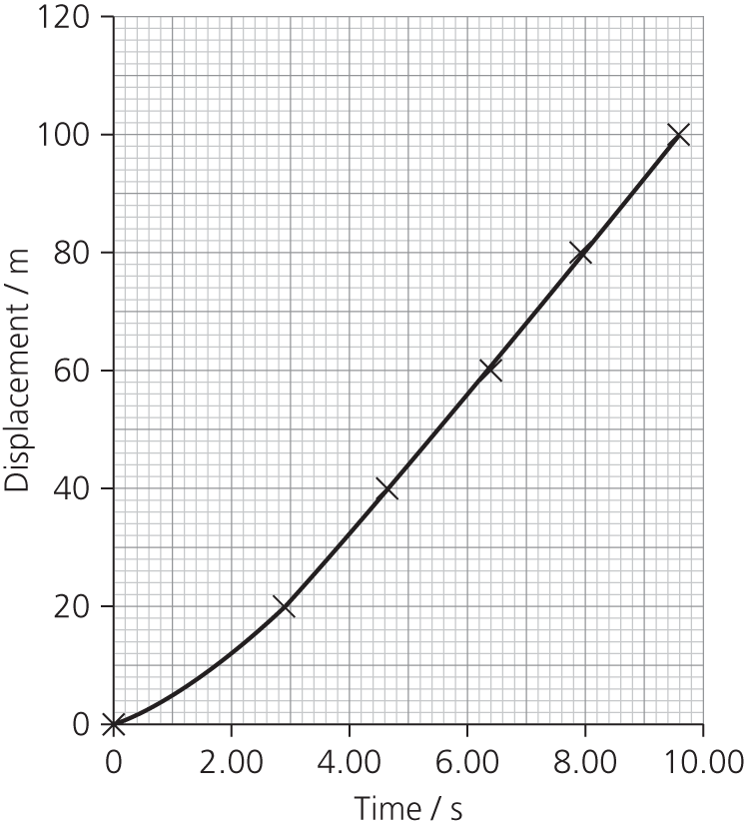

**A2** We assume that the average acceleration is attained half way through each of the time intervals given in the answer to A1. The initial acceleration (at 0 seconds) is unknown but can be determined from the graph.

|  |  |
| --- | --- |
| **Velocity /ms-1** | **Time / s** |
| 0.00 | 0.00 |
| 6.92 | 1.45 |
| 11.43 | 3.77 |
| 11.98 | 5.48 |
| 12.42 | 7.12 |
| 12.05 | 8.75 |

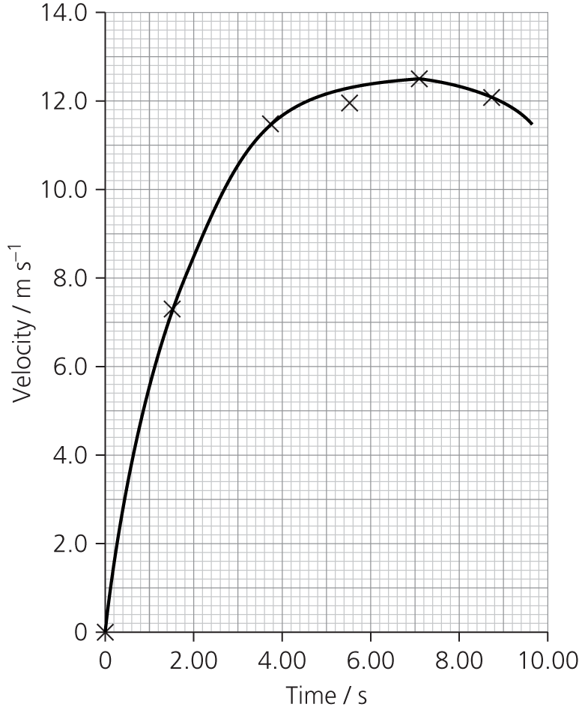

**A3** Distance–time graph:

|  |  |
| --- | --- |
| Acceleration / ms‑2 | Time /s |
| 0.00 | 0.00 |
| 4.79 | 0.72 |
| 1.94 | 2.61 |
| 0.32 | 4.62 |
| 0.27 | 6.30 |
| -0.23 | 7.93 |

**A4** Usain Bolt ran his 100 m race in 9.58 seconds at an average speed of 10.4 ms‑1. He accelerated for the first 7s, reaching a top speed of around 12.5 ms-1. His highest acceleration, 4.8 ms-2 , was during the first two seconds of the race. Remarkably, during the last few seconds of the race, he actually slowed down, but by that time the race was won!

**A5** The highest velocity, around 12.4 m s–1, should be marked at about 7.0 seconds. The highest acceleration, around 6.1 m s–2, should be marked at 0 s.

**A6** Acceleration begins at a maximum and declines steadily until about 4.8 s. After remaining steady for a second or so it then reduces to 0 at about 7.0 seconds. The acceleration then becomes negative but its size remains less than 1 m s–2.

**A7** Maximum acceleration is approximately 6.1 m s–2, but values for the acceleration are estimated averages based on 20 m sections of the race. It is probable that Bolt’s instantaneous acceleration is greater than this at some point.

**A8** Near the end of the race, over the last 30 m or so, Usain Bolt is slowing down slightly. He probably knew that he had won the race by then!

Assignment 3

**A1** A glider on an air track can be a suitable object. Use a piece of card to reflect the ultrasound. A mass on a pulley, or simply inclining the air track, will cause the glider to accelerate at a fairly constant rate although drag will increase with speed. You can reduce drag by keeping both the area of the reflecting card and the glider speeds small. If the glider is released from rest, the motion sensor should plot a graph of displacement against time. Take readings of displacement (*s*) at time *t*, and check they fit the equation *s* = ½ *at2*, preferably by plotting s (on the *y*-axis) against *t*2 (on the *x*-axis). The gradient will give you ½*a* , and so you can find the acceleration.

**A2** *v* = 331 + 0.6 × 20 = 343 m s–1

**A3** If the temperature in the room fluctuated by 5 °C, the velocity of sound could vary by about 3 m s–1 or about 1%. The timing of the pulses is likely to be significantly better than 1%, so the error in distance measurement could be 1 % (that is 1 cm in every metre).

Assignment 4

**A1** The time taken to fall between two markers, a known distance apart. Repeated for ball bearings of different radius.

**A2** Ball bearing radius: micrometer; uncertainty ± 0.01 mm

Distance: ruler (possibly vernier callipers); uncertainty ± 1 mm (or ± 0.1 mm)

Time: stopwatch; uncertainty ± 0.1 s

**A3** Mark several equal distance intervals, check that the time to traverse each interval is constant.

**A4** Parallax errors in judging when ball bearing passes line (systematic if constantly viewed from the wrong place); timing errors from manual operation of the stopwatch (probably random); variations in radius of ball bearing (check by taking three mutually perpendicular readings with micrometer); fluctuations in temperature of oil (random).

Assignment 5

**A1** Aristotle’s law coincides with casual observation. Because of air resistance a stone, for example, falls more quickly than a feather. Galileo’s view is counter-intuitive to some extent.

**A2a**. One reason was the lack of sensitive timing apparatus. Galileo needed to slow down the ‘falling’ so that he could time it.

**A2b**. The rate at which water flowed into the receptacle. Faster flow→ more sensitive.

**A2c**. So that the pressure did not noticeably change during the experiment, as that would mean the clock ran slower as the experiment wore on!

**A3a**. The receptacle for the water would have to be clean and dry before the experiment started. A cylinder would be released from rest at the top of a slope. As it passed a marker, the water would be allowed to flow. As the cylinder rolled past a second marker, the water flow would be stopped. The volume of water collected would indicate the time. Observations should be made so as to avoid parallax errors. The cylinder should roll in a straight line down the slope. Repeated readings should be taken and a mean value for time taken.

**A3b**. From *s* = ½ *at2*, plot *s* against *t*2. The gradient is ½*a*.

**A3c**. Ignoring the rolling cylinder’s moment of inertia (a concept that students have not yet studied), and so for a solid small-diameter cylinder, the acceleration down the slope is *g* sin *θ*.

**A4** Galileo formed theoretical ideas, but he tested them rigorously. He refined his experiments and repeated them many times to check his results and to calculate the mean. He used his observations to form new theory, for example his observations of Jupiter’s moons led to the demise of the Ptolemaic, geocentric system.

Assignment 6

**A1**

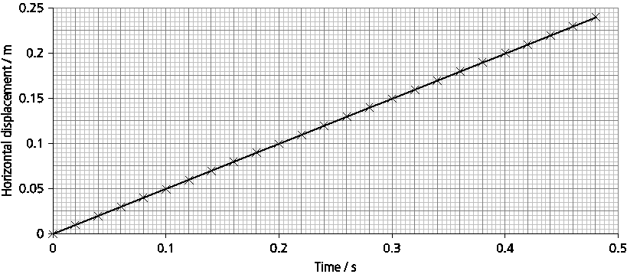

**A2** Horizontal velocity is constant, air resistance not really influential here due to low speed (0.5 m s–1).

**A3**

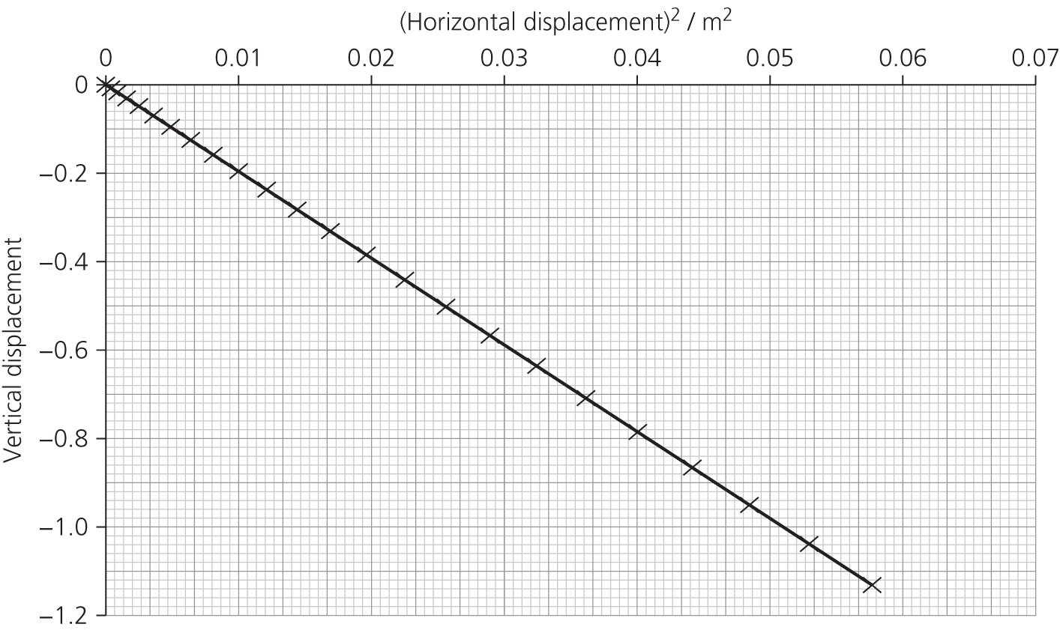

The droplets follow a parabolic path.

REQUIRED PRACTICAl QUESTIONS

**P1**

|  |  |  |
| --- | --- | --- |
| **Distance *s* / m** | **Mean time / s** | **Mean time squared / s2** |
| 0.8 | 0.401 | 0.16 |
| 1.4 | 0.541 | 0.29 |
| 2.0 | 0.646 | 0.42 |

**P2** The spread of readings around the mean (though there are only three readings) is about 0.02 s.

**P3** No. The spread of results means that we cannot be that precise. In this case 2 s.f. seems more reasonable (and this level of precision has been used in the *t*2 column).

**P4** We should be able to measure to the nearest mm, so all readings should be given to that level of precision, e.g. 0.900 m, etc.

**P5**

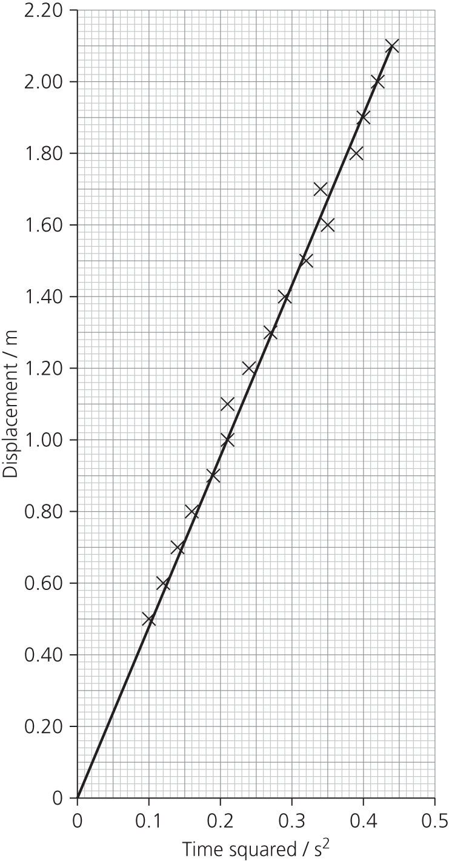

**P6** Gradient is 4.77; *g* = 2 × gradient = 9.54 m s–2.

**P7** Worst-fit gradient approximately 5.24, giving *g* = 10.48 m s–2.

Difference = 0.94, which is about 10% uncertainty; *g* = (9.5 ± 1.0) m s–2.

**P8** There was quite a wide scatter of results. These seem to be random, so repeating with more readings could help. There could be some systematic error, as the value is low compared to the accepted value. Perhaps the trap door does not open immediately and the timer reads too high as a result. Replace the magnet / trap door system with two light gates and record the velocity at each as an object drops through them. Then use *v*2 = *u*2 + 2*as* to find acceleration due to gravity.

PRACTICE QUESTIONS

**1a.i.** Vertically, *s* = ½*gt*2

1.5 = ½ × 9.81 × 𝑡2

𝑡 =  = 0.55 s

**1a.ii.** Horizontally, *s* = *vt* = 430 × 0.55 = 240 m

**1b.** The time of flight is the same for both A and B, because the vertical motion is independent of the horizontal motion and the acceleration due to gravity is the same for both. The horizontal acceleration is zero and thus horizontal distance is proportional to horizontal velocity.

**2a.** Gradient

**2b.**

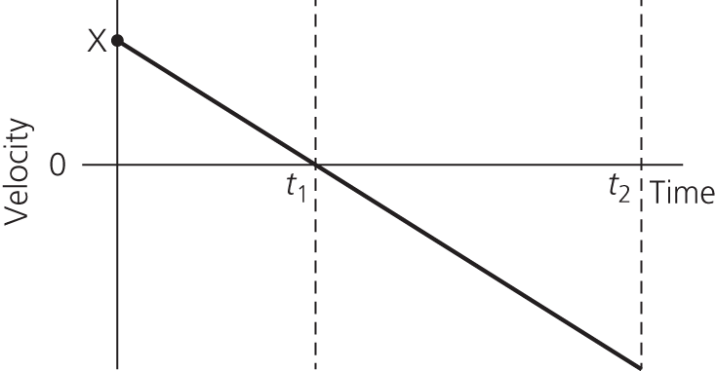

**3a.** *v*2 = *u*2 + *2as*; *u* = 0; *a* = *g*

*g* =  =  = 9.6 m s–1

**3b.** *W* = *mg* so weight is proportional to mass; doubling the mass doubles the weight; *g* remains the same.

**3c.** Card’s acceleration will be much less affected by air resistance than the ball’s OR the timing of the ball may give rise to greater uncertainty because the full width of ball may not pass through gate, so it would be difficult to determine the ‘length’ of ball passing through gate.

**4a.i.** *v* = *s/t*

*t* = 15 ms = 0.015 s

*v* = 0.68/0.015 = 45 m s–1

**4a.ii.** *a* = Δ*v*/Δ*t* = 45/0.015 = 3000 m s–2

**4b.i.** *s* = ½ *gt*2

*t* =  =  = 0.68 s

**4b.ii.** *s* = *vt* = 45 × 0.68 = 31 m

**4b.iii.** Air resistance causes horizontal deceleration.

**5a.** 70–90 seconds

**5b.** 140 seconds

**5c.** It is travelling in the opposite direction to its initial velocity.

**5d.** 360 m

**6a.** 304 km h–1

**6b.** 350°

**7.** C

**8.** D

**9.** A

**10.** C

**11a.** Throw 2 = 28.13 m s–1, from .

**11b.i.** When *v* = 0 vertically, *s* = *u*2/2*g* =  = 12.39 m, but we need to add launch height 1.80 m, so 14.19 m.

**11b.ii.** The flight needs to be considered in two halves:

In the first half, the javelin is launched at 15.59 m s–1 so *t* = *u*/*g* = 1.59 s.

In the second half, the javelin accelerates downwards from its maximum height of 14.19 m. From *s* = ½ *at*2,

*t*2 = = 2.89 s2

*t* = 1.70 s

Total flight time is therefore 1.59 + 1.70 = 3.29 s.

**11b.iii.** 48.59 m

**11c.** The maximum height, the range and the time of flight are all reduced.

**11d.** Higher range than expected, possibly wind assisted.

**11e.** All results should be recorded to the same level of precision

**11f.** Moving upwards has been defined by the data as positive for velocity. The final velocity of the javelin is negative as it is moving downwards.

**11g.** There is possibly a correlation – the taller the thrower, the longer the flight time and the further the range – but this is not conclusive, because there is not enough data and other variables are not fixed. More results are needed, possibly with other factors controlled.

Chapter 10: Forces in balance

Assignment 1

**A1** ±1% in the values for the masses is reasonable. These can be checked with a balance measuring to a resolution of 1 g. There is a spread in the results for the angle of at least ±3°. Each time the shoe was placed on the surface, a new set of contact points was formed, and as the surface is unlikely to be uniform, friction will vary.

**A2** The random error due to the variation in the friction could be reduced by repeating the readings more times and taking the mean.

**A3** *μ* = tan *θ*

Mean *θ* is around 21°, which gives *μ* = tan 21 = 0.38.

**A4** The means here are 21, 20, 21. which are not significantly different. Given the uncertainty due to the spread of results, there is no evidence that mass has any effect on the angle BUT it would be wrong to say friction is not affected by mass (weight). Even if *μ* is constant, the frictional force *F* = *μN*, and *N* depends on weight.

Assignment 2

**A1**

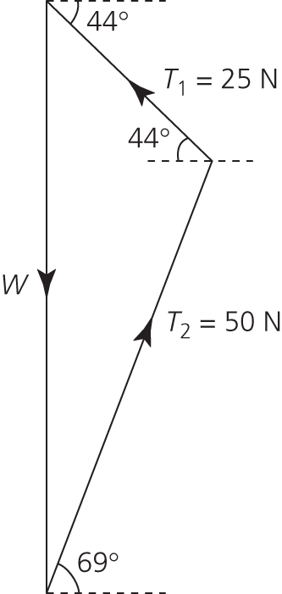

Scale drawing (or calculation using cosine rule or by resolving as in A2) gives

*W* = 64 N

**A2** Equating vertical components:

*T*1 sin 28° +*T*2 sin 42.5° = *W*

Equating horizontal components:

*T*1 cos 28° = *T*2 cos 42.5°

This leads to:

*W* = 63.6 ≈ 64 N

**A3** Friction in the pulleys would mean that the tension in the string on either side of the pulley is not equal.

It is difficult to measure the angle accurately.

We could use a finer thread, and take steps to avoid parallax errors when marking the sheet.

Use smooth pulleys or use a newton meter to check the tension readings.

Assignment 3

**A1** Vertical component *F* sin *θ*; horizontal component *F* cos *θ*

**A2** *W* = *U* + *F* sin *θ*

*F* cos *θ* = drag (total resistive forces)

**A3** The vertical component (*F* sin *θ* ) gets greater as *θ* increases. This tends to lift the board so it just skims the water surface. Drag due to the water resistance is reduced and so a higher speed is possible.

ASSIGNMENT 4

**A1** Volume = 4/3 π*r*3 = 4/3 π × (5.0)3 = 524 cm3. Uncertainty in measurement of diameter is at least ±0.1 cm, so percentage uncertainty of 1%, and this is the same for the radius; but *r* is cubed, so 3% uncertainty in volume which is ±16 cm3.

**A2** Mass of a sphere = 2700 × 524 × 10–6 = 1.41 kg; weight = 13.8 N

**A3** W1*x* = *Fy*

*F* =  = 7.52 N

**A4** Upthrust *U* = 13.8 – 7.52 = 6.28 N so 0.64 kg of liquid displaced. Density =  = 1220 kg m–3 to 3 s.f.

**A5** 3% on volume, less than 1% on distance measurements, so about 4% altogether. That’s about ±50 kg m–3.

**A6** Density is in the range 1180–1280 kg m–3, so the liquid is probably brine.

**A7** Reduce the uncertainty in volume measurement, perhaps by finding the mass with an electronic balance and then using an accepted, precise density value. Reduce the uncertainty in distances by having a bigger ruler, although it would be more difficult to manage experimentally.

PRACTICE QUESTIONS

**1a.** (sum of) clockwise moment(s) = (sum of) anticlockwise moment(s) for a system in equilibrium.

**1b.i.** 35 × 110 × 10–3 = 3.85 N m or 3.9 N m to 2 s.f.

**1b.ii.** 3.85 = *T* × 25 × 10–3

*T* = 3.85/25 × 10–3 = 0.150 × 103 = 154 N or 150 N to 2 s.f.

**2a.i.** 180 000 × 2.8 = 504 000 N m or 500 000 to 2 s.f.

**2a.ii.** 7.4 × lift fan thrust *F* = 18 0000 × 2.8 = 504 000 N m

*F* = 68 000 N

**2a.iii** 180 000 – 68 100 = 112 000 N (or by taking moments)

**2b.i.** *m* = *W*/*g* = 180 000/9.81 = 18 349 kg

*a* *= F*/*m* = 155 000/18 349 = 8.4 m s–2

**2b.ii.** Cross-sectional or surface area/shape/streamlining/aerodynamics/nature of surface/drag coefficient, because of its effect on air resistance/drag

OR Maximum thrust/force power of engine: maximum speed is when drag equals maximum thrust.

**2b.iii.** Line starting at zero and curving with decreasing gradient, reaching a constant velocity.

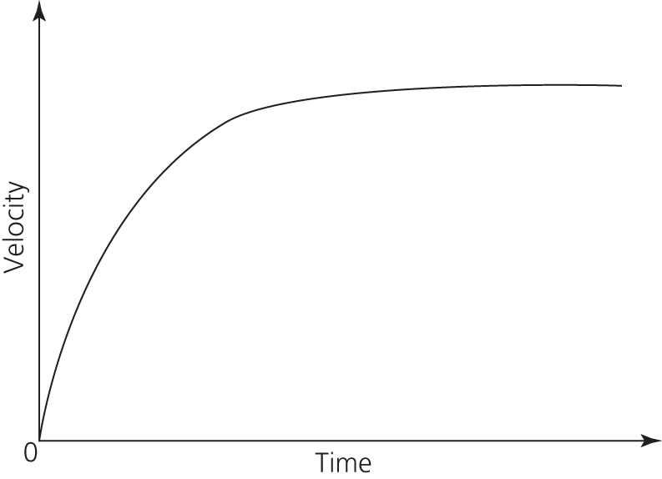

**2c.** Steepest/maximum gradient

**3a.** The two equal and opposite forces are not in line so they form a couple, producing a clockwise turning effect that causes the crate to rotate. While rotating, it is not in equilibrium.

**3b.** If he tied the rope further down the crate the size of the couple would be reduced which would reduce the tendency of the crate to topple over; if he also pulled at an upward angle to the horizontal, the vertical component of the pulling force would counterbalance the clockwise turning effect.

**4a.** The truck would tip over forwards as there would be an unbalanced anticlockwise moment about A.

**4b.** (2500 × 0.6)/0.4 = 3750 N

**5a.** Weight and contact force from the floor

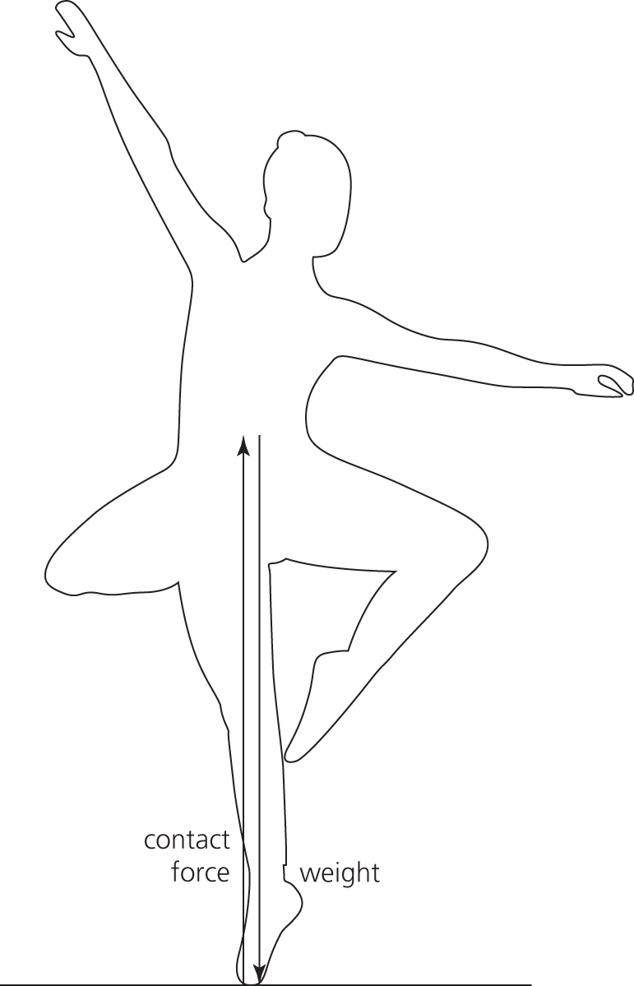

**5b.** She must keep her centre of gravity over the point of contact with the floor.

**5c.i.** *N* = 50 × 9.81 = 491 N

**5c.ii.** *F*A × 4 = 491 × 12

*F*A = 1470 N

**5c.iii.** *F*X = 1470 + 491 = 1964 ≈ 2000 N

**6.** B

**7.** D

**8.** D

**9.** B

**10**. B

**11.** A

**12.** C

**13.** C

Chapter 11: Forces and motion

Assignment 1

**A1** There will be some uncertainty in measuring the flag precisely. Although the time is measured by a computer, there will be some uncertainty in when the timer actually starts and stops; the light beam has a finite width, so how much of this has to be interrupted by the flag to start/stop the timer?

The mass (over the pulley) is typically accurate to 1%; this could be checked with an electronic top pan balance.

**A2** The air track should be levelled using a spirit level. Care should be taken to shield light gates from other light sources. The glider should be initially at rest, and should pass through the light gates unhindered.

**A3**

|  |  |  |  |  |  |
| --- | --- | --- | --- | --- | --- |
| **Mass / g** | **Force / N** | **Velocity / m s–1** | | ***t* / s** | ***a* / m s–2** |
| **Light gate 1** | **Light gate 2** |
| 10 | 0.10 | 0.24 | 0.49 | 1.35 | 0.19 |
| 20 | 0.20 | 0.25 | 0.66 | 1.09 | 0.38 |
| 30 | 0.29 | 0.25 | 0.78 | 0.96 | 0.55 |
| 40 | 0.39 | 0.28 | 0.89 | 0.85 | 0.72 |
| 50 | 0.49 | 0.31 | 0.99 | 0.76 | 0.89 |
| 60 | 0.59 | 0.34 | 1.08 | 0.70 | 1.06 |
| 70 | 0.69 | 0.44 | 1.18 | 0.62 | 1.19 |
| 80 | 0.78 | 0.55 | 1.28 | 0.56 | 1.30 |
| 90 | 0.88 | 0.66 | 1.39 | 0.52 | 1.40 |

**A4**

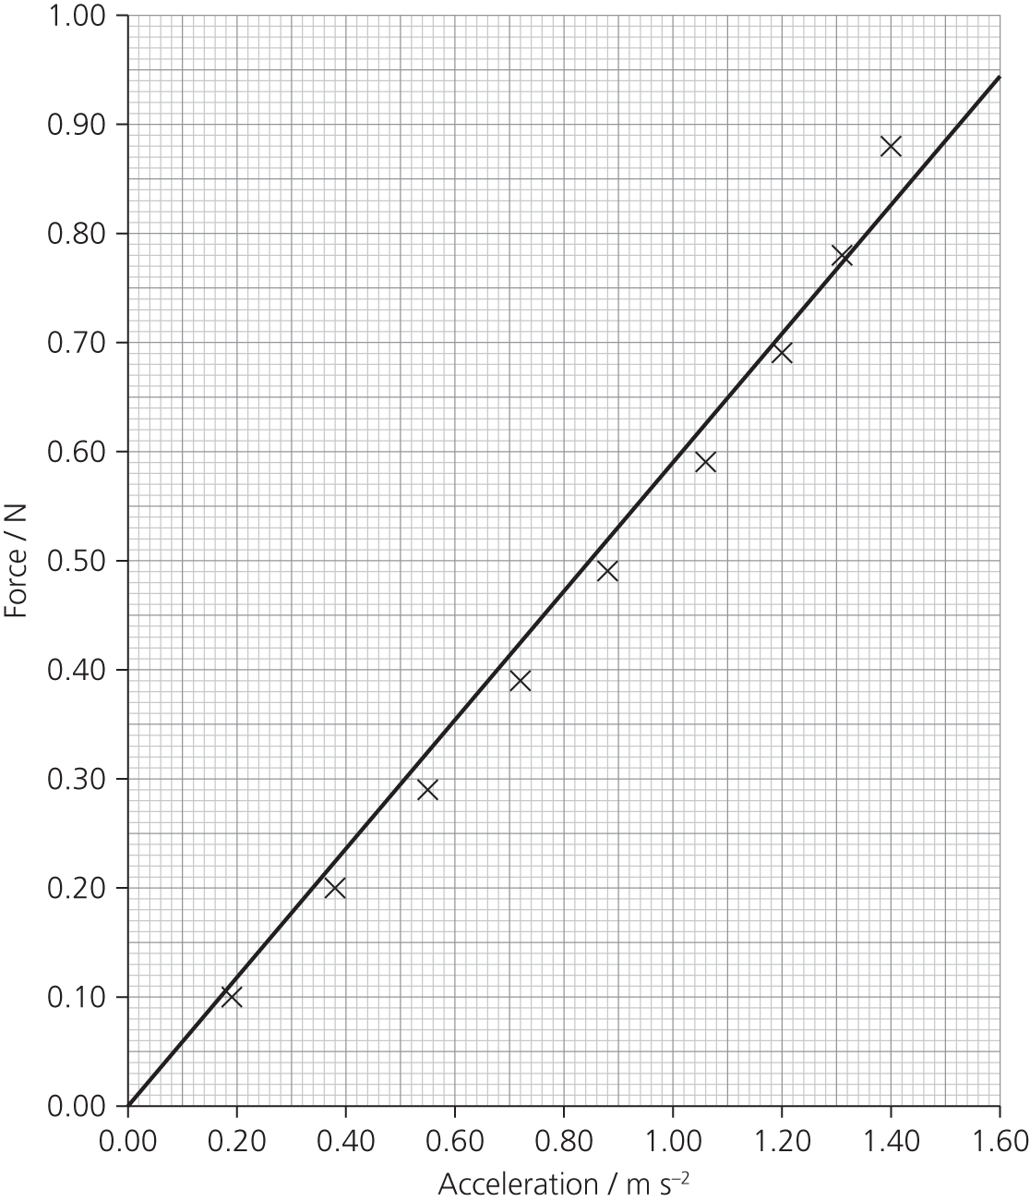

**A5** Yes, the acceleration is proportional to the applied force (the graph is almost a straight line).

**A6** Since *F* = *ma*, *m* = *F/a*, which we can find from the gradient of the graph. Mass is approximately equal to 580 g.

**A7** The air track may not have been perfectly level. Resistance forces may become more significant at higher speeds. The object that is accelerated is actually the glider plus the mass hanging over the pulley. Each time that a mass is added to the string, it increases the force but it also increases the inertial mass, that is the mass to be accelerated.

Assignment 2

**A1a**. Impulse ≈ ½ × 0.008 × 1600 = 6.4 N s

**A1b**. Impulse = ½ × 0.006 × 6300 = 19 N s

**A2a**. 6.4 kg m s–1

**A2b**. 19 kg m s–1

**A3a**. Hit the plate at 9 m s–1, so initial momentum = 9 × 0.5 = 4.5 kg m s–1.

Change in momentum is 6.4 kg m s–1, so final momentum is 4.5 – 6.4 = –1.9 kg m s–1,   
giving velocity = –1.9/0.5 = –3.8 m s–1. This is a velocity of 3.8 m s–1 in the other direction.

**A3b**. Hit the plate at 30 m s–1, so initial momentum = 30 × 0.5 = 15 kg m s–1.

Change in momentum is 16 kg m s–1, so final momentum is 15 – 18.9 = –3.9 kg m s–1,

giving velocity = –7.8 m s–1.

**A4** There is a close match between experimental and theoretical results, although there is significantly more variation in the results at high velocity. Typically, experimental readings are fed back into the mathematical model to improve its accuracy.

**A5** A mathematical model is usually much cheaper to construct and operate than the practical simulation or a set of experiments. The effect of changing different variables can be investigated more economically. It is necessary though to calibrate a mathematical model, comparing it with actual results.

**A6** The steel plates are rigid and rectangular whereas football boots are not. The nature of collisions is likely to be quite different. The effect of the ball spinning, or being wet, may need to be taken into account.

Assignment 3

**A1** It has been assumed that mass is constant.

**A2**

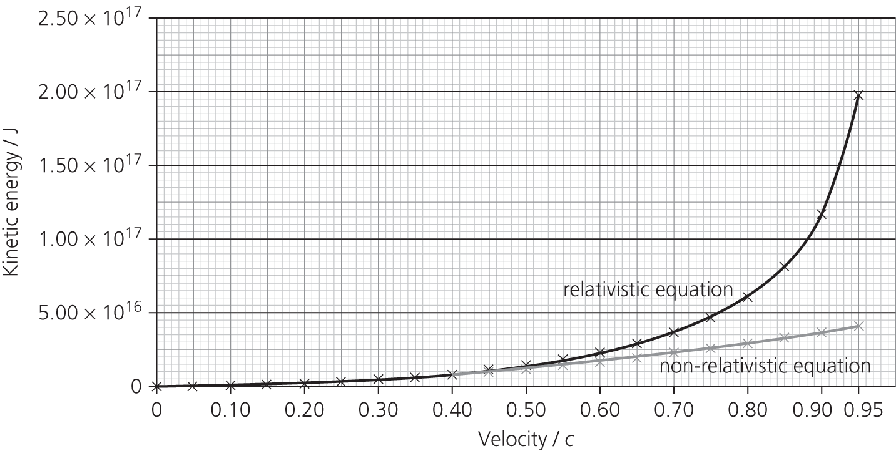

**A3** At about 0.35*c*.

ASSIGNMENT 4

**A1** and **A2** Uncertainties in measurement of height (± 1 cm), energy input ( ± 0.1 J), mass (± 0.1 g). These reading errors are random; repeated readings will improve the accuracy. Systematic errors might include: parallax error in reading the height, zero error on the joule meter.

**A3** Efficiency = ; adding the percentage uncertainties gives about 3% uncertainty.

**A4** Repeat readings for the same load. Make the motor lift the weight further, to reduce the percentage uncertainty in height and energy input.

ASSIGNMENT 5

**A1** 0.5 × 90 × 132 = 7605 J

**A2** The graphs should show the difference in the rate of change of momentum in the two situations, ideally with both traces on a single pair of axes. The graph for situation **a** will be much shallower than the graph for situation **b**, although the total change in momentum will be the same.

**A3** The more rapid change of momentum in situation **b** will do damage to the driver.

**A4** Allowing a greater distance for the energy in a collision to be absorbed will reduce the force on an object or person; crumple zones allow this.

**A5**

|  |  |  |  |
| --- | --- | --- | --- |
| **Speed / m s–1** | **Thinking distance / m** | **Braking distance / m** | **Stopping distance / m** |
| 13 | 9 | 10 | 19 |
| 22 | 15 | 28 | 43 |
| 30 | 21 | 53 | 74 |

To work out the braking distance, use: distance = 

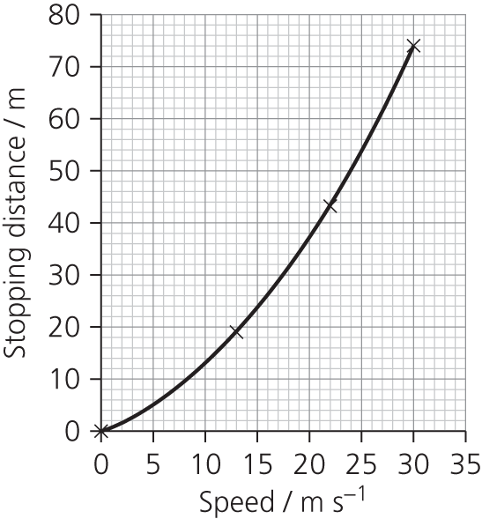

From the graph, stopping distance for 15 m s–1 = 24 m.

**A6** Students’ own answers.

PRACTICE QUESTIONS

**1a.** Gravitational potential energy *E*pis transferredto kinetic energy *E*k, which is transferred to gravitational potential energy *E*p.

No energy is lost from the system (since no work is done against resistive forces).

So final *E*p= initial *E*p

OR*h* = *E*p/*mg* and these are all constant so *h* is the same.

**1b.** Initial curve with decreasing gradient, reaching and maintaining constant maximum speed before X. Time B labelled as shown.

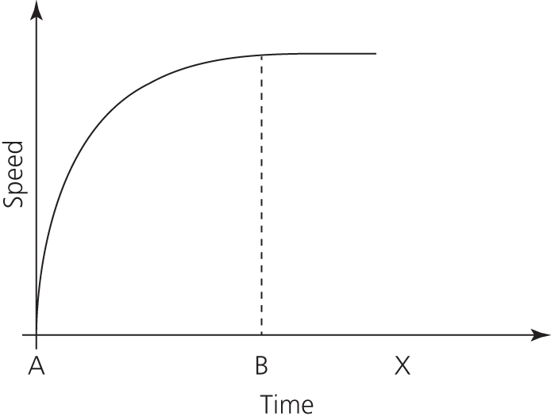

**1c.** The ball travels in a straight line at a constant speed/velocity; there is no (external) unbalanced/resultantforce acting on it.

**2a.i.** *a* = (*v* – *u*)/*t* = 58/3.5 = 16.57 m s–2 or 17 m s–2 (to 2 s.f.)

**2a.ii.** *F* = *ma* = 5800 × 16.57 = 96 106 N or 96 000 N (to 2 s.f.)

**2a.iii.** *s* = ½(*u* + *v*)*t* = ½ × 58 × 3.5 = 101.5 m or 100 m (to 2 s.f.)

OR same answer through use of *v*2 = *u*2 + 2*as* or *s* = *ut* + ½*at*2

**2a.iv.** Work done= *Fs*

Power output = ** =  = 2.8 MW

Efficiency = 20% = 1/5, so power input = 2.8 × 5 = 14 MW

**2b.** Loss of *E*k = gain in *E*p

½*mv*2 = *mg* Δ*h*

Δ*h = * =  = 170 m

**3a.** ∆*E*p = *mg* ∆*h* = 55 × 9.81 × 4.2 = 2266.1 J or 2300 J (to 2 s.f.)

**3b.i.** *E*k = ∆*E*p = 55 × 9.81 × 3.2 = 1726.6 J or 1700 J (to 2 s.f.)

**3b.ii.** *E*k = ½*mv*2 = 1726.6 J

*v* = = 7.924 m s–1 or 7.9 m s–1 (to 2 s.f.)

OR same answer from use of *v*2 = 2*as*.

**3c.** One arrow, vertical, upward pointing, starts on soles of feet.

**3d.** *a* = ∆*v*/∆*t* = 7.920/0.26 = 30.46 m s–2 or 30 m s–2 (to 2 s.f.)

OR same answer (to 2 s.f.) from use of *a* = 2*s*/*t*2 or *a* = *v*2/2*s*

**3e.** Answer could include:

* (elastic potential) energy is transformed to kinetic, or trampoline does work on gymnast
* kinetic energy is transformed into gravitational potential energy
* the gymnast must ‘jump’/bend knees/do work/‘use’ chemical energy/supply energy (to increase height)
* the gymnast must overcome resistive forces (drag/heat loss/reference to energy dissipated in trampoline).

**4.** C

**5.** B

**6.** A

**7.** A

**8.** C

**9.** A

**10a.i.** The car is not solid; the front of the car crumples so that the passenger compartment takes 120 ms to come to a stop.

**10a.ii.** Initial speed = 15 mph =  = 6.67 m s–1

Average acceleration = = –55.6 m s–2

Average deceleration = 55.6 m s–2

**10a.iii.** Yes. Because the average deceleration is over 5*g* and the duration of the collision is 120 ms, it is very likely that two consecutive measurements of deceleration are greater than 1.0*g*.

**10b.i.** It starts at around *t* = 30 ms and continues until *t* = 180 ms, so duration = 150 ms.

**10b.ii.** At 110 ms. This is the first time that two consecutive readings are less than 1.0*g*.

**10b.iii.** By finding the area between the graph and the *x*-axis between *t* = 30 and *t* = 180 ms (counting the squares), then finding the constant value of deceleration that would give the same area, the estimate is –1.2*g*.

**10b.iv.** *F* = *ma* = 1850 × –1.2 × 9.81 = –21.8 kN

**10b.v.** *Ft* = change in momentum = *m*Δ*v*.

So *v* =  = 1.70 m s–1.

OR, because average deceleration = 1.2*g*, Δ*v* = 1.77 m s–1.

Chapter 12: The strength of materials

Assignment 1

**A1** Gravitational potential energy → kinetic energy (the first ‘free fall’ part of the jump)

Gravitational potential energy + kinetic energy → elastic potential energy (as the cord begins to stretch) → elastic potential energy (when the jumper as has come to a halt)

**A2** Loss in gravitational potential energy = gain in kinetic energy

*mg* Δ*h* = ½ *mv2*, *v*2 = 2*g*Δ*h*, *v* = 24.2 m s–1

**A3** ½ *mv*2 = 20 600 J

**A4** 9.81 m s–2 down; the only force acting on the jumper is gravity since the cord hasn’t stretched yet and exerts no upwards force on the jumper.

**A5** When the force from the stretched cord just exceeds the weight of jumper. The jumper is still travelling downwards at this time. The resultant upward force will reduce his speed and eventually bring him to a halt.

**A6** Young modulus = ; stress =  = 1.03 × 107 Pa; strain = 1

Young modulus = 1.03 × 107 Pa

**A7** When the upward force on the jumper has had time to reduce the velocity to zero.

The overall transfer has been from gravitational potential energy to elastic potential energy.

**A8** Elastic strain energy stored, *E*el = ½ × Young modulus × (Δ*l*/*l*)2 × *V*

*V* = 30 × 2.87 × 10–4 m3

*E*el = ½ × 1.03 × 107 × 30 × 2.87 × 10–4 × (Δ*l*/*l*)2 = 4.43 × 104 × (Δ*l*/*l*)2 J

Gravitational potential energy lost = *mg*(Δ*l* + 30) = 70 × 9.81 × (Δ*l* + 30) = 687 × (Δ*l* + 30)

Equating gravitational potential energy lost with elastic strain energy stored,

687 × (Δ*l* + 30) = 4.43 × 104 × (Δ*l*/*l*)2

Multiply through by *l*2, i.e. 900, to give:

900 × 687 × (Δ*l* + 30) = 4.43 × 104 × (Δ*l*)2

6.183 × 105Δ*l* + 1.855 × 107 = 4.43 × 104(Δ*l*)2

4.43 × 104(Δ*l*)2 –6.183 × 105Δ*l* – 1.855 × 107 = 0

This is a quadratic in (Δ*l*)2; solving gives Δ*l* = 28.6 m (ignoring the negative root).

The bungee has stretched by almost its own length again (a strain of 0.95).

Total fall = 30 + 28.6 = 58.6 m

**A9** Maximum upward force is at the lowest point, since extension of the cord is greatest there.

Stress = Young modulus × strain = 1.03 × 107 × 0.95 = 9.79 × 106 Pa

Force = stress × area = 9.79 × 106 Pa × 2.87 × 10–4 m2 = 2810 N

But subtract the weight (690 N) = 2120 N

Since mass = 70 kg, *a* = 30.3 m s–2, so about 3*g*! (Most white-knuckle rides subject their victims to 3–4*g* for just a short time.)

Velocity at that point is zero.

**A10** Air resistance would tend to reduce the kinetic energy, and reduce the drop.

The mass of the bungee will be substantial, and would increase the extension (perhaps by a factor of 30%).

**A11** Four cords would reduce the extension, and the gravitational potential energy lost. The maximum force and acceleration would be lower.

Assignment 2

**A1** Stretched wire under tension could snap, so wear goggles.

Falling weights, so protect the floor and keep your feet out of the way.

**A2** Several measurements of the cross-sectional area of the sample need to be taken, using a micrometer or vernier callipers, as appropriate. The original length of the sample needs to be measured with a ruler. The extension should be recorded as the load (weight) is increased. Care should be taken not to load the sample above its elastic limit; check this by briefly removing each weight and checking the reading. Any permanent extension means that the elastic limit has been exceeded.

**A3** Matching to the graph:

A mild steel (extremely strong and stiff)

B nylon fishing line (strong, stiff)

C glass (stiff, brittle)

D rubber of inflatable boat (ductile, tough)

E high-density polythene (very ductile)

REQUIRED PRACTICAl QUESTIONS

**P1** Mean diameter 1.02 mm; mean cross-sectional area 0.82 mm2.

**P2**

|  |  |  |  |  |  |
| --- | --- | --- | --- | --- | --- |
| **Mass added / kg** | **Weight added / N** | **Micrometer reading / mm** | **Extension / m** | **Stress / GPa** | **Strain** |
| 0.00 | 0.00 | 0.02 | 0 | 0 | 0 |
| 0.10 | 0.98 | 0.04 | 2.00 × 10–5 | 1.19 × 106 | 1.00 × 10–5 |
| 0.20 | 1.96 | 0.06 | 4.00 × 10–5 | 2.38 × 106 | 2.00 × 10–5 |
| 0.30 | 2.94 | 0.08 | 6.00 × 10–5 | 3.57 × 106 | 3.00 × 10–5 |
| 0.40 | 3.92 | 0.10 | 8.00 × 10–5 | 4.76 × 106 | 4.00 × 10–5 |
| 0.50 | 4.91 | 0.12 | 1.00 × 10–4 | 5.96 × 106 | 5.00 × 10–5 |
| 0.60 | 5.89 | 0.14 | 1.20 × 10–4 | 7.15 × 106 | 6.00 × 10–5 |
| 0.70 | 6.87 | 0.20 | 1.80 × 10–4 | 8.34 × 106 | 9.00 × 10–5 |
| 0.80 | 7.85 | 0.22 | 2.00 × 10–4 | 9.53 × 106 | 1.00 × 10–4 |
| 0.90 | 8.83 | 0.24 | 2.20 × 10–4 | 1.07 × 107 | 1.10 × 10–4 |
| 1.00 | 9.81 | 0.26 | 2.40 × 10–4 | 1.19 × 107 | 1.20 × 10–4 |
| 1.10 | 10.79 | 0.28 | 2.60 × 10–4 | 1.31 × 107 | 1.30 × 10–4 |
| 1.20 | 11.77 | 0.30 | 2.80 × 10–4 | 1.43 × 107 | 1.40 × 10–4 |
| 1.30 | 12.75 | 0.32 | 3.00 × 10–4 | 1.55 × 107 | 1.50 × 10–4 |
| 1.40 | 13.73 | 0.36 | 3.40 × 10–4 | 1.67 × 107 | 1.70 × 10–4 |
| 1.50 | 14.72 | 0.40 | 3.80 × 10–4 | 1.79 × 107 | 1.90 × 10–4 |
| 1.60 | 15.70 | 0.44 | 4.20 × 10–4 | 1.91 × 107 | 2.10 × 10–4 |

**P3**

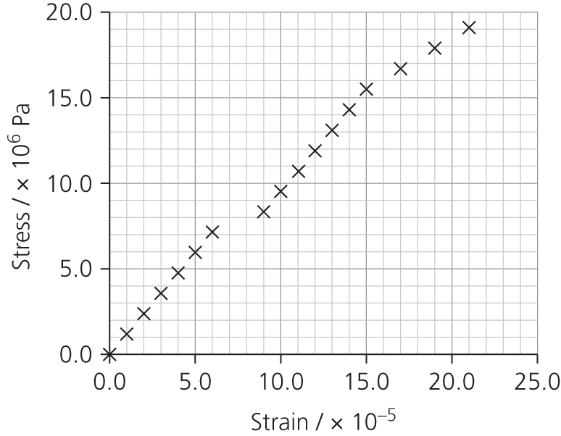

**P4** The graph has two straight-line regions, where stress is proportional to strain. It looks as if the wire slipped in the middle of the readings. Beyond a stress of 15.0 × 106 Pa the wire has been loaded beyond the elastic limit, and the wire is shows a larger strain per unit stress.

**P5** The gradient of each of the initial straight-line section is 1 × 1011 Pa; this is the Young modulus. The material with the closest value of the Young modulus is copper (1.17 × 1011 Pa).

PRACTICE QUESTIONS

**1a.i.** *F* ∝ *Δl* or *F* = *k* Δ*l* up to limit of proportionality, where *F* = force applied, Δ*l* = extension, *k* = constant.

**1a.ii.** Straight line, passing through the origin.

**1a.iii.** *k* = 500/0.385 = 1290 ± 20 N m–1

**1b.i.** Δ*W* = *F* Δ*s* so area beneath line from origin to Δ*l* represents work done or energy needed to compress/extend. Work done on the spring = energy stored. Area of triangle = ½ *b* × *h*, therefore *E* = ½*F* Δ*l*.

**1b.ii.** *F* = 360 N; *P* =  × =  × = 33.6 W (or 34 W to 2 s.f.)

**2a.** *k =* ∆*F/*∆*l* =  = 5.1 × 107 ± 2%

**2b.** Load = 2.8 × 105 N; stress = *F/A* =  = 1.1 × 108 Pa (or N m–2) or 110 MPa

**2c.** For 10 m length, ∆*l* =  = 2.94 × 10–3 m. For 1000 m therefore the extension is 0.29(4) m.

**3a.** Returns to original length/shape with zero extension/no permanent extension.

**3b.** Δ*W* = *F* Δ*s*, so area beneath curve A from origin to Δ*l* = 0.30 m represents work done in extending; approximately 6.0 J to 7.0 J.

**3c.** Young modulus = (*F/A*)/(Δ*l/l*) =  =  = 2.5 × 107 Pa

**4.** D

**5.** B

**6.** B

**7.** C

**8.** B

**9a.** A material is said to be ductile if it deforms plastically to a relatively large strain value. The curve for the cancellous bone has a long plastic region which extends to a strain of over 0.20.

**9b.** We need to compare the Young modulus for the two types of bone; this is given by the gradient of each graph.

Cortical bone, *E* =  = 16 GPa

Cancellous bone, *E* =  = 1.33 GPa, which is approximately 1/10 of the value for cortical bone.

**9c.** The area under the graph is the energy absorbed per unit volume.

For 21-year-old this is (11 × 4 × 106) × 0.5 = 22 MJ m–3.

For 65-year-old this is (7 × 1.5) × 0.5 = 5 MJ m–3.

For 80-year-old this is (1 × 5) × 0.5 = 2.5 MJ m–3.

Bones become less tough with age – they are able to absorb less energy without breaking. A minor fall for an elderly person is much more likely to result in a fracture.

Chapter 13: Electricity 1

Assignment 1

**A1a.** 0.50 mA × 0.4% = 0.002 mA; add on the resolution uncertainty to get an uncertainty of  
0.002 + 0.01 = 0.012 mA

**A1b.** 0.2 V

**A2** The maximum voltage which can be read on that scale.

**A3** You could use the resistance meter setting to look for a break in the circuit. With the headlights turned off, you could measure the resistance in various parts of the circuit, including the bulbs and the fuse. If the resistance was very large, or too big to measure (usually shown as a 1 on the left-hand side of the display), it would indicate the problem.

Use the multimeter as a voltmeter across the battery, to check the voltage.

**A4a.** 1.109 V × 0.1% → uncertainty of 0.001 V

**A4b.** 1.111 V; uncertainty of 0.001 V

**A4c.** 1.111 – 1.109 = 0.002 V. Adding the uncertainties gives an uncertainty of 0.002 V, or 100%.

**A4d.** Finding a small difference between two measurements can lead to large uncertainties.

Assignment 2

**A1**

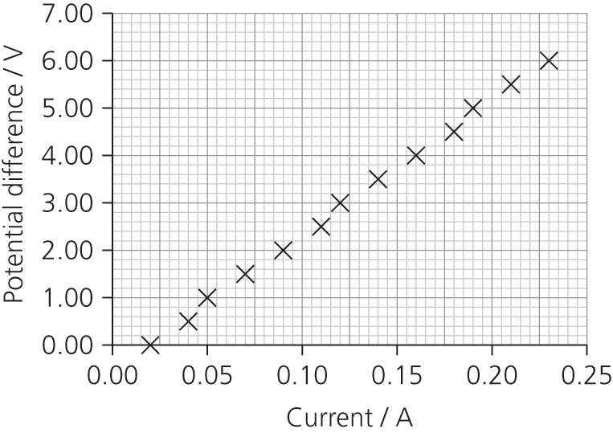

**A2** Resistance (pd/current) = 30 Ω; this holds true up to a current of about 0.2 A.

**A3** Ohmic, since potential difference is proportional to current, at least until the wire begins to get hot at around 0.2 A.

**A4** The graph shows two errors:

* there is a zero error – the ammeter is showing a reading when there is no potential difference
* the temperature of the wire is beginning to increase at the highest current readings.

REQUIRED PRACTICAl QUESTIONS

**P1** 32.5 Ω m–1

**P2** 3.3 × 10–8 m2

**P3** 1.07 × 10–6 Ω m

**P4** Spread of the readings for the diameter ≈ 10%. But to find area the value for diameter is squared, so there is a 20% uncertainty in the cross-sectional area of the wire.

**P5** A ‘worst-fit’ line has a gradient of around 30, so uncertainty approximately ±8%.

**P6** Total uncertainty = 20% + 8% = 28%. Resistivity = (1.07 ± 0.3) × 10–6 Ω m

PRACTICE QUESTIONS

**1a.** The potential difference across *R*1 = 12 – 8 = 4 V

So the current through *R*1 = *V*/*R* = 4/60 = 0.067 A

**1b**. *R*1 =  =  = 120 Ω

**1c**. *Q* = *It*; *Q* = 0.067 × 120 = 8.0 coulombs (C)

**2a**. Power = current × voltage. Apply this to lamps X and Y.

Lamp X: *I* = *P*/*V*; *I* = 36/12 = 3.0 A

Lamp Y: *I* = *P*/*V*; *I* = 2.0/4.5 = 0.44 A

**2b.i.** pd across *R*1 = 24 – 12 = 12 V

**2b.ii.** Current in *R*1 = the sum of the current through each lamp = 3.0 + 0.44 = 3.44 A

**2b.iii.** *R*1 =  =  = 3.5 Ω

**2b.iv.** pd across *R*2 = 24 V – pd across *R*1 – pd across lamp Y = 24 – 12 – 4.5 = 7.5 V

**2b.v.** *R*2 =  =  = 17 Ω

**2c.i.** The circuit resistance increases, so the current is lower, reducing the voltmeter reading.

**2c.ii.** The pd across lamp Y, and therefore the current through lamp Y, increases. The power/rate of energy dissipation in the lamp is greater, in other words lamp Y glows brighter.

**3a.i.** The total resistance of the circuit = 

*R*total =  = 5.0 Ω

**3a.ii.** For the combination of X, Y and Z:

Resistance of W + X = 6 Ω

Resistance, *R*, of (W + X) in parallel with Y is given by:

 = 

So *R* = 2 Ω

Adding the resistance of Z gives *R*total:

*R*total = 2 + 3 = 5 Ω, which agrees with the value given in part **a.i.**

**3b.i.** pd across Z = 2.0 × 3.0 = 6.0 V; so the pd across Y = 10 – 6 = 4.0 V

Current in Y =  =  = 1.3 A

**3b.ii.** Current through W = 2 – 1.3 = 0.67 A

pd across W = 0.67 × 3 = 2.0 V

**4.** B

**5.** D

**6.** C

**7.** C

**8.** D

**9.** A

**10a.** She needs to find the resistivity through the formula *R* = *ρl/A*. To find *l*, she will need to measure the length of the wire making up the coil.

Then she will need to measure the diameter of the wire and calculate the cross-sectional area *A*, using the formula *A* = π × (diameter/2)2.

To find the resistance *R, s*he will need a power supply (battery) which she should use to pass a current through the coil. She should connect an ammeter in series with the coil and a voltmeter in parallel and record the readings. She can then find *R* using *R* = *V/I*

Knowing, *R*, *l* and *A* she can find resistivity: *ρ* = *AR/l*

Compare this with the quoted value; if it falls within the uncertainty it may well be nichrome.

**10b.** To achieve a power of 4000 W on a supply of 240 V, she will need a resistance of 2402/4000 = 14.4 Ω.

Since *l* = *AR*/*ρ*, she will need a length *l* of wire given by: *l* =  = 2.82 m.

**10c**. 2.82 m is a lot of wire to coil up inside a kettle. Get some thinner wire! Or use a metal with a different resistivity.

To achieve this power the current will be 240/14.4 = 16.7 A. This current is too large for a standard 3-pin plug and fuse (13 A max.). It would need to be wired separately. That is a large current, which would require thick power cables that are well insulated.

Chapter 14: Electricity 2

Assignment 1

**A1** Completed columns A, B and C:

|  |  |  |
| --- | --- | --- |
| **External resistor R** | **Power in R** | **Gradient** |
| 10 | 0.4000 | 0.0188 |
| 20 | 0.5877 | 0.0087 |
| 30 | 0.6750 | 0.0036 |
| 40 | 0.7111 | 0.0009 |
| 50 | 0.7200 | –0.0006 |
| 60 | 0.7140 | –0.0014 |
| 70 | 0.7000 | –0.0018 |
| 80 | 0.6816 | –0.0020 |
| 90 | 0.6612 | –0.0021 |
| 100 | 0.6400 | 0.0064 |

**A2** Maximum power is at *R* =50 Ω.

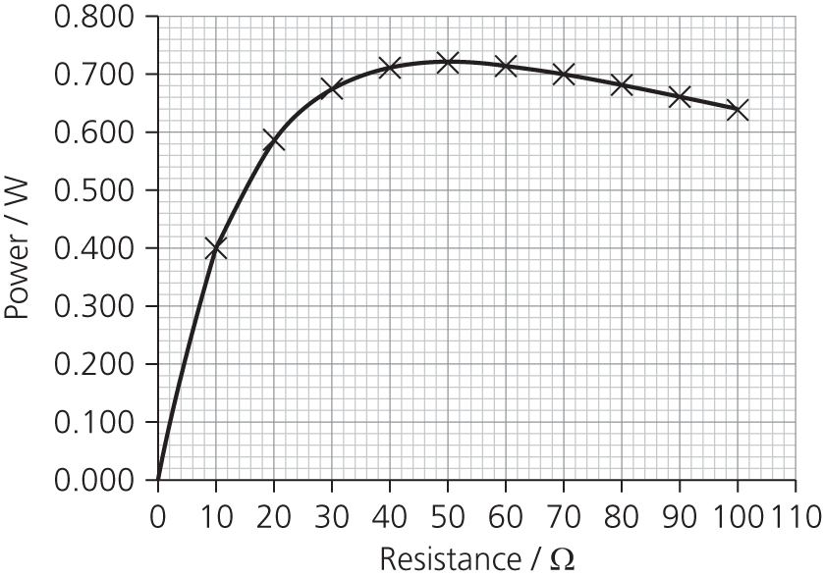

**A3** The maximum power will be delivered to the external circuit when the external resistance, *R*, equals the internal resistance, *r*.

**A4** This result has practical implications, for example, the output of an audio amplifier as used in a stereo system. Typically this has an internal (output) resistance of 8 Ω which matches the resistance of most loudspeakers (dc resistance).

Assignment 2

**A1** Change in *R* = 580 – 45 = 535 Ω. Change in temperature = 2600 – 20 =2580 K

Rate of change = 535/2580 = 0.21 Ω K–1

**A2** The resistance meter may only have a resolution of 1 Ω or 0.1 Ω which would correspond to a temperature resolution of only 5 K or 1 K. Making the wire longer would help, but it would make the thermometer unwieldy with poor spatial resolution (i.e. it would be difficult to measure the temperature at a point).

**A3** *ρ* = *AR/l*

Area, *A* = π*r*2 = π × (25 × 10–6)2 = 1.96 × 10–9 m2

*ρ* = × *R* = 1.31 × 10–9*R*

**A3a.** Using the value for *R* at room temperature: *ρ* = 5.88 × 10–8 Ω m

**A3b.** Using the value for *R* at operating temperature: *ρ* = 7.58 × 10–7 Ω m

**A4** The resistance of the cold filament is low, so the current is high at first. As the current flows, the filament gets hot and the resistance increases. But as the filament’s resistance increases, the current drops and its heating effect gets less. So the rate of change in *R* is less

**A5** The higher power lamp has a higher current, both at first and when it has reached its steady value. The resistance of the 100 W bulb is 240/4 = 60 Ω (cold) and is 240/0.43 = 560 Ω (hot).

The resistance of the 500 W bulb is 240/20 = 12.0 Ω (cold) and 240/2.08 = 115 Ω (hot). The higher-power bulb has a lower resistance filament, probably thicker (if the bulbs are a similar size, the filament can’t really be much longer). The larger filament takes longer to heat up.

**A6** The largest current surges through the filament when it is cold. If the filament has a weakness, this is the most likely time for it to break.

**A7** To calculate the total energy used during the current surge: Power = *IV*, and energy = *IVt*. Suppose that the initial current is 10 times the working current and lasts for the whole second. The energy use during that time equals 10 *IV*, 10 seconds’ worth of normal use. It isn't worth turning the light off for 10 seconds or less, but turning the light off for periods of more than 10 seconds will save energy and money.

Assignment 3

**A1**

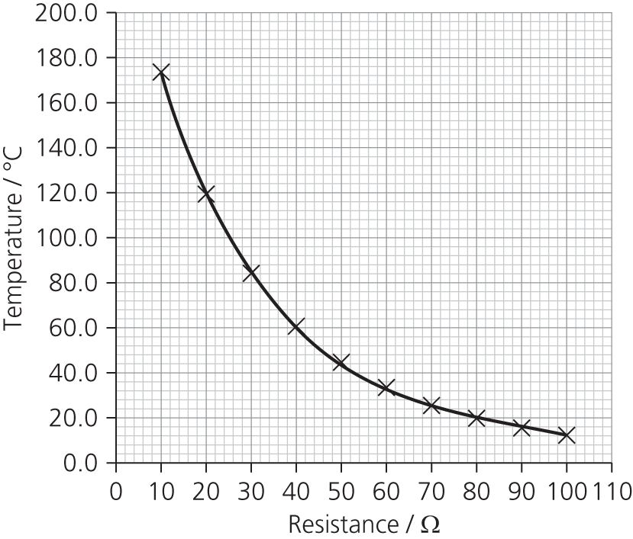

**A2** Read from the graph, temperature in the laboratory = 24 °C approx.

**A3** It is important that the thermometer is as close as possible to the thermistor in the water bath, so that local variations in temperature are not a problem. It should be held with its bulb in the middle of the water, not resting on the bottom. Convection currents can lead to uneven temperature, so stirring is important. The rate of heating and/or cooling should be sufficiently slow as to allow the thermometer to keep pace. The multimeter should be used on the most sensitive scale possible, even if that means changing the scale during the experiment*.*

**A4** By converting the measured temperature in Celsius to kelvin and plotting *R* against e1/*T*; or by plotting log *R* against 1/*T*.

Assignment 4

**A1** Circuit (a):

With the rheostat set at 0.5 Ω the total resistance in the circuit is 101.5 Ω.

*I* = *V*/*R* = 12/101.5 = 0.12 A

pd across buzzer = *IR*buzzer = 0.12 x 100 = 11.8 V

With the rheostat set at 16 Ω the total resistance in the circuit is 117 Ω.

*I* = *V*/*R* = 12/117 = 0.103 A

pd across buzzer = *IR*buzzer = 0.103 x 100 = 10.3 V

Circuit (b): this is a four-resistor problem, because the rheostat needs to be considered as two resistors *R*1 and *R*2 which total 16 Ω.

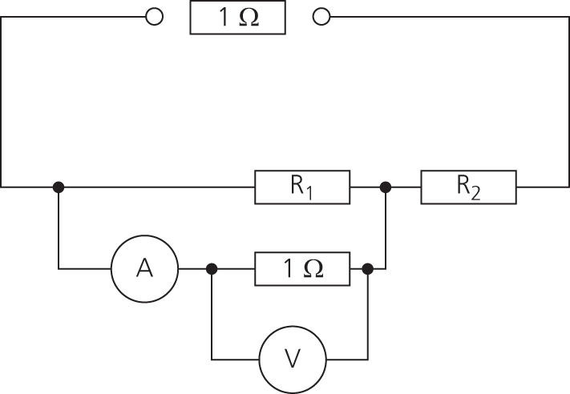

At one extreme, *R*1 = 0.5 Ω and *R*2 = 16 – 0.5 Ω = 15.5 Ω

Total resistance = 1 + 1/(1/0.5 + 1/100) + 15.5 = 1 + 0.50 + 15.5 = 17 Ω

Current in the series part of the circuit = *V*/*R* = 12/17 = 0.71 A

pd across *R*1 and buzzer = *IR* = 0.71 × 0.50 = 0.35 V

At the other extreme, *R*1 = (16 – 0.5) Ω = 15.5 Ω and *R*2 = 0.5 Ω

Total resistance = 1 + 1/(1/15.5 + 1/100) + 0.5 = 1 + 0.13.4+ 0.5 = 14.9 Ω

Current in the series part of the circuit = *V*/*R* = 0.80 A

pd across *R*1 and buzzer = *IR* = 0.80 × 13.4 = 10.7 V

Using the rheostat in circuit (b) gives a wider range of pds and so is the better arrangement.

**A2**

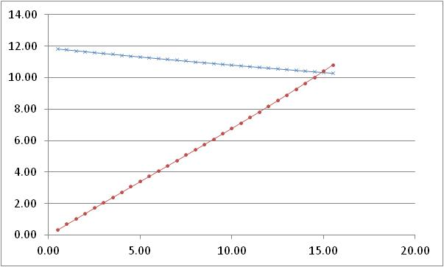

Resistance of the Buzzer = 100 Ω

**A3**

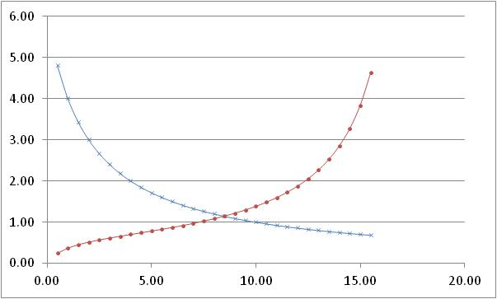

Resistance of the Buzzer = 1 Ω

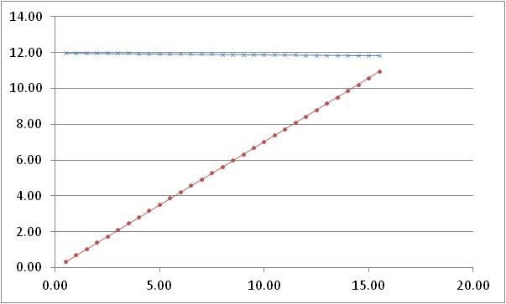

Resistance of the buzzer = 1 000 ΩA4.

When the resistance of the buzzer is low (eg, r = 1 Ω) both methods give a similar range of voltages, around 4-5 V in this case. However, when the resistance of the buzzer is high (r = 1 000 Ω), the first circuit hardly changes the potential difference at all, whereas the second circuit gives almost the full range of voltages (0-12 V).

**A4** The resistance of the bulb would not be constant. It would increase as the current through it increased. This would tend to limit the maximum current through the bulb.

REQUIRED PRACTICAl QUESTIONS

**P1** *V* = *Ɛ* – *Ir*. The intercept of a *V*–*I* graph = emf. Extending the line on the graph to the pd axis gives *Ɛ* = 1.5 V. Gradient = –*r* = –1 Ω.

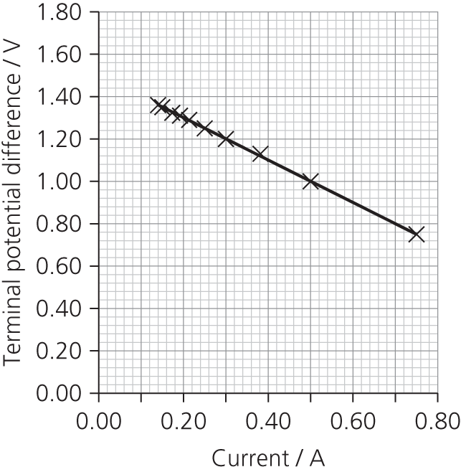

**P2** Uncertainty in current readings ± 0.01 A.

Uncertainty in terminal potential difference ± 0.01 V.

**P3** The emf will depend upon the light energy incident on the solar panel every second. You would need a constant source of illumination and a light-proof enclosure.

PRACTICE QUESTIONS

**1a.i.** *V* = *IR*; *V* = 4.2 × 1.5 = 6.3 V

**1a.ii.** pd = 12 – 6.3 = 5.7 V

**1a.iii.** Current in 2 Ω resistor, *I* = = 2.85; *I* = 2.9 A

**1a.iv.** Current in *R, I* = 4.2 – 2.85 =1.35; *I* = 1.4 A

**1a.v.** Resistance = = 4.2 Ω

**1a.vi.** Total resistance is sum of internal resistance and resistance of parallel part of circuit.

; *R*parallel = 1.35 Ω

Total resistance = 1.5 + 1.35 = 2.85 Ω

**1b.i.**

|  |  |
| --- | --- |
| **Resistor** | **Rate of energy dissipation / W** |
| Internal resistance (1.5 Ω) | 4.22 × 1.5 = 26.5 |
| 2 Ω | 2.852 × 2 = 16.2 |
| *R* (4.2 Ω) | 1.352 × 4.2 = 7.7 |

**1b.ii.** Using *P* = *IV*, rate of energy production by the cell = 4.2 × 12 = 50.4 W

Adding the values from the table in **b.i.**, rate of energy dissipation = 26.5 + 16.2 + 7.7 = 50.4 W

These values are the same, showing energy is conserved.

**2a.i.** *I* = . Total resistance = 5.0 + 50 + 35 = 90 kΩ = 90 000 Ω, so *I* = = 6.7 × 10–5 A

**2a.ii.** *V* = *IR*; *V* = 6.7 × 10–5 × 5000 = 0.33 V

**2b.** If the incident light on the LDR increases, its resistance decreases, so the proportion of voltage across it is reduced. As a result, the reading on the voltmeter increases.

OR the resistance of the LDR decreases so the current in the circuit increases, which causes the voltmeter reading to increase (*V* = *IR*).

**2c.** For *R*, resistance= 5.0 kΩ and pd = 0.75 V. So current in circuit is *I* = = 1.5 × 10–4 A

*I* × *R*total = 6.0, so *R*total = 6.0/1.5 × 10–4 = 40 000 Ω

*R*variable = 40 000 – 5000 – 5000 = 30 000 Ω or 30 kΩ

**3a.i.** Two parallel arms of circuit, with *R*AE = 20 + 20= 40 kΩ and *R*BF =10 + 5 = 15 kΩ

; *R*total = 10.9 kΩ

**3a.ii.** *I* = = = 1.1 mA

**3b.** pdAC = 6.0 V (12 V divided equally across AC and CE)

pdDF = = 4.0 V (12 V divided in proportion to the resistances 5 kΩ and 10 kΩ)

pdCD = 6.0 – 4.0 = 2.0 V (compare pdCE = 6.0 V and pdDF= 4.0 V)

**3c.i.** No change for A–C because no change in pd across this part of the parallel circuit.

**3c.ii.** Decrease in pd across D–F; resistance has decreased so a greater proportion of the 12 V is across the fixed resistor.

**4a.** Graph B

**4b.** Graph C

**4c.** Graph A

**5.** A

**6.** C

**7.** B

**8.** D

**9a.** Decreasing the temperature means that conduction electrons lose less energy in collisions with the positive ions that form the lattice. Onnes found that at a specific temperature (the critical temperature) there was a discontinuous change in the resistivity which suddenly dropped to zero.

**9b.** A higher critical temperature would allow us to get the advantages of superconductivity without the need to use liquid helium or even liquid nitrogen or expensive cooling apparatus.

**9c.** Strong magnetic fields are required, which normally requires a large electric current, and a lot of energy is wasted heating surroundings. Power loss = *I*2*R*, so if *R* drops to zero then very little energy is lost in the wires.

**9d.** Superconducting windings have zero electrical resistance, so there will be no *I*2*R* losses. The high current density achieved in superconductor windings means that the coils can be much thinner and therefore lighter than the heavy copper windings.

**9e.** The energy used by large motors is 25% of 4.2 × 1012 kWh = 1.05 × 1012 kWh.

Saving 2% of that gives a saving of 0.02 × 1.05 × 1012 = 2.1 × 1010kWh.