KS4 PSHCE LESSON PLAN.
DATE: LESSON FOCUS: Rights and Responsibilities in Society
Number of male students: | Number of SEN students: | Last lesson’s focus:
Number of female students: | Number of G & T students: | Next lesson’s focus:
Class/year group: | Misc:

LESSON OBJECTIVES.

- (1) I can learn more about which rights we have.
- (2) I can explore which responsibilities come with these rights.

STARTER.
- Share LOs with class.
- Refer class to LO1 for this starter activity.
- Ask students to read Photocopiable Resource 1 (‘Nujeen’ book excerpt). Excerpt refers to Nujeen’s safe arrival in Germany – more than 3000 miles away from her home in Aleppo.
- Remind students that Nujeen had the right to seek asylum in Germany due to the war in her own country. Explain that the local German people who welcomed Nujeen (and other Syrian citizens) to Germany with banners and drinks wanted to make people like her feel safe. They also wanted to show the Syrian people that shelter and food were available.
- Put class into small groups of 3/4. Ask students to discuss which rights - other than safety, shelter, food and the right to asylum - we are all entitled to in the modern world. Ideas to trigger thought: education, privacy, dignity, freedom, equality (gender, age, sexuality etc), information about global current affairs, access to a fair justice system etc.
- Ask spokespersons to feed back to class.
- Remind class that the main rights we’re entitled to are set out within (a) the UN Convention on the Rights of the Child and (b) the Universal Declaration of Human Rights. Also remind students that laws in individual democratic countries describe how certain rights can be achieved. For example, we have to be a certain age before taking a driving test or before becoming an MP.
MAIN.
- Refer class to LO2 for this main activity.
- Ask volunteers to explain why rights are so closely linked to responsibilities. Example of a good answer: I personally have the right to an education, so it’s only fair that I allow others to get an education too. It would be morally wrong of me to do anything to stop other students from learning (e.g. by bullying them or by causing disruptions in their lessons). In terms of wider society, the government gives us all legal responsibilities towards others. This is to ensure that our rights are more than just words on a piece of paper. There’s no point in a government telling us that we all have access to a fair justice system unless they put strict laws in place about the responsibilities of jurors, judges, lawyers etc. Vulnerable individuals and groups are at risk of exploitation if we don’t follow these laws.
- Split class in half. Put fifteen students into group A. Give all of them a copy of Photocopiable Resource 2 (Which responsibilities come with our rights?).
- Put the rest of the class into group B. Give all of group B one right each from Photocopiable Resource 3 (Rights to match responsibilities).
- Ask all the group B students (who have one right each) to stand around the outside of the room holding their right.
- Explain that there will be a challenge: group A students (who each have the table of responsibilities) must fill it in as quickly as possible, by matching the responsibilities in their table to the fifteen rights held by the group B students. To complete the challenge, group A students must move around the room ‘visiting’ the static group B students.
- Go through answers with class, praising students who found the right answers in the least time. Answers are on Photocopiable Resource 4 (Answers).
PLENARY.
- Put students into groups of 4/5 and give all students a copy of Photocopiable Resource 3 (Rights to Match Responsibilities).
- For as many of the fifteen rights as possible, ask each group to think of an example of that right being exploited (in this country or abroad).
- Ask spokespersons from a few groups to share their ideas.
- Examples of good answers:
- Right to access information via the mass media – The Chinese government bans many popular websites from the Chinese internet. This makes it very difficult for people living in China to expose/find out about corruption in China. Certain search terms (e.g. ‘persecute’) only lead to an error message or a blank screen on the Chinese internet.
- Right to freedom from exploitation – Barnardo’s has produced a report about some children in the UK being groomed to become sex workers. Such grooming takes place when adults use older teenagers to befriend children (by giving them gifts and using flattery). Once trust has been established, these teenagers then introduce the children to the adults. These adults expose the children to sexual exploitation.
- Right to leisure time – An MPs’ report (and undercover journalism) exposed the fact that Sports Direct exploited some of its workers in the UK by refusing them reasonable breaks. The company also paid certain workers less than minimum wage and made many employees feel their jobs were at risk if they took time off due to illness.
- Ask students to think about what they have learnt this lesson. Ask them to write a simple paragraph summarising why responsibilities are vital in order for us to access rights.
- Example of good answer:
Without responsibilities, rights are meaningless. In other words, there is little point in our government saying that children have the right to education if politicians don’t then provide children with schools. Society can only run smoothly if we take responsibility for other people’s rights as well as for our own. Tegan might not be the victim of harassment or abuse personally. However, if she and others ignore evidence that someone else is being victimised then this leads to a dangerous and demoralising culture of inequality, fear and mistrust.
SEN SUPPORT.
- For main activity, put students into group A and ask them to find the correct rights to match responsibilities A, C, I, M and N.
G & T SUPPORT.
- For plenary, nominate G & T students as group spokespersons.
HOMEWORK/STRETCH TASK.
- Write down four of your rights at school. Match them to your corresponding responsibilities. Example of one right and its corresponding responsibilities: I have the right to use the canteen every day. The responsibilities linked to this right are to queue for my food, to clear away my tray and to treat the canteen staff with good manners.

Photocopiable Resource 1 (Excerpt from ‘Nujeen’, pp. 212 -213: Starter).
When the train drew into Salzburg, police got on the train and made all Syrians get off. We realized then that there were hundreds of us. So much for our attempts to avoid drawing attention. The station was also full of refugees – so many had turned up when Hungary closed their doors and the new route opened from Slovenia that the mayor had to turn the underground car park into a camp. It looked well organized, with beds and first aid and a children’s play area. There were even local people holding signs saying ‘Wilkommen’ and ‘Welcome Refugees’ and handing out pears and bananas.

We were directed to a bus which drove us to a military base near a bridge over the River Saalach. There once again police boarded and water and biscuits. Finally, we were given a signal and walked in small clusters of twenty over the bridge into Germany. Well, I didn’t walk. I wish I could. Maybe I need a Peter to toss away my wheelchair.

On the way across someone gave me a packet of gummi bears. When we got to the other side, we didn’t know where to go, but someone had scrawled ‘Germani’ on the ground in
orange chalk as well as orange arrows, like something from Hansel and Gretel, guiding us as if Germany was our home. However, there were no German flags, so we weren’t sure whether we had arrived.

‘Where is Germany?’ I asked a policeman. He smiled. ‘Welcome to Germany,’ he said.

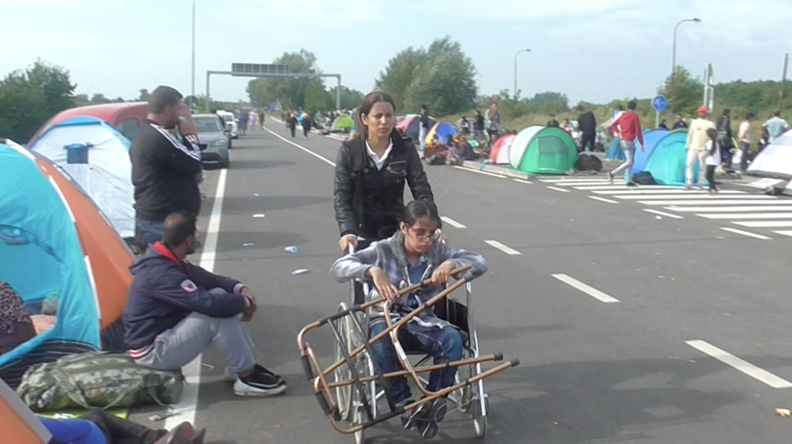
Photocopiable Resource 2 (Which Responsibilities come with our Rights? Main).
Below are some of our responsibilities in modern society. Which right matches which responsibility?
RESPONSIBILITY | RIGHT
A. University students: avoid disrupting other people’s learning (i.e. conduct yourself appropriately in seminars). | ……………………………………………………………………………  …………………………………………………………………………….
B. Employers: provide your employees with daily breaks and with paid annual leave. | ……………………………………………………………………………  …………………………………………………………………………….
C. Government: treat with compassion refugees and asylum seekers who arrive in your country. | ……………………………………………………………………………  …………………………………………………………………………….
D. Protestors: use non-offensive banners (e.g. avoid language that incites racial hatred). | ……………………………………………………………………………  …………………………………………………………………………….
E. Schools: provide children with internet access, protecting them from inappropriate websites. | ……………………………………………………………………………  …………………………………………………………………………….
F. Charities: promote key messages from important documents such as ‘The Universal Declaration of Human Rights’. | ……………………………………………………………………………  …………………………………………………………………………….
G. Social workers: ensure that strategies are in place to tackle poverty and neglect. | ……………………………………………………………………………  …………………………………………………………………………….
H. Religious leaders: avoid threatening/harming citizens who do not agree with your views on faith. | ……………………………………………………………………………  …………………………………………………………………………….
I. Judges: assume that all defendants are innocent until proven guilty. | ……………………………………………………………………………  …………………………………………………………………………….
J. Doctors: arrange for appropriate guidance, support and protection for children who you suspect to be sex workers. | ……………………………………………………………………………  …………………………………………………………………………….
K. Libraries: promote key facts about polling station locations and about elections dates. | ……………………………………………………………………………  …………………………………………………………………………….
L. Local council: make information freely available about where people can get married (stately homes, religious buildings etc). | ……………………………………………………………………………  …………………………………………………………………………….
M. Estate agents: ensure that clients from all ethnic backgrounds can view the houses that you advertise. | ……………………………………………………………………………  …………………………………………………………………………….
N. Police officers: avoid a culture in which movement between cities is arranged through bribes. | ……………………………………………………………………………  …………………………………………………………………………….
O. Trade unions: campaign about the prejudice that certain groups (e.g. women) experience in the workplace. | ……………………………………………………………………………  …………………………………………………………………………….
Photocopiable Resource 3 (Rights to Match Responsibilities: Main).
WITH RIGHTS COME RESPONSIBILITIES!
Look at the right you have been given. Find the student with the responsibility that matches it.
2. Right to an adequate standard of living.

1. Right to access information via the mass media.

4. Right to freedom from exploitation.

3. Right to seek asylum.

6. Right to marriage.

5. Right to equal pay for equal work.

8. Right to a fair and transparent justice system.

7. Right to be informed about your rights.

10. Right to a religion/to not believe in a religion.
ds
9. Right to move freely in your own country.

12. Right to freedom of expression.

11. Right to leisure time/holidays.

14. Right to own property.

13. Right to take part in government (e.g. voting).

15. Right to an education.

Photocopiable Resource 4 (Answer: Main).
Correct answers for the rights/responsibilities matching activity:
RESPONSIBILITY | RIGHT
A. University students: avoid disrupting other people’s learning (i.e. conduct yourself appropriately in seminars). | 15. Right to an education.
B. Employers: provide your employees with daily breaks and with paid annual leave. | 11. Right to leisure time/holidays.
C. Government: treat with compassion refugees and asylum seekers who arrive in your country. | 3. Right to seek asylum.
D. Protestors: avoid using offensive banners (e.g. featuring language that incites racial hatred). | 12. Right to freedom of expression.
E. Schools: provide pupils with internet access, protecting them from inappropriate websites. | 1. Right to access information via the mass media.
F. Charities: promote key messages from important documents such as ‘The Universal Declaration of Human Rights’. | 7. Right to be informed about your rights.
G. Social workers: ensure that strategies are in place to tackle poverty and neglect. | 2. Right to an adequate standard of living.
H. Religious leaders: avoid threatening/harming citizens who do not agree with your view on the world. | 10. Right to a religion/to not believe in a religion.
I. Judges: assume that all defendants are innocent until proven guilty. | 8. Right to a fair and transparent justice system.
J. Doctors: arrange for appropriate guidance, support and protection for children who you suspect to be sex workers. | 4. Right to freedom from exploitation.
K. Libraries: promote key facts about polling station locations and about elections dates. | 13. Right to take part in government (e.g. voting).
L. Local council: make information freely available about where people can get married (stately homes, religious buildings etc). | 6. Right to marriage.
M. Estate agents: ensure that clients from all ethnic backgrounds can view the houses that you advertise. | 14. Right to own property.
N. Police officers: avoid a culture in which movement between cities is arranged through bribes. | 9. Right to move freely in your own country.
O. Trade unions: campaign about the prejudice that certain groups (e.g. women) experience in the workplace. | 5. Right to equal pay for equal work.

