**KS4 PSHCE LESSON PLAN.**

|  |  |  |
| --- | --- | --- |
| DATE: LESSON FOCUS: **How do Organisations such as UNICEF Support Refugees and Asylum Seekers?** | | |
| Number of male students: | Number of SEN students: | Last lesson’s focus: |
| Number of female students: | Number of G & T students: | Next lesson’s focus: |
| Class/year group: | Misc: | |

**LESSON OBJECTIVES.**

* (1) I can find out how organisations such as UNICEF support refugees and asylum seekers.
* (2) I can decide how my school could do more to support refugees and asylum seekers.

**STARTER.**

* Share LOs with class.
* Refer class to LO1 for this starter activity.
* In small groups, read book excerpt (Photocopiable Resource 1). Excerpt refers to Nujeen’s home in Aleppo.
* Reinforce to class that there are millions of vulnerable families worldwide who wish to flee their home country, and that various organisations support with this process.
* Ask students to solve the anagrams on Photocopiable Resource 2. Solving the anagrams will uncover key facts about organisations that support refugees and asylum seekers.
* Answers: 1 = Turkey, 2 = population, 3 = sewage, 4 = translation, 5 = exhausted, 6 = refugee, 7 = local and 8 = Facebook.

**MAIN.**

* Refer class to LO2 for this main activity.
* Put class into groups of 3/4. Each group has fifteen minutes to plan an activity/project/event that the school could run in order to support refugees and asylum seekers.
* Give each group Photocopiable Resource 3 (What could we do to help?) and ask them to write down their plan. Suggestions are provided on the worksheet, to trigger thought.
* Have a class vote. Which group’s idea should be taken forward?
* Once the winner has been voted for, ask the winning group to see you after the lesson in order to agree on how the class will put their plan into action.

**PLENARY.**

* Put class into groups of 5/6. Ask each group to think of three reasons why specialist organisations are important to young citizens like Nujeen; citizens who feel they have no choice but to leave their own country. Refer students back to the book excerpt if necessary.
* Ask a spokesperson from each group to feed back. Suggested answers include to ensure that young adults across the world have access to an education no matter what their background is, to reunite families who become separated in the journey from one country to another, to ensure that young people are not exploited once they arrive in a new country (e.g. sold drugs or forced into the sex trade), to provide basics such as food, shelter and healthcare to families who’ve spent their life savings on escaping from their own country, to provide long-term support to refugees via language lessons and community activities, to support the victims of racism or hate crime etc.

**SEN SUPPORT.**

* For starter activity, provide first letter of each missing word.

**G & T SUPPORT.**

* For main activity, ask students to devise an activity/event/project aimed at *changing students’ perceptions of refugees and asylum seekers* – for the better. Steer them away from ‘simple’ fundraising ideas such as a cake sale.

**HOMEWORK/STRETCH TASK.**

* Choose five organisations that work with refugees and/or asylum seekers. For each of these organisations, provide a fact (not covered in this lesson) about one of their current campaigns.

**Photocopiable Resource 1 (Excerpt from ‘Nujeen’, p68: Starter).**

*Can birds sense bombing coming? It felt like it. Birds would stop singing and the air go taut and still as if time had stopped, then came the buzzing as the planes flew over, again and again. Once I saw a documentary that said honeybees can be trained to sniff out explosives – how weird is that?*

*When the raids started people would rush to basement shelters, but of course I couldn’t. My family wouldn’t leave me, so we all sat there on the fifth floor as sometimes the building shook and the windows rattled, everyone trying not to look scared. Often I cried, but I was allowed to because I was the youngest and disabled.*

*Once the bombers had gone, my siblings would go to the balcony where we could see columns of grey smoke rising from the shelling. I went once but not again. It was an awful*

*feeling, to know that in those places people were almost certainly dead, families like ours buried under concrete. It was a feeling mixed with relief that it wasn’t us. Is that wrong?*

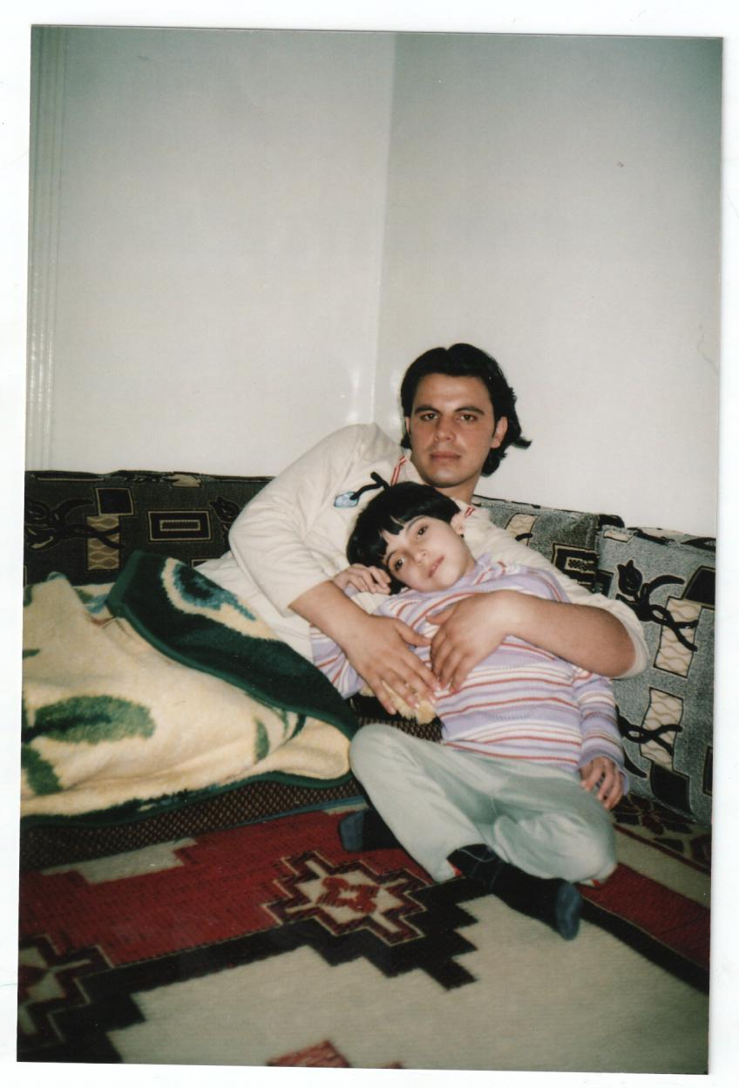

**PHotocopiable Resource 2 (Anagrams: Starter).**

WHICH ORGANISATIONS HELP REFUGEES AND ASYLUM SEEKERS?

*Unscramble the anagrams below in order to uncover important facts:*

WHICH ORGANISATIONS HELP REFUGEES AND ASYLUM SEEKERS?

* **UNICEF** (the United Nations International Children’s Emergency Fund) has recently done a lot of work with children affected by the Syrian refugee crisis. This help has been in Syria itself as well as in (1) _ _ _ _ _ _ [ryuTek], Egypt, Jordan, Syria, Lebanon and Iraq.
* UNICEF has calculated that children comprise 51% of the refugee (2) _ _ _ _ _ _ _ _ _ _ [laponotipu] generated by the crisis in Syria.
* There are many UNICEF projects aimed at the refugees, including counselling and schooling for affected children, the provision of vaccinations and nutritional supplements, and enabling access to (3) _ _ _ _ _ _ [gesawe] systems and to clean water.
* **Islamic Relief** sent volunteers to Greece, to help Syrians who arrived there by boat. They provided them with maps, food, advice and (4) _ _ _ _ _ _ _ _ _ _ _ [alatiotrnns].
* **The Red Cross** created a special reception centre on the Greek island of Lesbos. This centre was aimed at providing advice, beds and food to (5) _ _ _ _ _ _ _ _ _ [stehaexud] families.
* **The Refugee Council** helps asylum seekers who arrive in the UK, e.g. by giving free access to legal advice about next steps. It also supports people who’ve been given (6) _ _ _ _ _ _ _ [efuerge] status, e.g. to find accommodation and to work here.
* **Many other organisations** support refugees and asylum seekers, some on a (7) _ _ _ _ _ [oclla] level and some on a national/international basis. For example, lots of (8) _ _ _ _ _ _ _ _ [ebacokFo] groups have been set up in order to provide cars, mobile phones and clothing to vulnerable people who have fled their own country.

 

 

**Photocopiable Resource 3 (Ideas for School Activity: Main).**

WHAT COULD WE DO TO HELP?

*Write down your group’s plan for how your school can help refugees and asylum seekers:*

**OUR PLAN:** …………………………………………………………………………………………………………………………. ……………………………………………………………………………………………………………………………………………………………………………………………………………………………………………………………………………………………………………………………………………………………………………………………………………………………………………………………………………………………………………………………………………………………………………………………………………………………………………………………………………………………………………………………………………………………………………………………………………………………………………………………………………………………………………………………………………………………………………………………………………………………………………………………………………………………………………………………………………………………………………………………………………………………………………………………………………………………………………………………………………………………………………………………………………………………………………………………………