KS4 PSHCE LESSON PLAN.
DATE: LESSON FOCUS: How do the Media Portray Refugees and Asylum Seekers?
Number of male students: | Number of SEN students: | Last lesson’s focus:
Number of female students: | Number of G & T students: | Next lesson’s focus:
Class/year group: | Misc:

LESSON OBJECTIVES.

- (1) I can explore how the media portray refugees and asylum seekers.
- (2) I can describe how media bias affects the public’s perception of refugees and asylum seekers.

STARTER.
- Share LOs with class.
- Refer class to LO1 for this starter activity.
- Ask small groups to spend 90 seconds discussing how refugees and asylum seekers are commonly portrayed by the media (i.e. on the TV news, via social media, in newspapers, on documentaries etc).
- Give each group Photocopiable Resource 1 (How do the Media Portray Refugees and Asylum Seekers?). Ask them to tick media portrayal angles that are commonly used. Groups should also add their own ideas at the bottom of the sheet.
- Ask each group to leave their own worksheet on the table. Ask all students to walk around the room reading everyone else’s work.
- Ask volunteers to comment on whether the media usually portray refugees and asylum seekers in a positive or negative light. Encourage them to consider concepts such as stereotyping.
- Teacher prompts for discussion:
- Why is a story about a refugee/asylum seeker committing a crime more likely to sell newspapers than a refugee/asylum seeker leading a crime-free lifestyle? (Encourage students to think about soap operas…would Hollyoaks viewers be hooked by endless episodes about people going to work, eating their tea, ironing, paying their bills etc - or do the public find storylines about drugs, violence, fraud and betrayal more exciting to watch?).
- Do all websites, TV programmes and newspapers portray refugees and asylum seekers in the same way? Do ‘The Guardian’ and ‘The Mail’, for example, use the same approach?
MAIN.
- Refer class to LO2 for this main activity.
- Ask students to read book excerpt (Photocopiable Resource 2). The context for this excerpt is Nujeen’s safe arrival in Germany, after her arduous journey from Syria.
- Tell students they are going to devise a short drama performance about how media bias against refugees and asylum seekers affects the public’s perception of these individuals.
- Put class into groups of six. Each group member should choose a different character from Photocopiable Resource 3 (Drama Activity). Characters’ gender/names can be changed if necessary.
- Tell groups that they should each produce a piece of drama (lasting approximately two minutes) in which there are five scenes. In each of the five scenes, Ammar encounters one of the other characters at a different point in his day.
- Examples of piece of drama:
Scene 1 – Ammar rings Katy to ask if the house she’s renting out on Gumtree is still available. Once Katy hears that he’s from Syria, she makes what is clearly an excuse about the house having just been rented.
Scene 2 – Ammar sees Micah (who’s in Ammar’s son’s class) at the school gates when he drops off his son. Ammar asks Micah why he hasn’t been for tea for a while. Micah gets flustered and avoids eye contact with Ammar, saying he’s been too busy with homework.
Scene 3 – Ammar rings Imran to ask for legal advice about his refugee status. Imran says that it would be best to ring another firm because he’s got a heavy workload.
Scene 4 – Ammar goes to a shop to buy an evening meal for his family. He is asked by Saima to leave his gym bag at the entrance of the shop.
Scene 5 – Ammar returns home and greets Diane (one of his new neighbours, who’s taking her bin out). She completely ignores him, crossing the street to talk to another neighbour instead.
- Invite two groups to perform their piece of drama.
- After each performance, ask the audience to explain how media bias affected the way in which Ammar was treated.
PLENARY.
- Put class into pairs. Each pair sits in silence with Photocopiable Resource 4 (Silent Discussion) on the table between them.
- Ask pairs to follow instructions on sheet. Aim is to have a written discussion (no speaking allowed!) about how they’ll respond to media bias against refugees and asylum seekers in the future. In other words, what has this lesson taught them about the need for a more critical consumption of what the media show and say?
- Before they start writing, refer students to useful ideas section at bottom of worksheet.
- Invite volunteers to read out their discussions. Praise pairs who thought of ideas that weren’t on the worksheet.
SEN SUPPORT.
- For starter activity, ensure SEN students are in groups with G & T students.
G & T SUPPORT.
- For main activity, invite G & T students to incorporate other characters into the scenes, e.g. a student might play Diane in one scene and Ammar’s wife in another.
HOMEWORK/STRETCH TASK.
- Next lesson, bring a newspaper/magazine article or a website link that portrays a refugee or an asylum seeker in a very positive light.

Photocopiable Resource 1 (How do the Media Portray Refugees and Asylum Seekers? Starter).
HOW DO NEWSPAPERS, TV AND SOCIAL MEDIA PORTRAY REFUGEES AND ASYLUM SEEKERS?
Tick media angles that are commonly used:
The media often uses negative terms when discussing refugees and asylum seekers: ‘the strain on the NHS’, ‘the pressure on the education system’, ‘the draining of our resources’ etc.

The media often accuse refugees and asylum seekers of taking the jobs and houses of British-born people.

The media often encourage us to view refugees and asylum seekers as unique individuals (as opposed to a huge group of people, all with similar personalities).

The media go out of their way to promote inspirational stories about refugees and asylum seekers who make positive contributions to UK society.

The media focus on the so-called leniency of UK border control and imply that ‘anyone’ is allowed to stay in our country once they arrive.

Imply that
The media regularly remind us that the right to seek asylum is one of everyone’s basic human rights. The media also encourage us to be sympathetic towards refugees and asylum seekers.

The media portray refugees and asylum seekers as ‘lazy benefit scroungers’ who refuse to learn English or to integrate.

The media blame refugees and asylum seekers for most issues linked to terrorism and religious extremism.

Newspaper headlines are more likely to focus on a refugee/asylum seeker who is law-abiding than a refugee/asylum seeker who committed a crime.

Add your own ideas below. How else do the media often portray asylum seekers?

Photocopiable Resource 2 (Excerpt from ‘Nujeen’, pp. 234 -235: Main).
There is only one black cloud over our new home – the people upstairs don’t like us. They are a middle-aged German couple with a grown-up son and as soon as we moved in they complained to Social Services: why do we have refugees downstairs? Once Nahda’s children were playing and the woman came out screaming like a baddie from a movie and called the police. We were scared that maybe we would be taken away, so we try to be very quiet and stop the children from making any noise so she won’t complain. Even so, she still shouts at us a lot.

We were shocked that somebody would have a problem with us – we are just a group of young women and little girls and my sisters always keep everything spotlessly clean. We wear jeans and shirts, not some kind of Daesh hijab. I guess she has a problem with refugees, not with us in particular. I hadn’t really thought about what it meant to be a refugee, that you have no rights, and that people might be intimidated and look at you as aliens or as people with no lives who kill each other, not realizing that we do the same as them – get up in the morning, brush our teeth and go to school or work.

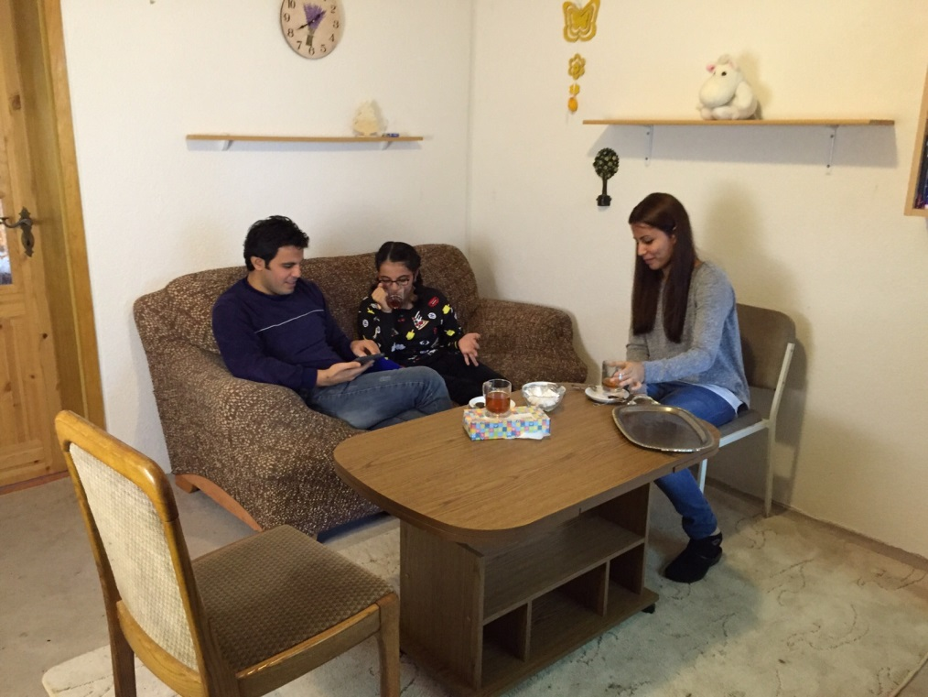

Photocopiable Resource 3 (Drama Activity: Main).
HOW DOES MEDIA BIAS AFFECT THE PUBLIC’S PERCEPTION OF REFUGEES AND ASYLUM SEEKERS?
Each person in your group will play one of the characters below:
I’m Katy and I’m a landlady. I saw an online report last week about a refugee family vandalising the garden in a rental property. Since seeing that, I’ve decided that it’s best to only rent out my properties to British-born tenants. That way, I’m not losing sleep about damage to my houses. I don’t want to worry about vandalism.
I’m Micah and I’m in year 8. My mum showed me a YouTube clip last month where a refugee beat up a British boy on a school field. Now I feel scared of some of the pupils in my class. They seem peaceful and normal on the surface but I don’t want to take any risks. It’s safer to avoid eye contact with them and leave them to make friends with people like them.

I’m Imran and I’m a lawyer. I personally don’t have any issue with refugees and asylum seekers. However, I admit that I avoid cases where I’m asked to represent refugees and asylum seekers. Those people get such negative press that I don’t want to become a lawyer specialising in immigration issues. This is for one simple reason –it could put off other clients from choosing me.

I’m Saima, a manager in a local shop. I’ve read so much in the papers about refugees and asylum seekers stealing. I take those articles really seriously because my shop’s in an area where lots of refugees live. I’ve asked my security staff to keep a close eye on anyone in the store who looks like a refugee. I know it sounds judgemental, but I can’t afford for profits to drop.

I’m Ammar, a 28-year old doctor. I arrived here from Syria as an asylum seeker last year. Luckily, we were given permission to stay – it was the happiest day of my life because my kids no longer witness death and destruction on a daily basis. My wife and I are keen to get permanent jobs in the NHS. Our dream is to both work full-time in order to save up for a deposit on a house.
I’m Diane, a retired engineer. My friend sent me a Facebook link about of a refugee family living in council accommodation. It made me furious. I’ve worked hard and spent 45 years paying my mortgage. Why should these people come into our country and get handouts? I make a point of blanking any refugees I meet. If everyone started to do that, they might go home.

Photocopiable Resource 4 (Silent Discussion: Plenary).
With your partner, have a silent discussion (speaking not allowed!) about the important question below. Student 1 should respond to the question first in writing. Student 2 will then respond to student 1’s comment. Student 2 will then respond to that, and so on:
HOW WILL I RESPOND TO MEDIA BIAS ABOUT REFUGEES AND ASYLUM SEEKERS IN THE FUTURE WHEN I ENCOUNTER IT?
USEFUL IDEAS: COMPLAIN TO THE BROADCASTER/PUBLISHER, CAMPAIGN ON SOCIAL MEDIA, REMEMBER THAT BAD NEWS HEADLINES (RAPE ALLEGATION!) SELL BETTER THAN GOOD NEWS (TAX PAYER!), POINT OUT ANY BIAS TO MY FAMILY, REMIND MYSELF THAT THE MEDIA OFTEN DEHUMANISE REFUGEES AND ASYLUM SEEKERS BY DESCRIBING THEM IN NON-HUMAN TERMS, E.G. ‘SWARMS OF REFUGEES’.

Student 1’s response: ____________________________________________________________ _____________________________________________________________________________ _______________________________________________________________________________________________________________________________________________________________

Student 2’s response: ____________________________________________________________ _____________________________________________________________________________ ______________________________________________________________________________________________________________________________________________________________

Student 1’s response: ____________________________________________________________ _____________________________________________________________________________ ______________________________________________________________________________________________________________________________________________________________

Student 2’s response: ____________________________________________________________ _____________________________________________________________________________ ______________________________________________________________________________________________________________________________________________________________

Continue writing on the back of the page if you have more ideas!

