KS4 PSHCE LESSON PLAN.
** FOR THIS LESSON, YOU’LL NEED A ‘WASHING LINE’ AND TEN PEGS. **
DATE: LESSON FOCUS: Making Informed Choices
Number of male students: | Number of SEN students: | Last lesson’s focus:
Number of female students: | Number of G & T students: | Next lesson’s focus:
Class/year group: | Misc:

LESSON OBJECTIVES.

- (1) I can find out what an informed choice is.
- (2) I can improve my ability to make informed choices.

STARTER.
- Share LOs with class.
- Refer class to LO1 for this starter activity.
- Ask a volunteer to read the ‘Nujeen’ book excerpt from Photocopiable Resource 1.
- Ask pairs to discuss why the imagery of Syria as a burning house (see last paragraph) is appropriate.
- Ask a few volunteers to feed back their answers.
- Example of a good answer: Describing Syria as ‘like being in a burning house’ is a good simile for two main reasons. Firstly, flames remind us of all the horrendous bombing that was taking place in Syria at the time that Nujeen’s family fled. Secondly, the image of a burning house emphasises the fact that citizens like Nujeen had to leave their country out of sheer desperation. In other words, they had no choice but to leave; they would face imminent death otherwise.
MAIN.
- Tell class that they will continue to focus on LO1 for the first part of this main activity.
- Ask a volunteer to describe what an informed choice is.
- Make sure that the class all know the correct answer: An informed choice is when you decide what to do only once you’ve found out lots of important information that’s relevant to your decision. Nujeen and her family didn’t have the luxury of an informed choice. This is because they not only had to leave their country against their will, but they had to leave as quickly as possible.
- Tell the class that you will read out six choices made by different citizens. Ask students to show an outstretched palm if they think the choice was informed, and to show a clenched fist if the choice was uninformed. See Photocopiable Resource 2 (Informed Choices) for these six choices and the correct answers.
- Refer class to LO2.
- Tie a ‘washing line’ across the length of the classroom. Tell the class that you’re pegging up ten tips for making informed choices. See Photocopiable Resource 3 (Tips for Making Informed Choices): enlarge the tips from this teacher resource worksheet. Ask class if they need clarification on what any of the tips mean.
- Put class into ten groups. Ask one member from each group to unpeg a tip from the washing line and take it back to their table.
- Tell each group to spend three minutes discussing why this tip is necessary when making an informed choice. Ask a few spokespersons for feedback.
- Repeat the process, i.e. each group pegs their first tip back up and collects a second tip to discuss for three minutes. Repeat again.
- Examples of good feedback from group spokespersons:
- We were discussing why it’s important to think about how our choices can affect other people. Luke made a really good point which was about safety. Let’s say a yr-10 student decides to start smoking in her room every time her parents go out. This could be really dangerous to her younger siblings if she accidentally starts a fire.
- Our group was focused on why you should avoid being very tired or very emotional when making an important choice. We imagined a yr-13 student who’s deciding whether to go to university in his home town or to go somewhere four hours away. If he’s in the middle of a huge row with his dad, he’ll probably feel desperate to get as far away from home as possible! A few days later however, once he’s made up with his dad, he might realise that living at home for university is the best option for him.
- The tip we chose was the one about making sure you have a contingency plan. We think this is really important when you make a choice about something. For example, say that you’re going travelling on your gap year and you’ve decided to carry all of your spending money in a money belt. A sensible contingency plan, in case the belt gets stolen, is to always carry emergency money in US dollars in your socks. It would be even better to also have an emergency credit card in a zipped pocket in your clothing.
PLENARY.
- Give students Photocopiable Resource 4 (Why are Informed Choices Important?).
- Ask them to re-read through the ten tips that were used in the washing line activity.
- Tell students to complete the paragraph at the bottom of the worksheet, summarising why it is important to make informed choices when we can (remind class about Nujeen’s family: we do not always have the time or resources to make a choice that is as informed as we would like).
- Example of a good paragraph:
When we are making a choice, we should make sure that it’s an INFORMED choice. This is really important because an informed choice can prevent us from making a mistake that affects our physical, mental or financial health. It also helps us to avoid doing something that we regret or that harms others. Informed choices rely on taking advice from people we trust and/or experts (to weigh up the pros and cons of what we decide). It’s also useful to decide if a contingency plan’s needed and whether we’re being influenced by peer pressure or tiredness. Obviously none of us can predict the future. However, at least an informed choice gives us confidence that we made the best decision with the information that we had!
SEN SUPPORT.
- For the washing line activity (main), prompt students about specific choices that they might be making over the next few months, e.g. what to study in year 12, whether it’s a good idea to get a part-time job or which new phone they should get when their contract runs out.
G & T SUPPORT.
- For the washing line activity (main), ask students to imagine that they’re a citizen with a lot of responsibility in society, e.g. an MP, a surgeon or a large business owner. Why is making informed choices especially relevant for such a citizen?
HOMEWORK/STRETCH TASK.
- Make a list of at least three choices you will need to make in the next year. For one of these choices, explain how you are going to make sure that it’s an informed choice.

Photocopiable Resource 1 (Excerpt from Nujeen, pp 132 - 133: Starter).
Read this excerpt from the book ‘Nujeen’:
Funny, after all the war documentaries I’d watched I had always thought of the Germans as the bad guys, and now they were our saviours. Maybe Mrs Merkel was trying to make amends for the past and Hitler, or maybe she was different because she grew up in East Germany behind the Berlin Wall which was built when she was seven.

Everyone in the café was trying to arrange passage to Greece. Some like us had come by road and plane, others by road the whole way. Many said they had sold all they had to come here, including heirlooms and family homes, or had borrowed money. One man said he had even met someone who had sold his kidney to fund the trip.

Some had already tried the crossing. We met one family who had failed because their dinghy was too overloaded and quickly sank. But they were trying again. ‘Either you die from shelling in Syria or you die at sea,’ shrugged the father. Though the Aegean crossing was much shorter and nowhere near as dangerous as the open sea between Libya and Lampedusa, at least fifty people had drowned making the crossing so far that year. ‘There’s no life left in Syria’ agreed someone else. ‘It’s like being in a burning house – it’s risky to jump out of the window, but what’s the alternative?’

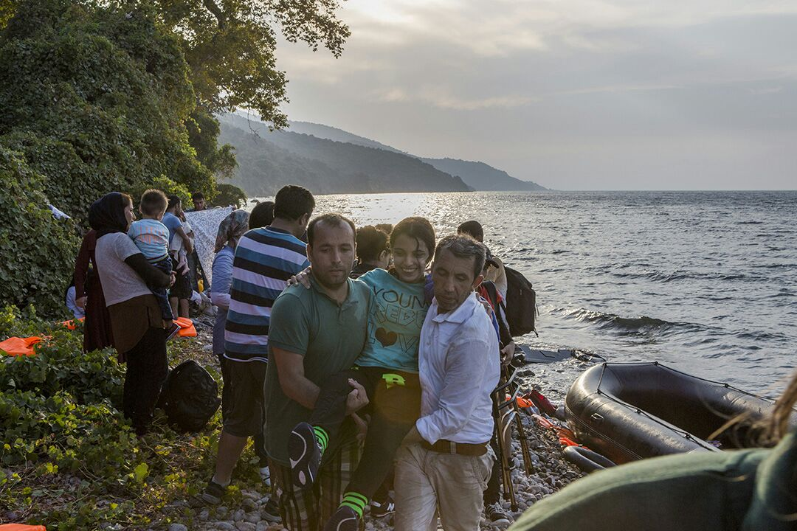
Photocopiable Resource 2 (Informed Choices: Main). TEACHER RESOURCE.
Read these out to students. They have to decide whether each choice is informed or uninformed:
1. I’ve just bought the first mobile phone I saw in a shop, because I dropped my old one this morning and I need a new one for tonight. I didn’t have time to read about my new contract or find out about the phone’s camera. (UNINFORMED).
2. I’ve decided to go to Manchester University. I’ve been to five open days across the UK and I liked Manchester best. The city’s size suits me, plus I’ve checked that I’ll have wheelchair access to everywhere I need for my course. (INFORMED).
3. I’m moving out of home soon and I’ve been weighing up whether to rent somewhere or buy my first house. I’ve taken advice from a friend who’s a property developer. I’ve also spoken to two local estate agents and had a mortgage approved in principle by my bank. I’ve created a spreadsheet too. It shows that I’ll save about £100 a month over the next three years if I buy somewhere, instead of renting. In three months, if property prices have stayed roughly the same, I’m going to buy a house near a good school. (INFORMED).
4. I’ve had painful breathing problems all morning. I’ve never had them before and I’m only fifteen, so I reckon it’s nothing serious. I’m not going to mention it to anyone because I’m home on my own this weekend and don’t want the hassle of booking a doctor’s appointment. I’d rather stay here and sleep. (UNINFORMED).
5. I’ve done lots of research on cannabis over the last few weeks, because I wanted to work out whether I should stop smoking it. I’ve looked at reputable websites and decided that there are lots of pros and cons. On one hand, it’s illegal - which makes it impossible to know the THC levels of what you buy. It can also lead to long-term psychosis. On the other hand, it alleviates physical pain and is much less likely to make someone aggressive/abusive than alcohol. All things considered, I’ve decide to quit by my 40th birthday next month. (INFORMED).
6. I’ve never been running. However, I’m five-stone overweight so I’ve decided to train for a marathon. I’m going to start getting fit tomorrow by drinking three energy drinks and then doing a ten-mile run. I’m not going to read any training advice because I’ll find it too boring. (UNINFORMED).

Photocopiable Resource 3 (Tips for Making Informed Choices: Main). TEACHER RESOURCE.
Enlarge (separately) each of these ten ‘tips for making informed choices’. Then peg each one to a different part of your washing line:
1. Get lots of information from experts and from people you trust about the choice you’re making.
2. Ask yourself how this choice will affect your mental health, physical health and financial health.
3. Work out what level of RISK you are willing to take when making this choice.
4. Once you have enough information, WEIGH UP THE ADVANTAGES AND THE DISADVANTAGES (e.g. write them down).
5. Think about how your choice will AFFECT OTHER PEOPLE.
6. Work out whether you are letting peer pressure influence your decision-making.
7. Avoid feeling VERY TIRED OR VERY EMOTIONAL when making your choice.
8. Accept that you will never be able to rule out uncertainty. The future is always unknown!
9. Decide on a CONTINGENCY PLAN (in case things go wrong).
10. Ask yourself how you might feel about your choice IN THE FUTURE. How will you feel in ten hours? In ten months? In ten years?

Photocopiable Resource 4 (Why are Informed Choices Important? Plenary).
Remind yourself of the ten tips for making informed choices. Use these to complete the paragraph at the bottom of the page:
HOW SHOULD I MAKE AN INFORMED CHOICE?
1. Get lots of information from experts and from people you trust about the choice you’re making.
2. Ask yourself how this choice will affect your mental health, physical health and financial health.
3. Work out what level of RISK you are willing to take when making this choice.
4. Once you have enough information, WEIGH UP THE ADVANTAGES AND THE DISADVANTAGES (e.g. write them down).
5. Think about how your choice will AFFECT OTHER PEOPLE.
6. Work out whether you are letting peer pressure influence your decision-making.
7. Avoid feeling VERY TIRED OR VERY EMOTIONAL when making your choice.
8. Accept that you will never be able to rule out uncertainty. The future is always unknown!
9. Decide on a CONTINGENCY PLAN (in case things go wrong).
10. Ask yourself how you might feel about your choice IN THE FUTURE. How will you feel in ten hours? In ten months? In ten years?

When we are making a choice, we should make sure that it’s an INFORMED choice. This is really important because …….. ………………………………………………………………………………………………………………………………………………………………………………………….………………………………………………………………………………………………………………………………………………………………………………………….………………………………………………………………………………………………………………………………………………………………………………………….………………………………………………………………………………………………………………………………………………………………………………………….

