KS4 PSHCE LESSON PLAN.
** BEFORE THE LESSON, YOU’LL NEED TO STICK EIGHT PIECES OF PAPER AROUND THE ROOM. **
DATE: LESSON FOCUS: Thinking Critically about Social Issues
Number of male students: | Number of SEN students: | Last lesson’s focus:
Number of female students: | Number of G & T students: | Next lesson’s focus:
Class/year group: | Misc:

LESSON OBJECTIVES.

- (1) I can find out more about critical thinking.
- (2) I can start to think critically about social issues.

STARTER.
- Share LOs with class.
- Refer class to LO1 for this starter activity.
- Ask students to read the ‘Nujeen’ book excerpt on Photocopiable Resource 1.
- Ask students to think about Nujeen’s question: If you don’t want to let refugees in for humanitarian reasons, what about the benefit we bring to the economy?
- Ask a volunteer to comment on what is intelligent about Nujeen’s question.
- Example of a good answer: Nujeen acknowledges that certain people don’t feel compelled to host refugees in their country on moral grounds. However, she also recognises that those same people might want refugees to live in their country because of the financial gains that immigrants can bring (e.g. through paying taxes and buying goods and services).
- Tell class that Nujeen’s line of reasoning is an example of critical thinking (a concept to be explored in the next activity).

MAIN.
- Tell class that the focus will continue to be on LO1 for the first part of this main activity.
- Enlarge the eight key skills on Photocopiable Resource 2 (What is Critical Thinking?).
- Stick up all eight key skills separately at eye level (one on the door, one on the window, one on the back wall etc).
- Ask 6-8 students to stand up. Tell this small group that you are going to read them the definition of one of the important key skills needed in critical thinking. Challenge the students in this small group to stand next to the key skill that matches that definition. Praise those who get it right, checking that all students are aware of which key skill is the correct answer. The definitions are on the bottom half of Photocopiable Resource 2.
- Ask a different small group of students to stand up. Read them the definition of different key skill and ask them to stand by the correct key skill. Repeat process until all key skills/definitions have been matched.
- Refer class to LO2 for this main activity.
- Give students Photocopiable Resource 3 (Thinking Critically about Social Issues).
- Ask them to read the six characters’ views on why critical thinking is essential when thinking about social issues.
- Invite six volunteers to come to the front of the class and sit in a row, on ‘hot seats’. These students will play the roles of the six characters from the worksheet.
- Ask a member of the audience to choose a hot seat character and ask her/him to elaborate on their views. The hot seat character must then use/encourage critical thinking in their response. (Obviously, the hot seat character can use their imagination when elaborating on the information on the worksheet, provided their comments seem consistent with those on the worksheet).
- Repeat this process until all hot seat characters have spoken.
- Examples of good work:
Audience member: Caleb, how can you deny that there are equal rights for all children in British schools? As a teacher, you must be aware that every child has the right to know what level they’re working at and to know how to improve that level. Are you prejudiced towards white working-class males, which is why you view them as underachievers?
Caleb: I am a keen supporter of the achievement of white working-class males (and indeed of all my students, regardless of gender or class background). That’s why I run intervention sessions for all pupils who need extra help. These sessions are one of the reasons why 95% of my students achieved a grade A*- C in last year’s GCSEs. In more general terms, I think we have a moral obligation to scratch beneath the surface of the national curriculum. Is equality on paper the same as equality in practice? I really don’t think so. There was an interesting article in the Guardian this week about three main ways in which white working class males are being let down by schools. The article was based on some research that involved twenty schools and over 3000 male students. The researchers offer convincing evidence that the education system is geared towards middle class female pupils.
PLENARY.
- Give students Photocopiable Resource 4 (What are the Key Things I’ve Learnt Today?). Ask them to reflect on the main things that they have learnt in today’s lesson, by filling in the worksheet.
- Invite a few volunteers to share their reflections with the class.

SEN SUPPORT.
- For starter activity, ask students to name three things that we have access to thanks to money raised through taxation (examples: ‘free’ education for children, ‘free’ healthcare, street lights, bin collections, libraries, improvements to our roads etc).
G & T SUPPORT.
- For definition-matching activity (main), G & T students should be in the groups for ‘consider everything in the right context’, ‘analyse’ and/or ‘evaluate’.
HOMEWORK/STRETCH TASK.
- Choose an issue that you feel really strongly about. Now imagine that you are someone who holds the opposing viewpoint to yours on this issue. Write a paragraph from that person’s point of view, showing evidence of that person’s critical thinking skills.

Photocopiable Resource 1 (Excerpt from Nujeen, p 265: Starter).
Read this excerpt from the book ‘Nujeen’:

So here’s the thing as I see it. Yes, I know we are expensive. Looking after migrants in 2015 cost German taxpayers more than $23 billion, according to the Economic Research Institute in Munich. But give us a chance and we can contribute. If you don’t want to let refugees in for humanitarian reasons, what about the benefit we bring to the economy?

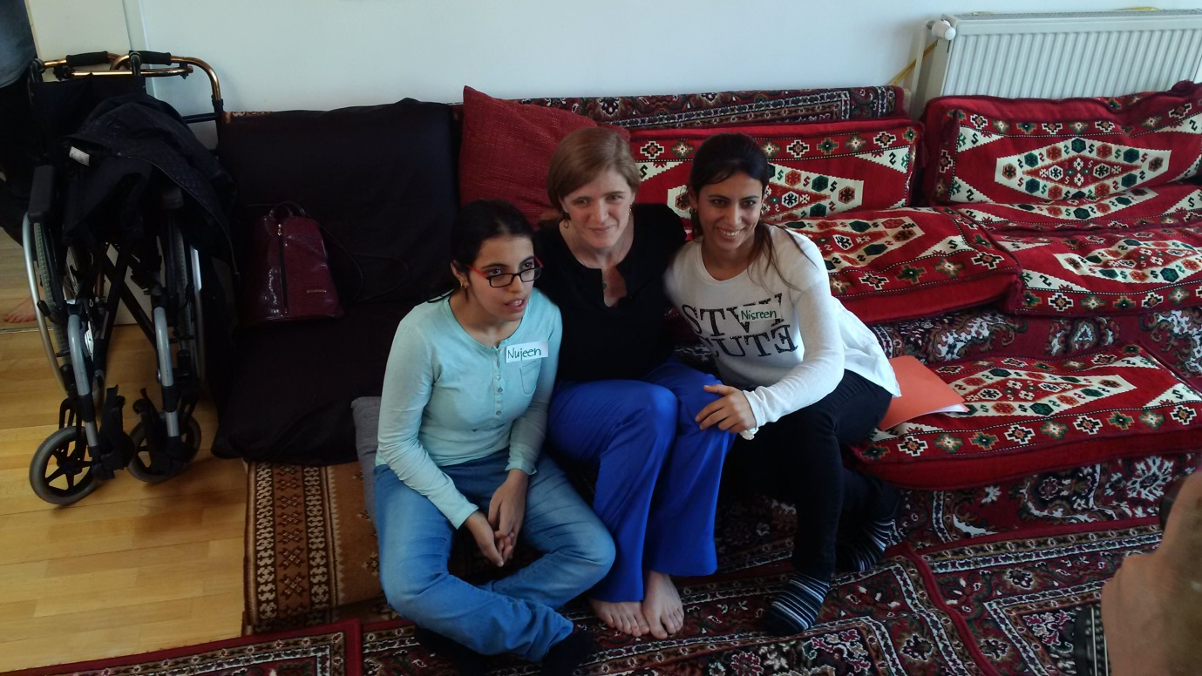

Photocopiable Resource 2 (What is Critical Thinking? Main). TEACHER RESOURCE.
WHAT ARE THE KEY SKILLS NECESSARY FOR CRITICAL THINKING?
Enlarge these key skills and stick them up at eye level in different areas of the room:
- Think clearly
- Be guided by good morals
- Consider everything in the right context
- Use evidence from good sources
- Take on board opposing viewpoints
- Reflect
- Analyse
- Evaluate
Answers:
- Think clearly:
Make sure that other issues are not clouding your opinions and decisions.
- Be guided by good morals:
Be fair, be tolerant and be compassionate.
- Consider everything in the right context:
Take into account the reasons why people might have acted in a certain way.
- Use evidence from good sources:
Look at information from expert researchers and from high-quality newspapers.
- Take on board opposing viewpoints:
Challenge your own opinions by considering the strongest alternative arguments.
- Reflect:
Think about the consequences of deciding what you decide.
- Analyse:
Discover more about something by examining it in detail.
- Evaluate:
Work out the importance or value of something.
Photocopiable Resource 3 (Thinking Critically about Social Issues: Main).
WHY IS IT ESSENTIAL TO THINK CRITICALLY ABOUT SOCIAL ISSUES?
Read about why the six characters below think it’s essential to think critically about social issues:
CALEB (teacher): People need to think more critically about our education system. The government says that the national curriculum gives equal rights to all students. If this is the case, then why are white working-class boys underperforming in exams year after year?

BETTIE (judge): People need to ask themselves whether the prison system is fit-for-purpose. I accept that some people have to be ‘removed’ from society for the safety of others. However, if the main point of prison is to rehabilitate, why do so many prisoners return to crime once they’re released?

MOHAMMED (psychiatrist): Society needs a completely new view on mental health. Even though it’s the 21st century, mental health is still a taboo subject for many people. If we continue to sweep mental illness under the carpet then we will overlook a quarter of the population!

RACHEL (police officer): Many people have a very blinkered view of the police force; whole communities perceive police officers as ‘the enemy’. Yet we protect victims of rape. We teach children about how to ride a bike safely. We arrest hit-and-run drivers. We give out free window alarms to deter burglars. Who can give a rational argument that these are the actions of the enemy?

TYRA (NHS manager): The way in which disability is viewed in the UK needs a radically fresh approach. Have you noticed that whenever a person with a disability is in a film, their disability is the main focus? It’s time we started viewing people primarily in terms of what they can do, rather than dwelling on what they can’t!

AKASH (full-time parent): I don’t want a ‘nanny state’ in which there’s CCTV in every family home. However, we must think more critically about how we’re parenting children in the UK. Why are the parents of obese children not being fined? This would be a win-win situation for these neglected children themselves, as well as for schools and hospitals.

Photocopiable Resource 4 (What are the Key Things I’ve Learnt Today? Plenary).
Think about the key things that you have learnt today. Then fill in the gaps below:
I’ve learnt that one of the key skills to think critically is …………………………………. …………………………………………………………………………………………………………………………..This is an important skill because ……………………………………………………………………… …………………………………………………………………………………………………………………………………………………………………………………………………………………………………………………………………………………………………………………………

Sometimes it takes a long time to decide what our opinions are on a particular issue because ……………………………………………………………………………………………….…… ……………………………………………………………………….…………………………………………………. …………………………………………………………………………………………………………………………………………………………………………………………………………………………………………………………
One thing that I’m going to do differently because of this lesson is ………………… …………………………………………………………………………………………………………………………… ……………………………………………………………………….…………………………………………………. ..………………………………………………………………………………………………………………………………………………………………………………………………………………………………………………………
In most jobs it’s really important to be a critical thinker. A good example of a job where critical thinking’s essential is ……………………….……………………………………. ……………………………………………………………………….…………………………………………………. …………………………………………………………………………………………………………………………………………………………………………………………………………………………………………………………

It’s vital to think critically about important social issues, such as the education system or immigration, because ……………………………………………………………………... ……………………………………………………………………….…………………………………………………. …………………………………………………………………………………………………………………………………………………………………………………………………………………………………………………………

