 Purple

Rhyming Words 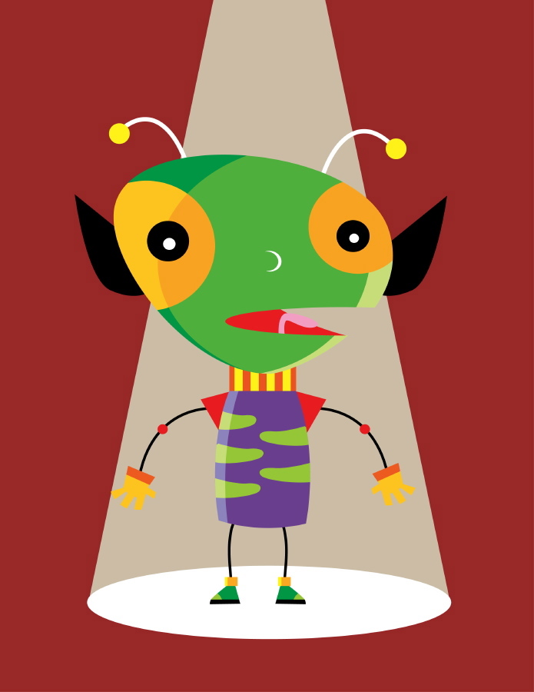

List the pairs of rhyming words on the following pages.

_____________ ________________ page 3

_____________ ________________ page 6

_____________ _______________ page 8

Draw a picture for each pair.

Red Cat and Dog in a Mess Band 2a Hunter Primary

Purple If Band 8 Hunter Primary

