

When Arthur wouldn’t sleep.
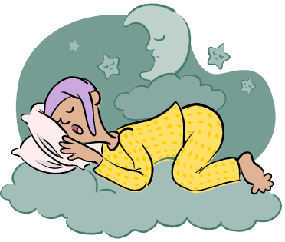
Answer the following questions in sentences in your jotter.

- What noises on Page 3 were preventing Arthur from sleeping?

- The hippo asked Arthur where he wanted to go. How did Arthur reply?

- What did the Ladybird remind Arthur he had to do?

- Describe what happened at the Crazylegs dancing competition.

- In the morning why could Arthur not tell Flora about the Crazylegs dancing competition.

Orange When Arthur wouldn’t sleep extra c Huunter Primary

