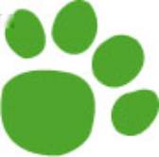

Match each animal to their favourite food.

worm worms

rabbit leaves

deer bark

beetle grass

bird earth

Draw a picture of one of the animals with their favourite food.

Green Worm looks for lunch 24a Hunter Primary

Write a sentence using each word. Don’t forget to start with a capital letter and finish with a full stop.

wiggled eating tried chewy twig earth

1.
2.
3.
4.
5.
6.

Green Worms looks for lunch 24b Hunter Primary

Write a sentence using each word. Don’t forget to start with a capital letter and finish with a full stop.

wiggled eating tried chewy twig earth

1.
2.
3.
4.
5.
6.

Green Worm Looks for Lunch 24c Hunter Primary

