

Answer the questions in a sentence. Use your book to help you. Don’t forget a capital letter and a full stop.

- What is a robot?
- What do robots look like?
- What do robots do?
- What is inside a robot?

Draw a robot from the future.

Blue Robots 18a Hunter Primary

Write some rhyming words and draw one picture for each rhyme.
job man sea
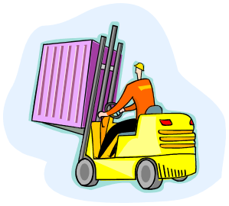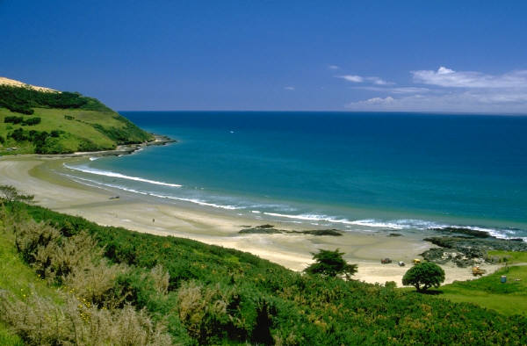
______________ ______________ _______________
______________ ______________ _______________
______________ ______________ _______________
______________ ______________ _______________

Blue Robots 18b Hunter Primary

Use your book to help you underline the correct ending for each sentence.
trick
A robot is a machine that does a job for you.
spell

cars.
Some tiny robots are as small as computers.
coins.

monkey.
Some big robots are bigger than a man.
mouse.

the bottom of the sea.
Robots can go to places like the bottom of the bin.
the bottom of the sandpit.

bumble bees
Some robots look for badgers
bombs.

What else have you learned about robots?

Blue Robots 18c Hunter Primary

