

Write some other funny ways to use an umbrella.

1.

2.

3.

4.

5.

Blue Mojo and Weeza and the Funny Thing 14a
Hunter Primary

Write some rhyming words and draw a picture for each picture.

boat tent rain  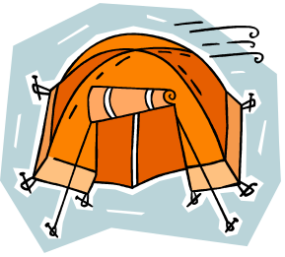 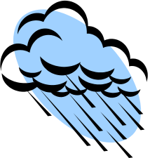
_____________ _____________ ____________
_____________ _____________ ____________
_____________ _____________ ____________

Blue Mojo and Weeza and the Funny Thing 14b

Hunter Primary

Use your book to help you underline the correct word for each sentence.

purple
Mojo and Weeza found a dirty thing.
funny

float
Mojo thought it was a boat but the boat didn’t sink
fly.

rhinocerous
The rocket didn’t take off.
rabbit

picnic
He climbed the tree and jumped but the parrot didn’t work.
parachute

bat
Mojo thought the umbrella was a ball
bath.

Blue Mojo and Weeza and the Funny Thing 14c
Hunter Primary

Number the pictures from the story so that they are in the correct order. Write a sentence for each picture.

Blue Mojo and Weeza Hunter Primary
and the Funny Thing 14d

