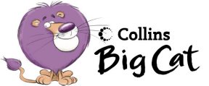Up Up And Away
Draw the pictures and copy the sentence.
Use your book to help you.

Over the house | Over the river
Over the mountain | Over the sea

Red 32a Hunter Primary

Up Up And Away
Write and illustrate your own story of a balloon journey.

My balloon went over……

Red 32b Hunter Primary

Up, Up And Away

True, false or don’t know?

The balloon went over the house. _____________

The balloon was blue. _____________

A fish was in the river. ____________________

The balloon went over the mountain. ___________

The balloon fell into the sea ______________

The balloon burst! ______________

The balloon went up, up and away….. draw where it went.

Red 32c Hunter Primary

Red32c Hunter Primary

