Tec And The Litter.
Where did Tec find the litter? Use your
book to help you find the answers.


The can was _______________________.

The banana skin was ________________

The packet was _____________________

The bottle top was __________________

Draw and write where Tec should put the litter on the back of your sheet.

Red 36a Hunter Primary

Red Hunter Primary

Tec And The Litter
Design a special badge to give to someone who always puts their litter in the bin.

Who will you give the badge to?

Why should they get the badge?

____________________________________________________

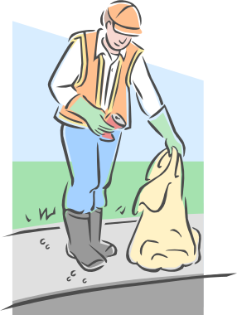

Red 36b Hunter Primary

