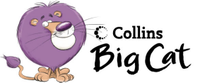

Write a Book Review

Your Task: Write a review of ‘Oliver’ to encourage others to read the book.

- Start with two or three sentences telling us about the book name and author.
- Then say a little about the story – remember not give too much of the story away! Mention some of the characters and little about their personalities e.g. Mr Bumble was cruel and mean but Mr Brownlow was kind and generous. Use good adjectives to describe them.
- Next explain why you like this book and any parts of the story that you didn’t like – why?
- Finally mention who would enjoy reading ‘Oliver’ – boys, girls or both and what age group you think it would suit.

Lime Oliver Hunter Primary

Write a Book Review

Your Task: Write a review of ‘Oliver’ to encourage others to read the book.

- Start with two or three sentences telling us about the book name and author.
- Then say a little about the story – remember not give too much of the story away! Mention some of the characters and little about their personalities e.g. Mr Bumble was cruel and mean but Mr Brownlow was kind and generous. Use good adjectives to describe them.
- Next explain why you like this book and any parts of the story that you didn’t like – why?
- Finally mention who would enjoy reading ‘Oliver’ – boys, girls or both and what age group you think it would suit.

Lime Oliver Hunter Primary

