

Cloud forest facts

Your task: to test your knowledge of the cloud forest facts.

You need: green paper torn or cut into six leaf shapes.

Now: Write a fact that you have learned about the cloud forest on your green leaf. Then stick your leaves on a piece of paper to make a big ferny green tree.
Give it a title “Cloud forest facts”. 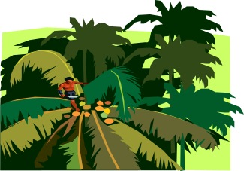

Lime Cloud forest Hunter Primary

Design a protest poster

Your task: to create a protest poster based on pages 30 and 31 of the book Cloud Forest.

You need: A 4 paper, crayons and your reading book.

Now: Study pages 30-31 in your reading book.
You are going to design a poster to try to encourage people to save the cloud forest. If you have the opportunity to use the internet, try to find out any extra information about the cloud forest and use it in your poster.
Ask your teacher for information about what makes a good poster.

Lime Cloud forest Hunter Primary

