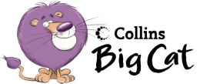
Name_______________________
Fly Away Home word wall
is | on | the | at | I
like | we | all | and | ladybird
tree | leaf | happy | shed | pond

Cats word wall
a | cat | has | eyes | ears
teeth | fur | legs | tail | one
two | three | four | five

The Big Splash word wall
she | is | big | getting | get
bath | boat | shark | flippers | goggles

The Pond word wall
can | see | we | a | pond
bird

