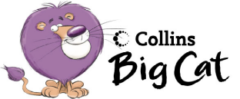The pond

Draw a picture of a pond and label all the animals.

Pink 21b Hunter Primary

Pink Hunter Primary

