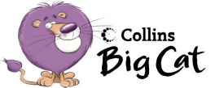Monster mess

Draw and label your own monster face

eyes nose mouth teeth ears horns

Pink 35b Hunter Primary

