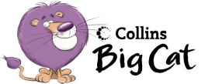
Name_______________________
Key words check Pink Band A - word wall
a | the | in | my | very
wet | I | am | and | they
play | red | green | yellow | blue

Colour Bears word wall
and | make | do | bears | colour
red | blue | yellow | green | orange
purple | brown

The See-Saw word wall
up | went | the | and | down
monkey | crocodile | lion | mouse | hippo
animals | see-saw

We Like Fruit word wall
I | like | we | all | fruit
apple | bananas | grapes | oranges | melons
strawberries

Word wall

