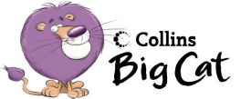We like fruit.

Draw a big bowl of your favourite fruits.

Write.

I like eating fruit.

Pink Hunter Primary

