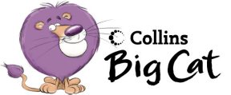
The Very Wet Dog

Colour to match
pond | mud
car | garden
mud | park
garden | pond
park | car

Draw a picture of the dog.

Pink 10a Hunter Primary

