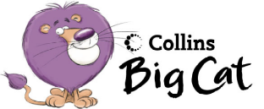Pink 15c Pushing and Pulling
Draw a picture of you on the monkey bars.

Copy the words below.

I am pulling.

