Monster Mess

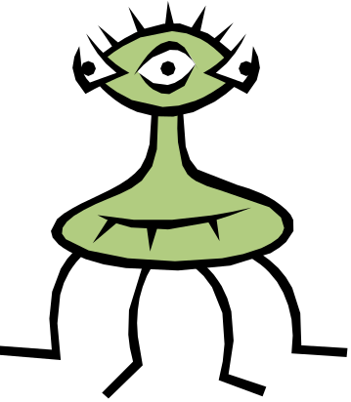Paint a monster with three horns and four legs.
Paint red spots on it’s body.

Pink 35c Hunter Primary

Pink Hunter Primary

