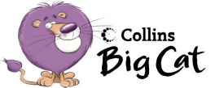Come To The Circus
Write the missing words from the story
Come see and the clowns circus

Come and see the _____________.

Come and ______________ the dancers.

Come ____________ see the juggler.

_________________ and see the magician.

Come and see the __________________.

Draw some silly clowns.

Pink 23a Hunter Primary

