The Battle Begins –

The Battle of Passchendaele
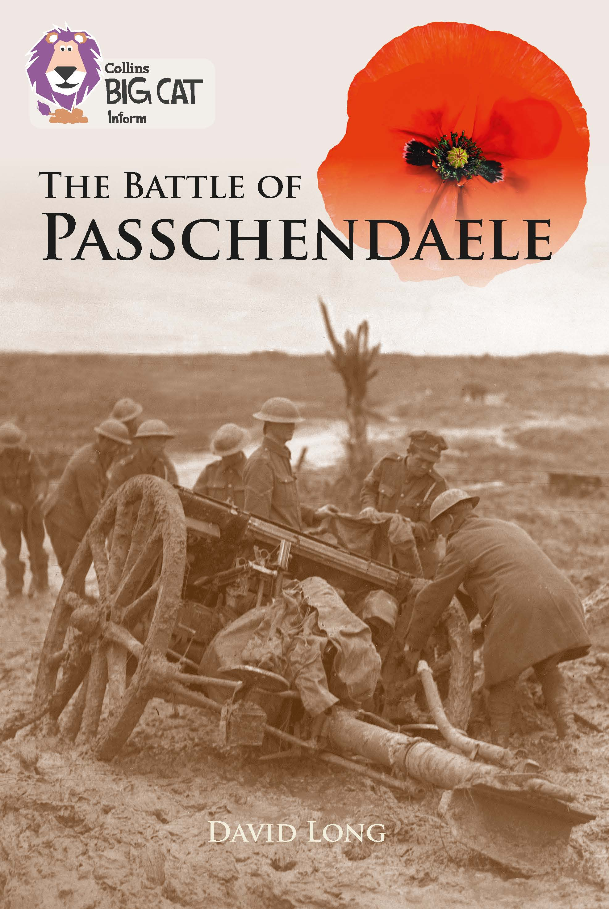
An extract has been selected to mimic the challenge of a reading comprehension paper.

Below are example questions that model some crucial question-types, followed by teaching suggestions (shown in purple font) which pre-empt potential pitfalls and misconceptions. As with all resources, apply professional judgement to guide your use of these examples; you may want to devise similar, or indeed entirely different, questions for other parts of the book.

Pages 28–31

Below are summaries of the six paragraphs on these pages. Number them 1–6 to show the order in which they appear:

Summer of stalemate

Stuck in the murderous mud

British and French helped by the weather

Mistaken confidence: concrete shelters

The shelling before the attack

Different ends, different fortunes

The correct sequence is as follows:

The shelling before the attack
Different ends, different fortunes
Stuck in the murderous mud
Summer of stalemate
British and French helped by the weather
Mistaken confidence: concrete shelters

When children are asked to order summaries, the real challenge is to understand the central point of each paragraph. In essence, the summaries are sub-headings; once children are able to link these to the paragraphs, the ordering aspect will be easy.

The most effective preparation for this skill would be plenty of practice summarising chunks of text into minimal word-counts and creating sub-headings for paragraphs / sections of information, orally and in writing, throughout the whole year (e.g. in topic lessons and in guided reading sessions).

If children have not had this experience or find it very difficult, the best test-technique is to read and understand each summary and then to hunt for key words in each paragraph.

Summer of stalemate: The word stalemate occurs in paragraph 4; you can double-check that this is the correct paragraph by looking for the time of year: Summer in the summary; mid-August in the paragraph.

Stuck in the murderous mud: Mud is mentioned in paragraph 3 – and men were drowning in it. Stuck must be inferred from caused rifles to jam…tanks couldn’t move…pause in the fighting.

British and French Helped by the weather: Weather is twice mentioned in paragraph 5, followed by examples of benefits to the British / French military.

Mistaken confidence: concrete shelters: Paragraph 6 talks about boosting spirits but this is followed by unfortunately. The word concrete is there, and if children don’t know the word bunker, they must infer the link to shelter it from, Hiding in strong concrete bunkers…hadn’t been affected at all by the rain.

The Shelling before the attack: A big clue here is before the attack, as this suggests it comes very early in the chapter. The word shelling may be unfamiliar, but is clearly linked to after…shells had been fired. If the word assault is not known, it must be inferred from the context of the last line of the paragraph.

Different ends, different fortunes: The second paragraph contains the phrases at one end and at the other end; these two phrases are linked within the paragraph by the word unfortunately which is linked to the word fortunes in the summary.

Pages 28–31

According to the text, how did the weather impact upon the first months of the battle?

A key theme running through this extract is the influence of the weather on the outcomes of battle. Many children are likely to fixate on the appalling negative impact of the torrential rain and the resultant quagmire and stalemate. Make sure that children also note the positive impact of the dry spell mentioned in the fifth paragraph; note too the implication of false confidence amongst the British and French forces, which also had tragic consequences for that side.

Independent work suggestions

- Children read selected / all chapters and summarise what each is about in no more than 10 words per chapter.

- While reading the information, children record unfamiliar words – but don’t allow them to look up meanings; instead the children must infer from context (using the techniques you have taught earlier – see above). Have children record how they have arrived at these meanings using evidence from the text.

- Have children compose true and false questions to ask each other; e.g. Soldiers died by drowning in the mud – true or false?

