The Tear Jar

Pages 39–41

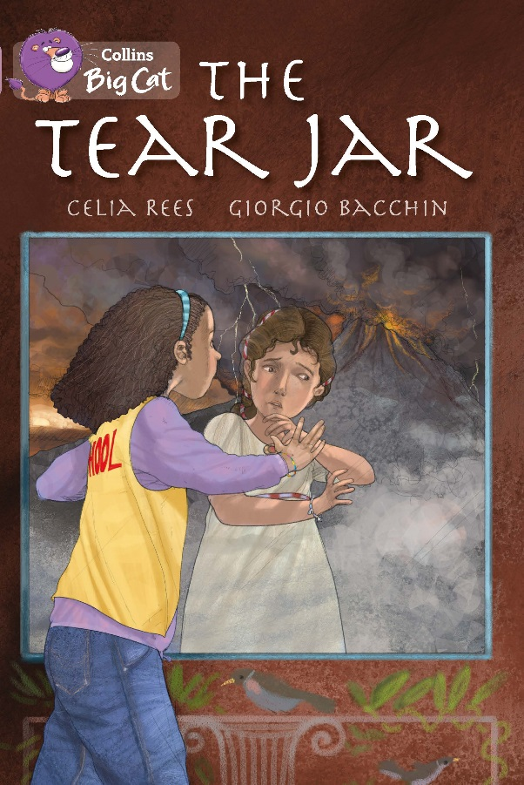
An extract has been selected to mimic the challenge of a reading comprehension paper.

Below are example questions that model some crucial question-types, followed by teaching suggestions (shown in purple font) which pre-empt potential pitfalls and misconceptions. As with all resources, apply professional judgement to guide your use of these examples; you may want to devise similar, or indeed entirely different, questions for other parts of the book.

Page 39

Which words suggest that Livilla had behaved without thinking?

If children don’t know the words impulse and defiance, demonstrate how a good answer can be developed from the context: Draw attention to the fact that Livilla had acted (in the text) means the same as “Livilla had behaved…” from the question; note also She hadn’t thought… This links with the phrase in the question: “without thinking”. These together help to locate the phrase, on impulse and out of defiance. Double-check against even vague recollections by the children of those two words from other contexts.

Page 39

…but out here, everything was different…

In the lines that follow, what mood is created – and how?

Reread the rest of that paragraph together and ask for immediate reactions. If children grasp the horror / terror, ask them to look again at how the author made them feel that; if they don’t, model the extraction of facts and ask them to put themselves in the scene – how would these things make them feel?
- The darkness is growing
- Rocks and ash are falling
- People are screaming and crying out for help
- An old lady is trampled by other people
- A mother loses grip of her child’s hand, and the child disappeared

Ask them: if these things were happening around you, how would they make you feel?
Discuss also the importance of the victims singled out for particular description: why an old lady? Why a mother losing hold of her child?

In the same paragraph

How is the crowd like a whirlpool?

First, establish the fact: the child disappeared.

If the children don’t know what a whirlpool is, don’t tell them; coach them through working it out: what’s a pool? What’s it made of? What’s “whirling"? What might it mean when a pool whirls?

Now, what would happen to a leaf in a whirlpool? We should know that it would disappear, because the child disappears like it!

The whirling water causes the leaf to disappear; the crowd causes the boy to disappear. So what can we say about the crowd? Look back at the rest of the paragraph for further evidence.

Pages 40–41

Why is Afranius particularly shocked?

Reread the two pages and check basic comprehension: what was Afranius expecting? His master’s ship. How do we know he was shocked? He ran even faster. Demonstrate that the reader shouldn’t be side-tracked by the description of the ship; it’s the fact that it isn’t there that is crucial to this scene.

But the question uses the word “particularly”, so we must go deeper with the answer: the ship belongs to his master, so Afranius is a servant or slave – as such, he is aware that the ship might not wait for him…but surely his master would wait for his own daughter?

Independent work suggestions

- Children read the whole of The Tear Jar and summarise what each chapter is about in no more than 10 words per chapter.

- While reading the story, children record unfamiliar words – but don’t allow them to look up meanings; instead the children must infer from context (using the techniques you have taught earlier – see above). Have children record how they have arrived at these meanings using evidence from the text.

- Throughout the story, have children note, “I know that X is feeling Y because on page… the author has written… This tells the reader that…”

- Have children compose true or false questions to ask each other; e.g. Lena is from Vesuvius –true or false?

