Antibiotic Resistance –

The Mysterious World of Microorganisms

Pages 62–65

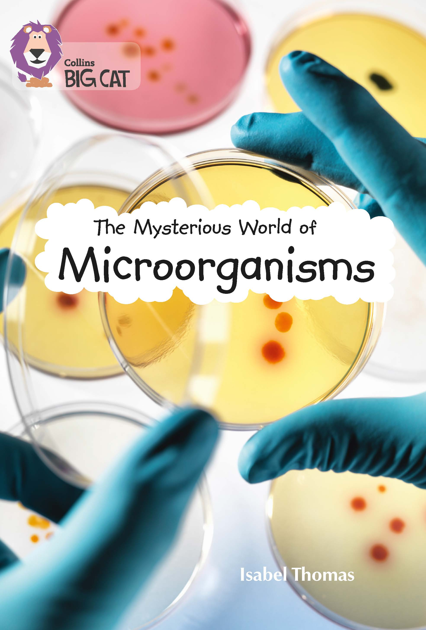
An extract has been selected to mimic the challenge of a reading comprehension paper.

Below are example questions that model some crucial question-types, followed by teaching suggestions (shown in purple font) which pre-empt potential pitfalls and misconceptions. As with all resources, apply professional judgement to guide your use of these examples; you may want to devise similar, or indeed entirely different, questions for other parts of the book.

Pages 62–63

Using the information from the text, tick one box in each row to show whether the statement is true or false.

 | True | False
Antibiotics are a miracle cure
Antibiotics can’t kill all bacteria
Taking antibiotics can cause bacteria to become resistant
Antibiotics are used to kill viruses

Questions such as this involve retrieval of information, but two problems arise: there are many potentially complex facts to be grasped; and the format can surprise or confuse some children. The best response to both of these issues is to methodically reread the text and reread each statement.

- “Antibiotics are a miracle cure”: the words miracle cure are there in the opening sentence and this might fool children reading in a panicky rush. Read the words around these words carefully: at first…seemed…But…
- “Antibiotics can’t kill all bacteria”: If an error was made with the first statement, a second could follow here – a miracle cure MUST kill all bacteria, surely! Also, cursory skim-reading might focus on the first statement of the third paragraph, The antibiotic starts to kill the bacteria… and miss the second, …but it can’t kill them all. Be clear that the children must read quickly, but they still have to read all of the text!
- “Taking antibiotics can cause bacteria to become resistant”: Children must first fully understand this counter-intuitive statement. Help them see that it is saying that antibiotics can cause resistance to antibiotics! Have them hold that idea in their heads as they re-read paragraphs 3 and 4. Then double-check against the final paragraph; why else would the author write: It is important to take antibiotics even when you really need them?
- “Antibiotics are used to kill viruses”: This just takes careful reading…but many children don’t read ‘ends’ (of pages or paragraphs) carefully, assuming perhaps that all the important info has happened by then. Reread that last sentence and understand it.

Pages 62–63

Which of the following words is closest in meaning to resistance, as it is used in this text?

difficult

unhealthy

microscopic

immune

Be clear that we are not just looking for the word that will work in context; they all will! If there is a lack of clarity, start by checking the most familiar words and see what can be eliminated.
Would a scientific text like this describe bacteria as difficult? That sounds more like a story!

Ask the children if antibiotics (i.e., medicines) can have health of their own. If not, how could anything be unhealthy to antibiotics?

If necessary, work together to define microscopic; then, explain that it is an unnecessary adjective when talking about bacteria!

Elimination of the above can bring us to immune…but just in case, bring up “immunity” – any prior knowledge of this word?

Finally, if necessary, test “immune” in place of resistant throughout the text.

Pages 62–63

Use the text to explain how taking antibiotics could lead to antibiotics becoming useless.

This retrieval question is asking for a summary and this will require solid understanding of the sequence of cause and effect. Some children may need help unpicking the process that is described.

Model locating the start of this medical process: bacteria…inside a person…person takes antibiotics…starts to kill bacteria…but can’t kill them all. (Here you can show that the detailed explanation of WHY it can’t kill them all is good to understand, but not required in the answer.) Now it’s important to understand how the remaining bacteria have benefitted: all the food and space to themselves. They reproduce… What is important about these resistant bacteria reproducing?

Pages 64–65

According to the text, how and why might “phages” be useful?

First, have children clarify exactly what a “phage” is – if necessary, show how the 2nd paragraph (page 64) doesn’t state this, but that the word these links back to viruses. Ask: are all viruses phages?

Once this has been understood, look together at page 65; model dismissing the info about their appearance as irrelevant to the question and focus the children on what they do.

Take the children back to the question. The ‘why’ has been answered in part, but needs also to refer to the initial problem of antibiotic resistance; the ‘how’ needs reference to what the scientists are trying to do.

Independent work suggestions

- Children read selected / all chapters and summarise what each is about in no more than 10 words per chapter.

- While reading the information, children record unfamiliar words – but don’t allow them to look up meanings; instead the children must infer from context (using the techniques you have taught earlier – see above). Have children record how they have arrived at these meanings using evidence from the text.

- Have children compose true or false questions to ask each other; e.g. Scientists want to put infected people in The Ganges – true or false?

