Macbeth

Pages 42–46

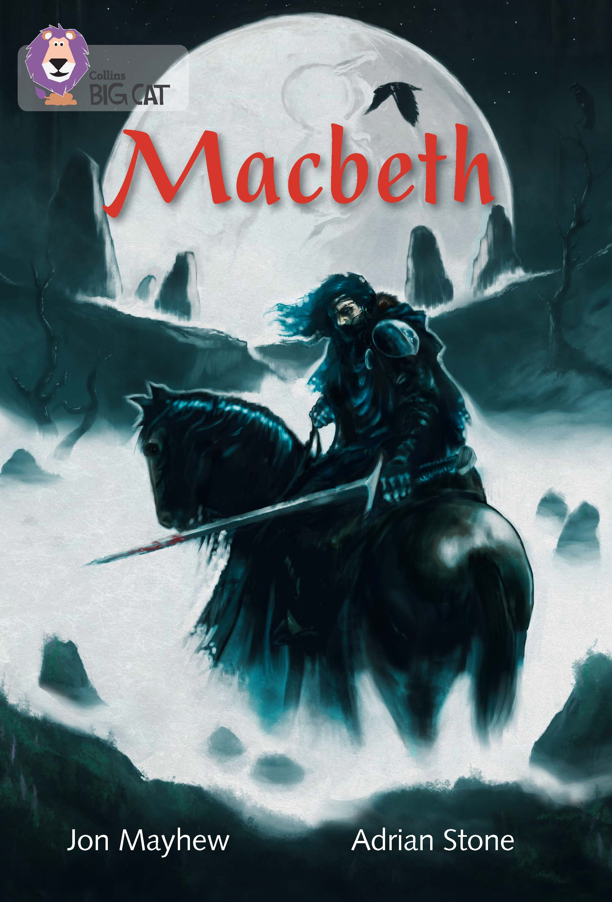
This is a prose retelling of Macbeth, from the viewpoint of a young servant. An extract has been selected to mimic the challenge of a reading comprehension paper.

Below are example questions that model some crucial question-types, followed by teaching suggestions (shown in purple font) which pre-empt potential pitfalls and misconceptions. As with all resources, apply professional judgement to guide your use of these examples; you may want to devise similar, or indeed entirely different, questions for other parts of the book.

Page 43

Which word suggests the narrator didn't want to be seen or heard?

If children aren’t clear of the meaning of crept, demonstrate that the answer can be developed from the context: As he ___ closer, he kept behind trees. Point out that the question asks for a single word; the phrase keeping behind the trunks does suggest the same thing, but there isn’t a single word within that phrase that fulfills this function on its own.

Page 43

Which of the following best defines the word ambush as it is used in the text?

a vicious attack

a surprise attack

a planned attack

First, remind the children that the text is written from the perspective of the child narrating. Then note that the last of these can be dismissed because word-substitution gives us, “they were planning a planned attack!” However, the attack is certainly vicious and a surprise, so word-substitution will not help children here. Model analysis of the immediate context: the narrator realises it is an ambush when they use a tree to block the path; he already knew it would be vicious as these were violent men (page 42), so he wouldn’t remark, “they were planning a vicious attack!” as a sudden realisation. The use of the tree to block the path indicates that, “they were planning a surprise attack.”

Pages 44–45

Use the text to give three examples of Banquo’s heroism.

If the children don’t know what heroism is, coach them through working it out: first identify the root ‘hero’; then, reread the scene and reflect on Banquo’s behaviour – given that the question states his heroism as fact, all that is left is to identify his actions. If they know heroism but find evidencing it hard, the same approach will work: when attacked by three men, initially he fights them off; he instructs the narrator to save himself, despite the fact that he might have benefitted from some help; and despite being knocked down, he rises again. His fourth and final act is passive – being killed – so the three prior actions must be the answer!

Page 45

I ran away… How is the sense of fear created in this paragraph?

It is important that children understand that the last three words of the question mean they cannot refer to the viciousness of the murder he has witnessed. Instead, they must imagine being the narrator in this paragraph: the facial scratching, the tearing, the burning lungs…but I didn't stop. What would make you keep going through such pain?

Page 46

Why does the narrator wipe his cheeks as he returns to the castle?

Children have to go beyond a desire to be clean in this answer; it is vital that they demonstrate understanding that he is a witness to a murder, and his efforts are to avoid being linked to the boy who tried to defend the victim.

Independent work suggestions

- Children read the whole of this retelling of Macbeth and summarise what each chapter is about, in no more than 10 words per chapter.

- While reading the story, children record unfamiliar words – but don’t allow them to look up meanings; instead the children must infer from context (using the techniques you have taught earlier – see above). Have children record how they have arrived at these meanings using evidence from the text.

- Throughout the story, have children note, “I know that X is feeling Y because on page… the author has written… This tells the reader that…”

- Have children compose true or false questions to ask each other; e.g. The murderers hit Banquo with a tree – true or false?

