The Water Cycle

Book background

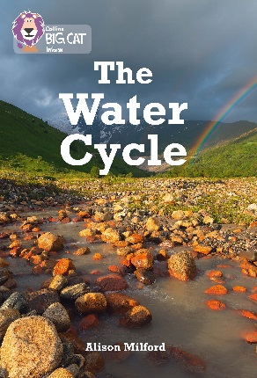
The initial pages introduce the water cycle and the vocabulary linked to this process. Explanations of precipitation, surface run-off, ground and underground water are then covered. The science of water, covering evaporation, transpiration and condensation are covered next. This is followed by the formation of clouds, particularly rain clouds and weather forecasting. The next section looks at why nature needs water and the importance of creating clean drinking water. The final section of the book looks at how we use water; climate change; and our impact on environments affecting the water cycle.

Subject areas / curriculum links

Science / Geography

Learning objectives

- Know the sequence of events that make up the rain cycle
- Describe each stage of the cycle
- Use the relevant terms for each part of the cycle

Prior knowledge

It would be useful if pupils:

- know the importance of water for all living things
- know what is meant by a cycle
- have met some of the terminology used in the water cycle.

Activities

Resources
- Scissors / glue
- Big Cat The Water Cycle activity sheet A
- Big Cat The Water Cycle activity sheet B

Introduction
- Use the following questions to ascertain the pupil’s initial understanding of the importance of water and the rain cycle:
- Why is water essential to us and all living things?
- What part does rain play in the water cycle?
- What is meant by a cycle?

Activity
- The Big Cat The Water Cycle activity sheet A can be used with varying ability levels. Initially, the activity sheet can be projected on the white board and used with a class or a group. Can they link the correct word on the diagram to the right description? The statements are not in any order. You can connect the titles and statements with numbers as they are revealed.

- The Big Cat The Water Cycle activity sheet A can be copied so that the pupils cut out the statements and stick them in the correct order.

- To increase the level of difficulty, the activity sheet can be copied without the statements or you can use Big Cat The Water Cycle activity sheet B and ask the pupils to write their own descriptions about what is happening at each stage.

Extension
- With a partner, try and list how many daily activities require water.
- What are the parts that you can see in the cycle and what are the parts that you cannot see?
- How could you observe evaporation?

Plenary / reflect
- What is precipitation?
- What happens during evaporation?
- Evaporation from plants has a special name – what is it?
- Give one other piece of information that you have learnt about the water cycle.

Assessing progression

Use the Big Cat The Water Cycle activity sheet B, which requires the pupils to write down and describe the water cycle in their own words.

Useful websites

http://www.bbc.co.uk/education/clips/z8qtfg8

