The Arabian Desert

Book background

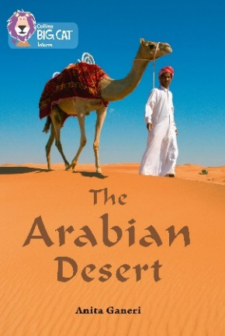
The book looks at the Arabian desert in great detail starting with how different deserts form. Although the environment is a harsh one, it does provide a living space for a variety of plants, animals and insects, all of which have to adapt to living in these difficult conditions. It also discovers how the desert people live in this region and how they depend on camels to help them survive. Finally, mention is made of the changing face of the modern desert, from the spread of desertification to the development of oil fields.

Subject areas / curriculum links

Geography / Science

Learning objectives

- Learn how a camel adapts to living in harsh conditions
- Recognise how camels are useful to the Bedouins
- Distinguish between true and false facts about the desert environment

Prior knowledge

It will be helpful if pupils:

- know that living things can adapt to local conditions.

Activities

Resources
- Big Cat The Arabian Desert book, for checking answers
- Big Cat The Arabian Desert activity sheet – True or False?
- Big Cat The Arabian Desert activity sheet – All about the Camel

Introduction
- This is a two-part lesson: a quiz covers information in the book and asks pupils to make some decisions about information, followed by an activity that looks at how the camel adapts to the harsh environment and how it is used by local tribes. These activities may be useful for different age groups.

Activity
- Introduce the lesson by using some of the questions at the back of the book (pages 54–55) and then asking pupils, possibly in pairs, to consider the questions on the activity sheet ‘True or False’. This activity can be made easier by allowing the book to be used for reference or by saying that there are 6 true statements and 4 false ones.

- Once completed, explain that pupils are going on to look at one aspect of desert life in more detail. Give out the activity sheet ‘All about the Camel’ which asks them to write information in the boxes about a) how different parts of the camel’s body help it adapt to living in the desert and b) how the camel is used by the Bedouin tribes.

Extension
- The pupils can make up some further questions themselves and pose these to the rest of the class.

Plenary / reflect
- Review the answers to the quiz questions and discuss whether it was easy or difficult to come to a decision. Did working with a partner make it easier or more difficult?
- What do they notice about how camels are used by the local people? Do camels become part of people’s lives? How do they look after them? Why might camels not be used so much in the future?

Assessing progression

- Younger pupils may find the camel activity sheet easier than the quiz questions.
- It is important that pupils understand that the desert is a living ecosystem and that animals, plants and even humans will adapt to the challenges of being there. Can they identify these challenges and how living things adapt to them?
- How far have they moved on in recognising that deserts are changing and may be very different places in the future?
- Do they know about the importance of camels in the lives of Bedouins?
- Can they recognise how and why camels are adapted to living in desert areas?
- Can they discriminate between true and false information?

Useful websites

http://www.bbc.co.uk/nature/life/Dromedary#p005lnxb An excellent website packed with information, video clips and pictures about the life of camels.
http://www.bbc.co.uk/news/business-35935661 A video clip which shows and talks about the sport of camel racing which is becoming popular all over the Gulf region. It shows the use of robot jockeys – a sign of things to come!

Activity / Information sheet acknowledgements
The publishers would like to thank the following for permission to reproduce photographs:

Wolfgang Zwanzger/Shutterstock.

