Technology in the Battle of Britain

Book background

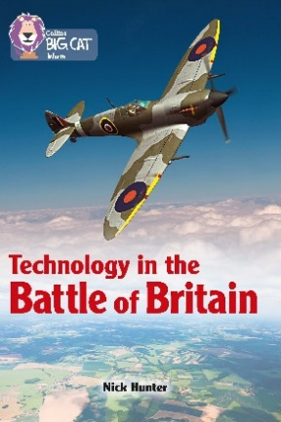
The book covers the initial stages of WWII from 1939 when Germany gradually overran many European countries. The invasion of Britain seemed inevitable. The Luftwaffe set out to destroy the RAF, as they could destroy the invading force. New technology thwarted their plans. Through the use of radar and telecommunications, the RAF were able to outmanoeuvre the Luftwaffe. The invasion failed; the Battle of Britain was won by the RAF. The fighter plane technology, as well as the technology used in air defences is carefully described. Also presented are breakthroughs in code breaking, manufacture of aircraft and medicine.

Subject areas / curriculum links

History / Geography

Learning objectives

- Develop knowledge about how the Battle of Britain was fought
- Understand the technology used in the battle
- Recognise on a map the places involved in the battle

Prior knowledge

It would be helpful if pupils:

- know what led up to the Battle of Britain
- know why it was essential for the Germans to defeat the RAF
- know how the German and British air forces compared.

Activities

Resources
- Big Cat Technology in the Battle of Britain information sheet – on white board or printed
- Copy of Big Cat Technology in the Battle of Britain – Air Defence activity sheet
- Scissors / glue

Introduction
- Discuss the background to the Battle of Britain and the threatened invasion. Write down the pupils’ contributions on the board to build up a picture of this threatening situation.
- What was the threat to Britain?
- Why was air supremacy so important to the Germans?
- What gave the RAF an advantage in the air?

- You could create either a pro’s and cons list for each side or a list of what was in favour for each side.

- Useful statistics could include aircraft numbers as of August 1940:
Luftwaffe: 1,137 fighters / 949 bombers / 336 dive bombers
RAF : 1,032 fighters (400 new fighters were being built every month)

Activity
- Using the Big Cat Technology in the Battle of Britain information sheet, look at the defensive system set up to combat the invading forces.

- Using the Big Cat Technology in the Battle of Britain activity sheet, pupils cut out and complete the task of setting up the home defence system.

- Using the information gathered on the white board, as well as in the book, ask pupils to write an account of an enemy attack. They can be either a fighter pilot or a plotter.

Extension
- Create a session of ‘radio’ interviews with a fighter pilot or a plotter.

Plenary / reflect
Use any of the key questions from above plus:

- Name three fighter airfields.
- How many radar sites are shown on the map? Name two.
- What body of water did the German aircraft have to fly over to get to Britain?
- Why was this strip of water a problem for German aircraft?

Assessing progression

- Use the written accounts to see how well each pupil has understood the information gathered. Give a brief explanation of the buildup to the Battle of Britain. Explain what is happening on the diagrammatic map.
- The ‘radio’ interview idea can be used to observe knowledge and understanding.

Useful websites

http://www.bbc.co.uk/history/ww2peopleswar/stories/98/a6864898.shtml
http://www.iwm.org.uk/history/8-things-you-need-to-know-about-the-battle-of-britain

Activity / Information sheet acknowledgements
The publishers would like to thank the following for permission to reproduce photographs:

Activity sheet (from top to bottom): Scanrail1/Shutterstock; Keith Tarrier/Shutterstock; Gabriele Maltinti/Shutterstock; stephen mulcahey/Shutterstock.
Information sheet (from left to right): War Archive/Alamy; Courtesy of Gardiner Houlgate.

