Roman Life in Britain

Book background

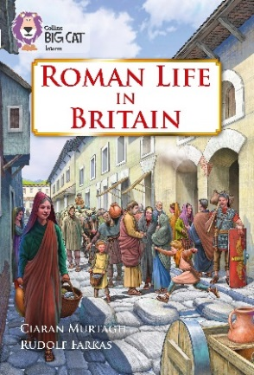
The book contains a brief background to the origins of Romans and Celts, the Romans’ reasons for invading Britain and the initial resistance of the Celts. The book also covers Roman life and how it impacted on Britain and where Roman remains can be found today. The final part of the book covers why the Romans left Britain and the legacy that they left behind.

Subject areas / curriculum links

Geography / History

Learning objectives

- Recognise that the road network introduced by the Romans underpins many of the roads used today
- Use maps to find courses of old Roman roads
- Create and use map keys
- Know places and place names in English towns connected with the Romans

Prior knowledge

It would be helpful if pupils:

- know the dominance of Rome and the extent of its Empire throughout the Mediterranean
- know that the Romans possessed superior armed forces and were well organised, building good roads and fortifications
- know that Emperor Claudius invaded Britain to appear a strong leader and to find great wealth for Rome.

Activities

Resources
- Three / four different coloured pencils
- Copy of Big Cat Roman Life in Britain activity sheet

Introduction
- Pages 18 to 19 give a brief outline of why the Romans thought road building was so important. The activity sheet Roman Life in Britain introduces three Roman roads that criss-crossed Britain around 100CE. Pupils are asked to draw in the three roads, using three different coloured pencils, after reading a brief description. They are then asked to complete the key.

- Further questions (these can be written on the white board or undertaken as a Q & A session):
- Why were the roads so important?
- Which road, going upwards, went south to north?
- Which road, going upwards, went west to east?
- Which road, going upwards, went east to west?

Activity
- Page 26 looks at the legacy and remains of what the Romans left in Britain. Good examples of Roman roads still in use can be found around Lincoln. Using either an OS map (Landranger 121) or a large-scale road map, look for the A15 north from the city, Ermine Street or the A46, Fosse Way, coming in from the south. How can they recognise that these roads are of Roman origin?

- The activity sheet also introduces the creation of a wall by Emperor Hadrian in 117CE to denote the north-west frontier of the Roman Empire at that time. The wall runs from the Solway Firth to Wallsend on the east coast at a distance of 117km (73 miles). There were gateways called mile castles at one mile intervals along the wall, and 17 forts.

Extension
- How did the Roman road system connect with Rome?
- Pupils can enter the Roman names for the cities shown on their maps. They are reproduced here:

Cirencester Corinium Dobunnorum
Chester Deva Victrix
Canterbury Durovernum Cantiacorum
Exeter Isca Dumnoniorum
London Londinium
Lincoln Lindum Colonia
Dover Dubris
York Eboracum

Plenary / reflect
The following questions will help the class reflect on the work that they have undertaken:

- Why did Emperor Claudius want to conquer Britain?
- Why were the Romans able to conquer large parts of Britain?
- Where did the Romans come from? How big was their Empire?
- How do motorways compare with Roman roads?
- How important are roads today?
- What is transported on motorways?

Assessing progression

- What was Watling Street?
- How might you recognise a Roman road on a map?
- Why were the roads important to the Roman Empire?
- The saying ‘All roads lead to Rome’ is still used today. What might it mean?

Useful websites

http://www.primaryhomeworkhelp.co.uk/
http://hadrianswallcountry.co.uk/history
www.primaryhomeworkhelp.co.uk/romans/hadrianswall.htm

