Mega Plants

Book background

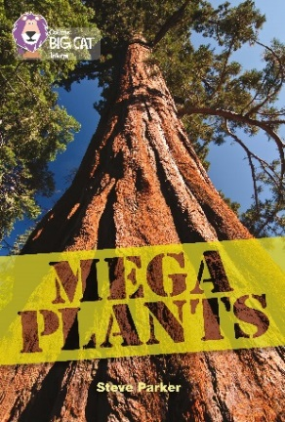
Mega plants are those which have massive leaves, enormous flowers, extra deep roots and supersized seeds. The book gives a brief explanation of how trees grow, followed by descriptions of the tallest, widest, longest-branched, ‘hugest’-leaved and biggest-seeded plants in the world. Likewise, mega plants are plants with the biggest flowers, the deepest roots and those which are the fastest growing. There is a section covering the weirdest and strangest looking plants, as well as mega sea plants. In the final section prehistoric plants are introduced, with the book finishing with a 1,000 tonne fungus – possibly the biggest plant in the world.

Subject areas / curriculum links

Science / Geography

Learning objectives

- Know how plants use light, water and nutrients to grow
- Be able to label a tree diagram to demonstrate the above
- Use an atlas to recognise specific countries, continents and oceans

Prior knowledge

It would be helpful if pupils:

- have some familiarity with an atlas
- know about and can name the parts of a tree.

Activities

Resources
- Big Cat Mega Plants page 3
- Big Cat Mega Plants information sheet – How Trees Work
- Big Cat Mega Plants activity sheet A – How Trees Live and Grow
- Big Cat Mega Plants activity sheet B – Mega Plants Around the World

Introduction
- Ask the pupils to discuss with a partner what they think a tree needs to help it grow. Collect some of their answers on the white board – these will make a useful comparison at the end of the lesson.

Activity
- Use the information sheet – How Trees Work – on the white board. You may wish to gradually reveal each part of the tree and discuss with the pupils each of the following aspects.
  - The importance of leaves being able to receive sunlight so that they can take in light energy.
  - Branches play a role in both extending the area of the leaves and also as a highway for transporting water and nutrients from the roots.
  - Likewise, the trunk supports all the branches but also transports water and nutrients from the roots.
  - Finally, the roots give secure footage supporting both the weight and size of the tree. They also take the water and nutrients from the soil, sending them around the tree.

- When you have finished, remove the information sheet from the white board and put up activity sheet A – How Trees Live and Grow. This asks pupils to describe how each part of the tree functions in their own words. You may wish to put some of the key words, e.g. captures, energy, stem etc., on the board.

Extension
- The Big Cat Mega Plants activity sheet B – Mega Plants Around the World – requires the use of an atlas and could be undertaken in pairs. This is a challenging activity and will test how well each pupil can use an atlas.

Plenary / reflect
- Choose a pupil to go through the worksheet on the white board and complete a section. You can choose a different pupil to complete each individual section. How did their original answers at the start of the lesson compare with the end result? What have they learnt?
- Go through the answers for Big Cat Mega Plants activity sheet B – Mega Plants Around the World.

Assessing progression

A comparison of the notes taken during the initial discussion at the start of the lesson and the answers given by pupils at the end should show the degree of progression made during this lesson.

Activity / Information sheet acknowledgements
The publishers would like to thank the following for permission to reproduce photographs:

(From left to right) Lightboxx/Shutterstock; Steve Mollin/Shutterstock; Jurgen&Christine Sohns/FLPA; Kobchai/Shutterstock; Photoshot/Topfoto; National Park Service Digital Image Archives/Wikimedia Commons; Thierry Guinet/Shutterstock; Visuals Unlimited/Science Photo Library; Shutterstock; Roger Caras/Science Photo Library; Courtesy of Big Baobab Modjajiskloof www.bibbaobab.co.za; Frans Lanting, Mint Images/Science Photo Library.

