Early Kings of England

Book background

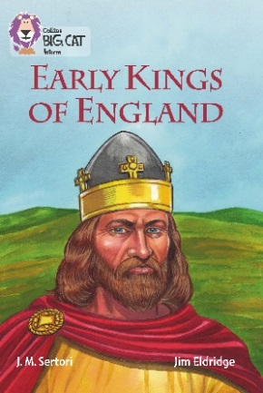
As the Roman Empire gradually collapsed, the Angle and Saxon tribes from Denmark began to arrive in England. Over 200 years they took over the west of England, embraced Christianity and anointed their own king. Evidence can still be found in place names and the findings of Sutton Hoo.

The Vikings started raiding in 793 BC and took over Northumbria. Yorvik, or York, became their capital. King Alfred fought them and won, forcing the Vikings to sign a treaty, creating the Danelaw. After the death of Alfred, his siblings and relatives fought for possession of the crown and lost parts of the kingdom. Eventually the Viking Swien Forkbeard beat King Athelred. Forkbeard’s son Cnut took the crown and married Athelred’s widow, Emma. With the early death of all Cnut’s sons, Emma managed to put her Saxon son, Edward, son of Athelred, on the throne. On Edward’s death Harold became King, but this was disputed by William of Normandy, leading to the Battle of Hastings.

Subject areas / curriculum links

Geography / History

Learning objectives

  - Name some key events in early English history
  - Place on a map some key historic places and events
  - Use an atlas to find key historic places and events

Prior knowledge

It would be helpful if pupils:

- know where the area of Wessex was sited
- know that King Alfred’s Wessex’ capital was Winchester
- know that the Vikings held Danelaw and Norse areas of Britain.

Activities

Resources
  - Big Cat Early Kings of England book
  - Big Cat Early Kings of England information sheet 1
  - Big Cat Early Kings of England activity sheet
  - Big Cat Early Kings of England information sheet 2 (based on the map found on pages 46–47)
  - Road atlas or detailed map of UK

Introduction
- This lesson can be used in a variety of ways dependent on the history topic area that you are working on. Using Big Cat Early Kings of England information sheet 1, briefly introduce the event or events that are relevant to your topic. Inform the pupils that they will research the chosen event in more depth by studying the relevant pages in the book. This task can be undertaken individually, in pairs or groups, dependent on resources.

Activity
- The six events shown on the map can be found in the Big Cat Early Kings of England book on the following pages:
  - The Battle of Badon Hill pages 6–7
  - Sutton Hoo burial ground pages 8–9
  - Vikings attack Lindisfarne pages 14–15
  - Jorvik pages 16–17
  - Alfred the Great pages 18–19
  - The Battle of Hastings pages 42–43
Ask the pupils to write down five facts or pieces of information from their event. Set a time limit.

- Big Cat Early Kings of England activity sheet asks the pupils to shade areas represented on a map with a different colour and complete a key when finished. There is also an opportunity to revise and use compass directions. In finding the places named on each picture, set the level of difficulty by either showing Big Cat Early Kings of England information sheet 2 or by asking the pupils to use a road atlas or detailed atlas to find the correct position for each place named. This is a good opportunity to review the use of a gazetteer. (If available an electronic device can also be used.)

Plenary / reflect
- The five pieces of information gathered at the start of lesson can now be can exchanged. If groups did the same task, did the facts differ?
- What was the most memorable piece of information?

Extension
- Can pupils place the events in order of occurrence?

Assessing progression

- Can pupils name and place an event during the period of the Early Kings of England?
- Can they describe the event that took place?
- Can they demonstrate the ability to research information about an event and use it in their writing?

Useful websites

http://www.bbc.co.uk/schools/primaryhistory/anglo_saxons/kings_and_laws/
http://projectbritain.com/history.html

