Creatures from the Past –

Fossils

Book background

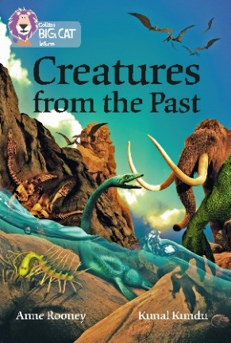
The book starts with a brief introduction to evolution and how today DNA is used to show how various organisms are related. This is followed by how fossils are created and their importance in revealing long-extinct animals and plants, as well as how they are key in dating rock strata. The theme of adaption is explored, showing why changes in the environment can make an animal extinct and how some adapted and survived, and how various animals evolved. The dinosaurs in all their various forms are covered, including how the movement of landmasses left dinosaur fossils in the Antarctic. Prehistoric animals of the sky, bugs of the swamp and creatures of the sea are also covered. Finally, after looking at what might have been the first organisms on earth, the book examines the impact of humans on wildlife.

Subject areas / curriculum links

Science / Geography / History

Learning objectives

  - Describe ways in which fossils are formed
  - Explain the importance of fossils in revealing extinct prehistoric creatures
  - Explain the importance of fossils in dating geological rock strata

Prior knowledge

It would be helpful if pupils:

- know how sedimentary rocks are created
- know that sedimentary rocks can be rich in fossils
- know how minerals can replace bone and living matter.

Activities

Resources
- Big Cat Creatures from the Past activity sheet
- Big Cat Creatures from the Past information sheet 1
- Big Cat Creatures from the Past information sheet 2

Introduction
- Use the following questions to explore how much prior knowledge pupils may have.
  - How do we know about extinct creatures that lived millions of years ago?
  - How are bones from these creatures able to survive over millions of years?
  - What is a fossil?
  - Can plants and small creatures be fossilised?

Activity
- Using Big Cat Creatures from the Past information sheet 1, ask the pupils to read through carefully, and see if they can answer the following questions (this can be undertaken in pairs or small groups).
  - Which has a better chance of becoming a fossil: a bone or feather? Give reasons for your answer
  - What can leave an imprint in sand or mud?
  - Why do we only know a few of the animals and plants that lived in the past?
  - How is our knowledge of past animals and plants improving each year?
  - What causes sediment to turn into rock?
  - How is it that fossils are found on high mountains, even the Himalayas?

- The Big Cat Creatures from the Past activity sheet extends these questions and uses pictures for the pupils to identify how creatures have been fossilised. The difficulty of this activity can be varied by either allowing the use of the information sheet or not. If they are doing the activity without the information sheet, you may wish them to work in pairs or small groups to pool their information.

Plenary / reflect
- Use Big Cat Creatures from the Past information sheet 2 to explore what they have learnt over this session. Use the pictures to ask questions about what they can see in each image.
- In picture A, can they recognise the various layers of sediment that have been put under pressure in this sedimentary rock?
- In picture B the rock has been split open to reveal an assortment of fossils. Can they tell you that these ammonites died and fell to the bottom of the sea where they were gradually covered? They may be able to see that there is a piece of fossilised wood in the centre. Can they also see that mineral replacement has taken place?
- In picture C they should be able to see clearly the mineral replacement, coloured light brown.
- In picture D the fossilised wood reveals the mineral replacement that has turned the wood into stone.

Assessing progression

- The plenary and the written answers from the activity sheet can be compared with the answers given at the start of the lesson.

Further ideas

The pupils can explore the work of Mary Anning and how important her findings were.
http://www.bbc.co.uk/education/clips/z4r4d2p
http://primaryfacts.com/2359/mary-anning-facts-about-the-famous-fossil-collector/

Activity / Information sheet acknowledgements
The publishers would like to thank the following for permission to reproduce photographs:

Information Sheet 1: Pictorial Press Ltd/Alamy; Activity Sheet, tr: The Natural History Museum/Alamy; bl: Tom Uhlam/Alamy; br: Education Images/UIG/Getty.

