Boudica

Book background

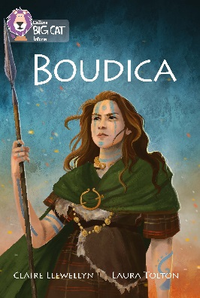
The book starts with a short introduction to the tribes that were indigenous to Britain before the Roman conquest. There is a brief background to the Iceni, Boudica’s tribe, how they lived and their artistic skill in working metal. The Roman invasion is covered briefly. The Iceni initially decided to work with the invaders, but the Romans treated the tribe badly and abused Boudica. For revenge, Boudica sacked Colchester and London. The Roman army, initially wrong-footed, eventually fought a major battle against the Iceni. The Romans were greatly outnumbered but using superior tactics and greater capability they defeated the Iceni. What happened to Boudica is unknown.

Subject areas / curriculum links

History / Geography

Learning objectives

  - Demonstrate the ability to contrast and compare two very different types of culture
  - Explain the similarities and differences between two images
  - Use the pictures and illustrations to inform their conclusions

Prior knowledge

It would be helpful if pupils:

  - know that the Iceni was one tribe out of many in Britain and that each tribe was independent
  - know that the Romans had conquered and ruled large parts of Europe for many years
  - know that the Roman army was very powerful and kept order throughout the empire
  - know that both societies had totally different beliefs and backgrounds.

Activities

Resources
- Big Cat Boudica information sheet
- Big Cat Boudica activity sheet
- Big Cat Boudica reference pages 6–9
- Big Cat Roman Life in Britain reference pages 12–13

Introduction
- This activity gives an opportunity for pupils to contrast two very different cultures. Using the Big Cat Boudica information sheet 1, ask the pupils to study the images carefully.
  - What can they identify in the hill fort? (buildings / ditches)
  - What materials do they think the fort is made out of?
  - Can they spot the wood palisade on top of the wall?
  - Why do they think it was built like this?

- Using the image of the village, can they identify what the buildings are made out of? Discuss what they can see happening in the picture. What are the people doing?

- Undertake the same activity with the Roman town.
  - Can they work out what some of the buildings are used for?
  - What are the main differences between the two places?
  - Can they find any similarities?
  - Why do they think the Romans considered the Celts rough and uncivilised?
You may wish to write up your findings on the white board at this stage.

Activity
- Ask the pupils to complete the Big Cat Boudica activity sheet using the information that they have found out from the information sheet.

Extension
  - Why do they think archaeologists find more Roman remains than Celtic?
  - What were the Celts actually quite skilled at?

Plenary / reflect
  - What features of a Roman town can be found in our towns today?
  - Which of the two places would they choose to live in? (Give four reasons for your choice.)
  - Why do they think there are such great differences between the Celtic hill fort and the Roman town? (Farming community and trading town)

Assessing progression

The outcome of the activity sheet will indicate pupils’ level of knowledge and understanding.

Activity / Information sheet acknowledgements
Artwork by Ruldolf Farkas and Laura Tolton.

