Lord Neptune and Goodwin Sands –

Caliban’s Cave: Band 15/Emerald Band

Pages 14–16 and 18–20

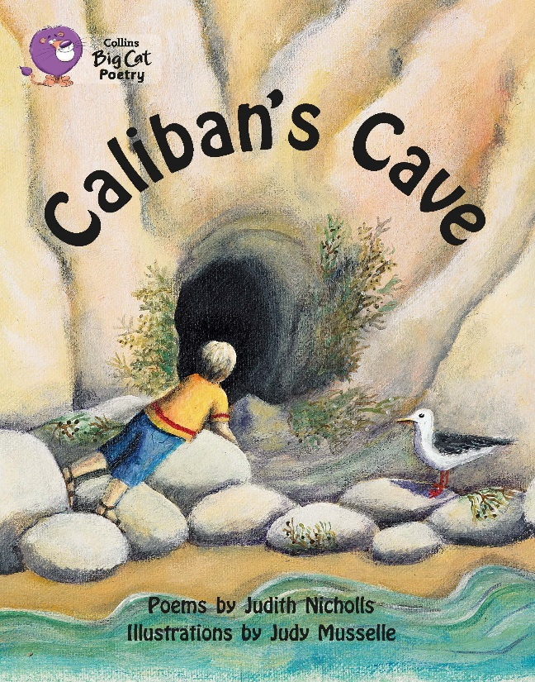
Two poems have been selected to mimic the challenge of a reading comprehension paper. There are questions on each, as well as questions that require comparison between the two.

Below are example questions that model some crucial question-types, followed by teaching suggestions (shown in purple font) which pre-empt potential pitfalls and misconceptions. As with all resources, apply professional judgement to guide your use of these examples; you may want to devise similar, or indeed entirely different, questions for other parts of the book.

Pages 14–16

Describe the events of the poem as they actually happen.

Many children are unused to the non-literal descriptions common in poetry, so as you work through the events in sequence, first query whether the ‘voice’ on the wind on pages 14 and 16 is ‘actual’ (we don’t know). Then, once the sandcastle has been built, check that all understand that the boy has not actually become a king! After that, check that children understand how the tide can cause a sandcastle to sink – increasing numbers of children have no practical experience of beach-play so we cannot take this knowledge for granted.

Pages 14-16

Which of the following statements best describes why the poet has used italic font in two stanzas?

It makes you read in a soft voice

It separates the real world from the supernatural

It shows Neptune’s speech

The first statement can be dismissed because italics might imply all sorts of different voices, not just soft. Many children may choose the third option because the voice is the focus of the italicised stanzas, but this can be discounted as only half of those lines are speech (the others are narration). This leaves the second, and if the ’facts’ of the poem have been understood, the separation of real world and mystery become clear.

Pages 18–20

Explain what each line of the fifth stanza describes.

Be aware that some children find this kind of low-level inference confusing. Unpick meaning line-by-line: many sail…some return – what does this imply about the rest? And following this, what must the third line mean? And how does the fourth confirm this?

Pages 18–20

In the sixth stanza, what is eerie about the voices that can be heard?

This is a cumulative-understanding question; if the previous question was not answered well, this one may be difficult. If problems arise, and expressions such as “long-lost sailors” are not familiar, return to the fifth stanza and understand it describes sailors drowning, before examining the nature of the voices.

Comparing the poems

In each poem, at what time of day does the sea seem most powerful and / or mysterious? How do you know?

Lord Neptune: Don’t assume knowledge of the word dusk. It is rarely used orally now in any context, so perhaps only the most regular readers will have this prior knowledge. However, even if the meaning is unknown, the word ‘at’ in at dusk his throne…indicates that this is the time.

Goodwin Sands: Take the clue from the question that we are looking for the most powerful / mysterious element – and here, that must be the voices of the dead (sixth stanza). Now look for words that indicate time…but don’t let anyone say the answer is night (an easy error to make); look at the words immediately before night to be clear of the time. (Notice also in the first stanza, dark winds crying / as dusk-drawn clouds wheel by.)

Which of these statements best describes both poems? Explain your answer using evidence.

The sea is powerful and mysterious

The sea kills people

You shouldn’t go in or play by the sea

Lord Neptune is more powerful than humans

Before beginning an elimination process, be clear that the children must have both poems in their heads (a common error is to refer only to the last one read). The first statement might seem to lack clarity; dismiss the second because no-one is killed in Lord Neptune; similarly, there is nothing in Lord Neptune to suggest the third statement; and there is nothing in Goodwin Sands about Neptune. Now check that first one again: “powerful” – it destroys a sandcastle…and kills people; “mysterious” – it may cause you to think of the Sea God, or hear voices of dead sailors.

Independent work suggestions

- Children read any / all poems and try to summarise what each is about in no more than 10 words per poem.

- While reading the poems, children record unfamiliar words – but don’t allow them to look up meanings; instead the children must infer from context (using the techniques you have taught earlier – see above). Have children record how they have arrived at these meanings using evidence from the text.

- As they read the poems, have children note, “I can tell that the poet Judith Nicholls thinks…because on page…, she has written… This tells the reader that…”

