Half-term Test 1 Pupil Book 3 (Chapters 1, 2, 3)
SECTION A: You must not use a calculator for these questions
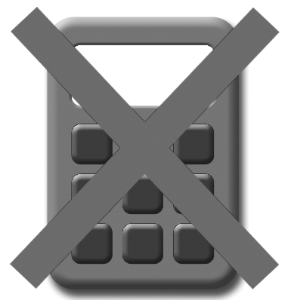
- (a) Fill in the missing output for this function machine.
4

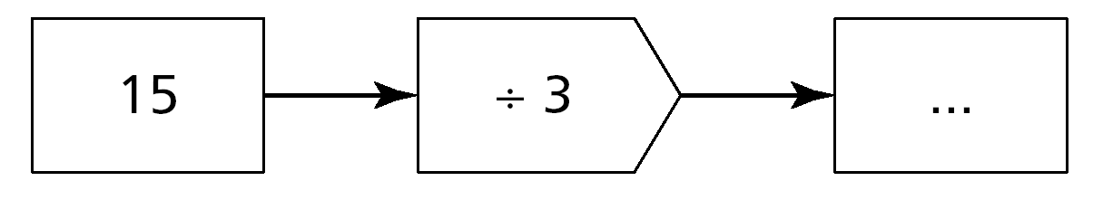

[1 mark]
(b) Fill in the missing input for this function machine.
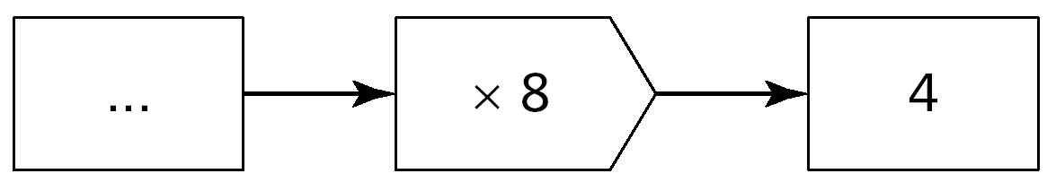

[1 mark]
- Fill in the missing numbers so that the answer is always 65.
One example is done to help you.
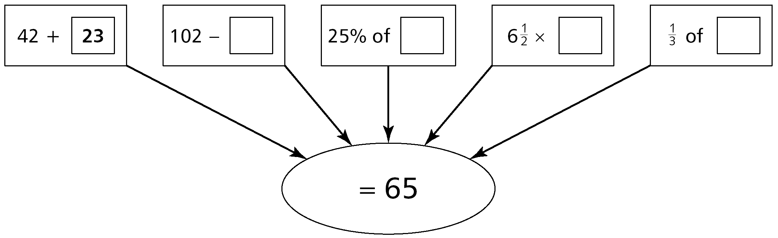

[4 marks]
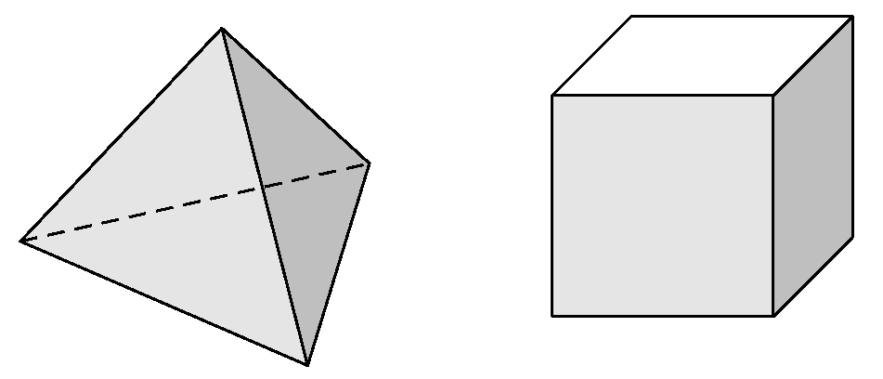
- Fill in the table showing the faces, edges and vertices of the two 3-D shapes shown.
5

[2 marks]
Shape | Faces | Edges | Vertices
A
B
A B
4 Look at these cards.
5

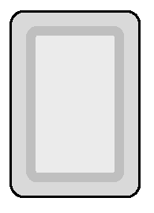
–2
0
+6
+9
–4
–7
+2

+
= –1
+

(a) Choose three cards that give the answer –1.

= 0
+

(b) Choose two cards that give the answer to

=
+
–4

(c) Choose a card that gives the highest possible answer to

=
+
–4

(d) Choose a card that gives the lowest possible answer to

[4 marks]
5 Given that 49 × 132 = 6468, work out:

- 49 × 13.2 = ................... [1 mark]
- 490 × 1320 = ................... [1 mark]
- 4.9 × 1.32 = ................... [1 mark]

6 This is a mapping diagram for a function:
2 → 6

3 → 7

6 → 10

The rule for the function is x → x + 4.
(a) Here is a mapping diagram for a different function.
2 → 0

5 → 3

10 → 8
5

Complete the rule for this function. x → ................... [1 mark]
(b) A further function has the rule x → 3x.
Complete the mapping diagram for this function.
2 → ......

5 → ......

...... → 27

[2 marks]

7 Tom is making patterns with matches:
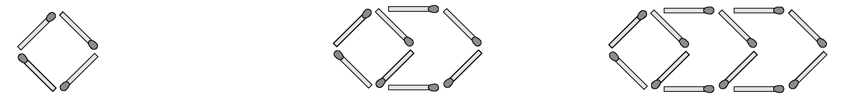

Pattern 1 Pattern 2 Pattern 3

(a) How many more matches will Tom need to make pattern 4?

...................................... [1 mark]
(b) How many matches altogether will Tom need to make pattern 5?

...................................... [1 mark]

(c) How many matches will Tom need to make pattern 12?

...................................... [1 mark]

(d) Tom has a box containing 99 matches. What is the largest pattern number he can make?

...................................... [2 marks]
8 Alisha makes and sells earrings.
She packs each pair of earrings in a small box that she makes from card.
6

Here is a sketch of the box she makes.
4 cm
2 cm
1 cm

(a) Draw the box accurately on the isometric grid. [2 marks]
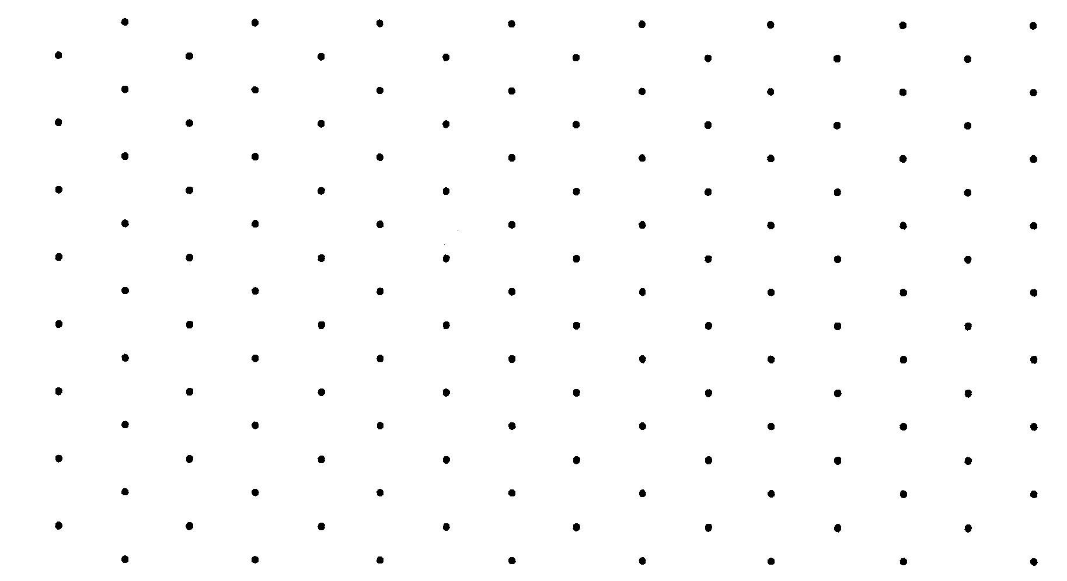

(b) Calculate the volume of the box and give the units in your answer.

...................................... [1 mark]

(c) Calculate the area of card Alisha needs to make one box.
Show your working. You may get a mark.

....................................................................................................................
...................................... cm² [2 marks]
9 Complete the table.

× | –3 | 5
4
–2
[2 marks]
SECTION B: You may use a calculator for these questions
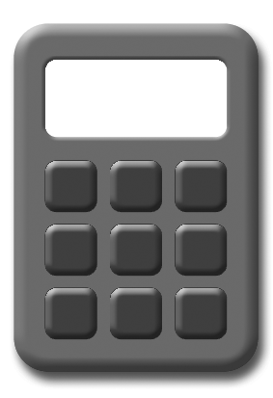

10 Here is a number sequence:
4

5 9 13 ......... .........

Write the next two numbers in the sequence. [1 mark]

Write the rule for the sequence. ...................................... [1 mark]

Here is another sequence.

......... 5 2 ......... –4

Write the two missing numbers in the sequence. [1 mark]

5

11 Arrange the following lengths in order, smallest to largest:

3.4 m 0.036 km 350 cm 3700 mm

.............................................................................................................. [2 marks]

12 Some people use stones to measure weight.
The diagram shows one way to change stones to kilograms.

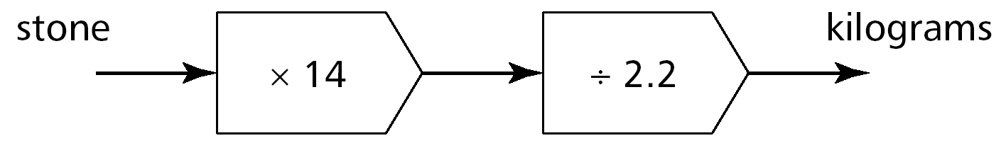
stones
kilograms

(a) Change 5 stones to kilograms. ............................... kg [1 mark]

(b) Change 25 kilograms to stones. ........................ stones [2 marks]

13 The area of the rectangle is 36 cm².
4 cm

(a) What is the length of the rectangle? ............................... cm [1 mark]
(b) A different rectangle also has an area of 36 cm². It is not a square.
5

Write what the length and the width of this rectangle could be.

Length = ............................... cm Width = ............................ cm [1 mark]

14 A roll of wallpaper has a length of 10.05 m.
Louise cuts three 2.6 m lengths from the roll.

What length of wallpaper is left? ............................... m [2 marks]

6

15 Find the area of this shape:
3.8 cm
0.6 cm
2.4 cm
1.2 cm

............................... cm² [3 marks]

16 A sequence is: 4, 7, 10, 13, 16, .......
The general term is given by the rule 3n + 1.

(a) Another sequence is 5, 8, 11, 14, 17, .......

Write down the general term for this sequence. .................................... [1 mark]

(b) Another sequence is given by 5, 9, 13, 17, 21, .......

Write down the general term for this sequence. ..................................... [1 mark]
17 The diagram shows a garden 2.8 m by 1.5 m which has a flower bed 1.2 m by 0.7 m surrounded by grass.
6

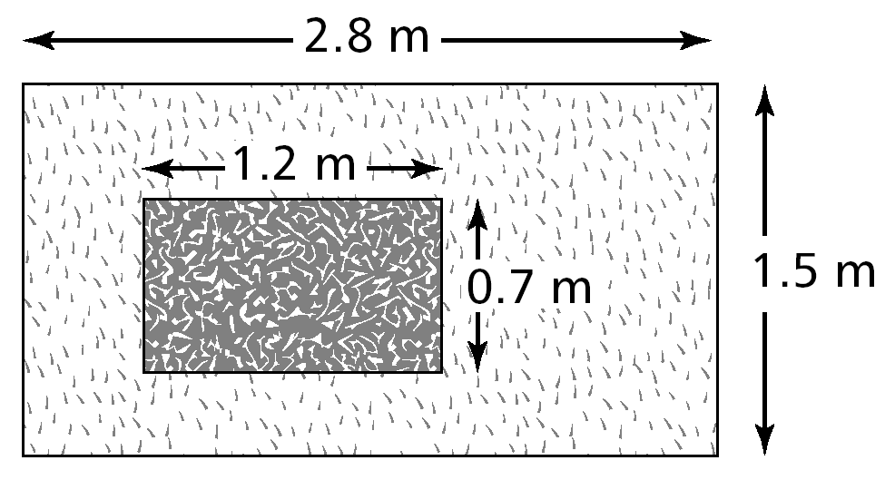

(a) What is the area of the grass? ............................... m² [1 mark]

(b) What fraction of the garden is taken up by the flower bed?

............................... [2 marks]

Total Marks 50
Investigation
Here are four consecutive digits:

1 2 3 4

Use the digits to make two 2-digit numbers that add together to give the biggest total.
+
=

Now use the digits again to make two 2-digit numbers that add together to give the smallest total.
+
=

Find the difference between the two answers.

Try this again for the digits 2, 3, 4 and 5. What do you notice?

Does this work for any four consecutive digits? Investigate.

Extension

Try this investigation using six consecutive digits.

